**MACHINE PROBLEM #4**

Script:

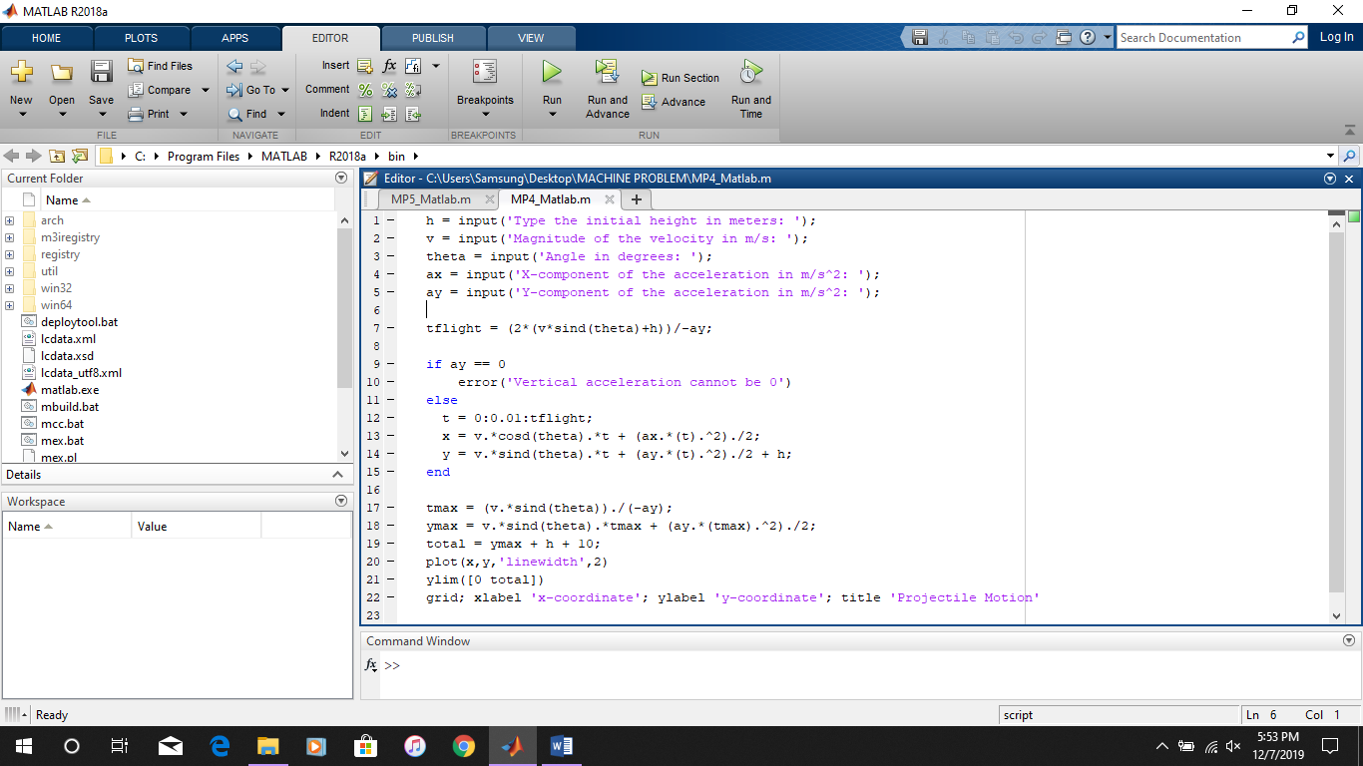

Test no.1 (without acceleration in the x-axis)

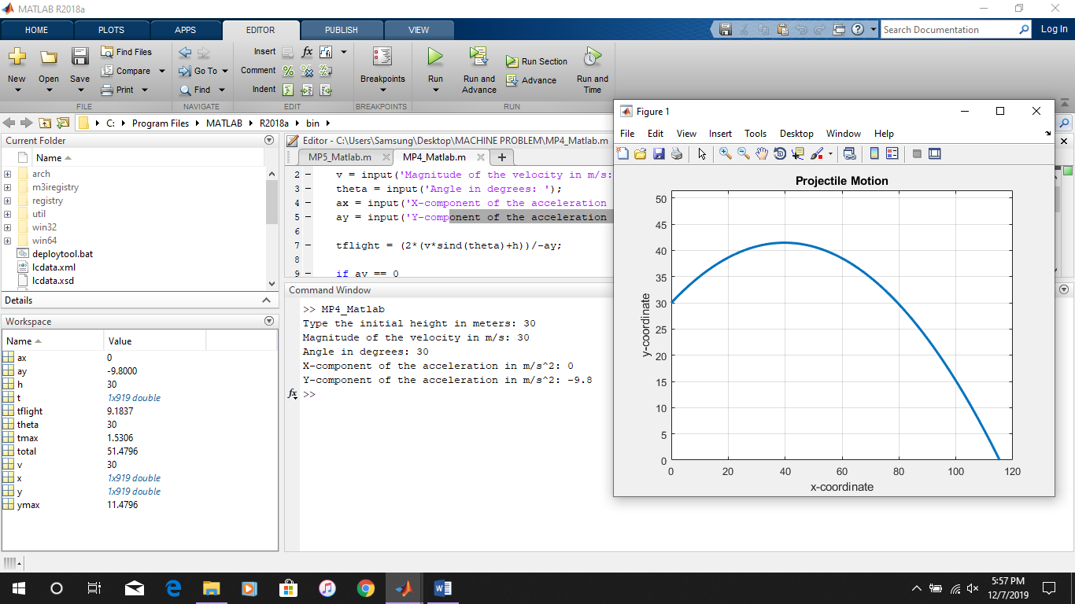

Test no.2 (with acceleration in the x-axis)

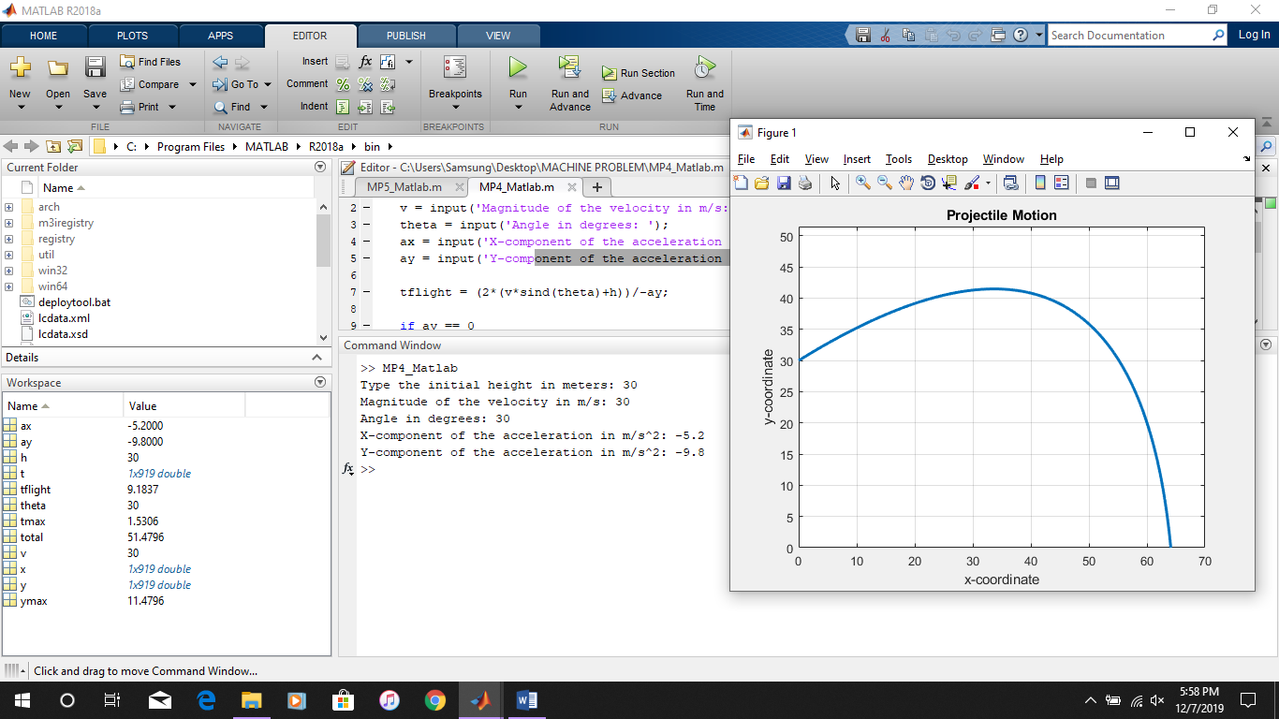

Test No. 3 (without acceleration in the x-axis)

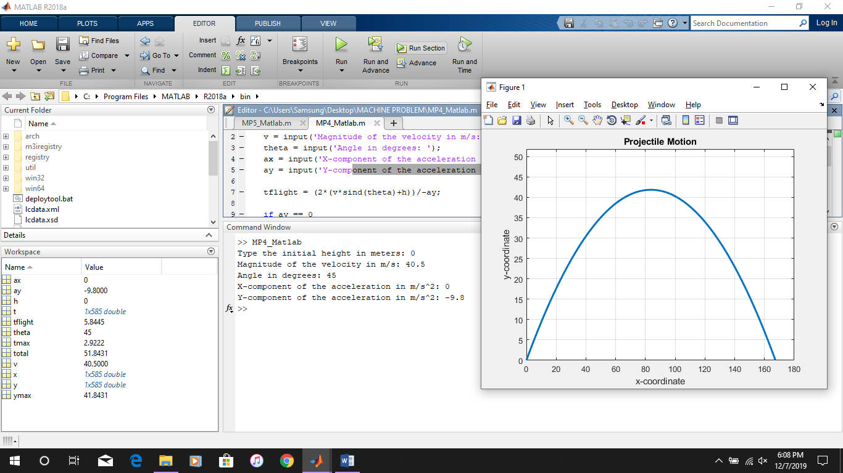

Test no.4 (with acceleration in the x-axis)

