# title: “Assignment 2 Reproducible Data”

author: “Thomas”Trey" Barnes" date: “July 17, 2019” output: html_document

download.file("https://d396qusza40orc.cloudfront.net/repdata%2Fdata%2Factivity.zip", destfile = "C:/Users/Trey Barnes/Desktop/RWDir/activity.zip", mode="wb")  
unzip("C:/Users/Trey Barnes/Desktop/RWDir/activity.zip")  
stepdata <- read.csv("activity.csv", header = TRUE)  
head(stepdata)

## steps date interval  
## 1 NA 2012-10-01 0  
## 2 NA 2012-10-01 5  
## 3 NA 2012-10-01 10  
## 4 NA 2012-10-01 15  
## 5 NA 2012-10-01 20  
## 6 NA 2012-10-01 25

library(magrittr)  
library(dplyr)

## Warning: package 'dplyr' was built under R version 3.5.3

##   
## Attaching package: 'dplyr'

## The following objects are masked from 'package:stats':  
##   
## filter, lag

## The following objects are masked from 'package:base':  
##   
## intersect, setdiff, setequal, union

## What is mean total number of steps taken per day?

For this part of the assignment you can ignore the missing values in the dataset. Calculate the total number of steps taken per day 1 If you do not understand the difference between a histogram and a barplot, research the difference between them. 2 Make a histogram of the total number of steps taken each day 3 Calculate and report the mean and median of the total number of steps taken per day

knitr::opts_chunk$set(echo= TRUE)  
databydate <- stepdata %>% select(date, steps) %>% group_by(date) %>% summarize(tsteps= sum(steps)) %>%na.omit()  
hist(databydate$tsteps, xlab = "Total daily Steps",main="Histogram of Total Steps by day", breaks = 20)

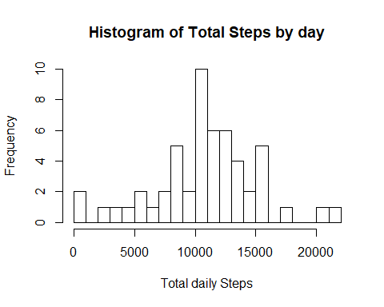

mean(databydate$tsteps)

## [1] 10766.19

median(databydate$tsteps)

## [1] 10765

## Time series plot

library(ggplot2)  
databyinterval <- stepdata%>% select(interval, steps) %>% na.omit() %>% group_by(interval) %>% summarize(tsteps= mean(steps))   
ggplot(databyinterval, aes(x=interval, y=tsteps))+ geom_line()

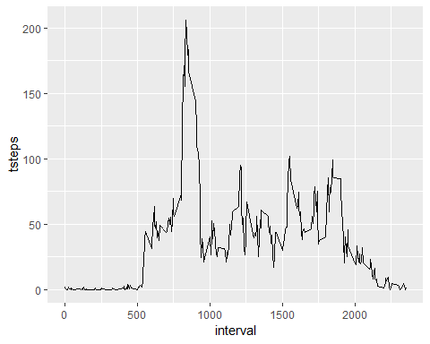

## The 5-minute interval that, on average, contains the maximum number of steps

databyinterval[which(databyinterval$tsteps== max(databyinterval$tsteps)),]

## # A tibble: 1 x 2  
## interval tsteps  
## <int> <dbl>  
## 1 835 206.

## Imputing missing values

## 1. Calculate and report the total number of missing values in the dataset (i.e. the total number of rows with NAs)

### generate listing of NA’s

missingVals <- sum(is.na(data))

## Warning in is.na(data): is.na() applied to non-(list or vector) of type  
## 'closure'

missingVals

## [1] 0

# Devise a strategy for filling in all of the missing values in the dataset. The strategy does not need to be sophisticated. For example, you could use the mean/median for that day, or the mean for that 5-minute interval, etc.

### For my strategy I will use the mean for that 5 -minute interval to replace all the missing values in the dataset. At the end, I will check if all the NAs have been replaced

library(magrittr)  
library(dplyr)  
  
replacewithmean <- function(x) replace(x, is.na(x), mean(x, na.rm = TRUE))  
meandata <- stepdata%>% group_by(interval) %>% mutate(steps= replacewithmean(steps))  
head(meandata)

## # A tibble: 6 x 3  
## # Groups: interval [6]  
## steps date interval  
## <dbl> <fct> <int>  
## 1 1.72 2012-10-01 0  
## 2 0.340 2012-10-01 5  
## 3 0.132 2012-10-01 10  
## 4 0.151 2012-10-01 15  
## 5 0.0755 2012-10-01 20  
## 6 2.09 2012-10-01 25

## Make a histogram of the total number of steps taken each day and Calculate and report the mean and median total number of steps taken per day.

FullSummedDataByDay <- aggregate(meandata$steps, by=list(meandata$date), sum)  
  
names(FullSummedDataByDay)[1] ="date"  
names(FullSummedDataByDay)[2] ="totalsteps"  
head(FullSummedDataByDay,15)

## date totalsteps  
## 1 2012-10-01 10766.19  
## 2 2012-10-02 126.00  
## 3 2012-10-03 11352.00  
## 4 2012-10-04 12116.00  
## 5 2012-10-05 13294.00  
## 6 2012-10-06 15420.00  
## 7 2012-10-07 11015.00  
## 8 2012-10-08 10766.19  
## 9 2012-10-09 12811.00  
## 10 2012-10-10 9900.00  
## 11 2012-10-11 10304.00  
## 12 2012-10-12 17382.00  
## 13 2012-10-13 12426.00  
## 14 2012-10-14 15098.00  
## 15 2012-10-15 10139.00

summary(FullSummedDataByDay)

## date totalsteps   
## 2012-10-01: 1 Min. : 41   
## 2012-10-02: 1 1st Qu.: 9819   
## 2012-10-03: 1 Median :10766   
## 2012-10-04: 1 Mean :10766   
## 2012-10-05: 1 3rd Qu.:12811   
## 2012-10-06: 1 Max. :21194   
## (Other) :55

## Making a histogram

hist(FullSummedDataByDay$totalsteps, xlab = "Steps", ylab = "Frequency", main = "Total Daily Steps", breaks = 20)

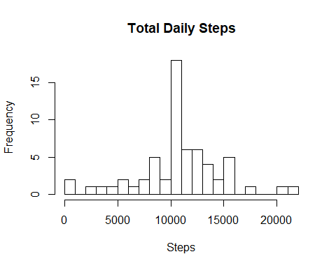

## Compare the mean and median of Old and New data

oldmean <- mean(databydate$tsteps, na.rm = TRUE)  
newmean <- mean(FullSummedDataByDay$totalsteps)  
oldmean

## [1] 10766.19

newmean

## [1] 10766.19

oldmedian <- median(databydate$tsteps, na.rm = TRUE)  
newmedian <- median(FullSummedDataByDay$totalsteps)  
oldmedian

## [1] 10765

newmedian

## [1] 10766.19

Are there differences in activity patterns between weekdays and weekends?

meandata$date <- as.Date(meandata$date)  
meandata$weekday <- weekdays(meandata$date)  
meandata$weekend <- ifelse(meandata$weekday=="Saturday" | meandata$weekday=="Sunday", "Weekend", "Weekday" )  
library(ggplot2)  
meandataweekendweekday <- aggregate(meandata$steps , by= list(meandata$weekend, meandata$interval), na.omit(mean))  
names(meandataweekendweekday) <- c("weekend", "interval", "steps")  
  
ggplot(meandataweekendweekday, aes(x=interval, y=steps, color=weekend)) + geom_line()+  
 facet_grid(weekend ~.) + xlab("Interval") + ylab("Mean of Steps") +  
 ggtitle("Comparison of Average Number of Steps in Each Interval")

