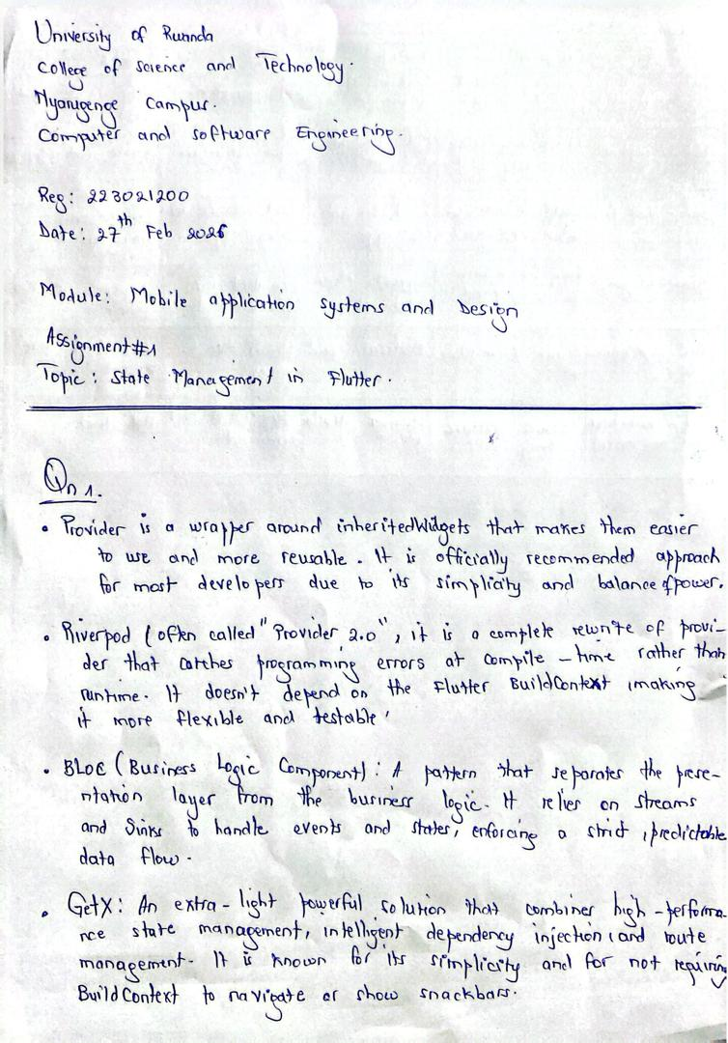
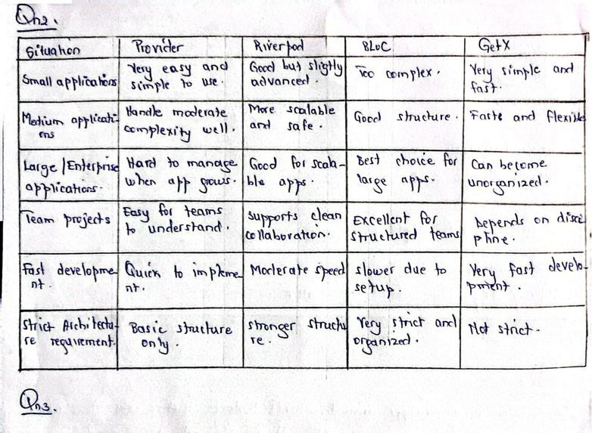

Q3.
- Adding dependency
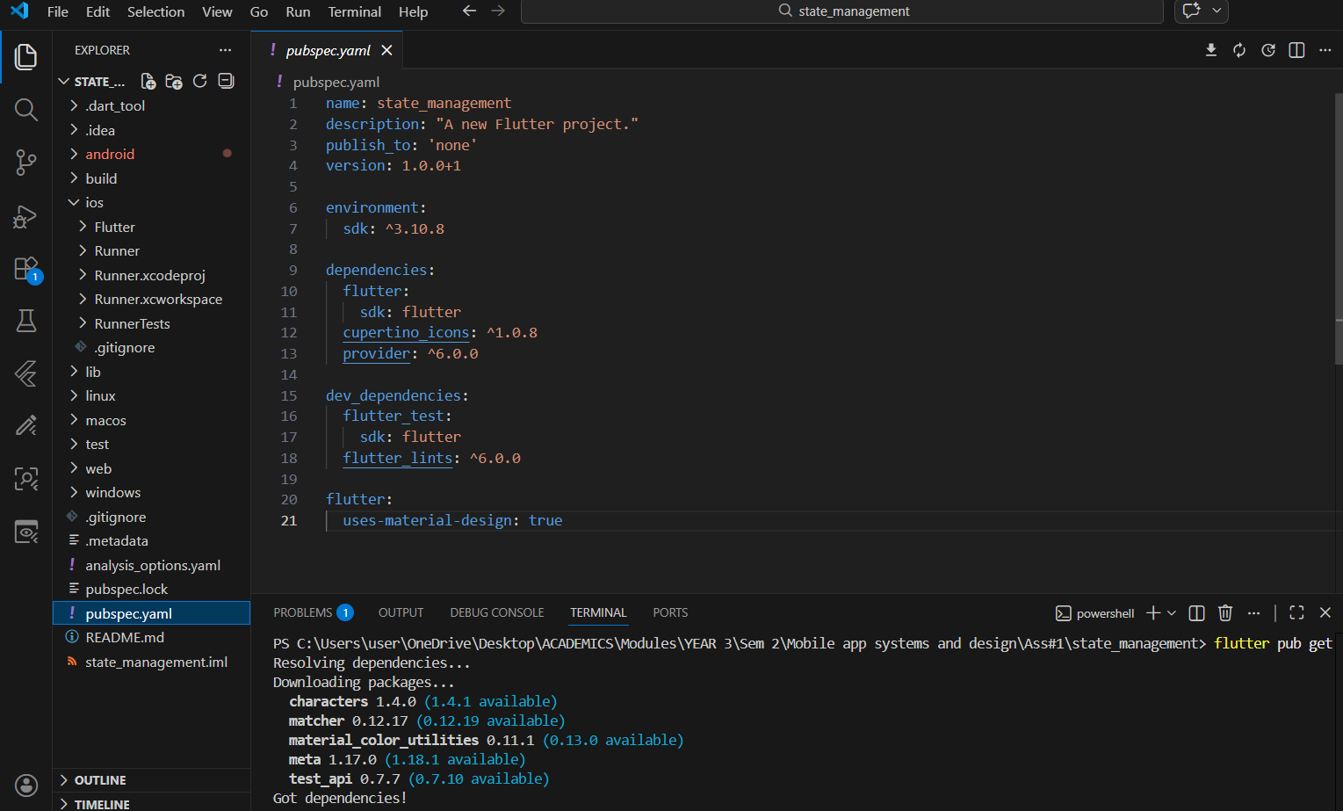

✅ Dependencies go in pubspec.yaml
✅ Run: “flutter pub get” to download them

- Creating a state class
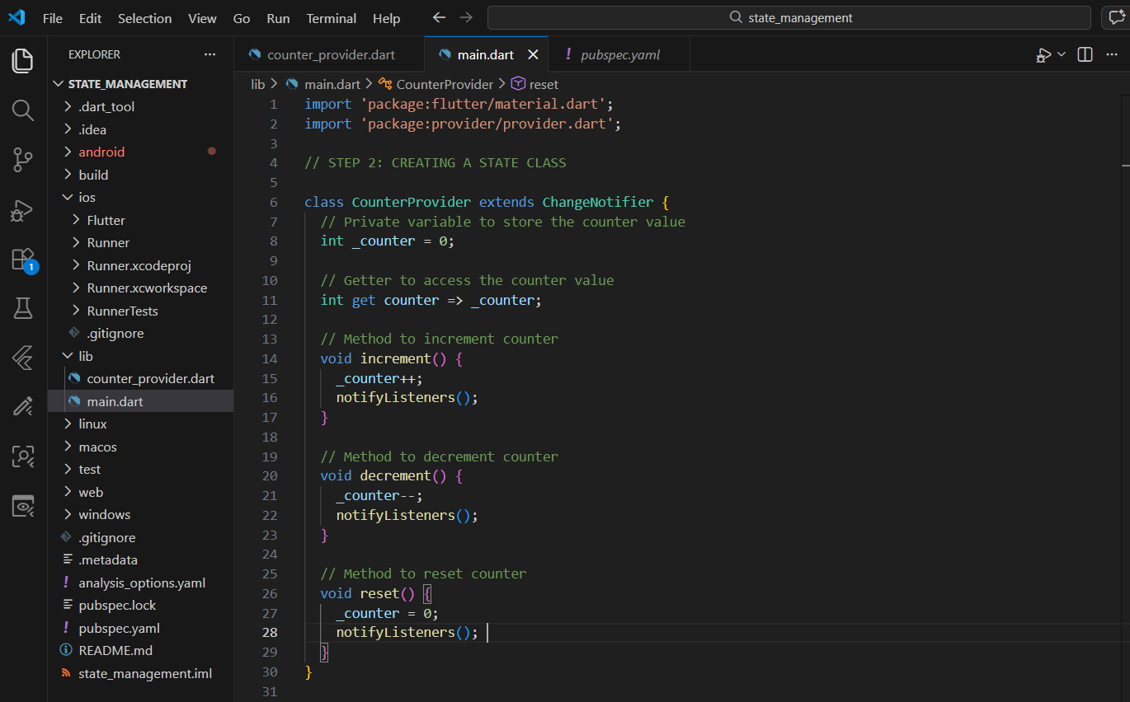

I created a new file called” counter_provider.dart” under lib folder
- A ChangeNotifier is a class that holds your app's state and notifies all listeners when the state changes.
- extends ChangeNotifier - makes this class observable
- _counter - private variable holding the state
- notifyListeners() - alerts all listeners that state changed

- Providing the state
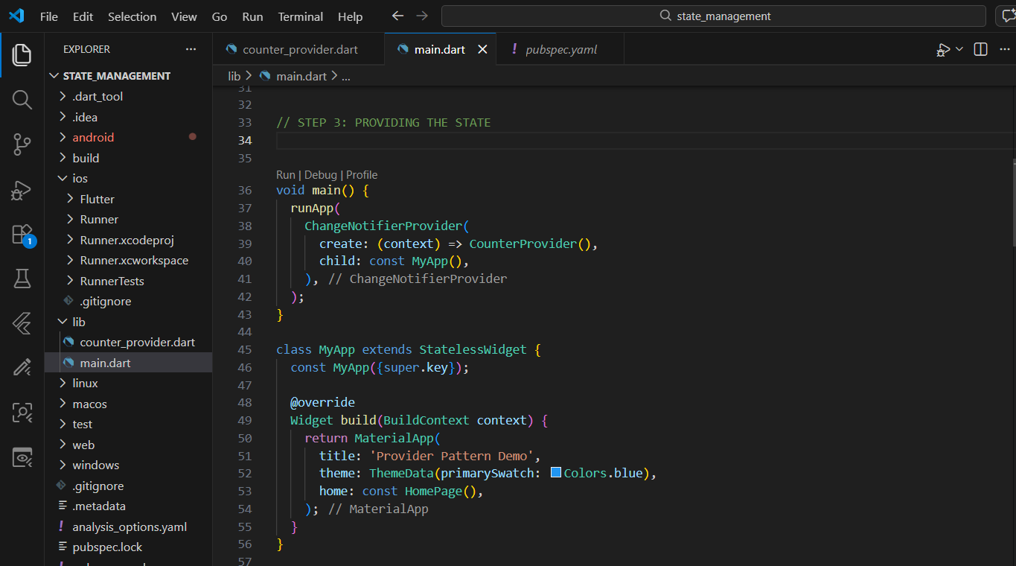

- MyApp: Wraps MaterialApp with MultiProvider to share CounterProvider across the app and MaterialApp sets app title and home page.
✅ This code Sets up a Flutter app with Provider state management for the counter.
Wraps the app with changeNotification to make counterProvider available to all widgets in the app.

- Accessing the state
We have multiple ways to access the state:
Option A: Using Consumer (Recommended for UI updates)
Consumer (Recommended): Rebuilds only the widget inside the Consumer when state changes; best for performance.

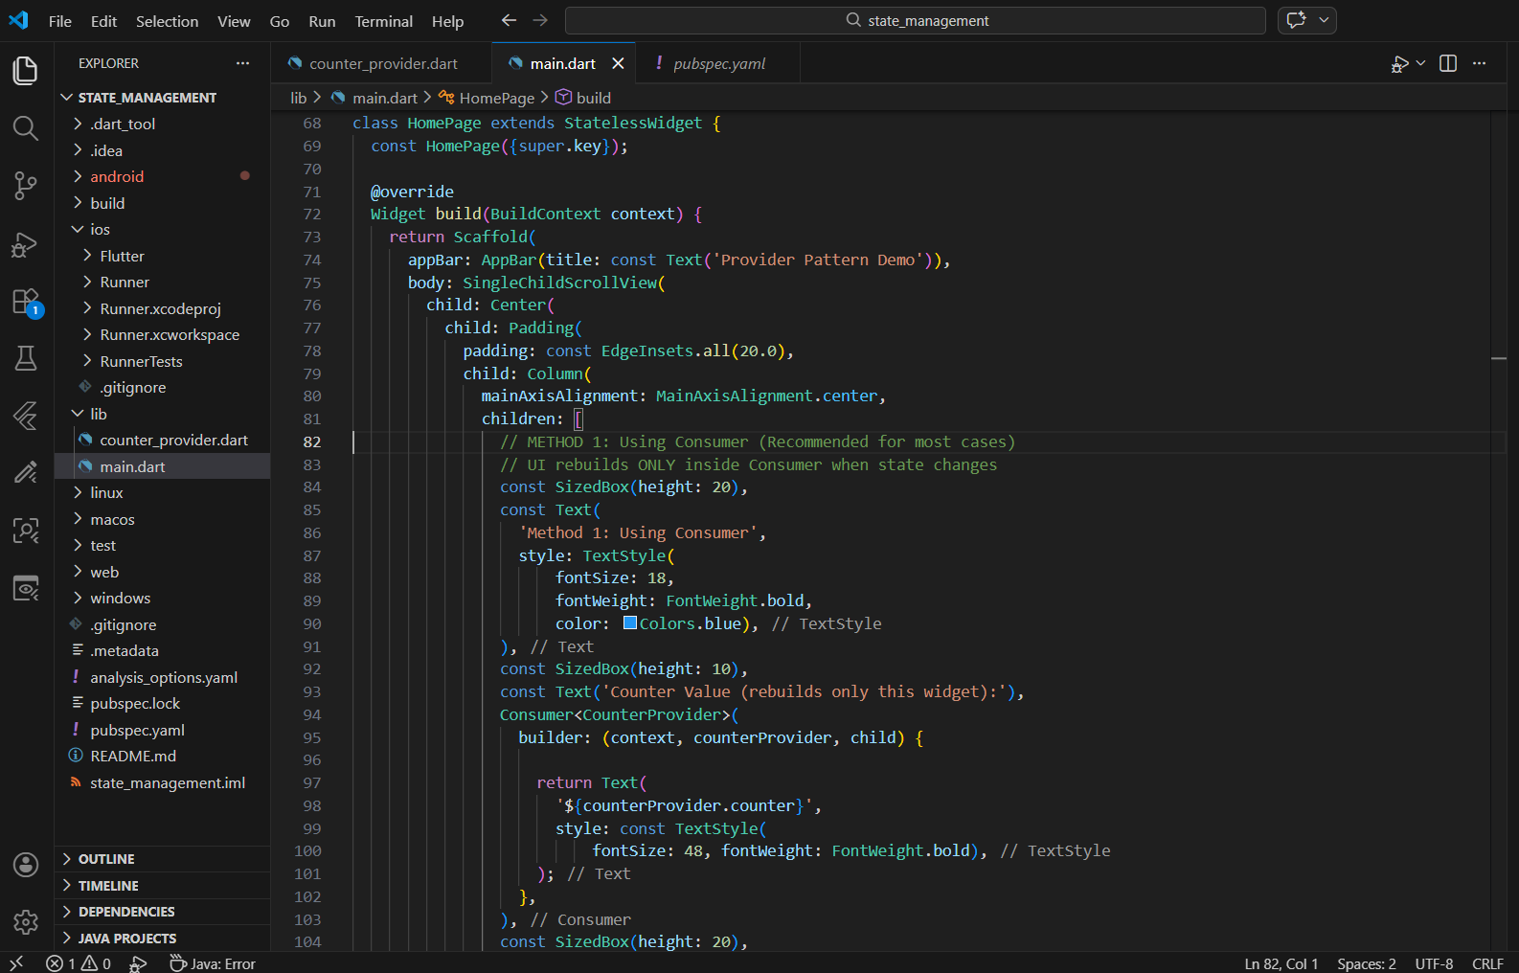
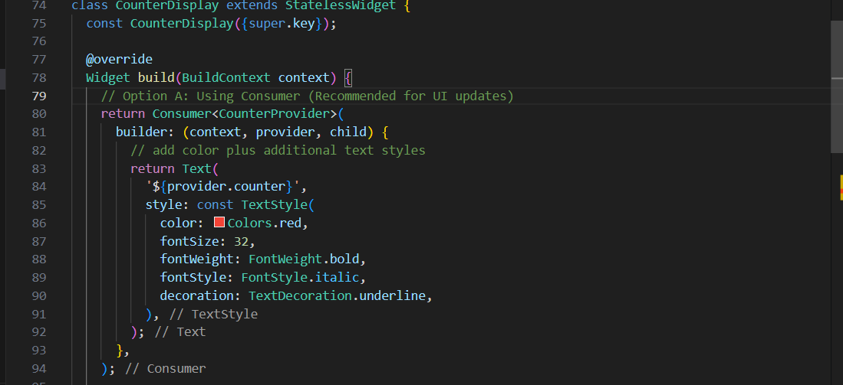

Option B: Using context.watch () (Newer, cleaner syntax)
It is the newer, cleaner syntax that also triggers rebuilds on change.

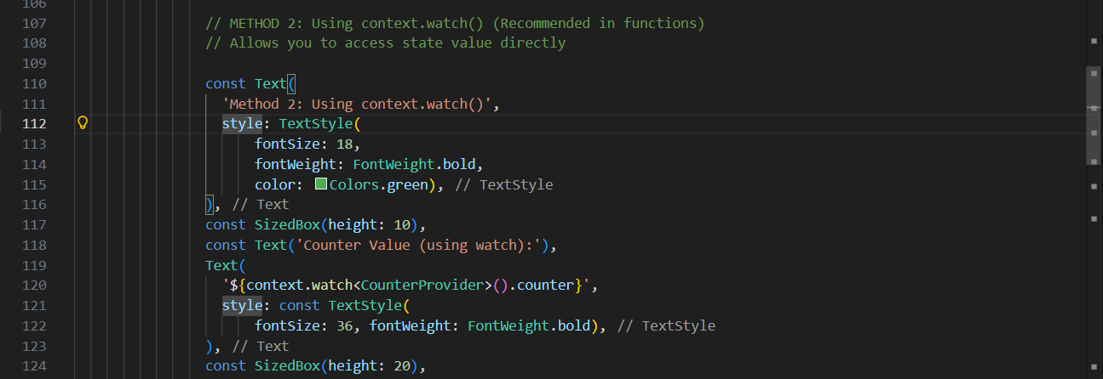

Option C: Using Provider.of() (Traditional way)
It is the traditional approach, more verbose but still widely used.
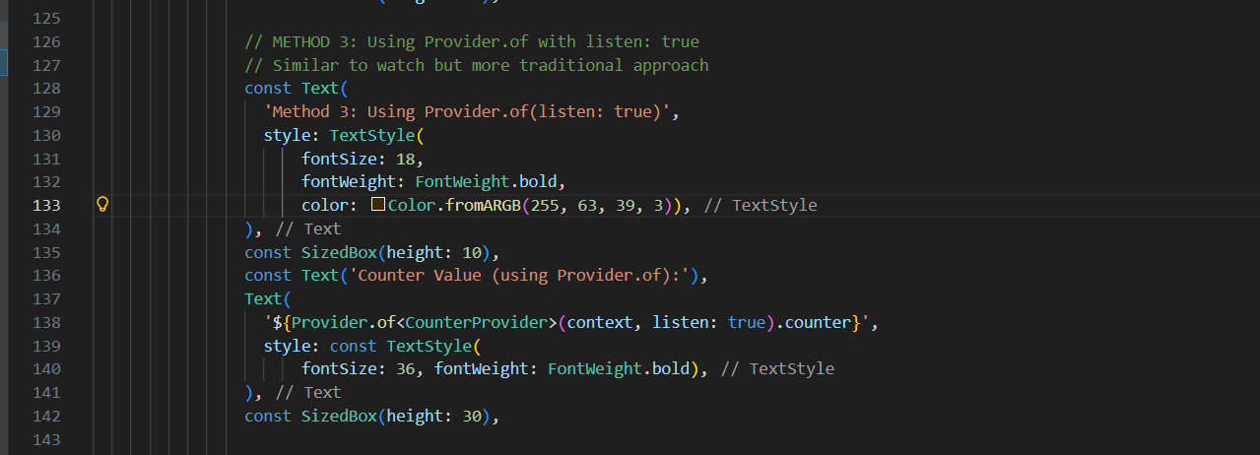

- Updating the state
Updating the State demonstrates how to call methods on the provider (like increment()) from UI elements such as buttons. When the method calls notifyListeners(), all listening widgets are notified and rebuild.
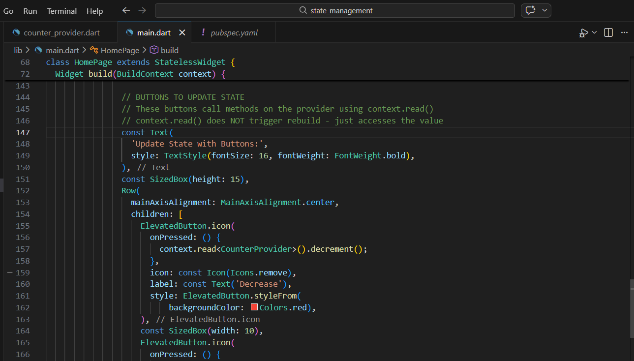
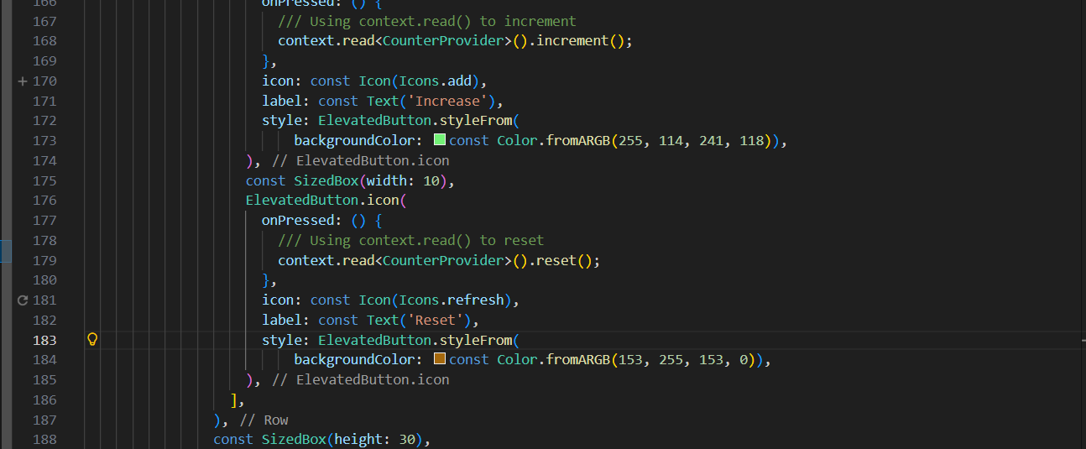

- How UI rebuild happens
Explains the full flow: user action → provider method called → notifyListeners() triggers → listening widgets rebuild with the new state. This closes the loop on how Flutter's reactive UI works with Provider.
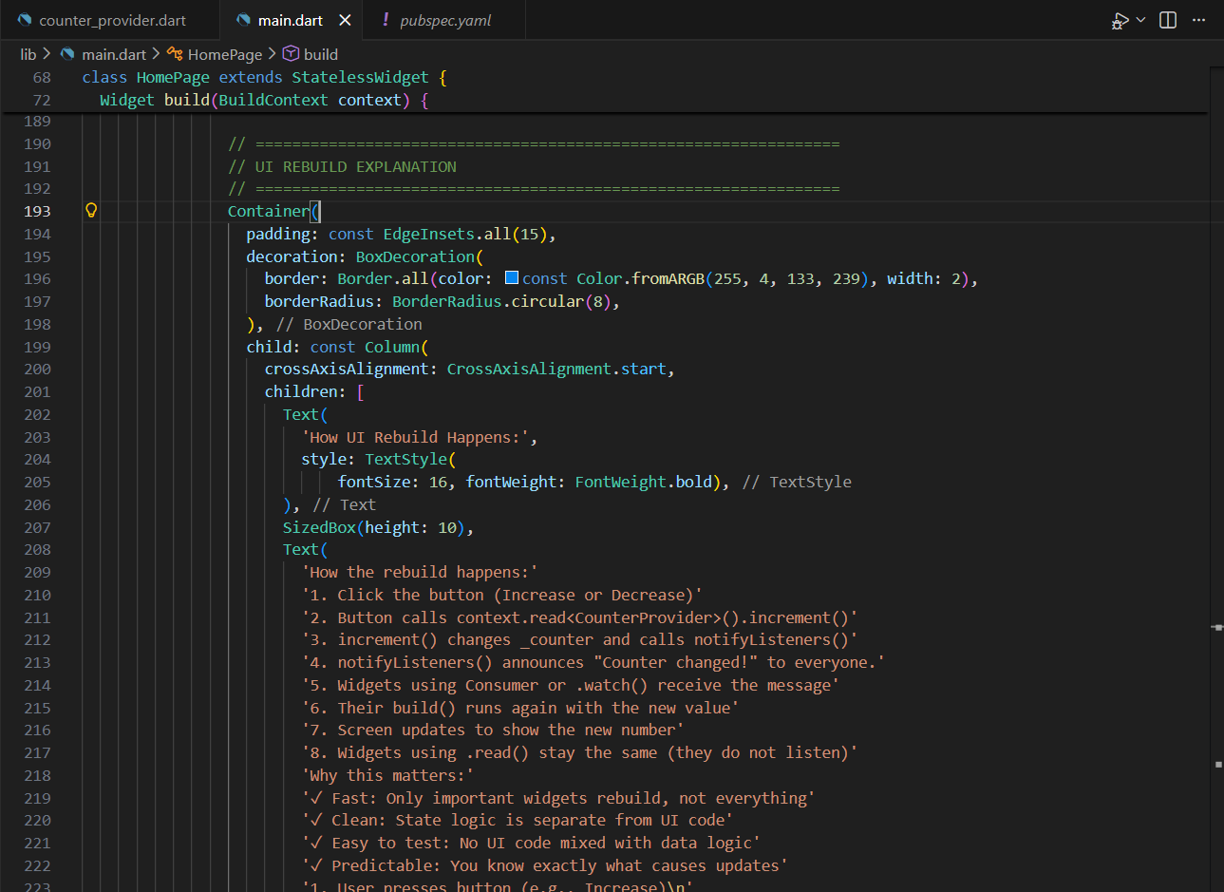
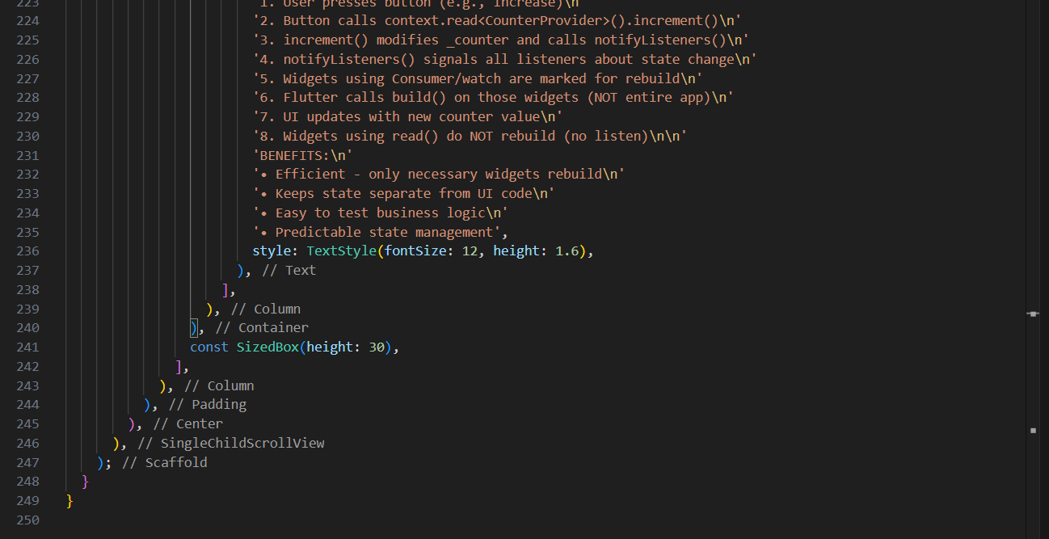

OUTPUT:
+increase

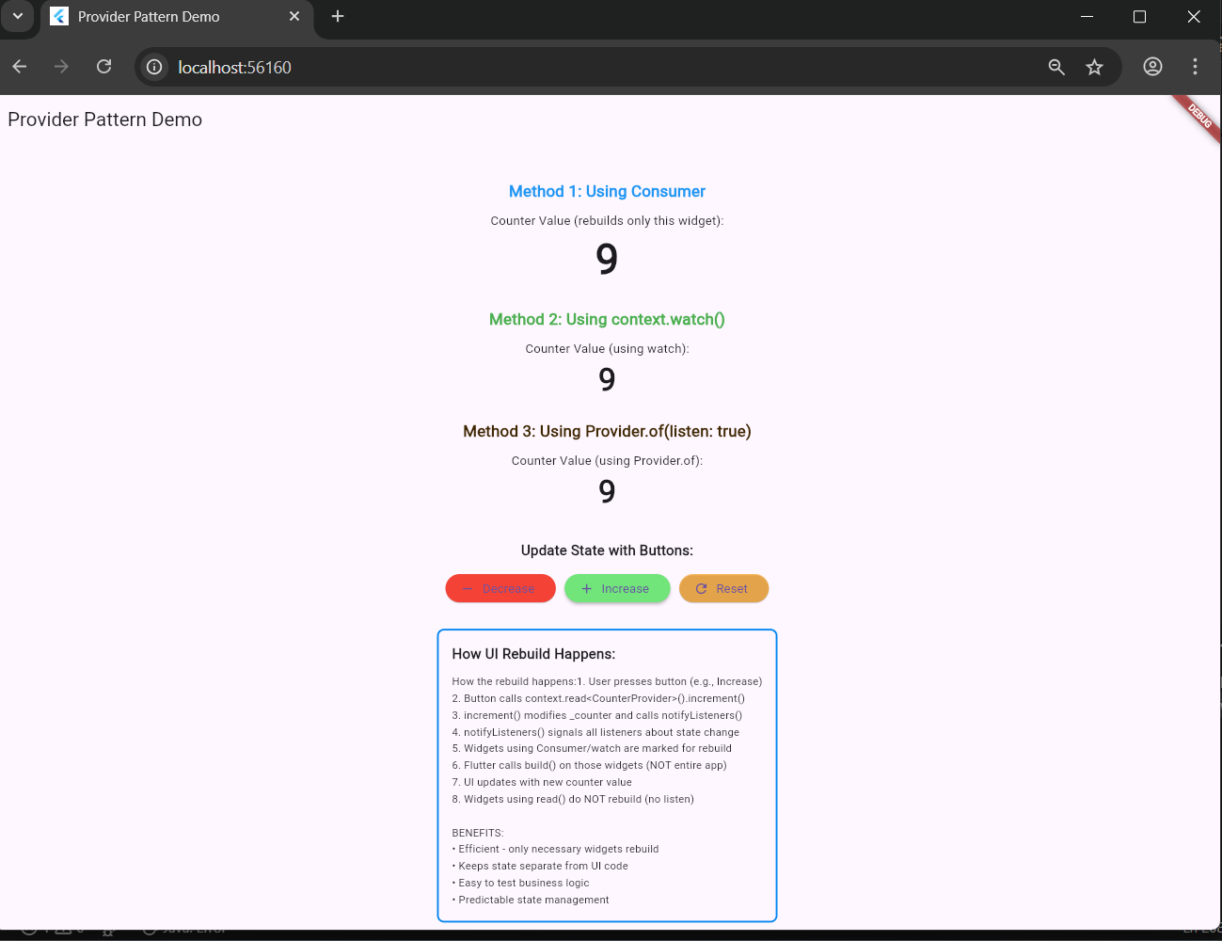

-decrease
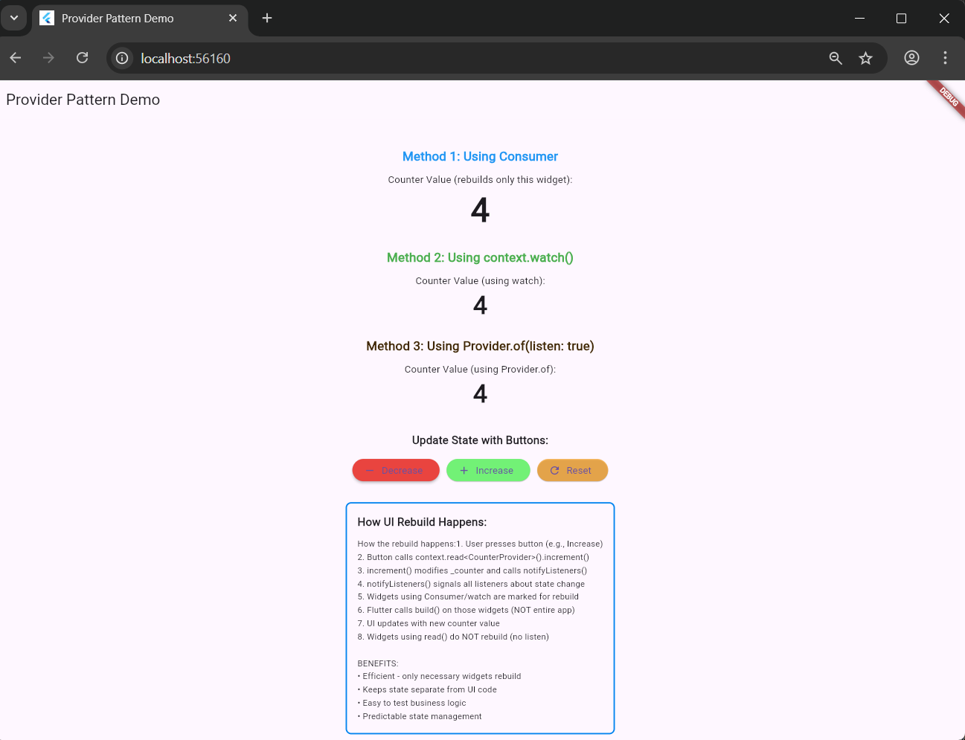

Reset
