Line endcaps

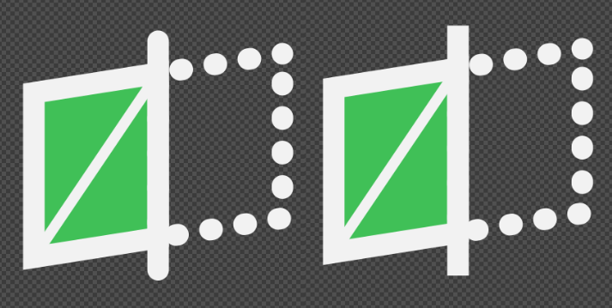

The general approach seems to be square corners. What should we do in a situation like this? The square cap looks a bit awful since the line does not match the general angle. Should we convert stroke to path and line up the end caps accordingly?

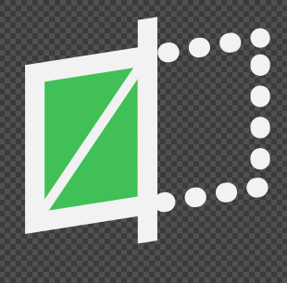

Stroke width on complex icons

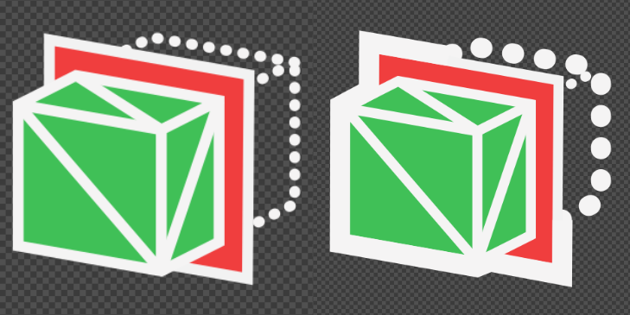
Some Mesh WB icons have dashed parts in the outline. This looks a bit messy using the starndard stroke, a bit better with some deviation (omitting the 3px all around).
Maybe for this case we should not try to mimic the original workbench icons too much:

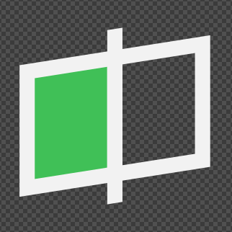

Remove the dotted lines to indicate cutaways, remove ‘mesh lines’

