How to develop an ADEventService adapter

Revision  
0.1, first draft, 20170210/SDE

# Intro

This introduction describes very briefly, how you would go about creating an adapter for the **ADEventServices** (ADESVC) from the sample **ADEAdapterWin** sample provided on GitHub.

How to deploy the ADEventService service is described elsewhere.

Note however, that the following description relies on a setup, where both an **ADEventSatellite** instance and a ADEventService instance is running and configured properly, including that the sample app described below is configured as a subscriber in ADEventService. Read more about basic setup in the radme file here … <https://github.com/Gentofte/ADEventService/blob/master/README.md> .

# Step-by-step

Download ADEventService source from … <https://github.com/Gentofte/ADEventService>

Open the solution ./ADEAdapter/ADEAdapterWin in Visual Studio

Open the file ADEventHandler00.cs located at …

.\ADEAdapterLib\ADEAdapterLib\Model\ADEventHandler00.cs

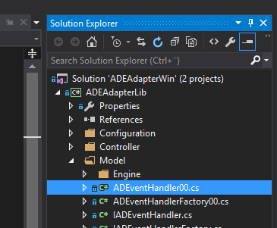

Begin editing the **HandleEvent()** method in ADEventHandler00.cs.

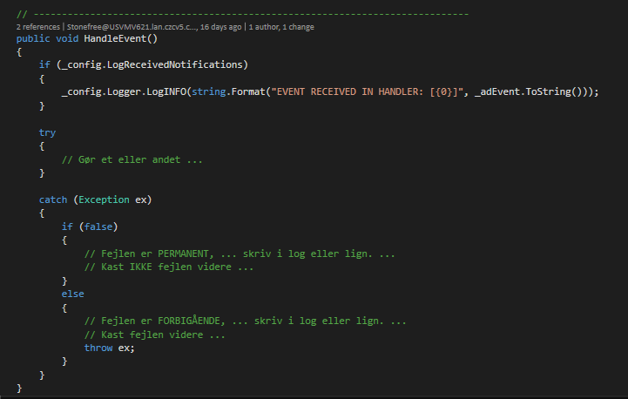

When you run the sample ADEAdapterWin app, the HandleEvent() method will be called whenever an event is received from AD.

**TIP!** You’re probably not authorized to change anything in AD, so it might be pretty boring siting around just waiting for an event to drop by. However, there is one record you are allowed to change in AD – ie. Information about yourself. Try to change your mobile number or other another attribute on your AD record (using AD User and Computers, or another AD tool). The change should generate an event, that will show up in HandleEvent().

For more elaborate dev and testing, you may consult with the IT-department to get access to a corner in AD, where you may manipulate objetcs.

# Queued entries

The sample app collects event in a RabbitMQ queue. Between dev sessions events may queue up. If you would delete queue up messages, open the RabbitMQ console/queues tab … <http://localhost:15672/#/queues> and flush the queue in question. For the sample application, the queue name will be something like **ADEA-XXX-776E16BD895E45E1A2A3EB0AED176EB0-UDVTEST-incomingevent-queue-v01**.

---ooo---