PERSONAL DATA

|  |  |
| --- | --- |
| **Name:** | Yevhen Khaliman |
| **Location:** | Ukraine, Kiev |
| **Mobile:** | +380639814467 |
| **E-mail:** | Eugen.haliman@gmail.com |
| **Skype:** | live:khalimaneugene |
| **LinkedIn:** | [**Evgeny Haliman**](http://linkedin.com/in/yevhen-khaliman/) |

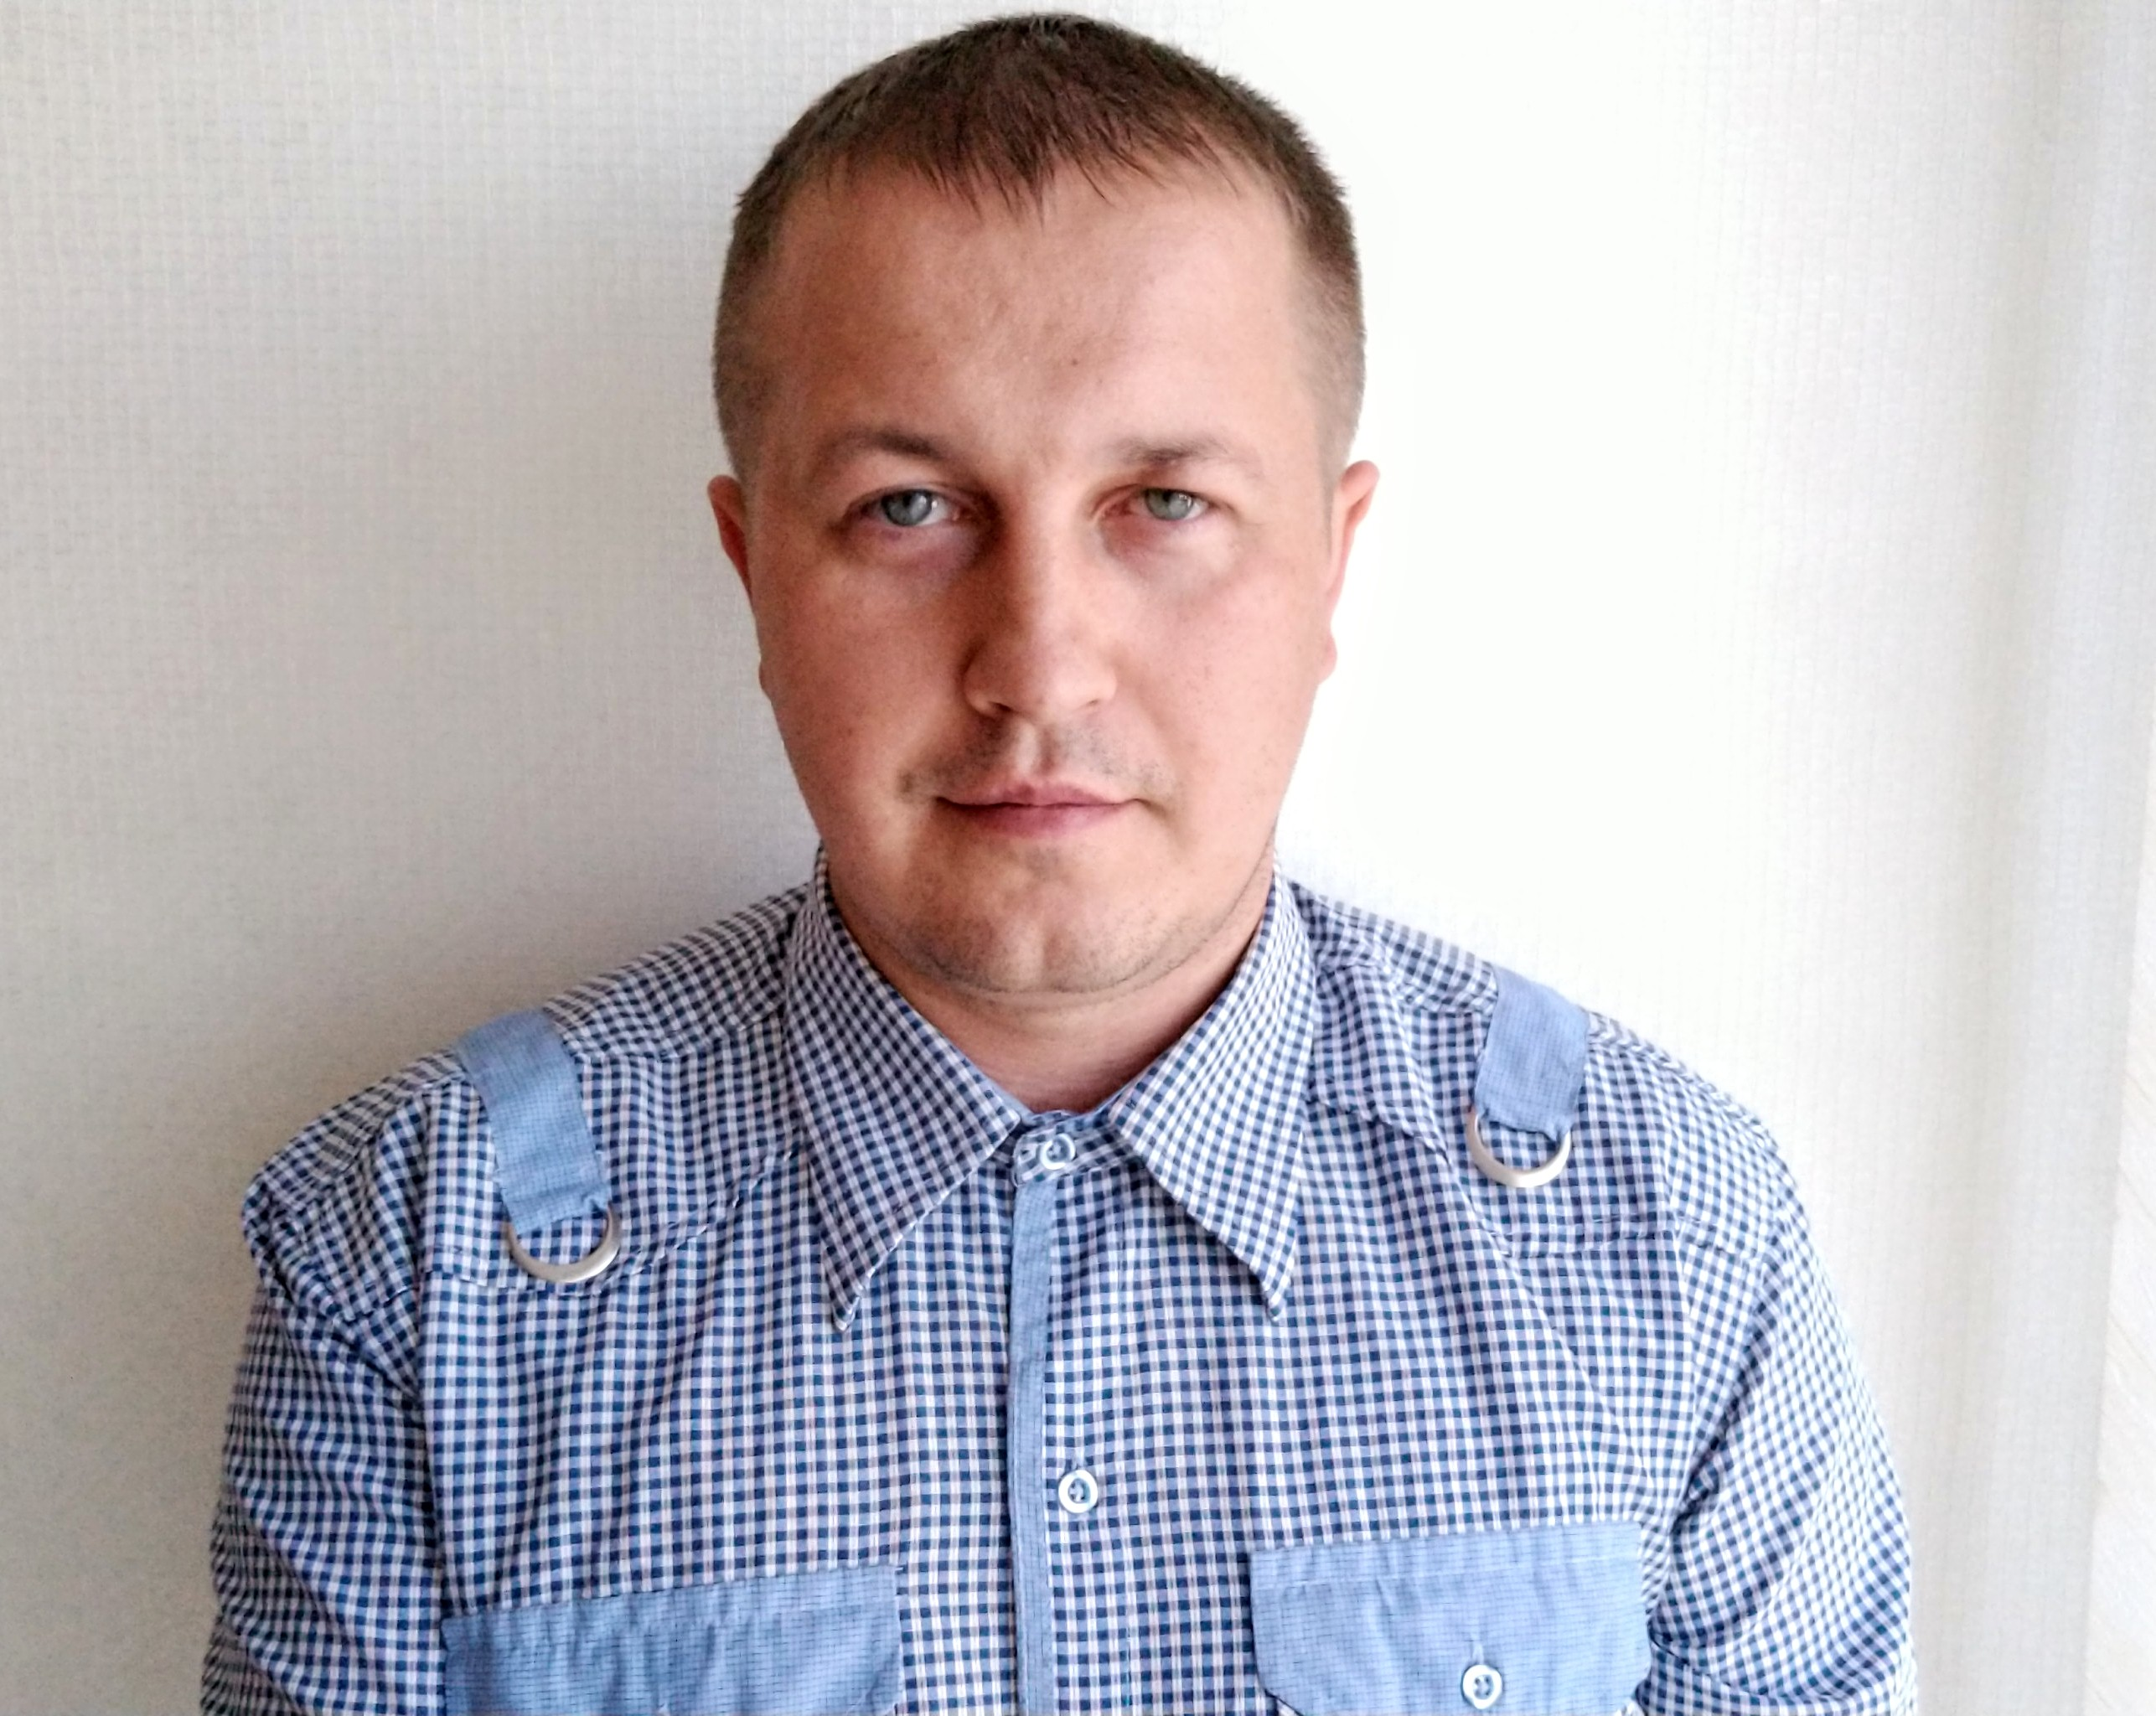

OBJECTIVE

|  |  |
| --- | --- |
| **Desired Position:** | **QA Automation Engineer** |

SUMMARY OF QUALIFICATION

|  |
| --- |
| I am working with Quality assurance starting from the **2018.**  My current stack of technologies is: **Java Core, frameworks: Selenium, Docker, Spring, Hibernate/ JPA** |

TECHNICAL SKILLS

* OOP, Java Core / EE, JDBC
* JSP/JSTL/Servlets, Junit, Log4j, Freemarker
* SQL, MySQL, PostgreSQL, Hibernate/ JPA
* Spring, Selenium, Cucumber, Postman, Appium
* HTML5/CSS3, Tomcat, Maven, Jenkins, Docker, RestAssured
* Intellij IDEA, JIRA, Javascript/jQuery,
* HTTP/HTTPS, Git, XML/JSON, YOUTRACK, TestNG, UPSOURCE

MY CODE SAMPLES

**Task Manager(**Java Core, **Spring MVC, Hibernate, jQuery, Freemarker, Bulma):**

[**Task_Manager_LInk**](http://taskmanager-3.herokuapp.com/)

[**GitHub(TaskManager)**](https://github.com/Genya9000/Task-Manager)

**Carriage** **System** (Java Core, JDBC, MySQL, Maven, Tomcat, Servlet/JSP, JSTL, Log4j, Junit, Bootstrap):

[**GitHub(Carriage)**](https://github.com/Genya9000/Postgre)

**English club (vue js + spring boot) :**

[**GitHub(EnglishClub)**](https://github.com/Genya9000/English_club)

LANGUAGES

* English – Intermediate
* Ukrainian – Native Speaker
* Russian – Native Speaker

EDUCATION

* 2002 – 2008 /National Technical University of Ukraine "Kyiv Polytechnic Institute" Specialist degree at “Telecommunication Systems and Networks”

PRACTICAL COURSES

|  |  |  |  |  |  |  |  |  |  |  |  |  |  |  |  |  |  |  |  |  |
| --- | --- | --- | --- | --- | --- | --- | --- | --- | --- | --- | --- | --- | --- | --- | --- | --- | --- | --- | --- | --- |
| |  |  | | --- | --- | | **Course name:** | **JavaRush**-online programming course in Java, which is 80% of the practice | | **Years of study:** | 05/2018 – 06/2019 |  |  |  | | --- | --- | | **Course name:** | **PROG.kiev.ua**(**Java Pro) - W**eb application development | | **Duration** | 02/2019 – 05/2019 | |  | | | **Course name:** | Java software developers training from EPAM Systems - Java basics with focus on web application development | | **Duration** | 03/2019 – 06/2019 | |  |  | | **Course name:** | Test Automation with Java(SoftServe IT-Academy)- Development of projects by means of Java for automation of tests and quality control of the software | | **Duration** | 03/2020 – 07/2020 | |

EXPERIENCE

|  |  |
| --- | --- |
| **Company** | “Volia” |
| **Duration** | 01/2008 – 07/2018 |
| **Description** | Technician inspector in a company providing access to cable television and broadband internet |
| **Responsibilities** | Сonnecting customers to the company network; Trouble-shooting ; Looking for new clients; |
|  | |
| **Company** | Freelance |
| **Duration** | 10/2017– 11/2019 |
| **Description** | Manual QA Engineer. Doing Test cases; writing bug reports.  Designed and developed multiple different web applications with java |
|  | |
| **Company** | “**Foxminded Software”** |
| **Duration** | 02/2020– 03/2020 |
| **Description** | Joint development of the project in position [Java trainee](https://rabota.ua/zapros/java-trainee/киев) |
|  | |
| **Company** | **Freelance, self-employed** |
| **Duration** | 03/2020 – 08/2020 |
| **Description** | QA Engineer. Checking the efficiencyof mobile and web applications. Reporting on identified inconsistencies |
|  |  |
| **Company** | **“SoftServe”** |
| **Duration** | 08/2020 – Nowadays |
| **Description** | Test Automation Engineer. Automation of test scripts and maintenance of the testing framework |

SPECIALIZED LITERATURE

**Ron Patton – “Software Testing”;**

**Cem Kaner, Jack L. Falk «Testing computer software»**

**Gerard Meszaros - xUnit Test Patterns**

**Herbert Schildt. “Java 8. The Complete Reference”;**