PERSONAL DATA
Name: | Yevhen Khaliman
Location: | Ukraine, Kiev
Mobile: | +380639814467
E-mail: | Eugen.haliman@gmail.com
Skype: | live:khalimaneugene
LinkedIn: | linkedin.com/in/yevhen-khaliman/

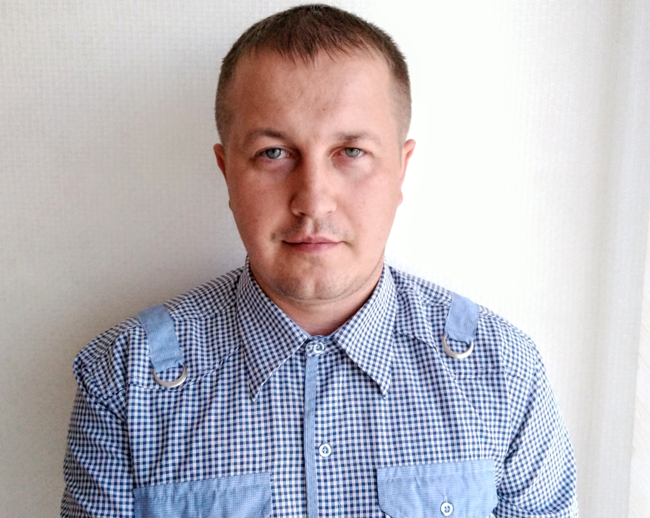

OBJECTIVE
Desired Position: | QA Automation Engineer

SUMMARY OF QUALIFICATION
I am working with Quality assurance starting from the 2018.

My current stack of technologies is: Java Core / EE, frameworks: Spring, Hibernate/ JPA, Selenium

TECHNICAL SKILLS
- OOP, Java Core / EE, JDBC
- JSP/JSTL/Servlets, Junit, Log4j, Freemarker
- SQL, MySQL, PostgreSQL, Hibernate/ JPA
- Spring MVC, Boot, Data, Security, Selenium, Cucumber, Postman
- HTML5/CSS3, Tomcat, Maven, Jenkins
- Intellij IDEA, Bootstrap, Javascript/jQuery, Bulma, Vue
- HTTP/HTTPS, Git, XML/JSON, YOUTRACK, TestNG, UPSOURCE

MY CODE SAMPLES
Task Manager(Java Core, Spring MVC, Hibernate, jQuery, Freemarker, Bulma):
http://taskmanager-3.herokuapp.com https://github.com/Genya9000/Task-Manager
Carriage System (Java Core, JDBC, MySQL, Maven, Tomcat, Servlet/JSP, JSTL, Log4j, Junit, Bootstrap):
https://github.com/Genya9000/Postgre
English club (vue js + spring boot) :
https://github.com/Genya9000/English_club

LANGUAGE COURSES
- Kyiv English school “British Council”
- FE Speaking Club

LANGUAGES
- English – Intermediate
- Ukrainian – Native Speaker
- Russian – Native Speaker

EDUCATION
- 2002 – 2008 / National Technical University of Ukraine "Kyiv Polytechnic Institute" Specialist degree at “Telecommunication Systems and Networks”

PRACTICAL COURSES
Course name: | JavaRush-online programming course in Java, which is 80% of the practice
Years of study: | 05/2018 – 06/2019

Course name: | PROG.kiev.ua(Java Pro)
Duration | 02/2019 – 05/2019
Course name: | Java software developers training from EPAM Systems - Java basics with focus on web application development
Duration | 03/2019 – 06/2019

EXPERIENCE
Company | “Volia”
Duration | 01/2008 – 07/2018
Description | Technician inspector in a company providing access to cable television and broadband internet
Responsibilities | Сonnecting customers to the company network;  Trouble-shooting ; Looking for new clients;
Company | Freelance
Duration | 10/2017– 11/2019
Description | Manual QA Engineer. Doing Test cases; writing bug reports.  Designed and developed multiple different web applications with java
Company | “Foxminded Software”
Duration | 02/2020– Nowadays
Description | Joint development of the project in position Java trainee

SPECIALIZED LITERATURE
Bruce Eckel. “Thinking in Java”, Fourth Edition;
Effective Java by Joshua Bloch;
Design Patterns by Eric Freeman;
Herbert Schildt. “Java 8. The Complete Reference”;

