CURRICULUM VITAE

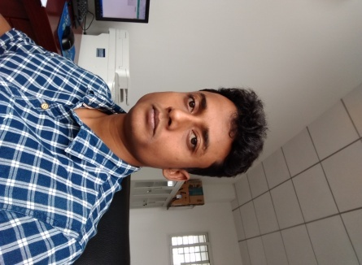Mr. Soumitra Dey

Research scholar (Ph. D),

Department of Mathematics,

Indian Institute of Technology Madras

Chennai 600036, INDIA.

Email: [deysoumitra2012@gmail.com](mailto:deysoumitra2012@gmail.com)

Phone: +919962878418

Mobile: +918145986285

Area of Research: Fixed point theory and Optimization, Nonlinear functional analysis.

Guide(s): Prof. V Vetrivel (IIT Madras, INDIA), Prof. Hong Kun Xu (HDU, CHINA).

Academic qualification:

|  |  |  |  |  |  |  |
| --- | --- | --- | --- | --- | --- | --- |
| No. | Degree | College/University | Passing year | Subject(s) | % of Marks | Class |
| 1 | B. Sc | Vidyasagar University | 2013 | Mathematics | 71 | 1st |
| 2 | M. Sc | IIT Madras | 2015 | Mathematics | 76 | 1st |
| 3 | Ph. D | IIT Madras | NA | Mathematics | 75 | 1st |

Qualifying examination:

NBHM (National Board for Higher Mathematics), 2017, Department of Atomic Energy.

Paper(s):

1. On Approximate solution to the Inverse Quasi-Variational Inequality Problem, Soumitra Dey and V Vetrivel, to appear in Math. Japonica, 2018.

Visit(s) Abroad:

1. Hangzhou Dianzi University (HDU), Hangzhou, China, 1st April to 30th June, 2018 (to visit my co-guide Prof. Hong Kun Xu).

2. Luoyang Normal University, Luoyang, China, 27th - 29th June, 2018.

Teaching:

I have been teaching assistant at IIT Madras at the undergraduate level for past three years, including Multivariable Calculus, Differential equation, Probability, and statistics.

Personal:

Date of Birth: 7th March, 1992, Single.