(i) A title and abstract for your talk

Title: Self-Assembled Colloids: From Filaments to 3D Sponges

Abstract: I will provide a brief overview of our group’s work in the area of colloidal self assembly. Colloids that are large enough to allow easy visualization using optical microscopes and are yet small enough to exhibit Brownian motion represent interesting model systems for the study of self assembly processes. I will present work from our group on the assembly of colloids into semiflexible filamentous objects. When such filaments are rendered active, they exhibit enhanced centre of mass diffusivity, resulting from an interplay between diffusophoretic active flows and Brownian conformational fluctuations of the filaments. In recent work, we have demonstrated that thermosensitive filaments can fold to form structures with helix-like geometry. Such filaments are constructed using a facile technique called ice templating. We have also used ice templating to create three dimensional objects with important technological applications.

(ii) A brief biographical sketch, for inclusion in the poster

Guruswamy Kumaraswamy is at the Chemical Engineering department at IIT-Bombay. Guru’s work focuses on controlling structure and investigating structure-property relations in soft matter systems. These systems range from polymers to surfactants and lipids and colloids. He collaborates extensively with industry in the area of polymers, healthcare, personal care, waste valorization, etc. Guru received a BTech in Chemical Engineering from IITB in 1994, followed by an MS (1996) and PhD (2000) in Chemical Engineering from the California Institute of Technology. He spent a year as a VW Postdoctoral Fellow at the Max Planck Institute for Colloids and Interfaces. From 2001-2019, he was a scientist in the Polymer Science and Engineering Division at the CSIR-National Chemical Laboratory in Pune. Recognitions for his work include the CSIR Young Scientist Award, the NCL Scientist of the Year Award and election to the Fellowship of the American Physical Society and the INAE.

(iii) A recent photograph (we can download this from your webpage, if it is ok with you)

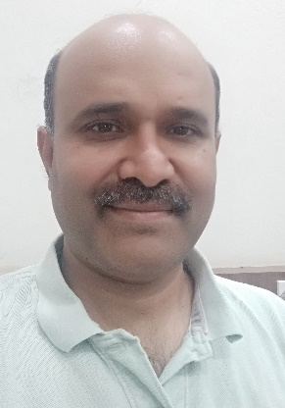

Or you can take one from my website, if you prefer:

https://www.che.iitb.ac.in/online/faculty/guruswamy-kumaraswamy https://sites.google.com/view/guru-group/group-members?authuser=0

(iv) An illustrative photo/picture that is representative of your work