

Well Master GeoMech v1.2.0
Operators Manual

Arkadeep Ghosh
Contents:
 | Chapter | Page No.
 | Preface
 | Loading .las files
 | Editing log alias file
 | Loading deviation data
 | Loading lithology details
 | Loading UCS from cores
 | Loading interpretation of image logs
 | Editing the model file
 | Plotting wellbore stability
 | Exporting data and plots

Preface:

This software is written to provide researchers, geoscientists, and field operators with a free and open-source tool to calculate geomechanical parameters from a given well data. In particular, it allows the calculation of pore pressure gradient, bottom hole pressure for a given mud weight, minimum horizontal stress, vertical stress, and an estimation of maximum horizontal stress, among other parameters. Provision is made for display of constraint data, allowing the operator to visually tune the model to perfection by iterating the calculations. Upon achieving satisfactory results, the calculated parameters can be exported to a las file. The model file is written do disk upon each iteration, such that it is immediately available to be applied to other wells after calibration on an analog well. Each iteration generates a plot that is displayed in the interface, as well as saved to disk, along with a .csv file that contains the data in numeric form, allowing easy use of other data analysis software (such as Orange Data Mining or Microsoft Excel and other similar tools). Finally, there is an option to export the displayed plots at a higher resolution in a WYSIWYG fashion.

The design of the software is made to allow calculation of these in a sequential manner that is easy to iterate and constrain. The results are calculated using the data contained in the las file and a set of about 20 constants, which are (mostly) stored in a file (model.csv). The UI allows the operator to change the values of these constants, thereby tuning the model. The design relies on sound inputs on part of the operator, who is expected to understand the concepts of wellbore geomechanics, and unrealistic inputs will result in unrealistic output, without the software trying to intervene.

Many contemporary software try to predict the optimal values of these parameters automatically, based on “best-fit” statistics, such as least squares minimization and gradient descent. While such approaches do have merit in some cases, this software takes a different approach. Here we try to make the best of both worlds, allowing the human operator to do the interpretation, and having the software carry out the tedious calculations in a scripted fashion. For example, we could have created a module to determine the width, azimuth and depths of breakouts from image logs (which would presumably try to set the threshold of detection automatically using standard deviation or similar statistics). And while that may have worked, a trained human operator can spot breakouts and interpret thousands of meters of image data in mere minutes, with higher confidence than what a statistical technique alone could achieve. So we decided to include the interpreted inputs from such a trained operator in a short .csv file and then use this input to constrain maximum horizontal stress. There are many instances in this software where this approach of deferring to human judgment is used.

The software is not perfect, and will be subject to continued improvement over time. There are many different approaches to calculating parameters such as pore pressure, minimum stress gradient and others, some work better in some regions than others. Further, newer and better techniques are developed all the time, as this is a field of active research. As such it is impossible to implement every single approach out there. Including a lot of different methods to calculate the same parameter results in confusion on part of the operator, especially if they are new to the discipline. In this software, we have chosen methods that are as generalized as possible, and are applicable as universally as possible. Ultimately, these are methods which have worked reliably in the personal and very limited experience of the author. By making it open-source, the idea is that should someone wish to implement a different algorithm, they are free to do so. We hope that the software is useful to the people working in the field of geomechanics, at all levels of expertise.
Loading .las files

Simply use the “Load Las” button after starting the program. Once a valid las file is accepted as input, the buttons to load deviation data or to proceed without deviation data become available.

Loading deviation data

Deviation data for use in this program has to be in a particular format for it to be usable. In particular, it must be a delimited text file, using either comma or space as delimiters, and with only one header row, with a delimited header denoting the field names of the data. If the depth of first data line is not zero, a zero depth data line will be automatically appended. Upon loading such a file, click the “Next” button to proceed to the well data screen. Here, choose the corresponding field for Measured depth, Inclination, and Azimuth, from the dropdowns, which will list all the available headers from the loaded deviation data. If the well is vertical, use the corresponding option after loading the las file, in which case the dropdowns in the well data section will be disabled.

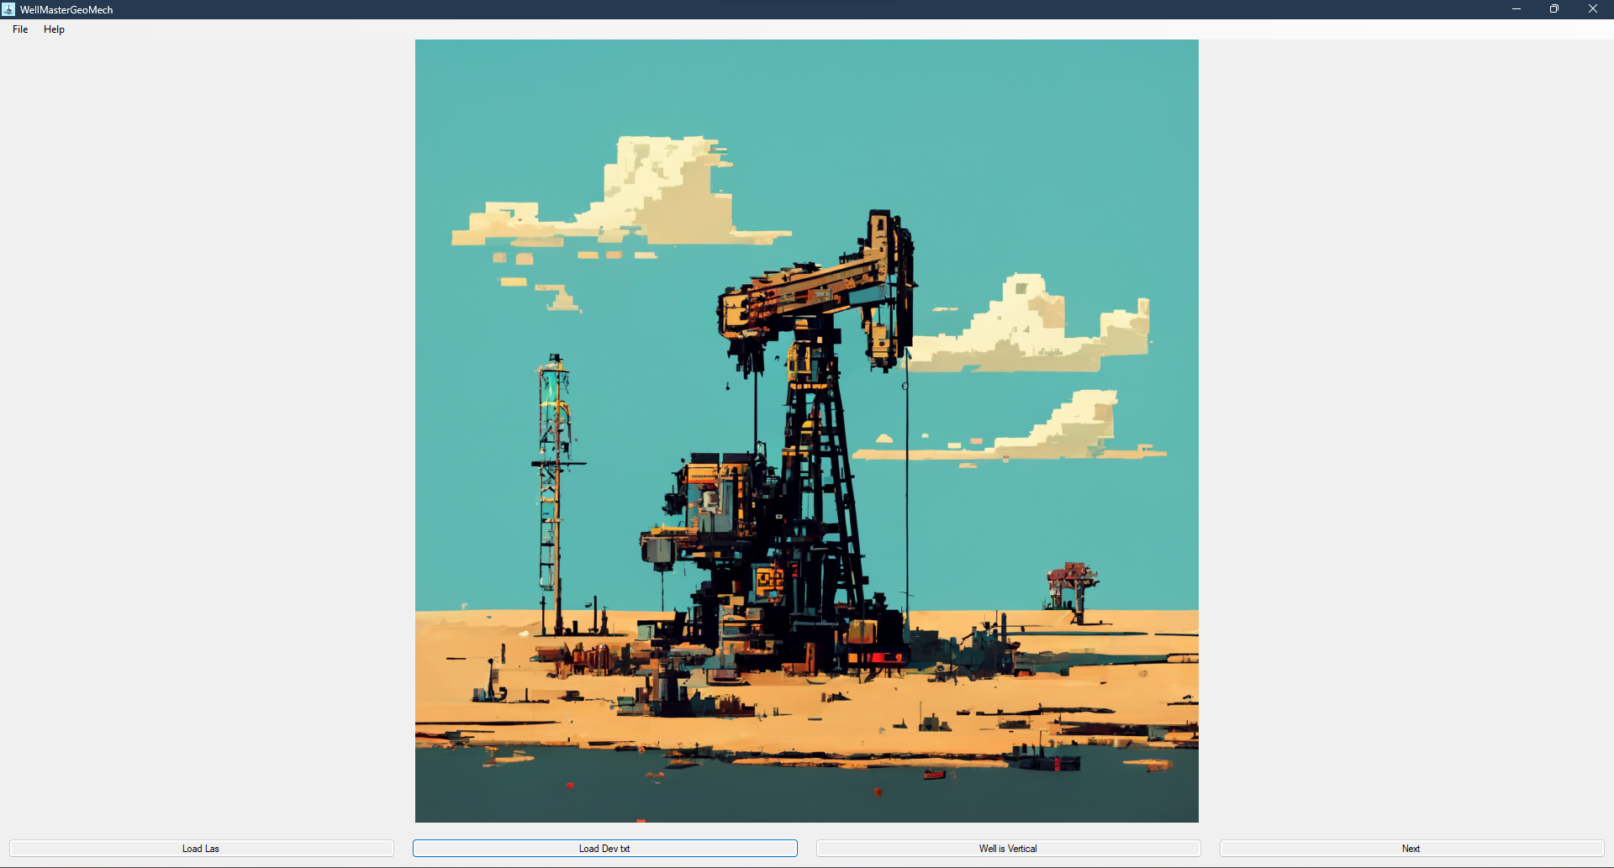

Modifying the Well Header Data

The well data section includes a section to display the log header data as recorded in the las file. These values may be edited by the operator if required. In particular, the KB/AG and GL/WD fields should be checked by the operator, as these will be used in the subsequent calculations. For onshore wells, the KB field should contain the elevation of the KB above MSL, in metres, while for offshore wells, this should contain the “Air Gap” below the rig floor. For onshore wells, the GL field should contain the elevation of the ground level at the spud point, above MSL, in metres. For offshore wells, the GL field should contain, in negative, the depth of water above the seafloor where the subsea stack is placed, in metres. Particular attention is called to the negative sign in case of offshore wells, as this is how the software determines if the given well is onshore or offshore.
While the software converts the depths from feet to metres if the las file is specified in feet, it does not convert the KB and GL data from feet to metres automatically. Care must be taken by the operator to ensure that KB and GL fields are specified in metres and not in feet.

Adding Casing Data

Lastly, there is a section to specify the details of the casing run in the well, along with details of the section where the casing was run, particularly the maximum ECD used to drill the section. The last casing is assumed to be run to TD and does not need to be specified separately. Currently there is no provision to specify liners, though such functionality is planned for future releases.

Adding Additional Well Data:

Certain additional well data may be included for the purpose of better calculating/constraining the pore pressure and geomechanical parameters. These are optional, but beneficial if used.

Interpreted Lithology:
The interpreted lithology can be specified using a csv file, of a particular format, described below. The file needs to contain a single row of headers. The ordering of rows as follows:
1) Top MD 2) LithoType 3) Nu 4) Mu 5) UCS 6) Biot’s Constant

The LithoType is a number with the following relationship:
0 : Shale
1 : Sandstone
2 : Limestone
3 : Evaporite
4 : Igneous/Metamorphic

The file needs to contain the Top MD and LithoType fields at minimum, while the other fields are optional.
The UCS field should contain the expected UCS in Mpa, while specifying a value of 0 will cause the software to use calculated values using Horsud’s correlation, while a value of 1 will cause the software to use calculated values using Lal’s correlation, and a value of 2 will similarly use Limestone correlation. If no UCS is specified, the software will default to Horsud’s correlation.

Interpreted Image Log:
The image logs are to be interpreted for occurrence of tensile fractures, borehole breakouts, or both of them. This information is to be incorporated into a csv file with fields as follows:
1) Top MD 2) Observation Type

The Observation Type is a number with the following relationship:
0 : No image log exists
1 : Image log exists, no breakouts or tensile fractures are visible
2 : Breakouts
3 : Tensile Fractures
4 : Both Breakouts and Tensile Fractures

An example file is shown in Appendix A.

UCS Values from Core Analysis
The lab tested values of UCS from core analysis are to be tabulated into a csv file, with the fields as follows:
1) MD
2) UCS value in MPa
These values are displayed in the UCS track to help contrain the values used for the model.

Click the Load Data and Proceed button to proceed to the next screen once satisfied that all the data has been loaded.

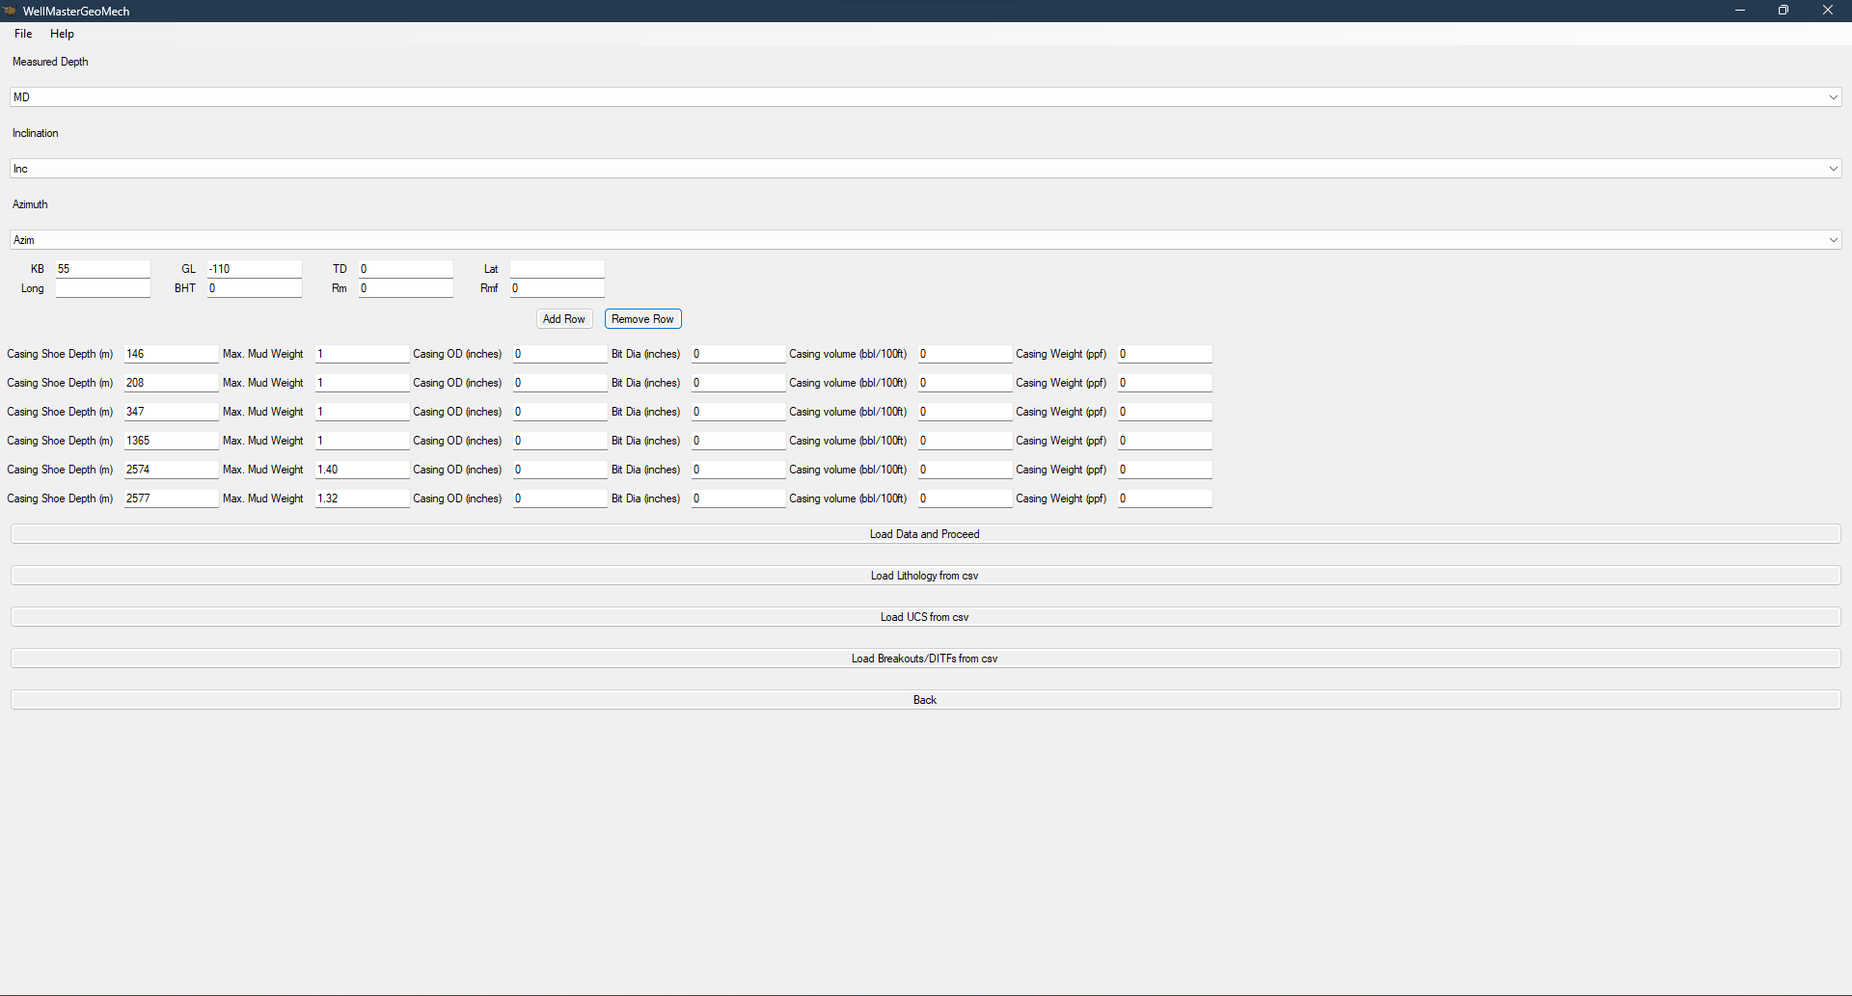
Tuning the Model:

On the main page, at the bottom row, are the model values. The very fist time the software is run, the boxes are populated with the default values for the equations used for the calculations. We can change the values as we see fit and click the recalculate. The calculations are carried out, saved to a file “Gmech.csv”, and the plot displayed in the interface. There are data entry boxes to the left and right of the plot pane, these are used to enter indications of well kick or mud loss (or any other indicator of pore pressure or fracture gradient, such as RFTs, minifracs and the like). Entering values here will put indicators on the plot to help visually constrain the results. If the calculated values in the plot do not agree with the constraints, carefully and conservatively change values in the model panel, until they do. Once it does, you have yourselves a calibrated model. The model will load the values from the previous run on the next startup of the software. If desired, the model.csv can be copied with a different name.

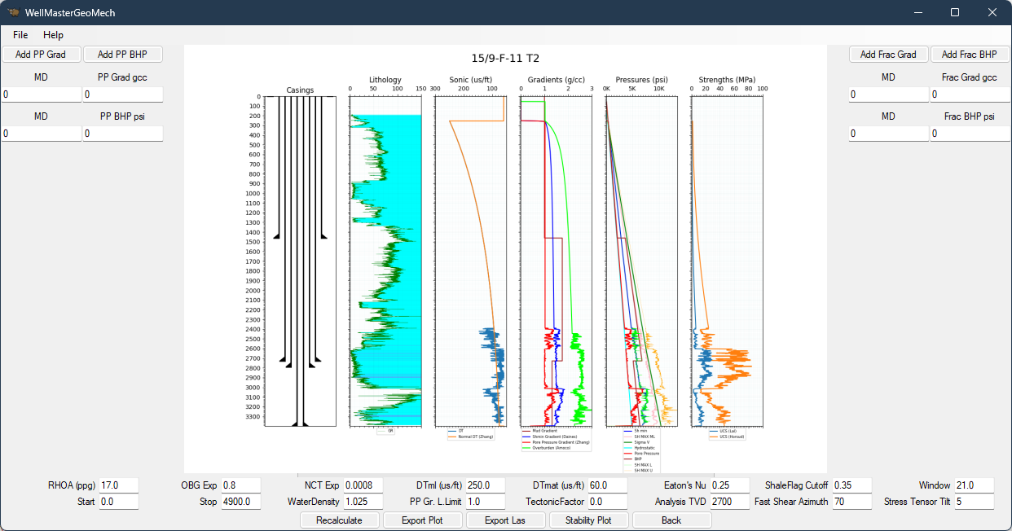
Well Bore Stability

The maximum horizontal stress is estimated from the stress polygon, which is further constrained using the values provided in the image log interpretation file. To check the stress polygon, enter any value between zero and the logger’s depth, in TVD, in the field marked “Analysis TVD”, and recalculate. The button for stability plots will then activate once the calculations are complete. Clicking it will display the stress polygon at the chosen depth, as well as the wellbore stability plots.

