This document describes how to set up your Python environment to work on the tasks outlined in the **RD Project Plan Brief Template_3d_cities.docx.** The python packages we are exploring include:

* Computational Geometry Algorithms Library (CGAL)
  + Specifically, Point Set Processing toolset
* NearPy (nearest neighbor search in high dimensional vector spaces)
* SciPy (no installation necessary)
* NumPy (no installation necessary)

For all whl files or packages installed using pip, use the following command

***python.exe -m pip install --no-deps <package or whl file>***

This avoids the unfortunate situation of pip installing the dependencies which include versions of SciPy and NumPy which render ArcGIS completely useless.

*NOTE: I have only tested with the 32-bit Py2.7 installations of the CGAL libraries, although Geoff Taylor has successfully integrated the 64-bit Py3.4 version with Pro’s Conda Python environment. Since we have not successfully completed the tasks which may (or may not) require NearPy, a 64-bit version has not been tested*

*.*

If you open the toolboxes.zip file you will find the Python wheel files for the CGAL bindings (top figure). Install the appropriate WHL File for your Python environment. If you open the ‘toolboxes’ folder you will see the python files and associated toolboxes for both Desktop and Pro environments (bottom figure). Feel free to have a look at these python files to get an understanding of that initial processing step.

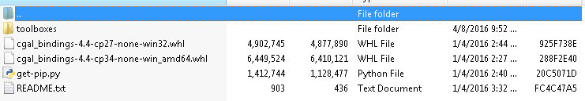

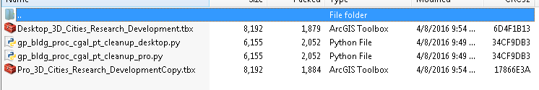

** LIST COMMANDS TO INSTALL PYTHON PACKAGES **

***python.exe -m pip install --no-deps /path_to/cgal_bindings-4.4-cp27-none-win32.whl***

***python.exe –m pip install --no-deps NearPy***