3D point processing R&D effort

**Purpose**

Airborne laser scanning (ALS) blah blah blah…

**Task summary**

The following tasks were proposed by this R&D effort:

* Remove noise points (outliers) within building footprint
* Generate mesh from remaining points
* Identify soft edges and planes in mesh
* Enrich point cloud by replacing soft edges with hard edges
* Enrich point cloud by replacing soft planes with hard planes

**Outlier removal**

The first task investigated in this R&D effort was removing non-roof component points from a point cloud representing a building. ALS collections efficiently collect 3d point information of building surfaces within a scene but also collect points along the building faces at an irregular spacing and inconsistent density compared to the surface which is normal to the XY plane. See Figure 1(left) where the points on the building facades are distributed much more irregularly compared to the XY planes which make up the major roof components.

The Computational Geometry Algorithms Library (CGAL) Point Set Processing package was utilized to remove the outlier points. The key module in the Point Set Processing package is the *remove_outliers* module which accepts two parameters:

* Neighborhood size of points used in the analysis
* Percentage of outliers to remove from points in neighborhood.

A range of values were tested as inputs to the *remove_outliers* module. It became clear that a single set of parameters would not provide a similar result across all point datasets. However, it was observed that a large neighborhood with small percentage worked well to remove outlier points while retaining the major components of the building geometry.

To ensure that as many outlier points as possible were removed in the processing as automated as possible, an iterative approach was designed with the stopping criteria defined by

$$ϵ=1-dot\left(h_{a}, h_{b}\right)>0.99$$

where *ha* and *hb*are the histogram of z-values for the point dataset after and before outlier removal, respectively, and $ϵ$ is the similarity measure calculated between successive outlier removal iterations utilizing the dot product between *ha* and *hb*.The dot product between two vector datasets *a* and *b*(i.e., histograms) is defined as the cosine of the angle between them which can be calculated as

$$cosθ=\frac{\left(a*b\right)}{\left\|a\right\|\left\|b\right\|}$$

where the double bars represent the Euclidean norm of the vector. This type of similarity measure has been used successfully in Landsat-based change detection methodologies [ASPRS article] and is also the basis for a well-known method comparing two spectral vectors (e.g., Spectral Angle Mapper [reference]). Table 1 shows measure of similarity between the four point datasets before and after outlier removal along with the number of points in each dataset. Figure 2 shows an example of the histogram of z-values before (blue) and after (red) the iterative processing. Note that major roof components (clusters) are retained whereas the lower frequency elevations are removed.

Table 1 Point removal statistics for the four building datasets.

|  |  |  |  |  |
| --- | --- | --- | --- | --- |
|  | **ALS point cloud (# of points)** | **After Outlier Removal (# of points)** | **Points removed** | **Similarity** |
| **Points 1** | 10089 | 9260 | 829 | 0.997222 |
| **Points 4** | 26351 | 25311 | 1040 | 0.999727 |
| **Points 5** | 44166 | 39509 | 4657 | 0.991172 |
| **Points 6** | 76861 | 73774 | 3087 | 0.995836 |

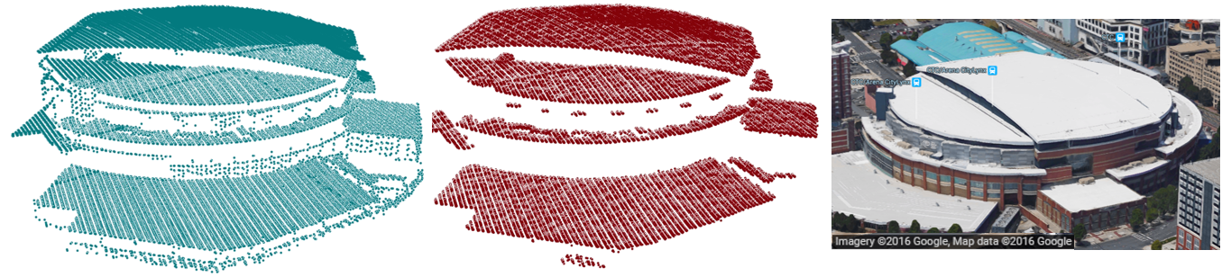

Figure 1 (left) Orignal ALS point cloud of a building of interest. (middle) Outlier points removed using CGAL's Point Set Processing package. (right) Google Earth perspective view of building of interest.

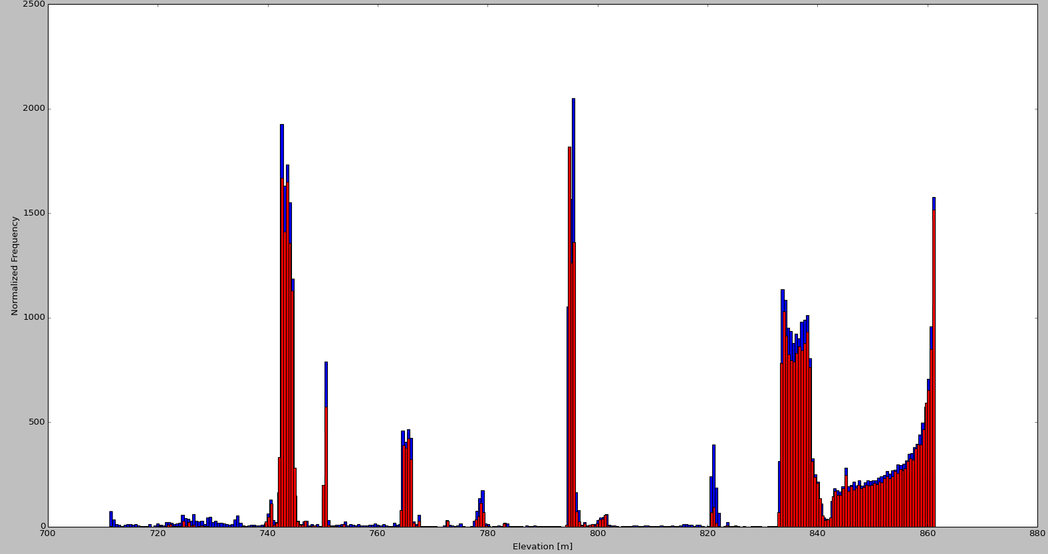

Figure 2 Histogram of z-values from building in Figure 1 before (blue) and after (red) iterative outlier removal. Note that the shape of the distribution remains the same with major clusters retained while lower frequency elevations are removed.

**Edge enhancement**

# Summary and Future Work