NC State University
Department of Electrical and Computer Engineering
ECE 463/563: Fall 2019
Project #3: Dynamic Instruction Scheduling

by

Bibin Kurian George

NCSU Honor Pledge: "I have neither given nor received unauthorized aid on this test or assignment."

Student’s electronic signature: _____Bibin Kurian George___
(sign by typing your name)

Course number: _______563__________
(463 or 563 ?)

Graphs
gcc_trace
S | N=1 | N=2 | N=4 | N=8
8 | 0.99 | 1.88 | 2.67 | 2.82
16 | 1 | 1.99 | 3.54 | 4.54
32 | 1 | 1.99 | 3.9 | 6.48
64 | 1 | 1.99 | 3.97 | 7.52
128 | 1 | 1.99 | 3.97 | 7.83
256 | 1 | 1.99 | 3.97 | 7.83

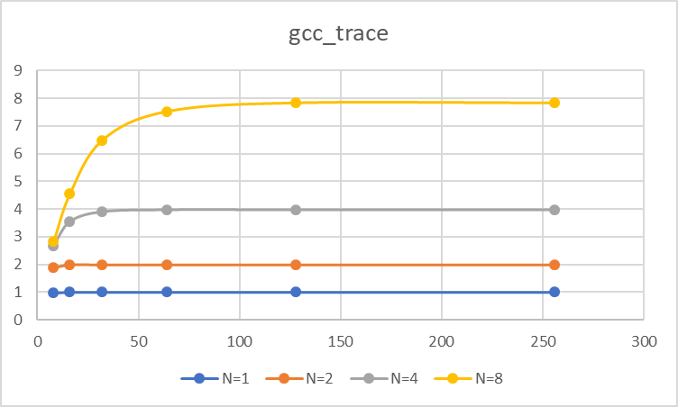
perl_trace
S | N=1 | N=2 | N=4 | N=8
8 | 0.98 | 1.68 | 2.18 | 2.28
16 | 1 | 1.89 | 2.91 | 3.37
32 | 1 | 1.98 | 3.68 | 5.18
64 | 1 | 1.98 | 3.91 | 6.95
128 | 1 | 1.98 | 3.94 | 7.61
256 | 1 | 1.98 | 3.94 | 7.75

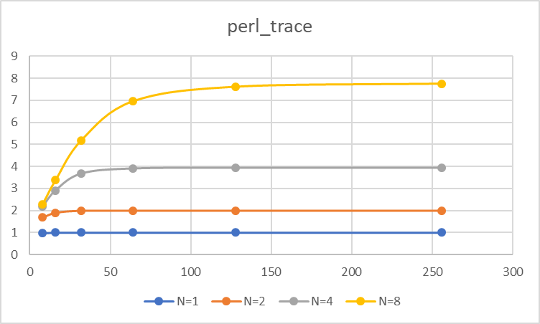

Analysis
As would be expected we see an increase in the IPC as the value of peak issue rate is increased, ie as the number of functional units and the number of entries in the dispatch queue increase the number of instructions that are able to execute simultaneously also increases which is reflected in the higher IPC.
Further we can see that having a high peak issue rate without a proportionally high scheduling queue size is a bottleneck for IPC. The smaller scheduling queue means that the processors aren’t leveraging the benefits afforded by register renaming as there are not enough independent instructions which can be readily picked up by the functional units from the scheduling queue.
Another important observation to be made is that after a certain point there is no benefit to increasing the scheduling queue size as there are not enough functional units to execute the instructions ready to be executed. Hence an increased schedule queue size needs to be accompanied by an appropriate increase in the peak issue rate and vice versa.
Furthermore it is observed that the instructions from the perl_trace file reach their peak IPC at higher scheduling queue sizes as compared to the measurements from the gcc_trace file. This can most probably be attributed to the higher dependence between instructions located close to each other in the perl_trace file and therefore not being able to be executed out of order. Once the scheduling queue size increases we are able to find more independent instructions which can be executed parallelly.

