Technical Manual

Service Record Generation System

Software Version : 0.00

Manual Version : 0.00

Original Author(s) : Geovani P. Duqueza

Contributors : <TBA>

# Foreword

The purpose of this manual is to guide both the developers, maintainers, and even some advanced users of this system. May this technical manual serve you well.

- GPD

# Flowchart

[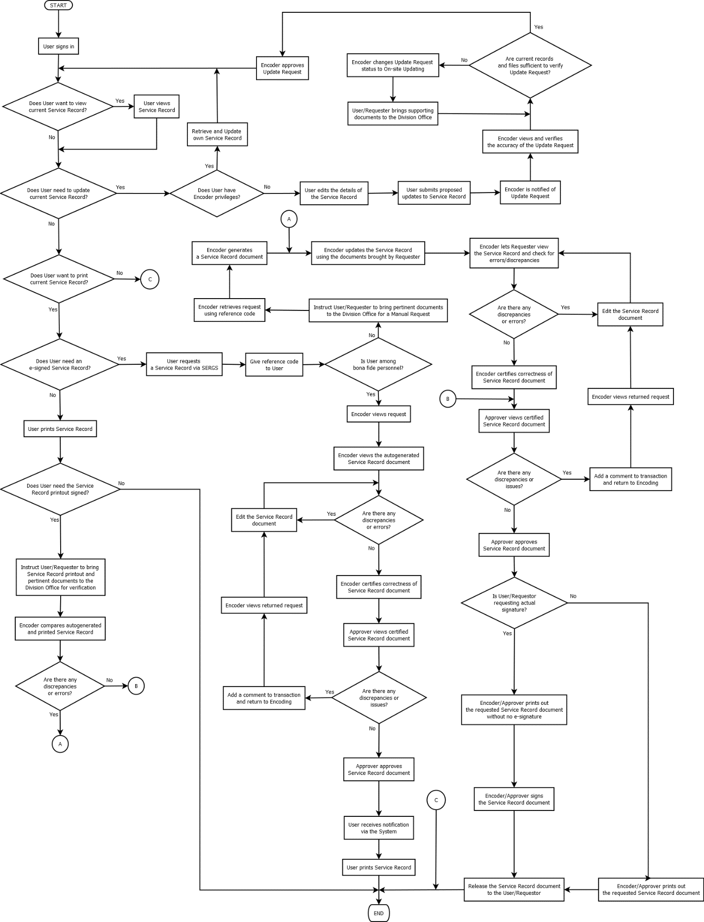](https://raw.githubusercontent.com/GeoDuqueza1939/SDOStoTomasBatangas/main/web/sergs/.docsanddesign/Workflow.png)

# UML Diagram

<UNDER CONSTRUCTION>

# Entity-Relation Diagram

<UNDER CONSTRUCTION>

# Coding Standards and Style Guide

## HTML

## CSS

## JavaScript

* Variable names shall use camel case.
* Class names shall use proper case.
* Constant names shall use upper case.
* Brackets shall be positioned as follows:
  + The opening bracket should be placed on the line next to the class, interface, function, or control structure identifier, vertically aligned to the first character in the respective identifier line.
  + The closing bracket should be placed on its own line, vertically aligned to the first character in the respective identifier line.

## PHP

* Variable names shall use camel case.
* Class names shall use proper case.
* Include functions and/or methods that create schemas/namespaces and entities/tables.
* Brackets shall be positioned as follows:
  + The opening bracket should be placed on the line next to the class, interface, function, or control structure identifier, vertically aligned to the first character in the respective identifier line.
  + The closing bracket should be placed on its own line, vertically aligned to the first character in the respective identifier line.

## Database

### Namespaces

* Namespaces shall be created on the fly the first time they are used, to allow for automatic database setup.

### Tables

* Tables shall be created on the fly the first time they are used, to allow for automatic database setup.
* Table names shall be coded in proper case and shall use underscores in lieu of spaces.
* In case table names signify acronyms, these shall be coded in capital letters.

### Attributes

* Attribute names shall be coded in lower case and shall use underscores in lieu of spaces.
* When referring to ID’s from another table, an attribute name shall be appended with postfix “-Id” without using underscores or spaces, e.g., personId (foreign key corresponding to ID in Person table), service_recordId (foreign key corresponding to ID in Service_Record table).
* Acronyms shall be coded as lowercase.