User manual — Field Box BT
App v0.8.0 · box firmware 0.3.1-bt · for teachers, no technical background needed

1. About this manual
Field Box is a field kit for environmental measurements, used by teachers and pupils on school trips and route walks. The kit has two parts: the box (a small sensor unit carried in a backpack) and the phone with the Field Box BT app (kept in a pocket). This manual describes both, function by function: what every button does, what every message means, and what to do when something does not work.
Who it is for. Teachers and pupils using the kit in the field. No technical knowledge is assumed. Installing the app and updating the box (for a technician) are described separately, in the installation guide (Install_EN.pdf).
How it is organised. Chapters 2 and 3 introduce the box and the phone. Chapter 4 describes every screen of the app. Chapter 5 is the field day, step by step. Chapters 6 and 7 say which files result and what the reports contain. Chapter 8 is the troubleshooting table: symptom, probable cause, what to do. At the end: specifications, glossary and the one-page field card.
Conventions.
- Button and menu names are in bold: Start, Connect to a box.
- Messages shown by the app are written like this: The clock is not set yet.
- The app is English only, whatever the phone's language.
- BOX_xxxx stands for the name of your box (for example BOX_3C3C).
Versions covered. App 0.8.0 and box firmware 0.3.1-bt. Boxes still on firmware 0.2.0-bt keep working, with the differences noted in chapter 9.

2. The box

2.1 What it is
The box is a small autonomous logger. It has three sensors, an internal memory, a status LED and a USB-C socket for power. It talks to the phone over Bluetooth; it has no screen and no buttons. From the moment it receives power it measures and writes one row every 5 seconds into its memory, whether or not any phone is connected.

2.2 The sensors and what they measure
Sensor | Measures | Unit | Shown in the app as
BME280 | air temperature | °C | Temperature
BME280 | relative humidity | % | Humidity
BME280 | atmospheric pressure | hPa | Pressure (plus an estimated altitude, in metres)
SCD41 | carbon dioxide (CO₂) | ppm | CO₂
VEML7700 | light | lux | Light
The CO₂ sensor produces a new value every 5 seconds; the others, every second. A sensor that does not answer leaves its cell empty in the files and shows – in the app — the box carries on with the others.
The CO₂ bands used in the charts and the report are those of the Magic Boxes lesson:
Band | CO₂ (ppm) | Colour
Excellent | below 800 | green
Good | 800–1200 | yellow-green
Moderate | 1200–2000 | amber
Poor | 2000–5000 | red
Dangerous | 5000 and above | purple
The temperature bands (for the outdoor lesson, not a comfort standard):
Band | Temperature | Colour on the chart
Cold | below 5 °C | red
Cool | 5–15 °C | amber
Comfortable | 15–28 °C | green
Hot | 28–35 °C | amber
Very hot | 35 °C and above | red

2.3 Power
The box is powered through its USB-C socket, from a powerbank or a phone charger. Push the plug in firmly; a small red light inside shows it has power. It has no battery of its own and no power button: while it is powered it runs; when you unplug it, it stops.
How long a powerbank lasts depends on its capacity; on Bluetooth the box draws noticeably less than the old Wi-Fi version did. For one field day an ordinary phone powerbank is enough — charge it the evening before.

2.4 The status LED
LED | Meaning
solid for 2 seconds right after power-up | the sensors started correctly
slow blink (once every half second) | a recording is running (Start was pressed in the app)
very fast blink (10 times a second) | the box's storage is full — see 2.5 and chapter 8
off | the box is running normally with no recording started (the continuous log is written anyway)
If the LED does not light at all after power-up, the box did not start or a sensor is not answering: unplug and plug the cable again.

2.5 The box's storage
The box has about 2.5 MB of file storage. A log row is about 60 bytes, so at one row every 5 seconds the storage holds about 150 hours (some six days) of continuous logging.
The box writes two kinds of file:
- the continuous log (log_<day>_<time>.csv): a new file at every power-up and at midnight, one row every 5 seconds;
- the points file (points_<day>.csv): one file per day, one row for every Read pressed.
When free space drops below 100 kB, the box deletes its oldest continuous log by itself to make room. Points files are never deleted automatically. If there is no old log left to delete, the box closes the current log, the LED blinks fast and the app shows … kB free on the box — full; the box has stopped logging; reads (Read) are still accepted as long as one more row fits.
The app warns early: below 300 kB free, the Point tab shows n kB free on the box — running low; download and delete old files on Files. Download (PDF report or Send all fetch the day's log by themselves) and delete old files on Files.

2.6 The Bluetooth name
Every box announces itself over Bluetooth as `BOX_xxxx`, where xxxx are four characters unique to that box (the same name is written on the box). This name goes into every file downloaded from the box and into the photo file names, so files from different boxes never mix.

2.7 The box's clock
The box has no battery-backed clock of its own. At every power-up it does not know the time; it learns it from the phone, automatically, the moment they connect. Until then:
- the rows measured are kept in temporary memory (at most one hour) and written with the correct time as soon as the phone connects;
- Read and Start are refused (The clock is not set yet.);
- on the Boxes tab the clock shows `(NOT SYNCED)` in red.
The time stays set as long as the box is powered, even if the Bluetooth link drops. It is lost only when the cable is unplugged.

2.8 The box without a phone
The box logs whenever it is powered, with or without a phone. You can leave it on all day in a classroom; the next time a phone connects, Files → PDF report fetches the day's log by itself and makes the day's report (the Box day pages, chapter 7). The only condition is that at some point that day a phone connected to set its clock; the rows from before (at most one hour) are recovered, older ones are lost.

3. The phone

3.1 Requirements
- A phone or tablet with Android 10 or newer.
- Bluetooth (for the box), GPS (for the route and the positions of reads) and a camera (for photographs). Without GPS or without a camera the app still works, minus those functions.
- No internet is needed in the field. Internet (Wi-Fi at home) is only used to prepare the map (chapter 5).

3.2 Installation
The app is installed from a file, fieldbox-bt-0.8.0.apk, not from the Play Store. The steps, with screenshots and the Android warnings that appear, are in the installation guide (Install_EN.pdf). The app appears on the phone as Field Box BT.

The Field Box BT icon, as it appears on the phone

3.3 Permissions asked and why
At first launch the app asks, one after another, for the permissions below. Grant them all; without one, that function is missing.
Permission | Used for | If you refuse
Location (choose the precise option) | the GPS route, the position of every read and every photo | reads are saved without coordinates; the route is not recorded; Live shows Route: not running — check the Location permission…
Nearby devices / Bluetooth | talking to the box | the app cannot connect to any box: Bluetooth permission is required to talk to the box. Tap Connect again and allow it.
Camera | the photographs at stations | Camera permission is needed to photograph a station.
Notifications (Android 13 and newer) | the permanent notification with elapsed time and the Read now button | you do not see the notification; the recording runs anyway
Permissions can also be granted later from Android settings: Settings → Apps → Field Box BT → Permissions. If Location was granted only after Start was pressed, stop and start the recording again (or tap the Route: … line on Live) so the route starts.
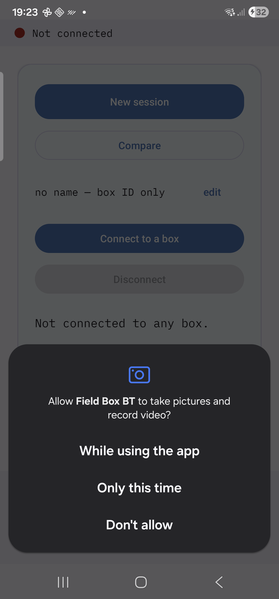
The Android permissions screen

3.4 Pairing with the box (once)
The phone and the box must be paired once, from the phone's Bluetooth settings: Settings → Bluetooth → Pair new device → `BOX_xxxx`. Do it at home, not in the field. A box that has never been paired does not appear in the app's list — this is the most common cause of "the app can't see my box". The steps with screenshots are in the installation guide.
Pair the phone with every box it might use.

3.5 The tabs at a glance
The app has five tabs, in the bottom bar:
Tab | What it is for
Boxes | connecting to the box; its state (clock, storage); the profile
Live | the sensors' current values, with trend arrows, and the charts of the last 50 minutes
Point | the measurement day: Start, the station list, Read, photographs, Stop, report
Map | today's route, coloured by one sensor; stations and photographs on the map
Files | the files on the box; the reports; Compare; the plan template
Secondary screens, opened from the tabs: Profile, Station plan, Compare, the camera.
The link strip. At the top of every tab a strip shows the state of the link to the box, so you never have to go back to Boxes:
What you see | What it means
🟢 BOX_xxxx · link good | connected, the box answers immediately
🟢 BOX_xxxx · link ok | connected, answers are slower — usually fine
🟠 BOX_xxxx · link poor | an answer was late or missing in the last 10 seconds: you are at the edge of range — bring the box closer to the phone
🟣 BOX_xxxx · link none | just connected; the link has not been judged yet (a few seconds)
🟠 Connecting… | you tapped a box and the app is connecting
🟠 Reconnecting to BOX_xxxx… | the link dropped; the app is restoring it by itself
🔴 Not connected | no box — go to Boxes or Point and choose the box
The link is judged by how quickly the box answers the app's questions (once a second): under 0.3 s = good; over 1 s, or a missing answer = poor. Bluetooth offers no "signal bars", so this is the only signal indicator.

4. The screens, function by function

4.1 Boxes
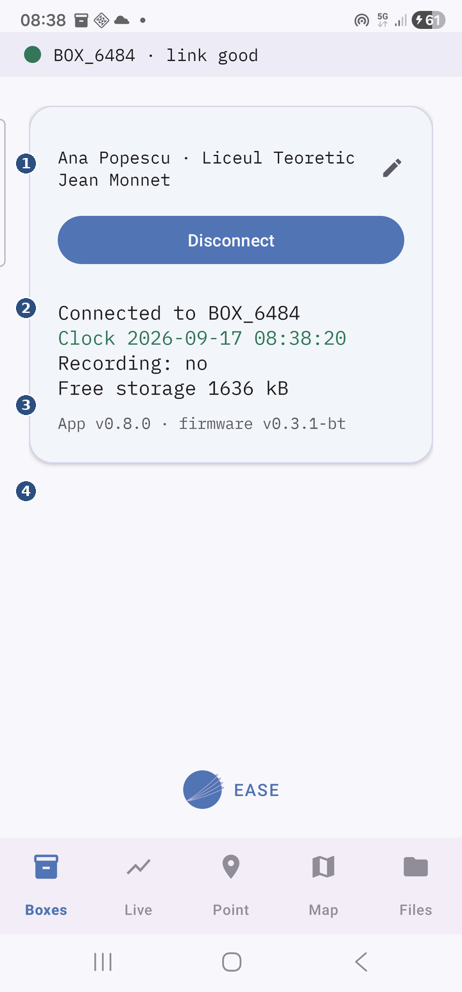
The app's start screen.
① The profile row — who carries the phone; tap it (the pencil) to change it.
② Disconnect — while connected; otherwise this is Connect to a box.
③ The box's status — which box you are connected to, its clock (green = set), whether it is recording, free storage.
④ Versions — app and box firmware; a long press opens the link log (testing only).
The profile row. At the top of the card is who carries the phone, as entered in the profile (for example Ana Popescu · Liceul Teoretic Jean Monnet) or no name — box ID only if nothing was entered. A small pencil at the end of the row is the hint that tapping the row opens the Profile screen (4.7).
Connect to a box. Opens the Choose a box dialog with the list of boxes paired with this phone. Tap yours. It is not a search: an unpaired box does not appear. If no box is paired at all, the message No paired box found. Open Bluetooth settings, pair with the BOX_XXXX device (it appears when the box is powered), then come back and tap Connect. appears with a Bluetooth settings button that opens the phone's Bluetooth settings. While you are connected the Connect to a box button is hidden.
Disconnect. Closes the link and forgets the box: the next connection shows the list again. Tapped by mistake, it loses nothing — reconnect.
The status lines (under the buttons), depending on the situation:
- Not connected to any box. — no box.
- Connecting… — in progress.
- Reconnecting to BOX_xxxx… — the link dropped; Connect to a box stays enabled so you can pick another box if needed.
- When connected, four lines: Connected to BOX_xxxx; Clock 2026-09-16 10:29:43 — in green if the clock is set, followed by `(NOT SYNCED)` in red if not (see 2.7; fixed by disconnecting and reconnecting); Recording: yes or Recording: no — whether Start was pressed; Free storage n kB — free space on the box.
- If connecting failed, a sentence you can act on and, beneath it in small type, the technical text of the error: The box is not answering. Check it is switched on and within a few metres, then tap Connect again.; Bluetooth is switched off on this device. Turn it on, then tap Connect again.; Could not connect. Try again; if it keeps failing, switch the box off and on.
The versions line. At the bottom: App v0.8.0 · firmware v0.3.1-bt (with — instead of the firmware until a box connects). These are the two numbers any support conversation needs.
The link-drop log (for testing, not for pupils): a long press on the versions line opens the Link drops dialog. It shows Drops: none recorded or Drops: 2 · longest 14 s (possibly · 1 needed a tap = one needed you to press Connect yourself), then the last 12 events, one per line: the time, then back in 6 s (healed by itself), back after 14 s (tap) (healed manually) or down… (still down). Clear drop log empties the list. A few short drops a day are normal.
The link notification. While a box is connected, the notification bar holds Field Box — connected to BOX_xxxx / Keeping the Bluetooth link to the box alive in the background. Leave it there: it keeps the link alive with the screen off. The phone's mobile internet keeps working.
Automatic reconnection. If the link drops (the box goes out of range, or blinks off for a moment), the app tries to restore it by itself, once a second, whichever tab you are on. Nothing to do; the box keeps logging meanwhile.

4.2 Live
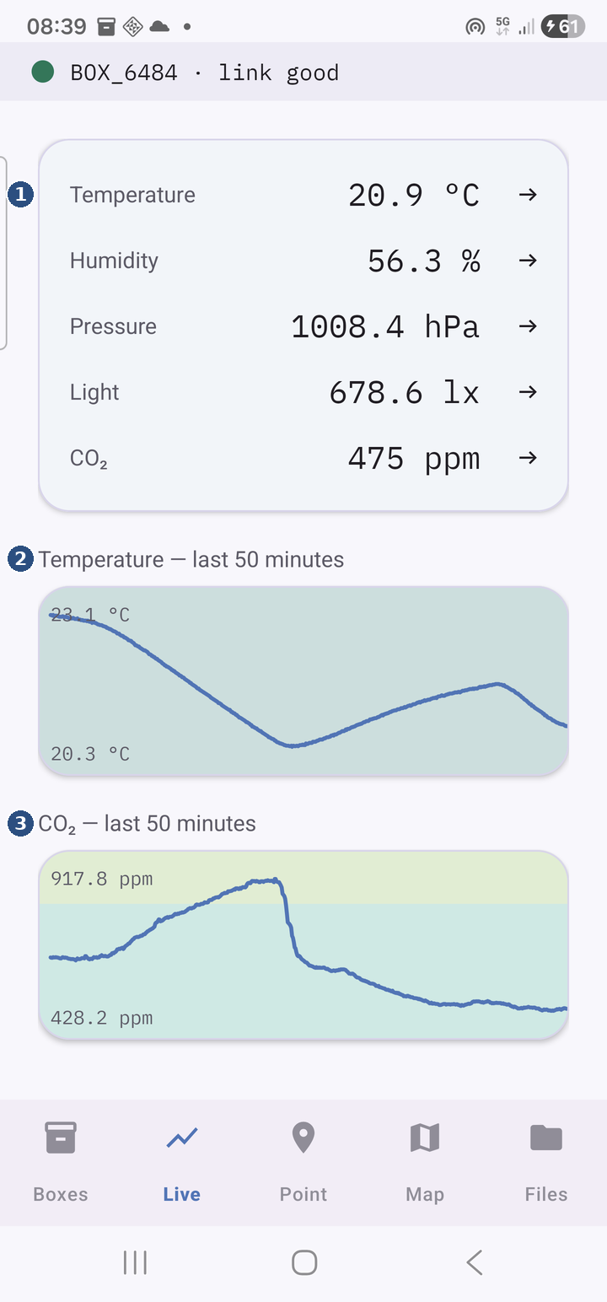
The sensors' values right now and two charts. Works without Start: useful for a demonstration in class.
① Current values — temperature, humidity, pressure, light, CO₂, each with its arrow: ↑ rising, ↓ falling, → steady, … not known yet (first 40 s).
② Temperature, last 50 minutes — the coloured bands behind it: cold, cool, comfortable (green), hot, very hot.
③ CO₂, last 50 minutes — the lesson's bands: under 800 excellent, up to 1200 good, up to 2000 moderate, up to 5000 poor, above — dangerous.
Without a box. If no box is connected the screen shows only Connect to a box first, on the Boxes tab. If the link drops while you are watching: Connection lost — reconnecting… the box may be out of range. The values come back by themselves when the link is restored.
The values. Five cards — Temperature (°C), Humidity (%), Pressure (hPa), Light (lx), CO₂ (ppm) — refreshed once a second. – means that sensor has not produced a value yet (CO₂ needs a few seconds after power-up; see chapter 8).
The trend arrows. After every value there is an arrow:

Arrow | Meaning
↑ | rose compared with 30 seconds ago
↓ | fell
→ | stayed put (change below the noise threshold)
… (faint) | not known yet — during the first 40 seconds after connecting, or after a gap
The comparison is between the mean of the last 10 seconds and the mean of 10 seconds from 30–40 seconds ago. Changes smaller than the sensor's noise count as "stayed put": 30 ppm for CO₂, 0.2 °C for temperature, 1.5 % for humidity, 0.5 hPa for pressure, 10 lx or 20 % of the value for light (whichever is larger).
The charts. Temperature — last 50 minutes and CO₂ — last 50 minutes show the history the box keeps (one point every 5 seconds, the last 50 minutes) — so they appear filled right after connecting, not from zero. Behind the line the lesson's bands are painted (2.2): for CO₂ green / yellow-green / amber / red / purple, for temperature red / amber / green / amber / red. Vertical ticks mark the Read moments. The text waiting for data in place of the chart means the history has not arrived yet (the first seconds) or the box has firmware that is too old (chapter 8).
The Route line. Shown only while a recording is running; it says what the phone's GPS route is doing:
Text | Meaning / what to do
Route: waiting for the first GPS fix… | normal at the start; get out under an open sky
Route: no point yet · n GPS fixes rejected (last ±x m, limit 100 m) | the phone delivers positions, but all worse than 100 m — indoors or next to buildings; wait outside
Route: n points recorded | working well
Route: n points · m skipped (weak GPS) | m positions were rejected (inaccurate, over ±100 m, or too close, under 3 m); normal indoors or under tree cover
Route: not running on the phone (the box is recording) — tap here to resume the route | the phone's route stopped (usually after an app update or when Android closed the app); tap the message — the route resumes, in a new file; the box lost nothing
Route: not running — check the Location permission, then stop and start the recording | the Location permission is missing; tap the message (it asks for it), then stop and start from Point
Route: not running — the system refused the start: … | Android refused the location service; the text after the colon is the technical reason; stop and start the recording
Route: off — this device has no GPS receiver | tablet without GPS: there will be no route; reads work without coordinates
The recording is started and stopped from Point (Start / Stop); the elapsed time is in the notification (4.9).

4.3 Point
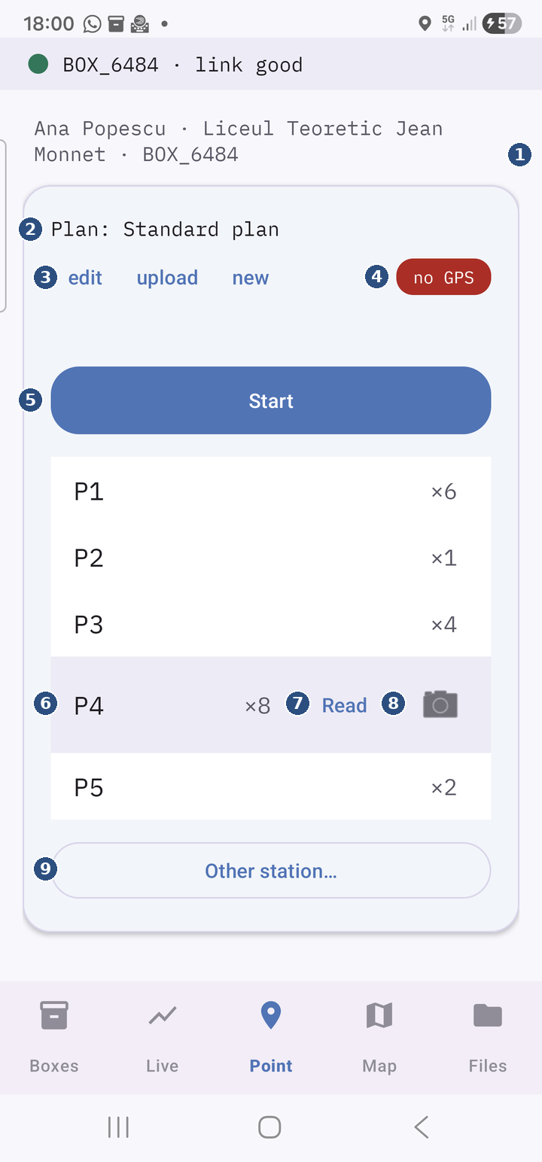
The measurement day's screen. It shows only what still needs an answer, then the station list. Chapter 5 walks through it in the order of a day; here are all the controls.
① The header — who carries the phone and which box it talks to.
② The active plan — the list of stations you walk.
③ edit · upload · new — change the plan, load one from a CSV, or start the next pupil's walk.
④ The GPS pill — red no GPS, amber weak, green GPS n m.
⑤ Start / Stop — starts and stops the day's recording.
⑥ The current station — the highlighted row; tap another row to make it current. The number on the right: how many times it was read.
⑦ Read — one reading at the current station (all sensors + the GPS position).
⑧ The camera — a photograph tied to the current station.
⑨ Other station… — add a station that is not on the plan; a long press on it removes it.
The header. The first line, of the form Ana Popescu · Liceul Teoretic Jean Monnet · BOX_3C3C, says who carries the phone and which box it talks to. no profile means the profile is empty; no box that no box is connected.
The Box card (only while no box is connected). The title Box, the list of paired boxes — tap yours (it connects directly, without going through Boxes) — and, below, Choose the paired box or Connecting…. If the Bluetooth permission is missing, the card asks for it and says Bluetooth permission is required to talk to the box. Tap Connect again and allow it.
Continue without a box. Hides the Box card for a photographs-only walk: the station list appears, the camera works, Read and Start stay disabled until a box connects (the status line says Connect a box to read — Photograph works without one.). If a box connects later, the choice cancels itself; if the link is lost for good, the Box card comes back.
The Profile card (only the first time). The title Profile, the explanation The name appears in the report and in file names. Without a name, the session is identified only by the box's ID. and two buttons: Set profile (opens the Profile screen, 4.7) and Skip (no name; the card does not come back). The profile can be filled in any time later, from Boxes or from new.
The plan line. Plan: Standard plan — the name of the active station plan — followed by three small buttons:
- edit — opens the Station plan screen (4.6);
- upload — loads a plan from a CSV file (see 4.6, "The plan from a file");
- new — the next pupil: the New walk dialog (below).
The GPS pill. Under the plan line, a coloured pill with the positioning state:
Pill | Meaning
🟢 GPS 8 m | a good fix, accuracy of at most 15 m
🟠 GPS 32 m (weak) | a weak fix (over 15 m) — it is used; keep going; it improves under an open sky
🔴 no GPS | no fix yet — at the start, indoors, with Location off or without the permission
GPS never blocks a read or a photo: without a fix, the read is saved with the station and the time, but without coordinates. Once, when the tab opens, one of these may appear: Location is switched off on this device. Readings will be recorded without coordinates. (turn Location on in the quick settings), Location permission refused. Readings will be recorded without coordinates. (grant it in Settings) or This device has no GNSS receiver. Readings will be recorded without coordinates. (a tablet without GPS).
The status line (under the pill). Empty when all is well. Otherwise:
- n kB free on the box — running low; download and delete old files on Files — under 300 kB free on the box;
- n kB free on the box — full; the box has stopped logging — storage full (2.5);
- Reconnecting to BOX_xxxx… / Link to the box dropped — reconnecting… — the link dropped; the app is restoring it;
- Connect a box to read — Photograph works without one. — you are working without a box;
- after a Start the box refused, the reason: The clock is not set yet. (2.7), The storage is full. (2.5), The box refused the request. or Could not reach the box. The message stays until the next successful Start.
Start. Starts the recording: marks the start in the box's log, starts the phone's own series (one row every 5 seconds with the box's values), the GPS route and the permanent notification (4.9). The button is enabled only with a box connected. The plan's first station becomes the current station, if none was yet.
Stop. Replaces Start while the recording runs. Stops the series, the route and the notification, marks the end in the box's log, writes the day's bundle (the session_….json and .gpx files, chapter 6) and shows the Done card. It works even if the box has meanwhile disconnected or if the phone has no GPS.
The station list. One row per station in the plan, plus those added today. On each row: the station's name and, once it has been read, how many times (×1, ×2 …). The current row is highlighted (lavender background) and only it has the Read and camera buttons. The current row is the one you tapped last; it never advances by itself — a group reads the same station several times before moving on.
- Tap a row to make it current ("this is where we are now").
- Read — one read at the current station: the box writes a row in its points file (with the phone's GPS position, if any), the phone writes its own copy, the counter grows and the phone vibrates briefly. A Read pressed before Start starts the recording by itself. If the box refuses: The box could not record this point — check the clock is synced and there is free storage.; if it does not answer: Could not reach the box. The button is disabled without a connected box.
- The camera (the icon on the current row) — opens the capture screen (4.10). Disabled while a photo is in progress.
- Other station… (at the end of the list) — a dialog with a Station name field: adds a station that is not in the plan, puts it in the list and makes it current. Usable any time, including mid-walk. It does not change the plan.
- Long press on a station added with Other station… — the dialog Remove P6 from today's list? Its readings stay in the files. with the Remove button takes it off the list; reads already made stay in the files. The plan's own stations cannot be removed here (edit them in Station plan).
The encouragement messages. At 1, 5, 10, 20 and 40 reads in one day the app shows a Field Box dialog with a short message from the team that built the kit. Tap OK; it has no effect on the data.
new — the next pupil. The New walk dialog has the fields Name, Group / school (optional) (prefilled with the current profile) and the Station plan list. Start over saves the chosen profile and plan, clears the counts, the current station and the stations added today, and hides the Done card. If there are reads today already, it asks first: Counts for n stations will be cleared — the files on the phone and the box stay. — the files are untouched; only the on-screen counts start from zero.
The Done card (after Stop). A one-line summary — 12 points · 1.84 km · 3 photos — and five actions:
- Map — opens the Map tab on today's route.
- PDF report — makes the day's report (chapter 7) and opens the share sheet. With a box connected it first fetches its log (the button reads Downloading the box log… n kB). The report made from here does not contain the map; for the report with the map, open the Map tab first, then make the report from Files.
- Send all — makes a ZIP with everything (chapter 7) and shows Package saved with a Send button that opens the share sheet (WhatsApp, e-mail, Drive…). On failure: The package could not be created.
- Continue measuring — brings the list back with its counts; the next Start records a second route in the same day, and the next Stop rewrites the day's bundle with both.
- New walk (next pupil) — the same dialog as new.
If there is nothing to report for the day, the summary reads Nothing to report yet. and PDF report / Send all are disabled.

4.4 Map
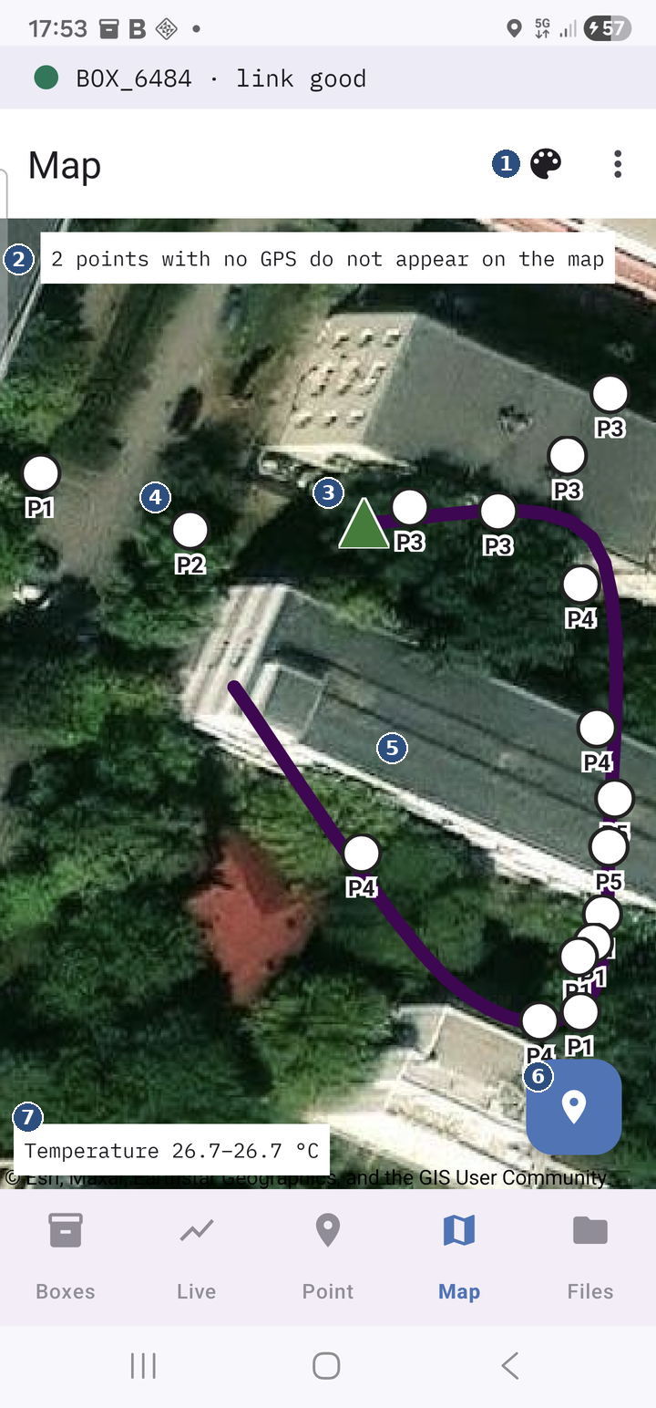
Today's route on a map, coloured by one sensor, with the stations and the photographs. It reads only what is already on the phone — it never asks the box — and refreshes by itself every 30 seconds, so it can be watched while walking.
① The palette — choose the sensor that colours the route (temperature, humidity, pressure, CO₂, light or none); next to it the ⋮ menu with the satellite view and Archive today.
② The banner — how many reads have no GPS position and so are not on the map.
③ The green triangle — where the recording started.
④ The named circles — the stations read; a station read several times is one circle, P3 ×4; tap it for the values.
⑤ The route — the path walked, coloured by the chosen sensor.
⑥ The position button — centres the map on where you are.
⑦ The legend — the chosen sensor and its range along the route (in this version it sits in the top bar, next to the palette).
The route. A continuous line through the recorded positions, coloured by the chosen sensor (temperature by default): from dark purple (low values) to yellow (high values). The legend in the top bar gives the sensor and its range, with the unit, for example Temperature 18.2–24.6 °C (the range is between the 5th and 95th percentile of the values along the route, so two extreme values do not wash the colours out). Stretches with no sensor value within ±60 s stay navy. A green marker with a white outline marks the start (start 10:29).
⋮ → Colour route by. Picks the sensor: Temperature (default), Humidity, Pressure, CO₂, Light or None (a plain navy line, no legend). The choice is remembered.
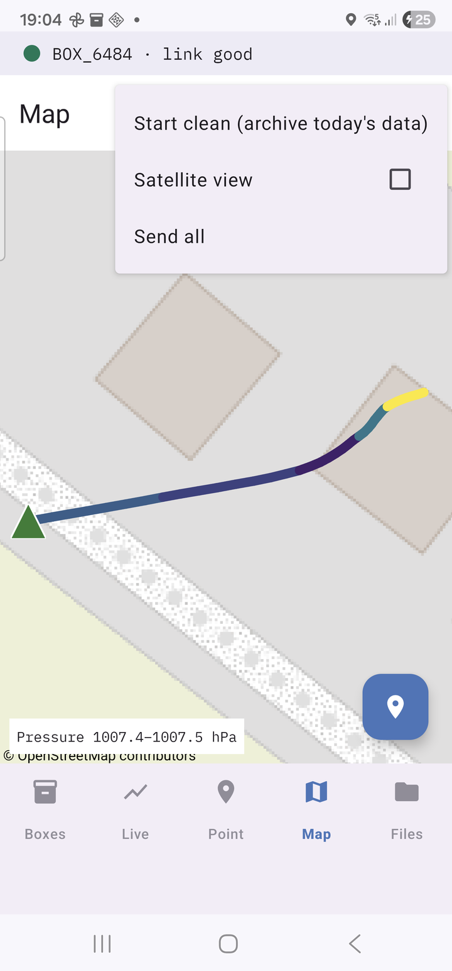
The ⋮ menu on Map
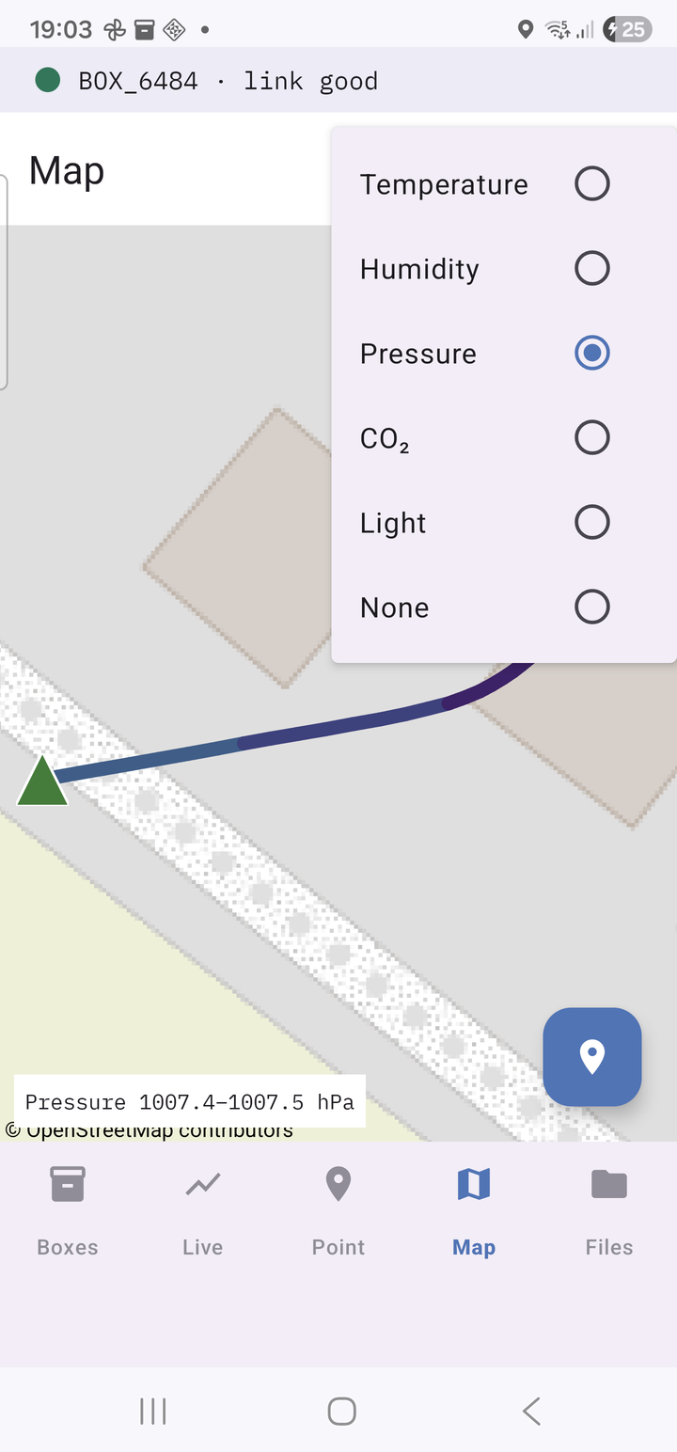
The Colour route by submenu
⋮ → Satellite view. Swaps the street map for satellite imagery. The tick is remembered. Map tiles seen once (on Wi-Fi) stay saved on the phone, separately for each view — prepare the area in advance in the view you will use.
The stations. Every station that was read appears as a white circle with its label. A station read several times is one circle, labelled P3 ×4, placed at the mean position. Tap the circle: a bubble titled P3 · 4 reads · 11:30:26–11:42:10 (or P3 · 11:30:26 for a single read) with the averages of the reads: Temperature: … °C, Humidity: … %, CO₂: … ppm, Pressure: … hPa, Altitude: … m, Light: … lux. Tap the bubble or the map to close it.
The photographs. Every photograph appears as a thumbnail where it was taken (it shrinks as you zoom out). Tap it: the bubble shows the photo, P3 · 11:30 · 12 m from the point (the station it belongs to — the nearest read point — and the distance to it) and the values measured at that point. If the photo was deleted or moved out of the gallery, its file name and the photo was not found appear instead.
Centre on me. The round button in the corner recentres the map on the phone's current position. Without a fix: No GPS fix yet — open the Point tab to start locating.
Messages on the map.
- No measurements today. The route appears after Record, points after Read now. — nothing yet today; the map stays on Romania.
- n points with no GPS do not appear on the map — n reads were made without a fix (indoors); they are in the files and the report, but cannot be drawn.
⋮ → Start clean (archive today's data). For a second session on the same day (another class in the afternoon, or a rehearsal before the real walk). The confirmation says exactly what happens: Today's files on the phone (route, points, series, photos list, report, box logs) move to Documents/FieldBox/archive/. The map starts empty; nothing is deleted. Continue? The Archive button moves the whole day folder to Documents/FieldBox/archive/<day>_<time>/, clears the counts on Point and shows n files moved to the archive. The map is empty for a new session. The photographs stay in the gallery (only their list moves, so they no longer appear on the map). Refused while a recording is running: Stop the recording before archiving today's data.
The map in the report. The report made from Files includes the map as you last saw it on this tab, that day. Open Map once before making the report.

4.5 Files
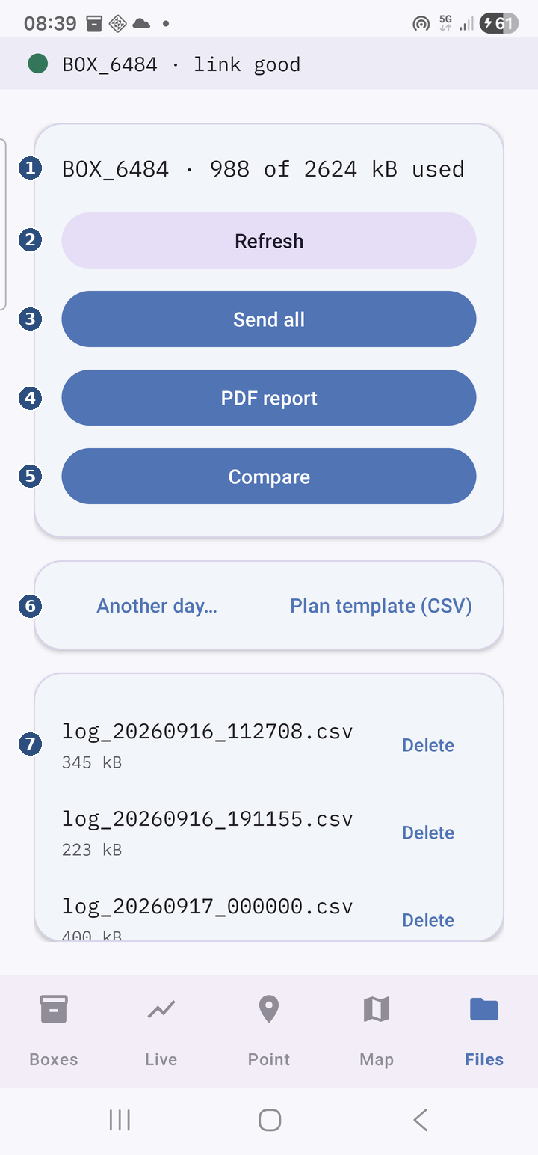
The files on the box and everything to do with reports.
① The box's storage — how much is used of how much there is.
② Refresh — re-reads the list of files on the box.
③ Send all — builds the day's ZIP (everything the teacher needs) and offers to send it.
④ PDF report — today's report; it fetches the box's log by itself.
⑤ Compare — the teacher's screen, with several pupils' sessions.
⑥ Another day… / Plan template (CSV) — a report for another day; a plan template to fill in.
⑦ The files on the box — name and size; Delete removes them from the box (not from the phone).
The storage line. BOX_3C3C · 812 of 2560 kB used — how much of the box's storage is in use — followed by · RECORDING while a recording is running. Without a box: Connect to a box first, on the Boxes tab. If the box could not be read: Could not read the box: …
Refresh. Re-reads the list from the box.
Send all. The same ZIP as on the Done card (chapter 7), from what is already on the phone for today, plus the box's log if it is connected. Package saved + Send.
PDF report. The report of today (chapter 7). With the box connected, it first fetches today's log from it (Downloading the box log… n kB on the button; about 20 seconds for a whole day) — keep the phone next to the box. Then Report saved + Send. If there is nothing today: Nothing to report for 16 Sep 2026.; on failure: The report could not be created.
Compare. Opens the comparison screen (4.8).
Another day… The report for another day. The Report for which day? dialog lists the days the phone has anything for, newest first, of the form 16 Sep 2026 — points · series · box log BOX_3C3C (what exists: points, a series, a box log). Pick the day; its report is made. If there is no day at all: Nothing on the phone to report yet. Tracks and photo lists alone do not make a day "with data".
Plan template (CSV). Writes the plan model plan_model.csv (the standard plan, one station per line) into Documents/FieldBox: Saved as Documents/FieldBox/plan_model.csv — one station per line. + Send, to send it to a laptop and fill it in (4.6).
The list of files on the box. One row per file: the name (log_20260916_102943.csv, points_20260916.csv), the size (n kB) and a Delete button. The log the box is writing right now has Delete greyed out — it cannot be deleted (or downloaded) while open.
Delete. Confirmation Delete file / Delete BOX_3C3C_log_….csv? This cannot be undone. → Delete. Files deleted from the box cannot be recovered. Delete only after the report or Send all has fetched the day's log (downloaded files are in the day folder, chapter 6). Possible messages: This file is being recorded — stop the recording first. (press Stop on Point), Could not delete the file. (the box did not answer; try again). After deleting a log, if the box immediately opens another one: Deleted — the box opened a fresh log (it logs whenever it is powered). — normal, the box logs while powered.
Downloading a single file. There is no separate download button: PDF report and Send all fetch that day's logs by themselves (and only those that are missing or have changed). A file from another day is downloaded by making that day's report with the box connected (Another day…).

4.6 Station plan
A plan is an ordered list of stations, with a name. The `Standard plan` has the stations P1, P2, P3, P4, P5 and always exists. The screen opens from edit on the plan line (Point tab).
The controls:
- the drop-down at the top — picks the plan to edit (every plan saved on the phone);
- the station list — drag the handle on the right to reorder; swipe a row to the left to delete it;
- the Station name field + + Station — adds a station at the end;
- Save as… — a dialog with Plan name: saves the current list as a new plan (or over one with the same name);
- Use this plan — saves the changes under the current name, makes it the active plan and closes the screen.
Changes not followed by Use this plan or Save as… are lost on leaving the screen (the back button). Names are cleaned automatically: leading/trailing spaces, empty rows and duplicates are removed. A plan left with no station at all is replaced by the standard plan.
The plan from a file (upload). The upload button on the plan line takes a CSV file (from My Files, WhatsApp, Drive…) and turns it into a plan:
- one station per line — or one single Excel row, with commas or semicolons; quotes are ignored;
- a first row that is a header word (station, stație, nume, name…) is skipped; any other first row is a station;
- the plan takes the file's name (Parcul_Herastrau.csv → the plan Parcul_Herastrau), is saved on the phone, becomes the active plan and also appears in the Station plan list; at most 200 stations.
Messages: Plan “Parcul_Herastrau” loaded: 7 stations (success), No stations found in x.csv. (empty file or header only), Could not read the file. (the file could not be opened). A model comes from Files → Plan template (CSV).

4.7 Profile
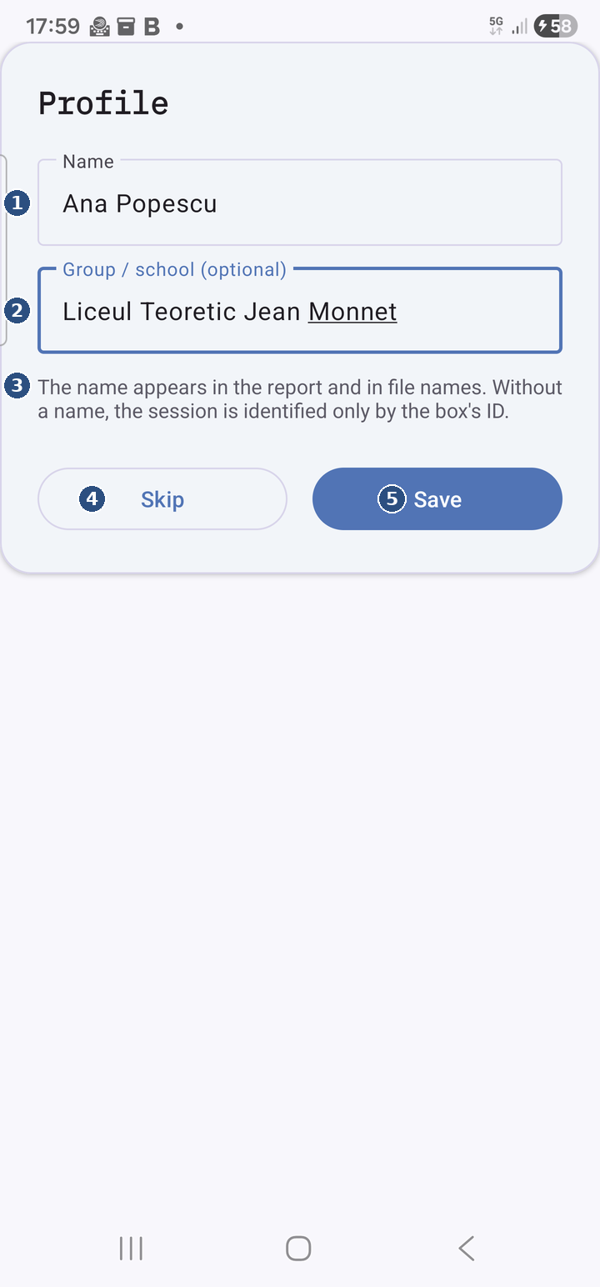
Who carries the phone. It opens at the app's first launch, from the top row of the Boxes tab, from Set profile on Point or, in short form, from new.
① Name — the pupil (or group) carrying the phone.
② Group / school — class or school; optional.
③ The explanation — the name goes into the report and the file names; without one, the day is identified by the box's ID only.
④ Skip — go on without a profile (not asked again at start).
⑤ Save — saves it; change it any time from Boxes (the pencil) or from new on Point.
- Name — the pupil's (or group's) name;
- Group / school (optional) — the class or school;
- Save — saves; Skip — leaves the profile blank and stops asking at launch.
Where the name appears: in the Point tab's header, in the top row of Boxes, on the PDF report's cover, in the Compare screen's legend and in file names (report_<day>_<Name>_<Class>.pdf, session_<day>_<BOX>_<Name>.zip). Without a name, files and the report carry only the box's code.

4.8 Compare (for the teacher)
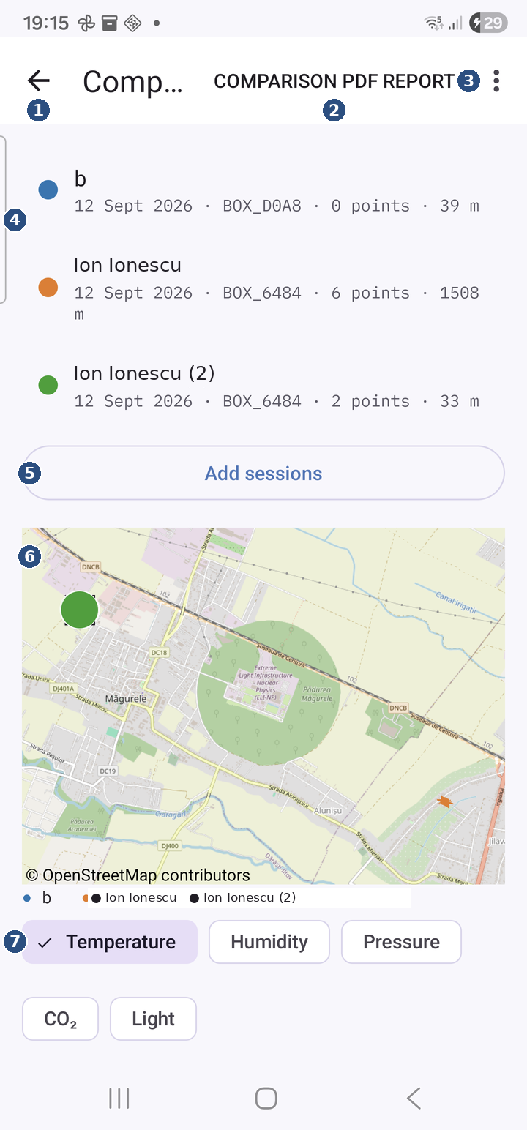
From Files → Compare. Puts up to 6 sessions — of different pupils — together on one map and one sensor at a time.
① Back — to the Files tab.
② Comparison PDF report — the comparison report with every loaded session.
③ The ⋮ menu — Clear all empties the list.
④ The loaded sessions — one per row with its colour, day, box, number of points and distance; swipe a row sideways to remove it.
⑤ Add sessions — pick the ZIPs the pupils sent (at most 6 sessions).
⑥ The map — everyone's route, each in its colour.
⑦ The compared sensor — tap a chip; below it, the table and chart by station or by time.
How sessions get in.
- Add sessions — pick one or more ZIPs received from the pupils (the ones made with Send all). A lone session_….json file is accepted too.
- Straight from WhatsApp (or any app): tap the ZIP and choose "Open with Field Box" — the session lands here directly.
- The empty screen says: No sessions loaded. Tap "Add sessions" and choose the ZIPs received from the pupils ("Send all"), or open a ZIP from WhatsApp with Field Box.
- A 7th session is refused: Maximum 6 sessions. — remove one first.
- A file that is not a session: x is not a Field Box session.; a broken one: Could not import x.
The session list. Every session has its own colour (the dot on the left), kept on the map, in the table and in the charts. On the row: the pupil's name (and group, if any) and <name> · <day> · n points · m m (the day, the number of reads, the metres walked); unknown day if the session has no known day. Swipe a row sideways to remove it; Session removed appears with Undo for a few seconds. ⋮ → Clear all deletes every imported session from the phone, after the confirmation Delete all sessions imported on this phone?.
The map. The routes, points (small circles in the pupil's colour) and photographs (black squares) of every session. Tap a point: <name> · <station> · <time>; tap a square: the photograph, large. Satellite view follows the setting on the Map tab.
The sensor. The chips Temperature, Humidity, Pressure, CO₂, Light pick the sensor compared. The choice is remembered.
The two modes (the toggle above the chart):
- By station (default) — a table with one column per pupil and one row per station: the mean of the Read readings at that station, ± the standard deviation, and n (how many reads). It works even if pupils walked on different days or different routes, as long as station names match. A bar chart shows the same data.
- By time — every pupil's 5-second series overlaid on a time-of-day axis. The axis is anchored to the first loaded session's day; anyone from another day is left out, with the reason under the chart: Ana — different day, Ana — unknown day, Ana — no data on this channel. If the sessions are not all from the same day, "By time" needs sessions from the same day. appears too.
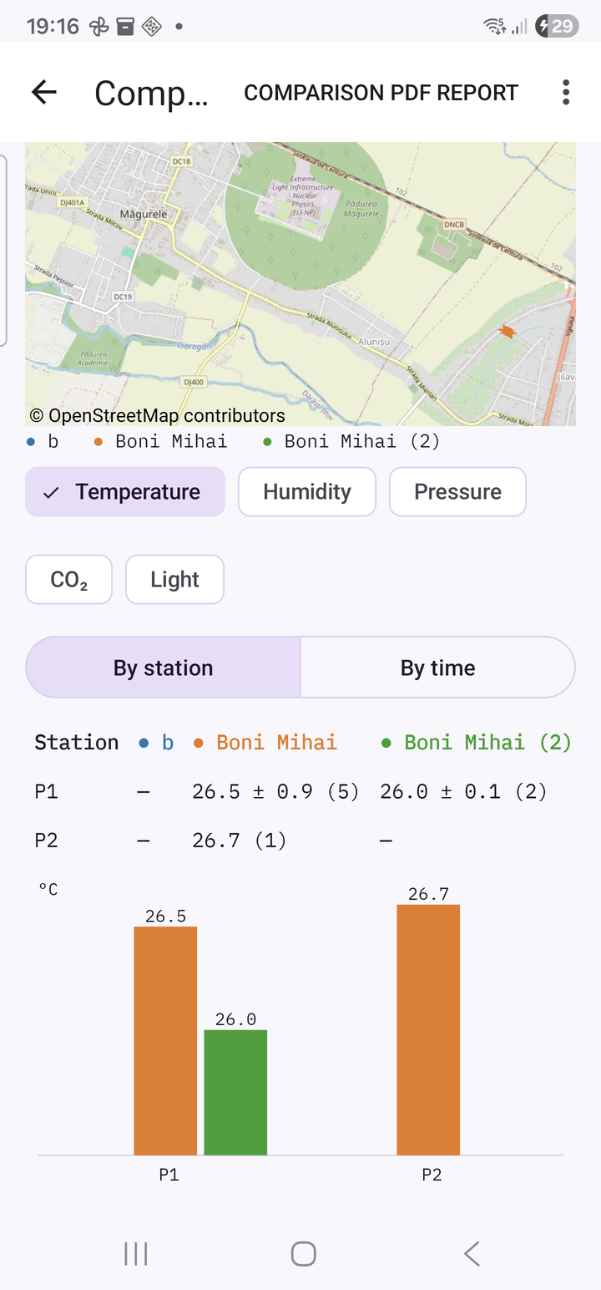
The By station mode
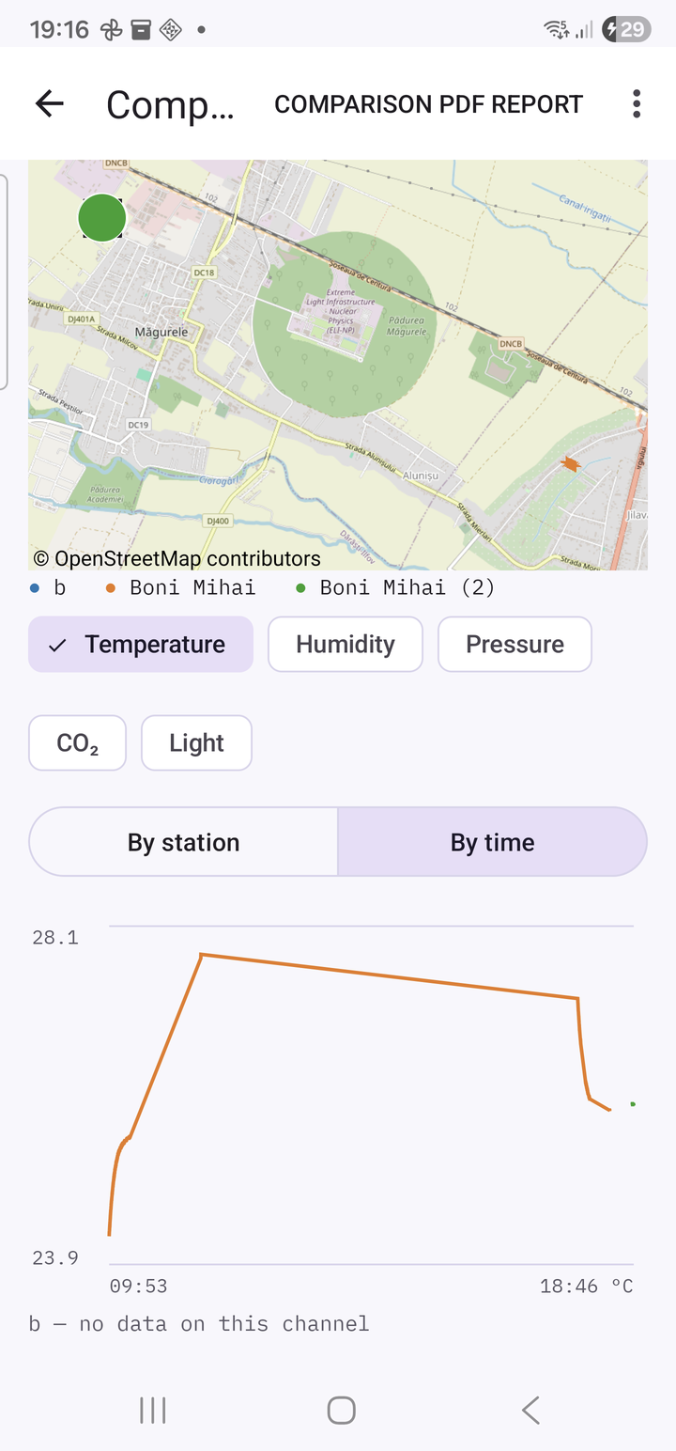
The By time mode
⋮ → Comparison PDF report. The comparison report (chapter 7). It saves and opens the share sheet: Report saved to Documents/FieldBox — opening the share menu. Without sessions: No sessions to compare.; on failure: Could not save the comparative report.
Imported sessions stay in Documents/FieldBox/compare/, so the comparison survives closing the app — but not an uninstall: after reinstalling, the ZIPs must be sent again.

4.9 The notification
While a recording is running (after Start), the notification bar holds a permanent notification, visible on the lock screen too:
- the title Field Box · 00:12:34 — the time elapsed since Start (measured by the box, so correct even after a pause of the phone);
- the text P3 next · CO₂ 812 ppm · 4 points — the current station, the CO₂ right now and how many reads were made today; or box disconnected if the box is not answering;
- the Read now button — a read at the current station in the list, exactly like the Read button on screen: its count grows, the phone vibrates. No need to open the app. Four taps at the same station are four reads at that station. The button is absent while the box is not answering;
- the Stop route button — stops only the phone's GPS route (the series and the notification); the recording stays on and the Done card does not appear. To end the walk use Stop on the Point tab.
The text refreshes every 5 seconds. The notification needs the Notifications permission (3.3).

4.10 The camera
Opens from the camera icon on the current row of the station list. The screen shows the camera preview and a single button, Take photo. There is no confirmation screen: if the shot is bad, take another. The back button closes the screen without a photo (except in the second the photo is being saved).
What happens on tap:
- the photograph is saved in the gallery, in the DCIM/FieldBox album, named <BOX>_<station>_<day>_<time>.jpg (for example BOX_3C3C_P3_20260916_103015.jpg; without a box, NOBOX_…);
- the GPS position and the time are written into the photo itself, so it places itself on a map in Google Photos or on a laptop;
- a row with the box, station, position, accuracy, date, time and file name is added to the day's photo list (photos_<day>.csv);
- the app confirms with Saved BOX_3C3C_P3_20260916_103015.jpg.
Messages: This device has no camera., Camera permission is needed to photograph a station., The photo could not be taken. Try again., The photograph was saved, but its manifest row was not: … (the photo is in the gallery, but will not appear on the map; note it down).

5. A field day, step by step
The day before:
1. Charge the box's powerbank and the phone.
2. Pair the phone with the box over Bluetooth, if not done yet (3.4).
3. Prepare the map, on Wi-Fi: open the Map tab at home and zoom/pan over the whole area you will walk (in the street or satellite view, whichever you will use). The parts seen stay saved; in the field, with no signal, they are still drawn. Areas never seen show grey — the route and the points are drawn regardless.
4. Fill in the profile (name and class) — it goes into the report and the file names.
5. Set the station plan if you use names other than P1 … P5: from edit (Station plan) or from a CSV with upload (4.6).
6. Grant the permissions to the app, if it has not got them yet (3.3).
In the field:
1. Power the box (USB-C plug into the powerbank). The LED stays on for 2 seconds: the sensors are ready. Put the box in the backpack, in an airy spot — not in a closed pocket, so the CO₂ sensor can breathe.
2. Open the app, the Point tab, and tap your `BOX_xxxx` in the Box card. The strip at the top turns green. (The first time, the Profile card: name and class, or Skip.)
3. Check on Boxes that the clock does not say (NOT SYNCED).
4. Get out under an open sky and wait for the pill to show GPS n m. From a cold start it can take 2–10 minutes; next to buildings, longer. It is not a fault. You can start without a fix too — it fills in on the way.
5. Start. The notification appears. Box in the backpack, phone in the pocket — within about 10 m of each other.
6. At every station: tap its row (it becomes current) → Read as many times as you like (wait for the buzz) → the camera if the station calls for a photo. Or, without opening the app: Read now from the notification. An unplanned station: Other station…
7. Glance at the strip at the top now and then: link poor or Reconnecting… = bring the box closer to the phone.
8. On return: Stop. The Done card appears.
9. Open Map once (so the map goes into the report), then Files → PDF report and Send all. Send the ZIP to the teacher (WhatsApp) or copy the folders to a laptop (chapter 6).
10. The next pupil with the same phone: new (or New walk (next pupil) on Done) → their name → Start over → from step 5.
The teacher, at home: collects the class's ZIPs in Files → Compare (or opens them straight from WhatsApp with Field Box), picks the sensor and the mode, then ⋮ → Comparison PDF report.

6. The files

6.1 Where they are
Everything the app saves on the phone goes into a folder named after the day, so a day is easy to find and to copy or delete in one go:
What | Where
a day's files (points, track, series, photo list, session bundle, ZIP, report, logs downloaded from the box, that day's comparison PDF) | Documents/FieldBox/<yyyy-MM-dd>/ — e.g. Documents/FieldBox/2026-09-16/
the photographs | DCIM/FieldBox/ — visible in the Gallery
days archived with Start clean | Documents/FieldBox/archive/<yyyyMMdd>_<HHmm>/
sessions imported into Compare | Documents/FieldBox/compare/
the plan template and a comparison PDF of mixed days | Documents/FieldBox/ (the root)
At the first launch of version 0.8.0, files left by earlier versions directly in Documents/FieldBox are moved, once, into their day folders (by the date in each file's name). Files with no date in their name stay at the root. If a file could not be moved, the app tries again at the next launch.

6.2 Every file type
Every CSV file has a first line with the column names, a comma as separator and a dot as decimal separator — they open directly in Excel or LibreOffice.
The points (the phone's copy) — points_phone_<yyyyMMdd>.csv, one row for every Read that day. Columns: date,time,station,lat,lon,temp_C,rh_pct,press_hPa,alt_m,co2_ppm,temp_scd_C,rh_scd_pct,light_lux — date, time, station, latitude/longitude (empty without GPS), temperature, humidity, pressure, estimated altitude, CO₂, the temperature and humidity measured by the CO₂ sensor, light. The map and the report are made from this file. (After a reinstall of the app, variants points_phone_<day> (1).csv may exist too; all are read.)
The track — track_<yyyyMMdd>_<HHmmss>.csv (the time in the name = the time of Start), one row for every accepted GPS fix (every 5 seconds, if it moved at least 3 m and the accuracy is under 100 m). Columns: date,time,lat,lon,accuracy_m. A second Start on the same day makes a second file.
The phone's series — log_phone_<yyyyMMdd>_<HHmmss>.csv, the box's values read by the phone every 5 seconds between Start and Stop; the same columns as the points (station = the one set on the box). Gaps left by a link drop fill themselves from the box's memory when the link comes back.
The photo list — photos_<yyyyMMdd>.csv, one row per photograph. Columns: box,station,lat,lon,acc_m,date,time,filename.
The photographs — <BOX>_<station>_<yyyyMMdd>_<HHmmss>.jpg in DCIM/FieldBox, with the position and time written into the file.
The box's log (downloaded) — BOX_xxxx_log_<yyyyMMdd>_<HHmmss>.csv (on the box it is called log_<day>_<time>.csv; on download it gets the box's name in front). One row every 5 seconds from power-up; the same 13 columns as the points. The station column holds >REC at Start, <REC at Stop and the station's name on the row after a Read; otherwise it is empty.
The box's points (downloaded) — BOX_xxxx_points_<yyyyMMdd>.csv, one row for every Read the box accepted, the same columns. This is the official record; the phone's copy is for the map.
The session bundle — written at Stop: session_<yyyyMMdd>_<BOX>_<Name>.json (a summary: profile, box, plan, span, track, series, points, photos, distance) and session_<yyyyMMdd>_<BOX>_<Name>.gpx (the route, importable into Strava, Google Earth, QGIS). <Name> is the last word of the name, without diacritics; without a profile it is absent.
The report — report_<yyyyMMdd>_<Name>_<Class>.pdf (without a profile: report_<yyyyMMdd>_<BOX>.pdf). Contents: chapter 7.
The ZIP (Send all) — session_<yyyyMMdd>_<BOX>_<Name>.zip, holding: session.json, route.gpx, report.pdf (the report, under this fixed name), photos/ (the day's photographs) and box_log/ (the box's raw logs for that day).
The comparison report — comparison_<yyyyMMdd>_<HHmm>.pdf in the day folder (when every session is from the same day) or comparison_mixt_<HHmm>.pdf at the root.
The plan template — plan_model.csv at the root: P1 … P5, one station per line, no header.

6.3 How to copy a day to a laptop
Connect the phone to the laptop with the USB cable (choose "File transfer" on the phone) or use Google Drive / My Files. Copy the folder Documents/FieldBox/<day>/ and, for the photos, DCIM/FieldBox/. Or, simpler, send the ZIP from Send all — it holds everything, photos and box log included.

6.4 How to delete a day
On the phone, in My Files: delete the folder Documents/FieldBox/<day>/ (and the photos in DCIM/FieldBox, if you wish). The app has no button for deleting files from the phone; it only has Start clean (moves them to archive/) and Delete on Files (deletes from the box, not from the phone). Delete from the box only after the day's log has been fetched (PDF report or Send all with the box connected).

7. The reports

7.1 PDF report (the report of a day)
Made from Files → PDF report (today), Files → Another day… (another day) or from the Done card (without the map). A4 format. Sections without data are simply absent.
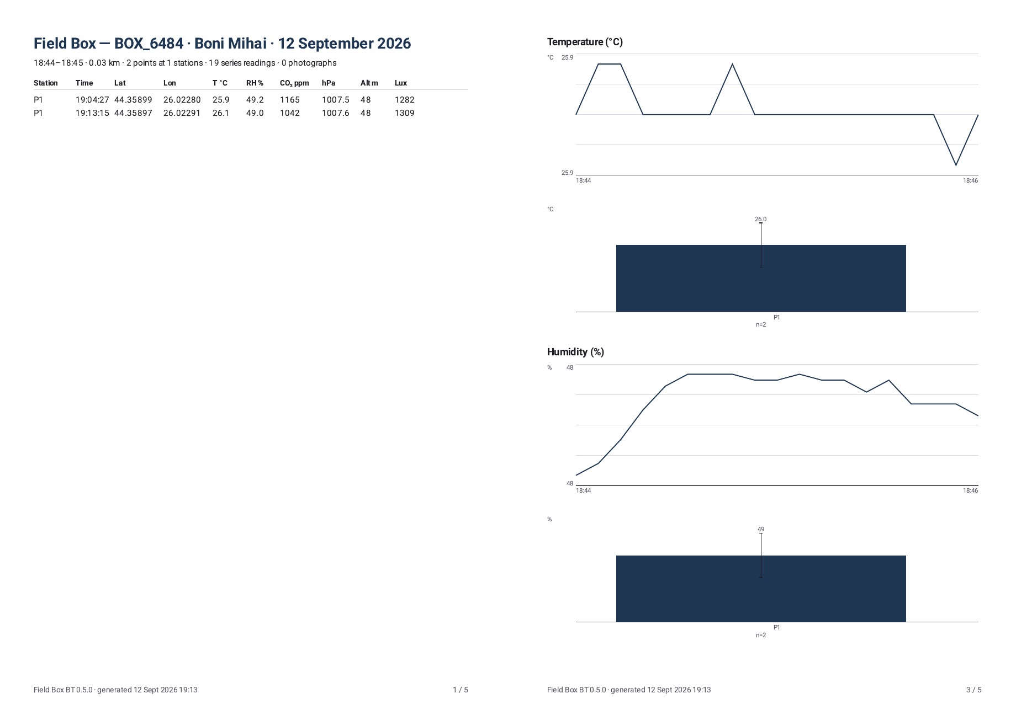
A page of the single-pupil PDF report
1. The cover. The title Field Box — BOX_xxxx · <Name> · <date>, a summary line built only from what exists (10:29–12:41 · 1.84 km · 12 points at 5 stations · 1590 series readings · 3 photographs · box log 08:02–15:47 · 5570 readings), the EASE mark, the map as last seen on the Map tab and, below, the first rows of the points table.
2. The points table. One row per Read: Station, Time, Lat, Lon, T °C, RH %, CO₂ ppm, hPa, Alt m, Lux. It continues on following pages (28 rows per page).
3. `Summary by station (mean ± standard deviation, n = readings)`. One row per station, one column per sensor: the mean of the reads at that station, ± the standard deviation, and the number of reads. Present when there are points.
4. The chart pages — Values over the whole period: for every sensor, the trend over the whole period (from the phone's series) with the station moments marked, plus the per-station bars with error bars; two sensors per page. These pages appear only when the box's log is not on the phone (otherwise the Box day charts replace them).
5. Box day (when the box's log is on the phone; one set per box): the page Box day — BOX_xxxx · <date> · 08:02–15:47, with the day's colour bar (every 5 seconds coloured by its CO₂ band), the curve CO₂ (ppm) over the day on the lesson's bands, the band legend (plus Recording = the grey span between Start and Stop), the day's facts (Highest CO₂ … ppm at hh:mm · lowest … ppm at hh:mm, Air was excellent or good n % of the logged time · … with the episodes over 1200 ppm, Warmest … °C at hh:mm · coolest …, Brightest … lx at hh:mm, Pressure …–… hPa) and a table Channel · min (at) · max (at) · mean · median · sd · n; the 24 h chart pages, two sensors per page, with the recording span shaded (shaded = recording hh:mm–hh:mm); the `Data quality — BOX_xxxx` page: Coverage hh:mm–hh:mm · n rows · n % of the day, Gaps: … (the gaps, with their length), Restarts: … (the box's restarts), Files: … (the source files), Firmware … · Field Box BT 0.8.0. On a day with no points and no map, the Box day page becomes the cover itself.
6. The photographs, 6 per page, each with the station, the time and the matched reading printed underneath (the nearest point or, failing that, the series row within 5 minutes).
The footer of every page: Field Box BT 0.8.0 · generated <date time> and the page number.

7.2 Comparison PDF report
From Compare → ⋮ → Comparison PDF report.
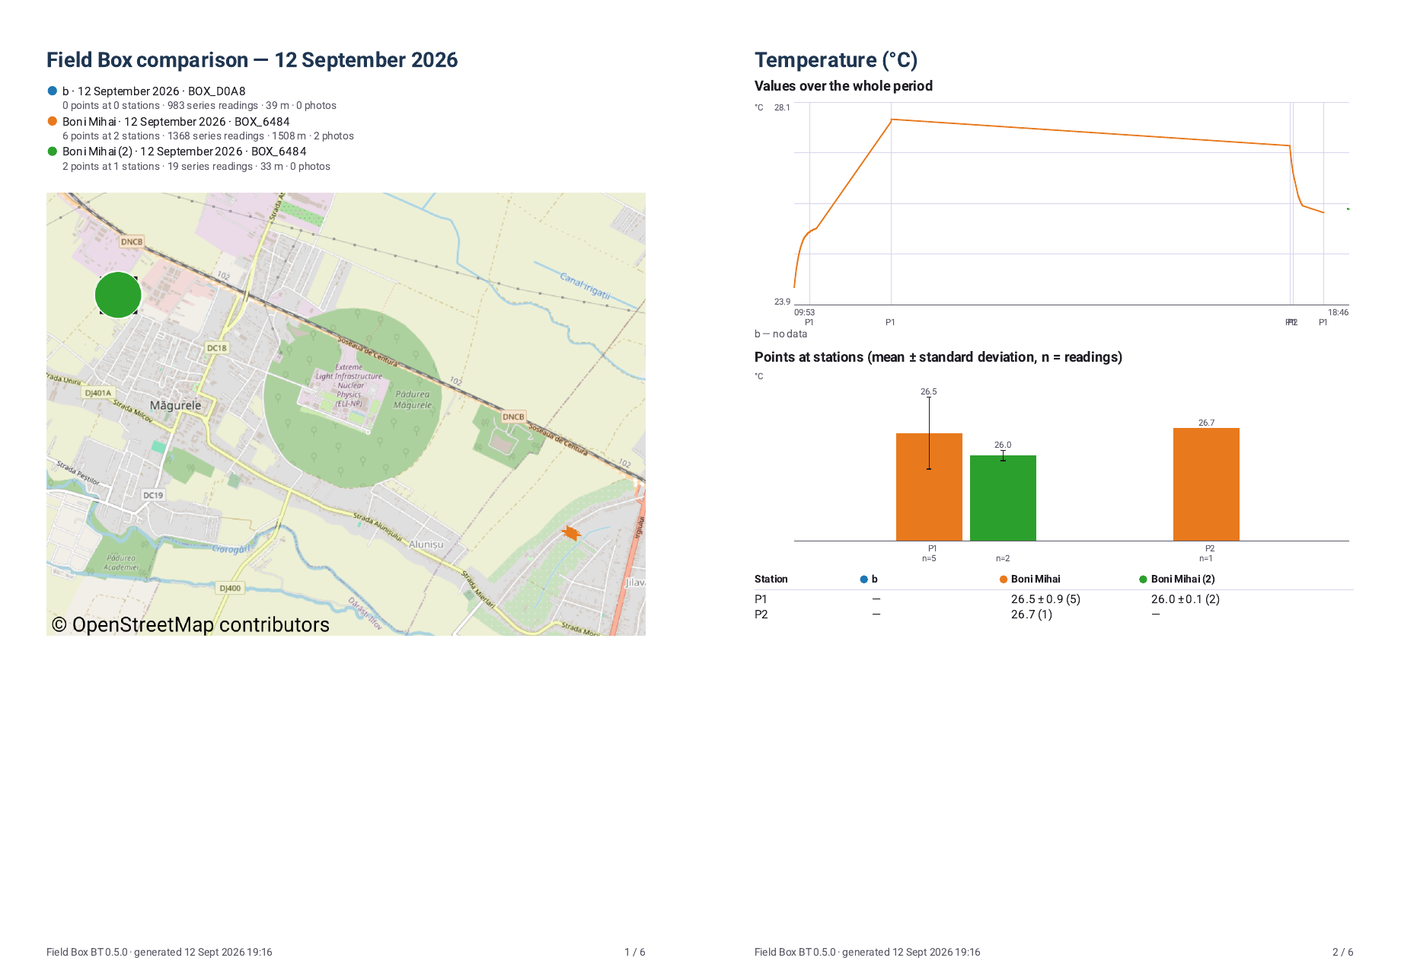
A page of the comparison PDF report
1. The cover Field Box comparison — <day> (or different days) with the legend (colour, pupil, day, box; points, readings, metres, photos per pupil) and the map with every route.
2. One page per sensor (Temperature, Humidity, Pressure, CO₂, Light): Values over the whole period — every pupil overlaid on the time axis (anchored to the first session's day; the others are left out, with the reason) — and Points at stations (mean ± standard deviation, n = readings): the table and the per-station bars.

7.3 The ZIP (Send all)
One file to hand to the teacher: session.json, route.gpx, report.pdf, photos/…, box_log/… (6.2). Made from the Done card or from Files; with the box connected it first fetches the day's log. The Compare screen reads exactly this ZIP.

8. Troubleshooting

8.1 The box and the link
What you see | Probable cause | What to do
the box is missing from Choose a box / the Box card | it was never paired with this phone | Settings → Bluetooth → Pair new device → `BOX_xxxx` (the box must be powered), then back to the app
No paired box found. … | same, no box paired at all | the Bluetooth settings button in the message
BOX_xxxx does not appear even in Bluetooth settings | the box is not powered, or already connected to another phone | check the red light; disconnect the other phone (Disconnect)
The box is not answering. Check it is switched on and within a few metres, then tap Connect again. | the box is off, too far, or busy with another phone | come within a few metres, check the power, tap Connect to a box again; if it persists, unplug and replug the box's cable
Bluetooth is switched off on this device. … | the phone's Bluetooth is off | turn it on in the quick settings
Could not connect. Try again; if it keeps failing, switch the box off and on. | a passing error | once more; then the box unplugged and plugged back in
Bluetooth permission is required to talk to the box. … | the Nearby devices permission is missing | Settings → Apps → Field Box BT → Permissions
Reconnecting to BOX_xxxx… / Link to the box dropped — reconnecting… | the link dropped (range, an obstacle) | nothing — the app restores it by itself; bring the box closer; the box keeps logging meanwhile
🟠 link poor often | at the edge of range (~10 m), the box in a metallised pocket, the phone in another bag | the box in the backpack of whoever holds the phone
🟣 link none for more than a few seconds | the link was just made and is not answering | wait; if it stays, Disconnect and reconnect
the link drops every few minutes | the phone is saving power | turn off battery optimisation for Field Box BT in Android settings; leave the link notification in place
the clock says (NOT SYNCED) | the box has just started and has not received the time | Disconnect, then connect again; if it persists, the box's cable out and in
Recording: no although you pressed Start | the box was restarted (cable) after Start | press Stop, then Start
the box's LED does not light at all | no power, loose cable, flat powerbank | push the plug in; another cable / another powerbank
the LED blinks very fast | storage full | see 8.6

8.2 GPS and the route
What you see | Probable cause | What to do
the pill says no GPS for minutes, outdoors | a cold start of the receiver | open sky, away from buildings, screen on on Point; 2–10 minutes; not a fault; you can work anyway (reads are saved without coordinates)
no GPS indoors | there is no GPS signal inside buildings | normal; reads work, without coordinates; the map shows n points with no GPS do not appear on the map
the amber pill GPS n m (weak) | accuracy over 15 m | usable; it improves while walking under an open sky
Location is switched off on this device. … | the phone's Location is off | turn it on in the quick settings
Location permission refused. … | you refused the permission | Settings → Apps → Field Box BT → Permissions → Location → Allow (precise)
Route: not running — check the Location permission… | the permission was missing at Start | tap the message, grant the permission, then Stop and Start
Route: not running on the phone (the box is recording) — tap here… | the app was updated or closed by Android during the walk | tap the message: the route resumes in a new file; nothing lost on the box
Route: no point yet · n GPS fixes rejected (last ±x m, limit 100 m) | the positions received are too inaccurate (indoors, a closed courtyard) | go to open ground; it resolves by itself
Route: n points · m skipped (weak GPS) keeps growing | indoors, under dense trees, standing still | normal; "skipped" is not lost data but rejected positions
Route: off — this device has no GPS receiver | a tablet without GPS | there will be no route; Read, Stop, report and ZIP still work
the route has "jumps" on the map | inaccurate positions accepted (up to 100 m) | normal next to tall buildings; the curve passes through every accepted position

8.3 Reads, stations, photographs
What you see | Probable cause | What to do
Start is greyed out | no box connected, or you are working without a box | connect the box (the Box card or the Boxes tab)
Read is greyed out | same | same; photographs work anyway
The clock is not set yet. at Start | the box has no time | Disconnect and reconnect (the time is sent on connection)
The storage is full. at Start | the box's storage is full | see 8.6
The box refused the request. | the box answered with an error | reconnect; if it persists, the box's cable out and in
Could not reach the box. at Start or Read | the link dropped just then | wait for the reconnection (green strip at the top), tap again
The box could not record this point — check the clock is synced and there is free storage. | the box refused the Read: clock not set or storage full | check the clock and Free storage on Boxes
Stop does not appear | the recording is not running (Start was not pressed or was refused) | press Start; watch the status line for a refusal
Stop does not appear on a tablet without GPS | — | in 0.8.0 Stop works without GPS too; if it is missing, see the case above
a station's count does not grow after Read now from the notification | the box was not answering (box disconnected) at that moment | the Read now button is absent while the box is not answering; try again when the notification shows CO₂ again
Read now from the notification counted at another station | the current station in the list was another one | tap the row of the station you are at before Read now
the notification is missing | the Notifications permission was refused, or the recording is not running | grant the permission; press Start
Camera permission is needed to photograph a station. | the Camera permission is missing | from Settings → Apps → Field Box BT
The photo could not be taken. Try again. | the camera is busy with another app or failed | close other camera apps; try again
The photograph was saved, but its manifest row was not: … | the photo is in the gallery, but could not be added to the day's list | note the station and time; the photo will not appear on the map/report
on the map, a photo shows the photo was not found | the photo was deleted or moved out of DCIM/FieldBox | look for it in the gallery; put it back into DCIM/FieldBox
a station added by mistake with Other station… | — | long press on the row → Remove (its reads stay in the files)
values show – on Live / in a bubble | the sensor has not produced a value yet (CO₂ needs a few seconds after power-up) or a sensor is not answering | wait 30 s; if one sensor stays – all day, note it for the technician
the arrows are missing (only …) | the first 40 s after connecting, or the link had a gap | wait; they come back by themselves
the Live charts stay at waiting for data | the box has firmware older than 0.3.1-bt, or you have just connected | a few seconds; if it persists, the box needs an update (technician) — values and reads work anyway
a Field Box dialog with a cheerful message | you passed 1/5/10/20/40 reads today | tap OK; it affects nothing

8.4 The app, updates, crashes
What you see | Probable cause | What to do
the app closed suddenly (crash) during the walk | — | reopen it; the data is on disk: every Read, every position and every photo is written to the files immediately. If Live shows Route: not running on the phone…, tap the message
after an app update the counts are at zero | the on-screen counts belong to the current day; an update can reset them | the files are intact; the map and the report show every read; tap the Route message on Live so the route resumes
on a new day the station list is at zero | normal: counts are per day | nothing
the phone drains fast | GPS every 5 s + permanent Bluetooth + the screen on | screen off in the pocket (Read now from the notification); lower brightness; a powerbank for the phone on long walks
the notification Field Box — connected to BOX_xxxx does not go away | normal while the box is connected | Disconnect on Boxes if you want it gone
the app asks for permissions again at launch | one of them is missing | grant it; Android stops asking after several refusals — then from Settings

8.5 Files and reports
What you see | Probable cause | What to do
the files are not where I expected (directly in Documents/FieldBox) | since 0.8.0 every day has its own folder | look in Documents/FieldBox/<yyyy-MM-dd>/; old ones were moved there automatically
today's map / report are empty although I measured | you pressed Start clean — the files are in archive/ | copy them back into the day folder in My Files, or make the report on a laptop from the archive
Nothing to report yet. / Nothing to report for <day>. | no points, no series, no photos and no box log for that day | connect the box (the report fetches the log) or pick another day
Another day… shows Nothing on the phone to report yet. | no day with points, series or a box log | connect the box and make a PDF report — it fetches the day's log
Another day… does not list a day I only have a track for | tracks and photos alone do not make a day "with data" | was Send all done that day? The ZIP has everything
The report could not be created | not enough space on the phone, or a broken file | free up space; try again; if it persists, copy the day folder to a laptop
The package could not be created (Send all) | same | same
the report has no map | the report was made from the Done card, or Map was not opened today | open Map, then Files → PDF report
the report has no Box day pages | the box's log is not on the phone | make the report with the box connected; phone next to the box while it downloads
Downloading the box log… takes long | Bluetooth is slow: a whole day is a few hundred kB | ~20 s; keep the phone next to the box
This file is being recorded — stop the recording first. | you tried to delete the open log | Stop on Point, then Delete
Could not delete the file. | the box did not answer | Refresh, once more
Deleted — the box opened a fresh log (it logs whenever it is powered). | you deleted the current log; the box opened another | normal
Send all does not open WhatsApp | the share sheet was dismissed | Package saved → Send; or find the ZIP in the day folder
Plan “x” loaded: 1 stations although the file had many | the file was saved with another separator (tab) | save from Excel as CSV (comma), or one station per line
No stations found in x.csv. | an empty file or header only | fill in one station per line
Could not read the file. | the file could not be opened from the source app | copy it into My Files first

8.6 The box's storage
What you see | Probable cause | What to do
n kB free on the box — running low; download and delete old files on Files | under 300 kB free | make a PDF report or Send all (fetches today's log), then Files → Delete on the old logs
n kB free on the box — full; the box has stopped logging / The storage is full. / very fast LED | no space and no old logs to delete | download and delete on Files; or delete an old points file (they are never auto-deleted); the box resumes its log by itself once there is room
old logs vanished from the box | the box deletes its oldest log by itself below 100 kB free | normal; download logs in time (the day's report)
the box's files vanished after a firmware update | the update from 0.2.0-bt to 0.3.x reformats the storage | expected; download everything before updating

8.7 Compare
What you see | Probable cause | What to do
Maximum 6 sessions. | a 7th session | swipe one out of the list (or Clear all)
x is not a Field Box session. | the file is not a ZIP from Send all or a session_….json | ask for the right ZIP
Could not import x. | a broken or incomplete ZIP (WhatsApp truncated it) | have it sent again
Ana — different day under the By time chart | the session is from another day than the first loaded | normal for By time; use By station for cross-day comparisons; or load the session from the wanted day first
Ana — unknown day | an old bundle, with no day | By station works
Ana — no data on this channel | that session lacks the chosen sensor | pick another sensor
"By time" needs sessions from the same day. | mixed days | same
the sessions vanished after a reinstall | the compare/ folder belongs to the app | send the ZIPs again

8.8 How to start over
What you want | What to do | What is lost
another pupil, same day, same files | new → Start over | only the on-screen counts
a new session on the same day, with an empty map | Map → ⋮ → Start clean | nothing: the files go to archive/
deleting a day from the phone | My Files: the folder Documents/FieldBox/<day>/ | that day (irreversible)
an empty box for tomorrow | Files → Delete on every file (after downloading) | the files on the box (irreversible)
the app as new | uninstall + reinstall | the profile, the plans, the Compare sessions; the files in Documents/FieldBox and the photos stay
If the link keeps dropping, note what Link drops says (long press on the versions line, Boxes tab) before restarting anything — that list is the evidence for the technician, together with the App v… · firmware v… line.

9. Specifications
Sensors | BME280 (temperature, humidity, pressure, estimated altitude), SCD41 (CO₂), VEML7700 (light)
The box's log | one row every 5 s, from power-up; a new file at every power-up and at midnight
The box's points | one row per Read; one file per day; never auto-deleted
The box's storage | ~2.5 MB (~150 h of log); below 100 kB free it deletes the oldest log; the app warns below 300 kB
History for Live | the last 50 minutes (600 samples at 5 s), sent on connection
The phone's series | one row every 5 s between Start and Stop; gaps filled from the box's history
GPS | one fix per second for the pill; the track at 5 s, accepted if accuracy ≤ 100 m and movement ≥ 3 m; pill green ≤ 15 m, amber above
Read | instant: the values at that moment + the latest GPS fix
Trend arrows | mean of the last 10 s against the mean 30–40 s ago; dead bands 30 ppm / 0.2 °C / 1.5 % / 0.5 hPa / 10 lx or 20 %; unknown for the first ~40 s
Link quality | the last 10 answers: good median < 0.3 s; poor one answer > 1 s or missing; ok otherwise
CO₂ bands | < 800 Excellent · 800–1200 Good · 1200–2000 Moderate · 2000–5000 Poor · ≥ 5000 Dangerous
Temperature bands | < 5 Cold · 5–15 Cool · 15–28 Comfortable · 28–35 Hot · ≥ 35 Very hot (°C)
Bluetooth | Bluetooth Classic (serial port); name BOX_xxxx; practical range ~10 m; paired once
The box's clock | no battery; set by the phone on connection; at most one hour of rows kept until set
LED | solid 2 s at boot = sensors OK; 0.5 s blink = recording; 0.1 s blink = storage full
Android | 10 or newer; Location (precise), Bluetooth/Nearby devices, Camera, Notifications
Files | CSV (comma, decimal point, header), JSON, GPX, PDF (A4), ZIP, JPG with position in EXIF
Folders | Documents/FieldBox/<yyyy-MM-dd>/, archive/, compare/; DCIM/FieldBox
Compare | at most 6 sessions; By time needs the same day
Plans | at most 200 stations from a CSV; duplicate names removed
Versions | app 0.8.0; firmware 0.3.1-bt
Compatibility | 0.2.0-bt boxes work: the log runs only between Start and Stop, and the Live charts may stay empty; updating to 0.3.x reformats the box's storage (download everything first)

10. Glossary
- Box — the logger with sensors, BOX_xxxx.
- Station — a pre-arranged place where the group stops and reads; it has a name (P1, P2 … or any text).
- Plan (station plan) — the ordered station list of a walk; it has a name; Standard plan = P1 … P5.
- Walk — one pupil's pass along the route, from Start to Stop; new begins the next walk.
- Read — one press of Read (or Read now): all the sensor values at that moment, plus the GPS position, at the current station.
- The current station — the highlighted row of the list; Read and Read now go there.
- Point — a read, as it appears in the files, on the map and in the report.
- Series — the values taken automatically every 5 seconds (the phone's: between Start and Stop; the box's: all the time).
- Log — the box's continuous file, one row every 5 seconds.
- Track / route — the GPS positions recorded by the phone every 5 seconds.
- GPS fix — one determination of the position by the GPS receiver, with an accuracy in metres.
- Session — everything that came out of one day (track, points, series, photos), summarised in session_….json.
- Bundle / ZIP — the file from Send all, with everything belonging to the session.
- Day folder — Documents/FieldBox/<yyyy-MM-dd>/.
- Archive — the folder Start clean moves a day's files into.
- Day report — the PDF with points, map, charts and the Box day pages.
- Box day — the report pages made from the box's continuous log.
- Link — the phone–box Bluetooth connection; good / ok / poor / none.
- Drop — an interruption of the link, restored automatically.
- NOT SYNCED — the box's clock has not yet been set by the phone.
- Pairing — the one-time Bluetooth pairing, from the phone's settings.
- Band — a range of values with a name and a colour (Excellent … Dangerous; Cold … Very hot).
- ppm — parts per million (CO₂); hPa — hectopascal (pressure); lx — lux (light).
- Manifest (photos list) — the file photos_<day>.csv that links every photo to its station and position.

11. Field card (one-page summary)
1. Box powered → red light, LED solid 2 s → into the backpack.
2. Point tab → tap your BOX_xxxx (first time: the profile or Skip) → green strip at the top. On Boxes: the clock without (NOT SYNCED).
3. Box in the backpack, phone in the pocket — within ~10 m.
4. Outside, under an open sky, until the pill reads GPS n m (2–10 min from cold).
5. Start. The notification Field Box · 00:00:00 appears.
6. At every station: tap its row → Read (as often as you like; wait for the buzz) → the camera if needed. Or Read now from the notification, without opening the app. An unplanned station: Other station…
7. link poor / Reconnecting… → bring the box closer to the phone.
8. On return: Stop → the Done card.
9. Map (once) → Files → PDF report → Send all → the ZIP to the teacher (WhatsApp), or copy Documents/FieldBox/<day>/ and DCIM/FieldBox to a laptop.
10. The next pupil: new → their name → Start over → from step 5.
11. Box storage running low (running low): report made, then Files → Delete on the old logs.
12. The teacher: Files → Compare → Add sessions (the class's ZIPs) → ⋮ → Comparison PDF report.

