Install guide — Field Box BT
App v0.8.0 · box firmware 0.3.1-bt

1. What you need
- An Android 10 or newer phone, with GPS and Bluetooth.
- The install file `fieldbox-bt-<version>.apk` (for example fieldbox-bt-0.8.0.apk).
- A Field Box with firmware 0.3.1-bt (older boxes on 0.2.0-bt still work, but without continuous background logging — see §5).

2. Installing the APK on the phone
The app is not on the Play Store; it is installed from an APK file sent by the coordinator. The steps below are from a Samsung phone on Android 14–16; on other phones the wording may differ slightly, the order is the same.
1. Get the file fieldbox-bt-<version>.apk onto the phone — via WhatsApp, a USB cable or Google Drive.
2. Received on WhatsApp: tap the file right in the chat (the first tap downloads it, the second opens it) — no need to go to Downloads; continue with step 3. Received another way: open My Files → Downloads and tap the file.
3. If an "Open with" window appears, choose Package installer (not Field Box BT — that is the app already installed, not the installer).
4. At "Do you want to install this app?" tap Install. The first time Android may ask to allow installs from that source (WhatsApp or My Files): a settings screen with "Allow from this source" appears — switch it on, go back and tap the file again.
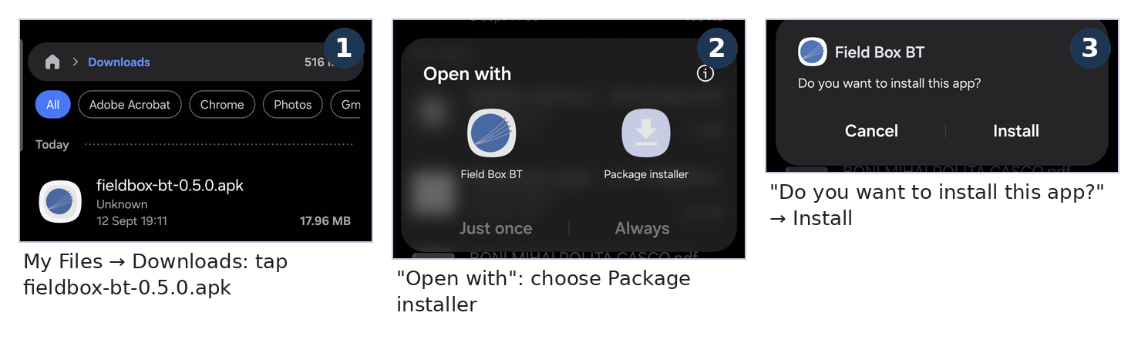
Steps 2–4
5. Google Play Protect — "App scan recommended" appears: the app is not from the Play Store, so Google does not know it. Tap Scan app; the scan takes a few seconds. Without internet, tap More details → Install without scanning.
6. At "This app looks safe" tap Install.
7. At "App installed" tap Open.
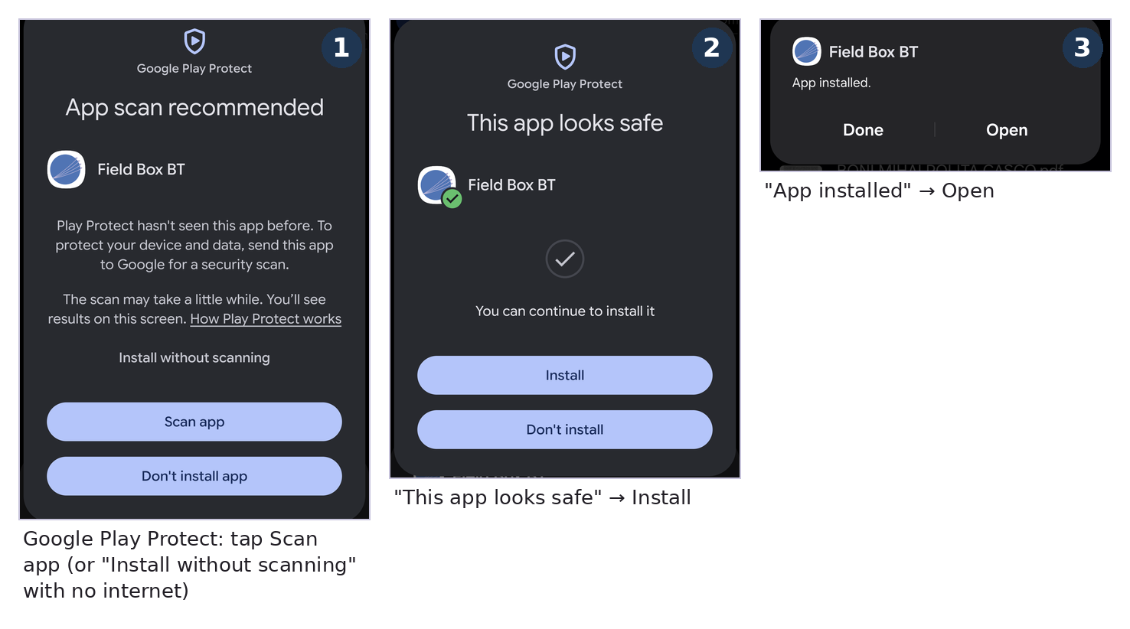
Steps 5–7
The app appears on the phone as Field Box BT. A newer version is installed the same way, over the old one — the profile, files and bundles on the phone stay. The installed version is shown on the Boxes tab, under the connection status (App v0.8.0 · firmware v…).

3. First launch
On first open the app asks, in turn:
1. Profile — the pupil's/teacher's name and class/school (optional). They appear in the report and in file names. Tap Save, or Skip (the session is then identified by the box code only). Can be changed any time with edit on the Boxes tab.
2. Camera — "Allow Field Box BT to take pictures…" → While using the app (for the station photos).
3. Location — choose Precise (not Approximate!) and While using the app. Without "Precise" the route cannot be recorded.
4. Notifications → Allow (the permanent notification shows the link state and has the Read now button).
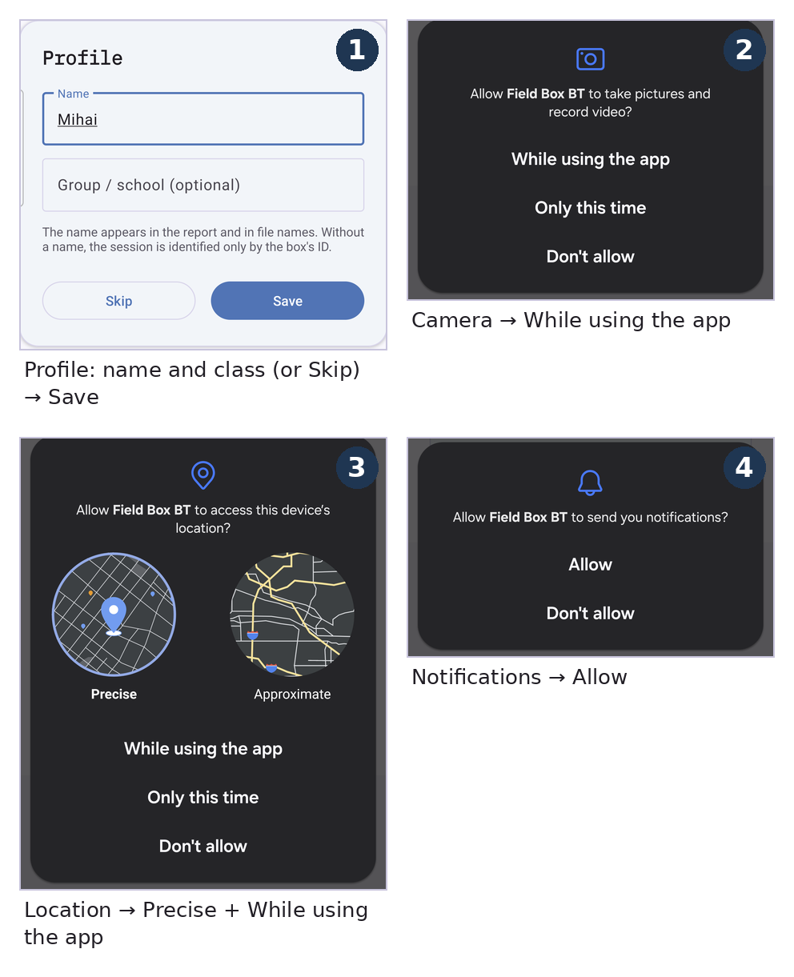
First launch: profile and permissions

Bluetooth pairing (once, per phone and box)
The box must be paired with the phone before the app can see it.
1. Power the box (the LED blinks). On the phone: Settings → Bluetooth (or long-press the Bluetooth icon in the quick settings).
2. Under Available devices the box appears as BOX_xxxx (the code on its label) — tap it.
3. At "Bluetooth pairing request — Pair with BOX_xxxx?" tap Pair. No PIN is asked. The box moves to "Paired devices"; the pairing is kept.
4. In the app, Boxes → Connect to a box. The first time Android asks for the Nearby devices permission → Allow.
5. In the Choose a box window tap BOX_xxxx. Within a few seconds the strip at the top turns green: BOX_xxxx · link good, and the card shows the box's firmware and clock (synchronised automatically).
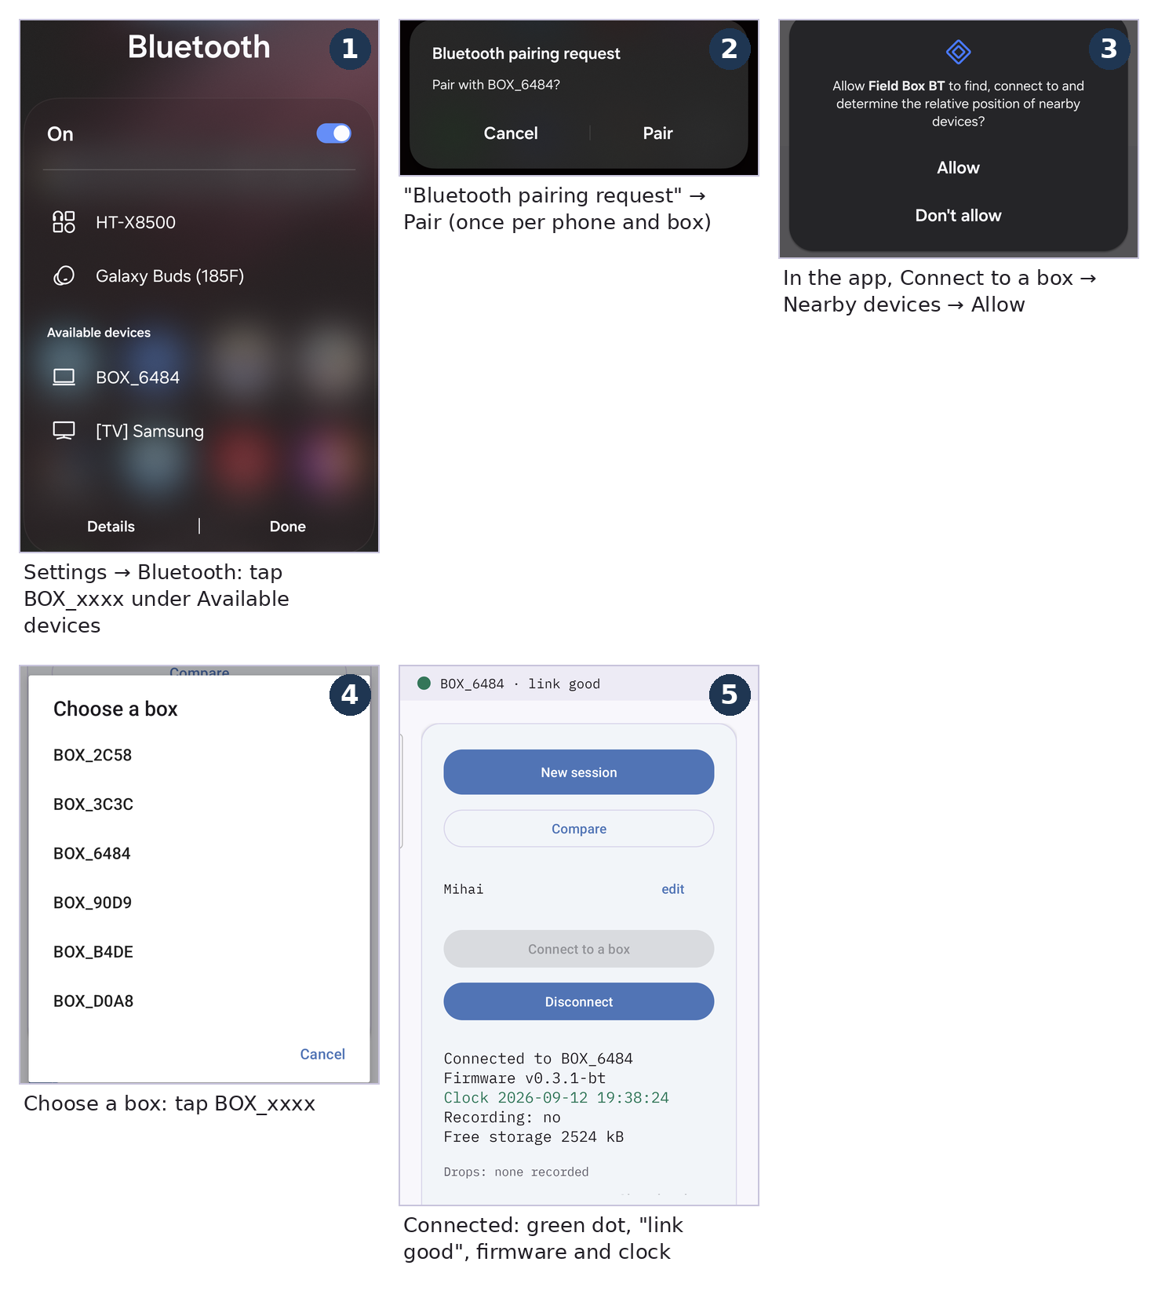
Bluetooth pairing and the first connection

4. Quick check
Before heading out to the field, verify:
- The Live tab shows sensor values (not blank) once connected.
- The Point tab, held outdoors for 1–2 minutes, reaches a GPS fix (the pill turns green).
- The Map tab shows map tiles (not just grey), if the area has had signal at some point.

5. Updating the box (firmware) — for the technician only
This step is not for teachers — it is for whoever maintains the boxes. The box's program (the firmware) is written from a Windows computer, over the USB cable, with the Arduino IDE. Every step below has a picture: the red frame shows where to click, and the mouse arrow rests on it.
First of all: get the data off the box. The first boot after a firmware flash reformats the box's storage. In the app, Files tab: Download on each row, or PDF report (which fetches the day's log by itself). Anything still on the box is erased.

5.1 What you need
- A Windows 10/11 computer with internet access (for the one-time setup only).
- Arduino IDE 2, free from arduino.cc → Software, installed with the default options.
- A USB data cable (not a charge-only one) for the board inside the box. If Windows does not see the board, install the CH340 driver (search for "CH340 driver" on the maker's site, WCH).
- The `firmware/fieldbox_bt_v0_3` folder from the FieldBox package (the unzipped ZIP, e.g. in Downloads). It holds two files, `fieldbox_bt_v0_3.ino` and `partitions.csv`; keep them together.

5.2 Setting up the Arduino IDE (once per computer)
1. Open the Arduino IDE and click the File menu.
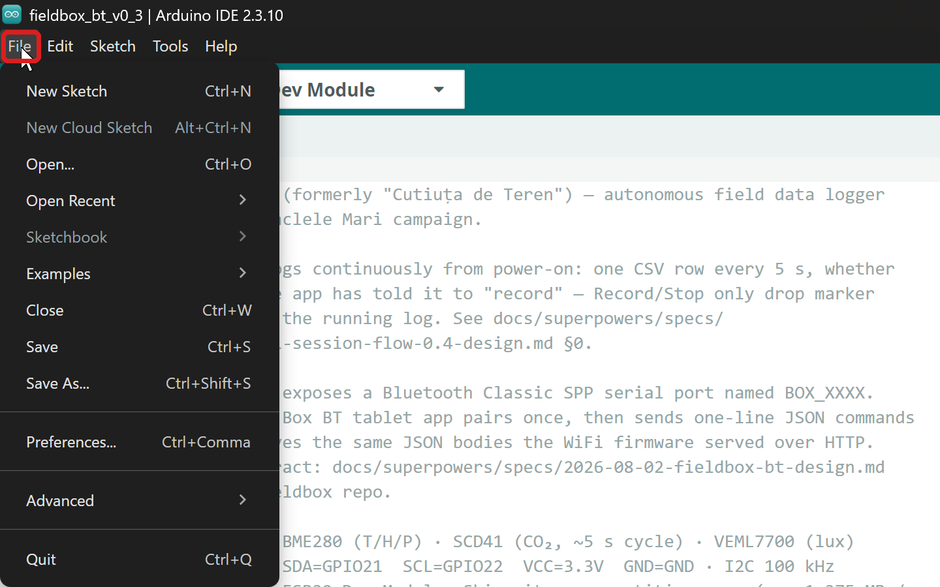
The File menu
2. Choose Preferences….
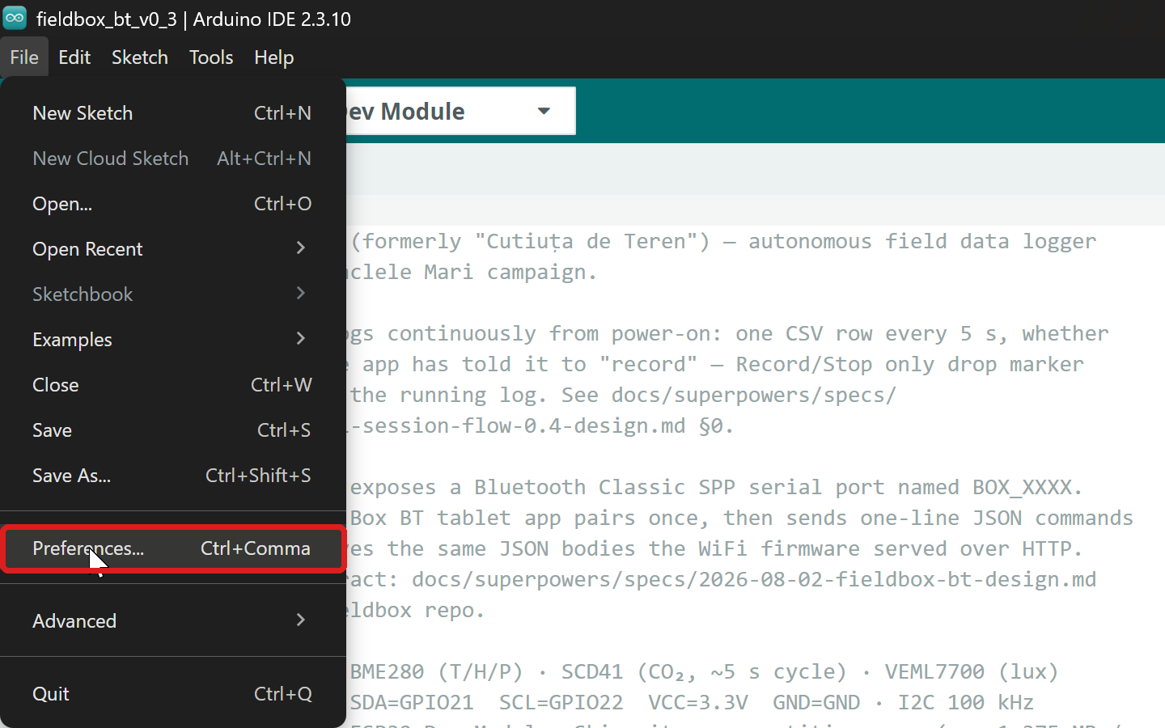
File → Preferences
3. In Additional boards manager URLs paste the address below, then click OK: https://raw.githubusercontent.com/espressif/arduino-esp32/gh-pages/package_esp32_index.json
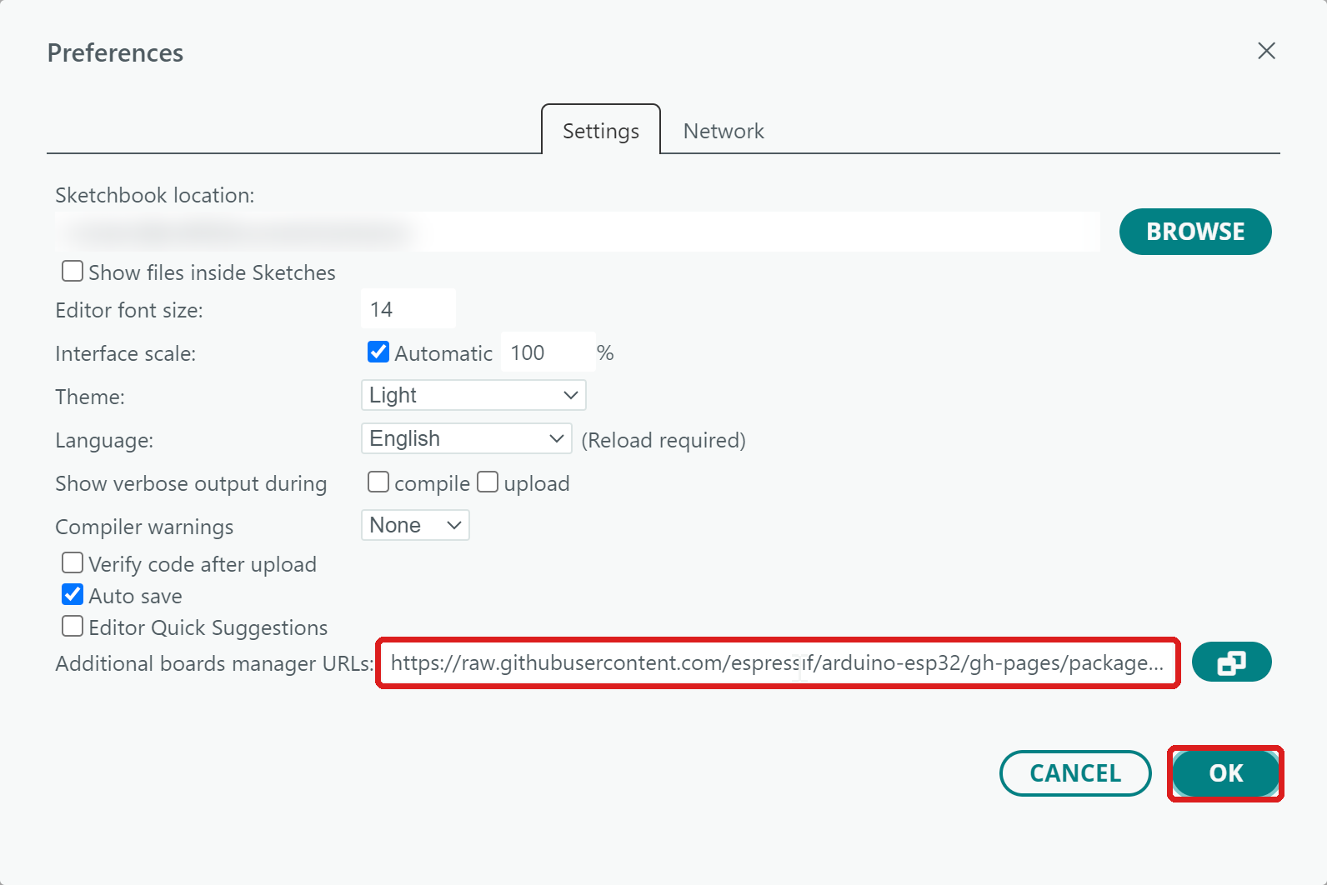
The ESP32 boards address in Preferences
4. Click the second icon in the left bar (Boards Manager), type esp32 in the search box and, on esp32 by Espressif Systems, click INSTALL. Do not pick "Arduino ESP32 Boards" above it. It takes a few minutes. If it says "installed" under the name, there is nothing to do.
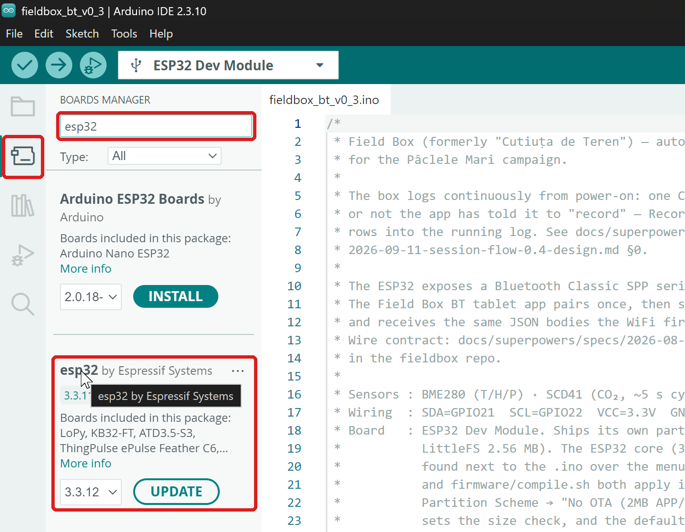
Boards Manager: esp32 by Espressif Systems
5. Click the third icon (Library Manager) and install these libraries one by one. Type the name and click INSTALL. If it asks about dependencies, click INSTALL ALL.
- Adafruit BME280 Library
- Adafruit VEML7700 Library
- Adafruit Unified Sensor (usually installed together with the first one)
- SparkFun SCD4x Arduino Library
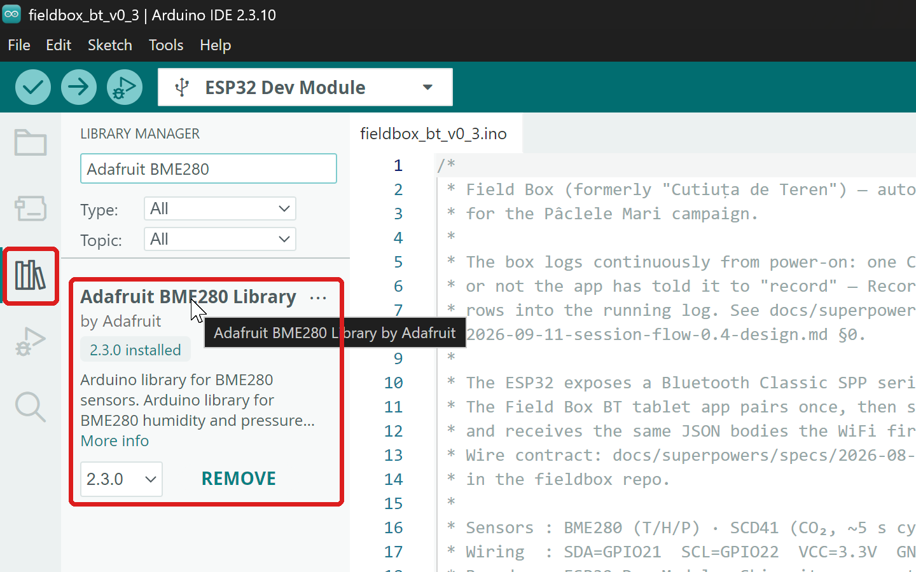
Library Manager: Adafruit BME280
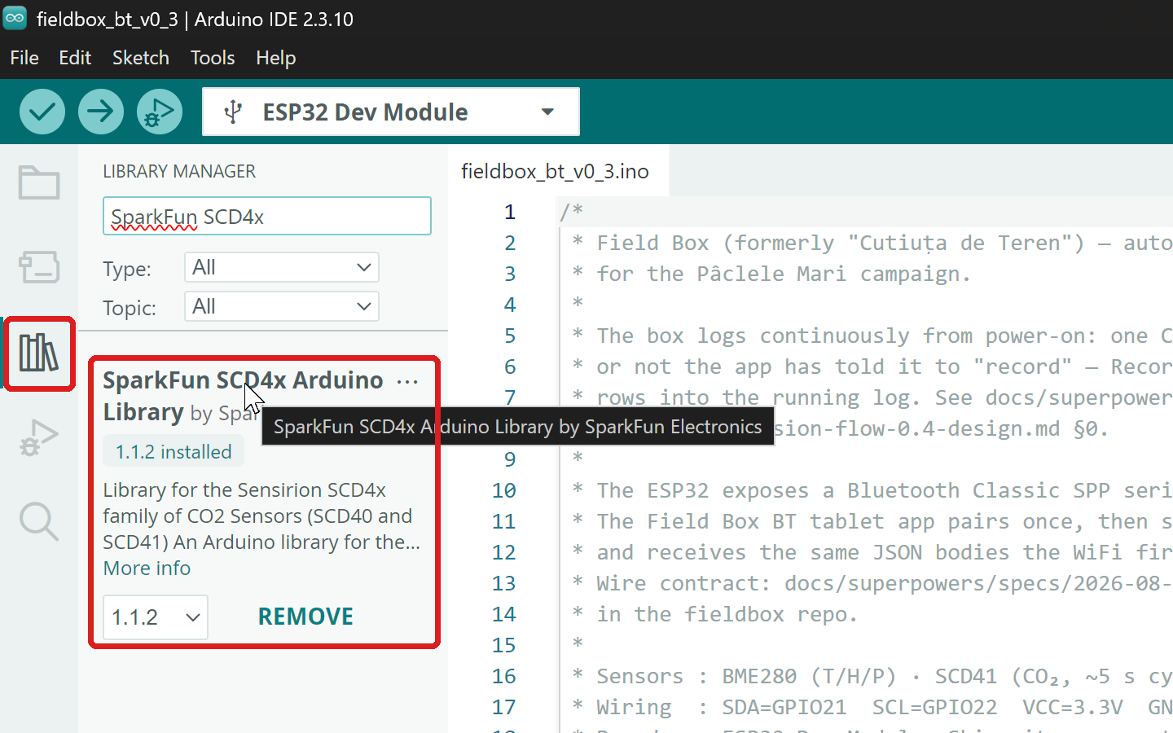
Library Manager: SparkFun SCD4x

5.3 Writing the firmware to the box
1. Plug the board inside the box into the computer with the USB cable.
2. In the Arduino IDE: File → Open….
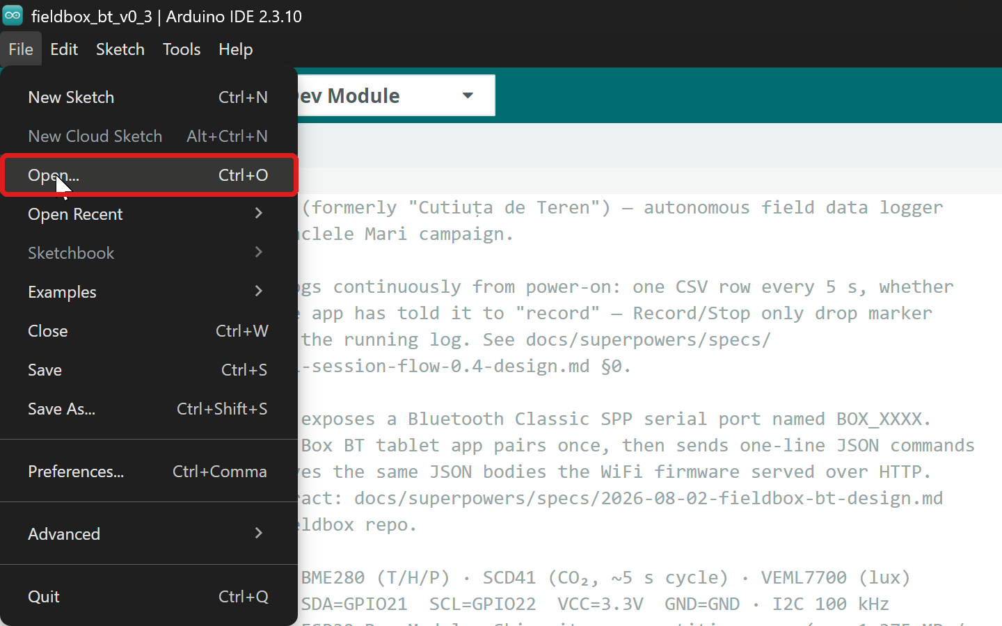
File → Open
3. In the Open window, pick Downloads on the left, then double-click the FieldBox_v… folder.
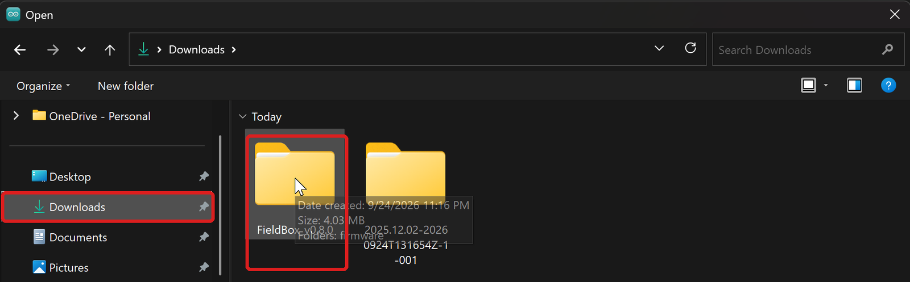
Downloads → FieldBox
4. Double-click firmware…
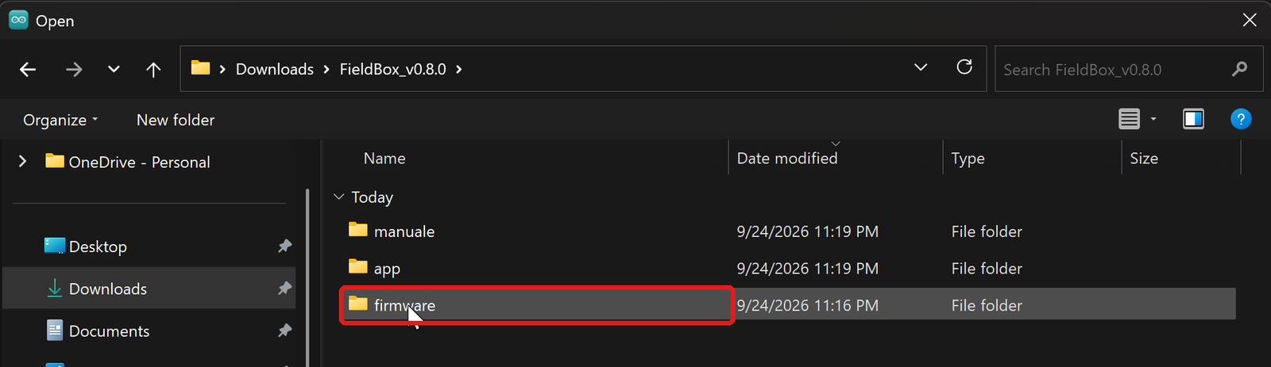
The firmware folder
5. …then fieldbox_bt_v0_3.
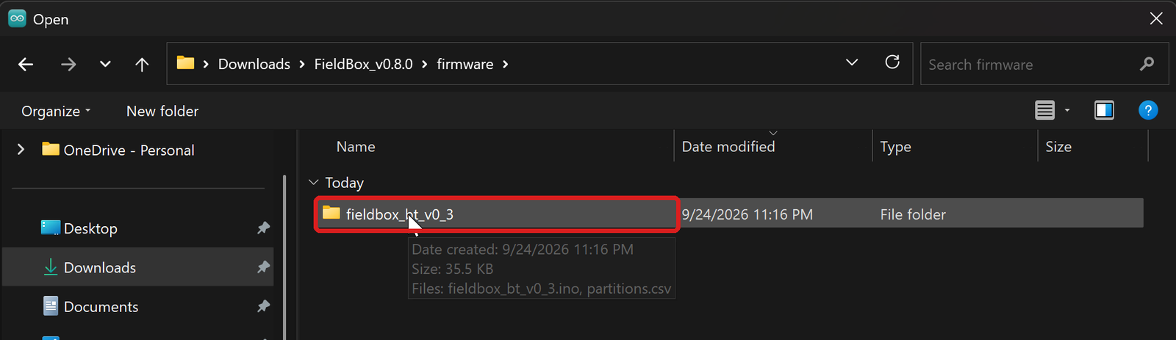
The fieldbox_bt_v0_3 folder
6. Select fieldbox_bt_v0_3.ino and click Open. The program opens in a new window. Carry on in that one, titled fieldbox_bt_v0_3.
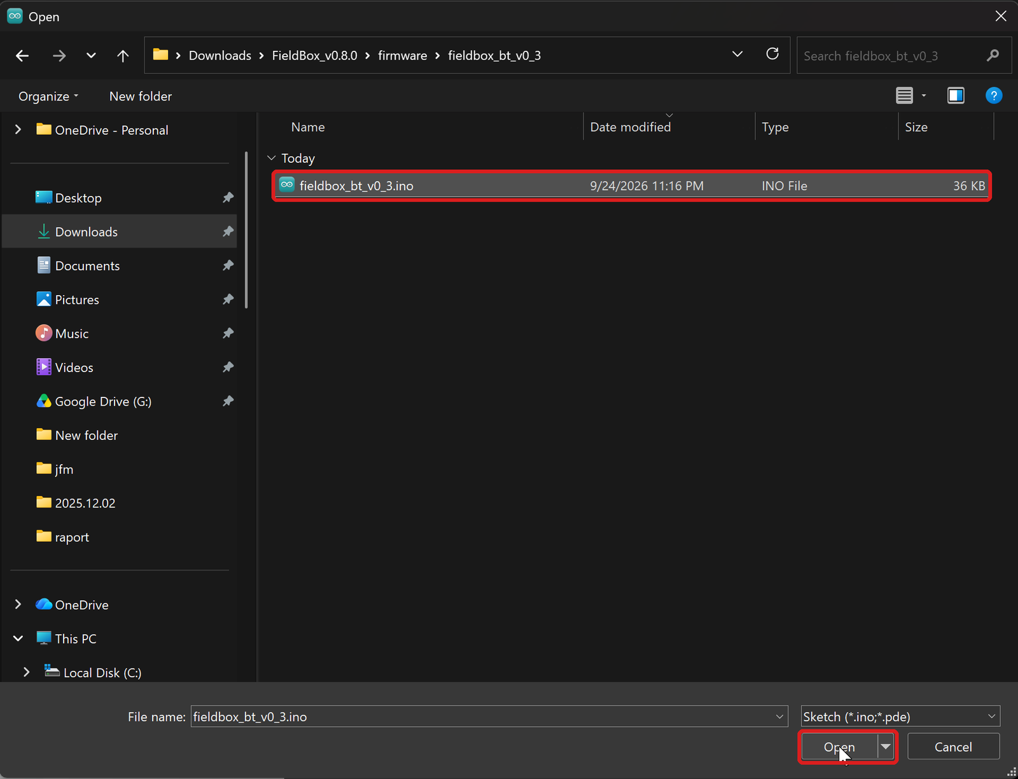
Opening fieldbox_bt_v0_3.ino
7. Tools → Board → esp32 → ESP32 Dev Module.
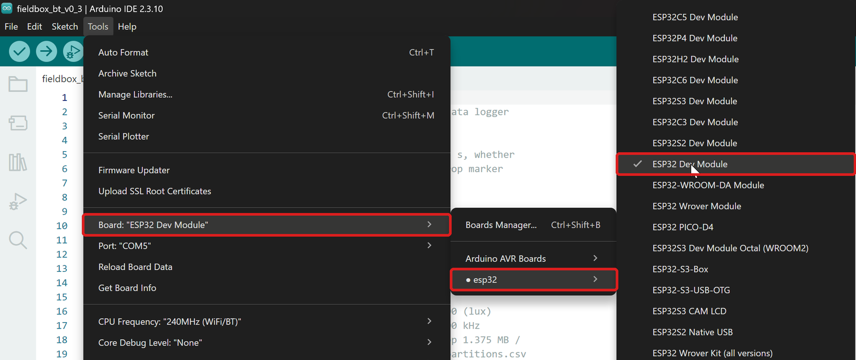
Tools → Board → esp32 → ESP32 Dev Module
8. Tools → Port → the board's port (e.g. COM5). If several ports are listed, unplug the cable and see which one disappears, then plug it back in. The port that comes back is the box.
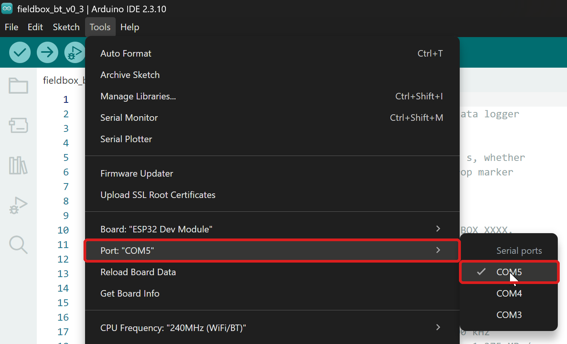
Tools → Port
9. Tools → Partition Scheme → No OTA (2MB APP/2MB SPIFFS).
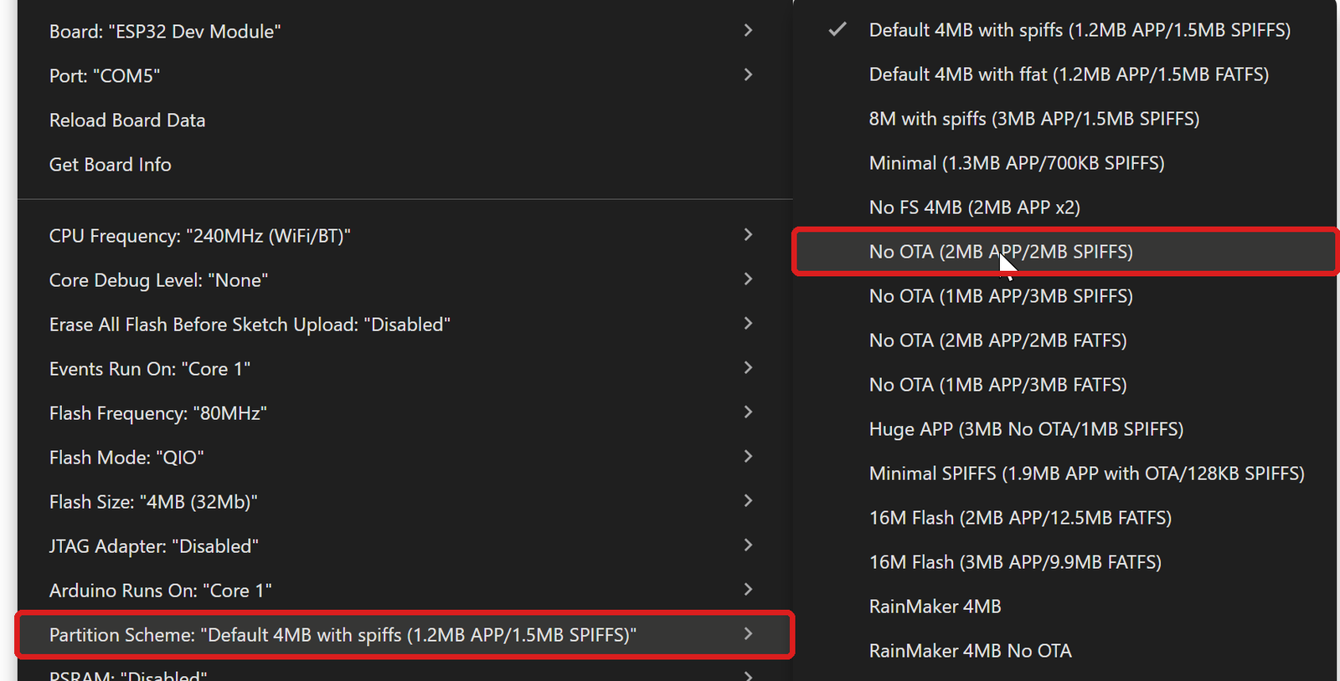
Tools → Partition Scheme → No OTA (2MB APP/2MB SPIFFS)
10. Open Tools once more and check the three lines: Board: "ESP32 Dev Module", Port: "COM…" and Partition Scheme: "No OTA (2MB APP/2MB SPIFFS)".
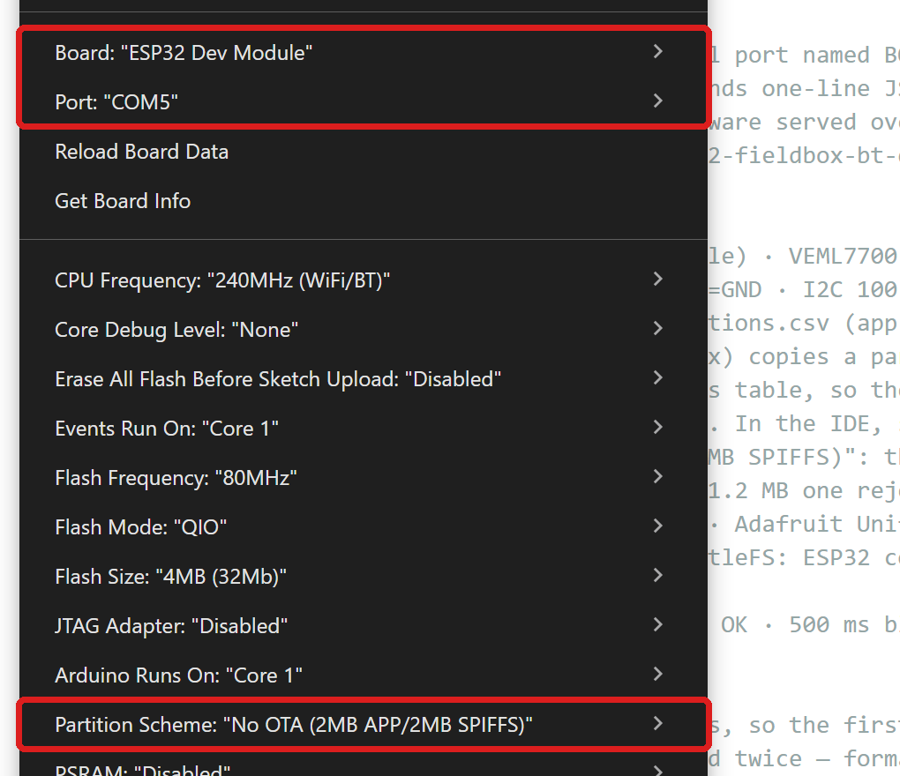
Checking the Tools settings
11. Click the round button with the right arrow (Upload).
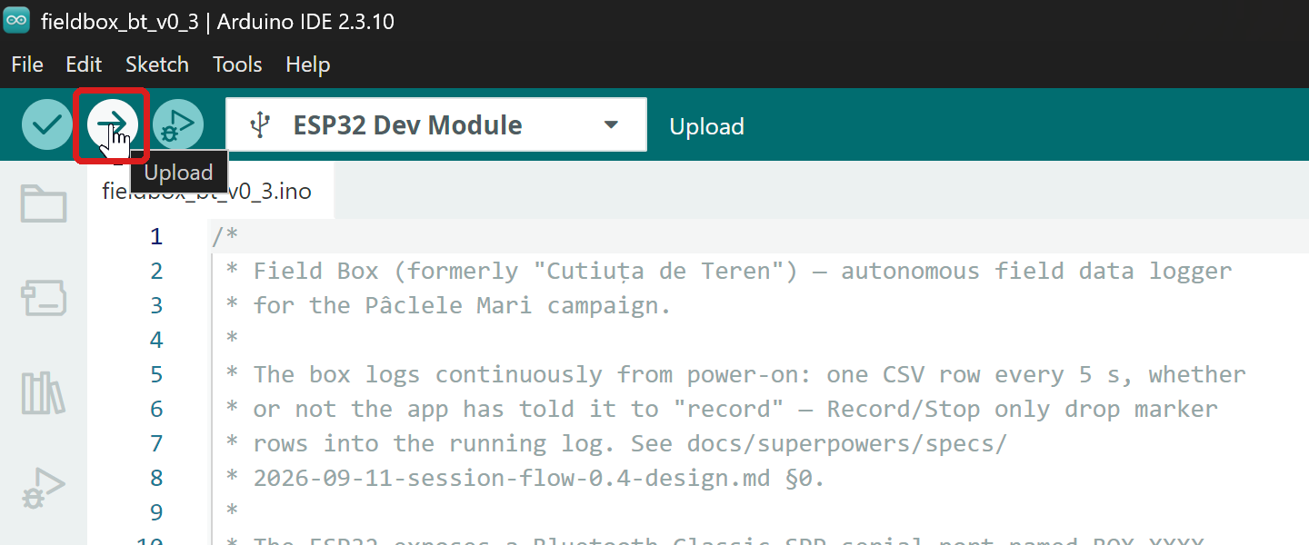
The Upload button
12. Wait. First Compiling sketch… (a few minutes the first time), then Uploading…, with Writing at … lines climbing to 100 %.
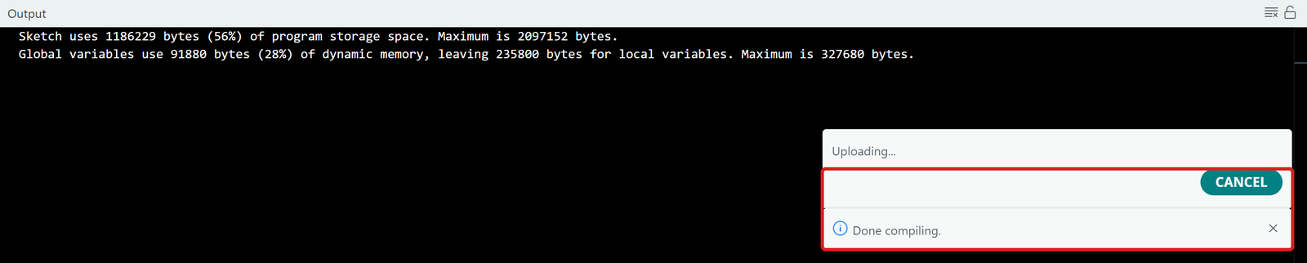
Compiling done, writing started
13. It is done when the bottom pane shows Hash of data verified and Hard resetting via RTS pin…. Unplug the USB cable.
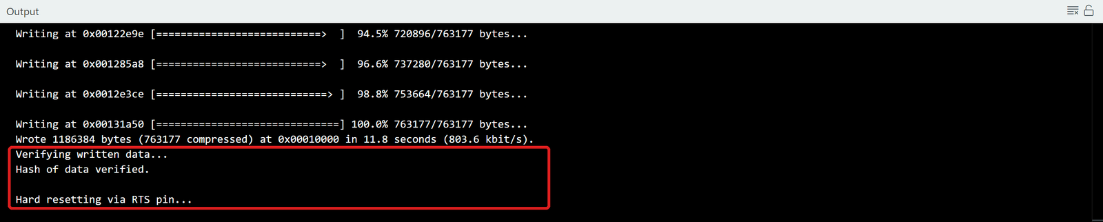
Successful write
On the first boot after the write, the box reformats its storage (a few seconds). Then the LED stays on for 2 seconds if the sensors are fine. In the app, the Boxes tab shows the new version (firmware v0.3.1-bt).
If it does not work:
- No port under Tools → Port: the cable is charge-only, or the CH340 driver is missing.
- "Failed to connect… Wrong boot mode": hold the BOOT button on the board while the bottom pane says Connecting…, then release it.
- "Sketch too big": No OTA (2MB APP/2MB SPIFFS) was not selected at step 9.
- "…h: No such file or directory": one of the libraries from step 5 of §5.2 is missing.
Other notes:
- The box's name (`BOX_xxxx`) comes from the board's Bluetooth MAC address and does not change with a firmware update.
- The package also has the ready-built `firmware/fieldbox-fw-<version>.bin`, for those who use esptool or the Flash Download Tool. It is written at address `0x0`.
- A box on 0.2.0-bt still works with the 0.8.0 app, but without continuous background logging (the log only runs while a recording is active). Mixed fleets (some boxes updated, some not) are fine.

6. Uninstalling / data
- Uninstalling the app does not delete the files in Documents/FieldBox and DCIM/FieldBox — they stay on the phone.
- However, sessions imported for comparison, in Documents/FieldBox/compare/, are lost — on reinstalling, the pupils' ZIPs must be sent again.
- To free up space: from the Files tab, download and then delete old files from the box; on the phone, delete past days' files from Documents/FieldBox once they have been copied to a laptop.

