BENCH-Z GMS: A CROSS-PLATFORM WEB APPLICATION FOR GYM MEMBERSHIP, CASHLESS PAYMENT, AND PREDICTIVE ANALYTICS MANAGEMENT



A CAPSTONE AND RESEARCH PROJECT

BY:
NESTOR ADRIAN L. CANLAS
JOFFER GEORGE I. ESCOTO
KEANNE ANDREI B. MADIA
ALDRICH G. CALUNGCAGIN

APRIL 2026

Predictive Analytics. Refers to the use of historical data, statistical algorithms, and machine learning techniques to identify the likelihood of future outcomes based on historical data (Davenport, 2007). In this study, it specifically refers to the member attendance forecasting module.
A Capstone and Research Project
Presented to the Faculty of
College of Information and Communications Technology
Nueva Ecija University of Science and Technology
Cabanatuan City, Nueva Ecija

In Partial Fulfillment of the
Requirements for the Degree
Bachelor of Science in Information Technology
With Specialization in Web Systems Technology

By:
Nestor Adrian L. Canlas
Joffer George I. Escoto
Keanne Andrei B. Madia
Aldrich G. Calungcagin

APRIL 2026


Republic of the Philippines
Nueva Ecija University of Science and Technology
College of Information and Communications Technology

E N D O R S E M E N T

Predictive Analytics. Refers to the use of historical data, statistical algorithms, and machine learning techniques to identify the likelihood of future outcomes based on historical data (Davenport, 2007). In this study, it specifically refers to the member attendance forecasting module.

System and Manuscript Readiness:

RODIBELLE F. LEONA, MIT
Capstone Adviser

Manuscript Review and Editing:

RODIBELLE F. LEONA, MIT
Research Editor

Completeness of Deliverables:

CRIS NORMAN P. OLIPAS, Ed.D.
Faculty-in-Charge, ITCAP01 3F
TABLE OF CONTENTS
Chapter I | 1
The Problem and Its Background | 1
Introduction | 1
Review of Related Literature | 2
Synthesis | 10
Conceptual Framework | 10
Statement of the Problem | 13
Scope and Delimitations | 15
Significance of the Study | 16
Definition of Terms | 18
Chapter II | 24
Methodology | 24
Research Design | 24
Research Locale | 27
Research Respondents | 28
Research Instruments | 31
Data Gathering Procedure | 33
Data Analysis Techniques | 36
Ethical Considerations | 49

Appendices
1. Request Letter for Adviser
2. Survey Instrument for the Technical Assessment of the Developed Gym Management System
3. Survey Instrument for Assessing the User Experience of the Developed Gym Management System
4. WCAG-Based Accessibility Evaluation Instrument
5. Proposed Use Case Diagram
6. Proposed Data Flow Diagram
I. Context Diagram
II. Level 1 – Data Flow Diagram
III. Register Member Level 2 – Data Flow Diagram
IV. Retrieve Plan & Compute Total Level 2 – Data Flow Diagram
V. Validate Access Credentials Level 2– Data Flow Diagram
VI. Authenticate Admin Session Level 2 – Data Flow Diagram
7. Proposed Class Diagram

LIST OF TABLES
Table No. | Table Title | Page No.
Table 1 | Distribution of respondent | 31
Table 2 | Scoring Rubric for Functional Suitability | 38
Table 3 | Scoring Rubric for Performance Efficiency | 39
Table 4 | Scoring Rubric for Compatibility | 41
Table 5 | Scoring Rubric for Capability | 42
Table 6 | Scoring Rubric for Usability | 43
Table 7 | Scoring Rubric for Reliability | 44
Table 8 | Scoring Rubric for Security | 46
Table 9 | Scoring Rubric for Maintainability | 47
Table 10 | Scoring Rubric for Safety | 48
Table 11 | Scoring Rubric for Web Content Accessibility Guidelines | 49

LIST OF FIGURES
Figure No. | Figure Title | Page No.
Figure 1 | Conceptual Framework for the Development of the Bench-Z Fitness Gym Application Using Agile Scrum Methodology | 11
Figure 2 | Geographical Location of Benchz Fitness Gym, Cabanatuan City, Nueva Ecija | 27
Figure 3 | Flowchart of the Data Gathering Procedures | 33

Chapter 1
THE PROBLEM AND ITS BACKGROUND
Introduction
Despite the digital shift in enterprise businesses, micro and small-to-medium fitness facilities often lag in technological adoption. Industry observations suggest a significant percentage of local gyms still rely on manual logbooks and cash drawers, directly contributing to high membership attrition rates due to poor user experience and administrative bottlenecks. To modernize these operations, this study integrates a Double Binding security architecture (a dual-credential system utilizing both a physical RFID keychain and a digital QR token linked to a single user profile). By establishing a secure, seamless, and frictionless environment for health tracking and facility access, this system organically advances Sustainable Development Goal (SDG) 3 (Good Health and Well-being) by encouraging consistent fitness participation, and SDG 9 (Industry, Innovation, and Infrastructure) by upgrading local micro-enterprises with resilient, cloud-first digital payment and identity infrastructures.
Despite the digital shift in enterprise businesses, micro and small-to-medium fitness facilities often lag in technological adoption. Industry observations suggest a significant percentage of local gyms still rely on manual logbooks and cash drawers, directly contributing to high membership attrition rates due to poor user experience and administrative bottlenecks. To modernize these operations, this study integrates a Double Binding security architecture (a dual-credential system utilizing both a physical RFID keychain and a digital QR token linked to a single user profile). By establishing a secure, seamless, and frictionless environment for health tracking and facility access, this system organically advances Sustainable Development Goal (SDG) 3 (Good Health and Well-being) by encouraging consistent fitness participation, and SDG 9 (Industry, Innovation, and Infrastructure) by upgrading local micro-enterprises with resilient, cloud-first digital payment and identity infrastructures. In the modern fitness industry, the efficient management of membership tracking, attendance validation, and payment processing is critical for operational success. However, many facilities still rely on traditional manual workflows. These outdated methods are highly prone to data errors, slow transactions, and limited accessibility, which create severe administrative bottlenecks during peak hours. Consequently, these manual inefficiencies lead to a poor overall user experience, directly resulting in reduced member satisfaction and lower retention rates.
To combat these challenges, the fitness sector is increasingly adopting digital solutions such as automated membership systems, cashless payment gateways, and basic analytics dashboards. Despite these initial technological advancements, critical gaps remain. Current gym systems frequently suffer from fragmented platforms, weak data security protocols, a lack of real-time operational analytics, and limited integration of robust identification methods. Because existing systems often treat these functions as isolated modules rather than a unified ecosystem, facilities are left vulnerable to security risks, unauthorized access, and incomplete business data.
This study provides a novel contribution to the field by developing a cohesive, data-driven, cross-platform web application that centralizes these operational pillars. What makes this system uniquely innovative is its “Double Binding” approach, which seamlessly integrates a hybrid physical RFID and digital QR-based identification system into a unified profile alongside automated cashless payment processing. Unlike existing fragmented applications, this secure, all-in-one ecosystem ensures redundant facility access while equipping administrators with predictive, real-time analytics for member retention and revenue tracking.
The core features of this system are deeply embedded with global sustainability objectives. By streamlining facility access and improving the user experience, the system actively encourages regular physical participation, directly advancing Sustainable Development Goal (SDG) 3: Good Health and Well-being. Furthermore, deploying a secure, cross-platform infrastructure with integrated digital finance and hybrid identification directly supports the technological innovation targets of SDG 9: Industry, Innovation, and Infrastructure.
Ultimately, this study aims to design, develop, and evaluate a comprehensive, data-driven cross-platform web application that seamlessly integrates gym membership validation, cashless payment processing, and advanced analytics management.
Review of Related Literature
This section presents the literature reviewed by the researchers to gain better insights into the concepts covered in this study.

Digital Transformation in Fitness Facility Operations
The digital transformation of the fitness industry has fundamentally shifted how facilities handle their daily operations, moving away from error-prone manual logbooks toward automated, cloud-based infrastructures. Recent literature firmly establishes that digitizing gym operations significantly improves efficiency and user satisfaction. Studies by Hussain et al. (2025) and Alboneh & Snae (2025) demonstrated that web-based platforms for registration and management directly enhance administrative productivity and member engagement. By automating data entry, these systems reduce the administrative burden on gym staff, allowing them to focus on customer service rather than tedious paperwork.
Identification Systems and Access Control
A critical limitation in these existing systems is their reliance on a single method of identification, utilizing either a digital log or a manual check, which creates operational loopholes. This disconnection between physical tracking and web databases often results in inaccurate attendance records or allows for “buddy punching,” where members share credentials to bypass entry fees.
QR code generation for member access has been demonstrated as a fast and cost-effective alternative to physical credentials in gym management contexts, enabling seamless member verification without specialized hardware beyond a standard camera scanner (Villanueva et al., 2025). However, systems that rely exclusively on digital QR credentials expose a critical single point of failure, as members without functional smartphones or with depleted device batteries are entirely denied facility access (Villanueva et al., 2025). The Bench-Z Fitness Gym application resolves this gap by employing a “Double Binding” approach that simultaneously assigns a physical RFID keychain and a digital QR token to every verified member profile, ensuring that a redundant fallback credential is always available regardless of device availability.
RFID-based attendance automation has been shown to significantly reduce human error and shorten entry wait times in web-based gym management systems compared to manual logbook methods (Suryawanshi et al., 2024). However, deploying RFID as a standalone access credential introduces a security vulnerability, as single-token systems remain susceptible to card cloning and relay-attack exploits in the absence of a secondary server-side verification layer (Suryawanshi et al., 2024). The Bench-Z Fitness Gym application resolves this limitation through a dual-credential architecture where each scanned RFID Unique Identifier (UID) is matched against a server-verified member profile in real time, ensuring that a cloned or stolen card cannot independently grant unauthorized facility access.
Modernization of Financial Transactions and Security
The financial modernization of fitness facilities has heavily leaned toward digital transactions, especially with the widespread adoption of e-wallets. Bulaclac et al. (2025) proved that integrating QR-enabled cashless payments reduced transaction times by 80% and error rates to just 2%. This is particularly relevant when standardizing payments through APIs like PayMongo, which ensure interoperability and seamless transaction logging. Furthermore, Adegbite (2025) noted the importance of standard data protection in digital finance. Without robust encryption like AES-256, digital payment systems remain vulnerable to interception. Despite these advancements, many small-scale gym applications documented in current research function without unified validation mechanisms. These systems often treat software management and payment processing separately, creating a fragmented user experience where financial data is not smoothly tied to physical facility access.
Mobile wallet adoption among Filipino consumers, particularly Generation X, is primarily driven by perceived ease of use, embedded security features, and peer social influence, establishing GCash-based digital payment as a mainstream transaction method in the Philippine market (Cacas et al., 2022). However, existing adoption literature evaluates cashless behavior primarily in general retail contexts, leaving a significant gap in how digital payment systems integrate specifically into membership-based service platforms where payment must directly trigger account access and subscription renewal (Cacas et al., 2022). The Bench-Z Fitness Gym application bridges this gap by embedding the PayMongo API natively into the membership lifecycle, ensuring that QR Ph-standard digital payments function as a fully integrated trigger for member account status updates rather than a standalone external checkout process.
The sustained adoption of digital payment tools among micro-business owners in the Philippines is primarily contingent on perceived security, with merchants who trust their payment provider’s fraud detection and data protection capabilities being significantly more committed to long-term cashless operations (Pleno, 2024). However, most micro-businesses lack the internal technical capacity to independently implement compliant payment security protocols, creating a structural dependence on the security posture of their chosen third-party payment aggregator (Pleno, 2024). The Bench-Z Fitness Gym application addresses this structural reality by leveraging PayMongo’s PCI DSS Level 1-certified and SOC 2 Type 2-audited infrastructure, delegating all transaction-layer cryptographic security to a nationally recognized compliant gateway without requiring the gym to independently maintain a dedicated secure payment server.

Data Analytics for Proactive Gym Management
Data utilization has evolved into a cornerstone of modern business management, enabling a shift from reactive to proactive decision-making. Acepcion et al. (2025) demonstrated that predictive analytics are essential for high-level decision-making, noting that technical experts favor these systems for their high degree of accuracy. While such systems allow administrators to identify profitable membership tiers through attendance and payment logs, a significant gap remains regarding operational granularity. Previous research primarily emphasizes general data accuracy, leaving a practical need for integrated systems that specifically track real-time retention metrics and staff allocation. Most existing platforms fail to visualize peak-hour congestion or automatically flag “at-risk” members with declining attendance, features that are critical for sustaining gym profitability and central to the current study’s analytics framework.
Cross-Platform Accessibility in Management Systems
Cross-platform accessibility has emerged as a fundamental requirement for modern management systems, primarily through the use of unified codebases. Jošt & Taneski (2025) confirmed that cross-platform development provides a cost-effective strategy for delivering functional features across diverse devices while maintaining high performance. This architecture ensures a consistent user experience, whether the portal is accessed via a mobile browser or a desktop terminal. However, current literature frequently treats these accessibility features as isolated modules rather than a fully integrated ecosystem. A significant technological gap remains in the simultaneous deployment of physical and digital credentials to ensure identification reliability. Unlike existing systems that separate software management from payment processing, the current industry lacks a cohesive framework that binds a physical RFID keychain and a digital QR code to a unified member profile. This redundancy is critical; it ensures that if a physical tag is misplaced, the digital alternative allows for uninterrupted facility access and operational continuity.
Software Quality Evaluation (ISO 25010)
The ISO/IEC 25010:2023 standard defines eight core product quality characteristics Functional Suitability, Performance Efficiency, Compatibility, Interaction Capability, Reliability, Security, Maintainability, and Flexibility that collectively measure the degree to which a software system meets its stakeholders’ stated and implied needs, with research on the standard reaching its highest recorded publication volume in 2023 and its most critical applications found in business management tools across public administration, finance, and healthcare (Rojas et al., 2025). Security and Interaction Capability were identified as the two characteristics most consistently deficient in existing business-facing web applications, as these systems handle sensitive personal and financial data demanding robust access control and intuitive usability simultaneously (Rojas et al., 2025). The Bench-Z Fitness Gym application is evaluated against ISO/IEC 25010:2023 with primary emphasis on Security validated through its AES-encrypted data layer and PayMongo-compliant payment processing and Interaction Capability, ensuring both gym administrators and members can navigate the system efficiently without requiring prior technical expertise.
Among the ISO/IEC 25010:2023 characteristics, Functional Suitability, Reliability, Interaction Capability, and Security have been identified as the most practically critical dimensions for business-facing web applications, with Security enhancements such as two-factor authentication and data encryption consistently ranking as the most recommended improvements by end users in post-evaluation assessments (Nugraha & Rachman, 2024). However, applying ISO/IEC 25010:2023 retrospectively to an already-deployed application constrains the utility of the evaluation, as identified security gaps can only be flagged as post-deployment recommendations rather than resolved during the active development cycle (Nugraha & Rachman, 2024). The Bench-Z Fitness Gym application addresses this limitation by treating ISO/IEC 25010:2023 quality criteria as prospective design benchmarks from the earliest Agile sprint, embedding Security and Interaction Capability requirements directly into the feature backlog to ensure they are resolved during development rather than after deployment.
Agile Scrum in Web Development
Agile Scrum has been established as the preferred development methodology for responsive, multi-module web systems because its iterative sprint structure enables continuous validation of inter-module integration and stakeholder requirements across short development cycles, significantly reducing the compounding risk of late-stage defects that are characteristic of sequential Waterfall-based approaches (Jošt & Taneski, 2025). Agile methodologies record a project failure rate of 10% compared to 30% for Waterfall, and successful completion rates of 40% versus only 15% for Waterfall in comparable software environments, a disparity attributed to Agile’s capacity to identify and resolve integration issues within sprints rather than after months of irreversible sequential development (Almajali et al., 2023). The Bench-Z Fitness Gym application is built using the Agile Scrum framework precisely because its three integrated subsystems the hybrid RFID/QR access module, the PayMongo cashless payment module, and the membership analytics dashboard each require continuous incremental testing against actual gym staff workflows, a degree of adaptive validation that a rigid Waterfall sequence cannot accommodate without incurring costly late-stage rework.
Agile-based iterative development cycles are uniquely suited to cross-platform management systems because short sprint-feedback loops allow developers to continuously validate feature parity and interface consistency across different device classes before the system is committed to a production release (Jošt & Taneski, 2025). However, existing cross-platform Agile research focuses primarily on rendering and performance dimensions without examining how Scrum’s sprint structure specifically accommodates hardware-dependent features such as RFID readers and QR code scanners within a web-based environment (Jošt & Taneski, 2025). The Bench-Z Fitness Gym application addresses this gap by allocating dedicated Agile sprints to the hardware-interfacing modules specifically the RFID reader communication layer and the camera-based QR scanner integration ensuring that physical device compatibility is treated as a first-class sprint deliverable rather than a last-mile implementation concern.
Synthesis
A synthesis of the reviewed literature reveals converging themes highlighting the necessity of automating gym operations. Studies consistently demonstrate that digitizing registration, integrating cashless e-wallet payments, and utilizing data analytics drastically reduce administrative overhead, eliminate manual recording errors, and shorten transaction times. The modern consensus dictates that cloud-based infrastructures are no longer optional but essential for maintaining competitive fitness facility operations.
However, a critical review of these existing systems reveals notable contradictions and limitations. Most platforms treat access control, financial transactions, and data analytics as highly fragmented, isolated modules rather than a unified ecosystem. Furthermore, systems relying exclusively on digital QR codes expose a single point of failure if a user’s device is unavailable, while standalone RFID systems remain vulnerable to card-cloning exploits. Additionally, current analytics frameworks frequently lack operational granularity, failing to provide predictive models for churn or real-time occupancy-based scheduling.
The proposed Bench-Z GMS is explicitly designed to resolve these cumulative gaps. By implementing a 'Double Binding' (RFID + QR) architecture, the system eliminates the single points of failure found in previous access models. Furthermore, by seamlessly natively integrating the PayMongo API and a predictive analytics dashboard into the membership lifecycle, this system unifies payment, secure access, and retention tracking into a single, cohesive cross-platform ecosystem.
However, a critical review of these existing systems reveals notable contradictions and limitations. Most platforms treat access control, financial transactions, and data analytics as highly fragmented, isolated modules rather than a unified ecosystem. Furthermore, systems relying exclusively on digital QR codes expose a single point of failure if a user’s device is unavailable, while standalone RFID systems remain vulnerable to card-cloning exploits. Additionally, current analytics frameworks frequently lack operational granularity, failing to provide predictive models for churn or real-time occupancy-based scheduling.
The proposed Bench-Z GMS is explicitly designed to resolve these cumulative gaps. By implementing a 'Double Binding' (RFID + QR) architecture, the system eliminates the single points of failure found in previous access models. Furthermore, by seamlessly natively integrating the PayMongo API and a predictive analytics dashboard into the membership lifecycle, this system unifies payment, secure access, and retention tracking into a single, cohesive cross-platform ecosystem.
Theoretical Framework
This study is theoretically grounded in the Technology Acceptance Model (TAM), which posits that user adoption of a new information system is primarily determined by two factors: Perceived Usefulness and Perceived Ease of Use. In the context of Bench-Z Fitness Gym, the system's cross-platform accessibility and seamless PayMongo checkout address 'Perceived Ease of Use,' while the automated attendance logging and predictive analytics address 'Perceived Usefulness' for the administrators. This theory directly guides the study's user experience evaluations.
Conceptual Framework
The conceptual framework of this study is structured using the Agile Scrum Methodology, illustrating the logical progression from foundational gym requirements to the realized software solution. The Scrum framework supports iterative development, enabling the system to evolve through continuous stakeholder feedback, modular feature delivery, and regular quality evaluation.
The Agile Scrum Model consists of the Requirements Analysis, Design, Development, Testing, and Deployment Phases. Monitoring and maintenance will occur after the system is deployed.

Figure 1
Conceptual Framework for the Development of the Bench-Z Fitness Gym Application Using Agile Scrum Methodology
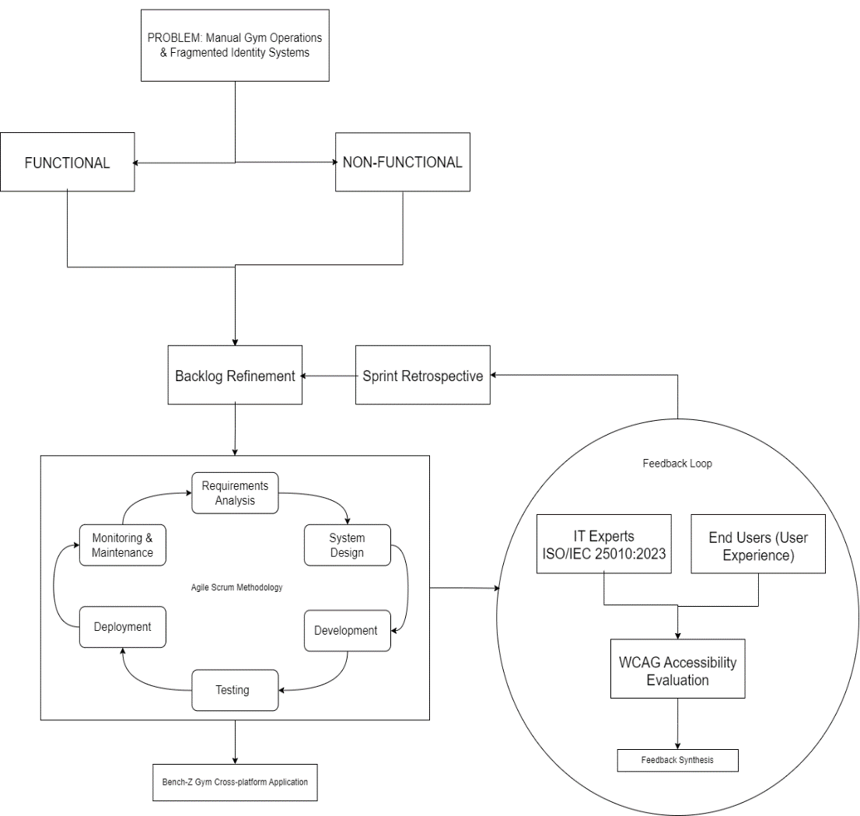

The development process begins with Requirements Analysis. During this phase, the proponents analyzed the operational bottlenecks of traditional fitness facilities, specifically focusing on the inefficiencies of manual logbooks and the security loopholes of single-method identification, such as “buddy punching.” From this analysis, functional requirements were established, including a member self-service portal, a cashless payment module utilizing the PayMongo API (Tier 1), and a membership analytics dashboard. Crucially, the non-functional requirements were also defined, emphasizing data protection through AES-256 encryption, Multi-Factor Authentication (MFA) for administrative access, and cross-platform accessibility. Through continuous Product Backlog Refinement, these requirements were detailed and prioritized to ensure strict alignment with the project’s objectives.
Following this, the project enters the Design and Development (Sprints) phases. The system architecture was constructed using the Laravel Framework (PHP) for robust backend routing and a MySQL database for centralized data storage. Development will be executed in iterative sprints, with a heavy focus on hardware-software interfacing. Rather than relying on motorized gates or electronic door strikes, the system will interface RFID readers and camera-enabled QR scanners directly with the web application to serve as an automated attendance and verification kiosk. This will ensure the “double binding” authentication logic successfully links a physical RFID Unique Identifier (UID) and a digital QR token to a single, secure member profile.
Once the functional modules are built, the system will undergo rigorous testing. IT experts will be tapped to evaluate the technical architecture against the ISO 25010:2023 Software Quality Standards, specifically assessing Functional Suitability, Performance Efficiency, Compatibility, Interaction Capability, Reliability, Security, Maintainability, and Portability. Simultaneously, end-users, comprising Gym Owners and Members, will be asked to evaluate the practical application, focusing on Functional Suitability, Interaction Capability, Reliability, and Security. Feedback that will be obtained during these evaluations will be incorporated into sprint retrospectives to resolve any software defects or usability issues.
QR Ph. The Philippines’ QR code standard based on the Europay-Mastercard-Visa (EMV) standard, which provides a safe, simple, and convenient way for Filipinos to pay and transfer money digitally (Bangko Sentral ng Pilipinas).
Following the system's deployment, the project transitions into the Monitoring and Maintenance phase. During this stage, the deployed web application undergoes continuous observation to ensure server stability, database integrity, and the smooth execution of the PayMongo cashless transactions and hybrid identification hardware. Furthermore, feedback from gym members and administrators is actively gathered to identify any post-deployment usability issues or emerging operational bottlenecks. Because the system follows the Agile framework, any required bug fixes, security patches, or feature enhancements identified during maintenance are continuously fed back into the Product Backlog to be addressed in future development sprints.
Statement of the Problem
This study aims to design, develop, and assess a Data-Driven Cross-Platform Web Application for Gym Membership, Cashless Payment, and Membership Analytics Management. Specifically, it seeks to answer the following:
Objective 1: To design and develop the system following the iterative stages of the Agile Scrum Methodology (Requirements Analysis, Design, Development, Testing, and Deployment).
2. How may IT experts assess the technical features of the application using the ISO/IEC 25010:2023 Software Standards in terms of:
2.1. Functional Suitability;
2.2. Performance Efficiency;
2.3. Compatibility;
2.4. Interaction Capability;
2.5. Reliability;
2.6. Security;
2.7. Maintainability;
2.8. Flexibility; and
2.9. Safety?
3. How may the end-users (Gym Owners and Members) assess the application in terms of:
3.1. Functional Suitability;
3.2. Interaction Capability;
3.3. Reliability; and
3.4. Security?
- How may the accessibility of the web application be assessed based on the Web Content Accessibility Guidelines (WCAG) standards in terms of:
4.1. Perceivable;
4.2. Operable;
4.3. Understandable; and
4.4. Robust?
For the technical and end-user evaluations (Questions 2 and 3), a weighted mean threshold of ≥ 3.41 (Suitable/Adequate) is established as the minimum acceptable benchmark for a positive evaluation outcome. Furthermore, Web Content Accessibility Guidelines (WCAG) compliance is included as an evaluation criterion to ensure the digital portal remains inclusive, legally compliant, and fully operable for users with varying visual or physical abilities.
Scope
The primary focus of this study is to develop a specialized management system for gym operations that emphasizes data integrity, security, and cross-platform accessibility. The scope centers on the development of a hybrid multimodal identification system that implements a double-binding check-in process. In this setup, members will be issued both a unique QR-based digital ID and a physical RFID-enabled keychain, both of which are bound to a single member profile to ensure redundant and flexible facility access. This will be supported by hardware-software interfacing, with the system integrating RFID readers and camera-based QR code scanners that communicate directly with the Laravel-based web application for real-time verification.
Functionally, the system will include a comprehensive membership management module capable of digital registration and real-time status tracking across tiers, including full membership, monthly passes, and walk-in or day passes. This module will automatically manage active, expired, and suspended statuses based on validation logic. To empower end-users, the system will include a member self-service portal that allows clients to access session history, view discounts, and manage profile information. Financial operations will be streamlined through a cashless payment module utilizing the PayMongo API (Tier 1). This integration will facilitate automated transactions via QR Ph standards and maintain a detailed transaction history specifically designed for administrative auditing. Furthermore, the system will aid decision-making through an advanced membership analytics dashboard, which provides visual summaries of occupancy trends, retention metrics to identify at-risk members, and insights into the revenue contribution of different membership pass. All these features will be protected by a strict security framework that uses AES-256 encryption for sensitive data and multi-factor authentication (MFA) for administrative functions.
Despite these capabilities, the study will observe specific technical boundaries to maintain its focus on web and systems technologies. The research excludes the integration of heavy physical hardware, such as automated turnstiles, electronic door strikes, or motorized gates, and focuses strictly on software-side validation of RFID and QR credentials. Furthermore, the system does not incorporate biometric authentication technologies, such as fingerprint, iris, or facial recognition. In terms of financial integration, the study is limited to e-wallet and QR Ph verification via PayMongo; it will not directly interface with bank accounts or credit card processors. Additionally, as a cloud-hosted web application, it requires a stable internet connection and does not support offline data entry or local database synchronization. Finally, the study does not cover ancillary management systems, such as employee payroll processing, inventory management for gym merchandise, or point-of-sale (POS) systems for physical products.
Delimitations
To maintain focus strictly on scalable software-side validation, the system specifically excludes offline capabilities, as the cloud-first architecture decision means the system lacks offline functionality or local database synchronization. This is acknowledged as a limitation in areas with unstable internet. Furthermore, regarding direct banking and e-wallets, the system relies exclusively on PayMongo Tier 1 API limitations, supporting only GCash, Maya, and GrabPay, QRPH,D excluding direct traditional bank transfers. Finally, the system excludes hardware integration with heavy physical infrastructure, such as motorized turnstiles and biometric fingerprint or facial scanners.
Significance of the Study
The development of this data-driven, cross-platform web application has significant value for stakeholders in the fitness and technology sectors by modernizing gym membership management with secure, efficient technologies. Specifically, the output and methodology of this study will benefit the following groups:
Gym Owners and Administrators. Through the output of this study, a centralized, automated web platform, this group will gain an efficient tool for managing memberships, attendance, and payments of gym members. In practice, by using a hybrid RFID and QR-based identification system, they will significantly reduce manual administrative errors and prevent unauthorized facility access. Furthermore, they will gain practical decision-making tools through the integrated analytics dashboard, which provides data-driven insights into gym occupancy and revenue trends to support strategic business growth.
Gym Members. This group will benefit practically by experiencing a more convenient and secure fitness environment. Through the system’s flexible access options, members can utilize either physical RFID keychains or digital QR IDs to enter the facility. Additionally, they will gain the practical advantage of using the cashless payment module, which reduces queues and eliminates the risks of manual cash handling. Ultimately, members will be assured of accurate attendance tracking and the strict protection of their personal and financial data through the system’s robust security protocols.
Information Technology Professionals and Developers. This group will acquire significant methodological and practical benefits by using this study as a technical reference. The output demonstrates best practices in developing cross-platform applications that successfully integrate hardware-software interfacing alongside secure payment gateways. Methodologically, the study provides a clear, replicable model for executing the Agile Scrum Methodology and evaluating software architecture against rigorous ISO 25010:2023 standards, specifically regarding system security and maintainability.
Future Researchers. This group will benefit from the foundational output and methodological framework established by this research. By analyzing the system’s design and identifying delimitations, future researchers can practically extend this work. They are provided with a proven baseline that they can enhance by incorporating more advanced technologies, such as biometric authentication, deeper predictive analytics, or offline database functionality, to further advance gym management systems.
Definition of Terms
The following terms are conceptually and operationally defined to provide the meaning of the terms used in this study.
Agile Scrum Methodology. An iterative and incremental software development framework is employed to manage complex product development processes, promoting adaptability, collaboration, and continuous improvement (Hussain et al., 2025). In this study, the term refers to the structured development phases, known as sprints, that guided the creation of the gym management system, emphasizing continuous stakeholder feedback, modular feature delivery, and regular quality evaluation.
AES-256 Encryption. A robust encryption method employing a 256-bit cryptographic key to securely encode and decode digital data, thereby safeguarding sensitive information against cyber threats (Adegbite, 2025). In this study, the term refers to the specific security protocol implemented within the system to protect the personal, financial, and authentication data of gym members from unauthorized access or potential breaches.
Cashless Payment Module. A digital financial system, often QR-enabled, that facilitates electronic monetary transactions and tracking without the need for physical currency, enhancing convenience and transaction security (Bulaclac et al., 2025). In this study, the term refers to the system component that integrates the PayMongo API (Tier 1) to enable secure QR PH-enabled e-wallet payments for gym services, while simultaneously recording transactions for administrative auditing and accountability.
Cross-Platform Web Application. A software application designed to function across multiple computing platforms or operating systems using a single, unified codebase, while maintaining near-native performance (Jošt & Taneski, 2025). In this study, the term refers to the browser-based gym management system developed to operate consistently across both desktop and mobile web environments, ensuring seamless access and usability for staff and members.
Data-Driven Management System. An administrative framework anchored in analytics-based competition (Davenport & Harris, 2007) that leverages continuous data analysis to enhance operational efficiency. In this study, it refers to the predictive metrics generated for gym administration.
Double Binding (Hybrid Multi-Modal Identification). A redundant authentication mechanism that requires two distinct and parallel forms of identification linked to a single entity, enhancing security and access control (El-Rahman & Alluhaidan, 2024). In this study, the term refers to the core authentication logic that simultaneously binds a physical RFID Unique Identifier (UID) and a digitally generated QR token to a single member profile, ensuring secure and continuous facility access.
Functional Modules. Distinct, independently executable software components that collectively form a larger and more comprehensive system architecture, enabling modularity, scalability, and maintainability within software systems (Kolhe & Sharma, 2021). In this study, the term refers to the core system components developed during the Agile sprints, specifically including the Membership Management module, Hybrid Identity Binding module, Cashless Payment Integration module, Analytics Dashboard, and the Security Framework.
Gym Membership Management System. A specialized web-based software system designed to support fitness facilities in the remote management of member information, digital payment transactions, and routine operational processes, thereby enhancing administrative efficiency and service delivery (Alboneh & Snae, 2025). In this study, the term refers to the integrated, cross-platform web application developed as the primary system output, which automates key functions such as member registration, data validation, attendance tracking, and payment processing within the fitness facility.
Hardware-Software Interfacing. The point of communication and automated data exchange between physical hardware devices and programmed software applications (Kolhe & Sharma, 2021). In this study, the term refers to the integration process that enables the gym’s RFID readers and camera-based QR scanners to communicate in real time with the Laravel-based web application for membership verification.
Hybrid Multi-Modal Identification System. A security access system that utilizes multiple types of credentials (e.g., physical tokens and digital codes) to ensure strict user verification (El-Rahman & Alluhaidan, 2024). In this study, the term refers to the primary system output that combines physical RFID-based access and digital QR-based verification, preventing unauthorized entry and eliminating credential sharing (buddy punching).
ISO 25010:2023 Software Quality Standards. An internationally recognized framework that provides comprehensive quality models for software product evaluation, specifically assessing reliability, efficiency, and security (International Organization for Standardization, 2023). In this study, the term refers to the specific evaluation model employed by IT experts to assess the application across functional suitability, performance efficiency, security, and other key technical characteristics.
Laravel Framework. A free, open-source PHP web application framework designed for developing web applications following the model-view-controller (MVC) architectural pattern (Kolhe & Sharma, 2021). In this study, the term refers to the backend software architecture used to manage routing, authentication, database interactions, and secure API integrations for the gym management system.
Membership Analytics Dashboard. A visual user interface that consolidates and provides real-time access to financial information and member data for management purposes (Alboneh & Snae, 2025). In this study, the term refers to the system component that provides administrators with graphical summaries of occupancy trends, revenue performance, and member retention metrics.
QR Code (Quick Response Code). A machine-readable, two-dimensional matrix barcode used to accelerate tracking and digital payment processes (Bulaclac et al., 2025). In this study, the term refers to the unique digital barcode generated by the application, serving as a gym member’s digital identifier and payment verification tool.
QR Ph Standard. The national Quick Response code and real-time electronic fund transfer framework in the Philippines, enabling interoperable e-wallet payments via the PayMongo gateway.
RFID (Radio Frequency Identification). A wireless technology that employs electromagnetic fields to automatically identify and track tags attached to objects or individuals (Huang et al., 2022). In this study, the term refers to the specific wireless technology utilized for automated recognition of gym members and the logging of their attendance.
RFID Unique Identifier (UID). A distinct, immutable alphanumeric code programmed into an RFID tag during the manufacturing process (Huang et al., 2022). In this study, the term refers to the specific alphanumeric string permanently assigned to a registered gym member’s keychain for secure identification within the system’s database.
Retention Metrics. Quantitative data and predictive indicators are used by organizations to measure customer retention and monitor activity over a specified period (Acepcion et al., 2025). In this study, the term refers to the system-generated indicators displayed on the gym’s dashboard that identify patterns of declining attendance and enable proactive follow-up with at-risk members.

Chapter 2
METHODOLOGY
This chapter discusses the research design, research locale, research respondents, research instruments, data collection procedures, data analysis methods, and the ethical considerations involved in conducting the proposed study.
Research Design
This study will utilize a Developmental Research Design combined with a Quantitative Descriptive Approach to design, develop, and evaluate a data-driven gym management system.
Developmental research is appropriate for this study because it focuses on the systematic design, development, and evaluation of technological solutions intended to address real-world problems. In this case, the study aims to develop a cross-platform web application that integrates gym membership management, cashless payment processing, and membership analytics.
The choice of developmental research is justified by the project's nature, which will involve multiple phases, including system planning, design, implementation, testing, and refinement. Unlike purely descriptive or experimental research, this approach will emphasize the creation of a functional system and the assessment of its effectiveness in improving existing manual processes. The gym's current operations, which rely on logbooks, manual payment tracking, and CCTV verification, suffer from inefficiencies that require a structured system solution.
Furthermore, the study will employ a quantitative descriptive method to evaluate the Bench-Z Fitness Gym Cross-platform App against ISO/IEC 25010 software quality standards, including functionality, usability, reliability, and performance efficiency. Data will be collected from gym staff and members through structured questionnaires to determine the system’s level of acceptability.
By combining developmental and quantitative approaches, the study ensures that the proposed system is not only properly developed but also objectively evaluated based on measurable criteria, making the research both practical and evidence-based.
The pairing of developmental and descriptive approaches is methodologically justified (Richey & Klein, 2014) (Richey & Klein, 2014) as it allows for both the systematic creation of the software and the objective measurement of its quality. To capture richer usability data and system adoption barriers, a brief qualitative component via post-evaluation open-ended interviews will supplement the structured questionnaires.
Software Development Methodology
The development of the system will follow the Agile Scrum cycle, which emphasizes iterative development, continuous feedback, and incremental delivery of system components. This approach will be selected to ensure flexibility and adaptability throughout the development process, allowing the researchers to refine system features based on evolving requirements and identified issues.
The process will begin with the requirements and logic mapping phase, during which the proponents will identify the essential technical and theoretical foundations of the system. In this stage, the concept of “Double Binding” will be established, referring to the relational mapping of RFID UIDs and QR tokens to a single member account within the database. The technical stack will also be finalized, including the selection of the Laravel framework and MySQL for backend development, along with the integration of the PayMongo API to support automated, secure financial transactions.
Following this, the development will progress through iterative cycles known as sprints, each focusing on specific functional components of the system. The implementation will include the Hybrid Identity Binding feature, which will enable communication between RFID readers and camera-enabled devices with the web application for real-time membership verification. In addition, a cashless payment module will be developed by integrating the PayMongo API, enabling secure QR PH transactions and automatic payment confirmation. The system will also include a data analytics dashboard to display retention metrics and membership pass insights, while security measures such as AES-256 encryption and Multi-Factor Authentication (MFA) will be implemented to protect sensitive data and restrict administrative access.
At the end of each development cycle, evaluative feedback and testing will be conducted to assess the functionality and performance of the implemented features. The system will be evaluated against ISO/IEC 25010 standards, focusing on functional suitability, performance efficiency, compatibility, usability, reliability, security, maintainability, and portability. This will ensure that the system is consistently aligned with recognized software quality benchmarks throughout the development process.
Finally, the system will undergo deployment, resulting in a fully functional cross-platform web application. The completed system will serve as an integrated solution that transforms manual gym operations into an automated environment, highlighted by the Hybrid Multi-Modal Identification System, which will provide members with flexible and reliable access to the facility.
Research Locale
The study will be conducted at Benchz Fitness Gym, located at 441 Champaca St., Brgy. D.S. Garcia, Cabanatuan City, Nueva Ecija. Figure 2 shows the geographical location of the research locale.
Figure 2
Geographical Location of Benchz Fitness Gym, Cabanatuan City, Nueva Ecija


Benchz Fitness Gym was selected as the research locale due to its reliance on manual operational processes, making it a suitable environment for evaluating the effectiveness of a data-driven system. Currently, the gym uses handwritten logbooks for attendance tracking, whiteboards to monitor membership validity, and cash-based transactions for payments. These practices have resulted in operational inefficiencies, including inaccurate record-keeping, delays during peak hours, difficulty verifying active memberships, and reliance on CCTV footage for transaction validation.
The locale is particularly appropriate for this study because it exhibits real-world challenges that align with the objectives of the proposed system. The presence of issues such as payment discrepancies, manual computation of revenue, and lack of automated monitoring provides a practical basis for implementing and testing the proposed cross-platform web application. Furthermore, the gym has existing technological readiness, including computers and internet connectivity, which supports the feasibility of deploying a digital solution.
Selecting Benchz Fitness Gym enables the researchers to conduct a direct comparison between the existing manual workflow and the proposed automated system. This enables measuring improvements in operational efficiency, record accuracy, transaction transparency, and overall user experience. Therefore, the locale is deemed highly suitable for assessing the effectiveness and acceptability of the Bench-Z Fitness Gym Cross-Platform App within an actual gym management environment.
Research Respondents
The respondents of this study are categorized into three distinct groups to ensure a comprehensive evaluation of the system’s functionality, usability, and technical quality.
The first group consists of Web Developers, who will serve as the system's technical evaluators. These respondents will be selected through purposive sampling based on their expertise in web development. The selection of exactly 5 IT Experts is justified through purposive sampling literature (Creswell, 2014) (Creswell, 2014), which states that a small, highly specialized panel is sufficient for rigorous technical architectural validation, provided their credentials (e.g., portfolios and years of experience) are formally formally documented during the data gathering phase to ensure respondent validity. To qualify, they must have more than 5 years of experience in web development projects and an evident web development portfolio to demonstrate their exposure to industry-standard web system technologies. Their primary role is to assess the system’s technical architecture against ISO 25010:2023 Software Quality Standards. Their expert feedback is essential to validate that the system’s codebase is secure, scalable, and adheres to industry standards for cross-platform interoperability.
The second group comprises Gym Owners and Administrators, who are the primary system administrators. These respondents were selected using Purposive Sampling because they possess specific knowledge of the gym’s daily operations, revenue management, and administrative bottlenecks. In this study, they are tasked with evaluating the Admin Dashboard, specifically focusing on the accuracy of the Membership Analytics, the reliability of the PayMongo cashless payment integration, and the efficiency of the Hybrid Multi-Modal Identification (RFID and QR) system. Their feedback is critical in determining if the system successfully reduces the workload associated with manual tracking and improves decision-making through data visualization.
The third group consists of the Gym Members, representing the facility's active clientele. Bench-Z Fitness Gym currently serves an estimated total active population of N = 58 members. To ensure a statistically adequate sample size, Slovin's Formula was applied with a 5% margin of error (e = 0.05):


Based on this computation, a sample size of 50 active gym members was randomly selected for testing the user-facing features. These respondents will assess the Member Self-Service Portal, evaluating the ease of registration, the convenience of the cashless payment module via e-wallets, and the responsiveness of the mobile-accessible interface. Their evaluation is essential for determining the system's Usability and Functional Suitability from a consumer perspective, specifically establishing whether the shift to digital identification and payments enhances the overall gym experience."
For IT Professionals and Web Developers, the inclusion criteria require that respondents have a background in web development, software engineering, or database management, and prior experience evaluating or developing information systems. Individuals without technical expertise in system development were excluded from this group.
For the Gym Owners and Administrators, respondents must be directly involved in the daily operations and management of Benchz Fitness Gym. Those who are not actively participating in administrative tasks or decision-making processes were excluded.
For the Gym Members, respondents must be active gym members and have interacted with or tested the Bench-Z Fitness Gym Cross-Platform App, particularly its self-service and payment features. Members who had not used the system or were under 18 years old were excluded from participation. Additionally, respondents who failed to complete the evaluation questionnaire were also excluded from the final data analysis.
Table 1
Distribution of Respondents
Respondents Group | Number of Respondents | Percentage
Web Developers | 5 | 8.62%
Gym Owners | 3 | 5.17%
Gym Members | 50 | 86.21%
Total | 58 | 100.00%

The table above presents the distribution of the 58 respondents involved in the study. The Web Developers (8.62%) and Gym Owners/Administrators (5.17%) were selected using purposive sampling based on their specific technical expertise and administrative roles. Meanwhile, the Gym Members (86.21%), who represent the primary end-users of the application, were selected through random sampling to ensure a fair representation of the facility's active clientele.
Research Instruments
To quantitatively evaluate the quality and performance of the Bench-Z Fitness Gym Cross-Platform Application, this study employs a structured survey questionnaire as its primary research instrument. The instrument is developed in accordance with ISO/IEC 25010:2023, the Software Quality Model, ensuring that the evaluation remains objective, systematic, and aligned with internationally recognized software engineering standards. It comprises three distinct sets of questionnaires, each tailored to the expertise and roles of the identified respondent groups.
The first instrument, the Technical Assessment Questionnaire, is intended for IT professionals and web developers with relevant subject-matter expertise. This instrument assesses the system based on the nine software quality characteristics defined in ISO/IEC 25010: Functional Suitability, Performance Efficiency, Compatibility, Interaction Capability, Reliability, Security, Maintainability, Flexibility, and Safety. These criteria determine the extent to which the system satisfies functional requirements, performs efficiently under expected workloads, supports cross-platform operation, and ensures data protection through security mechanisms such as AES-256 encryption and multi-factor authentication. Furthermore, it evaluates the system’s modularity and capacity for future enhancements.
The second instrument, the User Experience Questionnaire, is designed for gym owners and members. It focuses on the practical and interactional aspects of the application and evaluates four key quality characteristics relevant to end users: Functional Suitability, Usability, Reliability, and Security. Specifically, it examines whether the system effectively supports routine gym operations, such as attendance monitoring and payment processing; whether it is user-friendly for individuals with limited technical expertise; whether it operates consistently with minimal errors; and whether users perceive their personal and financial data as secure.
The third instrument, the WCAG-Based Accessibility Evaluation Tool, is adapted from Olipas (2026) and used to assess the web application's accessibility. This instrument is grounded in the four core principles of the Web Content Accessibility Guidelines (WCAG): Perceivable, Operable, Understandable, and Robust. It ensures the application is inclusive, accessible, and functional for users with diverse needs, including those who use assistive technologies.
To address Research Question 4, which focuses on the application’s accessibility in relation to WCAG standards, data will be gathered using both an automated web accessibility evaluation tool and a standardized WCAG compliance checklist to ensure a comprehensive evaluation.
All instruments utilize a 5-point Likert scale to measure respondents’ level of agreement with each quality indicator. Responses are assigned corresponding numerical values ranging from 1 to 5, thereby enabling quantitative analysis and supporting the derivation of statistically grounded conclusions.
Prior to full administration, a Pilot Test of the questionnaires will be conducted with a small control group (3 to 5 respondents). Items will be revised based on their feedback to ensure clarity. Following data collection, Cronbach's Alpha will be computed to verify the internal consistency and reliability of the Likert-scale instruments. Furthermore, to supplement the unpublished WCAG instrument, automated validation tools (such as WAVE or axe DevTools) will be utilized to cross-validate the accessibility findings.
Data Gathering Procedures
The data-gathering process of this study follows a structured, systematic approach to ensure the validity, reliability, and ethical integrity of the collected data. The process is divided into several phases, namely: preparation, orientation, administration, retrieval, and data organization.

Figure 3
Flowchart of the Data Gathering Procedures
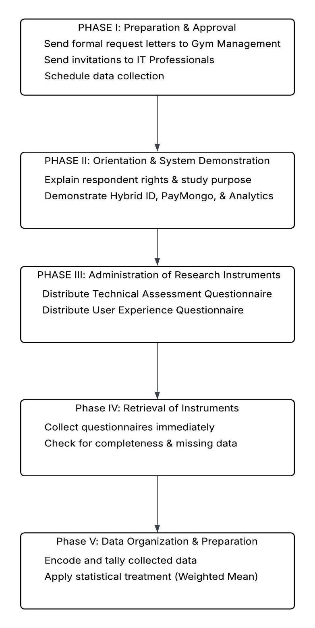

The first phase is the preparation and approval stage. The researchers will prepare a formal letter of request addressed to the management of Benchz Fitness Gym, seeking permission to conduct the study within the premises and to involve the gym owners, administrators, and members as respondents. A separate request will also be sent to selected IT professionals and web developers, inviting them to participate as technical evaluators of the system. These letters will clearly state the study's purpose, the procedures involved, and the expected participation of the respondents. Upon approval, the researchers will coordinate with gym management to schedule data collection at a convenient time that does not disrupt regular gym operations.
The second phase involves the orientation and system demonstration. Before administering the research instruments, the researchers will conduct a brief orientation session for all respondents. During this session, the study's purpose will be explained, and respondents will be informed of their rights, including the option to participate voluntarily, confidentiality, and the right to withdraw at any time. Following the orientation, the researchers will demonstrate the developed Cross-Platform Web Application. This includes showcasing key system features such as the Hybrid Multi-Modal Identification System (RFID and QR Code), the Cashless Payment Module integrated with PayMongo, and the Membership Analytics Dashboard. This step ensures that respondents have sufficient understanding of the system’s functionalities before providing their evaluation.
The third phase is the administration of the research instruments. The appropriate questionnaire will be distributed to each group of respondents based on their role. The Technical Assessment Questionnaire will be given to IT professionals and web developers, while the User Experience Questionnaire will be administered to gym owners and members. The researchers will be present during the evaluation to clarify any questions and ensure that the respondents complete the questionnaire independently, without external influence.
The fourth phase is the retrieval of the instruments. To ensure a high retrieval rate and data completeness, the researchers will collect completed questionnaires immediately upon respondents' completion. Each questionnaire will be checked for completeness to avoid missing data. Incomplete responses, if any, will be politely verified with the respondents before final collection.
The fifth phase is the data organization and preparation for analysis. The collected data will be systematically encoded, tallied, and organized into tabular form. The responses will then be subjected to appropriate statistical treatment, such as the computation of weighted means, to facilitate analysis and interpretation. All collected data will be handled with strict confidentiality and will be used solely for academic purposes.
Data Analysis Techniques
To determine the demographic profile and distribution of the respondents, Frequency Count and Percentage Distribution will be utilized.
To address each research question systematically, the study employs specific data analysis techniques aligned with the nature of the data gathered from each respondent group.
For the first research question, which asks how the system may be designed and developed following the stages of the Agile Scrum Model in terms of Requirements Analysis, Design, Development (Sprints), Testing, and Deployment, no statistical treatment is applied. This question will be answered through process documentation and narrative description, where the researchers will document each sprint’s objectives, outputs, and outcomes to present a chronological account of the system’s construction as qualitative evidence of the methodology’s proper execution.
For second research question, which asks how IT experts may assess the technical features of the application using the ISO 25010:2023 Software Standards in terms of Functional Suitability, Performance Efficiency, Compatibility, Interaction Capability, Reliability, Security, Maintainability, Flexibility, and Safety, data that will be gathered from the IT professionals using the Technical Assessment Questionnaire will be analyzed using the Percentage, Frequency, and Weighted Mean to determine the central tendency of their ratings per quality characteristic. The formula is as follows:


The following scoring rubrics present the qualitative interpretation scale used for each ISO/IEC 25010:2023 quality characteristic evaluated in this study. These rubrics provide standardized verbal descriptions corresponding to the weighted mean scores derived from the respondents’ assessments.
To identify significant perception gaps between the technical evaluators and the end-users, a comparative analysis will be conducted using the Mann-Whitney U test (or Independent T-test, if data normality is confirmed). Additionally, to formalize the qualitative documentation for Objective 1, a standardized Sprint Log Template (detailing objectives, deliverables, issues resolved, and retrospective notes) will be utilized to ensure rigor and consistency across the Agile Scrum lifecycle.
Table 2
Scoring Rubric for Functional Suitability
Range | Qualitative Remarks | Verbal Description
4.21 – 5.00 | Highly Suitable | The Bench-Z Fitness Gym Cross-Platform App meets or exceeds all functional requirements with high accuracy, completeness, and efficiency.
3.41 – 4.20 | Suitable | The Bench-Z Fitness Gym Cross-Platform App meets most functional requirements, with satisfactory levels of accuracy, completeness, and efficiency.
2.61 – 3.40 | Somewhat Suitable | The Bench-Z Fitness Gym Cross-Platform App meets some functional requirements but demonstrates low levels of accuracy, completeness, or efficiency.
1.81 – 2.60 | Unsuitable | The Bench-Z Fitness Gym Cross-Platform App meets very few functional requirements, with low accuracy, completeness, and efficiency.
1.00 – 1.80 | Highly Unsuitable | The Bench-Z Fitness Gym Cross-Platform App fails to meet most, if not all, functional requirements, with very low accuracy, completeness, and efficiency.

The table 2 presents the scoring rubric used to interpret the functional suitability evaluation results.
Table 3
Scoring Rubric for Performance Efficiency
Range | Qualitative Remarks | Verbal Description
4.21 – 5.00 | Highly Efficient | The Bench-Z Fitness Gym Cross-Platform App’s performance is exceptional, meeting or exceeding all efficiency requirements. Users experience no delays or errors, and the system performs consistently well under all operating conditions.
3.41 – 4.20 | Efficient | The Bench-Z Fitness Gym Cross-Platform App’s performance is above average and meets most efficiency requirements. Users experience minimal delays or errors, and the system performs well under normal operating conditions.
2.61 – 3.40 | Less Efficient | The Bench-Z Fitness Gym Cross-Platform App’s performance is average, with room for improvement. Users may experience occasional delays or errors, but overall, the system functions adequately.
1.81 – 2.60 | Inefficient | The Bench-Z Fitness Gym Cross-Platform App’s performance is below average and fails to fully meet efficiency requirements. Users may experience delays or errors that affect productivity.
1.00 – 1.80 | Highly Inefficient | The Bench-Z Fitness Gym Cross-Platform App’s performance is significantly below expectations, frequently causing delays, errors, or failures that disrupt normal operation.

The table 3 presents the scoring rubric used to interpret performance efficiency evaluation results.
Table 4
Scoring Rubric for Compatibility
Range | Qualitative Remarks | Verbal Description
4.21 – 5.00 | Highly Compatible | The Bench-Z Fitness Gym Cross-Platform App is fully compatible with other hardware and software and seamlessly integrates without any issues or modifications.
3.41 – 4.20 | Compatible | The Bench-Z Fitness Gym Cross-Platform App can work with other hardware or software with minor adjustments or configurations.
2.61 – 3.40 | Somewhat Compatible | The Bench-Z Fitness Gym Cross-Platform App can work with other hardware or software, but requires significant adjustments or configurations.
1.81 – 2.60 | Less Compatible | The Bench-Z Fitness Gym Cross-Platform App struggles to work with other hardware or software and needs major adjustments.
1.00 – 1.80 | Not Compatible | The Bench-Z Fitness Gym Cross-Platform App cannot work with other hardware or software and requires a complete redesign or replacement.
The table 4 presents the scoring rubric used to interpret the evaluation results for compatibility.
Table 5
Scoring Rubric for Interaction Capability
Range | Qualitative Remarks | Verbal Description
4.21 – 5.00 | Highly Interactive | Users can perform tasks intuitively and efficiently, with smooth system responses and clear, immediate feedback.
3.41 – 4.20 | Interactive | Users can perform tasks with some guidance or minor delays; system feedback is generally adequate.
2.61 – 3.40 | Less Interactive | Users face difficulties interacting with the system, with delays or unclear feedback reducing task efficiency.
1.81 – 2.60 | Poorly Interactive | Users experience significant difficulties, with delayed responses and confusing feedback.
1.00 – 1.80 | Non-Interactive | Users cannot effectively interact with the system due to poor responsiveness, unclear instructions, or system errors.
The table 5 presents the scoring rubric used to interpret the evaluation results for interaction capability.
Table 6
Scoring Rubric for Reliability
Range | Qualitative Remarks | Verbal Description
4.21 – 5.00 | Highly Reliable | The Bench-Z Fitness Gym Cross-Platform App performs consistently without failures, delivering accurate, dependable results under all conditions.
3.41 – 4.20 | Reliable | The Bench-Z Fitness Gym Cross-Platform App generally operates as expected, with only minor or occasional errors.
2.61 – 3.40 | Slightly Reliable | The Bench-Z Fitness Gym Cross-Platform App is prone to errors or interruptions, affecting performance and dependability.
1.81 – 2.60 | Unreliable | The Bench-Z Fitness Gym Cross-Platform App frequently experiences errors or interruptions, reducing overall dependability.
1.00 – 1.80 | Non-Reliable | The Bench-Z Fitness Gym Cross-Platform App frequently fails or produces inaccurate results, making it unreliable for its intended use.
The table 6 presents the scoring rubric used to interpret the reliability evaluation results.
Table 7
Scoring Rubric for Security
Range | Qualitative Remarks | Verbal Description
4.21 – 5.00 | Strong Security | The Bench-Z Fitness Gym Cross-Platform App has multiple layers of security measures that provide comprehensive protection against unauthorized access, data breaches, and other threats. Security features are regularly updated and tested to ensure effectiveness.
3.41 – 4.20 | Adequate Security | The Bench-Z Fitness Gym Cross-Platform App has basic security measures that prevent the most common threats; however, some vulnerabilities may exist and require improvement.
2.61 – 3.40 | Weak Security | The Bench-Z Fitness Gym Cross-Platform App has significant security vulnerabilities, with gaps that may allow unauthorized access, data breaches, or other threats. Immediate improvements are needed.
1.81 – 2.60 | Very Weak Security | The Bench-Z Fitness Gym Cross-Platform App’s security measures are largely ineffective, leaving it vulnerable to breaches or data loss.
1.00 – 1.80 | No Security | The Bench-Z Fitness Gym Cross-Platform App has no effective security measures and is highly vulnerable to breaches and data loss. Urgent action is required.
The table 7 presents the scoring rubric used to interpret security evaluation results.

Table 8
Scoring Rubric for Maintainability
Range | Qualitative Remarks | Verbal Description
4.21 – 5.00 | Highly Maintainable | The Bench-Z Fitness Gym Cross-Platform App easily adapts to new requirements, environments, or user needs without affecting performance.
3.41 – 4.20 | Maintainable | The Bench-Z Fitness Gym Cross-Platform App can adapt to most changes with minor adjustments while maintaining acceptable performance.
2.61 – 3.40 | Less Maintainable | The Bench-Z Fitness Gym Cross-Platform App adapts poorly to changes, requiring major adjustments that may affect performance.
1.81 – 2.60 | Hardly Maintainable | The Bench-Z Fitness Gym Cross-Platform App struggles to adapt to changes, limiting usability and requiring significant effort to maintain.
1.00 – 1.80 | Not Maintainable | The Bench-Z Fitness Gym Cross-Platform App cannot adapt to changes, severely limiting usability and overall functionality.
The table 8 presents the scoring rubric used to interpret maintainability evaluation results.
Table 9
Scoring Rubric for Flexibility
Range | Qualitative Remarks | Verbal Description
4.21 – 5.00 | Highly Flexible | The Bench-Z Fitness Gym Cross-Platform App easily adapts to new requirements, environments, or user needs without affecting performance.
3.41 – 4.20 | Flexible | The Bench-Z Fitness Gym Cross-Platform App can adapt to most changes with minor adjustments while maintaining acceptable performance.
2.61 – 3.40 | Less Flexible | The Bench-Z Fitness Gym Cross-Platform App adapts poorly to changes, requiring major adjustments that may affect performance.
1.81 – 2.60 | Hardly Flexible | The Bench-Z Fitness Gym Cross-Platform App struggles to adapt to changes, limiting usability and requiring significant effort to modify.
1.00 – 1.80 | Not Flexible | The Bench-Z Fitness Gym Cross-Platform App cannot adapt to changes, severely limiting usability and overall functionality.
The table 9 presents the scoring rubric used to interpret the evaluation results for flexibility.
Table 10
Scoring Rubric for Safety
Range | Qualitative Remarks | Verbal Description
4.21 – 5.00 | Highly Safe | The Bench-Z Fitness Gym Cross-Platform App effectively prevents hazards, protects users and data, and functions securely under all conditions.
3.41 – 4.20 | Safe | The Bench-Z Fitness Gym Cross-Platform App is generally safe, with only minor risks that do not significantly affect users or data
2.61 – 3.40 | Slightly Unsafe | The Bench-Z Fitness Gym Cross-Platform App poses significant safety risks to users and their data.
1.81 – 2.60 | Unsafe | The Bench-Z Fitness Gym Cross-Platform App exposes users and data to significant risks, affecting reliability and functionality.
1.00 – 1.80 | Highly Unsafe | The Bench-Z Fitness Gym Cross-Platform App is unsafe and poses serious risks to users and their data. Urgent corrective actions are required.
The table 10 presents the scoring rubric used to interpret safety evaluation results.
For the third research question, the same rubrics presented above will be used, but in the context of the evaluation to be conducted by end-users. Frequency, percentage, and weighted means will also be computed.
For the fourth research question, which focused on web accessibility assessment, frequency, percentage, and weighted mean will be used. Also, Table 11 will be used as the scoring rubric.
Table 11
Scoring Rubric for Web Content Accessibility Guidelines
Range | Qualitative Remarks | Verbal Description
4.21 – 5.00 | Highly Accessible | The Bench-Z Fitness App is considered fully compliant with web content accessibility standards.
3.41 – 4.20 | Accessible | The Bench-Z Fitness is perceived to have minor issues, but is generally accessible.
2.61 – 3.40 | Moderately Accessible | The Bench-Z Fitness is perceived to have accessibility barriers.
1.81 – 2.60 | Slightly Accessible | The Bench-Z Fitness is perceived to have major accessibility issues.
1.00 – 1.80 | Not Accessible | The Bench-Z Fitness is perceived not usable for users with disabilities.

Ethical Considerations
This study strictly adhered to established ethical principles governing research involving human participants, grounded in the fundamental principles of respect for persons, beneficence, and justice, as articulated in the Belmont Report (National Commission for the Protection of Human Subjects of Biomedical and Behavioral Research, 1979). These principles ensured that all respondents were treated with dignity, protected from harm, and provided equal opportunity to participate without coercion or discrimination.
Informed Consent. Prior to system evaluation, informed consent was explicitly obtained from all respondents. Participants were provided with an introductory letter detailing the study's purpose, the estimated time required to complete the questionnaire, and their exact rights as research participants.
Voluntary Participation. Participation in this study was entirely voluntary. Respondents were explicitly informed of their right to withdraw from the evaluation at any time without facing any penalties, coercion, or negative consequences regarding their gym membership or professional standing.
Confidentiality and Data Privacy. In strict compliance with the Data Privacy Act of 2012 (Republic Act No. 10173), both the researchers and the developed system adhered to rigorous data protection standards. All evaluation data gathered from IT experts and gym end-users was treated with strict confidentiality and anonymized to prevent personal identification.
Fair Selection of Respondents. Following the principle of justice, respondents were selected impartially and without discrimination. IT professionals, gym administrators, and active gym members were chosen solely based on their direct relevance to the study's objectives to ensure valid and reliable evaluations.
Researcher Integrity. The researchers guarantee that all collected survey data was reported truthfully and accurately, free from fabrication or alteration. The data will be stored securely, used exclusively for academic research purposes, and safely disposed of upon the conclusion and approval of the study. Specifically, all digital data will be stored in password-protected and encrypted files, while physical instruments will be safely shredded. In compliance with the Data Privacy Act of 2012, all collected data will be securely destroyed after a retention period of three (3) years.

REFERENCES
Acepcion, R., Jr., Bautista, J. V. P., Espartinez, R. A., Mancera, F. W., Magdael, A. J., & Sabado, S. C. (2025). Fit Track: A gym member monitoring system with predictive analytics for Almo Fitness Gym. International Journal of Latest Technology in Engineering, Management & Applied Science (IJLTEMAS), XIV(X), 162–171. https://doi.org/10.51583/IJLTEMAS.2025.14100000222
Adegbite, M. A. (2025). Data privacy and data security challenges in digital finance. Journal of Digital Security and Forensics, 2(1), 6–19. https://doi.org/10.29121/digisecforensics.v2.i1.2025.40
Alboneh, A. F. A., & Snae, M. (2025). Development of a web-based gym information system at Nahaga Sabu Seba. Journal of Artificial Intelligence and Engineering Applications (JAIEA), 4(3), 1907–1914. https://doi.org/10.59934/jaiea.v4i3.1080
Almajali, D. A., Al-Okaily, M., Alsakarneh, A., & Al-Omoush, K. (2023). Structured software development versus agile software development: A comparative analysis. International Journal of System Assurance Engineering and Management, 14(6), 2370–2380. https://doi.org/10.1007/s13198-023-01958-5
Bangko Sentral ng Pilipinas. (2019). Circular No. 1055: Adoption of the national quick response (QR) code standard. BSP Official Circular. https://www.bsp.gov.ph
Bulaclac, J. R., Pastorfide, J. M. V., Herrera, N. G., & Tambio, C. N. C. (2025). Revolutionizing gym management: A QR-enabled cashless system for smarter payments and tracking. Interdisciplinary Journal of Information, Knowledge, and Management, 20, Article 35. https://doi.org/10.28945/5650
Cacas, A., Diongson, M. B. A., Olita, G. M., & Perkins, R. (2022). Influencing factors on mobile wallet adoption in the Philippines: Generation X's behavioral intention to use GCash services. Journal of Business and Management Studies, 4(1), 149–156. https://doi.org/10.32996/jbms.2022.4.1.18
El-Rahman, S. A., & Alluhaidan, A. S. (2024). Enhanced multimodal biometric recognition systems based on deep learning and traditional methods in smart environments. PLOS ONE, 19(2), e0291084. https://doi.org/10.1371/journal.pone.0291084
Huang, Y., Fu, B., Peng, N., Ba, Y., Liu, X., & Zhang, S. (2022). RFID authentication system based on user biometric information. Applied Sciences, 12(24), 12865. https://doi.org/10.3390/app122412865
Hussain, A. R., Yi, K. W., Halimi, S. N. R., & Abidin, S. M. F. S. (2025). Q-Fitness Gym System: An integrated web application for smart gym operations and member engagement. International Journal of Research and Innovation in Social Science (IJRISS), 9(10), 7393–7407. https://doi.org/10.47772/IJRISS.2025.910000602
International Organization for Standardization. (2023). ISO/IEC 25010:2023—Systems and software engineering: Systems and software quality requirements and evaluation (SQuaRE). ISO. https://www.iso.org/standard/35733.html
Jošt, G., & Taneski, V. (2025). State-of-the-art cross-platform mobile application development frameworks: A comparative study of market and developer trends. Informatics, 12(2), 45. https://doi.org/10.3390/informatics12020045
Kolhe, P. R., & Sharma, A. (2021). A brief study of Laravel framework with PHP. International Journal of Emerging Technologies and Innovative Research (JETIR), 8(7), c656–c661. https://www.jetir.org/papers/JETIR2107356.pdf
National Commission for the Protection of Human Subjects of Biomedical and Behavioral Research. (1979). The Belmont report: Ethical principles and guidelines for the protection of human subjects of research. U.S. Department of Health and Human Services. https://www.hhs.gov/ohrp/regulations-and-policy/belmont-report/index.html
Nugraha, U., & Rachman, M. A. N. (2024). Evaluation of Ixitask application quality based on ISO/IEC 25010:2023 in marketing division. In V. Mardiansyah & B. A. Prasetyo (Eds.), Proceedings of the Widyatama International Conference on Engineering 2024 (WICOENG 2024) (pp. 139–147). Atlantis Press. https://doi.org/10.2991/978-94-6463-618-5_15
Olipas, C. N. P. (2026). Design and validation of an accessibility evaluation instrument based on the Web Content Accessibility Guidelines (WCAG). Unpublished manuscript
Pleno, A. B. (2024). E-payment system readiness of micro business owners. Journal of Social Entrepreneurship Theory and Practice, 3(2), 59–73. https://doi.org/10.31098/jsetp.v3i2.2800
Republic of the Philippines. (2012). Republic Act No. 10173: Data Privacy Act of 2012. Official Gazette of the Philippines. https://www.officialgazette.gov.ph/2012/08/15/republic-act-no-10173
Rojas, H., Renteria, R., Durán, V. M., Gutiérrez, Y. T., Cabrera, M. J. I., & Aminuddin, A. (2025). Mapping the evolution and future directions of ISO/IEC 25010: A bibliometric and thematic analysis. Engineering, Technology & Applied Science Research, 15(3), 22887–22894. https://doi.org/10.48084/etasr.11772
Suryawanshi, A., Bokare, N., Bhadre, S., & Lahankar, R. (2024). Web-based gym management system using XAMPP and MySQL. International Journal of Advanced Research in Computer Science, 15(1), 88–94. https://www.ijarcs.info
Villanueva, K., Sevilla, M., & Verecio, C. (2025). QR code-based management system for Olympic Fitness Gym. Asia Pacific Journal of Information Technology, 8(2), 66–75.

APPENDICES

Appendix A
Request Letter For Adviser


Appendix B
Survey Instrument for the Technical Assessment of the Developed Gym Management System
Dear Respondents,
Greetings of Peace!
Predictive Analytics. Refers to the use of historical data, statistical algorithms, and machine learning techniques to identify the likelihood of future outcomes based on historical data (Davenport, 2007). In this study, it specifically refers to the member attendance forecasting module.
The primary purpose of this questionnaire is to evaluate the technical architecture and practical usability of the developed gym management system. The data gathered will be utilized to determine the system's compliance with ISO/IEC 25010:2023 software quality standards, specifically focusing on its functionality, performance efficiency, security, and overall user experience. Your feedback is crucial in assessing how effectively the system addresses the common problems encountered in manual gym operations, such as attendance tracking and payment processing.
If you agree to participate, you will be asked to evaluate your experience with the application using the provided 5-point Likert scale. The questionnaire will take approximately 10–15 minutes to complete.
Participation in this study is entirely voluntary. You are not required or obligated to answer the survey. You have the right to decline or withdraw from participation at any time without any penalty or consequence. If you wish to withdraw, you may exit the questionnaire at any point before submitting your responses. However, once your responses are submitted, they will be considered part of the study.
Respondent Role (Please check one):
☐ | IT Professional / Web Developer  (Evaluating ISO 25010 Technical Standards)
☐ | Gym Owner / Administrator  (Evaluating Admin UX & Analytics)
☐ | Gym Member  (Evaluating Member Portal & Cashless Payment)
There are no direct risks associated with your participation in this study. While there may be no immediate personal benefits, your responses will significantly contribute to refining a more secure, efficient, and transparent automated management system that can benefit the local fitness community.
[ ] | IT Professional / Web Developer (Evaluating ISO 25010 Technical Standards)
[ ] | Gym Owner / Administrator (Evaluating Admin UX & Analytics)
[ ] | Gym Member (Evaluating Member Portal & Cashless Payment)
All information gathered will be treated with strict confidentiality in compliance with the Data Privacy Act of 2012 (R.A. 10173). Your responses will remain anonymous, and any data collected will be used solely for academic research purposes. The data will only be accessed by the researchers and will not be disclosed to any unauthorized individuals or organizations.
It is important that you fully understand the purpose of this study and your rights as a participant. Should you have any questions, clarifications, or concerns, you may contact the researchers through our designated representative.
Thank you very much for your valuable participation.
Sincerely,

Nestor Adrian L. Canlas
Joffer George I. Escoto
Keanne Andrei B. Madia
Aldrich G. Calungcagin
(Researchers)

I. Respondent Profile
Direction: Please check or provide details where applicable.
Panuto: I-tsek at ilagay ang tamang impormasyon kung kinakailangan.
Name (Optional):
Sex: ☐Male  ☐Female | Age:
You Are:  ☐Gym Admin  ☐Gym Member  ☐Web Developer | (For Web Developers Only)  Years of Experience in IT/Development:  ☐1-3 years  ☐4-6 years  ☐7+ years

FOR IT EXPERTS
Instructions: Please rate the system’s accessibility on each item using the 5-point scale below: 5 – Highly Suitable | 4 – Suitable | 3 – Somewhat Suitable | 2 – Unsuitable | 1 – Highly Unsuitable
Functional Suitability
Item Statements | Highly Suitable | Suitable | Somewhat Suitable | Unsuitable | Highly Unsuitable
The Bench-Z Fitness Gym Cross-platform App provides all the functions necessary to complete required tasks. (Completeness)
The Bench-Z Fitness Gym Cross-platform App performs its functions accurately and correctly. (Correctness)
The Bench-Z Fitness Gym Cross-platform App’s functions are appropriate to the actual needs of the users. (Appropriateness)

Performance Efficiency
Item Statements | Highly Efficient | Efficient | Less Efficient | Inefficient | Highly Inefficient
The Bench-Z Fitness Gym Cross-platform App responds quickly when tasks are performed. (Time Behavior)
The Bench-Z Fitness Gym Cross-platform App uses computing resources efficiently. (Resource Utilization)
The Bench-Z Fitness Gym Cross-platform App maintains acceptable performance even during high user activity. (Capacity)

Compatibility
Item Statements | Highly Compatible | Compatible | Somewhat Compatible | Less Compatible | Not Compatible
The Bench-Z Fitness Gym Cross-Platform App operates properly alongside other existing software systems. (Co-Existence)
The Bench-Z Fitness Gym Cross-Platform App can effectively exchange data with other relevant platforms. (Interoperability)

Interaction Capability
Item Statements | Highly Interactive | Interactive | Less Interactive | Poorly Interactive | Non-Interactive
The Bench-Z Fitness Gym Cross-Platform App is easy to learn and use for first-time users. (Learnability)
The Bench-Z Fitness Gym Cross-Platform App interface is inclusive and accessible to users with varying skill levels. (Inclusivity)
The Bench-Z Fitness Gym Cross-Platform App design promotes active user engagement. (User Engagement)

Reliability
Item Statements | Highly Reliable | Reliable | Slightly Reliable | Unreliable | Non-Reliable
The Bench-Z Fitness Gym Cross-Platform App is available whenever it is needed. (Availability)
The Bench-Z Fitness Gym Cross-Platform App continues to operate despite minor errors or disruptions. (Fault Tolerance)
The Bench-Z Fitness Gym Cross-Platform App can quickly recover from system failures. (Recoverability)

Security
Item Statements | Strong Security | Adequate Security | Weak Security | Very Weak Security | No Security
The Bench-Z Fitness Gym Cross-Platform App adequately protects sensitive information from unauthorized access. (Confidentiality)
The Bench-Z Fitness Gym Cross-Platform App ensures the integrity and accuracy of stored data. (Integrity)
The Bench-Z Fitness Gym Cross-Platform App is resistant to unauthorized modification or security threats. (Resistance)

Maintainability
Item Statements | Highly Maintainable | Maintainable | Less Maintainable | Hardly Maintainable | Not Maintainable
The Bench-Z Fitness Gym Cross-Platform App structure allows for easy modification or enhancement. (Modularity)
The Bench-Z Fitness Gym Cross-Platform App components can be reused or updated without major issues. (Reusability)
The Bench-Z Fitness Gym Cross-Platform App is easy to test and troubleshoot when problems arise. (Testability)

Flexibility
Item Statements | Highly Flexible | Flexible | Less Flexible | Hardly Flexible | Not Flexible
The Bench-Z Fitness Gym Cross-Platform App can be adapted to changing user or operational requirements. (Adaptability)
The Bench-Z Fitness Gym Cross-Platform App can be installed or deployed with minimal difficulty. (Installability)
The Bench-Z Fitness Gym Cross-Platform App can scale effectively as demand increases. (Scalability)

Safety
Item Statements | Highly Safe | Safe | Slightly Safe | Unsafe | Highly Unsafe
The Bench-Z Fitness Gym Cross-Platform App operates within defined limits that prevent unsafe use.
The Bench-Z Fitness Gym Cross-Platform App includes safeguards that reduce the risk of user errors.
The Bench-Z Fitness Gym Cross-Platform App provides clear warnings when potentially unsafe actions are attempted.

FOR END USERS
Instructions: Please rate the system’s accessibility on each item using the 5-point scale below: 5 – Highly Suitable | 4 – Suitable | 3 – Somewhat Suitable | 2 – Unsuitable | 1 – Highly Unsuitable
Functional Suitability
Item Statements | Highly Suitable | Suitable | Somewhat Suitable | Unsuitable | Highly Unsuitable
Bench-Z Fitness Gym Cross-Platform App provides all the functions necessary to complete required tasks. (Completeness)
Bench-Z Fitness Gym Cross-Platform App performs its functions accurately and correctly. (Correctness)
Bench-Z Fitness Gym Cross-Platform App’s functions are appropriate to the actual needs of the users. (Appropriateness)

Interaction Capability
Item Statements | Highly Interactive | Interactive | Less Interactive | Poorly Interactive | Non-Interactive
Bench-Z Fitness Gym Cross-Platform App is easy to learn and use for first-time users. (Learnability)
Bench-Z Fitness Gym Cross-Platform App interface is inclusive and accessible to users with varying skill levels. (Inclusivity)
Bench-Z Fitness Gym Cross-Platform App design promotes active user engagement. (User Engagement)

Reliability
Item Statements | Highly Reliable | Reliable | Slightly Reliable | Unreliable | Non-Reliable
Bench-Z Fitness Gym Cross-Platform App is available whenever it is needed. (Availability)
Bench-Z Fitness Gym Cross-Platform App continues to operate despite minor errors or disruptions. (Fault Tolerance)
Bench-Z Fitness Gym Cross-Platform App can quickly recover from system failures. (Recoverability)

Security
Item Statements | Strong Security | Adequate Security | Weak Security | Very Weak Security | No Security
Bench-Z Fitness Gym Cross-Platform App adequately protects sensitive information from unauthorized access. (Confidentiality)
Bench-Z Fitness Gym Cross-Platform App ensures the integrity and accuracy of stored data. (Integrity)
Bench-Z Fitness Gym Cross-Platform App is resistant to unauthorized modification or security threats. (Resistance)

Appendix D
WCAG-Based Accessibility Evaluation Instrument

Instructions: Please rate the system’s accessibility on each item using the 5-point scale below: 5 – Highly Accessible | 4 – Accessible | 3 – Moderately Accessible | 2 – Slightly Accessible | 1 – Not Accessible

Item Statements | 5 Highly Accessible | 4 Accessible | 3 Moderately Accessible | 2 Slightly Accessible | 1 Not Accessible
A. Perceivable
1. The developed system provides appropriate alternative text for all non-text content.
2. Informative images include meaningful descriptions.
3. Complex visuals (charts, infographics) are accompanied by textual explanations.
4. Video content includes captions or subtitles.
5. Audio content provides transcripts.
6. Multimedia elements have accessible alternatives.
7. Content structure (headings, lists, landmarks) is properly organized.
8. The interface remains usable when zoomed up to 200%.
9. Content adapts to different screen sizes and orientations.
10. Text meets recommended color contrast standards.
11. Information is not conveyed by color alone.
12. Text is readable, resizable, and clearly visible.
B. Operable
1. All functionalities can be accessed using a keyboard.
2. No keyboard traps are encountered.
3. Navigation follows a logical tab sequence.
4. Navigation menus are consistent across pages.
5. Pages have clear and descriptive titles.
6. Users can easily determine their location within the system.
7. Buttons and links are easy to identify and interact with.
8. Click/touch targets are appropriately sized.
9. The system supports multiple input methods (mouse, keyboard, touch).
10. Users can control or extend time limits.
11. Moving or blinking content can be paused or stopped.
12. The system avoids flashing elements that may trigger seizures.
C. Understandable
1. Content is written in clear and simple language.
2. Instructions are easy to understand.
3. Terminologies are appropriate for the target users.
4. System behavior is consistent across all pages.
5. Navigation and layout remain uniform.
6. Actions produce expected and logical results.
7. Forms include clear labels and instructions.
8. Errors are clearly identified and explained.
9. The system provides helpful suggestions for correcting errors.
D. Robust
1. The system works across different browsers and devices.
2. Code structure follows web standards.
3. The system remains functional under different environments.
4. The system is compatible with screen readers.
5. ARIA roles and labels are properly implemented.
6. Dynamic content updates are properly communicated to assistive tools.

Appendix E

Proposed Use Case Diagram
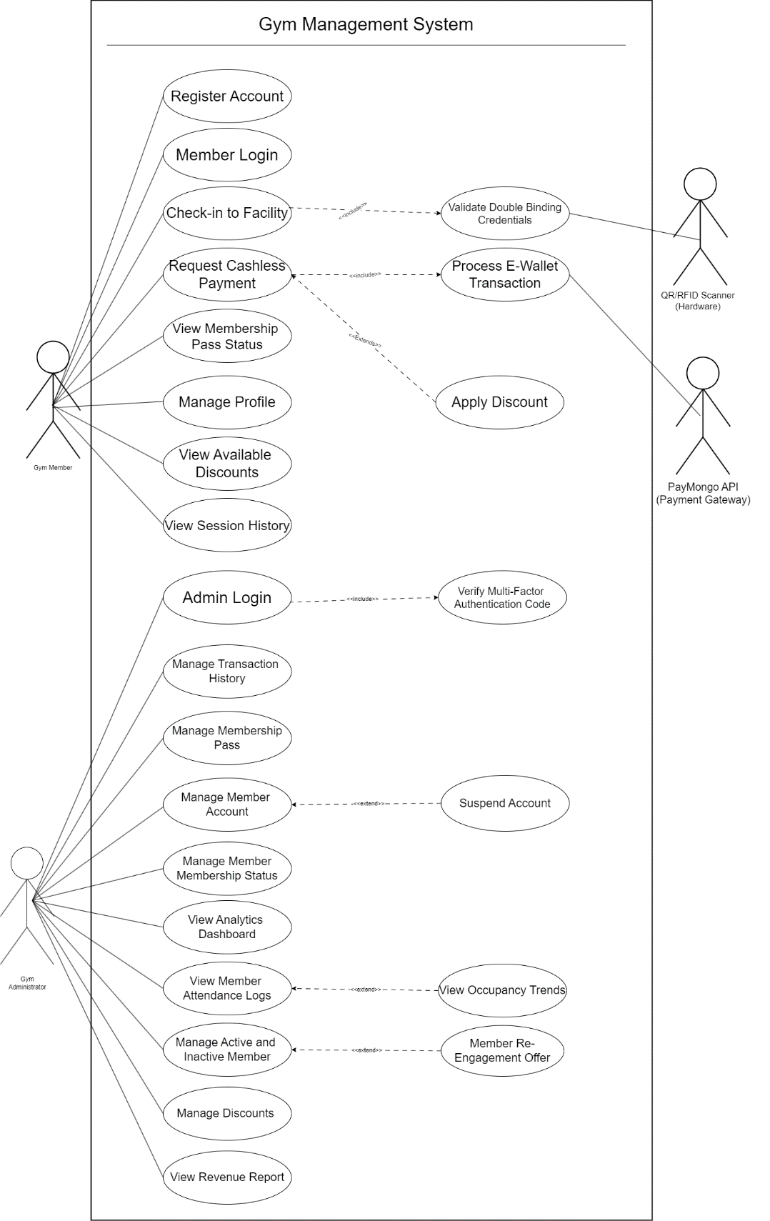

Appendix F
Proposed Data Flow Diagram

I. Context Diagram
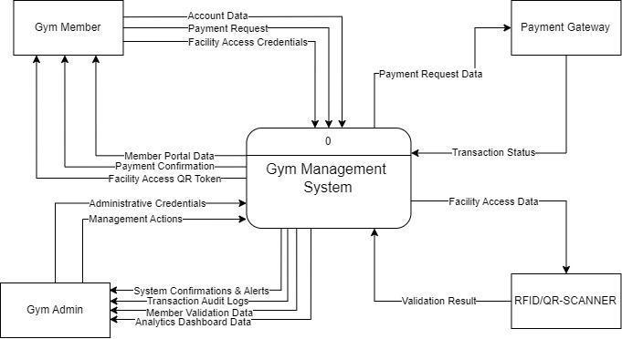
II. Level 1 Diagram
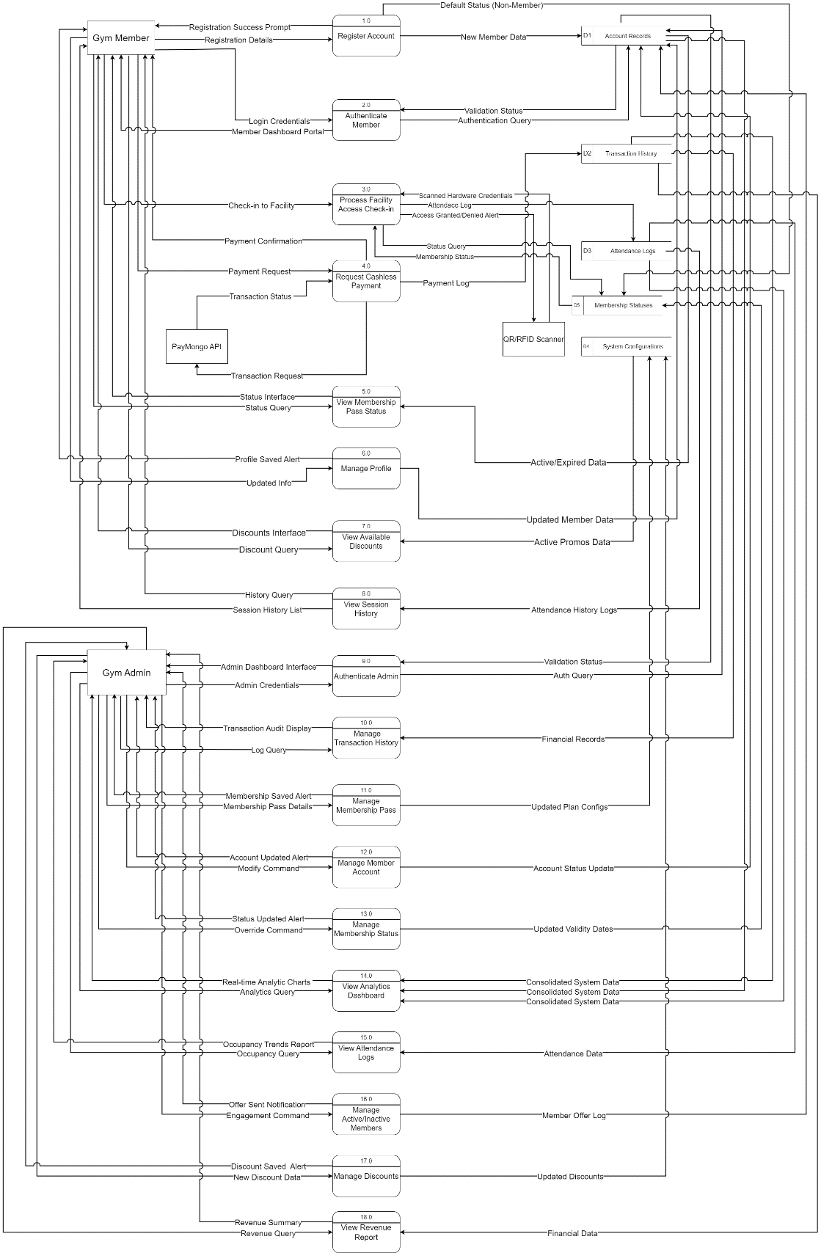
III. Level 2 Diagram
Process 1 (Register Member)
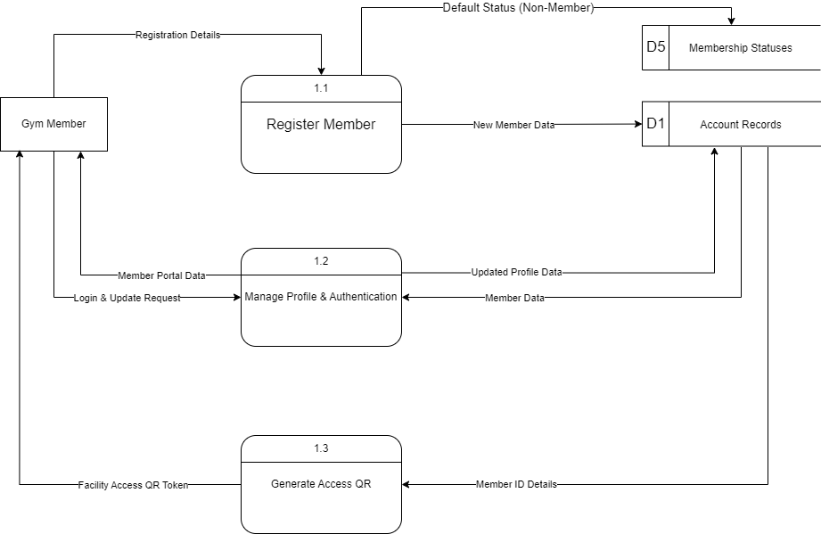
IV. Level 2 Diagram
Process 2 (Retrieve Pass & Compute Total)
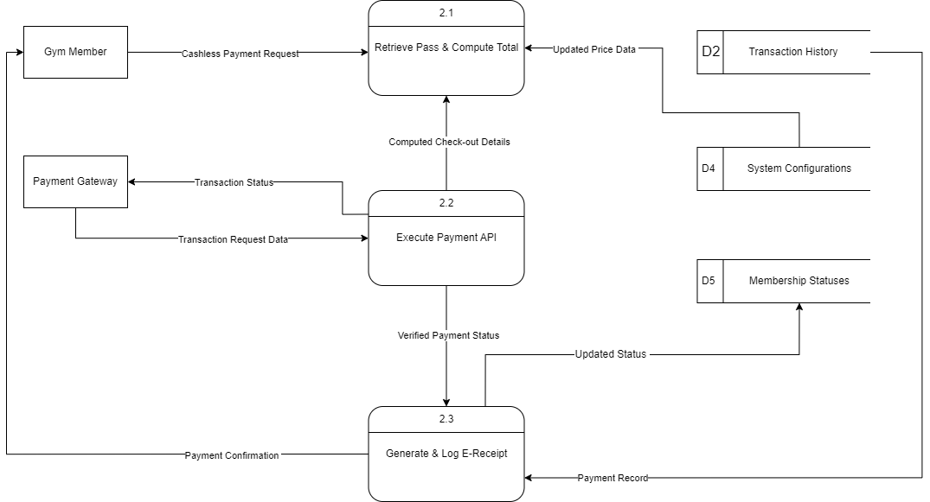
V. Level 2 Diagram
Process 3 (Validate Access Credentials)

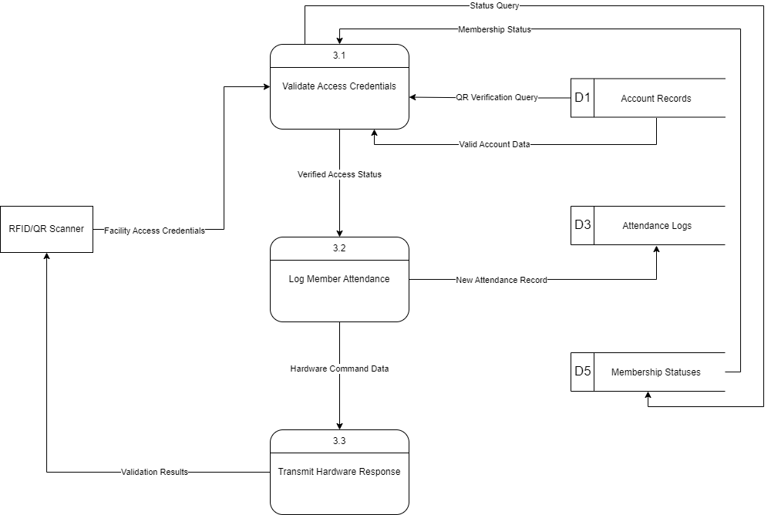
VI. Level 2 Diagram
Process 4 (Authenticate Admin Session)

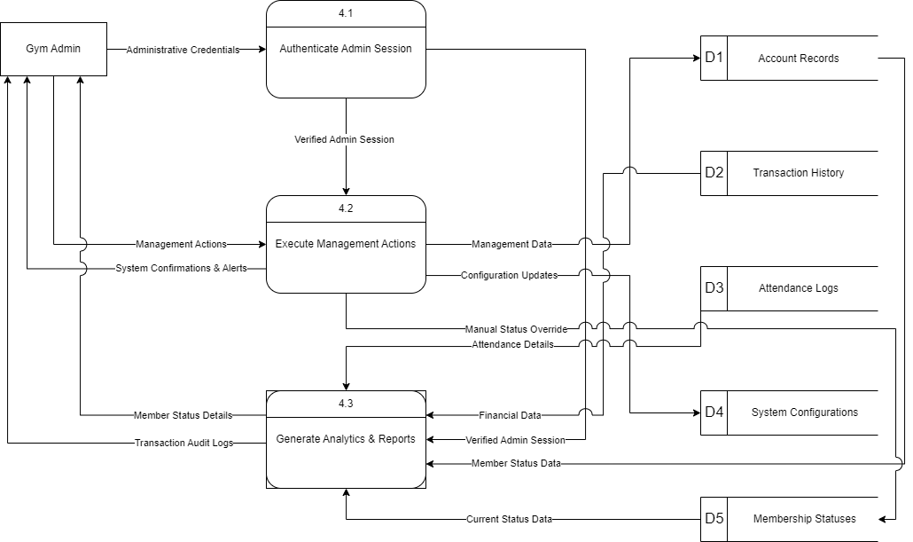
Appendix G
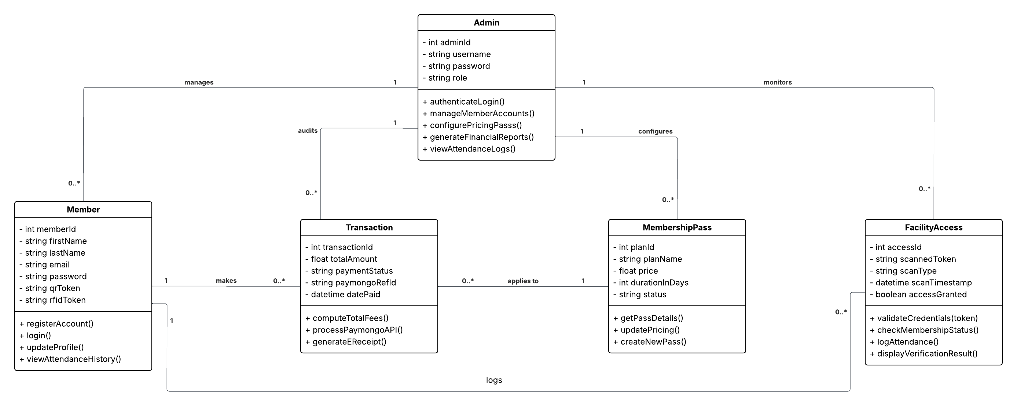
Proposed Class Diagram

