测量传感器灵敏度K随工作电压$U_{s}$的变化数据
Us/V | U0/V | U/V | U0-U/V | K/(V/T)
2.50 | 1.2250 | 1.2880 | 0.063 | 17.54
3.00 | 1.4735 | 1.5523 | 0.0788 | 21.94
3.50 | 1.7284 | 1.8110 | 0.0826 | 23.00
4.00 | 1.9726 | 2.0748 | 0.1022 | 28.46
4.50 | 2.2135 | 2.332 | 0.1185 | 32.99
5.00 | 2.467 | 2.587 | 0.12 | 33.41
5.50 | 2.714 | 2.845 | 0.131 | 36.48
6.00 | 2.952 | 3.097 | 0.145 | 40.37
6.50 | 3.195 | 3.348 | 0.153 | 42.60
7.00 | 3.443 | 3.604 | 0.161 | 44.83
7.50 | 3.683 | 3.856 | 0.173 | 48.17
8.00 | 3.930 | 4.100 | 0.17 | 47.33
8.50 | 4.176 | 4.343 | 0.167 | 46.50
9.00 | 4.414 | 4.593 | 0.179 | 49.84
9.50 | 4.655 | 4.842 | 0.187 | 52.07

$K−U_{s}$图像 K-Us线性拟合图像
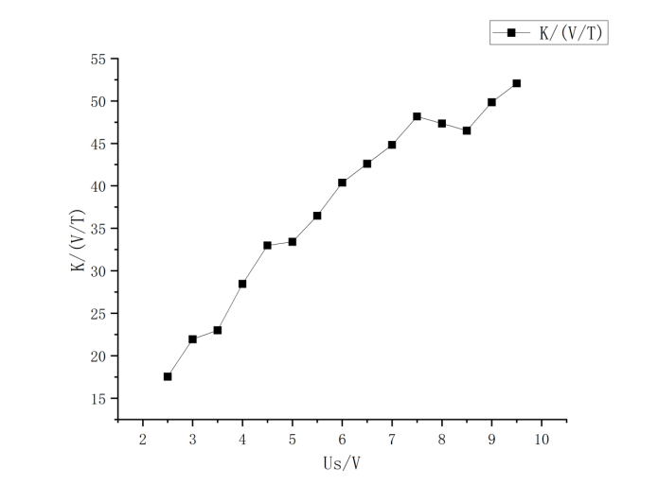
K-Us线性拟合图像

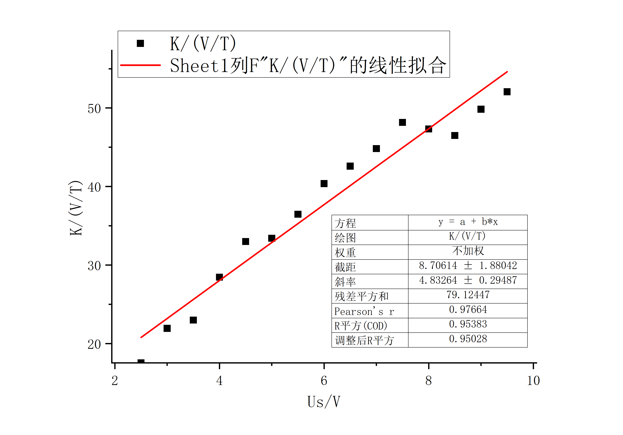

测量输出电压U($U_{0}=0$)
随磁感应强度B的变化数据 U-B线性拟合图像

Im/A | B/mT | U-U0/V
0 | 0 | 0
0.05 | 0.7183 | 0.0289
0.1 | 1.4366 | 0.0535
0.15 | 2.1549 | 0.0740
0.2 | 2.8732 | 0.0985
0.25 | 3.5915 | 0.1228
0.3 | 4.3098 | 0.1433
0.35 | 5.0281 | 0.1688
0.4 | 5.7464 | 0.1937
0.45 | 6.4647 | 0.2156
0.5 | 7.183 | 0.2390
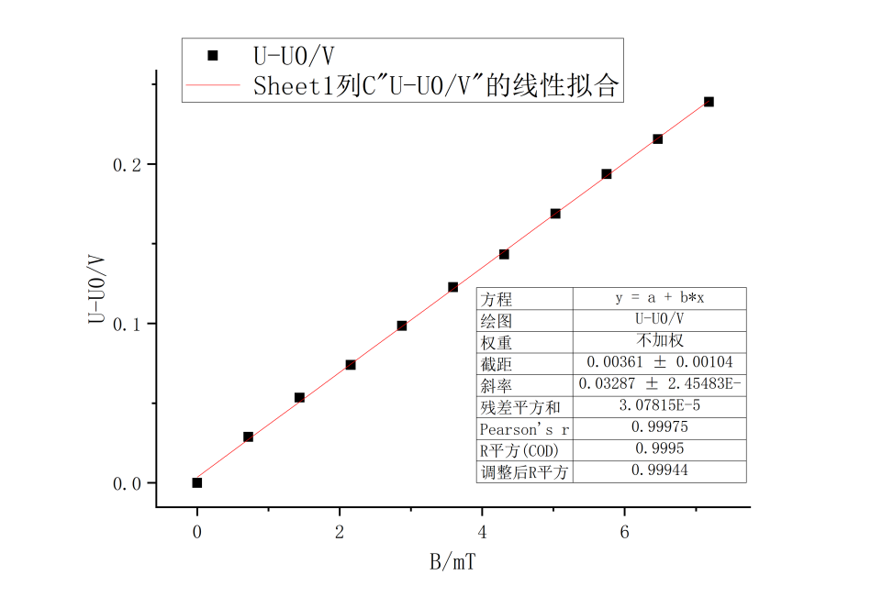
测量螺线管内磁场分布数据
x/cm | U-U0/V | B/mT（实验） | B/mT（理论） | x/cm | U-U0/V | B/mT（实验） | B/mT（理论）
13 | 0.0610 | 1.85580 | 1.80825 | -1 | 0.123 | 3.74201 | 3.59075
12.5 | 0.0788 | 2.39732 | 2.31525 | -2 | 0.1228 | 3.73593 | 3.589
12 | 0.0927 | 2.82020 | 2.71575 | -3 | 0.1228 | 3.73593 | 3.58575
11.5 | 0.1026 | 3.12139 | 2.99075 | -4 | 0.1225 | 3.72680 | 3.58075
11 | 0.1100 | 3.34651 | 3.17125 | -5 | 0.1222 | 3.71767 | 3.573
10 | 0.1158 | 3.52297 | 3.3695 | -6 | 0.1217 | 3.70246 | 3.56125
9 | 0.1192 | 3.62641 | 3.464 | -7 | 0.1211 | 3.68421 | 3.54325
8 | 0.1209 | 3.67813 | 3.51425 | -8 | 0.12 | 3.65075 | 3.51425
7 | 0.1219 | 3.70855 | 3.54325 | -9 | 0.1184 | 3.60207 | 3.464
6 | 0.1225 | 3.72681 | 3.56125 | -10 | 0.1155 | 3.51384 | 3.3695
5 | 0.1228 | 3.73593 | 3.573 | -11 | 0.1093 | 3.32522 | 3.17125
4 | 0.1229 | 3.73897 | 3.58075 | -11.5 | 0.1031 | 3.13660 | 2.99075
3 | 0.1230 | 3.74201 | 3.58575 | -12 | 0.0912 | 2.77457 | 2.71575
2 | 0.1230 | 3.74201 | 3.589 | -12.5 | 0.081 | 2.46425 | 2.31525
1 | 0.1228 | 3.73593 | 3.59075 | -13 | 0.0639 | 1.94402 | 1.80825
0 | 0.1229 | 3.73897 | 3.5915

磁感应强度实验值和理论值图像
