EquiPop: The Book
Compiled from the repository sources - version dev. Every example runs; every figure has a script.

1. What EquiPop measures

The idea
Ask a person in any town: "what is your neighbourhood?" Nobody answers with the name of a statistical zone or a four-digit area code. People experience the town from where they stand — the nearest streets, the nearest shops, the nearest thousand people. EquiPop takes that everyday experience seriously and turns it into a measurement. For every person in the data (or, technically, for every small square of the map that people live on), the software looks outward from that person's own doorstep and collects their k nearest neighbours — the closest 50, or 400, or 25,600 people, where k is simply the number you asked for. It then describes that personal collection: how many of them belong to some group you care about, what the typical income among them is, how far away the last of them lives.
Because the neighbourhood is built outward from each individual, it is called an egocentric neighbourhood — "ego" being the person at the centre. Every person gets their own, and no two are identical, just as no two people share exactly the same view from their kitchen window.
Why go to this trouble? Two reasons, and they are the reason this software family exists at all. The first is that the arbitrary map disappears. Administrative borders were drawn for taxation and elections, not for describing social life, and two neighbours on opposite sides of a district line are still neighbours. Egocentric neighbourhoods do not know the border is there. The second reason is that the neighbourhood gets a size dial. Is "my neighbourhood" the fifty people nearest me, or the sixteen hundred? There is no single right answer — so instead of choosing one, EquiPop lets you compute them all. Any quantity you care about — a segregation index, the share of highly educated people around each resident, an accessibility score — stops being a single number frozen at one administrative level and becomes a profile across scales: a curve showing how the answer changes as the neighbourhood grows.
Very often, that curve is itself the finding. If a minority group is strongly concentrated at the scale of fifty neighbours but the concentration has faded by the scale of six thousand, the town sorts people street by street rather than district by district — and that is a different social story, with different policy implications, than the reverse.
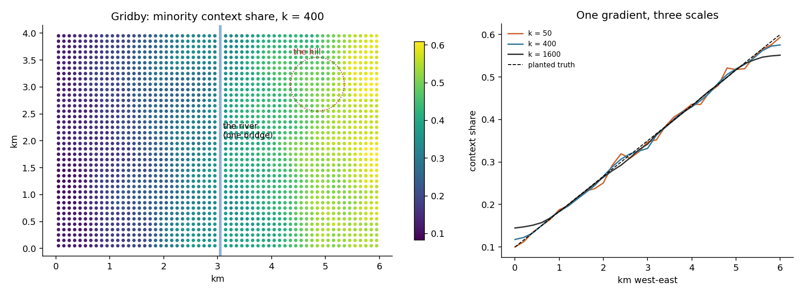
Figure: Gridby: the context share at k = 400, and the same gradient seen at three scales
The figure introduces Gridby, the invented town used for the examples throughout this book. Gridby was generated by a small script (founded, in its fictional history, in 1848 — which is also the random seed that makes it reproducible), and it was built with *planted* properties that we know exactly: the minority share rises smoothly from 10 % at the western edge to 60 % at the eastern edge, a river with a single bridge runs down the middle, there is one hill, and most jobs cluster west of the water. Real data shows everything at once and therefore nothing clearly; Gridby lets every figure in this book demonstrate exactly one phenomenon against a truth we can check. In the left panel, each dot is a 100-metre square coloured by the share of minority residents among the 400 people nearest to it. In the right panel, the same information is averaged into a curve, once for each of three neighbourhood sizes. Notice how the k = 50 curve is jumpy — small neighbourhoods are noisy — while k = 1,600 is smooth, and all three follow the dashed line, which is the gradient the town was actually built with. Same town, same people, three magnifications of the same truth.

Cook it
The example below is complete: you can paste it into any Python window after chapter 2's installation and it will run. Reading it line by line: the first three lines fetch the tools; load("gridby") creates the teaching town; the CellData(...) call packs the town's residents into the internal format the engines use (their coordinates, how many people live in each square, and how many of those belong to the group we labelled g); and the final line is the actual analysis — one engine call, three neighbourhood sizes at once.
from equipop.datasets import load
from equipop.cells import CellData
from equipop.fastcounts import run_knn_counts

g = load("gridby")
p = g["people"]
cd = CellData(E=p.x.to_numpy(), N=p.y.to_numpy(),
n=p.count_all.to_numpy(),
binary_sums={"g": p.count_group.to_numpy()},
value_arrays={}, unit_size=100.0)
out = run_knn_counts(cd, k_values=[50, 400, 1600])
print(out[["EastWest", "NorthSouth", "N_400", "R_g_400"]].head())

The result is a table with one row per inhabited square and a small family of columns for every k you asked for. The naming is systematic, so it is worth learning once. N_400 is how many people were actually counted when reaching for the 400 nearest — it can be slightly more than 400, and the "Under the hood" section explains why. T_g_400 is how many of those belong to the group. R_g_400 is the share — T divided by N — which is the number most analyses want. And Dist_400 records how many metres outward the search had to travel. Read R_g_400 aloud as: "among the 400 people nearest to this square, this is the fraction who belong to group g."

The dials
k_values — as many scales as you like in one run; the engine is built so that asking for five scales costs barely more than asking for one. unit_size — the resolution of the underlying grid, in metres (100 is the classic for register data). Everything else in this book is, in a sense, more dials for this one idea.

Under the hood
Three conventions do quiet work inside every result, and we state them here once so later chapters can rely on them. First, k is defined on raw counts, and whole squares enter the neighbourhood at once: if the search has gathered 398 people and the next square holds 5, all 5 come in, and N_400 honestly reports 403 rather than pretending to have stopped at exactly 400. Second, when several squares lie at *exactly* the same distance, they enter together, as one atomic ring. This makes results deterministic and symmetric in every direction; a tiny tolerance (a millionth of a metre) absorbs computer rounding noise, and a legacy mode can reproduce the original 2000s software's one-square-at-a-time behaviour when backward comparability demands it. Third, rows with missing coordinates are dropped with a printed count — never silently — and if the data runs out before k is reached, you receive partial results with the honest numbers, never an empty cell.

Pitfalls
The scale dial cuts both ways. Comparing the share at k = 400 in a dense city with the share at k = 400 in the countryside compares neighbourhoods of very different physical size — in the city those 400 people live within a few blocks, in the countryside they may be spread over many kilometres. The population is held fixed; the geography floats. That is a feature, and chapter 4 turns it into a whole menu of choices — but only if you know it is happening.

2. Install and first run

The idea
EquiPop is an ordinary Python package, and that is a deliberate choice: no separate program to install, no licence server, no GIS system as a prerequisite. If your computer can run Python — and any computer with the free Anaconda distribution can — then one command in a terminal window fetches EquiPop from the internet and makes it available everywhere on your machine. The command is pip install equipop, and "pip" is simply Python's built-in app store: it downloads the package, checks what it depends on, and puts everything in place.
The core installation is intentionally small. It brings only the essential mathematical libraries, which means it installs in under a minute and works on modest machines. The heavier abilities — reading satellite rasters, opening GIS shapefiles, importing SPSS files, drawing maps — live in optional helper packages that you install only if and when you need them. You never have to guess which one: the moment a function needs a helper that is missing, EquiPop stops and tells you its exact name and the exact command to install it.

Cook it
Open a terminal (on Windows, search the Start menu for "Anaconda Prompt") and type:
pip install equipop

When the prompt returns, the installation is done. Now the thirty-second first analysis. Paste the following into any Python window — Jupyter, Spyder, or plain python in the terminal. It invents a tiny dataset of seven people by hand, so nothing needs to be downloaded: each person has an x and a y coordinate (in metres) and a 0/1 marker called hi for belonging to some group.
import pandas as pd
from equipop.cells import build_cells
from equipop.fastcounts import run_knn_counts

df = pd.DataFrame({
"x": [100, 150, 300, 320, 900, 950, 980],
"y": [100, 120, 300, 310, 900, 920, 950],
"hi": [1, 0, 1, 1, 0, 0, 1]})

cd = build_cells(df, "x", "y", binary_vars=["hi"], unit_size=100)
print(run_knn_counts(cd, k_values=[3, 5]))

Two things happen here. build_cells takes the seven individuals and sorts them into 100-metre squares — people who share a square are counted together, which is both faster and, with register data, often required for privacy. Then run_knn_counts builds each square's egocentric neighbourhood at two sizes, k = 3 and k = 5. The printed table shows every column type you will meet in this book: N_local (how many people share your own square), N_3 (at least three — whole squares enter at once, as chapter 1 explained), T_hi_3 and R_hi_3 (the group count and the group share among them), and Dist_3 (how far, in metres, the search travelled to find three people). If that table printed, your installation is complete and correct, and everything else in this book will run.

The dials
The optional helpers, installed on demand with the same pip install pattern: geopandas pyogrio for GIS files such as shapefiles and GeoPackages; rasterio for rasters, including elevation models; pyreadstat for SPSS .sav files; openpyxl for Excel; matplotlib jenkspy for the mapping functions; and pyarrow for the very-large-run machinery of chapter 17.

Under the hood
It is worth understanding, once, why the software works on squares ("cells") rather than directly on individuals, because this single design choice explains much of EquiPop's speed and reach. When build_cells aggregates people into 100-metre squares, a country of sixteen million residents becomes a few million squares — a size that fits comfortably in an ordinary computer's memory — while losing at most fifty metres of positional precision, which is usually finer than the data's own accuracy. All engines in this book work on those squares and share the conventions of chapter 1. The engine used above is the "fast engine", the workhorse for counts and shares; its two siblings handle value statistics (chapter 6) and travel effort over rivers and hills (chapters 9 and 10).

Pitfalls
Coordinates must be metric — expressed in metres, like the Swedish or UTM national grids — not in degrees of longitude and latitude. Degrees are not distances (a degree of longitude shrinks as you travel north), so distance-based analysis on them is meaningless. If your data arrives in longitude/latitude, chapter 3 shows the one-line conversion, and EquiPop will even *suggest* a suitable metric system for your part of the world if you do not know which one to use.

3. Data in: files, coordinates, and the quiet traps

The idea
Every analysis in this book starts the same way: a table arrives with one row per person (or per square), an east–west coordinate, a north–south coordinate, and some columns describing people. This chapter is about getting that table into EquiPop safely — and it is longer than "read the file" deserves, because the traps of this stage are quiet ones. A wrong half-life announces itself in odd results; a wrong coordinate system produces maps that look perfectly plausible and are perfectly wrong.
Reading the file is the easy part. The read_table helper opens the formats register researchers actually meet — comma files, semicolon files (the Nordic default, since our decimal commas occupy the comma's job), tab files, Excel sheets, SPSS .sav files, zipped GIS layers — and it *sniffs* rather than assumes: the separator, the character encoding, the invisible "byte-order mark" that Windows sometimes hides at the start of a file, all detected and reported in one printed line. If that line says "semicolon, 2,699 rows, 6 columns" and you expected commas and seven columns, you have learned something important for the price of reading one sentence.
Coordinates deserve the slow paragraph. A coordinate system is an agreement about what the two numbers *mean*, and there are two families. Longitude and latitude — the familiar degrees — describe positions on a globe, and degrees are not distances: a step of one degree east is 111 kilometres at the equator and half that in northern Sweden. Distance-based analysis on degrees is therefore meaningless. The second family, metric (projected) systems, lays a flat grid over a region and counts metres: Sweden's SWEREF 99 TM, the older Swedish RT90, the international UTM zones. EquiPop requires the metric kind, and helps you get there: a one-line conversion projects degrees into metres, and if you do not know which metric system suits your region, the software will inspect your coordinates and *suggest* one.
The last idea of the chapter is snapping. Register squares are usually identified by coordinates that follow a convention — the square's south-west corner, or its midpoint — and different registers follow different ones. EquiPop snaps every point onto a clean grid of square midpoints, which makes data from mixed conventions line up, and prints how far the points moved so a convention mismatch (a systematic 50-metre shift, say) becomes visible instead of silent.

Cook it
from equipop.io import read_table
from equipop.projection import suggest_projection, project_to_metric
from equipop.cells import build_cells

df = read_table("residents.sav") # sniffed and reported
# if the coordinates are degrees:
print(suggest_projection(df, "lon", "lat"))
df = project_to_metric(df, "lon", "lat", crs="EPSG:3006") # SWEREF 99

cd = build_cells(df, "x", "y", binary_vars=["HighEdu"],
value_vars=["income"], unit_size=100)

Rows with missing coordinates are dropped at the build_cells step — with a printed count, in the family tradition — because a person who cannot be placed on the map cannot have a neighbourhood; their other columns are untouched, and chapter 16 shows how such rows simply receive missing results when working inside Stata.

The dials
read_table accepts explicit overrides (separator, sheet name, layer name) for the rare file that defeats sniffing; unit_size sets the grid; assign_zones attaches administrative-area labels from a polygon file to every point, which chapter 4's area mode and chapter 14's aggregations both use.

Under the hood
Why 100-metre squares? Partly tradition — Nordic registers deliver at that resolution — and partly a genuine sweet spot: fine enough that snapping moves a point at most 71 metres (half a diagonal), coarse enough that a whole country stays computable (chapter 2's memory argument). The snapping itself is a floor-division to the grid, plus half a square — deterministic, reversible in spirit, and identical across every engine so that all chapters' results align square for square.

Pitfalls
A war story, because it teaches better than a rule. A Swedish dataset once arrived with columns proudly named after SWEREF 99 — and coordinates that were actually RT90, the *previous* national system. The numbers looked reasonable; the two systems differ in ways a tired eye forgives; and every distance would have been subtly wrong. The tell was the value range: SWEREF 99 TM eastings in Sweden live roughly between 250,000 and 950,000, while RT90 eastings run about 1.2 to 1.9 million. Column names are testimony; value ranges are evidence. Thirty seconds with df.describe() before any analysis — checking that the coordinate ranges are plausible for the system you believe you have — is the cheapest insurance in this entire book. And one more habit from the same family: registers sometimes mix corner-coded and midpoint-coded squares; if a joined dataset refuses to line up, check whether one side's coordinates are all divisible by 100 and the other's all end in 50.

4. The neighbourhood definition menu

The idea
The word "neighbourhood" quietly hides a decision, and this chapter puts that decision in plain view. Whenever you draw a neighbourhood around a person, you are choosing to hold *something* constant and to let everything else vary. EquiPop makes the choice explicit and, rather than forcing one answer, offers the entire menu — all computable in the same run, side by side:
- k fixes the POPULATION. "Your neighbourhood is your 400
nearest people, wherever they happen to live." Everyone gets the same number of neighbours; how much ground that takes floats.
- r fixes the GEOMETRY. "Your neighbourhood is everyone within
500 metres, however many that is." Everyone gets the same circle; how many people it contains floats.
- tau fixes the EFFORT. "Your neighbourhood is everyone you can
reach within eight rounds of walking" — where hills, rivers and bridges make some directions cheaper than others (chapters 9 and 10 build this machinery).
- the unbounded decayed sum fixes NOTHING. Every person in the
data counts, but distant ones count less, faded by a distance- decay weight (chapter 7). No boundary at all — just a horizon of fading relevance.
- area fixes the ADMINISTRATION. The municipality is the
neighbourhood, as in the classical statistics — included in the menu so the old and the new can be compared inside one system.
None of these is the "correct" definition. They answer different questions, and asking how their answers differ is often an analysis in itself.
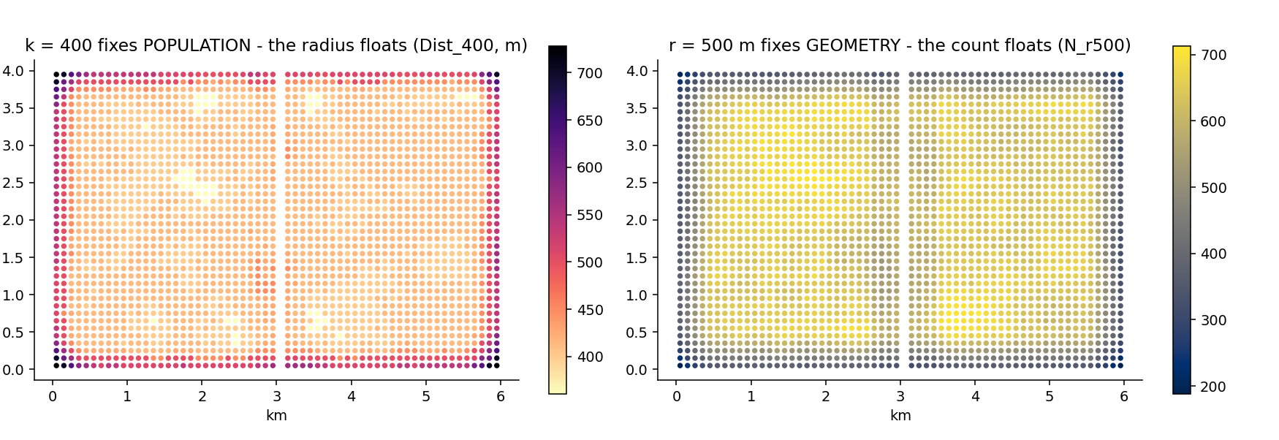
Figure: What floats: the k/r duality on Gridby
The figure makes the first two menu items argue with each other, using the same town. In the left panel, k = 400 is held fixed and the colour shows Dist_400 — how far each square's search had to travel to gather its 400 people. In the dense centre the search stops within a few hundred metres; at the town's edge it must reach far. The *radius* is what floats. In the right panel the choice is reversed: r = 500 metres is held fixed, and the colour shows N_r500 — how many people that circle contains, from a handful at the edge to over a thousand in the centre. Now the *count* is what floats. Neither map is wrong; each is the shadow of the other's choice.

Cook it
The menu items combine freely in one call, and the columns they produce follow the naming system of chapter 1 with a small twist: radius-based columns carry the radius in their name, so N_r500 means "the count within 500 metres" while plain N_400 still means "the count at k = 400".
out = run_knn_counts(cd, k_values=[400], r_values=[500])
# columns: N_400, R_g_400, Dist_400 AND N_r500, R_g_r500

The administrative member of the menu has its own small function, because it needs one extra piece of information — which area each person belongs to (here a column named Kommun):
from equipop.area import area_stats
per_area = area_stats(df, area_col="Kommun",
binary_vars=["hi"], value_vars=["income"])

The result is the familiar one-row-per-municipality table — counts, shares, and value statistics — produced from exactly the same variable declarations as the egocentric analyses, so switching between worlds costs one line.

The dials
Any mix of k_values and r_values in one call; tau_values on the effort engines of chapters 9–10; decay= for the unbounded sum; and area_stats for the administrative family, which also accepts survey-style weights for its counts and shares.

Under the hood
A design principle governs which columns exist in which mode, and once you see it, the output tables explain themselves: a column exists only where it measures something. Dist_ exists only for k — when the radius is fixed at 500 metres, "how far did the search go" has a trivial answer (500 metres), so no column pretends otherwise. Rounds_, the effort analogue, exists only on the graph engines. Area mode has neither, because an administrative area does not grow outward — there is no search whose length could be measured. Columns are honestly absent, never filled with a placeholder. A pleasant bonus of the radius world: the equal- distance tie problem of chapter 1 simply vanishes, because every square within the radius is included wholly by definition — there is no "last neighbour" whose ties need arbitrating.

Pitfalls
Radius users inherit the mirror image of chapter 1's warning: the count N_r500 varies enormously across space — that is precisely the point, geometry fixed and population floating — which means that a *share* like R_g_r500 may rest on twelve people in a sparse square and on twelve hundred in a dense one. Twelve people make a fragile percentage. The N_ columns always show you the basis a share stands on; reporting shares without their basis is how honest maps mislead.

5. Counts and ratios: the fast engine

The idea
This chapter belongs to the workhorse. Almost every analysis in the book begins the same way: for every inhabited square, gather the k nearest people and count who they are. The engine that does this is called the *fast engine*, and its four output columns per scale — N, T, R and Dist — are the vocabulary the rest of the book speaks. It pays to sit with them for a moment longer than chapter 1 could afford.
N_400 is the honest headcount: how many people were actually gathered when reaching for 400. As chapter 1 explained, whole squares enter at once, so the number can overshoot slightly — and the engine reports the truth rather than trimming it, because every share is only as honest as the count beneath it. T_g_400 is how many of those people carry the marker you asked about — the letter T is for *treatment*, a habit from the software's research history, and you can request several markers at once: highly educated, foreign-born, under eighteen, each getting its own T and R columns from a single run. R_g_400 is the division of the two, the *context share* — the single most used number in this family of methods, readable aloud as "among this person's 400 nearest, the share who are g". And Dist_400 records the search radius in metres, which is not a by-product but a finding in its own right: it is the physical size of a 400-person world, small where the town is dense and vast where it is not.
One more idea completes the picture: pre-aggregated data. Register extracts often arrive with one row meaning "27 persons with these properties in this square" rather than one row per person. The cell format of chapter 2 is built for exactly this: the counts simply *become* the cell masses, and every result behaves as if the 27 rows had been written out one by one. The example below shows the direct route.
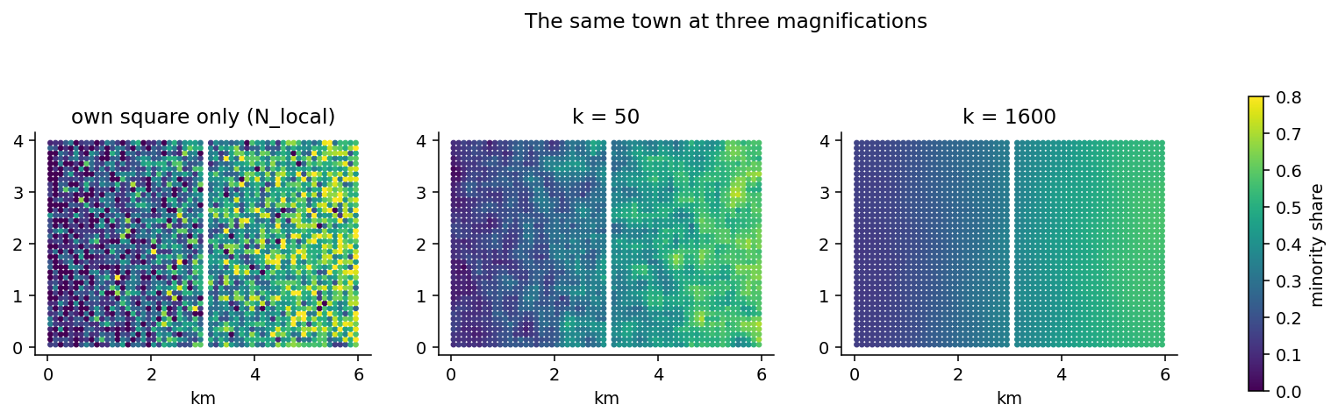
Figure: The same town at three magnifications
The figure shows why "which k?" deserves respect rather than habit. All three panels colour the same quantity — the minority share — for the same town. The left panel uses only each square's own residents: it is truthful and almost unreadable, a static of tiny denominators. The middle panel, k = 50, begins to show the planted west-to-east gradient through heavy noise. The right panel, k = 1,600, shows the gradient with complete serenity — and has, in exchange, smoothed away every street-level detail. None of the three is the correct picture. They are magnifications, and the honest analysis reports the ones that matter for its question — often several.

Cook it
The call below computes two group markers at three scales in one pass, on the Gridby data from chapter 1. Gridby's people table is pre-aggregated — each row is a square carrying count_all persons — so the counts go straight in as cell masses via CellData, with one summed column per marker:
from equipop.datasets import load
from equipop.cells import CellData
from equipop.fastcounts import run_knn_counts

g = load("gridby")
p = g["people"]
cd = CellData(E=p.x.to_numpy(), N=p.y.to_numpy(),
n=p.count_all.to_numpy(),
binary_sums={
"minority": p.count_group.to_numpy(),
"majority": (p.count_all - p.count_group).to_numpy()},
value_arrays={}, unit_size=100.0)
out = run_knn_counts(cd, k_values=[50, 400, 1600])

(If your data is one row per person instead, build_cells from chapter 2 does the aggregation for you — the two routes meet in the same CellData and the engines cannot tell them apart.)
The result carries R_minority_50 through R_majority_1600 — six share columns from one spatial search, because the engine finds each square's neighbours once and counts all markers on the way.

The dials
k_values and r_values (chapter 4) in any mix; m_neighbors and chunk, two purely technical knobs that trade memory for speed and that you will likely never touch; and origins=, which computes results for a subset of squares while keeping the full population as the searchable mass — the key that unlocks the very large runs of chapter 17.

Under the hood
The speed comes from a data structure called a KD-tree — think of it as a pre-sorted index of the map that can answer "what is near this point?" without checking every square. Using it, the original research runs processed seventy-three thousand Stockholm squares in under a minute, and chapter 17 stretches the same engine to national scale. One guarantee is worth knowing because it protects you silently: the engine first fetches a generous batch of neighbours per square, and if any square's batch turns out too small to reach its k (it happens at the edge of sparse regions), that square is automatically re-queried against the whole dataset. The result is always exact — the batching is a speed device, never an approximation.

Pitfalls
Two habits keep fast-engine results honest. First, never compare an R at one k with an R at another as if they measured the same thing — chapter 1's magnification lesson in reverse. Second, treat N_local (the own-square headcount) with care in publications: with register data, a map of squares containing one or two identifiable people is a disclosure risk, which is one reason the aggregation of chapter 2 exists at all. The egocentric shares are naturally safer — they always average over k people — but the local column deserves a privacy glance before it travels.

6. Value statistics: the neighbourhood as a distribution

The idea
Shares answer "how many of my neighbours are X?" This chapter's engine answers a richer question: "what are my neighbours *like*?" Take income. Among each person's 400 nearest, one can compute the average income, the median income (the middle person's — often more telling than the average, because a single millionaire drags an average but not a median), the standard deviation, and even a Gini coefficient — the classic 0-to-1 measure of inequality, where 0 means everyone earns the same and values towards 1 mean a few earn nearly everything. Computing a Gini *per neighbourhood* turns inequality itself into a local, mappable variable: not "is this country unequal?" but "how unequal is the world each person actually lives in?" — which can then sit on the right-hand side of a regression like any other characteristic.
Real registers have holes: some people's income is missing, coded away, or genuinely unknown. The engine's convention here deserves a careful sentence, because it is easy to guess wrong. A person with a missing income still counts as a neighbour — they live there, so they belong to the k — but they contribute nothing to the income statistics. And so every statistic travels with a companion column, Nv_ (for *N valid*), reporting how many of the k actually had a usable value. A median of 400 neighbours resting on 396 valid incomes is solid; the same median resting on 31 is a rumour, and the Nv_ column is how you tell the difference at a glance.
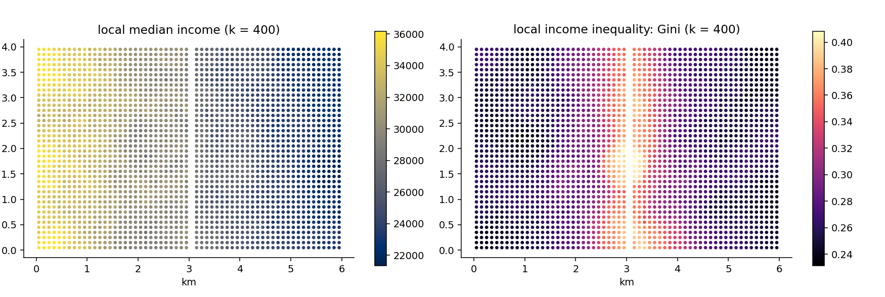
Figure: Local median income and local inequality on Gridby
For this figure, Gridby's residents were given invented incomes — the town has no economy of its own, so the script draws lognormal incomes, somewhat higher in the west and deliberately more unequal near the river, purely to have something worth mapping. The left panel shows the local median at k = 400: the built-in west-east tilt appears exactly as planted. The right panel maps the local Gini — and this is the picture worth pausing on, because it is a map most statistics never produce: *inequality as experienced*, square by square, highest in the band along the river where the script mixed rich and poor most thoroughly. Two neighbourhoods can share the same median and live in utterly different worlds; the pair of maps together says so.

Cook it
from equipop.cells import build_cells
from equipop.analysis import run_knn_stats

cd = build_cells(df, "x", "y", unit_size=100,
binary_vars=["HighEdu"],
value_vars=["income"])
out = run_knn_stats(cd, k_values=[400, 1600],
stats={"income": ["mean", "median", "gini"],
"HighEdu": ["ratio"]})

Reading the call: value_vars declares which columns hold continuous values (their actual numbers are kept, square by square, for exact statistics — see below); the stats dictionary then says which statistics each variable should receive. The output follows the naming system: Mean_income_400, Med_income_400, Gini_income_400, their basis Nv_income_400 — and, because the engine also handles group markers, R_HighEdu_400 arrives from the same run.

The dials
The statistics registry currently offers mean, sd, se, median, gini for values and ratio for group markers — and "registry" is meant literally: adding a new statistic to the software is one dictionary entry, not new machinery, so the list grows on request. k_values and r_values combine as always (chapter 4): the median income within 500 metres is one option away.

Under the hood
A median cannot be computed from summaries: you need the actual values, sorted. The engine therefore keeps, for every square, the stored list of its residents' values, and when a neighbourhood is assembled, the statistics are computed on the genuinely pooled numbers — the median is the *exact* median of those k people, the Gini the exact Gini, not an approximation stitched from per-square averages. This costs memory, which is why continuous variables must be declared in value_vars rather than being carried by default, and it is the honest price of statistics one can cite without footnotes.

Pitfalls
Two, both about small print. A Gini computed on very few valid values is unstable — with Nv below a few dozen, treat the number as weather, not climate, and consider filtering such squares from maps. And register incomes are often *top-coded* (capped at some ceiling for confidentiality): means and Ginis feel the cap, medians usually do not — one more reason the median is the workhorse of neighbourhood income analysis.

7. Distance decay: nearer matters more

The idea
Everything so far has treated the k-th neighbour exactly like the first: inside the neighbourhood, everyone counts as one. That is a clean convention, but it quietly contradicts everyday experience — the family next door plainly matters more to your daily life than a household four kilometres away who happens to be your 1,599th nearest. Distance decay repairs this by giving every neighbour a weight that starts at 1 on your own doorstep and fades with distance, so that counts and shares become *weighted* counts and shares in which nearby people carry more.
The question is how fast the fading should happen, and EquiPop's answer is a dial with a physical meaning: the half-life. You state one number — the distance at which a neighbour should count half as much as someone at your door — and the software computes the technical curve parameters for you. "Half-life 2 kilometres" is a statement a reader can picture; the equivalent raw coefficient (a beta of −0.00034662) is not, and that is the whole reason the dial exists.
Around that single dial, the software offers a *family of curve shapes*, because a century of research has found that different phenomena fade differently: commuting tolerates distance differently than shopping, and migration differently again. Five shapes are built in — the gently fading exponential (negexp, the default and the workhorse), a bell-like curve that stays flat nearby then drops (expnormal), two intermediate shapes, and the power family, whose personality deserves its own paragraph. A power curve drops steeply at first and then almost refuses to die: even far away, it keeps a little weight. Since version 1.4 the power curve takes a second dial, gamma, that controls the *thickness of that far tail* independently of the half-life — small gamma for "distance never quite kills relevance", large gamma for "beyond the half-life, interest collapses".
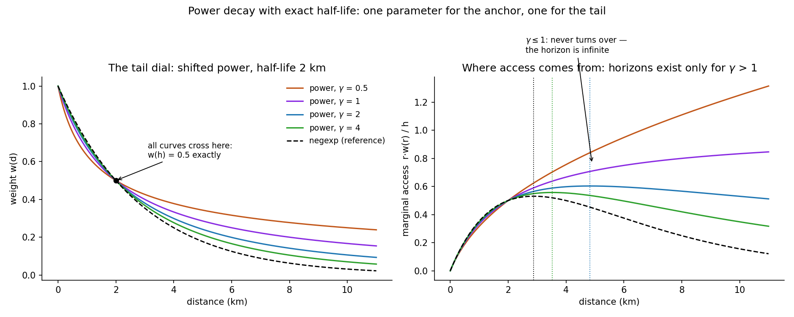
Figure: The tail dial, and where access comes from
The figure earns a slow look. In the left panel, four power curves with different gammas all pass through exactly the same point — a weight of one half at the two-kilometre half-life — because the half-life is the anchor, while gamma fans the tails apart; the dashed line is the familiar exponential for comparison. The right panel asks a subtler question: if opportunities are spread evenly across the map, *from what distance does most of your access actually arrive?* Nearby rings are small (little area, few opportunities); distant rings are large but heavily faded; in between lies a sweet spot — the opportunity horizon, marked by the dotted verticals, a concept chapter 12 builds into a full analysis. And notice the two curves that never turn downward: for gamma of one or below, the tail is so thick that access keeps arriving from ever farther away — mathematically, the horizon is infinite. The software tells you so, out loud, rather than printing a misleading number.

Cook it
Decay attaches to an analysis as one object. The example computes ordinary and decayed results side by side, which is the recommended habit — the comparison is free and often the finding:
from equipop.decay import Decay
from equipop import run_knn

dec = Decay(model="negexp", half_life_m=2000)
out = run_knn(cells, k_values=[400], unit_size=100, decay=dec)
# plain columns: N_400, T_400, R_400
# decayed columns: ND_400, TD_400, RD_400

Two conventions keep the columns interpretable. The neighbourhood itself is still defined by the *raw* count — your 400 nearest are your 400 nearest regardless of weighting — and the decayed columns are then recorded for that same set of people, which guarantees a decayed count can never exceed its raw twin. And for the boundary- free variant from chapter 4's menu — every person in the data, decay-weighted, no k at all — the fast engine accepts the same object directly:
out = run_knn_counts(cd, decay=Decay(model="power",
half_life_m=2000, gamma=1))
# adds ND_inf, TD_g_inf, RD_g_inf ("inf" for unbounded)

The dials
model (the five shapes), half_life_m (the dial with a meaning), gamma (the power family's tail thickness), and beta for experts who want to set the raw coefficient directly. The older power form without gamma remains available so that results from earlier versions reproduce exactly.

Under the hood
The unbounded sums cannot literally visit every square in a country, so the engine computes, per curve, the distance at which the weight falls below a millionth, and stops there — printing that truncation radius so the choice is on the record. For the curious: the "exact half-life for any gamma" trick works by shifting the power curve's starting point, which is also why the legacy power form (which shifted by a fixed one metre) had an oddly heavy tail — a story told in full in the design-decision register of Appendix B.

Pitfalls
The half-life is a *modelling choice*, and the most common mistake is treating it as a fact. Where possible, estimate it — observed commuting flows, when available, let the data choose its own half-life (a planned feature waits exactly for such a file) — and where not, report results at two or three half-lives so the reader sees what depends on the dial. And never compare decayed numbers across different curve shapes as if the shapes were interchangeable: at the same half-life, a power curve and an exponential agree at exactly one distance and disagree everywhere else — that is, after all, the entire point of having a family.

8. Hexagons: changing the tiles under the town

The idea
Every result so far has stood on a grid of squares, and a fair reader should ask: how much of what I see is the town, and how much is the squares? The question has a formal name — the Modifiable Areal Unit Problem, MAUP to its friends — and it is one of geography's oldest embarrassments: draw the collection units differently and many statistics change, sometimes a little, sometimes alarmingly. Electoral gerrymandering is the famous weaponised case; innocent grid choices are its accidental cousin.
Squares have two quirks worth knowing. A square has two kinds of neighbour — four that share an edge, at distance one, and four that touch only at a corner, at distance one-and-a-half in walking terms but often treated the same — which injects a faint diagonal flavour into anything built on adjacency. And a square grid has two privileged directions, which a strongly gridded street plan can resonate with. The classic alternative is the hexagon: six neighbours, all sharing a proper edge, all at exactly the same centre-to-centre distance, no corner-only contacts, no privileged axis. Beehives and board-game designers converged on it for the same reason.
EquiPop's position is not that hexagons are better — it is that the choice of tiles should be a testable dial, not an unexamined habit. Swapping the tessellation is one function call; everything downstream (every engine, every statistic, every chapter of this book) runs unchanged on either; and re-running an analysis on both is a do-it-yourself MAUP experiment that turns an old embarrassment into a robustness check for your particular result.
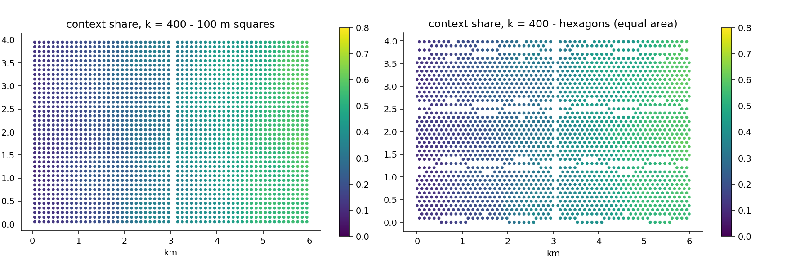
Figure: The same context share on squares and on hexagons
The figure runs the chapter 1 analysis twice on Gridby — identical people, identical k = 400, only the tiles changed (the hexagons are sized to match the squares' area, so the comparison is fair). The two maps are, to the eye, the same map; the share ranges agree to the second decimal (0.08–0.61 on squares, 0.09–0.61 on hexagons). That resemblance is not an accident of Gridby — it is the egocentric method doing its job. Because neighbourhoods are built from *people counted outward*, not from the tiles themselves, the tiles only decide how finely the population is pinned down before the counting starts. In the original research validation, a POI-density analysis of Malta that wobbled noticeably under square-grid changes became stable once the egocentric machinery ran on top — the method absorbs most of what MAUP throws at it, and this chapter is how you verify that claim on your own data rather than taking it on faith.

Cook it
from equipop.hex import build_hex_cells
from equipop.fastcounts import run_knn_counts

hx = build_hex_cells(rows, "x", "y", binary_vars=["g"],
hex_size=107) # width across flats, metres
out_h = run_knn_counts(hx, k_values=[400])

build_hex_cells is the hexagonal twin of chapter 2's build_cells: same inputs, same declarations, and it returns the same internal format — which is precisely why nothing downstream needs to know the tiles changed. One sizing note: to compare fairly against 100-metre squares, choose the hexagon width so the *areas* match; 107 metres across the flats gives a hexagon of almost exactly one hectare, the same ground as a 100-metre square.

The dials
hex_size — the width across the flats, the hexagonal analogue of unit_size. That is the whole list; the point of the design is that there is nothing else to learn.

Under the hood
Hexagons cannot be indexed by rounding coordinates the way squares can; the builder uses the standard axial-coordinate mathematics from computational geometry (snap to a skewed lattice, then a small correction called cube-rounding picks the truly nearest hexagon centre). The result is exact nearest-hexagon assignment, and the printed output includes the same movement report as the square snapper, so convention mismatches stay visible here too.

Pitfalls
Two honest limits. First, comparability: a result at k = 400 on squares and one on hexagons are comparable; a *radius* result needs the equal-area sizing above, or you are comparing differently grained pinning of the population. Second, the current boundary of the software: the terrain machinery of the next two chapters — rivers, hills, travel effort — presently runs on the square grid only; its hexagonal counterpart (six equal neighbours make for elegant effort models) is designed and on the roadmap, and this book will gain the sentence announcing it when it lands. Until then: tessellation experiments for counting and statistics, squares for terrain.

9. Friction: when straight lines lie

The idea
Every distance so far has been drawn with a ruler — the straight line from square to square. Towns are not rulers. A river without a bridge makes two squares 200 metres apart effectively distant; a railway yard, a motorway cutting, a fenced industrial estate do the same. This chapter introduces the machinery that lets the map push back: friction.
The mental model is walking. Imagine standing on your square and spreading outward one step — one square — at a time; call each sweep of steps a round. On an open plain, three rounds reach everything within three squares, a tidy diamond. Now declare some squares *costly*: entering a river square costs not one round but seven (one for the step, six for the friction you assigned it). The spreading walk now flows around the river, squeezes across the bridge, and the shape of "what I can reach in three rounds" stops being a diamond and starts being the truth. The software computes this spreading exactly — the algorithm underneath is the classic shortest-path method of computer science (Dijkstra's, for the curious), run from every inhabited square.
Friction changes the *questions* you can ask, and two new column families appear to answer them. Rounds_200 answers "how much walking effort until I have gathered my 200 nearest people?" — the effort twin of Dist_200, and the two disagreeing is exactly where the ruler was lying. And tau — chapter 4's third menu item — turns the question around: N_tau3 counts the people reachable within an effort budget of three rounds, the honest version of "who lives within fifteen minutes of me".
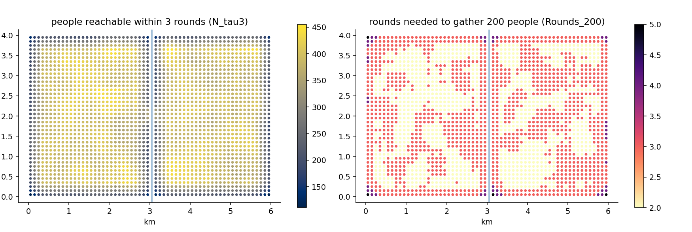
Figure: The river's shadow on Gridby
The figure lets Gridby's planted river (friction 6, one bridge) speak. In the left panel, the colour is N_tau3 — how many people each square can reach in three rounds. Away from the water the values follow simple density; along the river a dark seam appears on both banks: for those squares, half the world sits behind a six-round wall, and only the bridge's neighbourhood escapes the shadow. In the right panel the same story is told in the other currency — Rounds_200, the effort to gather 200 people — and the seam brightens instead of darkens: river-hugging squares need more rounds for the same crowd. Same wall, two shadows. In chapter 11 this seam reappeared, uninvited, as the edge of the LISA clusters — planted geography echoing through every layer of analysis, which is precisely what Gridby is for.

Cook it
Friction arrives as a small table of costly squares — coordinates plus a friction value — and everything else is one call:
from equipop.datasets import load
from equipop.friction import run_knn_friction

g = load("gridby")
res = run_knn_friction(g["people"], k_values=[200],
fr=g["friction"], unit_size=100,
tau_values=[3])
# columns: N_200, Rounds_200, T_/R_ as usual, and N_tau3, R_tau3

The friction table's convention deserves one careful sentence: squares *not listed* in the table cost the default, and the default is zero extra — so the natural way to use the file is as a list of barriers, naming only the rivers, the cuttings, the fences. (If you prefer the opposite — listing the *passable* squares in a world of walls — set default_friction high and list the roads; the machinery is indifferent.)

The dials
fr (the friction table) and default_friction; and since version 1.15 the table need not be typed at all — features_to_friction rasterizes your river and railway *line or polygon features* onto the grid, with overlapping features stacking their costs additively (a river and a railway in one square cost both); k_values and tau_values from the shared menu; and origins=, which computes results for a subset of squares against the full population — the same key that chapter 17 uses at national scale, available here because effort computations are the expensive ones.

Under the hood
Costs attach to the square being *entered* — friction is a property of the destination step, added on arrival — and diagonal steps count one-and-a-half, so that effort approximates true walking distance rather than chessboard distance. The Rounds reported are *flat-equivalent*: a value of 5 means "as much effort as five open squares", whatever mixture of walking and wall- climbing produced it, which keeps the number comparable across a map. The engine was validated the way this book prefers: on real Stockholm water barriers, where the correlation between beeline and effort results decays with distance from the water in exactly the pattern theory predicts. And a promise for the next chapter: the machinery here treats all costly squares alike, whichever direction you cross them — hills, where *direction matters*, get their own chapter and their own mathematics, built on this same spreading walk.

Pitfalls
Friction values are model choices wearing numeric clothes. "The river costs six" is a statement about how much that river deters, not a measurement — so, as with half-lives in chapter 7, report sensitivity (does the seam survive at friction three? at ten?) rather than false precision. And keep the two uses of the table conceptually separate: a *barrier* (high friction, rarely crossed) and a *slowdown* (mild friction, routinely crossed) are different claims about the world; a value of 2 says people cross constantly at modest cost, a value of 50 says essentially never — make the number say what you mean.

10. Slopes and the journey home

The idea
Chapter 9's friction treats every barrier the same in both directions: a river costs six to cross, eastbound or westbound. But one kind of terrain refuses that symmetry. Walking *up* a hill and walking *down* it are famously different experiences, and any machinery that prices them equally has quietly flattened the world. This chapter makes effort directional.
The ingredient is an elevation model — a height for every square of the map, from a national terrain file or, as here, from Gridby's planted hill. From heights come slopes: for every step between neighbouring squares, the software knows the rise (or fall) over the run. Each step's cost is then the ordinary one round *multiplied by a slope penalty*, and the penalty curve is a chooseable model. The default is the venerable Tobler hiking function, distilled from real walking data a half-century ago, and it encodes two truths worth saying in words: climbing is punished increasingly steeply, and — the subtle one — the cheapest step is not the flat one but a *very gentle descent*, exactly as every hiker knows in their knees. A simpler linear model is available when you would rather state your own price per percent of climb, separately for up and for down.
Directionality unlocks a question that symmetric friction cannot even ask: what about the journey home? Every trip out of a valley is a climb back; every errand from a hilltop is a climb at the end. With roundtrip=True, the software computes the outbound and the homebound effort along their own best paths and reports their average — so the numbers stay comparable with one-way runs (on flat ground the two are identical, and the software's tests hold it to that), while genuinely hilly ground reveals its asymmetries. In the original Malta validation this produced the memorable "valley tax": residents of the lowest-lying quarter of the island carried a measurably heavier round-trip stretch than hillside dwellers, a pattern invisible to every symmetric method.
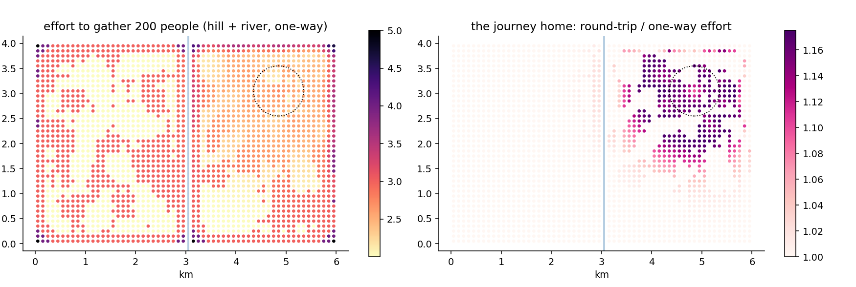
Figure: The hill's toll, and the journey home
On Gridby, the left panel shows one-way effort to gather 200 people, with both terrain features at work: the river's seam from chapter 9, and now a warm halo on the north-eastern hill (the dotted circle) where every direction out means climbing. The right panel asks the round-trip question — homebound effort divided by outbound — and the hill lights up alone: for its residents, the full cost of daily life runs up to 18 % above what a one-way analysis would report. The river, note, stays dark in this panel: a river punishes both directions alike, so the round trip forgives it nothing and adds nothing. The two panels together are the chapter's argument: *symmetric* obstacles shape the left map, *asymmetric* ones the right.

Cook it
from equipop.datasets import load
from equipop.slope import run_knn_slope

g = load("gridby")
res = run_knn_slope(g["people"], k_values=[200],
altitude="dem.tif", # or a DataFrame(x, y, alt)
fr=g["friction"], # rivers still apply
roundtrip=True, unit_size=100)
# columns as chapter 9, with Rounds_200 now terrain-aware

The altitude can arrive three ways: a path to a terrain raster (GeoTIFF), which the software averages into square heights for you, sea-noise clipped and reported; a plain table of x, y, alt; or a raw array. Friction and slopes combine naturally — the river costs its six *and* the approach to it may climb — because barriers and terrain are different facts about the same walk.

The dials
model ("tobler" or "linear"), the linear model's lambda_up and lambda_down (your price per unit of climb and of descent), roundtrip, tau_values for effort budgets, and origins= for subset runs at scale. A flat elevation model reproduces chapter 9 *exactly* — regression-tested — so slopes are strictly an extension, never a reinterpretation.

Under the hood
The slope of a step is computed over the true centre-to-centre distance — a diagonal step is longer, so the same rise is a gentler grade — and the penalty multiplies the *movement* cost while friction adds to the *destination*, a division of labour that keeps the two ideas composable. Round trips are computed by running the spreading walk twice, once outward and once with every step's direction reversed, then averaging per leg. And all reported Rounds remain *flat-equivalent* (chapter 9's currency): a 5 means "as much effort as five open, level squares", whatever mixture of climbing produced it.

Pitfalls
Terrain data has resolution, and slopes are its derivative — the noisiest thing you can compute from it. A 90-metre elevation model averaged into 100-metre squares gives honest neighbourhood-scale grades; expecting it to know about a staircase is asking the data for fiction. And the hiking-function warning mirrors chapter 9's: Tobler describes walking. For cycling, driving, or wheelchair accessibility the penalty curve is a different research statement — the linear model with your own lambdas is the honest tool there, reported with the same sensitivity habit as every other dial in this book.

11. Spatial autocorrelation: clusters, hot spots, and one loud warning

The idea
Earlier chapters ask *how unevenly* something is spread across a town. This chapter asks a different, complementary question: *does the map cluster?* Imagine cutting the map into tiles and looking at each tile together with its immediate surroundings. Do high values tend to sit next to other high values, forming patches — the way house prices usually do? Do high and low alternate like a checkerboard? Or, if you shuffled all the tiles randomly, would the map look just the same?
The classic single-number answer is Moran's I, which runs from roughly −1 to +1. A strongly positive I says "like sits with like": the map is patchy, clustered. A strongly negative I says values alternate — rare in social data, but it is what a perfect checkerboard produces. An I near zero says the arrangement is indistinguishable from shuffled tiles. Because a single global number can hide a lot, Moran's I also comes in a local version, usually called LISA (for *Local Indicators of Spatial Association*): one value per square, telling you whether *that* square sits in a patch of high values surrounded by high (labelled HH), low surrounded by low (LL), or is a lonely outlier — a high square in low surroundings (HL) or the reverse (LH). A close cousin, the Getis–Ord Gi\* statistic, ranks every square on a hot-to-cold scale, which is where "hot spot map" comes from.
All of these statistics need one ingredient decided in advance: a formal answer to *"who counts as whose neighbour?"* — in the jargon, a weights matrix. EquiPop's contribution is that this answer comes from the same menu as everything else in the book: the k nearest squares (with chapter 1's fair treatment of equal distances), everyone within a radius, or distance-decay weights where nearer squares count more. And, in the family style, every statistic can be computed as a profile across scales.
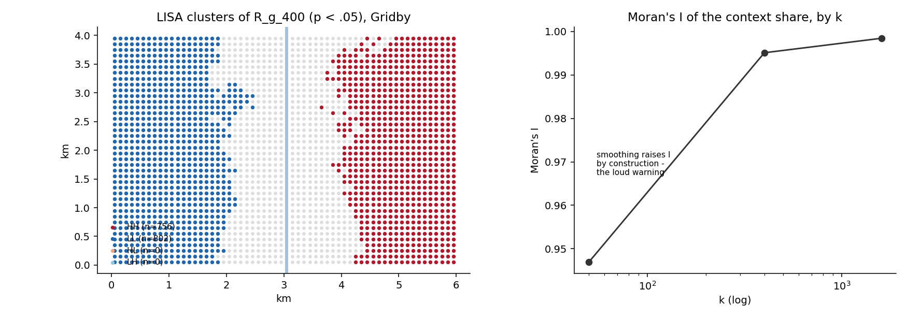
Figure: LISA clusters of the context share, and Moran's I by k
On Gridby, the LISA map finds exactly what the town was built with: a red High-High cluster filling the east (where the planted minority share is high, surrounded by more of the same), a blue Low-Low cluster filling the west, and the boundary between them riding the planted gradient, with the river visible as an edge. The grey squares are those whose local pattern could plausibly be an accident of shuffling — they fail the significance test explained below. The right panel shows the scale profile of the global I, and it is the doorway to this chapter's most important warning, saved for the Pitfalls section.

Cook it
Three calls cover the whole toolkit. The first builds the "who is whose neighbour" matrix — here, each square's eight nearest squares. The second computes the global Moran's I with a significance test. The third computes the local version, one row per square.
from equipop.autocorr import (build_weights, morans_i,
local_morans, local_g)

W = build_weights(out.EastWest, out.NorthSouth, mode="knn", k=8)
glob = morans_i(out.R_g_400, W, permutations=999, name="R_g_400")
lisa = local_morans(out.R_g_400, W, permutations=999)
gi = local_g(out.R_g_400, W, star=True)

About that significance test: the p-values here come from permutation — the computer literally shuffles the values across the map hundreds of times and asks how often pure chance produces a pattern as strong as the observed one. It is the "would shuffled tiles look the same?" question, answered by actually shuffling. The lisa table gives each square its local statistic Ii, its quadrant label (HH, LL, HL or LH), and its shuffle-based p-value; join it back to your results and map the significant quadrants, and you have drawn the classic LISA cluster map.

The dials
mode (knn / r / decay) and its size parameter; row_standardize (on by default, meaning each square's neighbours share one unit of influence between them; switch it off for the G statistics, which prefer plain 0/1 weights); permutations and seed (the shuffling is reproducible); and autocorr_profile(df, cols) for one I per scale in a single call.

Under the hood
For readers who compare software: the local Moran here uses the same variance convention as the widely used PySAL esda library — the module is cross-checked against it down to the ninth decimal for LISA and the eighth for Gi\*, with one documented difference: our k-nearest weights include equal-distance ties as a whole ring (chapter 1's convention), where most libraries cut at exactly k. Housekeeping is loud in the usual way: missing values are replaced by the mean for the global statistic *with a printed count*, and a square with no neighbours at all gets an honest NaN rather than a silent zero.

Pitfalls
The loud warning, in full — please read this one. Suppose you feed a context share such as R_g_1600 into Moran's I. Think about what that column is: every square's value is an average over its 1,600 nearest people, and two squares a hundred metres apart share almost all of those 1,600. Their values are therefore nearly identical *by construction* — not because the town clusters, but because the two neighbourhoods overlap. Smoothing a map always makes it look clustered. On Gridby, the global I rises from 0.947 at k = 50 to 0.998 at k = 1,600; that rise is the smoothing, not the town. The software detects context-share columns by their name and prints a caution automatically. Measuring the autocorrelation of a smoothed surface is perfectly legitimate — it answers "how far does the smoothed structure reach?" — but it is a different question from "does the raw residential pattern cluster?" For the latter, analyse raw local shares instead. The entire pitfall is knowing which of the two questions you are asking; the software makes sure you cannot fail to ask it.

12. Access potential: what can be reached, and from where it comes

The idea
The neighbourhood chapters ask who is *around* each person. This chapter turns the question outward: what can each place *reach*? The measure is nearly a century old and admirably simple — sum up everything of interest (jobs, shops, clinics), letting each item count less the farther away it is, using exactly chapter 7's decay weights. The result is called an access potential (after Hansen, who proposed it for jobs in 1959): a single number per location, "the decayed mass of opportunity within reach". High where opportunity is close and plentiful, fading with distance from it.
Two properties make the EquiPop version worth a chapter rather than a footnote. The first is speed with exactness: computing the potential at *every* square of a map sounds like a million-by- million sum, but a classical piece of mathematics (the Fast Fourier Transform — the same trick inside every audio equalizer) computes all of it at once, exactly, in about a second for a whole country of grid squares. No sampling, no approximation, no iterations.
The second property is a happy double meaning. Feed the machine *opportunities* (jobs) and each square's value reads "how much can a resident here reach" — the access map. Feed it *people* instead, and each square's value reads "how many decay-weighted residents could reach something placed *here*" — which is precisely the question a planner asks before opening a clinic, a supermarket, or a bus stop. The same computation, pointed the other way, becomes a site-search surplus map, and its brightest square is the best location for the next facility.
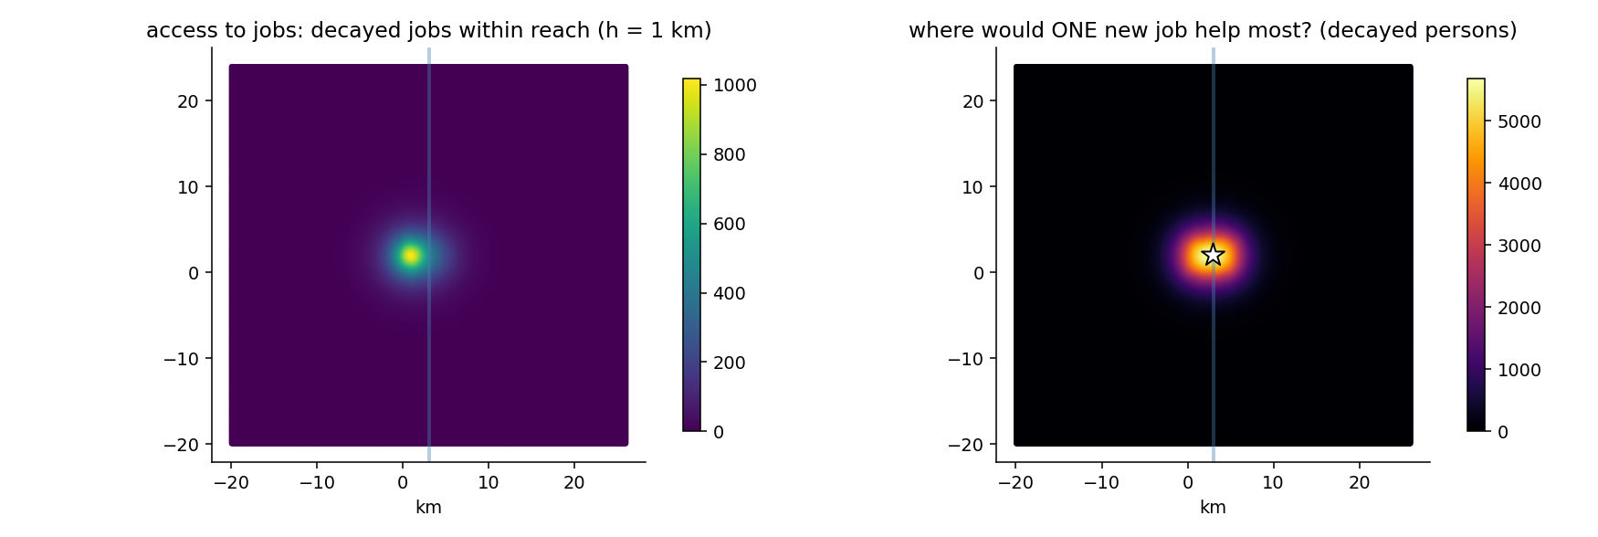
Figure: Access to jobs, and where one new job would help most
On Gridby the two readings share a figure. The left panel is access to jobs at a one-kilometre half-life: bright around the planted western jobs cluster, dimming eastward, with the river's faint shadow (access here is straight-line; chapter 10's effort version returns below). The right panel is the reversed question — where would a single new job reach the most decay-weighted people? — and the white star marks the answer, which turns out to be a small delight: the best square sits one cell west of the bridge, at exactly the bridge's height. Nobody told the mathematics about the bridge; it found the town's pinch-point on its own, because that is where the two banks' populations come closest to being one market. Planted geography, discovered independently — Gridby doing its job.
A companion number rounds out the idea: the opportunity horizon. Under an even spread of opportunities, nearby rings of distance contribute little (small area), distant rings little too (heavy decay); in between lies the distance from which the *most* access arrives. For the exponential decay at a one-kilometre half-life that sweet spot sits at 1,443 metres — a useful translation of an abstract dial into "the scale my analysis is really about". And chapter 7's warning matures here into a theorem: for power decay with gamma at or below one, the horizon is *infinite* — ever-farther rings keep contributing — and the software says so in words rather than printing a number that could not mean anything.

Cook it
from equipop.datasets import load
from equipop.decay import Decay
from equipop.access import potential_surface, opportunity_horizon

g = load("gridby")
dec = Decay(model="negexp", half_life_m=1000)

jobs = g["jobs"].rename(columns={"jobs": "mass"})
acc = potential_surface(jobs, dec, unit_size=100) # access map

people = g["people"].rename(columns={"count_all": "mass"})
site = potential_surface(people, dec, unit_size=100) # site search
best = site.loc[site.potential.idxmax()]

print(opportunity_horizon(dec)) # 1443 m

One rename is the whole interface: whatever column you call mass is what gets summed. The output covers every grid midpoint in the data's (slightly padded) bounding box, one potential per square — including uninhabited squares, since a planner's candidate site need not currently house anyone.

The dials
The decay object carries the substance (model, half-life, gamma); pad_cells widens the computed frame beyond the data's box; eps sets where the kernel is truncated (defaulting to weights below a millionth — printed, as always). For terrain-honest access there is effort_potential, the same idea computed over chapter 10's slopes and rivers, round trips included, with the half-life stated in rounds of effort rather than metres.

Under the hood
Why is the FFT version *exact* rather than approximate? Because on a regular grid the Hansen sum is, mathematically, a convolution — the same weighting pattern slid across every square — and the Fourier transform computes convolutions perfectly, not approximately; the only care needed is padding the frame so the pattern cannot wrap around the map's edges, which the function handles and tests. The Malta validation ran the full 1.3-million- midpoint island in 1.4 seconds and located the optimal next point of interest at the Birkirkara–Msida seam — the real-world sibling of Gridby's bridge star.

Pitfalls
Access is not competition. A bright square on the left panel says much can be *reached* there; it says nothing about how many others reach the same things — for that, chapter 13's floating catchments deflate supply by pressure, and the honest study reports the pair (the J-versus-A distinction of that chapter is exactly the potential-versus-competition distinction of this one). And the site-search reading inherits a modelling caveat: the star answers "where would a new facility reach the most people *given the decay*" — it optimises reach, not need, not equity, not land prices. It is the beginning of a planning argument, not its conclusion.

13. Competition: the FCA family and the propensity matrix

The idea
The access measures of chapter 12 count what you can reach. But many of the things worth reaching — jobs, school places, appointments at a clinic — are rival: what I take, you cannot have. A town where everyone can *reach* five hundred jobs but ten thousand people are reaching for them is not a town of good access. The floating- catchment family of methods (FCA, for *Floating Catchment Area*) prices that rivalry, and it does so in one straightforward pass, no iteration, no equilibrium-solving.
The algorithm is best understood exactly as a researcher first sketched it on paper, in four steps. Step one: from each home, sum up the reachable jobs, letting distant ones count less (the distance-decay idea of chapter 7). Step two: turn the telescope around — from each *workplace*, sum up the search pressure aimed at it: how many decay-weighted job-seekers can reach this place? Step three: deflate. A workplace offering 5 jobs under a pressure of 10 seekers has, per seeker, only 5 ÷ 10 = 0.5 *competed-for* jobs to give. Step four: return to the homes and re-do step one, but summing the competed-for stocks instead of the raw ones. The result, called A, is each home's jobs-per-worker *actually available once everyone else is also reaching*. Step one's raw sum is kept too, under the name J — and comparing them is illuminating: J is what you can see, A is what you can get, and J divided by A tells you how many effective competitors stand between you and each visible job.
So far, one big market. But real people compete in *segments*: a job requiring a medical degree is not part of everyone's market. The simple version handles this with a match table — run the analysis once for low-educated workers against low-education jobs, once for everyone else against the rest, walls between the markets. The refined version, and the subject of this chapter's second half, replaces the walls with a propensity matrix, written M. Each row of M belongs to a group of workers; each column to a category of jobs; and each entry is the share of that group's job search aimed at that category. A row like (0.85, 0.15) says: this group directs 85 % of its search at the first category and 15 % at the second. One special case is worth pausing on. Suppose the matrix says every group searches only within "its own" category — a 1 in each row's own column, 0 everywhere else (mathematicians call this shape an *identity matrix*). With that table, the propensity method gives exactly the same numbers as the walls version — not roughly the same, but the same to more decimal places than the computer can meaningfully print, and an automatic test re-checks this agreement every time the software changes, so the two can never quietly drift apart. The moment any entry departs from 0 or 1, the walls become porous, and the markets begin to influence each other's competition.
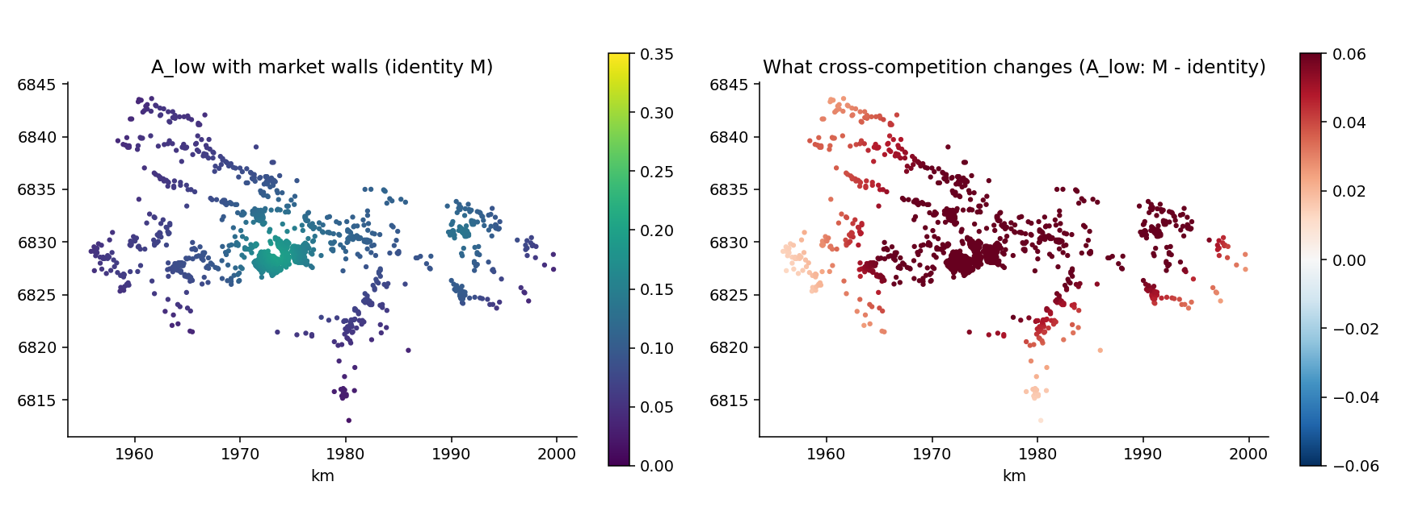
Figure: Access with market walls, and what cross-competition changes
The figure runs on the anonymised municipality data — a real Swedish register whose coordinates were rigidly moved to protect privacy while keeping every distance intact. Under the walls scenario, low-educated workers face a stark market: A = 0.154, roughly one available job for every six and a half seekers. The right panel shows what happens under an *illustrative* propensity matrix in which 15 % of low-educated search crosses into the other market while 25 % of educated search invades theirs: low-educated access nearly doubles, to 0.301. Reaching even a modest slice of the richer adjacent market outweighs the extra invasion of one's own poorer one — the walls themselves were a large part of the penalty. The map shows *where* the gain lands. And here the chapter's refrain must be said plainly: that matrix was chosen for the figure, not estimated from behaviour. The matrix *is* the model.

Cook it
from equipop.datasets import load
from equipop.decay import Decay
from equipop.fca import fca_segments, fca_propensity
import pandas as pd

p, j = load("municipality")
dec = Decay(model="negexp", half_life_m=3000)

M = pd.DataFrame([[0.85, 0.15], [0.25, 0.75]],
index=["low", "oth"], columns=["lowjob", "othjob"])
d, s = fca_propensity(p, j, M,
{"low": "LowEdu_sum", "oth": "Other_sum"},
{"lowjob": "LowEdu_jobs", "othjob": "Other_jobs"}, decay=dec)
# d gains A_low, A_oth, J_low, J_oth ; s gains R_lowjob, R_othjob

Reading the call: the two dictionaries name which column holds each group's workers and each category's jobs; M is the search table; and the decay object sets how fast distance fades relevance (here, a job 3 kilometres away counts half). The outputs follow the story above — one A and one J per group of workers, one competed-for ratio R per category of jobs.

The dials
reach picks the neighbourhood definition from chapter 4's menu (decay, radius, the fixed-mass kFCA catchments, or travel effort over a terrain model with the round trip home included); method="3sfca" adds a further refinement in which demand first splits itself across reachable options; balance= switches to a market-clearing variant for readers with an economics background; and cell_propensity=True unlocks the spatially varying version of M described next.

Under the hood
Where should M come from? Two estimators are recommended, and one honest baseline. The baseline is the observed cross-table: among employed members of each group, the shares actually holding each job category. It requires no model at all — but be clear about what it measures: the *outcome* of past matching, complete with any exclusion built into it, not what people would search for in an open market. The first recommended estimator, (c), reuses regressions you may already have: predict each person's probability of holding each category, then divide each group's vector by its sum so it adds to one. One warning matters here: if your regression included area effects (as multilevel models do), strip them from the prediction — geography is the FCA's job, and keeping it in M as well would count the same space twice. The second estimator, (f), is the ambitious one: do not average the predictions into one matrix per group at all. Average them per *map square* instead, and pass the per-square probability columns with cell_propensity=True. In a segregated town, where you live predicts what you search for; this "propensity field" lets the matrix vary across the map, and the engine carries it at no extra cost. Housekeeping is loud as always: rows that do not sum to one are normalized with a printed notice; a genuinely impossible match (an entry of exactly zero) stays impossible; and a home that can reach no supply at all receives A = 0 with a printed count, never a silently missing value.
Both sides of k. One dial deserves its own passage, because it turns out to hide a research question. Chapter 4's fixed-mass neighbourhoods appear here as the kFCA reach: catchments that grow until they contain k units of mass. The quiet question is: k units of *whose* mass? Setting k_side="supply" means every worker weighs their nearest 500 *jobs*, wherever those are — everyone faces the same menu of options, and the ground it covers floats. Setting k_side="demand" reverses the telescope: every *workplace* weighs its nearest 500 workers — each employer has a recruitment pool of fixed size, and access at a home reflects how many such pools it belongs to. Both are reasonable stories about how labour markets work; they simply are not the same story. Setting k_side="both" computes the pair in one call, returning A_ksupply and A_kdemand side by side (the names carry the anchored mass, so they read correctly whether the "supply" is jobs, clinics or school places).
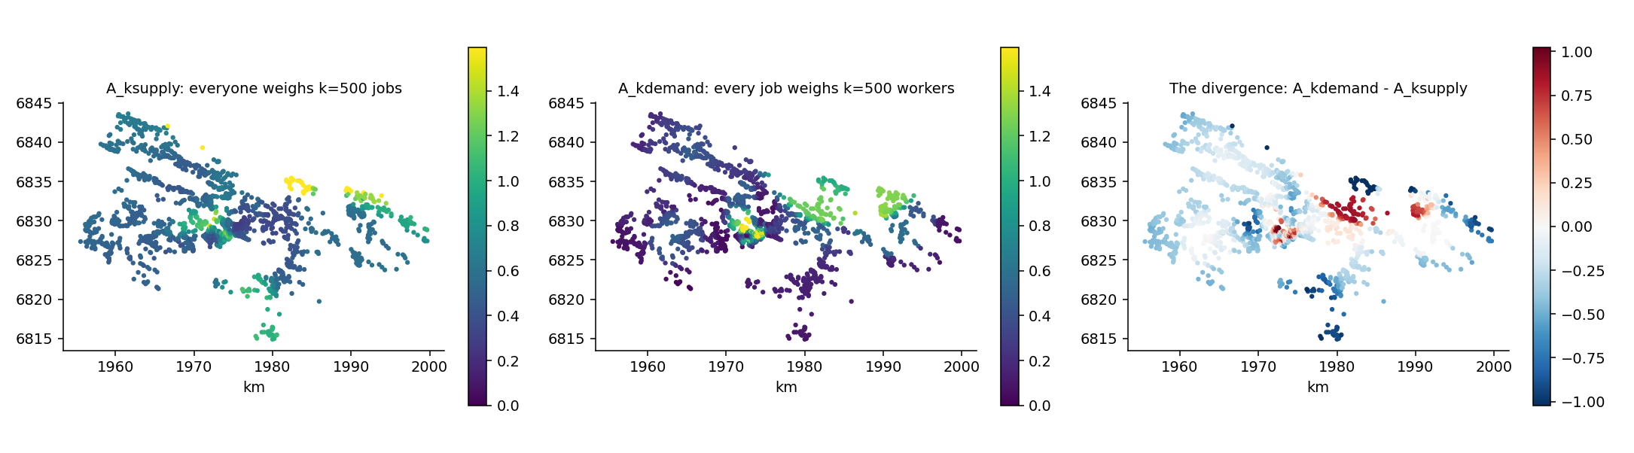
Figure: Two conventions, and where they disagree
How different can two reasonable conventions be? On the anonymised municipality, very: the two access maps correlate at only 0.33, and for a typical home the two numbers differ by about 0.29 — on an access level averaging 0.63, which is to say the convention choice moves the answer by roughly half its size, even though both versions conserve the same municipal total. The divergence map on the right shows the disagreement's geography: red where fixed recruitment pools flatter a home, blue where a fixed job menu does. The lesson is the propensity lesson in different clothing: what looks like a technical setting is a model of behaviour, and when two defensible models disagree this much, the disagreement itself belongs in the paper.

Pitfalls
The +95 % in the figure is a *scenario*, not a finding: its matrix was invented to make the mechanism visible. With a matrix estimated from your own data, the same computation becomes research; without one, it is sensitivity analysis. Both are legitimate — confusing them is not, and every caption should say which one it is. A second habit worth forming: never report A without J beside it. A alone cannot tell the reader whether a change came from geography (more jobs within reach) or from competition (the same jobs, fewer rivals) — the pair can.

15. The ArcGIS door: EquiPop where the data already lives

The idea
Most people who need egocentric neighbourhoods do not live in a Python prompt. They live in ArcGIS Pro, with the register extract already loaded, symbolised and half-explored. The toolbox exists so that EquiPop meets them there — and so that nothing in the meeting changes an answer.
That last clause is the design. The toolbox is glue only: it moves arrays between Pro and the equipop package and does not compute anything itself. Every number you see in an attribute table came out of the same functions the test suite guards, the Stata bridge calls and the answer keys pin down. The door is thin on purpose, because a door that computes is a door that drifts.
Two tools, two questions. *Counts and Shares* asks how many people are near me and what proportion of them are something. *Value Statistics* asks what the values around me look like — the median income among my nearest four hundred neighbours, the spread, the Gini. Barriers and terrain are not a third tool: they are ingredients that change what "near" means, which is why they sit inside machine 1 rather than beside it.

Coordinates come from the data
Earlier versions asked the user to supply X and Y columns, and politely suggested renaming things when the names were unfamiliar. That was backwards. A point layer already knows where its points are; asking its table for coordinates is asking the wrong part of the file.
So the loader reads geometry directly. Only when the input is a plain table — a CSV, an Excel sheet, a geodatabase table — does the question of coordinate columns arise at all, and then the tool guesses (X/Y, East/North, Easting/Northing, POINT_X, XKoord…), pre-fills its guess, and lets you override it. It never asks you to rename a column, because renaming someone's data to suit a tool is a tool's failure, not a user's.
Coordinates must be metric, and this is refused rather than patched over: EquiPop's distances are metres, and a degree is not a distance. What the refusal adds is the fitting projection, computed from the data's own extent — a Swedish layer is pointed at SWEREF 99 TM, an Anatolian one at UTM zone 36N. If you would rather not stop, the *auto-project* checkbox reads a layer on the fly in that projection and says so loudly; your stored data is never modified. A bare table cannot be auto-projected: its numbers carry no coordinate system to project *from*, and guessing would be invention.

Barriers, in whatever shape they arrive
Chapter 9 built friction from a table of cells. In the field, barriers arrive as rivers and railways in a line shapefile, lakes in a polygon layer, or a friction surface in a raster — and asking a user to convert those into a cell table by hand is asking them to do the tool's job.
The barrier input therefore routes by what the thing is:
- lines charge every grid cell they genuinely cross;
- polygons charge every cell they cover, holes excluded, all
parts of a multipart feature included;
- rasters are sampled at analysis-cell midpoints, NoData and
zero costing nothing;
- points and tables snap to their cells.
Two features in one cell need a rule, and the default is additive: a river crossed at a railway costs both, which is what the ground does. Where stacking is wrong — two overlapping polygons describing the same marsh, say — max, min and mean are one click away.
A subtlety worth stating, because it was found the hard way: a cell is charged only when the feature's presence there has positive *measure*. A line grazing a cell corner and a polygon touching a cell edge both have zero presence and cost nothing. Two independent implementations — one via shapely, one in plain numpy for hosts whose Python cannot grow geopandas — agree on this cell for cell, which is how the convention got pinned down.

Population, and what k counts
Register data rarely gives one row per person. It gives places with populations: a block of forty, a farm of two. Machine 2's full-population field takes that seriously — set it, and *k counts persons*, so a place of forty weighs forty times a place of one in every statistic, the median and the Gini and each percentile included. The implementation is deliberately unclever: rows are expanded to persons before the neighbourhood is drawn, so weighted order statistics are correct by construction rather than by a formula that might be subtly wrong at the edges.
Tick only the measures you want. Nv_&lt;field&gt;_k always comes along: how many neighbours actually had a usable value, so thin coverage shows up as a number rather than hiding inside an average.

Reading the messages
The messages pane is where EquiPop is loudest, and in this release it finally carries the package's own voice as well as the door's:
Coordinates read from feature geometry (475559 points). Working CRS: SWEREF99 TM (EPSG:3006) [time] reading input: 0.9 s [fast] 422549 cells, k = [444], fast pass with m = 874 cells [time] calculating: 1 min 12 s [time] writing results to the layer: 3 min 02 s [time] TOTAL: 4 min 57 s - most of it in 'writing results'
Three habits pay off. Read the working CRS, because every distance is metres *in that projection*. Read the stage timings, because they name the slow step instead of leaving you to guess — and on large data the slow step is often ArcGIS writing fields, not EquiPop computing them. Read m = N neighbour cells: it is how many cells each origin looked at, and it affects speed only, since any origin not settled inside its neighbourhood is recomputed exactly.
Beside the output, each run leaves a manifest — version, working CRS, whether it was auto-projected, every parameter, row and cell counts, per-stage timings. A results layer without provenance is a number without a footnote.

Pitfalls
Shapefiles cap field names at ten characters. Mean_income_200 does not fit, and a shapefile target is refused *before* the computation with that advice rather than after it. Shortening is available as an opt-in, collision-free by construction — because truncating P25_income_400 and P75_income_400 to the same ten characters would silently merge two different answers — and the mapping is printed and saved beside the output. A file geodatabase has no such limit and is the better home.
Pro remembers your last run. That is Pro being helpful, and it means a field choice can outlive the layer it was chosen for. The dialog now clears field boxes that don't exist in the current input and validates the rest before Run, but if a result looks like someone else's run, suspect a remembered parameter first.
Effort has a scale ceiling that plain counts do not. Barriers and terrain build a movement graph over the whole bounding box, empty ground included, so they suit a bounded study area rather than a country at 100-metre cells. The tool estimates the memory in advance and tells you what to change — usually a larger cell size, which is in any case the strongest speed control you have: doubling it quarters the number of origins.

Under the hood
The toolbox is validated against a simulated arcpy — a stand-in that answers the same calls Pro does, so every glue path can be exercised in continuous integration on a machine with no ArcGIS licence anywhere near it. That simulator has caught real bugs before they shipped, and it is also honest about what it cannot catch: file locking, schema caching, Pro's parameter memory, DLL conflicts, and a Swedish locale writing 0,000001 where Python expects a point. Those arrived from the field, each one now a test.
Which is the closing thought. The simulator proves the logic; only the field proves the behaviour; and a synthetic town with a published answer key — Gridby, whose river genuinely divides a poorer west bank from a richer east — is what turns "it ran" into "it computed the right thing".

16. EquiPop inside Stata

The idea
Many researchers live in Stata: the data sits in Stata's memory, the regressions run there, the co-authors expect do-files. EquiPop respects that. Rather than asking you to export your data to Python, run something, and import results back — three chances to make a mistake — the toolbox reaches *into* Stata. Since version 17, Stata has been able to talk to Python directly, and EquiPop uses that channel so your data never leaves Stata's memory: a command reads the coordinate columns, hands them across the bridge, computes, and returns the results as ordinary new variables, row by row, ready for regress on the very next line. A person whose coordinates were missing simply gets missing results, exactly as Stata users expect.
Two commands exist. The first, equipop_knn, is the original and does one thing well: nearest-neighbour counts and shares (the material of chapters 1 and 4). The second, equipop_run, is the whole toolbox behind one door: an engine() option chooses among counts, value statistics, river-and-hill effort, and the labour- market competition analysis of chapter 13 — whose outputs A and J arrive as regression-ready variables, which is precisely how the accompanying journal work uses them.

Cook it
One-time setup: tell Stata which Python to use (python query shows the current one) and make sure EquiPop is installed in *that* Python with pip install equipop. Then, with the ado-files from the repository's stata/ folder on your adopath:
* nearest-neighbour shares, two definitions from chapter 4's menu:
equipop_run, engine(counts) x(X) y(Y) treat(HighEdu) ///
k(200) r(500) replace

* the income statistics of chapter 6, among each person's 400 nearest:
equipop_run, engine(stats) x(X) y(Y) values(Income) ///
stats(mean gini) k(400) replace

* chapter 13's competition analysis - your data in memory is the
* demand side; the supply (jobs) comes from a file on disk:
equipop_run, engine(fca) x(X) y(Y) demandvar(Workers) ///
supply("C:\data\jobs.csv") supplycol(Jobs) halflife(3000) replace
regress health_outcome A

Reading the last block: every row of your dataset is a worker; the jobs file provides the workplaces; halflife(3000) says a job three kilometres away counts half; and after the command, two new variables exist in your data — A, the competition-adjusted jobs per worker at each person's location, and J, the competition- blind potential — so the regression on the next line is not a metaphor but the actual workflow.

The dials
Each engine has the options of its chapter: treat() for group variables, values() and stats() for the statistics engine, dem() and roundtrip for terrain effort, tau() for effort isochrones, and the fca options shown above. replace overwrites result variables from an earlier run — without it, the command politely refuses to destroy anything.

Under the hood
Both commands are thin: perhaps forty lines of glue whose only job is moving arrays across the bridge. All mathematics lives in the Python package, where the automatic test suite covers it — and the glue itself was validated by running its code, word for word, against a simulated Stata before shipping. The practical consequence: when something fails, it is almost always the environment (Stata pointing at a different Python than the one where EquiPop was installed) rather than the computation, and python query is the first thing to check.

Pitfalls
The one genuine trap is having several Pythons on one machine — Anaconda's, the system's, one inside a project — and installing EquiPop in a different one than Stata talks to. The symptom is "module not found" even though pip install reported success. The cure is mechanical: python query in Stata shows the path Stata uses; run pip install equipop with *that* Python. Everything else is ordinary Stata life.

