FAGI-gis
version 1.1

Usage

1. The basic interface for FAGI consists of a menu bar and the map control.

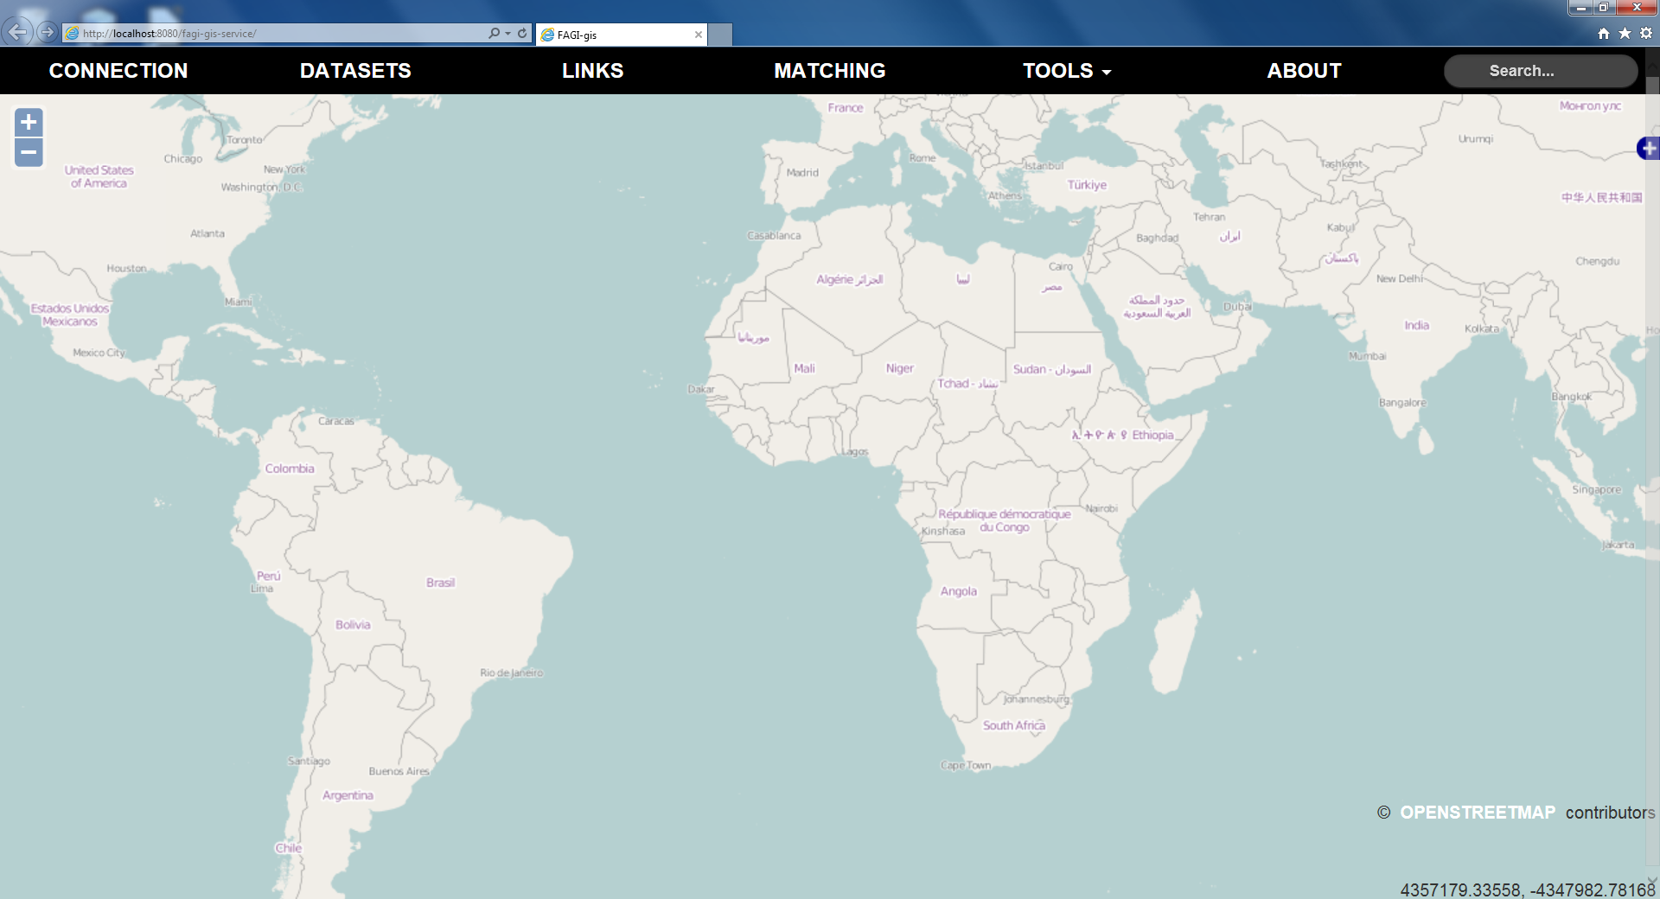

2. The 'Connection' tab is for specifying the credentials for connecting to the required databases installed on the system. Namely, Virtuoso and PostGIS. Clicking on submit will attempt connection to the databases.

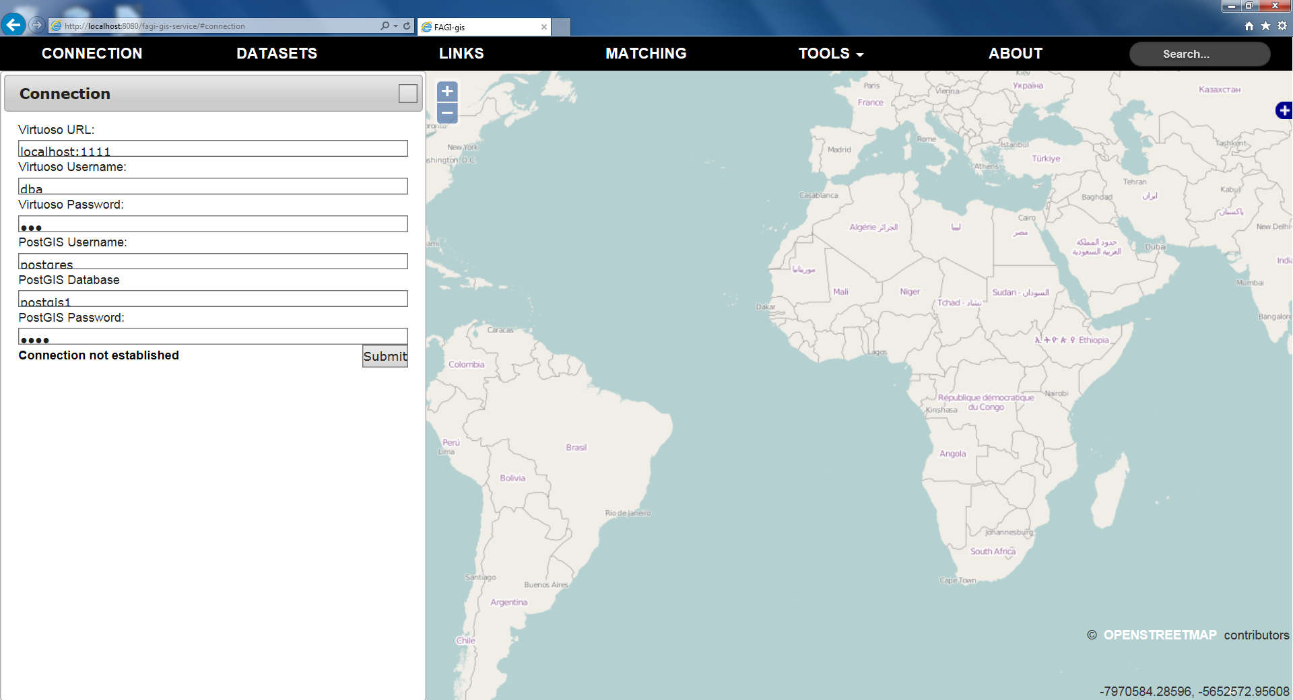

3. The 'Datasets' tab is for specifying the dataset input for FAGI-gis. A dataset is a pair consisting of the RDF graph name and the SPARQL service hosting the graph.

FAGI-gis outputs all data into a new graph called the “target” graph hosted at the supplied SPARQL service.

For improved performance, FAGI-gis uses uploads through files and therefore requires a pre-defined path from which Virtuoso can import data. The path can be set be editing the 'DirsAllowed' attribute of the virtuoso.ini file used to start Virtuoso.

For simplicity the first dataset is considered the “A” dataset while the second is considered the “B” dataset. Choosing the dominant dataset affects the output of the the fused triplets during the fusion phase.

Clicking submit will validate the supplied datasets.

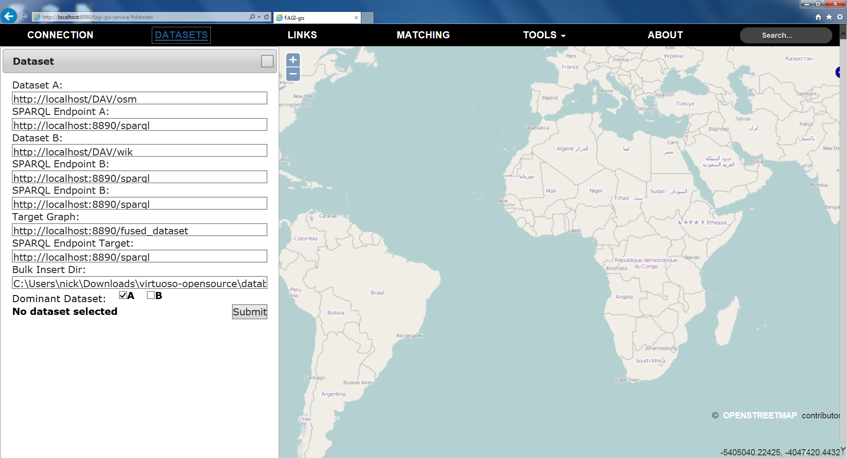

4. The 'Links' tab is for supplying the links' file. Link are loaded into the list after upload and one can select some or all of them.

Links can also be filtered by type. The available types of each dataset are discovered by FAGI-gis and provided in the selection windows. Selecting multiple types is also possible.

On submit, FAGI-gis will perform schema matching on the linked data in order recommend possible similarities on metadata properties.

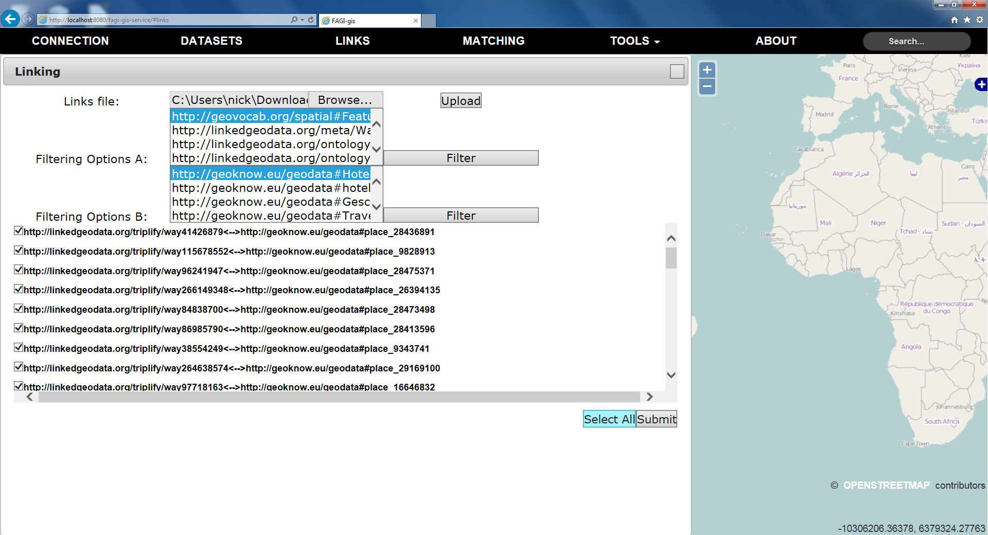

5. The 'Schema Matching' tab offers recommendations for metadata fusion actions based on various metrics. Matching is calculated based on the property value of each metadata triplet.

By selecting a property from the list, the proposed matches are highlighted with the matching score presented.

One can select a property from each dataset and add their link to the selected-for-fusion list on the right. (the geometry property is always included) The resulting name will be used as the property value when a fusion action is performed and can be edited by clicking on it.

Clicking the Preview button will load all the linked geometries onto the map and set up the state for performing fusion actions.

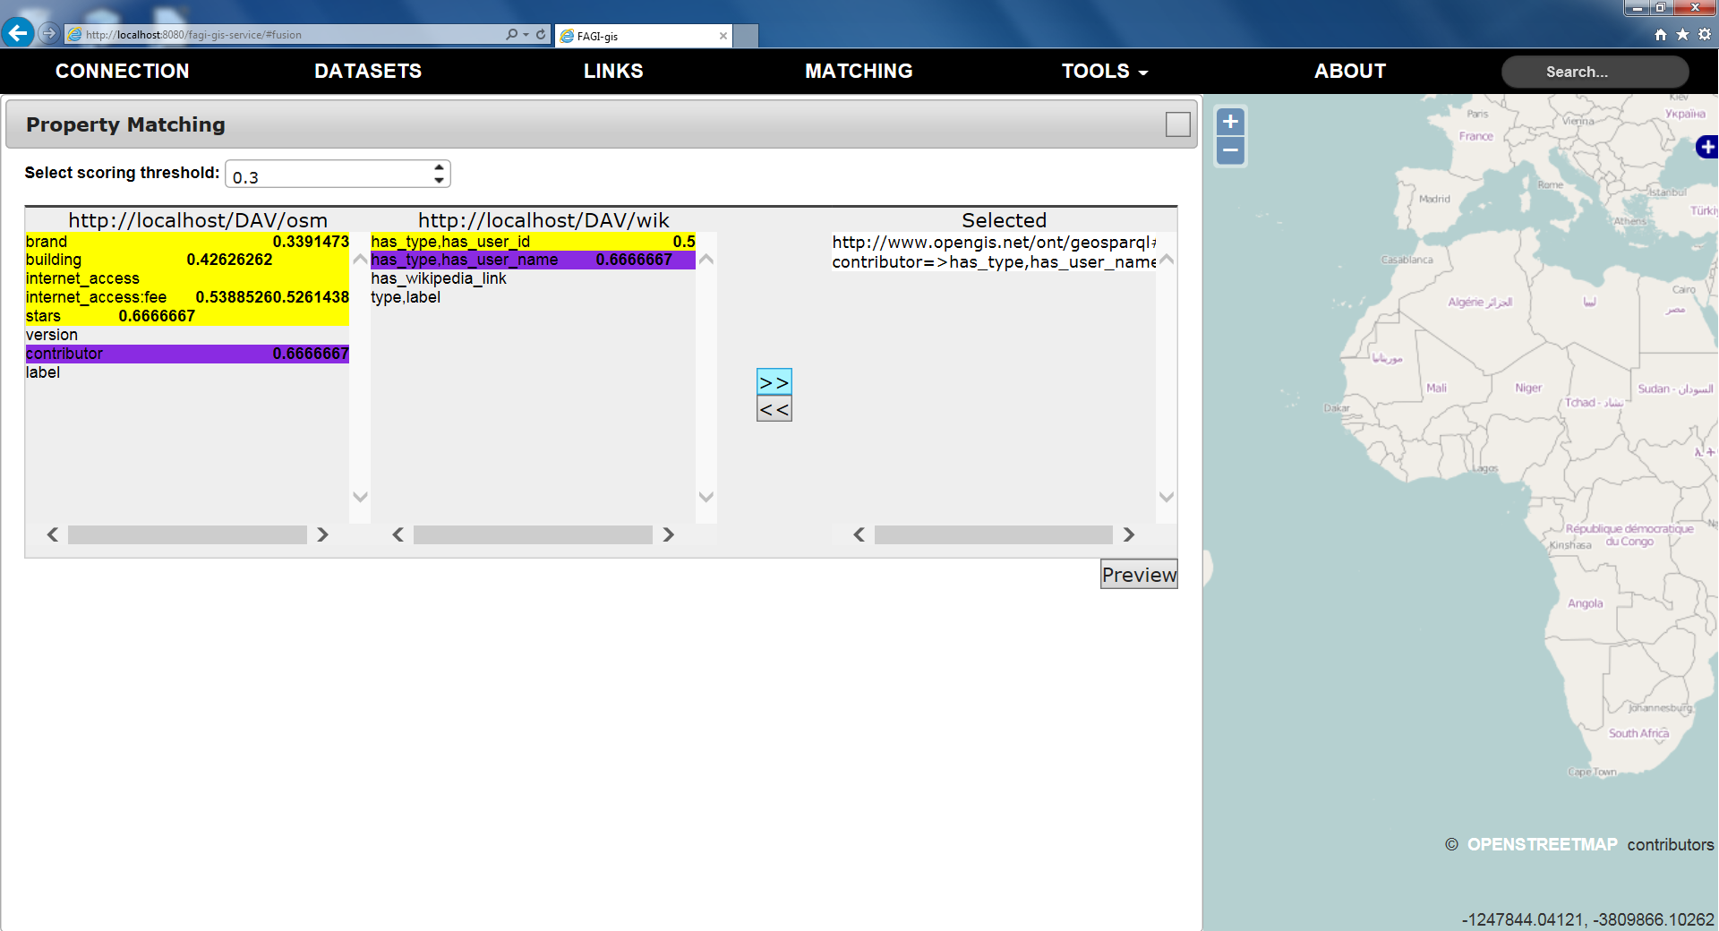

6. After previewing one can see the linked entities on the map. A thin red line is drawn between two linked geometries. At this stage one can freely move the supplied geometries just by dragging on the map and change their geometric properties.

Clicking on the connecting line will bring the fusion table to the front. Here, the list of all the properties of each entity is provided and one can include more specific pairs of properties for fusion.

The table on the bottom shows the selected properties for fusion and offers a range of fusion actions.

Clicking the Fuse button will execute the selected fusion actions and store them in the “target” graph of the previously specified SPARQL service.

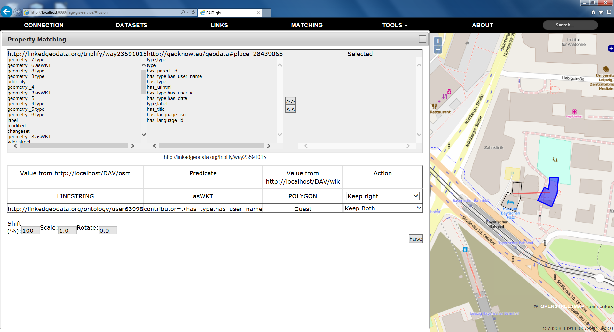
From then on one can close the table and move on to the next pair of linked entities.

