Moss species distribution patterns and their dependency to different substrates and forest structure compositions by a modified Whittaker nested sampling method

A. Schönberg1 , A. Schupp1,2 & J. Schwalb1
1Master student at the department of physical Geography, Philipps University Marburg, Germany
2Master student at the department of Archaeology, Philipps University Marburg, Germany

Abstract

Keywords: Bryophytes, Nested plot design, substrate dependency, distribution pattern
1. INTRODUCTION
Bryophytes are the second biggest species group within the plant kingdom behind the much larger angiosperms (Crosby et. al. 1999, Frahm & Frey 1992). There are approximately 25,000 species taxonomically divided into hornworths (Anthocerotopsida), two classes of the liverworts (Marchantiopsida, Jungermanniopsida) and the mosses (Bryopsida) (Zechmeister, Grodzinska & Szarek Lukaszewska 2003). Unlike many other plants bryophytes can reproduce both sexually and vegetative (Frey & Kürschner 2011, Mishler 1985). Recent researches suggest that mosses play an important role as an omnipresent component in plant communities worldwide and strongly influence the water, nutrient and carbon cycle of their habitat (Turetsky et. al. 2012, Gerson 1969, Gignac 2001). Their role as the simplest terrestrial plant puts them in the spotlight of research which tries to draw back the lines of plant evolution from aquatic to terrestrial habitats (Cove, Knight & Lamparter 1997). Bryophytes lately interested researchers for many applications: Mosses were successfully used as accumulation indicators for pollutants like trace metals, heavy metals, radionucleides and for toxic organic compounds (Giordano et. Al. 2005, Harmens et. al.2010, Nentwig et. Al. 2009, Zechmeister, Grodzinska & Szarek Lukaszewska 2003). Forest integrity research puts much effort in research because the irreplaceable and vulnerable role of mosses in healthy forest habitats is endangered by actual forest management practices (Fenton 2005, Frego 2007, Mezaka, Brūmelis & Piterāns 2012, Peck 2006). And their vulnerability to abiotic environmental stress makes them a promising indicator species for global change research (During 1979, Gignac 2001, Ogwu 2019). Even their antifungal and antifeedant contents find use in the cosmetic industry (Frahm 2004). Because of their small size compared to other plants, bryophytes never truly stood in the focus of nature preservation measures (Drehwald 2013, (Furness & Grime 1982). “The progress in moss taxonomy is years behind that in vascular plants [...] the field is still in the exploratory, floristic stage of development, and many of the commonest species are very poorly understood taxonomically, floristically, and ecologically [...] while a large part of the southern hemisphere still remains undiscovered.” (Anderson 1963). This changed since the time Anderson (1963) but even in the 21. there are huge distribution gaps of common species (based on missing Data) in Germany which represents the one of the most studied countries in bryophyte research (Meinunger & Schröder 2007). Mosses were just recently added to the red list of endangered species which may leads to more research measures to enhance the knowledge about their role in diverse ecosystems (Drehwald 2013).
The goal of this work is to map the mosses in a typical central European temperate forest to investigate moss distribution patterns. We hope to find relationships between the occurrence and abundance of moss species in different habitats and growing on different substrates. We investigate if there are any species that occurs exclusively on a certain habitat (Oak-, Beech-, Spruce-, Douglas fir- and Larch forest departments), a certain tree species (Beech, Oak, Spruce, Larch, Douglas fir) or on certain substrates (epiphytic, soil, deadwood). We chose a nested plot design in which a main plot contains many subplots. Hier auf tempus achten (einiges im prasens eineiges im past, wir wollen präsens, und “hope” is hier blöd. We hope to increase the accuracy of species richness and distribution on substrates by this plot design (Ilić, Igić, Ćuk & Vukov 2018). Epiphytic mosses were recorded on a variety of tree species and in three levels (one to three meters above the tree-root). Also the moss distribution on dead wood and soil was recorded. We assume that there are similar moss species compositions in similar habitats, tree species and substrates. We want to verify the following hypotheses. There are different moss species compositions in richness and appearance in the forest departments dependent on the dominant tree species. Hier nochmal formulierung der hypothesen überprüfen These moss distribution patterns should also be found on the corresponding substrates within the forest departments and the maximum growing height of epiphytic mosses is dependent on the tree species on which it grows. To test our hypotheses we use the vegetation survey data to get information about the moos distribution in the different forest departments and on different substrates within. To compare the collected data we will generate data about the species richness and coverage of the plots. We will use a multi-variate statistical approach (ordination and cluster analysis) to find patterns and use common statistic test procedures to verify the relevance of our hypotheses.

2. Data and Methods
2.1 Study area
The research was performed from May to Juli 2019 in the Marburg Open Forest (MOF) near the small town of Caldern which is a part of the administrative district of Marburg (Hessen, Germany). Geologically the area is dominated by limestone, greywacke, shales and conglomerate stone (Hessisches Landesamt für Umwelt und Geologie 2007). It is part of the geologic constellation “Rheinisches Schiefergebirge” and the soil composition in this area is described as solifluidal sediments and brown earth (Bodenviewer 2020). The highest elevation is the “Hungert” with 412 meters above sea level (Opentopomap 2020). It represents a typical central European temperate forest and is divided into forestry departments with mainly Fagus sylvatica , Quercus petrea cf , Picea abies, Pseudotsuga menziesii and a single small department with Larix decidua. Also some clearings, meadows, an abandoned quarry and some tiny creeks which don’t carry water permanently are located there. The Quercus petrea departments include a mix of Quercus petrea and Fagus sylvatica and as typical for economically used forest the departments can include small amounts of other tree species. For our study we focused on the departments of the four main tree species Fagus sylvatica , Quercus petrea cf , Picea abies and Pseudotsuga menziesii along with the Larix decidua department and a clearing (Fig. 1). We didn’t collect data for the quarry or the creeks. The departments north of the primary road are classified as natural reserves where it is restricted to enter and collect plant samples.

Fig. 1: Study site with vegetation departments and main plot positions

2.2 Field Methods
For our study and regarding to our hypothesis we will perform a moss vegetation survey after BRAUN-BLANQUET (1928) and use a nested plot design to collect data for different substrates via multiple subplots per main plot. Due to the different sizes of the departments and the goal to collect representative data we calculate the amount of plot per tree species as followed. For the angiosperm species we sampled on three plots in Fagus sylvatica departments and five plots in Quercus petrea cf. departments because Fagus sylvatica occurs there too. For the gymnosperm species we sampled on one plot for Larix decidua because there is only one department with poor coverage in the study area. For Pseudotsuga menziesii we sampled on four plots along with four plots for Picea abies to get equal amounts of plots for each tree species for comparison reasons. Further we sampled on a clearing to get data to compare to the forest plots.
For the planned amount of plots per forest department we searched for most representative positions (Dierschke 1994) within the departments and used a nested plot design to collect data regarding to our hypothesis. The nested plot design was chosen to improve the accuracy and reliability of moss occurrence and richness (Barnett & Stohlgren 2003, Stohlgren, Falkner & Schell 1995). The typical “Whittaker plot” (Shmida 1984) used multiple spatial scales (1m², 10m², 100m² subplots within a 1000m² main plot) to collect species richness data. But this scale is too big for our approach to sample mosses so we modified it into a 10m x 10m main plot in which we aligned all substrates (soil, deadwood, epiphyte) as subplots within. Therefore a “main plot” was set up on a representative position within the department and a 5 meter radius was set. This area of ca. 78.5m² is comparable to a 10x10 meter squared plot which is typically used for forest vegetation plots (Dierschke 1994).
First we estimated the coverage for the main plot area for the tree, scrub and herb-layers as well as taking the coordinates and pictures. Then we set up the subplots for the different substrates to identify the moos species occurring on it. This improves subjectivity issues of the vegetation survey as well as delivering data about the distribution of moos species within a main plot. For the substrates we choose soil, deadwood and epiphyte because we expected to find those substrates in most plots. A planed rock subplot was discontinued because of poor rock and stone appearance on the surface of nearly all plot positions. For every subplot the species were identified and the coverage was estimated based on the Braun-Blanquet scale (Braun-Blanquet 1928) while the frequency distribution is based on the subplot type and is not in relation to the main plot.

2.3 Plot and sampling design
2.3.1 Soil
For the soil subplots we identified all moss species occurring on bare soil. Typically this substrate contains small elevations which are free from vegetation due to the exposition to the wind, missing sunlight and animal activity. The coverage is estimates in relation to the whole main plot area to prevent high cover values if there is only a small area of soil related to the main plot area. Further this allows comparing high coverage values on vegetation free areas like clearings or meadows with plots where only small areas are free of vegetation. On the other hand there could be a high amount of low coverage values for plots in the forest.

2.3.2 Deadwood
Like for soil we identified all moos species occurring on deadwood but estimated the coverage in relation to the accumulated area of deadwood in the main plot area instead to the whole main plot area. Here we expected deadwood occurring relatively common on the main plots unlike the soil subplots. We focused our interest on the comparability of the species within a plot instead of the plots among themselves.
2.3.3 Epiphyte
For the epiphyte subplots we first identified the tree species within the main plot. For every tree species we set up an epiphyte subplot to later compare the epiphytic moos species by tree species. Therefore we identified the moos species and estimate the coverage by the mean on all trees of the same species within the main plot. If there are more than only a few trees we chose representative trees as a sample for the area. Further we divided the subplots into elevation levels to later test our hypothesis about the elevation dependent occurrence of moos species by tree class (Tab.1).
Level | Elevation
1 | ground up to 1 meter
2 | 1 meter up to 2 meters
3 | above 2 meters
Tab. 1: Epiphytic subplot levels
This sampling design can result in single species occurring multiple times on a main plot with different coverage values which has to be handled in data pre-processing. If any type of substrate is missing on a main plot we don’t generate it instead of setting zeros values due to multivariate statistical approaches like ordination cannot handle zeros. (In discussion?) ne weil das zu preprocessing gehört. Für das mit de Zeros noch ein zitat aus MVS quelen

3. Data preparation and analysis
3.1 Data pre-processing
At First the collected data was digitalized in a single table. Additionally a second table was digitalized containing the information for the main plot like the coordinates and the environmental parameters of tree,- scrub,- and herb-layer coverage. For further analysis the main species table was edited to ensure there were no missing data (missing data of what?) Wird im nächstes satz erklärt woher missin data kommen kann. It is possible that the cover for a species is missing when it was found within a moos sample and not collected on the plot elsewhere. To avoid an information loss this species all get the same value for cover instead of deleting the species. Assuming that with higher coverage’s the species would be collected elsewhere on the plot and to reduce a possible manipulation we assign an “r” to those species. Any moos species with a missing name entry will be deleted if we were not able to reproduce the information. To allow mathematical operations and perform multi-variant statistical methods the Braun-Blanquet scale for the coverage is translated into numeric values. We assigned the mean value in percent from the Braun-Blanquet scale as the numeric mean value (Tab. 2).

Braun-Blanquet scale | Cover in percent | Numeric mean conversion
r | far less then 1 % | 0,1
+ | less then 1% | 0,5
1 | less then 5% | 2,5
2 | 5-25 % | 15
3 | 25-50 % | 37,5
4 | 50-75 % | 62,5
5 | 75-100 % | 87,5
Tab. 2: Braun-Blanquet scale numeric conversion
Due to our sampling design a moos species can occur multiple times within a main plot on different subplots and on several elevation levels on different tree species. To investigate the differences between the main plots we need to accumulate the coverage for species occurring on multiple subplots. Therefore we used the pivot-table format to calculate the mean coverage values in order to get a new dataset with the species on the main plots independent of the substrate they occur on. To investigate similarities of the substrate subplots we computed a dataset which includes all subplots. Additionally we compute datasets with only the occurance of species for both the mainplots and the substrates to reduce the importance of dominant species and to compare the plots only by the occuring species.

3.2 Data analysis
3.2.1 Species richness and total coverage
First we generated a species table with all moos species occurring in the study area with information about their occurrence on the different plots. Than we calculated the species richness and total coverage for every species for the main- and subplots to get an overview of the distribution of moss species in the study area. For the total coverage we used the sum of numeric values from every subplot. This grants to compare the dominance of species within a plot but the values can not be compared to other plots. The species richness is the amount of unique species occurring on the plot.
Further to examine the distribution of the species we identified which species occurs only on one of the different substrates to see if there are any relationships between the substrates. To examine the distribution of species on the substrates we identified those species only occurring on a single substrate to see if we find typical (indicator) species for the substrates. If those typical species are missing because they occur on more than one substrate we generated two lists with terrestrial species by combining the species occurring on deadwood and soil and test which species occur on epiphyte. The same procedure is performed for epiphytic species by combining epiphyte and deadwood species and check which do not occur on soil.

3.2.2 Ordination and cluster analysis
To investigate our hypothesis that the differences in moos compositions depends on the forest departments we used the multi-variant statistical method of ordination and cluster analysis. We used the “vegan” R-package for “Hierarchic Clustering” (HC) and “K-means Clustering” (KM) (Oksanen et. al. 2019). To further visualize the distances of the Objects the function computes a “Non-Metric Multi-dimensional Scaling” (NMDS) and “Detrended Correspondence Analysis” (DCA) ordination (Hill & Gauch 1980, Leyer & Weschke 2007, Minchin 1987). We estimate that the three classes are sorted in the three clusters due to similarities of the extracted values. To check the quality of the assignment.
Alternativer text: Quellen von oben noch einbauen
MVS und hand sorting tables
Hier muss noch eine verbindung der hand sorted als darstellung der ergebnise gemacht werden.
Am besten MVS und hand sort in einem für jeweils MP und SU das macht mehr sinn, da beide methode das gleiche ergbenisse darstellen nur eben MVS ein erster ansatz ist als vorbereit für handsorted.
“einführung”
Now to investigate our hypothesis that the moos compositions depend on the forest department or on the substrates (Hypothesen ungenau?) we need to analise if there are similaritys between the depratments. Our processed data have multi variant information for the plots (species and their respectiv coverage) what is mathematical a multi dimensional hyperspace. To handle this n-dymensional hyperspace we use the multi variant statsical approches of ordination and cluster analysis as discribed in LEYER & WESCHE 2007 (S.159-167) and the Vegan Package for R (Oksanen et al. 2018).
“beschreibung MVS”
An Ordination reduces the dimension down to two with an loss of information but allows to see the relationship of the tested objects (in our case the plots). Objects in close naighborhood are more similar to each other than object in greater distance. The cluster analysis is another method to show similaritys of tested data where objects that are more sorted in clusters which are more similar to each other. We use a combnation of an ordinaten and cluster analysis to visualize the similritys of our datasets. From the multiple alorithems availbe we choose the DCA and NMDS ordinations and the hireachic Clustering (HC) and the k-means clustering (KM). For the cluster methods a desired amount of clusters can be choosen.
“datensätze”
To compare the impact of the covergae values we will use both the datsets with coverage and with only the occurance of species. Further it is possible that there occure dominat species which occure on most plots and can not be used to compare the plots. Those species could effect the results for the multovarinat statistical methods because they would indicate a similarity between plots but do not differ by department or substarte. Therefore we test our datasets for significant doinat species and compute new datasets (cleaned) withour those species.
Auswahl cluster anzahl und workflow für main und subplot
We will perfome this workflow on both the data for the mainplots and the data for the subplots. For the clustering we will choose five clusters for the mainplots assuming one cluster for each of the four main tree species and on as a mix of other departmnets. For substarte dataset we choose tree clusters assuming one for each substarte
„hand sorting species table“
The multi variant staticical apporich serve to get an overview on the collected data. To find relationships which where not detected directly we generate species tables and sort them „by hand“ to find similaritys. For this species tables we converted the numeric mean values back to the Braun Blanque scale for an easier interpretation. The species table is sorted by moving the rows with species and the columns with the plots untill most cells with content are arranged in direct neigborhood. First according to our hypothesis about similartys of the mainplots we will arrnage the table with the mainplot data. Further we will arrange the table with all substrate plots to investigate similaritys within the different substrates independet of the plots position.
Weitere methoden
“cor tests environmental parameter”
The main plots have different coverage values for the tree, scrub and herb layers. To investigate if there are any correlations with the richness and total coverage of the plots we used a Spearman correlation test. We tested each total coverage and species richness versus the coverage of tree, scrub and herb layers as well against the tree species and the tree class (angiosperm and gymnosperm).
“methods cor test”
To test our hypothesis that the elevation distribution of epiphytic moos species depends on the tree species we analyzed the correlation between the maximum height level moss species occurs and the tree species it was collected on. Therefore we used our collected data for the epiphyte subplots with information about the maximum height level if any moos species occur for all tree species. Further we assign angiosperm and gymnosperm to generate the tree-class parameter. Nur mit tree type geht das doch gar nicht? 9 klassen gegen 3 höhen testen, was soll da der cor wert auch aussagen, es gibt ja keine skala für tree-typ nur für tree-class. Than we used the cor.test with the Pearson method to test if there is a correlation between the tree-class and the maximum height level of epiphytes.

4. Results
Basisdaten zu Moosen in Caldern
For the Caldern Forest we found 32 different Moos-species in total within the soil, deadwood and epiphyte substrates (see fig.x). The soil and epiphyte substrates contain 18 different species each and the deadwood substrate has the highest diversity with 21 species. The most common Species within the main plots is Hypnum cupressiforme which is by far the most common species by occurrence on plots on deadwood (94%) and epiphyte (100%). On soil the most common species is Polytrichum formosum (71%).
In total we found 32 different moos species in the study area based on our sampling design. Most common species overall is Hypnum cupressiforme occurring on every main plot (18/18) with the by far highest dominance in total coverage (see fig). Further common species are: Brachyothecium rutabulum (15/18), Dicranum scoparium (12/18), Politrichum formosum (11/18) and Orthotrichum affine (11/18). For the soil subplots Politrichum formosum (10/14), Brachyothecium rutabulum (8/14) and Atrichum undulatum (8/14) represent the most common species and with their respective total coverage this is the typical composition on soil in the study area. While Hypnum cupressiforme occurred very rare on soil compared to the other substrates (3/14) it is the most common species on deadwood (17/18) and epiphyte (30/30) subplots. Typical compositions on deadwood are Hypnum cupressiforme (17/18), Brachyothecium rutabulum (12/18) and Dicranum scoparium (9/18). The epiphyte subplots show a high amount of species occurring only on very few plots compared to the other substrates. Again Hypnum cupressiforme (30/30), Brachyothecium rutabulum (14/30) represent the typical species along with Orthotichum affine (11/30).
Some species only occur on a single substrate others on two or on all tree. Only on soil subplots occurred: Hylocomium splendens, Plagiomnium affine cf , Plagiomnium undulatum, Pleurozium schreberi and Rhizomnium punctatum. On deadwood subplots Dicranella heteromalla and Ditrichum heteromalla cf and on epiphyte respectively Bryum capillare, Frullania dilatata, Metzgeria simplex, Scapania nemorosa cf, Ulota crispa and x. Some typical epiphytes like Orthotricum affine and respectively typical terrestrial species like Polytrichum are missing in this list because they occur on deadwood to. With the deadwood substrate combined to soil and epiphyte we receive a list that is more likely represent the typical compositions seen in the field. For terrestrial species (not occurring as epiphytes) there are
Atrichum undulatum, Eurhynchium praelongum, Herzogiella seligeri, Hylocomium splendens, Plagiomnium affine, Plagiomnium affine cf., Plagiomnium undulatum, Pleurozium schreberi, Polytrichum formosum, Rhizomnium punctatum, Rhytidiadelphus squarrosus and Scleropodium purum as well as for epiphytes (not occurring on soil): Bryum capillare, Ceratodon purpureus, Frullania dilatata, Metzgeria furcata, Metzgeria simplex, Orthodicranum montanum, Orthotrichum affine, Plagiothecium laetum, Scapania nemorosa cf., Thuidium tamariscinum, Ulota crispa and "x"
Results MVS for main plots
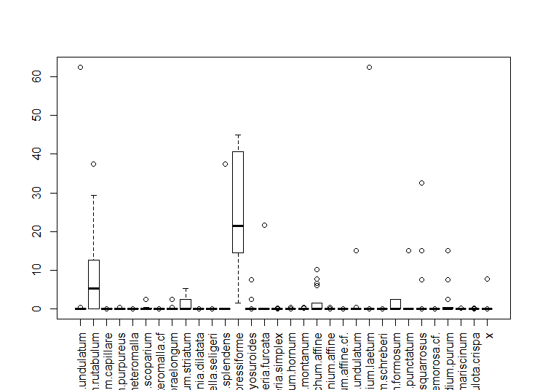
The dataset for the mainplots with coverage is highly dominated by hypnum cupressiforme and brachyothecium rutabulum as well as hypnum cupressiforme occures on all plots and brachyothecium rutabulum on 15/18 plots. Additionally to the full datasets we therefore used cleaned datasets without both species.
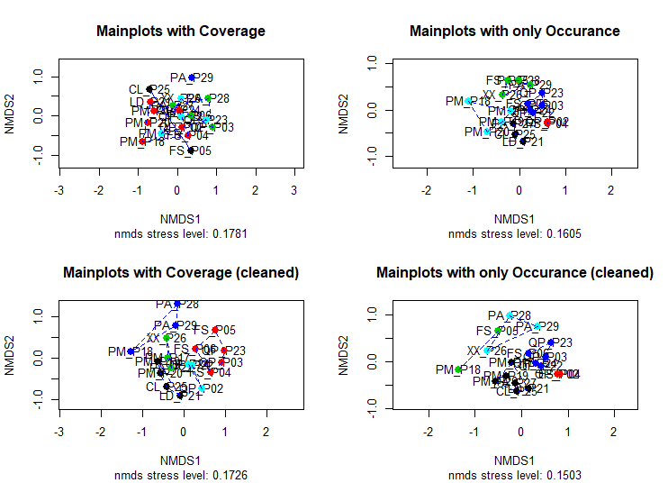
The mulit varinat statistical methode shows no significant similaritys of the forst departments (see fig) independet on the used dataset. In generall the plots are arranged in close ditance to each other independet on the tree typ. For exampe the PM plots can be found in close distance to echa other but they are not seperated clearly to the other plots.Furher the QP plots are arranged in close distance to each other but are mixed together with some FS plots. The best result is generated by the dataset with only occuring species including the dominat ones (fig oben rechts). Here the plots with angiosperm tree species occure in close distance to each other in the blue cluster and further the gymnosperm tree species plots are arranged in two seperated clusters (black and turkis). But even with this datset it is not possible to clearly seperate the moos speces compositions by the tree typ.
The arranged species table for the mainplots show equal relsuts as the cluster analysis (see fig). While some departments of the same tree typ share the same species those species occure on other plots too. For example Euryhnichum striatum can be found on all PM plots but occure on two other plots.Further there are no specific species combinations which only occure within the same tree typ. Like with the results for the ordinationn and cluster analysis the PM plots show some similarities as well as the QP plots. With this results we have to decline our hypthesis that there are typical moos compositions which depent on the forest typ (wiederholung der hypothese und ablehnung sauber formulieren und an hypothese anpassen). But we can see that there are slightly similarities between the departments containing gynmosperm treespecies as well as between departments with angiosperm treespecies.

“Results MVS hand sorted subplots”
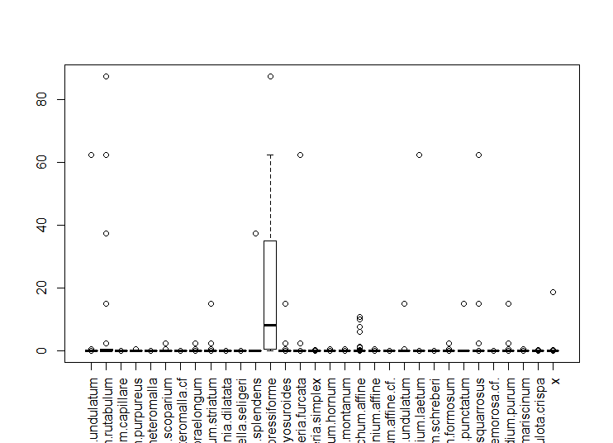
The dataset with all subplots with coverage is highly dominated by hypnum cupressiforme (see fig) and further hypnum cupressiforme occures on 50/62 plots. Additionally to the datasets with all species with coverage and with only occurance we therefore used cleaned datasets without hypnum cupressiforme.
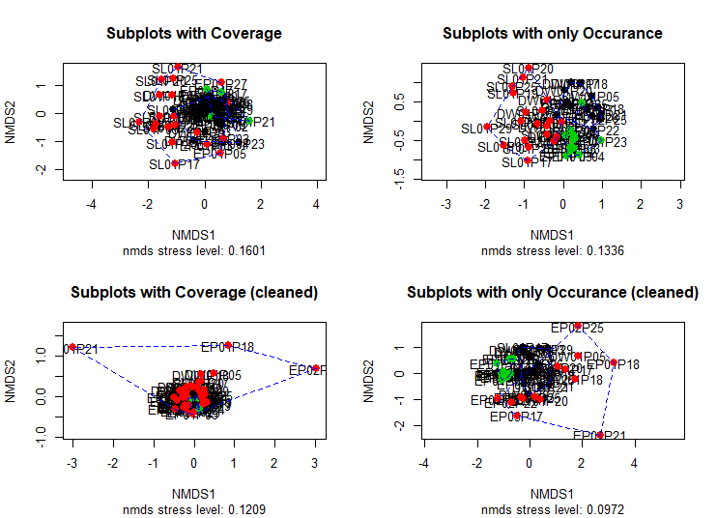

The result for the ordination for the subplot datasets with all species show a seperation of the soil plots as well as the epipytical and deadwood plots in very close distance to each other. The deadwood plots lay some who between the soil and epipytic plots. Combined with the cluster analysis most plots of a single substarte are arrange together in a cluster. Especially with only occurance of species we can see a possible relationship within the subplots: There are cleary seperated soil and epipytical plots with deadwood plots between them. On the other hand with the cleand datasets some epipytical plots are more unequal to all other and therefore the rest of the plots is arranged in close distance but even here we can see that some soil and epipytic subplots are seperated while deadwood plots are some how mixed with both other substartes.

The relationshio between the tree substartes can be seen more clearly in the arranged species table. There are significant moos species compostitions on the soil and epipytic subplots wihch do not share any species with each other while both share species with deadwood. On the other hand the deadwood subplots only contain two unique species occuring only on deadwood: Dicranella heteromalla and Ditrichum heteromalla cf.. Eccept hypnum cupressiforme and brchyothecium only tree species occure on all tree substartes: Mnium hornum, dicranum scoparium and eurynthium striatum. But even with hypnum cupressifirme and brachyothecium which occures on all substrates we can see significant differneces: On deadwood the cover of both species is higher than on epipytic plots. Further both species occure much lesser on soil and with only low coverage.

Hier die typischen leitarten auflisten auch mit result von indicator species test?

This visualises the results we found out in the plots occuriance statistc (see cahapter) (um auf die arten zu verweisen?).This result proves our (alternative) hypothesis that there are relationships of moos compositons and their repsecitv substarte instead of the forest typ they occure in.

Results cor test tree species
In total we found nine tree species on our main plots (with their respective amount of subplots): Fagus sylvatica (8), Quercus petrea cf (6), Picea abies (4), Carpinus betulus (2), Betula pendula (2), Larix decidua (2), Pseudotsuga menziesii (4), Sorbus aucuparia (1) and Acer spec (1). We hypothised that there is a correlation between the tree type and the maximum height of epiphytes. The hypothesis that on angiosperm tree species epiphytic mosses reach higher elevation than on angiosperm can be accepted. Except on one Larix decidua gymnosperms only have epiphytes up to one meter while on angiosperms moos species typically reaches up to two meters. The correlation between the tree class and the maximal height of epiphytes delivers a correlation value of -0.6111822 (weak negative correlation). With a p-value of 0.0004283. With this result we can conclude our hypothesis that angiosperm have epiphytes in higher elevations.
“Results cor test environmental parameters”
We could not find any significant correlations between the species richness or total coverage and the tested variables (Tab. 3).

Variable 1 | Variable 2 | Cor. value | P-value
Richness | Tree layer coverage | 0.0509392 | 0.8409
Richness | Scrub layer coverage | -0.5039678 | 0.03297
Richness | Herb layer coverage | -0.09983415 | 0.6935
Richness | Tree species | -0.396783 | 0.103
Richness | Tree class | -0.3476427 | 0.1575
Total coverage | Tree layer coverage | -0.1783518 | 0.4789
Total coverage | Scrub layer coverage | 0.03294554 | 0.8967
Total coverage | Herb layer coverage | 0.08304375 | 0.7432
Total coverage | Tree species | 0.1318336 | 0.6021
Total coverage | Tree class | -0.2634893 | 0.2908
Tab. 3: Correlation of environmental parameters with coverage and specis richness

5. Discussion
“species identification ingenerell”
In general moos species can be more difficult to identify than other plants (De Queiroz 2007). Species which we could not identify in the field were collected and identified later. It is possible that some species where not found in the field but later found within a sample. In this case we could not estimate the coverage afterwards. Further some moss species can be difficult to distinguish. For example the Metzgeria species or Orthodicranum montanum and affine were difficult to keep apart. Therefore we avoided to artificially generate more different species due to unsure identification results by choosing the same species for similar moos samples. For example if we estimated most Orthodicranum species to be montanum we avoided to identify a single sample as affine if we are not very sure of it’s difference. It is possible that we found more or less species due to those identification issues.
“resluts discussion from hypothesis to conclusion”
“issues and probem”
“cor tests”

Conclusion

With our hypothesis about the depenacey of forest departmnets and moos compositions declined we can prove that the moos composions depend on the substrate. We assume a gradient from epipytic plots over deadwood to soil. Hereby we think that

References:
Moss usabilities and basic knowledge:
• Drehwald, U. (2010): Nachsuche Verschollener Moose Für Die Hessische Rote Liste Moose. Göttingen

• Drehwald, U. (2013): Rote Liste Der Moose Hessens. In: Hess. Ministerium Für Umwelt, Energie, Landwirtschaft Und Verbraucherschutz (Hmuelv), Pages: 78

• Frahm J.P. (2004): Recent Developments Of Commercial Products From Bryophytes. In: The Bryologist. Volume: 107, Pages: 277-283

• Gerson, U. (1969): Moss-Arthropod Associations. In: The Bryologist. Volume: 72, Pages: 495-500

• Gignac, L. D. (2001): Bryophytes As Indicators Of Climate Change. In: The Bryologist. Volume: 104, Pages: 410-420

• Giordano, P., Adamo, S., Sorbo, S. & S. Vingiani (2005): Atmospheric Trace Metal Pollution In The Naples Urban Area Based On Results From Moss And Lichen Bags. In: Environmental Pollution. Volume: 136, Pages: 431-442

• Harmens, H., Norris, D. A., Steinnes, E., Kubin, E., Piispanen, J., Alber, R., Aleksiayenak, Y., Blum, O., Coskun, M., Dam, M., De Temmerman, L., Fernandez, J. A., Frolova, M., Frontasyeva, ´ M., Gonzalez-Miqueo, L., Grodzi ´ Nska, K., Jeran, Z., Korzekwa, ´ S., Krmar, M., Kvietkus, K., Leblond, S., Liiv, S., Magnusson, ´ S. H., Mankovsk ˇ A, B., Pesch, R., R ´ Uhling, ¨ A., Santamaria, J. M., ˚ Schroder, W., Spiric, Z., Suchara, I., Th ¨ Oni, L., Urumov, V., Yu- ¨ Rukova, L., & H. G. Zechmeister (2010): Mosses As Biomonitors Of Atmospheric Heavy Metal Deposition: Spatial Patterns And Temporal Trends In Europe. In: Environmental Pollution. Volume: 158, Pages: 3144-3156

• Peck, J.E. (2006): Towards Sustainable Commercial Moss Harvest In The Pacific North-West Of North America. In: Biological Conservation. Volume: 128, Pages: 289–297

Moss Ecology:
• Anderson, L. E. (1963): Modern Species Concepts: Mosses. In: The Bryologist. Volume: 66, Pages: 107-119

• Cove, D.J., Knight, C.D. & T. Lamparter (1997): Mosses As Model Systems. In: Trends Plant Science. Volume: 2, Pages: 99-105

• Crosby, M.R., Magill, R.E., Allen, B. & S. He (1999): A Checklist Of The Mosses. In: Prospectus. Missouri Botanical Garden, St. Louis

• De Queiroz, K. (2007): Species Concepts And Species Delimitation. In: Systematic Biology. Volume: 56, Pages: 879-886

• Dierschke, H. (1994): Pflanzensoziologie: Grundlagen und Methoden. Ulmer, Stuttgart.

• During H.J. (1979): Life Strategies Of Bryophytes: A Preliminary Review. In: Lindbergia. Volume: 5, Page: 2-18

• Fenton, N.J. & K.A. Frego (2005): Bryophyte Conservation Under Remnant Canopy In Managed Forests. In: Biological Conservation. Volume: 122, Pages: 417-430
• Frahm. J.P. &W. Frey (1992): Moosflora. Page: 8

• Frego K.A. (2007): Bryophytes As Potential Indicators Of Forest Integrity. In: Forest Ecology Management. Volume: 242, Pages: 65-75

• Frey, W. & H. Kürschner (2011): Asexual Reproduction, Habitat Colonization And Habitat Maintenance In Bryophytes - A Review. In: Flora. Volume: 206, Pages:173-184

• Furness, S. B. & J. P. Grime (1982a): Growth Rate And Temperature Responses In Bryophytes. I. An Investigation Of Brachythecium Rutabulum. In: Journal Of Ecology, Volume: 70, Pages: 513-523

• Furness, S. B. & J. P. Grime (1982b): Growth Rate And Temperature Responses In Bryophytes. Ii. A Comparative Study Of Species Of Contrasted Ecology. In: Journal Of Ecology, Volume: 70, Pages: 525-536

• Meinunger, L. & W. Schröder (2007): Verbreitungsatlas der Moose Deutschlands. Hrsg. O. Dürhammer für die Regensb. Bot. Ges., 3 Bd., Regensburg

• Mezaka, A., Brumelis, G. & A. Piterans (2012): Tree And Stand-Scale Factors Affecting Richness And Composition Of Epiphytic Bryophytes And Lichens In Deciduous Woodland Key Habitats. In: Biodiversity Conservation. Volume: 21, Pages: 3221-3241

• Mishler, B. D. (1985): The Morphological, Developmental, And Phylogenetic Basis Of Species Concepts In Bryophytes. In: The Bryologist. Volume: 88, Pages: 207-214

• Nentwig, W., Bacher, S., Brandl, R., & M. Lay (2009): Ökologie Kompakt. Spektrum Akademischer Verlag Gmbh. Heidelberg

• Ogwu, M. C. (2019): Ecological and Economic Significance of Bryophytes. URL: https://orcid.org/0000-0001-6054-1667 Seoul National University (Access: 17.01.2020)

• Oksanen, J., Guillaume Blanchet, F., Friendly, M., Kindt, R., Legendre, P., McGlinn, D., Minchin, P. R., O'Hara, R. B., Simpson, G. L., Solymos, P., Stevens, M.H.H., Szoecs, E. & Helene Wagner (2019): Community Ecology Package. URL: https://github.com/vegandevs/vegan (Access: 29.01.2020)

• Turetsky, M. R. Et Al. (2012): The Resilience And Functional Role Of Moss In Boreal And Arctic Ecosystems. In: New Phytology. Volume:196, Pages: 49-67

• Zechmeister, H.G., Grodzinska, K. & G. Szarek Lukaszewska (2003): Bryophytes. In: Markert, Bioindicators And Bio-Monitors. Elsevier Science Ltd., Amsterdam, Pages: 329-375

Nested Plot Design:
• Barnett, D. T. & T.J. Stohlgren (2003): A Nested-Intensity Design For Surveying Plant Diversity. In: Biodiversity And Conservation. Volume: 12, Pages: 255-278

• Braun-Blanquet, J. (1928): Pflanzensoziologie. Grundzüge der Vegetationskunde. Montpellier

• Mills S. E. & S. E. Macdonald (2004): Predictors Of Moss And Liverwort Species Diversity of Microsites In Conifer-Dominated Boreal Forest. In: Journal Of Vegetation Science. Volume: 15, Pages: 189198

• Shmida, A. (1984): Whittaker’s plant diversity sampling method. Israel journal of Botany. Volume: 33, Pages: 41-46

• Stohlgren, T.J., Falkner, M. B. & L. D. Schell (1995): A Modified-Whittaker Nested Vegetation Sampling Method. In: Plant Ecology. Volume 117, Number 2 / April, 1995. Pages: 113-121

• Worthen, W. B. (1996): Community Composition And Nested‐Subset Analysis: Basic Descriptors For Community Ecology. In: Oikos. Volume: 76, Pages: 417-426

• Jiang, Y., Liu, X., Song, S., Yu, Z., & X. Shao (2015): Diversity And Distribution Of Ground Bryophytes In Broadleaved Forests In Mabian Dafengding National Nature Reserve, Sichuan, China. In: Acta Ecol Sin. Volume: 35, Pages: 13-9

• Ilić, M., Igić, R., Ćuk, M. & D. Vukov (2018): Field Sampling Methods For Investigating Forest-Floor Bryophytes: Microcoenose Vs. Random Sampling. In: Archives Of Biological Sciences. Volume: 70(3), Pages: 589-598

Statistics:
• Duprel, J. B., Röhrig, B., Hommel, G. & M. Blettner (2010): Auswahl Statistischer Testverfahren. In: Deutsches Ärzteblatt. Volume: 107, Number: 19, Pages: 343-348

• Leyer, L. & K. Wesche (2007): Multivariate Statistik In Der Ökologie. Einfache Einführung In Die Vielfältigen Methoden Der Multivariaten Analyse Ökologischer Daten. Springer, Heidelberg, Pages:

• Petzold, T. (2008): Datenanalyse Mit R Ausgewählte Beispiele. Lehrmaterial An Der Tu Dresden, Not Published

• Hill, M.O. & H.G. Gauch (1980): Detrended Correspondence analysis: an improved ordination technique. In: Vegetation, Volume:42, Pages: 47-58

• Minchin, P. R. (1987): An evaluation of the relative robustness of techniques for ecological ordination. In: Vegetatio, Volume: 69, Pages: 89-107

Geology:

• Opentopomap (2020): https://opentopomap.org/#map=15/50.83684/8.67922 (Access: 29.01.2020)

• Bodenviewer (2020): http://bodenviewer.hessen.de/mapapps/resources/apps/bodenviewer/index.html?lang=de (Access: 25.01.2020)

• Hessisches Landesamt für Umwelt und Geologie (2007): Geologische Übersichtskarte von Hessen. Wiesbaden

