**Abstract**

**Keywords:** Bryophytes, Nested plot design, substrate dependency, distribution patterns

**1. INTRODUCTION**

Bryophytes are the second biggest species group within the plant kingdom behind the much larger angiosperms (Crosby et. al. 1999, Frahm & Frey 1992). There are approximately 25,000 species taxonomically divided into hornworths (*Anthocerotopsida*), two classes of the liverworts (*Marchantiopsida, Jungermanniopsida*) and the mosses (*Bryopsida*) (Zechmeister, Grodzinska & Szarek Lukaszewska 2003). Unlike many other plants bryophytes can reproduce both sexually and vegetative (Frey & Kürschner 2011, Mishler 1985). Recent researches suggest that mosses play an important role as an omnipresent component in plant communities worldwide and strongly influence the water, nutrient and carbon cycle of their habitat (Turetsky et. al. 2012, Gerson 1969, (Gignac 2001). Their role as the simplest terrestrial plant puts them in the spotlight of research which tries to draw back the lines of plant-evolution from aquatic to terrestrial habitats (Cove, Knight & Lamparter 1997). Bryophytes lately interested researchers for many applications: Mosses were successfully used as accumulation indicators for pollutants like trace metals, heavy metals, radionucleides and for toxic organic compounds (Giordano et. Al. 2005, Harmens et. al.2010, Nentwig et. Al. 2009, Zechmeister, Grodzinska & Szarek Lukaszewska 2003). Forest integrity research puts much effort in research because the irreplaceable and vulnerable role of mosses in healthy forest habitats is endangered by actual forest management practices (Fenton 2005, Frego 2007, Mezaka, Brūmelis & Piterāns 2012, Peck 2006). And their vulnerability to abiotic environmental stress makes them a promising indicator species for global change research (During 1979, Gignac 2001, Ogwu 2019). Even their antifungal and antifeedant contents find use in the cosmetic industry (Frahm 2004). Because of their small size compared to other plants, bryophytes never truly stood in the focus of nature preservation measures (Drehwald 2013, (Furness & Grime 1982). “The progress in moss taxonomy is years behind that in vascular plants [...] the field is still in the exploratory, floristic stage of development, and many of the commonest species are very poorly understood taxonomically, floristically, and ecologically [...] while a large part of the southern hemisphere still remains undiscovered.” (Anderson 1963). Even in the twenty first century there are huge distribution gaps of common species (based on missing Data) in Germany which represents the one of the most studied countries in bryophyte research (Meinunger & Schröder 2007). Mosses were just recently added to the red list of endangered species which hopefully leads to more research measures to enhance the knowledge about their role in diverse ecosystems (Drehwald 2013).

The goal of this work is to map the mosses in the Marburg Open Forest (MOF) near Cölbe (Hesse, Germany) to investigate moss distribution patterns along different substrates. We hope to find relationships between the occurrence and abundance of moss species in different habitats and growing on different substrates. We investigate if there are any species that occur exclusively on a certain tree species or on certain substrates (epiphytic, soil, deadwood) and which relations could be derived from these patterns. We chose a nested plot design in which a mainplot contains many subplots. We hope to increase the accuracy of species richness by this plot design (Ilić, Igić, Ćuk & Vukov 2018). Epiphytic mosses were recorded on a variety of tree species and in three levels (one to three meters above the tree-root). Also the moss distribution on dead wood and soil was recorded. We assume that there are similar moss species in the same habitats (e.g. Beech, Spruce, Oak) and tree species. Also we hope to find relationships between the occurrence of moss species and the corresponding substrate it is growing on (e.g. soil, deadwood, epiphytic).

**2. Data and Methods**

**2.1 Study area**

The research was performed from May to Juli 2019 in the Marburg Open Forest (MOF) near the small town Caldern which is a part of the administrative district of Marburg (Hessen, Germany). Geologically the area is dominated by limestone, greywacke, shales and conglomerate stone (Hessisches Landesamt für Umwelt und Geologie 2007). It is part of the geologic constellation “Rheinisches Schiefergebirge” and the soil composition in this area is described as solifluidal sediments and brown earth (Bodenviewer 2020). The highest elevation is the Hungert with 412 meters above sea level (Opentopomap 2020). It represents a typical central European temperate forest and includes departments with mainly *Fagus sylvatica* , *Quercus petrea cf* , *Picea abies, Pseudotsuga menziesii, a* single small department with *Larix decidua* and some clearings, meadows and an abandoned quarry. Additionally there are some tiny creeks which don’t carry water permanently. The *Quercus petrea* departments include a mix of *Quercus petrea* and *Fagus sylvatica* and as typical for economically used forest the departments can include small amounts of other tree species. For our study we focus on the departments of the four main tree species *Fagus sylvatica , Quercus petrea cf , Picea abies* and *Pseudotsuga menziesii* along with the *Larix decidua* department and a clearing (Fig. 1). We didn’t collect data for the quarry or the creeks. The departments north of the primary road are classified as natural reserves where it is restricted to enter and collect plant samples.

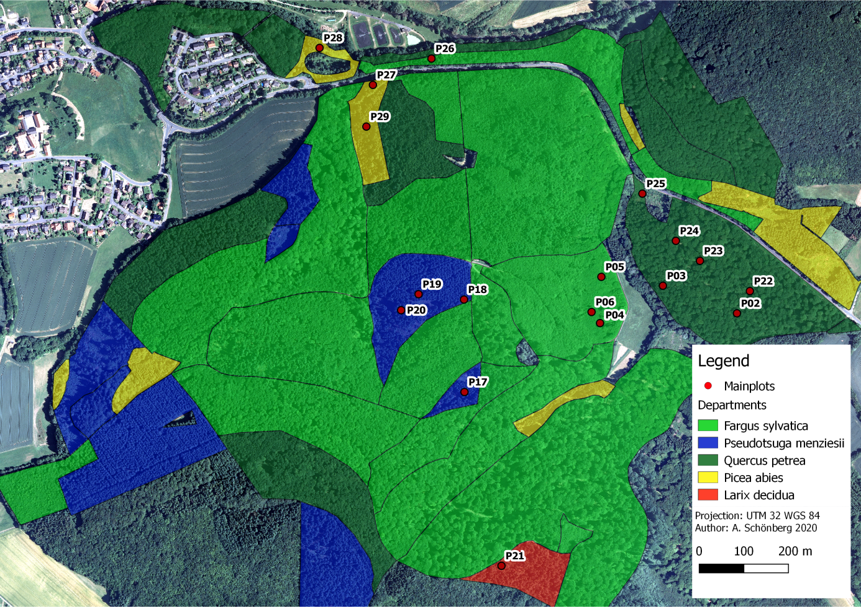

Fig. 1: Study site with vegetation departments and main plot positions

**2.2 Field Methods**

For our study and regarding to our hypothesis we will perform a moss vegetation survey after BRAUN-BLANQUET (1928) and use a nested plot design to collect data for different substrates via multiple subplots per main plot. Due to the different sizes of the departments and the goal to collect representative data we calculate the amount of plot per tree species as followed. For the angiosperm species we sampled on three plots in *Fagus sylvatica* departments. Five plots in *Quercus petrea cf.* departments because there occur *Fagus sylvatica* too. For the gymnosperm species we sampled on one plot for *Larix decidua* because there is only one department in the study area. For *Pseudotsuga menziesii* we sampled on four plots along with four plots for P*icea abies* to get equal amounts of plots for each tree species. Further we sampled on a clearing to get data to compare to the forest plots.

For the planned amount of plots per forest department we searched for most representative positions (Dierschke 1994) within the departments and used a nested plot design to collect data regarding to our hypothesis. The nested plot design was chosen to improve the accuracy and reliability of moss occurrence and richness (Stohlgren, Falkner & Schell 1995). The typical “Whittaker plot” (Shmida 1984) used multiple spatial scales (1m², 10m², 100m² subplots within a 1000m² main plot) to collect species richness data. But this scale is too big for our approach to sample mosses so we modified it into a 10m x 10m main plot in which we aligned all substrates (soil, deadwood, epiphyte) as subplots within. Therefore a “main plot” was set up on a representative position within the department and a 5 meter radius was set. This area of ca 80 m² is nearly equal to a 10x10 meter squared plot and typically used for forest vegetations plots (Dierschke 1994). First we estimated the coverage for the main plot area for the tree, scrub and herb-layers as well as taking the coordinates. Then we set up the “subplots” for the different substrates to identify the moos species occurring on it. This improves the subjectivity of the vegetation survey as well as delivering data about the distribution of moos species within a main plot. For substrates we choose soil, deadwood and epiphyte because we expected to find those substrates in most plots. For every subplot the species were identified and the coverage was estimated based on the Braun Blanquet scale (Braun-Blanquet 1928) while the frequency distribution is based on the subplot type and not in relation to the main plot.

**2.3 Plot and sampling design**

**2.3.1 Soil**

For the soil subplots we identified all moss species occurring on bare soil. Typically this substrate contains small elevations which are free from vegetation due to the exposition to the wind and missing sunlight. The coverage is estimates in relation to the whole main plots area to prevent high cover values if there is only a small area of soil related to the main plot area. Further this allows comparing high coverage values on vegetation free areas like clearings or meadows with plots where only small areas are free of vegetation. On the other hand there could be a high amount of low coverage values for plots in the forest.

**2.3.2 Deadwood**

Like for soil we identified all moos species occurring on deadwood but estimated the coverage in relation to the accumulated area of deadwood in the main plot area instead to the whole main plot area. Here we expected deadwood occurring relatively common on the main plots unlike the soil subplots. We focused our interest on the comparability of the species within a plot instead of the plots among themselves.

**2.3.3 Epiphyte**

For the epiphyte subplots we first identified the tree species within the main plot. For every tree species we set up an epiphyte subplot to later compare the epiphytic moos species by tree species. Therefore we identified the moos species and estimate the coverage by the mean on all trees of the same species with the main plot. If there are more than only a few trees we chose representative trees as a sample for the area. Further we divided the plots into elevation levels to later test our hypothesis about the elevation dependent occurrence of moos species by tree class (Tab.1).

|  |  |
| --- | --- |
| **Level** | **Elevation** |
| 1 | Ground up to 1 meter |
| 2 | 1 meter up to 2 meters |
| 3 | Above 2 meters |

Tab. 1: Epiphytic subplot levels

This sampling design can result in single species occurring multiple times on a main plot with different coverage which has to be handled in data pre-processing. If any type of substrate is missing on a main plot we don’t generate it instead of setting zeros values due to multivariate statistical approaches like ordination cannot handle zeros.

**2.4 Species identification**

In general moos species can be more difficult to identify than other plants. Species which we could not identify in the field were collected and identified later. It is possible that some species where not found in the field but later found within a sample. In this case we could not estimate the coverage afterwards. Further some moss species can be difficult to distinguish. For example the *Metzgeria species* or *Orthodicranum montanum* and *affine were hard to keep apart.* Therefore we avoided to artificially generate more different species due to unsure identification. For example if we estimate most *Orthodicranum* species to be *montanum* we will avoid to identify a single sample as affine if we are not very sure. It is possible that we found more or less species due to those identification issues.

**3. Data preparation and analysis**

**3.1 Data pre-processing**

At First the collected data was digitalized in a single table. Additionally a second table was digitalized containing the information for the main plot like the coordinates and the environmental parameters of tree,- scrub,- and herb-layer coverage. For further analysis the main species table was edited to ensure there were no missing data. It is possible that the cover for a species is missing when it was found within a moos sample and not collected on the plot elsewhere. To avoid an information loss this species all get the same value for cover instead of deleting the species. Assuming that with higher coverage’s the species would be collected elsewhere on the plot and to reduce a possible manipulation we assign an “r” to those species. Any moos species with missing name entry will be deleted if we were not able to reproduce the information.

To allow mathematical operations and perform multi-variant statistical methods the Braun-Blanquet scale for the coverage is translated into numeric values. We assigned the mean value in percent from the Braun-Blanquet scale as the numeric mean value (Tab. 2).

|  |  |  |
| --- | --- | --- |
| **Braun-Blanquet scale** | **Cover in percent** | **Numeric mean conversion** |
| **r** | Far less than 1 % | 0,1 |
| **+** | Less than 1% | 0,5 |
| **1** | Less than 5% | 2,5 |
| **2** | 5-25 % | 15 |
| **3** | 25-50 % | 37,5 |
| **4** | 50-75 % | 62,5 |
| **5** | 75-100 % | 87,5 |

Tab. 2: Braun-Blanquet scale numeric conversion

Due to our sampling design a moos species can occur multiple times within a main plot on different subplots and on several elevation levels on different tree species. To investigate the differences between the main plots we need to accumulate the coverage for species occurring on multiple subplots. Therefore we used the pivot format table to calculate the mean coverage values to get a new dataset with the species on the main plots independent of the substrate they occur on. To analyze the different substrates by main plot position we further generated datasets for the three substrates (soil, deadwood and epiphyte). To further investigate similarities of the substrate subplots we computed a dataset which includes all subplots.

**3.2 Data analysis**

**3.2.1 Species richness and total coverage**

First we generated a species table with all moos species occurring in the study area with information about their occurrence on the different plots. Than we calculated the species richness and total coverage for every species for the main and subplots to get an overview of the distribution of moss species in the study area. For the total coverage we used the sum of numeric values from every subplot. This grants to compare the dominance of species within a plot but the values should not be compared to other plots. The species richness is the amount of unique species occurring on the plot.

Further to examine the distribution of the species we identified which species occur only on one of the different substrates to see if there are any relationships between the substrates. To examine the distribution of species on the substrates we identified those species only occurring on a single substrate to see if we find typical (indicator) species for the substrates. If those typical species are missing because they occur on more than one substrate we generated two lists with terrestrial species by combining the species occurring on deadwood and soil and test which species occur on epiphyte. The same procedure is performed for epiphytic species by combining epiphyte and deadwood species and check which don’t occur on soil.

**3.2.2 Ordination and cluster analysis**

To investigate our hypothesis that the differences in moos compositions depends on the forest departments we used the multi-variant statistical method of ordination and cluster analysis. We used the “vegan” R-package for hierarchic clustering (HC) and K-means clustering (KM) (Oksanen et. al. 2019). To further visualize the distances of the Objects the function computes a non-metric multi-dimensional scaling (nmds) and detrended correspondence analysis (dca) ordination. We estimate that the three classes are sorted in the three clusters due to similarities of the extracted values. To check the quality of th

“cor tests environmental parameter”

The main plots have different coverage values for the tree, scrub and herb layers. To investigate if there are any correlations with the richness and total coverage of the plots we use “cor.tests”. We tested each total coverage and species richness versus the coverage of tree, scrub and herb layers as well as versus the tree species and the tree class (angiosperm and gymnosperm).

“methods cor test”

At least to test our hypothesis that the elevation distribution of epiphytic moos species depends on the tree species we analyzed the correlation between the maximum level species occurs and the tree species it was collected on. Therefore we use our collected data for the epiphyte subplots with information about the maximum height level any moos species occur for all tree species. Further we assign angiosperm and gymnosperm to the generate the tree-class parameter. Nur mit tree type geht das doch garnicht? 9 klassen gegen 3 höhen testen, was soll da der cor wert auch aussagen, es gibt ja keine skala für treetyp nur für treeclass. Than we used the cor.test with the pearson method to test if there is a correlation between the the treeclass and the maximum height level of epipythes.

Results cor test

In total we found nine tree species on our main plots (with their respective amount of subplots): *Fagus sylvatica* (8), *Quercus petrea cf* (6), *Picea abies* (4), *Carpinus betulus* (2), *Betula pendula* (2), *Larix decidua* (2), *Pseudotsuga menziesii* (4), *Sorbus aucuparia* (1) and *Acer spec* (1). We hypothised that there is a correlation between the tree typ and the maximum height of epiphytes. We hypothised that on angiosperm tree species epipyht moos reaches higher elevation than on angiosperm. Except on one *Larix decidua* gymnosperms only have epiphytes up to one meter while on angiosperms moos species typically reaches up to two meters. The correlation between the tree class and the maximal height of epiphytes delivers a correlation value of -0.6111822

With a p-value of 0.0004283. With this result we can conclude our hypothesis that angiosperm have epiphytes in higher elevations.

“Results cor test environmental parameters”

We could not find any significant correlations between the species richness or total coverage and the tested variables (see fig)

|  |  |  |  |
| --- | --- | --- | --- |
| **Variable 1** | **Variable 2** | **Cor. value** | **P-value** |
| Richness | Tree layer coverage | 0.0509392 | 0.8409 |
| Richness | Scrub layer coverage | -0.5039678 | 0.03297 |
| Richness | Herb layer coverage | -0.09983415 | 0.6935 |
| Richness | Tree species | -0.396783 | 0.103 |
| Richness | Tree class | -0.3476427 | 0.1575 |
| Total coverage | Tree layer coverage | -0.1783518 | 0.4789 |
| Total coverage | Scrub layer coverage | 0.03294554 | 0.8967 |
| Total coverage | Herb layer coverage | 0.08304375 | 0.7432 |
| Total coverage | Tree species | 0.1318336 | 0.6021 |
| Total coverage | Tree class | -0.2634893 | 0.2908 |

Tab. 2:

**4. Results**

**Basisdaten zu Moosen in Caldern**

For the Caldern Forest we found 32 different Moos-species in total within the soil, deadwood and epiphyte substrates (see fig.x). The soil and epiphyte substrates contain 18 different species each and the deadwood substrate has the highest diversity with 21 species. Most common Species within the main plots is *Hypnum cupressiforme* which is further the most common species by occurrence on plots on deadwood (94%) and epiphyte (100%). On soil the most common species is *Polytrichum formosum* (71%).

In total we found 32 different moos species in the study area based on our sampling design. Most common species overall is *Hypnum cupressiforme* occurring on every main plot (18/18) with the far highest dominance in total coverage (see fig). Further common species are: *Brachyothecium rutabulum* (15/18), *Dicranum scoparium* (12/18), *Politrichum formosum* (11/18) and *Orthotrichum affine* (11/18). For the soil subplots *Politrichum formosum* (10/14), *Brachyothecium rutabulum* (8/14) and *Atrichum undulatum* (8/14) represent the most common species and with their respective total coverage this is the typical composition on soil in the study area. While *Hypnum cupressiforme* occurred very rare on soil compared to the other substrates (3/14) it is the most common species on deadwood (17/18) and epiphyte (30/30) subplots. Typical compositions on deadwood are *Hypnum cupressiforme* (17/18), *Brachyothecium rutabulum* (12/18) *and Dicranum scoparium* (9/18). The epiphyte subplots show a high amount of species occurring only on very few plots compared to the other substrates. Again *Hypnum cupressiforme* (30/30), *Brachyothecium rutabulum* (14/30) represent the typical species along with *Orthotichum affine* (11/30).

Some species only occur on a single substrate others on two or on all tree. Only on soil subplots occurred: *Hylocomium splendens, Plagiomnium affine cf , Plagiomnium undulatum*, *Pleurozium schreberi* and *Rhizomnium punctatum*. On deadwood subplots *Dicranella heteromalla* and *Ditrichum heteromalla cf* and on epiphyte respectively *Bryum capillare, Frullania dilatata, Metzgeria simplex, Scapania nemorosa cf, Ulota crispa* and x. Some typical epiphytes like *Orthotricum affine* and respectively typical terrestrial species like *Polytrichum* are missing in this lists because they occur on deadwood to. With the deadwood substrate combined to soil and epiphyte we receive a list that more likely represent the typical compositions seen in the field. For terrestrial species (not occurring as epiphytes) there are *Atrichum undulatum Eurhynchium praelongum Herzogiella seligeri*

*[4] Hylocomium splendens Plagiomnium affine Plagiomnium affine cf.*

*[7] Plagiomnium undulatum Pleurozium schreberi Polytrichum formosum*

*[10] Rhizomnium punctatum Rhytidiadelphus squarrosus Scleropodium purum* and for epiphytes (not occurring on soil): [1] *Bryum capillare Ceratodon purpureus Frullania dilatata Metzgeria furcata*

[5] *Metzgeria simplex Orthodicranum montanum Orthotrichum affine Plagiothecium laetum*

[9] *Scapania nemorosa cf. Thuidium tamariscinum Ulota crispa*  "x"

(hier noch nicht auf deadwood als übergang eingehen?)

**TODO:**

**artenliste von hand verschieben Methode und result**

**MVS Methode und result**

**Literature**