Asian longhorn beetle (*Anoplophora glabripennis*)

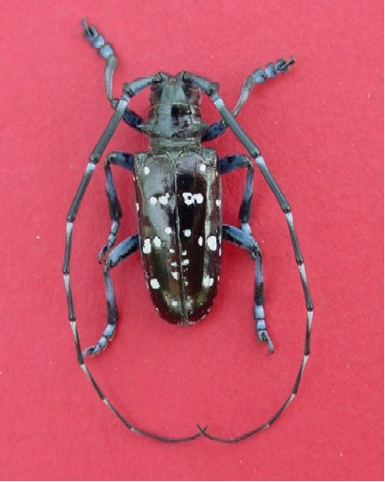

Anoplophora glabripennis male (Photo: Michael Bohne, USDA Forest Service, www.forestryimages.org)

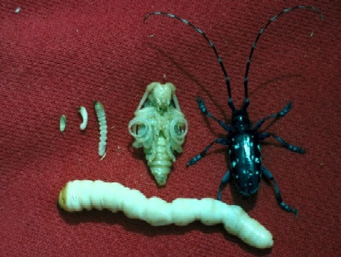

Anoplophora glabripennis life cycle (Photo: Kenneth R. Law, USDA APHIS PPQ, www.forestryimages.org)

**Habitat Description:**

- The Asian longhorn beetle lives in urban (ornamentals), rural (shelters and hedgerows), agricultural (windbreaks) locations and forests.

- Adult beetles infest trees like *Populus, Salic, Ulmus* and *Acer*.

- Its native range lies in China, Hong Kong, The Republic of Korea and the Democratic People’s Republic of Korea.

- Its alien range lies in North America (USA & Canada) and in several european countries (e.g. Germany, France, Slovakia, Austia)

**Nutrition:**

-Adult Asian longhorn beetle feed on leaves, petiole and twigs. They appear to attack healthy trees (under investigation), as well as stressed trees.

**Pathway:**

-The Asian longhorn beetle is transported on infested fire wood, containers, pallets & dunage.

- Has reached the USA and other countries is in wood packing materials.

- Intercepted frequently at ports and found in warehouses throughout the United States.

**General Impacts:**

- It attacks hradwood tree species in the eastern part oft he US (discovered in 1996).

- Eggs are injected under the bark surface, where they hatch into larvae.

- The tunnels oft he larvaes destroy the structural integrety oft he trees.

**Impacts North America:**

=> 30-35% of trees in urban eastern states are susceptible to its attack.

=> Urban areas could lose as much as 35 percent of their tree canopy cover and 30 percent of their trees (1.2 billion trees) (Billion = Milliarde! :D) loss of value of $669 billion.

=> The potential impact to forests is the loss of 71 billion trees valued at over $2 trillion dollars, if the beetle reaches natural forests (Trillion = Billion!)

=> Also the production of maple syrup and tourism is at risk.

=> The loss of trees may also decrease property values, cause aesthetic damage and lessen environmental benefits such as cleaning air and water and providing energy-conserving shade.

**Impacts natural habitat:**

- Unimportant for the Poster?

**Managment Info:**

**-** Eradication programme implemented by the US Animal and Plant Health Inspection Service (APHIS)

- Intensive visual inspections when the beetle is reported.

- Trees at high risk are felled and chipped (400mtrs from the edge of the known infestation)

- Using the systemic insecticide, imidacloprid, which has been shown to kill adult beetles.

**Bibliography:**

Poland, T.M., Haack, R.A., Petrice, T.R., Miller, D.L., Bauer, L.S. & Gao, R. 2006a. Field evaluations of systemic insecticides for control of *Anoplophora glabripennis* (Coleoptera: Cerambycidae) in China. *Journal of Economic Entomology 99*(2): 383-392.

Smith, M.T. & Wu, J. 2008. Asian longhorned beetle: renewed threat to northeastern USA and implications worldwide. *International Pest Control (November-December)*: 311-316.

Invasive Species Specialist Group (ISSG) (2009): Global Invasive Species Database. < http://www.iucngisd.org/gisd/species.php?sc=111 > (Zugriff: 28.01.2019)