**Exemplary species spread due to global transport**

Asian tiger mosquito (*Aedes albopictus*) 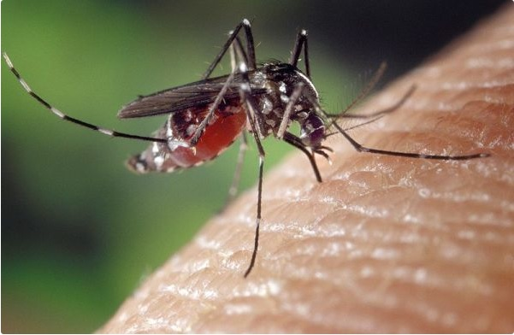

*Aedes albopictus* on human skin (Photo: James Gathany, Centres for Disease Control and Prevention, USA)

**Natural habitat**:

The Asian Tiger Mosquito ist described as a treehole mosquito. Its natural habitat is closely located to water surrended by vegetation. Due to its massive ecological flexibility the mosquito can be found in many different locations. These can also lie within urban regions and man made sites. Espacially tires, which are stored outside, are perfect breeding places for the Asian Tiger Mosquito (Moore 1999, in Eritja *et al*. 2005).

**Reproduction:**

The female mosquito lays eggs above the water surface in treeholes, tires and other locations. The ability to breed in artifical containers helps them to spread all over the world. Espacillay close to global trading routes the mosquito can be found (Lounibos 2002 in Vezzani and Carbajo, 2008). The combination of short photoperiods and low temperatures can induce the females to lay diapausing eggs. An ability which other mosquitos lack and help the Tiger Mosquito to survive long routes (Hanson and Craig 1995, in Eritja *et al*. 2005).

**Pathway:**

The mosquito was found for the first time in 2001 in the port of Los Angeles (Linthicum 2001, in Eritja *et al*. 2005). The movement moist vegetation, wet tyres or water containers that can hold eggs or larvaes. Most oft he long range colonizations ist he result of passive transportations by man (Eritja *et al*. 2005).

**General Impacts:**

The Asian Tiger Mosquito is an aggressive day biter which attacks humans, livestock, amphibians and birds (Eritja et al. 2005). There are a total of four Flaviviruses (Dengue, West Nile and Japanese Encephalitis), ten Bunyaviruses (e.g. Jamestown Canyon, Potosi, Cache Valley and Tensaw) and seven Alphaviruses that the mosquito is known to be receptive to in laboratory conditions. These include Yellow Fever, Rift Valley Fever, Chikungunya and Sindbis (Enserink, 2008). However the extent to which *Ae. albopictus* can transmit diseases in the real world is unclear and depends on many factors including numbers, whether it bites humans, whether it takes blood meals from multiple people and how effectively the virus makes it from the mosquito’s gut to its salivary glands (Enserink, 2008). The Asian Tiger Mosquito has been demonstrated to have a competitive advantage over a number of other mosquito species (O’Meara *et al*. 1995; Juliano, 1998; Lounibos, 2002; Braks *et al*. 2004 in Vezzani and Carbajo, 2008).

**Management Info:**

**Preventative measures:**

Starting in 1992, several countries in South America (Venezuela, Chile, Bermuda, Costa Rica, Argentina and Brazil) have dictated embargoes on used tire importations (Eritja *et al*. 2005).

In the Netherlands horticultural companies have taken steps to reduce the risk, for instance, by treating shipments before they leave China (Enserink, 2008).

**Physical Control:**

Using special traps to catch the mosquito which use ammonia, fatty acids and lactic acids to produce a smell similar to that of a human body in an upward air current (Meeraus *et al*. 2008).

**Integrated Management:**

In Switzerland, monitoring systems consisted of over 300 strategically positioned oviposition traps along main traffic axes, including parking lots within industrial complexes, border crossings and shopping centres (Wymann *et al*. 2008).

**Bibliography:**

**Enserink, M.** (2008): A mosquito goes global. Science 320: 864-866.

**Eritja, R., Escosa, R., Lucientes, J., Marque, E., Molina, R., Roiz, D. & Ruiz, S**. (2005): Worldwide Invasion of Vector Mosquitoes: Present European Distribution and Challenges for Spain, *Biological Invasions 7*: 87-97.

**Invasive Species Specialist Group (ISSG)** (2009): Global Invasive Species Database. <http://www.iucngisd.org/gisd/species.php?sc=109> (Zugriff: 02.02.2019)

**Meeraus, W.H., Armistead, J.S. & Arias, J.R.** (2008): Field comparison of novel and gold standard traps for collecting *Aedes albopictus* in Northern Virginia. Journal of American Mosquito Control Association 24(2): 244-248.

**Vezzani, D. & Carbajo, A.E.** (2008): *Aedes aegypti*, *Aedes albopictus*, and dengue in Argentina: current knowledge and future directions. Mem Inst Oswaldo Cruz, Rio de Janeiro 103(1): 66-74.

**Wymann, M.N., Flacio, E., Radczuweit, S., Patocchi, N. & Luthy, P.** (2008): Asian tiger mosquito (*Aedes albopictus*) a threat for Switzerland? Eurosurveillance 13: 1-3.