Climate characterization of octopus Locations used for the calibration
Only the first two principal components were selected, as they explain the main climatic variability. Although the third component adds some information related to precipitation (see pdf ‘biplot PC1_PC2_PC3’), PC1 and PC2 together capture a sufficient amount of climatic variation to support the cluster analysis and climate characterization.
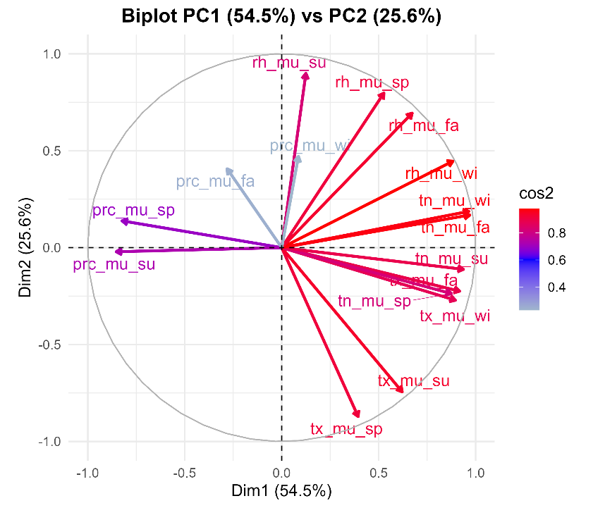
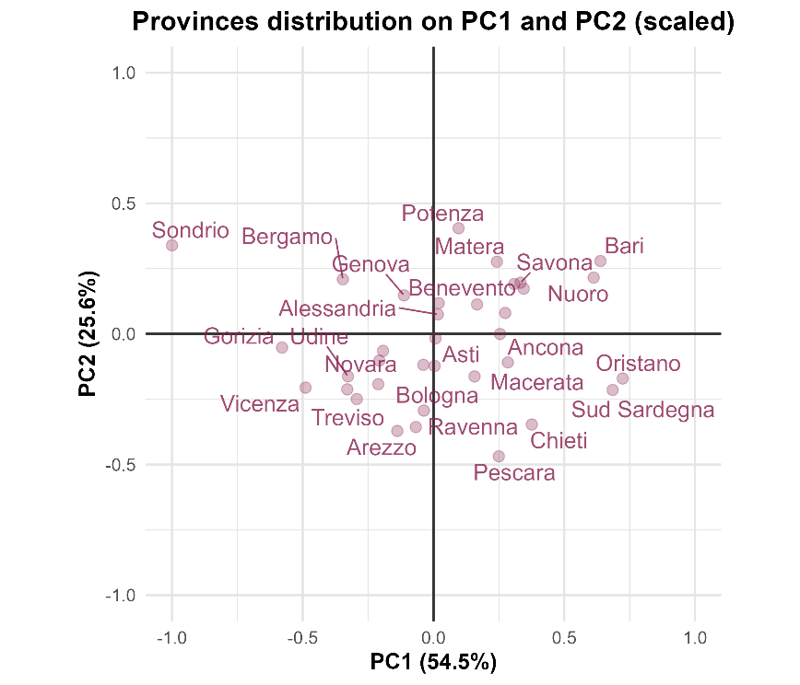

Quadrant | PC1 sign | PC2 sign | Climatic type | Description | Examples
Upper right | + | + | warm–humid | Transitional inland Mediterranean zones, moderately humid | Matera, Benevento, Potenza
Lower right | + | – | Warm–dry | Coastal and subcoastal Mediterranean areas, arid and hot | Pescara, Chieti, Ravenna, Sud Sardegna
Upper left | – | + | Cold–humid | Northern and pre-Alpine areas with low temperature and high humidity | Sondrio, Bergamo, Gorizia, Vicenza
Lower left | – | – | Cold–dry | Continental or mountain-influenced zones, dry and cool | Udine, Arezzo, some inland valleys

Relative humidity not clear! Considering the provincial distribution, this climatic variable does not appear reliable (e.g.,Ravenna is not a dry province but rather a wet one). Moreover, relative humidity, which should be correlated with precipitation, seems to behave independently (the arrows’ angles are closer to 90°). Therefore, the function used to calculate relative humidity may have introduced noise and potentially distorted the results.

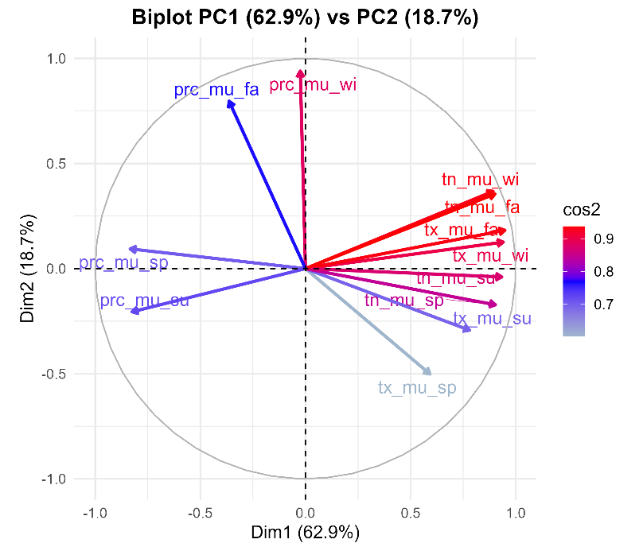
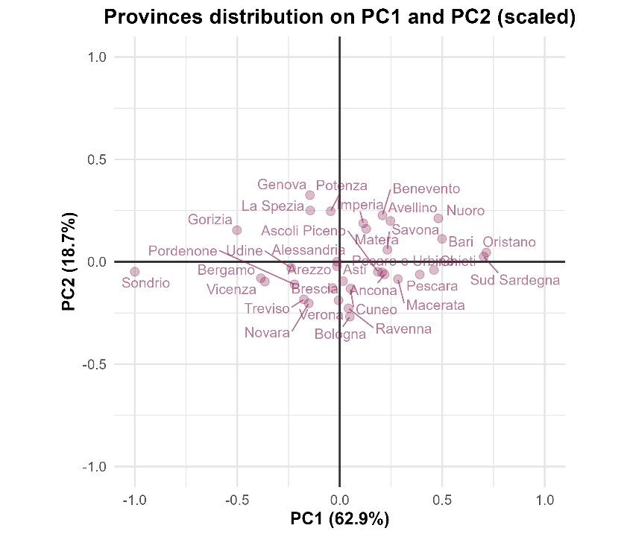
Biplot without RH

After removing relative humidity from the PCA, a clearer seasonal coherence emerged: each variable within the quadrants now corresponds more consistently to specific season. This suggests that the quadrants mainly reflect seasonal patterns.
Therefore, it may be an oversimplification to describe them only in terms of “warm/cold” and “dry/humid”, since seasonality appears to play a relevant role within each quadrant.
Right side: warmer
Left side: colder
Above side: wetter (especially in winter and autumn)
Below side: driest (especially in winter and autumn), but with more precipitation in summer.

Quadrant | PC1 | PC2 | Climatic characteristics | Climate-key
Upper right | Warm (winter and autumn) | Wet (autumn–winter precipitation) | Warm and moderately humid climates, influenced by autumn and winter rainfall, characterized by mild winters and moderate humidity, with limited rainfall in spring and summer. | Warm- wet winter
Lower right | Warm | Dry (autumn and winter) | Warm and dry almost all year, higher temperatures (especially in summer and spring) and low precipitation (especially in winter and autumn); | Cold -wet winter
Upper left | Cold | Wet (autumn–winter precipitation) | Cold and humid climates with lower annual temperatures and higher precipitation, particularly in autumn and winter. | Cool-slightly rainy summer
Lower left | Cold | Relatively dry (especially in autumn and winter) | Cold but relatively dry climates with moderate to low rainfall, mostly concentrated in spring and early summer. | Warm-dry summer

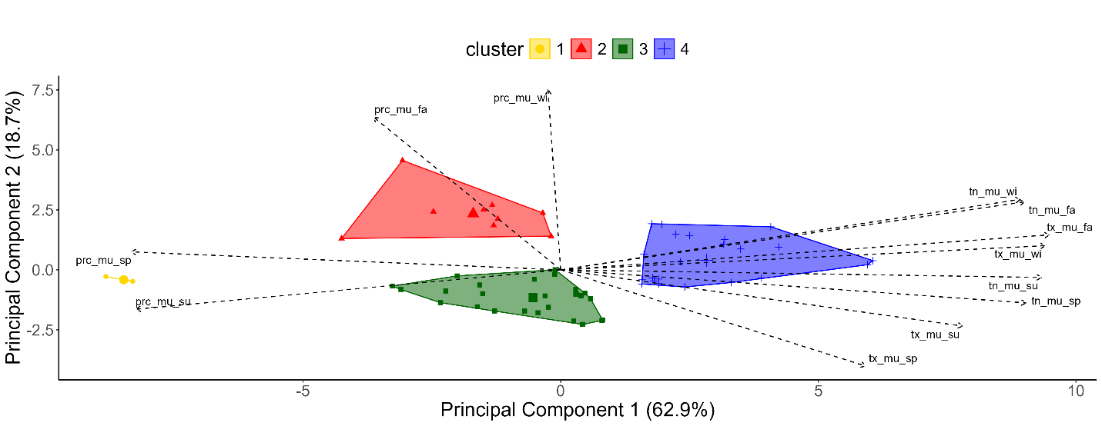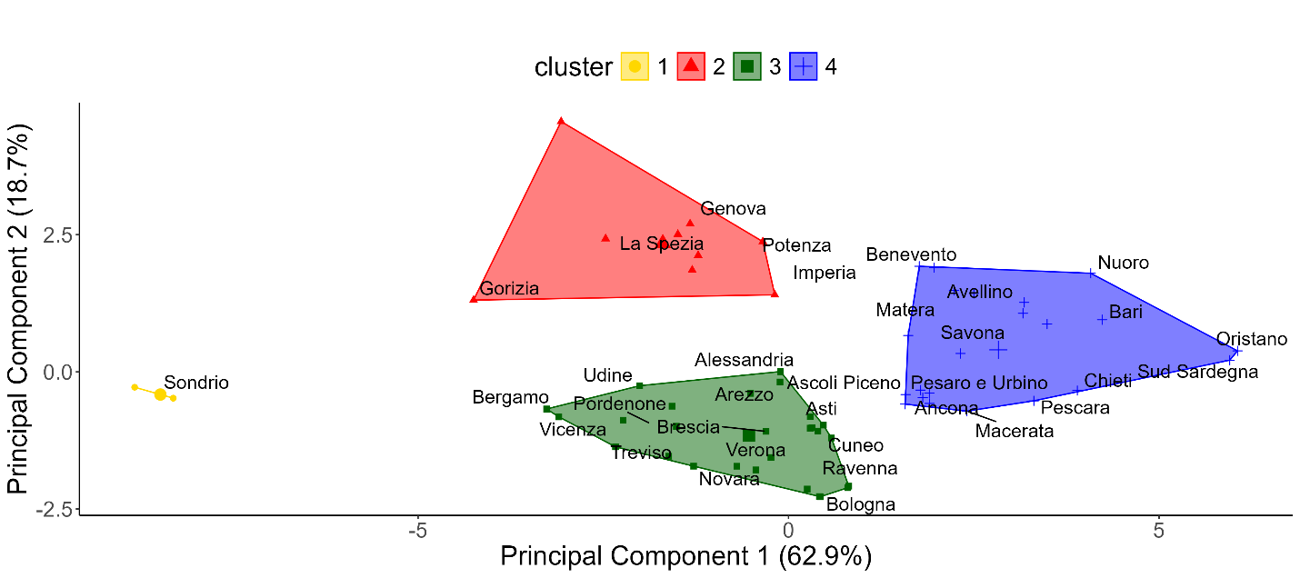
The hierarchical clustering (Euclidian distance and ward linkage method) based on the first two principal components identified four distinct climatic groups.
The first cluster (yellow) corresponds to colder areas with higher precipitation during spring and summer, reflecting the thermal and hydric regime typical of the Alpine regions (Sondrio), characterized by cold winters and comparatively wetter warm seasons.
The second cluster (red) represents cooler and more humid or transitional climates, mainly including the Ligurian provinces.
The third cluster (green) groups provinces with moderate temperature and precipitation regimes, typical of inland and northern lowland areas.
The fourth cluster (blue) clearly represents the warmest and relatively driest conditions in terms of rainfall, corresponding to the Mediterranean zones of southern and coastal Italy.

