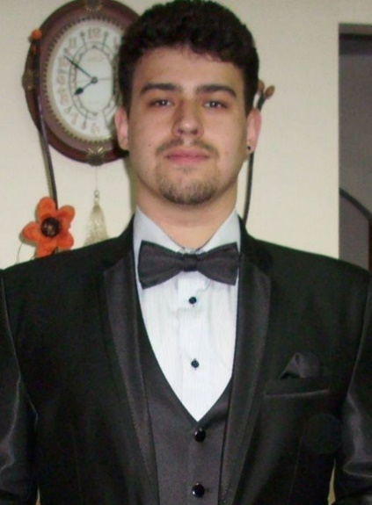***Morosanu George-Cosmin***

PERSONAL DATA

* Birthdate: 17.09.1996
* Phone Number: +40751 871 000
* E-mail: [georgecosminmorosanu@gmail.com](mailto:georgecosminmorosanu@gmail.com)
* LinkedIn:

<https://www.linkedin.com/in/george-cosmin-morosanu-58272115a/>

I am a third-year bachelor student in Computer Science at “Alexandru Ioan Cuza” University of Iasi, Romania, and I am looking for a job with a friendly environment so I can evolve professionally.

EDUCATION

* September 2015 - (July 2018)

***FACULTY OF COMPUTER SCIENCE****, ​Iasi – ​Bachelor Studies* *Informatics specialization*

“Alexandru Ioan Cuza” University, Romania

* September 2011 - July 2015

***MIHAIL KOGALNICEANU****, ​Vaslui – ​High School Diploma*

*Computer Science and Mathematics*

LANGUAGE SKILLS

* **Romanian** - first language
* **English** - ​fluent, spoken and written

COMPUTER SKILLS

Theoretical and practical knowledge

* C#(.Net)
* Java
* C/C++
* Python
* SQL, PL/SQL, MySQL
* PHP, HTML, CSS, JavaScript

PROJECTS AND ADDITIONAL TRAININGS

* **MediArch** (Medical Archive) – *September 2017 - Present*

This would be my **license** (Work in progress).

It is an Web Application via C# ASP.Net Core; The database is an Oracle SQL Server.

The architectural pattern I am using is MVC (Model-View-Controller).

It should help the patients by saving all their consults and prescriptions into a database, making them available at any time.

As complexity, I will try to compete with the one from the next project (Course Manager), and I think I got some great chances.

* **Course Manager** – *October 2017 - February 2018*

A 6-man team **project** for one of our courses (Introduction in .NET ~ 2nd semester, 3rd year).

It is an Web Application via C# ASP.Net Core, and we were using MVC as architectural pattern. The database was an Oracle SQL Server.

We have used Trello for delegating tasks.

I and the most of the team were fully focused on Back-End part, choosing only 2 of our team mates to the Front-End part.

At the end of the semester there was a competition (hold by Centric IT Solutions Romania, Iasi), and our project obtained the 3rd place.

* **FII Online Admission** – *2017*

A group **project** (25+ man team) for one of our courses (Programming Engineering ~ 2nd semester, 2nd year). We have used Trello for delegating tasks.

We divided into 4 modules (Administration, Front-End, Back-End and Quality Assurance). I was part of Back-End module, but I helped Front-End module too.

The technology we used was: PHP, HTML, CSS, JavaScript and Oracle SQL.

This application was used at the enrollment in our Faculty, in August 2017.

* “**Monster Party**” and “**Bomber Bot**” – *2016 - 2017*

Small team (3 up to 4 man) **project**; Mostly focused on Front-End

We have used: PHP, HTML, JavaScript, CSS and MySQL

* **Graphic Design Training** – “Fii Practic” *2016*

“*Fii Practic*” is an event hosted by Faculty of Computer Science in collaboration with many IT Companies from Iasi, Romania, and there are plenty of interesting trainings every student can apply for.

Training hold by *Centric IT Solutions Romania, Iasi*.

The training was focused on Adobe Illustrator and Adobe Photoshop.

At the end of this training I have done a small project (remaking Twitch.tv design) and I have obtained an Diploma.

* **Full-stack .NET Training** – “Fii Practic” *2018* – hold by *BEENEAR S.R.L.*

Focused on .NET technology; In progress.

* **Back-end .Net Training** – “Fii Practic” *2018* – hold by *Maxcode*

Focused on .NET technology; In progress.

PERSONALITY

* I am open-minded, responsible, devoted, trustworthy, ambitious, funny (at least I like to think like this about myself) and a good team player
* I will always keep my word
* I like to be an active person by practicing as many sports as possible
* I am learning pretty quick, and I like to learn from my (and others) mistakes
* Former volunteer at ASII (which is the Association from Computer Science Faculty)
* I like to play the guitar (I also taught 2 or 3 friends some basic chords)
* I got a driving license (B category)

INTERESTS

* Working and learning in an innovative and friendly environment
* Gaining practical experience
* Being part of a team
* Making friends