
Extensive Manual
Sebastian Stumpf
sebastian.stumpf@unibe.ch

This manual is intended to guide users through ICP-Base and its core features. I tried my best to explain everything more extensively so that it also makes (at least a little bit) of sense to users that are not deeply familiar with LA-ICP-MS. If you don’t want to read the whole manual, please conduct the short manual.
When encountering a problem, please first consult the Common_Pitfalls_ICP-Base.pdf (downloadable here: https://github.com/GeoSebastianStumpf/ICP-Base/releases) — it covers the most common problems and how to resolve them, as well as instructions on how to report a bug or contact me.
If you have any other questions, need a custom feature, want to collaborate, or have a LA-ICP-MS system for which import is not yet implemented, feel free to reach out via email!
This software improves through user feedback. Without feedback, issues can go unnoticed and useful features may not be considered. Contributions, suggestions, and reports are always welcome.

Philosophy and data structure
This software is designed to integrate with your existing LA-ICP-MS data processing workflow while automatically building a structured database of all analyses. It stores raw data, quantification steps, final results, and metadata from both the LA and ICP-MS systems in a consistent format.
The metadata is stored separately and does not influence the quantification. It is retained for purposes such as long-term monitoring and method development.
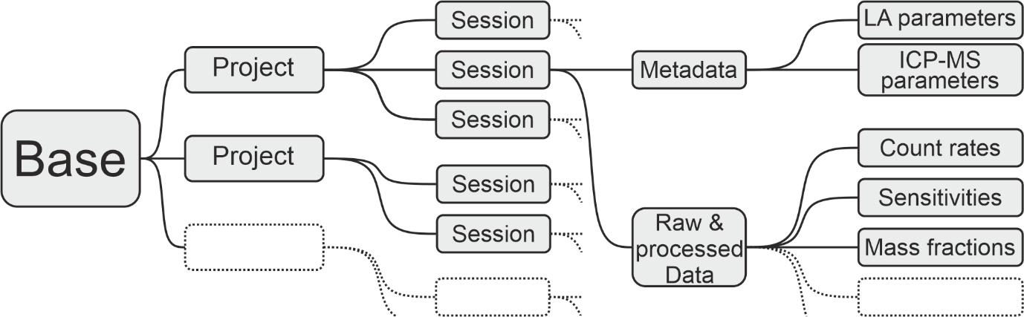

It is therefore strongly recommended to maintain a single Base that contains multiple Projects, each of which can include multiple Sessions. Using multiple Bases reduces the benefits of a centralized data structure and should be avoided.
The Base Module is the central hub from which all data can be accessed. When adding a new session, the linear quantification workflow is started and the software guides you through the processing steps.
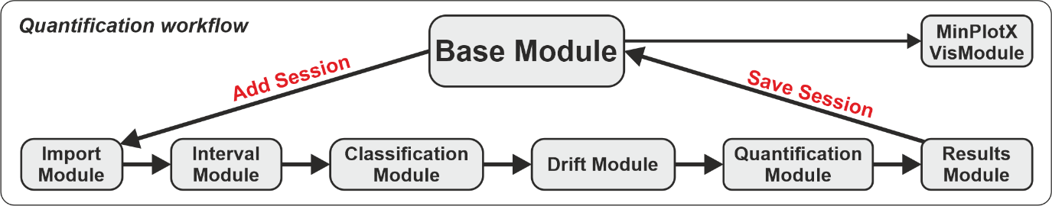

Base
The base, as the name suggests, is the basis of ICP-Base. Here, all your measurements, called “Sessions” are stored in “Projects”.

First time use
If this is your first time using it, just press the “Add Project” button and by double-clicking on the project name, you can change it. The projects can also be deleted again and duplicated (see buttons below “Add Project”).
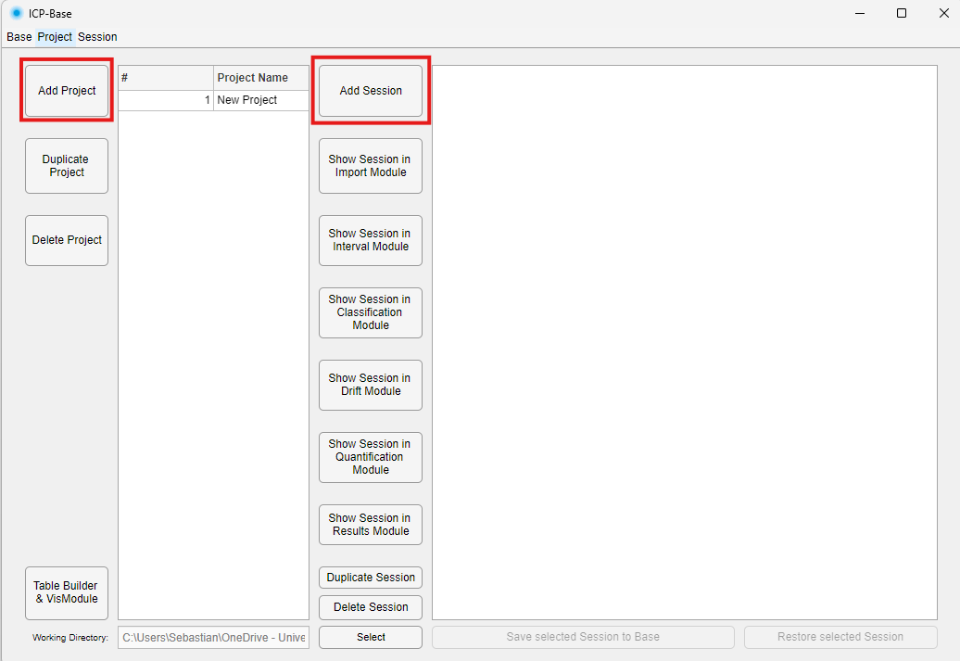
Once you selected the project, press the “Add Session" button (to the right of the Project Name list) to add a new measurement session. This starts the data reduction process and the Import Module will be opened.
If you click the button and there is nothing happening for a few seconds – chill and wait, don’t stress it. Especially when starting the modules for the first time, MATLAB takes a while to initialize, but don’t worry, it will get quicker afterwards.
There is no limit as to how many sessions can be added to a given project.

Loading a base
If you already worked with ICP-Base before and you saved a base to your computer, you can now open it again to access it.
Click on the “Base” Menu on the top left of the base. Next, click “Open Base” and select the Base that you previously saved to your computer (.h5 file).
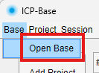
Now that your projects and sessions are loaded, select the project you want to work on. If a project is selected, the sessions contained in this project will become visible in the right table.

Saving and restoring sessions
A green session indicates that the session is synced with the database (the .h5 file stored on your computer). When a green session is opened in a Module, it is loaded from the database. If nothing is changed and it is closed again, it remains synced (green).
When a new session is added or an existing session is modified, it turns orange in the Base Module, indicating it is no longer synced with the database. Pressing the "Save selected Session to Base" button writes the current state of the session to the database, overwriting the previous version. If an orange session has never been synced, the database has no record of it. If it was previously synced and then modified, pressing "Restore selected Session" reloads the last synced version from the database, discarding any changes made since.
An important practical note: green (synced) sessions are not held in RAM, whereas orange (unsynced) sessions always are. Having many large unsynced sessions open simultaneously will therefore increase memory usage and may slow down your computer.

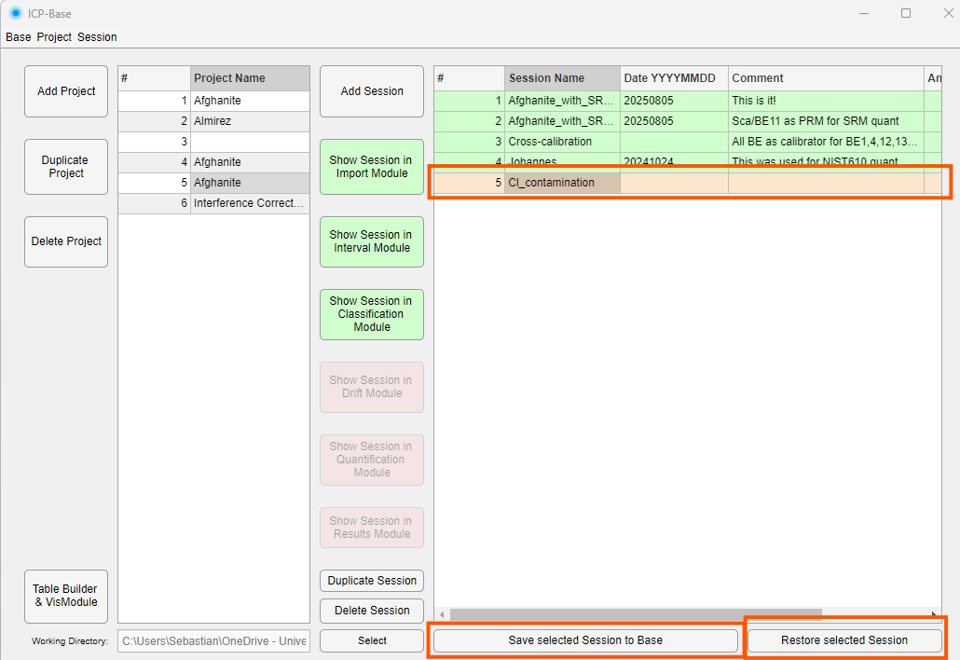

Importing and exporting projects
With this you can import projects that were previously exported using the button “Export Project(s)” button. You can import projects into an empty or existing base. If imported into an existing base, the project will be listed as the last project of the base.
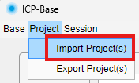

Importing and exporting sessions
With this you can import projects that were previously exported using the button “Export Session(s)” button. First select the project that you want to import the session to. The session will be listed as the last session of the project.
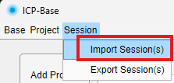

Table Builder Submodule
This module lets you choose projects and sessions for which a general data table will be built.
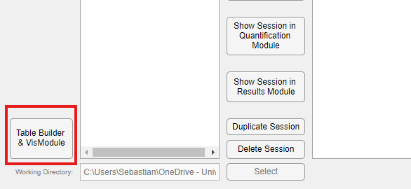
In the tree menu, select the sessions for which a general data table should be built. Be aware that this feature relies on analyte-calibrator assignment in the Results Module (i.e. see chapter 8.4 Configure Output Table). So every analyte for a given session needs to be assigned to a given calibrator of that session.
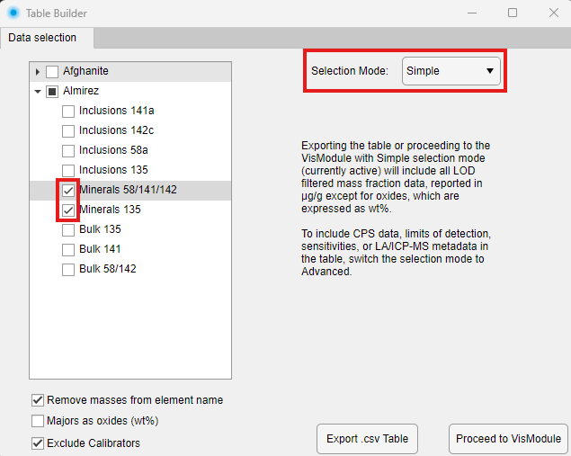
If the “Simple” selection mode is chosen, only “Mass fractions µg/g” is possible as selection. This means that the table will contain only this data. You can remove the masses from the element name, show majors as oxides and exclude calibrators. The “Majors as Oxides” will take the majors as defined in the Oxides.csv sheet. The preferred isotopes will be taken from each session individually.
If the advanced selection mode is chosen you can choose individually which data should be in the table.
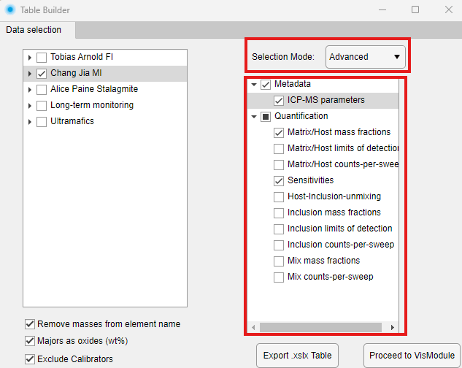
You can right-click the “Export as .csv” button to export the data as .mat.
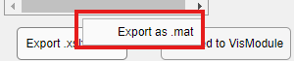
Or you proceed to MinPlotX’s VisModule.

Import Module
Congrats, you successfully started the data reduction. This is a linear workflow where you will unlock one module after the other. Once you unlocked more of them, you can also jump between them using the colored buttons at the top.
There are multiple types of data that can be imported, not all of it is mandatory though. First, you need to figure out what types of data you have available and how the files look like.
There are three main types of data:
- Signal data
- Laser metadata
- ICP-MS metadata
To import the correct data, you have to know which filetypes and datatypes you have. If you are not sure, check the example files that come with the software or ask the lab manager.

Signal data
Signal data are the raw counts-per-second file(s) holding the data of the ICP-MS measurement. These files are specific to different mass spectrometer brands and also to some degree of how people like to measure (“Continuous” vs “Single”).
First, check if you have one large file that holds multiple analyses/spots ( “Continuous” ) or multiple files where every file holds one analysis/spot (“Single”).
If you have measured with an Agilent make sure to also read chapter 3.1.3 before starting to import your data (but don’t skip reading chapters 3.1.1 and 3.1.2).

Continuous
Choose the correct ICP-MS type (Continuous) and file or folder type in the dropdown menu and press the “Get Signal File” button. Then select the file/folder that you want to import. For very large files, this can take a few seconds.
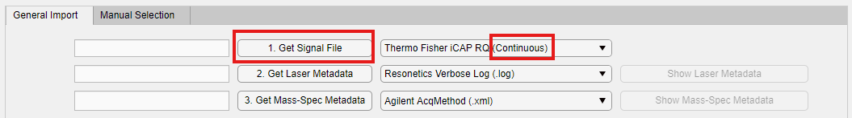
Now that the “Continuous” data were imported successfully, ICP-Base requires laser metadata to assign the signals to the correct measurement spots. Continue reading chapter 3.2.

Manual Selection
This feature is useful if no laser metadata is available to find the signal starts and ends and the signals are irregularly spread out in the continuous file e.g. if they have been measured on a manual laser system like a GeoLas which is common for inclusion analysis.
After importing (Continuous) data navigate to the “Manual Selection” Tab. Use the Zoom feature on the plot to zoom in to the signals.
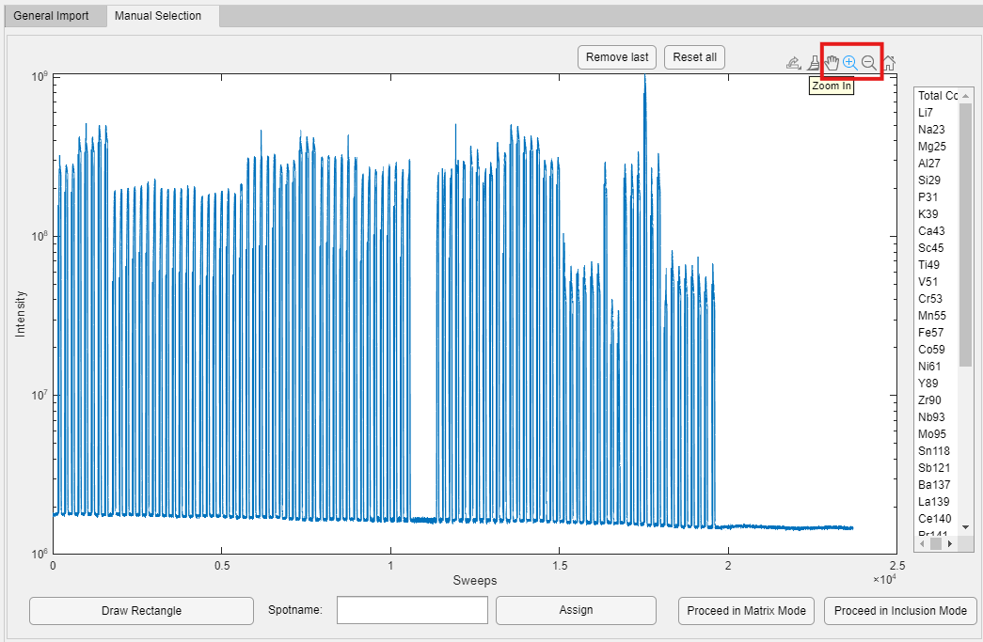
Next, use the “Draw Rectangle” button and draw a rectangle on the plot via drag-and-drop. Be aware that the Zoom tool has to be deselected first! The vertical extend of the rectangle does not matter, just align the left and right sides with the signal start and end.
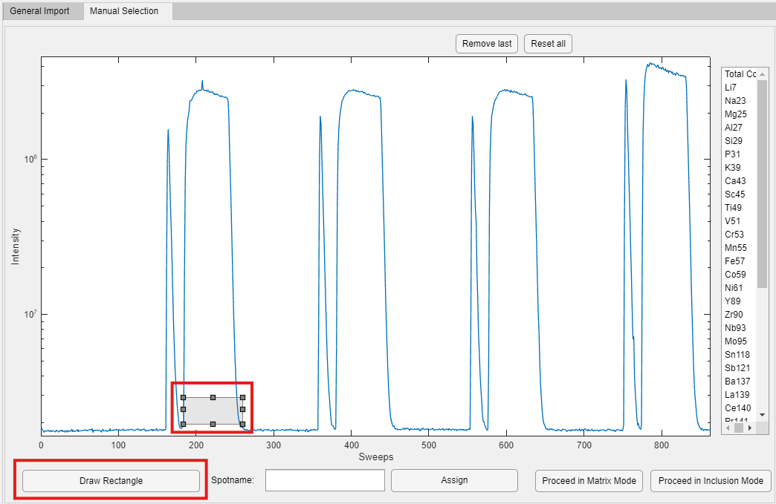
Type in the name of the spot and press “Assign”. The plot can be moved using the pan tool (the hand next to the zoom tool) which also has to be deselected when “Draw Rectangle” should be used.
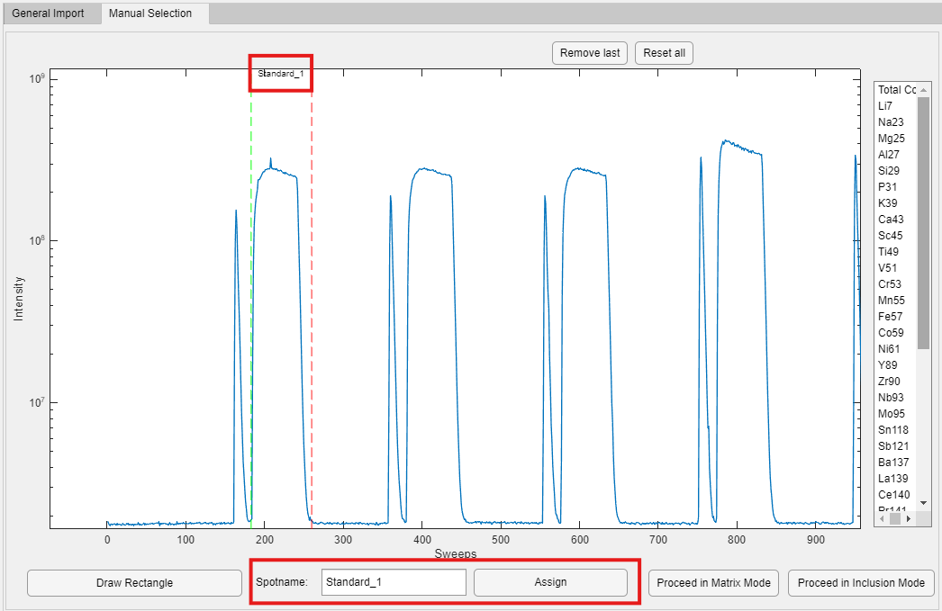
This will assign the left and right corners of the rectangle as the start (green) and end (red) of the signal. Do this for all spots and then proceed in matrix or inclusion mode. This feature only works for continuous data.
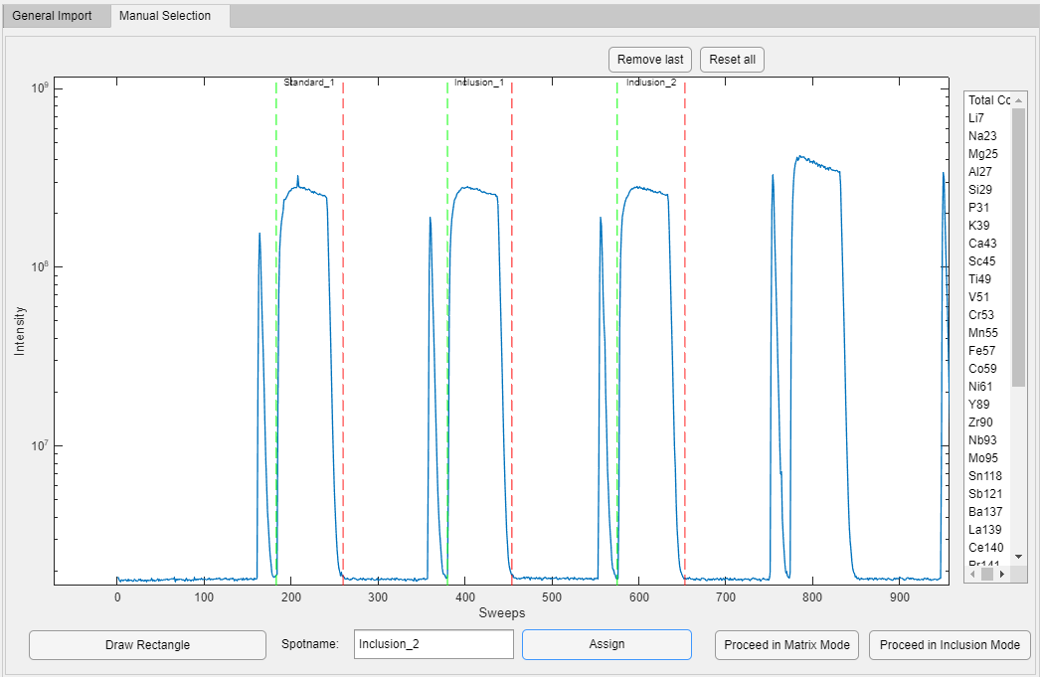

Single
Choose the correct ICP-MS type (Single) and press the “Get Signal File” button. Then select the file(s) that you want to import. For a high amount of files, this can take a few seconds.
If the import was successful, the signals are visualized in the plot, the black dashed lines are the signal start and end that are automatically detected by ICP-Base. If the signal starts and ends have not been detected correctly (i.e. the black dashed lines do not align with signal start and end) you can change the detection threshold to a number between 0 and 1 and press the “Detect Signals” button. Play around with this until the signals are detected properly.
By default the spots are named based on the filename.
For Agilent and Element XR files, the acquisition time (necessary for the drift correction) is taken from the header of the file (it is written in there). For PerkinElmer .xl and Nexion .csv files, the acquisition time is taken from the file information. This means that the acquisition time corresponds to the time the file was saved on your computer. If you change the file and save it again, this time will change and will be wrong - so be careful. You can import the acquisition times via the provided template though (see XY).
For “Single” data it is not mandatory, but highly recommended, to import laser metadata, if these exist (unlike for the “Continuous” data). If laser metadata is imported the filename changes to the name that the spot has in the laser metadata file. If you want to import laser metadata, continue with chapter 3.2, otherwise continue with chapter 3.3.
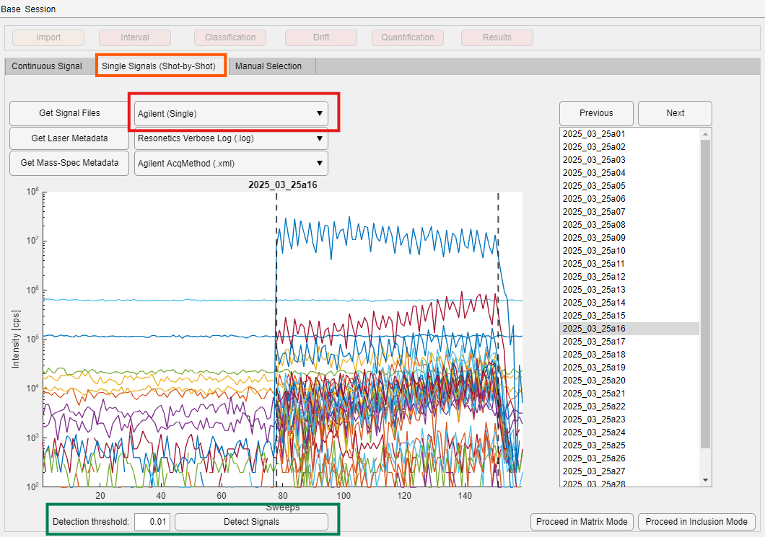

Agilent Batch Folder
If you have the Agilent batch folder (.b) you can select “Agilent Batch Folder (.b)” in the dropdown menu. Then after pressing “Get Signal File” you can select this folder and all the analyses (.d) will be imported. It is not possible to select the .d folder directly! It has to be the batch folder (.b). Make sure to not tinker with the folders beforehand.
If your data type is “Continuous”, there will only be one .d folder within the batch. If this is the case, your data will be visualized in the “Continuous Signal” Tab. It is then required to also import laser metadata in order to detect the signals. See chapter 3.1.1.
If your data type is “Single” then there will be a lot of .d folders in the batch folder. In this case, your data will be visualized in the “Single Signals (Shot-by-Shot)” Tab. It is not required to import laser metadata. See chapter 3.1.2.
ICP-Base also automatically imports the AcqMethod.xml file and HardwareConfig.xml file (see chapter 3.3) when reading in the batch folder. Therefore, all the ICP-MS metadata is also imported already. If you are happy with the filenames and no laser metadata should be imported, you can immediately proceed to the next module (chapter 3.8).

Laser metadata
Laser metadata are logbook-type output files from the software that runs the laser system when used in programmed lasering mode. There are many different styles and file types but in general, they contain more or less the same information about the laser system: spot names, spot sizes, fluences, gas flows and more laser specific parameters.
Press the “Get laser Metadata” button, select the type of your laser log file in the dropdown menu and import it. Again, if you are unsure which type of file you have, check the example files and find a match. Note that the file needs to be in the non-modified output format from the laser software in order to work!
Once the metadata is imported it can be made visible by clicking the “Show Laser Metadata button”.

Continuous signal data
After successfully importing the signal data and the laser metadata, press the “Detect Signals” button. ICP-Base first uses a bisection method to detect the signal starts and ends based on the amounts of spots that were measured.
Zoom in on the first signal all the way on the left of the plot to check if the detection was successful. You can zoom in the lower plot by using the Zoom in function from MATLAB.
If it worked, it should look like this:
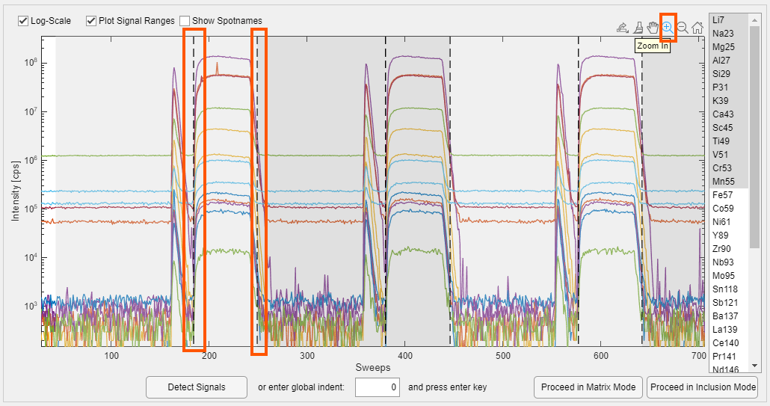

If the bisection method did not work, it looks like this:
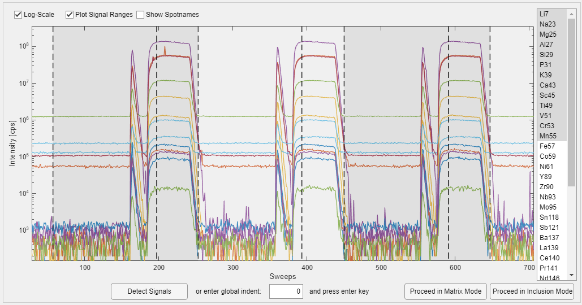
In this case, ICP-Base uses the laser “On” and “Off” timestamps provided in the laser metadata file to set the signal starts and ends. You have to use the bottom left edit-field to move the starts and ends to the right place. To achieve this, type in the number of sweep (x-axis) of where the first signal starts and press “Enter” on your keyboard.
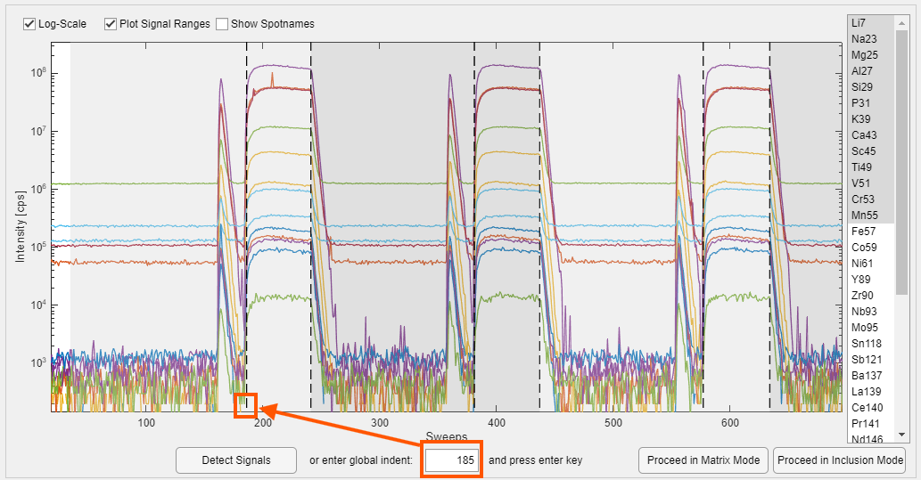
If this was successful, continue with the import of ICP-MS metadata.

ICP-MS metadata
ICP-MS metadata include file(s) that are output by the ICP-MS systems. These file(s) can hold crucial metadata like the dwell times, which are used for the calculation of the limits of detection (LOD) or machine specific parameters used for long term monitoring.
For importing these metadata, you do not need to worry about “Continuous” or “Single”. Just import the chosen metadata once to cover the whole session.
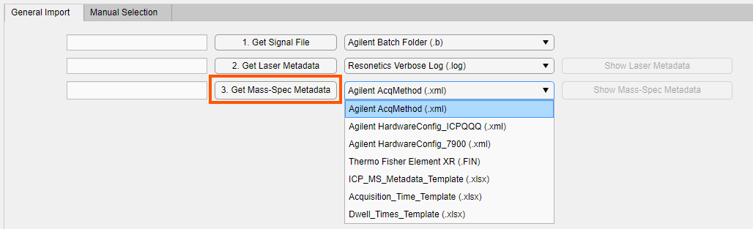
Once the metadata is imported it can be made visible by clicking the “Show Mass-Spec Metadata button”.

Dwell times
These values are critical to correctly calculate the LODs.
If the dwell times are unknown or were not provided by the lab manager, you may ignore this import step. ICP-Base will assume dwell times of 10 ms for all analytes, which is a pessimistic approach that returns relatively high LODs. Later, the dwell times can be changed manually in the Quantification Module and you can recalculate the results, to get the correct LODs (see chapter 7.4).

Thermo Fisher Element XR
Thermo Fisher provides the dwell times in the .FIN file.

Thermo Fisher iCAP RQ
The iCAP RQ provides the dwell times in the signal file. If you imported the signal data, the dwell times were already imported too.

Machine specific parameters
These parameters are mass spectrometer tuning and machine settings like RF Power, RF matching, Extracts, Lenses, Gas flows etc.

Agilent
Agilent provides the AcqMethod.xml and the HardwareConfig_XXX.xml files.

Thermo Fisher iCAP RQ
The iCAP RQ output files also holds all the parameters. If you imported the signal data, such parameters already were imported too.

Templates

Dwell_Times_Template.xlsx
This template is a provisory solution to import any dwell times by just making the first row of the sheet hold the exact same analyte names as the signal file and the first row holding the dwell times in seconds. This has become somewhat redundant since ICP-Base has default dwell times set to 10 ms.

Acquisition_Times_Template.xlsx
This template allows you to import any acquisition time by making the first column of the sheet hold the times. Make sure to use the same format as in the template and don’t change anything else.

SILLS projects
ICP-Base can import SILLS projects. Up to this point, it imports the (spike corrected) data, the dwell times and the intervals (background, host, inclusion). This makes it quick to recalculate former SILLS projects with little effort in ICP-Base.

Linescan import
The signal data and the ICP-MS metadata can be imported like normal. The LA metadata (log-files) will look different though. So far, there are two options for the import of linescan log-files from the Resonetics systems (GeoStar software).
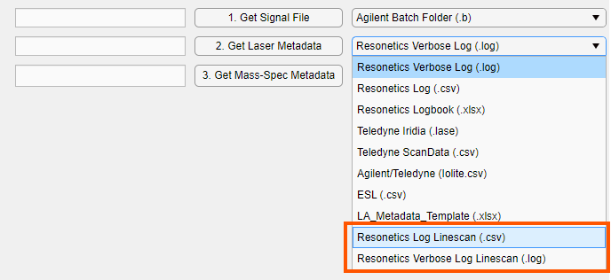
ICP-Base will probably fail to detect the starts and ends with the bisection method if there were cleaning paths (sorry, I’m working on it). For the continuous case, simply use the global indent edit field (as described in 3.2.1) to get the right signal starts and ends.

Moving average
To get to this feature, right-click on the “Proceed to Matrix Mode” button and then select “Moving average settings”.
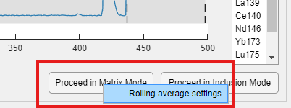
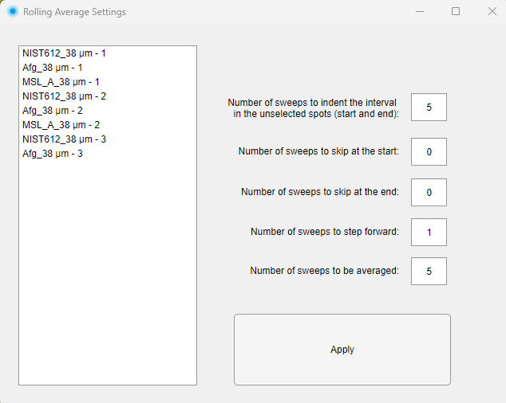This will open a small sub-module. In the list box, select the spots that should be processed.
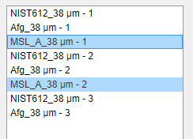
Next, you can select the number of sweeps to indent the matrix interval of the unselected spots. This is made to make the life of the user a bit easier since the global interval setting (see 4.5.1.1.) should not be used anymore if the Moving average feature was used. If the value was well chosen here, less time has to be spent to manually adjust the intervals for e.g. the standards.
You can also skip some sweeps at the start and end of the signals if desired. If the number of sweeps to step forward equals 1, this feature will result in a Moving average. If this is changed to a higher numbers, this is in theory not a true Moving average anymore.
After you set all of this, press “Apply” and read the instructions in the pop-up carefully! The pop-up will close and at first, nothing looks different. Now proceed in “Matrix Mode” and you will see the result in the next module.
This feature can not only be applied on linescans but also on spots. If used smartly, it can be used to explore e.g. downhole fractionation (e.g. 5 sweeps step forward and 5 sweeps window results in systematically processing the data of a single spot at different ablation depths).

Proceeding to next module – Matrix vs Inclusion Mode
After importing all the data needed, it is possible to proceed in “Matrix Mode” and “Inclusion Mode” by selecting the appropriate one of the bottom right buttons. Both lead to the same modules and data reduction workflow, they just show/hide different buttons/functions/tables.
“Proceed in Matrix Mode” should be chosen if spot analyses of homogeneous materials are to be quantified. This default mode facilitates quick interval setting and hides a few inclusion related options to make the Graphical User Interface (GUI) easier to read.
“Proceed in Inclusion Mode” should be chosen for inclusion quantification. This mode enables a slower but more thorough way of setting the different intervals.
Once you pressed either button, ICP-Base will ask if you want to save the data – press “Save” to proceed. This means that your imported data will be saved back to the base. The “New Session” will now be visible within the project in the base. This does NOT save the data permanently on your computer though! For this you have to save the whole base (see chapter 8.5)
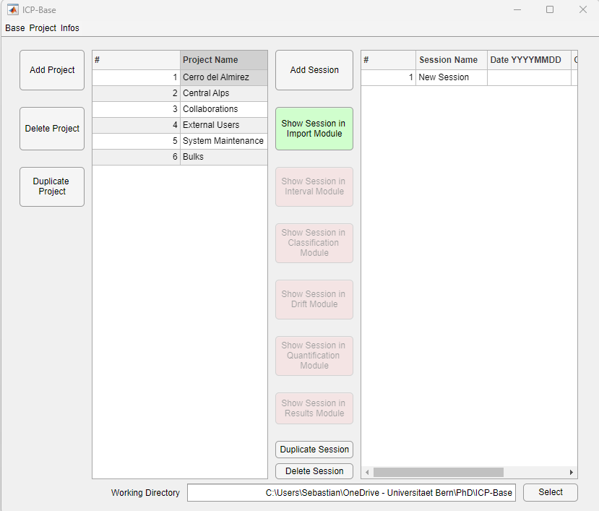

Interval Module
From here on, it does not matter anymore if the datatype is “Continuous” or “Single”, all the data is treated and visualized in the same way. There are some small differences though if “Matrix Mode” or “Inclusion Mode” have been chosen.

Spike elimination

Matrix Mode
I would recommend to start with a spike elimination so that possible spikes do not interfere with the interval setting. ICP-Base uses a Grubbs’s Test to check if a sweep for a given analyte is an outlier by comparing the value of that sweep with the values of four sweeps before and after. Every sweep below 600 counts per second is not considered. This threshold can be changed in the code if necessary. The spike elimination only works once per spot (so clicking it more often does not eliminate more spikes).
To eliminate the spikes for a given spot, press the “Eliminate Spikes” button and to bring them back the “Reset Spike Elimination” button.
If you want to eliminate the spikes in every spot, you can just right-click the “Eliminate Spikes” button and then click “Apply globally”. The same is possible with the “Reset Spike Elimination” button. Regarding the “Individual” and “Individual (Inclusion only)” continue reading the next chapter.
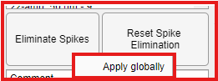
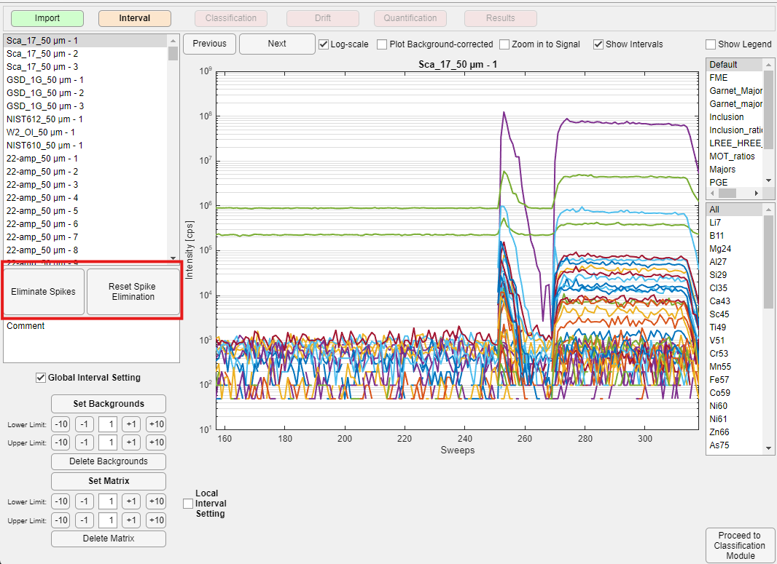

Inclusion Mode
It generally works the same as for the “Matrix Mode” with the difference, that ICP-Base ignores all the data within the “Inclusion” Interval. So if you set your inclusion intervals first and at the end press the “Apply globally” button (see above) all the spikes will be cleared except for the data within the inclusion intervals, which will remain unchanged.
Next, you can right-click the “Eliminate Spikes” button and select “Individual (Inclusion only)” which will let you manually ignore or accept spikes just in the inclusion interval.
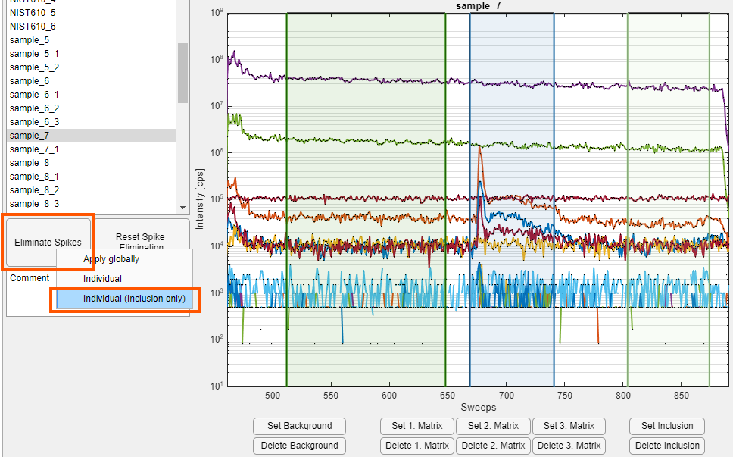
A the Spike Submodule will then pop-up showing the spikes in red and the suggested corrected value in green. If you accept, the data will be corrected. If you ignore, the spike will not be corrected. When you are done clicking through all the spikes, click “Finish” and continue in the Interval Module.
If you just select “Individual” you can correct all spikes manually, also those that are not in the inclusion intervals.
A good practice is to first set all the inclusion intervals, then do the spike elimination globally which will ignore the inclusion data. Next, do the “Individual (Inclusion only)” spike elimination to carefully ignore and accept the spikes in the inclusion interval.
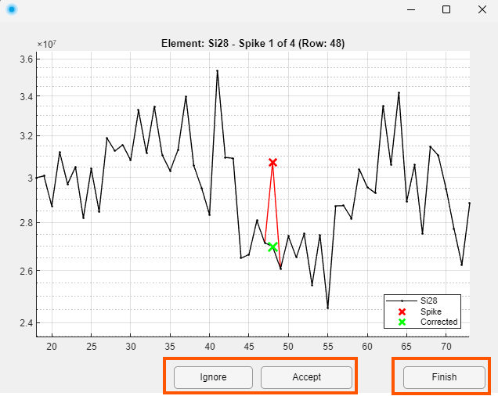

Spike Elimination Settings
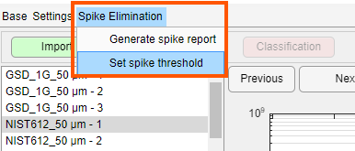
The spike threshold is the minimum number of cps on which the spike correction is applied. So if its set to 300 no spike correction will be done below 300 cps.
The spike report is a list of the eliminated spikes.

Plot styles
Either you use the default visualization, or you can choose plot styles to visualize and highlight analytes that are of interest and plot analyte ratios. If the second case is what you want, you first have to think about what you want to show.
Are there certain analytes that are more important than others? Are there certain analytes that are commonly found in unwanted mineral inclusions or impurities that should be avoided?
Once you know what you want to show, you can generate your very own plot style. They are shown in the top right corner of the Interval Module.
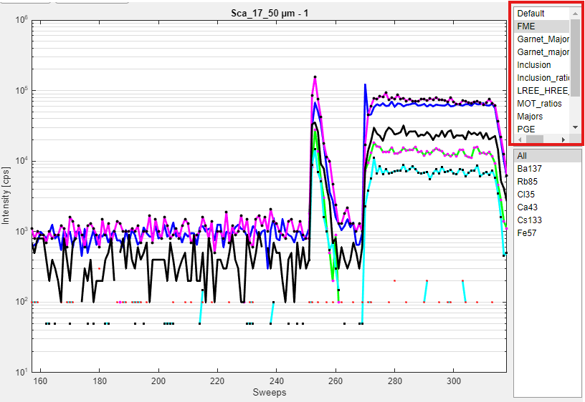

How to get make them
In the ICP-Base folder you will find a subfolder called Plot_Styles. Within that folder you will find a few .csv sheets that contain the plot styles.
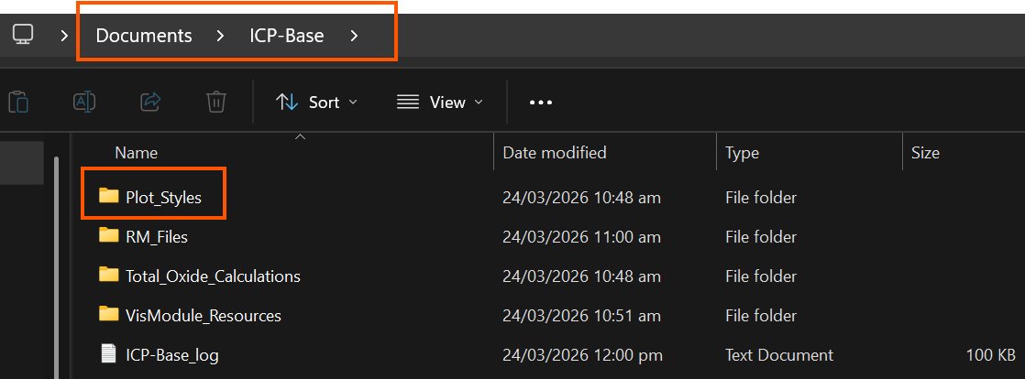
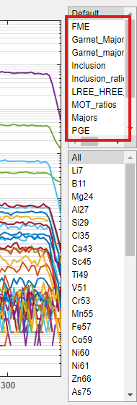
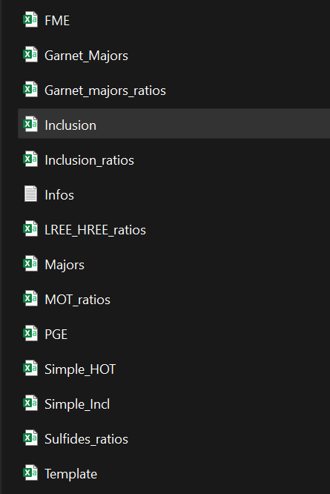
Alternatively, you can select the “Settings” menu and then “Change plotstyles folder” and select a folder of your choice.
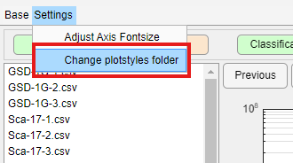
This will then always load in the plotstyles from this folder for this session (not globally) – be careful if you change the path or rename the folder.
You can now simply copy an existing style and modify it or make a completely new one based on the Template.csv that is automatically containing all the analytes that were measured this session.
To make these, simply fill in the plot properties and save the file in the same folder. When naming the file, never use – and avoid whitespaces and other special characters! If you do use them, you will probably not be able to load the plot style.

“Normal” plots
These plot properties are partly restricted by MATLAB itself. For example there are the colors “black”, “blue” and “cyan” that can be used like this because they are default colors in MATLAB. This does not work for most other colors though. If you want a specific colour, just use the hex code (e.g. #FFB442), these always work and are easy to get.
If no marker is wanted, put Marker, MarkerFaceColor and MarkerEdgeColor to “none” and MarkerSize to 0.
Here is an example and some possible line and marker styles:
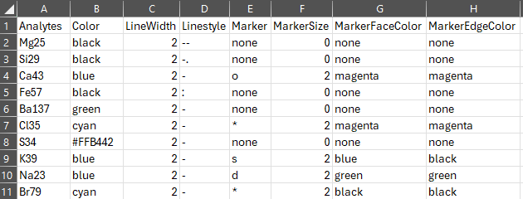
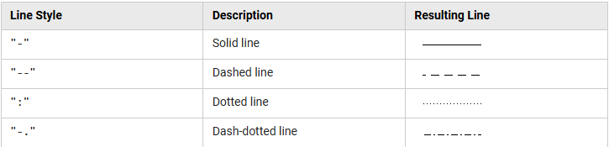
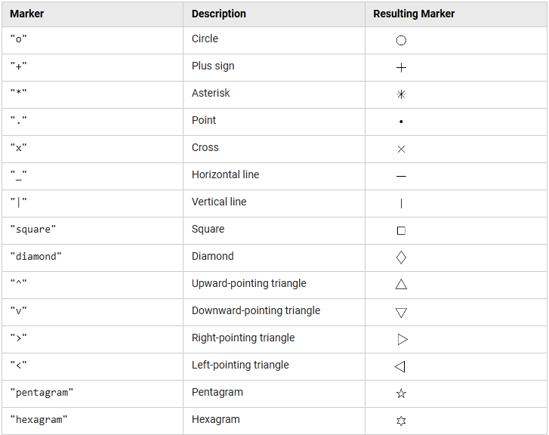
If there is an analyte in the plot style that was not measured this session, it will simply not be shown in the Interval Module. Also if your input was nonsensical or wrong it will also not show up in the Interval Module.
Once you have made your plot style, right-click the list box and press “Refresh”. The new plot style should now show up. If it does not, you might have named it wrong (using special characters or – or whitespaces, see above) or saved it to the wrong place.
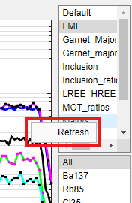

“Ratio” plots
In the same manner as the “normal” plots, you can also visualize analyte ratios by establishing the nominator and denominator. The rest of the visualization properties are the same as for the “normal” plots (see above).
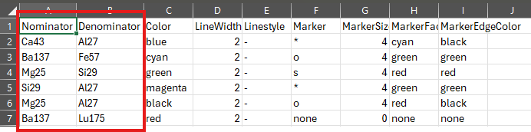

Saving signal figures
If you want to save the figure of the signal for publication, first go to “Settings” an then “Adjust Axis Fontsize”. This will trigger a pop-up in which you can change the font size of the plot. For publication-ready figures a font size of 20-30 is good, 12 is the default.
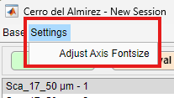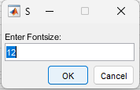
Once that is done, you can navigate to the top right corner of the plot, select the leftmost icon and save the figure in the desired format.
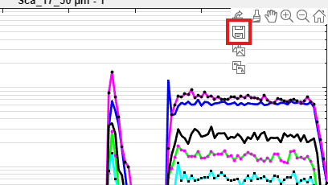

General visualization features
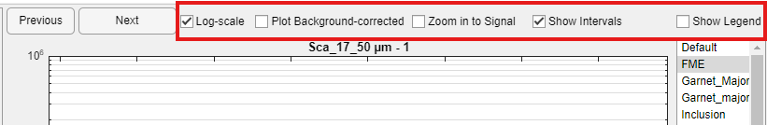

Plot Background-corrected
If a background interval is already set, you can check the “Plot-background corrected” checkbox in order to, who would have though, plot the background-corrected. ICP-Base subtracts the mean of the background counts-per-second of each analyte from the whole signal. This means that for sweeps that are higher than the mean there will still be some counts left, even in the designated background. Don’t worry about this, just accept and ignore it. In any case, all the background signal intensities for all the analytes will now be around zero.

Zoom in to Signal
If you check the “Zoom in to Signal” checkbox ICP-Base will automatically use the signal start and end (as detected in the Import Module) to be the x-axis limits. If the starts and ends were not correctly detected, this will also not correctly display anything.

Zooming in and out manually
It is also possible to use the built-in “Zoom In” and “Zoom Out” function of MATLAB. If you use these you will be able to zoom in and out where ever you want. If this tool is selected, you are not able to move the interval lines anymore. To be able to move them again, click on the selected tool (e.g. “Zoom in”) once more to deselect it – these are toggles. The interval lines are only movable if you have not selected any tool!
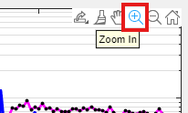

Show Intervals
The “Show Intervals” checkbox can be used to hide or show the intervals (if any were set befire). This can be desired if the intervals are already set but the figure should be saved without the intervals.

Show Legend & Log-scale
“Show Legend” shows the legend and “Log-scale” changes the plot from log to linear scale and vice versa.

Datatips On/Off
If the datatips are turned on (button is grey) the lines in the plot can be clicked on to tell you the name of the analyte and the cps value. Make sure to de-select the datatips (it’s a toggle) in order to move the interval lines.
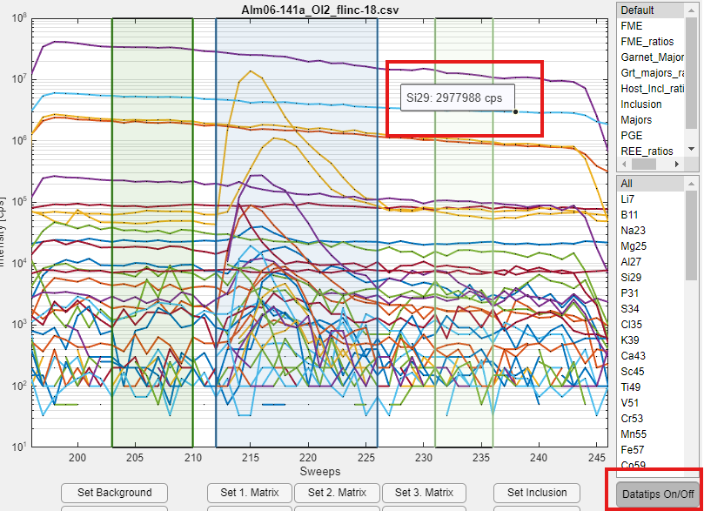

Commenting a spot
For every spot, it is possible to write a comment in the box provided to the lower left of the signal display. If an apatite inclusion was hit by accident, for example, you can write “Ca and P inclusion” and later in the results, you instantly know why your Ca and P are way too high with respect to the other comparable spots.

Interval setting
Disclaimer: If your computer is old and/or slow, the dragging of the intervals can be quite slow and lagging behind. Right now there is nothing I can do about this, I might try to optimize this in the future (if such an optimization is possible and not limited by MATLAB itself).

Matrix Mode

Global Interval Setting
By default, the “Global Interval Setting” panel is visible at the bottom left of the tab. Like the name suggests, it lets you set the background and matrix intervals for all spots at the same time. This is based on the signal start and end of each spot as they were detected in the Import Module.
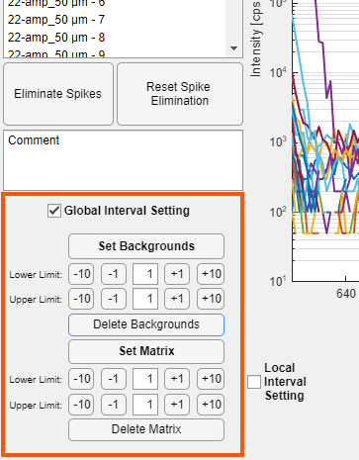
First, press the “Set Backgrounds” and “Set Matrix” buttons. This will set the backgrounds (grey interval) and the matrix intervals (green) for all spots.
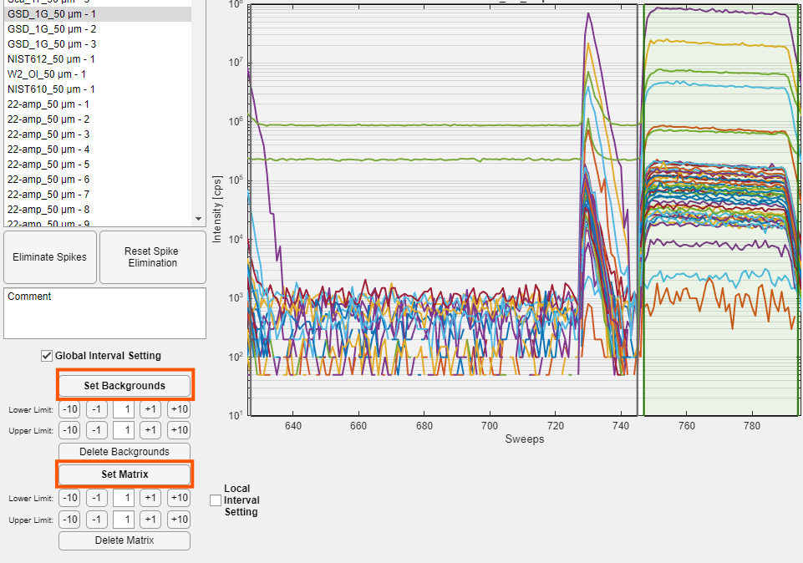
The numbers of ±10, ±1 and the number in the field (1 by default) correspond to the number of sweeps that will be indented from the signal start and end (as detected in the Import Module).
So for the background “Lower Limit”, if you press +10 it will move 10 sweeps to the right of the signal end of the spot beforehand. If you press -10 on the “Upper Limit”, it will move 10 sweeps to the left of the signal start of this spot. For the first spot where there is no preceding signal end, ICP-Base will assume this based on the signal starts and ends of all other spots.
For the matrix “Lower Limit”, if you press +10 it will move 10 sweeps to the right of the current signal start and if -10 is pressed it will move 10 sweeps to the left of the current signal end.
You can also simply type the number in the central cell by which you wish to shift a given interval border.
Once all interval borders are set, it is possible to move (i) the whole intervals by clicking, holding and dragging the middle of the interval, or (ii) any interval border by clicking, holding and dragging it. When you move them like this, make sure to not overlap interval borders.
If you click “Delete Backgrounds” or “Delete Matrix” ALL the corresponding interval borders will be deleted in this file!
The same is true for the shifting of the lower and upper limits when you click afterwards "Set Background" or "Set Matrix" – all the intervals will be moved accordingly. Make sure to not press these buttons if you already spent some time manually adjusting individual background and signal intervals.
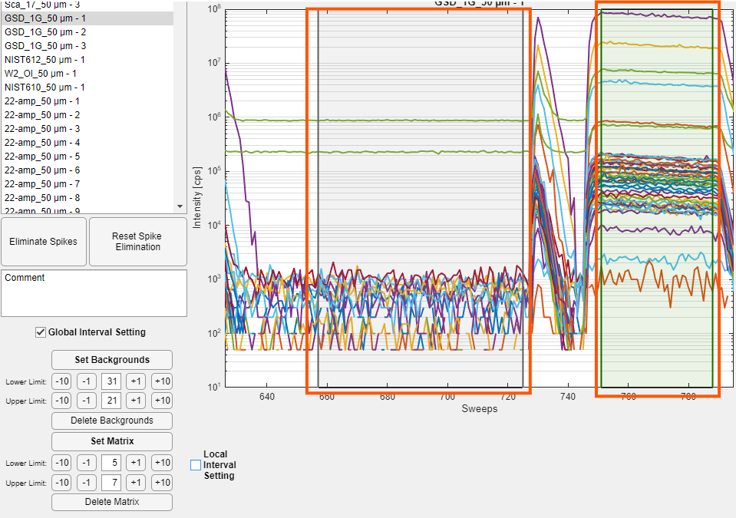

Global Interval Setting for Spot Groups
First set the intervals globally (see above)!
Right click on the “Set Backgrounds” or “Set Matrix” button and click “Set for spot groups”
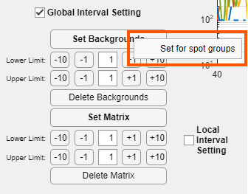
This opens a new window.

If e.g. all spots that contain “GSD” in the spotname should be moved enter “GSD” in the field and press “Choose”. This highlights all these spots. You can also manually select them in the spot name list.
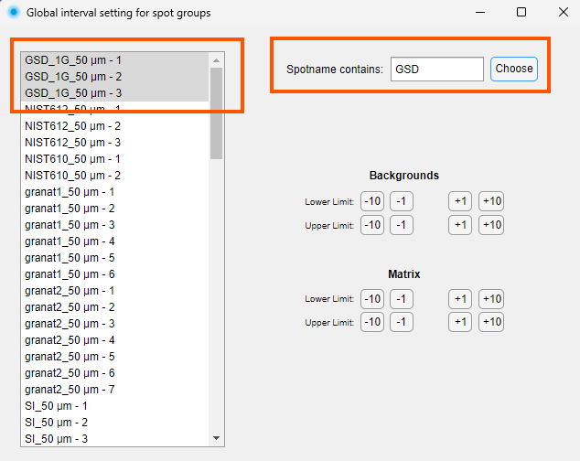
By pressing the ±1 and ±10 buttons you can move the interval lines. This is directly visible in the Interval Module.

Local Interval Setting
By checking the “Local Interval Setting” checkbox a few buttons show up that will only affect the current spot.
By clicking the “Set XY” buttons, you can set a given interval by dragging and dropping the cursor over the plot.
By clicking the “Delete XY” buttons, you can delete an interval just for this spot.
For the matrix, it is possible to set three different intervals which makes it possible to avoid inclusions. The counts-per-second of the different matrix intervals will be averaged (weighted) in the Quantification Module.
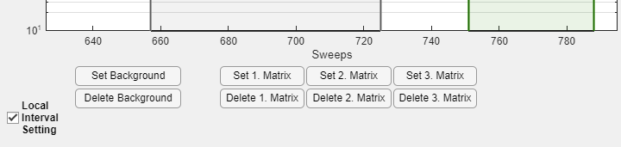

How to do this efficiently
First, navigate to one of the first spots (but not the first one as it has no preceding spot). Then press the “Set Backgrounds” and “Set Matrix” button and adjust the intervals using the ±10 and ±1 buttons. Check these settings for a few of the spots at the start, middle and end of the measurement session. Once you are happy and the intervals fit the spots, uncheck the “Global Interval Setting” to hide the buttons as to not press them by accident. Next, manually click through all of them (yes, really) to check for inclusions and impurities that should be avoided. Adjust the intervals manually by dragging them and delete or add more using the “Local Interval Setting”.

Inclusion Mode
In the “Inclusion Mode”, the “Global Interval Setting” is hidden to make sure users actually look at all their spots. All buttons will only affect the current spot.
By clicking the “Set XY” buttons, you can set a given interval by dragging and dropping the cursor over the plot.
By clicking the “Delete XY” buttons, you can delete an interval.
Additionally to the three matrix intervals, the user can also set an “Inclusion” interval (blue).
Once you set your background, host (matrix) and inclusion intervals, continue reading chapter “4.6 Signal Unmixing” to get more information about how to deconvolve the signals.

Deleting a spot
If a spot should be disregarded completely, delete all intervals of that spot using the “Local Interval Setting”. It will still show up in the next modules but nothing will be quantified. There is no option to actually delete the data itself.

Signal Unmixing
When analyzing fully enclosed inclusions of any sort (fluid/solid/single-phase/poly-phase), the raw signal data will always be the sum of the counts-per-second (cps) derived from ablation of the inclusion and the surrounding host (since both are ablated at the same time).
This implies, that the data within the inclusion interval that you set is not just the cps of the inclusion but is the cps of a host-inclusion-mix. In order to quantify the inclusion, we need to deconvolve this host-inclusion-mix to pure host and pure inclusion contributions.
There are two unmixing modes which can be changed in the “Unmixing via” dropdown menu located below the “Delete Background” button (see figures below).

Matrix-only tracer
This unmixing method is based on one analyte that is chosen as the matrix-only tracer (MOT). This analyte is significantly present in the host but not in the inclusion. In the example below, Mn55 is abundant in the host olivine and no inclusion peak is visible in the blue inclusion interval which makes it a good choice for the matrix-only tracer.
In theory, any analyte can be chosen but be aware that the matrix-only tracer analyte needs to be characterized in the calibrator (i.e. have an µg/g value in the RM file) in order to calculate the limits of detection! If the e.g. Sca17 standard RM file contains no value for Co and Co59 is chosen as the MOT, you will be able to unmix the signal but no detection limits can be calculated.
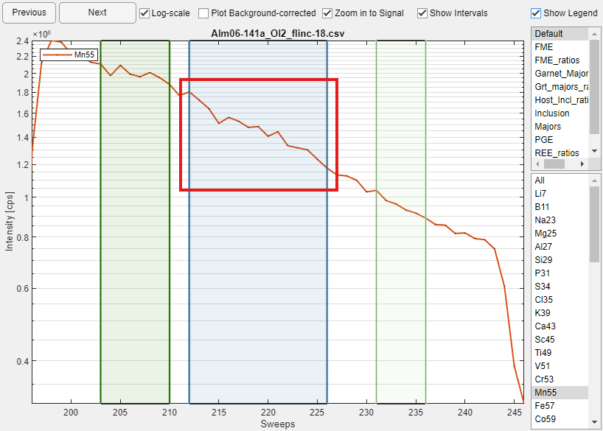
After you found out which analyte you want to choose as the MOT, simply select the analyte in the dropdown menu. Additionally, you can use the matrix interval from another spot. You can change this with the “From spot:” dropdown menu. Even if you choose the matrix from another spot, make sure to still set at least one matrix interval for the spot since this is needed for the calculation of the limits of detection.
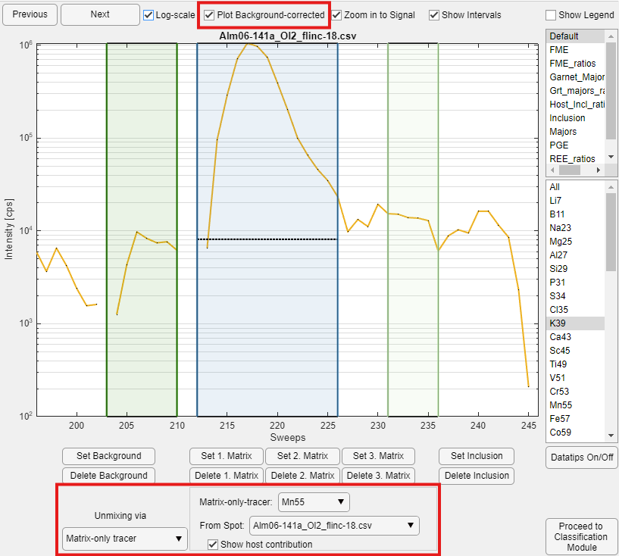
Make sure to give every spot at least one host interval – it is needed to calculate the limits of detection! Also make sure that the matrix-only tracer element is defined in the reference material that is ultimately used to quantify the spot – this is also needed to calculate the limits of detection.
You can visualize the host contribution to the mix (dotted black line) by checking the “Plot Background-corrected” checkbox. This is necessary because the matrix-only tracer method is applied to the background-corrected cps data. The host contribution to the mix is visualized as a horizontal line since the whole method is based on the average cps of the analytes in the intervals and not on single sweeps. This visualization is just to give you an idea of how well it worked.
Since every analyte has its own host contribution, I recommend looking at the analytes of interest/importance to see how well the fit is. By moving the host and inclusion intervals the black dotted line can be adjusted on-the-go. In the example above, the estimated host contribution is as good as it gets.

Two internal standards
This other inclusion unmixing method is purely mathematical and cannot be visualized like the matrix-only tracer method. If this method is chosen, nothing further happens in this module. The next steps necessary for the quantification are input in the Quantification Module.

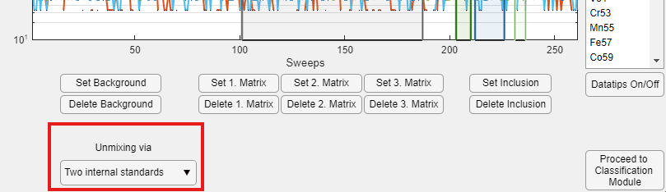

Proceeding to next module
After doing the spike correction, setting the intervals and doing the host-inclusion-unmixing you are good to go to the next module. Make sure to not have standalone background intervals (which have no matrix interval) and vice versa.

Classification Module
In this module, all you have to do is to tell ICP-Base which measurement spots correspond to calibration material and sample material.

Types
There are four types a measurement spot can represent: “Unknown”, “In-House Reference Material”, “Quality Control Reference Material” and “Calibrator”.
All spots are set to “Unknown” (UNK) by default. These are the spots about which nothing is known (as the name suggests).
A ”Calibrator” (CAL) can also be referred to as the “external standard”. The quantification of all other spots relies on them as they are used to determine analyte sensitivies for a given measurement session.
A “Quality Control Reference Material” (QCRM) is a material for which the “true” composition is known. Those are solely used for quality control and have no influence whatsoever on the actual quantification of the other spots. They are measured and then treated like “Unknowns” during the whole quantification process, just at the end you can compare the results with the “true” composition.
An “Interference Correction Material” (ICM) is a material used for interference correction of any kind.

Reference materials
Every spot classified as QCRM and CAL needs to have an assigned reference material. For UNK and ICM this is not needed.
In the ICP-Base folder you will find a subfolder called RM_files which holds a bunch of filename.csv files that contain the composition of a given reference material in element µg/g. You can add new ones or alter the existing ones as you like, just maintain the given format and do not name the files using special characters, - , or spaces. The third column can hold the uncertainty in µg/g.
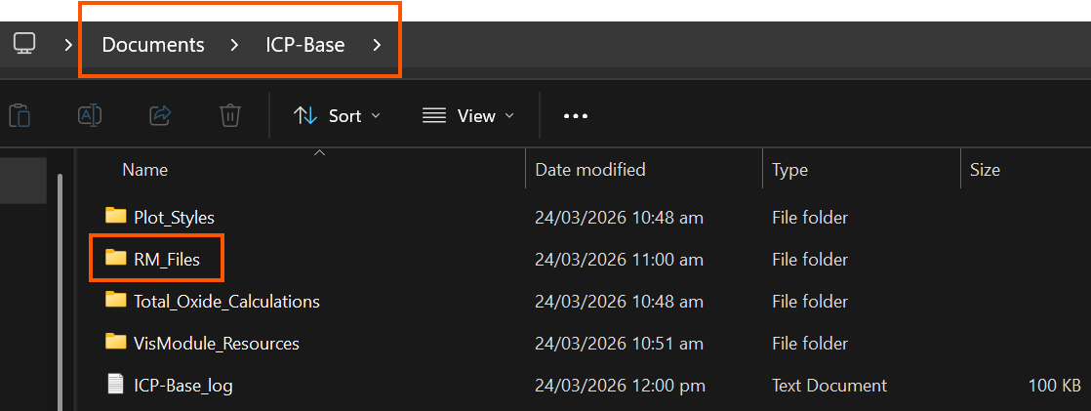
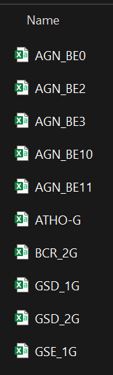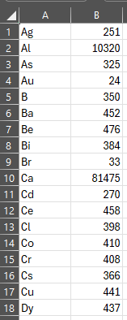
Press the “Get RM files” button and these reference material files will be imported to ICP-Base and displayed.
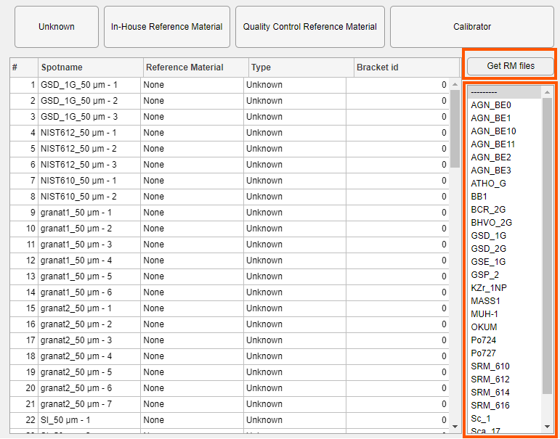
If you add a file later or alter one simply press the “Get RM files” button again.
Alternatively, If you don’t have administrator rights to your computer, you can select the “Settings” menu and then “Change reference material folder” and select a folder of your choice.
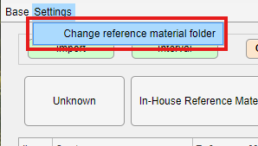
This will then always load in the reference material files from this folder for this session (not globally) – be careful if you change the path or rename the folder.

How to do the classification

Manually
You can simply mark one or more cells of the table (any column) by clicking, holding and dragging the cursor over the table. Once you have selected those spots, press one of the buttons on top to select a type. Control click allows to select individual lines together.
For UNK and IHRM you are done, there is no further information needed.
For QCRM and CAL the rows will turn orange and you also have to assign a reference material.
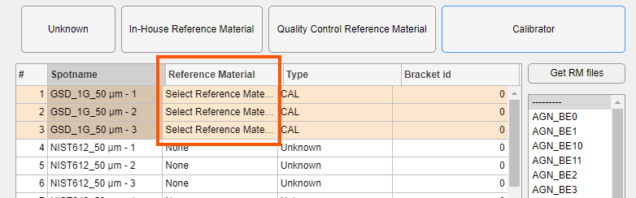
Select the lines and simply click in the list to the right on the reference material that you want to allocate to these spots.
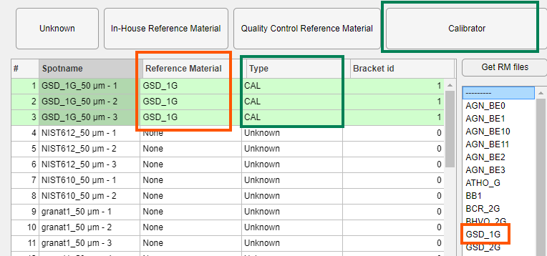

Using the spot names
A more efficient way of allocating a high amount of spots quickly is by using the spot names. Type a string in the field on the bottom left and press the “Choose” button.
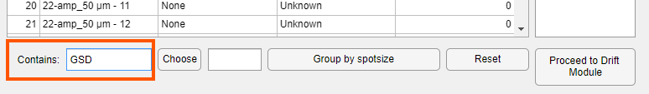
This will “lock” the string in
Now all spots that contain that string are selected (even though, unfortunately, it is not visible).
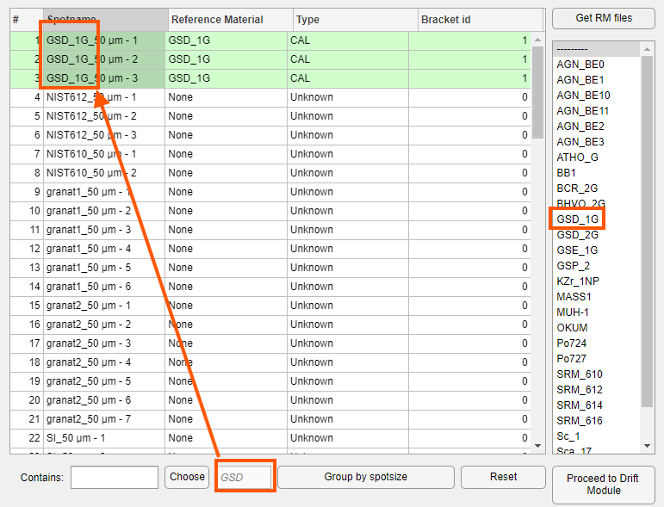
If you click anywhere in the table, the selection will be changed to the selection in the table and the grey string will vanish.
Below find an example of how it could look like. Also note the column “Bracket id” that we will discuss next.
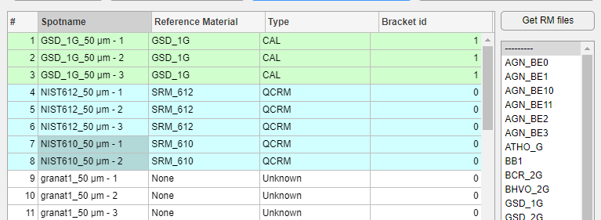

Bracket id
First of all: Bracket ids are only important for CALs. All other types will and should always have a bracket id of 0.
Secondly, what is a bracket? A bracket is (loosely) defined as two or more CAL spots that enclose spots of all other types. All the UNK, IHRM and QCRM type spots within the bracket will be quantified based on the sensitivity of the enclosing CAL spots. ICP-Base will take adjacent CAL spots of the same reference material and the same bracket id and average them together for drift correction. Why this is the case and what that means will be explained in more detail in chapter 6. Drift Module.
However, if CAL spots of the same reference material were measured with different settings that leads to different cps signal data (e.g. different fluence or spot size) they have to be treated separately. If you ablate a e.g. NIST SRM 612 with 80 µm spot size will give you vastly more cps than ablating it with a 20 µm spot size. This will result in vastly different sensitivities. Averaging them together would be wrong and will eventually lead to a wrong drift correction and wrong results.
Different bracketing strategies:
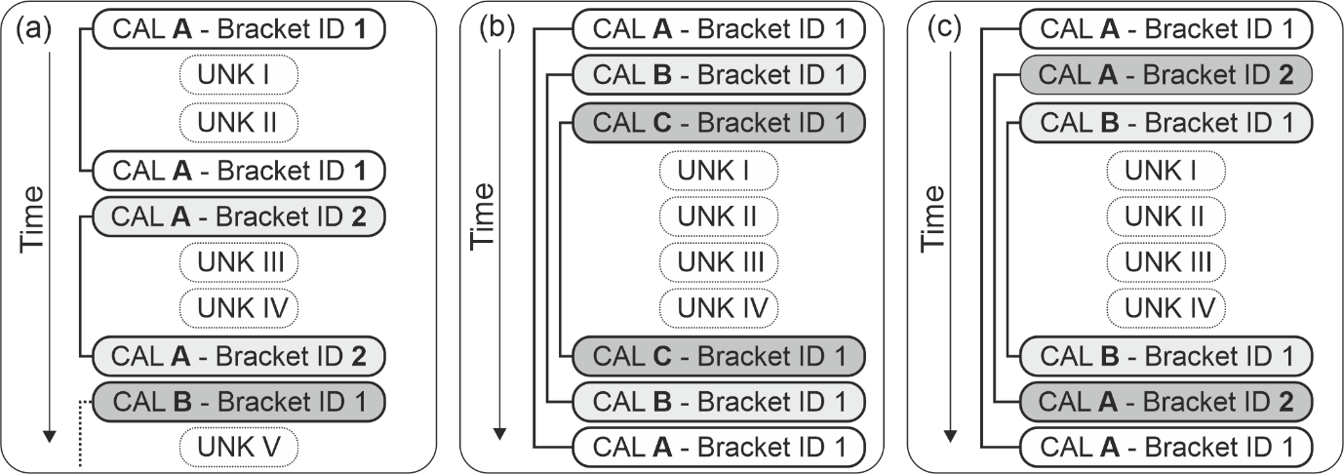
In the example of my measurement session, the session starts with measuring all spots with 50 µm. Later in the session, smaller spots (38 µm) were analyzed and the CALs were correspondingly also set to 38 µm. It is important that the CAL spots that were measured with 50 µm are not treated together with the CAL spots with 38 µm spot size.
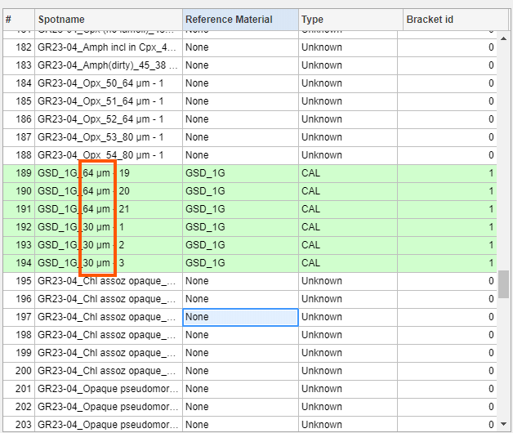
What needs to be done, is to assign a different bracket id to the 38 µm CAL spots. This be can be done by manually selecting the cells and typing in e.g. “2” and pressing “Enter” on your keyboard. If laser metadata holding the spot sizes was imported, you can also press the “Group by spotsize” button at the bottom of the table.
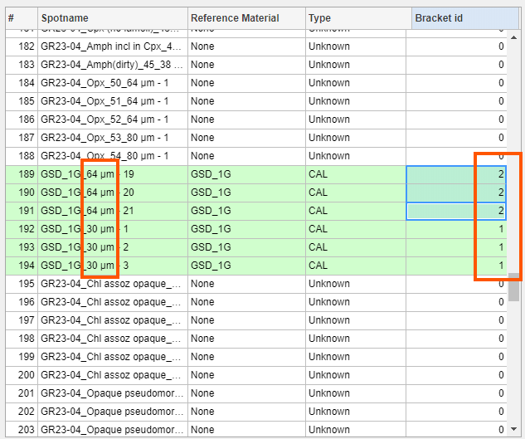
Be aware that two or more calibrator spots can have the same bracket id because they are different reference materials, so there is no need to split them up using the id as the CAL name is already unique. Bracket ids should only be used to separate CALs that are the same reference materials. They should not be used to separate different reference materials from each other!
If you measured CALs with different spot sizes than the unknowns or the QCRM but you did not sort them, do not worry it does not matter. Simply assign them the bracket ids as above. In this case, the sensitivity (see next chapter 6. Drift Module) will be calculated for all spots within that bracket. This means that the 80 µm spots could also be quantified using the 50 µm CALs and vice versa. The UNK, IHRM and QCRM always have bracket id 0, they are not explicitly assigned to a CAL. More detailed explanations follow in chapter 7.1.1.
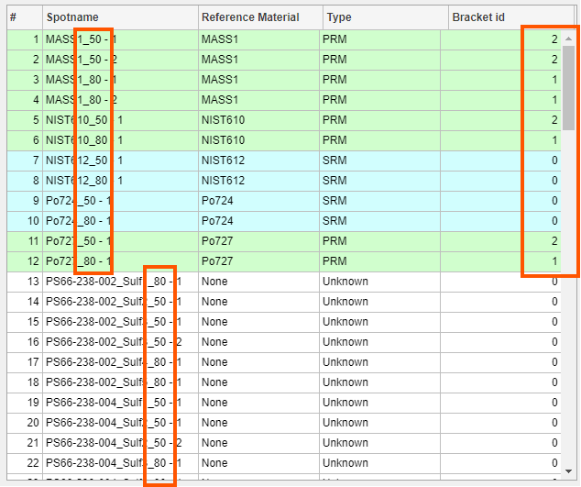

Checking reference values
By right-clicking on a reference material in the table (this works row-wise) you can select “Show RM values” which will pop up a small table showing the reference material values. These are non-editable, if you want to change them do it in the .csv RM files.
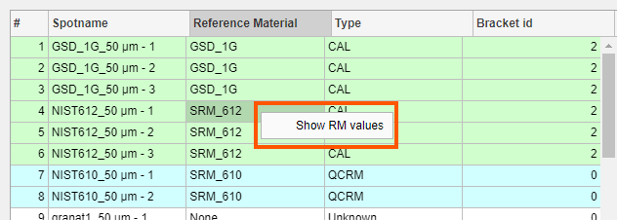

Interference Correction
If an ICM is chosen, the Proceed button will automatically turn purple and lead to the configuration of the interference correction.
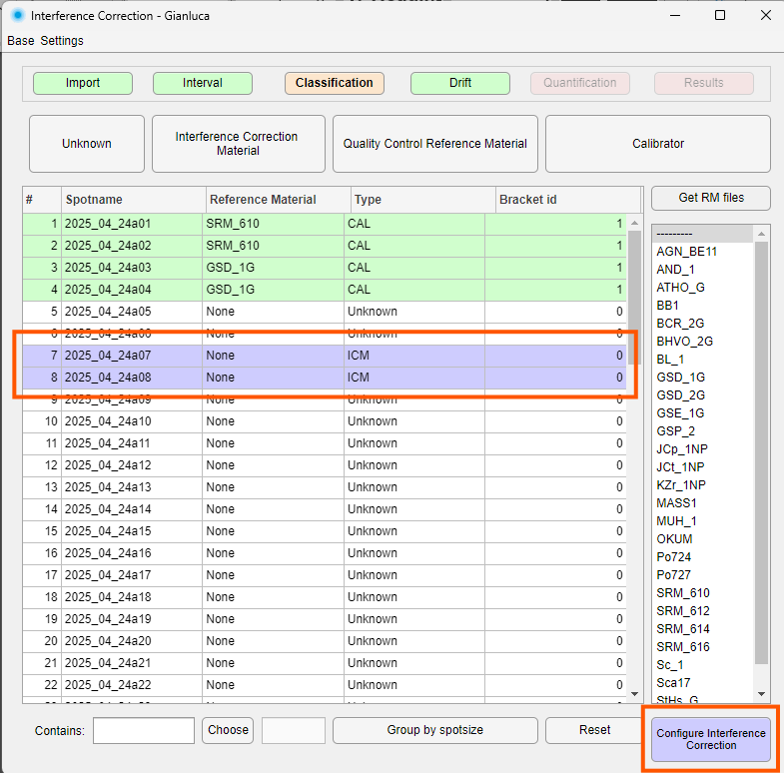
By pressing the “Configure Interference Correction” button a submodule is opened.

Interference Correction Configuration
The interference corrections are purely cps-based and affect all spots (CAL, QCRM, UNK) of the session.
Corrections should only be applied if you fully understand what they do and why they are appropriate for your data. Incorrect configuration/correction will introduce systematic errors that propagate through all subsequent data processing steps and may be difficult to detect.

Laser Backgrounds
“Laser Backgrounds” (Kendrick et al. 2020, Chemical Geology) are when e.g., a nominally Cl-free material (like Quartz) is ablated but yet a significant amount of Cl cps occur.
First assign an ID to the ICMs. This follows pretty much the same principle as the bracket ids. If one ICM material was measured with e.g. a different spot size it produces a different amount of cps and therefore needs it’s own ID.
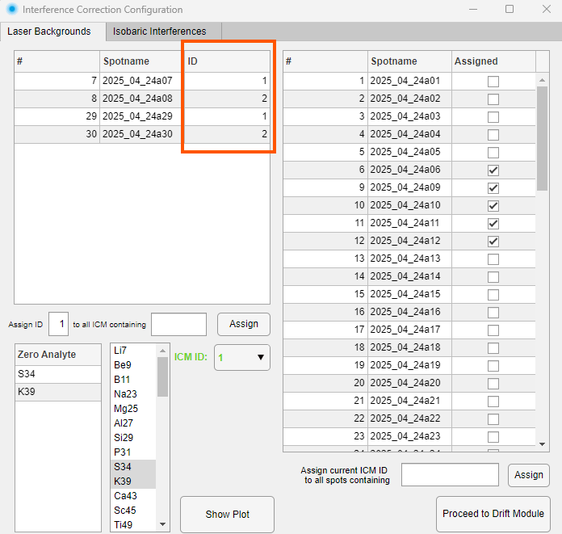
Secondly select the ICM via it’s ID (the names of the ICM’s don’t play a role) in the green dropdown menu and choose which elements they should be used to correct for, in this example ICM ID 1 corrects for S34 and K39.
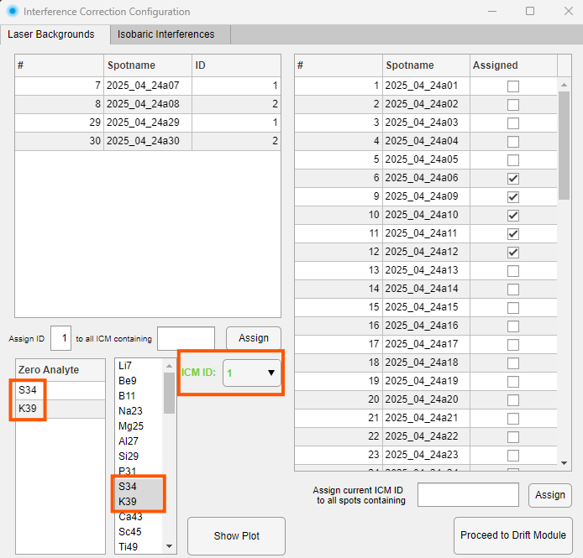
Next, select which spots should be corrected.
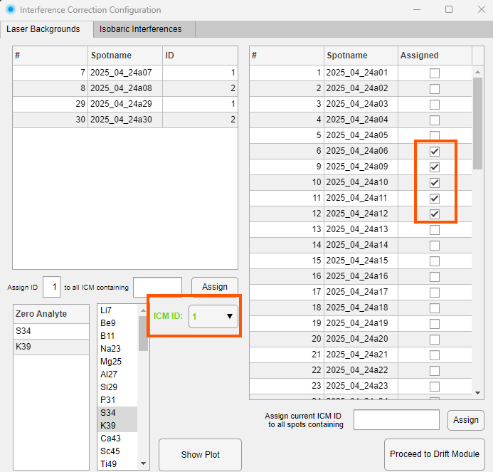
The laser background correction works like this: ICMs sharing the same ID are divided into consecutive groups: a new group begins whenever a non-ICM spot or an ICM with a different ID appears between two ICMs of the same ID. Within each group, the background-corrected intensities of the selected analytes are averaged, and this average is assigned to the midpoint acquisition time of the group. If only one group exists, that single average is applied as a constant correction to all assigned spots. If multiple groups exist, the group averages are connected by linear interpolation, and spots falling outside the time range of the ICM groups are corrected by linear extrapolation. The resulting time-dependent blank signal is then subtracted from the background-corrected intensities of all non-ICM spots assigned to that ID. The "Show Plot" function visualises the correction curve (ICM points, group averages, and the interpolated/extrapolated line) alongside the assigned spots before and after correction, allowing the user to assess the quality and plausibility of the blank correction prior to proceeding.

Isobaric Interferences
The isobaric interference correction removes spectral overlaps where one element (the interferer) contributes signal at the mass of another element (the target). For each correction pair, ICMs sharing the same ID are divided into consecutive groups using the same grouping logic as the blank correction: a new group begins whenever a non-ICM spot or an ICM with a different ID appears between two ICMs of the same ID. Within each group, the ratio of target signal to interferer signal is computed for each ICM spot and averaged across the group, with the average assigned to the midpoint acquisition time of the group. This ratio represents the overlap factor: because the ICM ideally contains the interfering element but not the target element, any signal measured at the target mass in the ICM must originate from the interferer, and the ratio therefore captures how much signal appears at the target mass per unit of interferer signal. If only one group exists, this ratio is applied as a constant to all spots in the session. If multiple groups exist, the group averages are connected by linear interpolation, and spots outside the time range of the ICM groups are handled by linear extrapolation, accounting for instrumental drift in the overlap factor over time. The correction is then applied to all non-ICM spots by computing:
corrected target = measured target − (measured interferer × ratio)
This subtracts the estimated interference contribution from the measured target signal, leaving only the true target intensity. The target must always have a higher mass number than the interferer. Multiple correction pairs can be defined per ID, and multiple IDs can be used to track different interference contributions independently. The "Show Plot" function visualises the ratio curve alongside the target element intensities before and after correction, allowing the user to assess the correction prior to proceeding.
First assign an ID to the ICMs. This follows pretty much the same principle as the bracket ids. If one ICM material was measured with e.g. a different spot size it produces a different amount of cps and therefore needs it’s own ID.

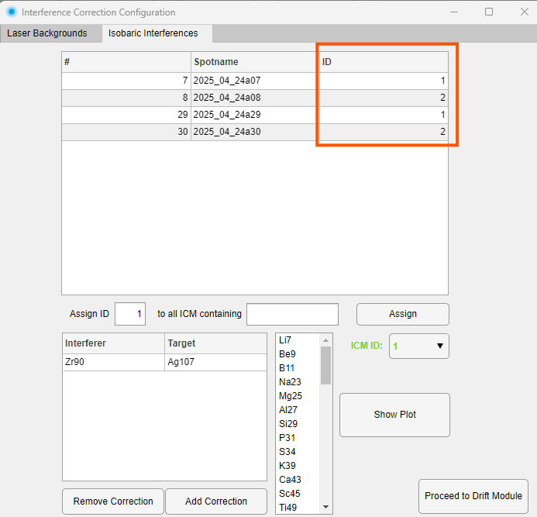
Next, select the ICM ID of choice in the green dropdown and add a new correction by pressing the “Add Correction” button. Click in the Interferer and Target columns and select an element in the listbox to assign them.
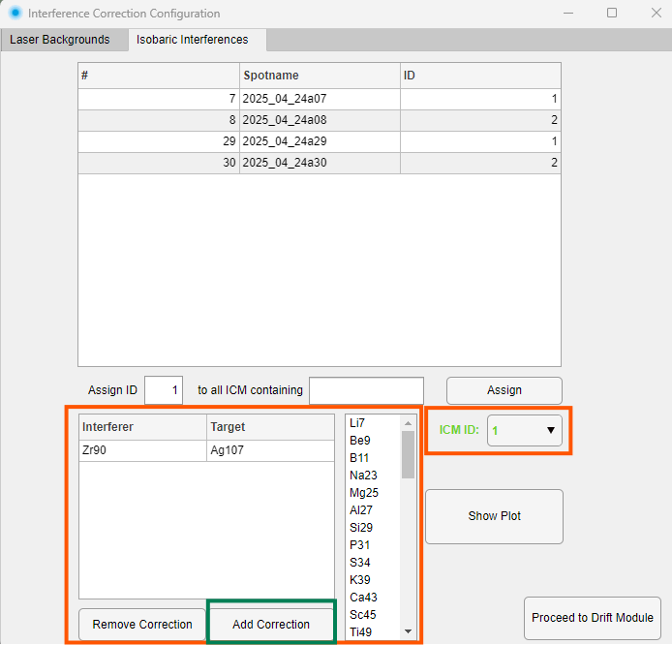
Example: TaO⁺ interference on ¹⁹⁷Au
In LA-ICP-MS, tantalum oxide ions (¹⁸¹Ta¹⁶O⁺, mass 197) form in the plasma and overlap directly with the only gold isotope, ¹⁹⁷Au⁺. In a sample rich in Ta but containing little or no Au, part of the measured "Au" signal is therefore actually TaO⁺ — i.e., Ta is the interferer (mass 181) and Au is the target (mass 197), satisfying the requirement that the target mass exceed the interferer mass.
Setup:
- Choose an ICM that contains Ta but is essentially Au-free (e.g., a Ta-bearing reference material with no significant Au).
- Assign this ICM an ICM ID (say ID 1), measured at intervals throughout the session.
- Define the correction pair: Interferer = Ta, Target = Au, under ID 1.
Calculation (per ICM group):
Suppose in one ICM group the background-corrected signals average:
- Ta = 50,000 cps
- Au = 25 cps
Ratio = Au / Ta = 25 / 50,000 = 0.0005
This ratio (0.0005) represents the TaO⁺-to-Ta⁺ formation rate at the conditions of that group, assigned to the group's midpoint acquisition time. If multiple ICM groups are measured, this ratio is tracked over time and interpolated/extrapolated across the session.
Application to an unknown spot:
If the unknown spot has:
- Ta = 80,000 cps
- Au (measured) = 60 cps
Then at that spot's acquisition time, the interpolated ratio (≈0.0005) gives:
corrected Au = 60 − (80,000 × 0.0005) = 60 − 40 = 20 cps
So 40 cps of the apparent Au signal is attributed to the TaO⁺ overlap from Ta, and the corrected Au signal (20 cps) reflects the true Au content of the spot.

Proceeding to the next module
After setting all your types, reference materials, assigning the bracket ids and if necessary configuring the interference correction, you can proceed to the next module.

Drift Module
In this module, the user cannot give any input in the software. The drift is calculated for you in a fixed manner. All you have to do is look and think!
The CALs are used to calculate the sensitivity of every analyte that was measured and is in the reference material file. An example: for a NIST SRM 612, which contains 44 µg/g of Ti you get 1000 cps. The sensitivity is then 1000 cps divided by 44 µg/g equals a sensitivity of 22.72 counts-per-second-per-microgram-per-gram (cps/µg/g) for Ti. ICP-Base will do this for every spot that is classified as a CAL. If the spots are adjacent to each other and of the same reference material and of the same bracket id, they will then be averaged.
ICP-Base will then fit a line from each average to the next average (this is why the line starts at the center symbol for the case when 3 spots of CAL were recorded per bracket start and bracket end).. In other words - for each bracket, a line will be fit from the bracket start to the bracket end.
Time (horizontal axis) is expressed as “Integer Time Points” because they are much easier to handle during programming. The higher the integer time point, the more time has passed during your measurement session.
ICP-Base visualizes the changes of sensitivity of a reference material over the time of the whole measurement session. The small dots represent the actual measured and calculated sensitivities for the selected CAL and bracket id. The lines show a linear fit between the averages.
A blue line means that the sensitivity of a given analyte changed less than 5 % from the start of the bracket to the end of the bracket. Orange indicates a change of 5 to 10 % and red (not shown in the example) shows a change of more than 10 %.
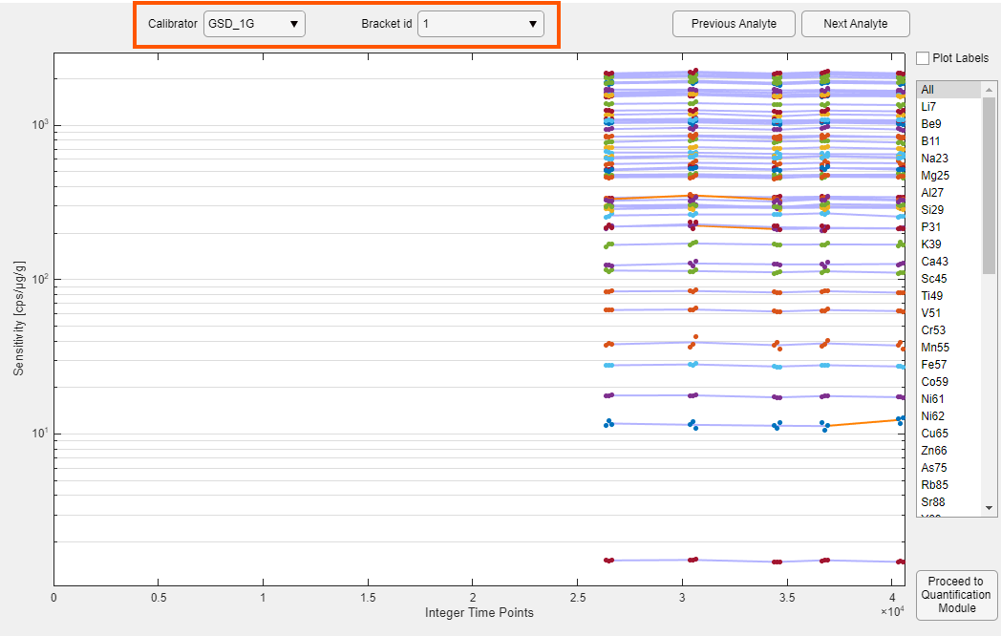
In this example, we see the sensitivities of the GSD-1G reference material of bracket id “1” which corresponds to the 30 µm spot size. By changing the “Bracket id” dropdown to “2” we see the 80 µm spots. Of course, those are earlier in time since they were analyzed at the start of the session.
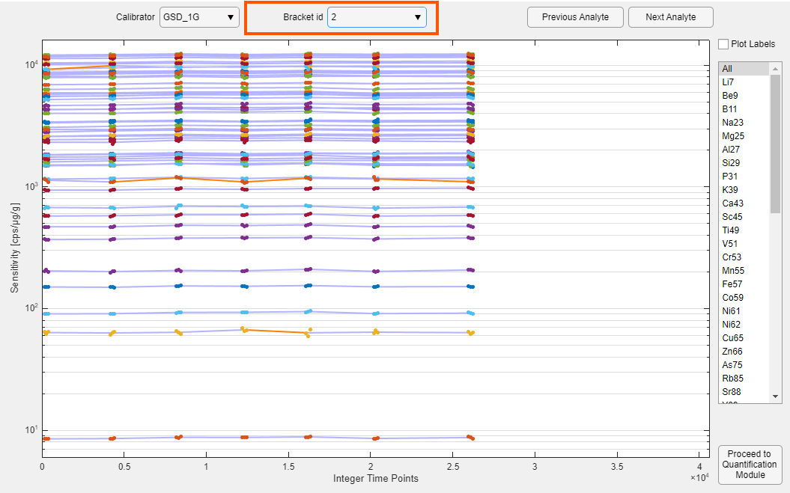
The same can be done for all Calibrators assigned in the Classification Module.
The UNK, IHRM and QCRM spots lie between the CAL spots in time. ICP-Base gets the integer time points of them, fits them to the line and derives the sensitivity from them. This process is commonly referred to as “Drift correction”. In other words - we are correcting the drift of sensitivity for each UNK, IHRM and QCRM over time based on a linear regression of the sensitivities of the CALs.

Disregarding a CAL
If you now see that a certain CAL is just throwing off the sensitivity and you want to disregard it, you can go back to the Interval Module and delete all Intervals set for that CAL. See chapter 4.5.3 for further explanations on how to do so.

Proceeding to next module
Once you have looked at your drift, you can immediately proceed to the next module. There is nothing to do for you except look and think.

Quantification Module
In this module, the user is asked to input the internal standards. The internal standardization process plays a critical role in the quantification process.
ICP-Base features a few practical and novel quantification techniques due to the way it manages reference materials and the bracket ids.

Implications of using multiple CALs and bracket ids
To explain the implication in its simplest case, let us focus on the first bracket of my example. The first six spots are all CALs, spots 7 to 32 are UNK, IHRM and QCRM, spots 33 to 38 are again CALs. The CALs are of the same bracket id but have two different reference materials (Sca-17 and GSD-1G). This means that for spots 7 to 32, ICP-Base calculates the sensitivity twice – once for each reference material – bracket id pair (GSD-1G – id 1, Sca-17 – id 1). This means that you can quantify these spots twice – once for each reference material – bracket id pair. In this example, the bracket ids don’t matter because all CALs in the first bracket have the same bracket id.
But if you were to not only use two different reference materials but also e.g. two different bracket ids for a given bracket, you could quantify the spots within that bracket four times! Once for each reference material – bracket id pair e.g. GSD-1G – id 1, GSD-1G – id 2, Sca-17 – id 1, Sca-17 – id 2.
This implies, that a given spot is not strictly assigned to one reference material but that it can be quantified using multiple CALs in parallel. This allows for direct comparison of the results obtained by using multiple CALs (and bracket ids) without having to redo the data reduction for each CAL individually.
Basically, we are splitting up the data reduction into multiple quantification strands that run in parallel. These quantification strands can also be run in sequence – and that is where it gets real spicy. But first, let us talk about the “normal” parallel quantification.

Internal standardization
For quantification, ICP-Base offers two types of internal standard approaches: (i) Use of known analyte mass fractions in µg/g. (ii) a normalization to a given amount of total element oxides. If you come from a different software and/or only have NaCl eq. data, don’t worry it will also work (see chapter 7.2.4.1).
Generally explained, if you use an internal standard µg/g value of 10, you will get some results. If you change it to 20 µg/g, you will get exactly double of what you got with 10 and so on. So the internal standard just “shifts” the data to the right place. If you double the internal standard, you will “shift” it double and get double the µg/g.

Analyte [µg/g]
If you want to use an analyte mass fraction for internal standardization, either click into one cell or select multiple cells (click and drag down) in the “Analyte” column of the quantification table (see below). This makes the list of possible internal standards for a given reference material (GSD-1G in this case) pop up to the right of the table. Then click on the analyte of choice in this list box.
For the NIST610 spots, which are classified as QCRM, ICP-Base knows the value for Si (or any other element) from the reference material file and automatically fills it in.
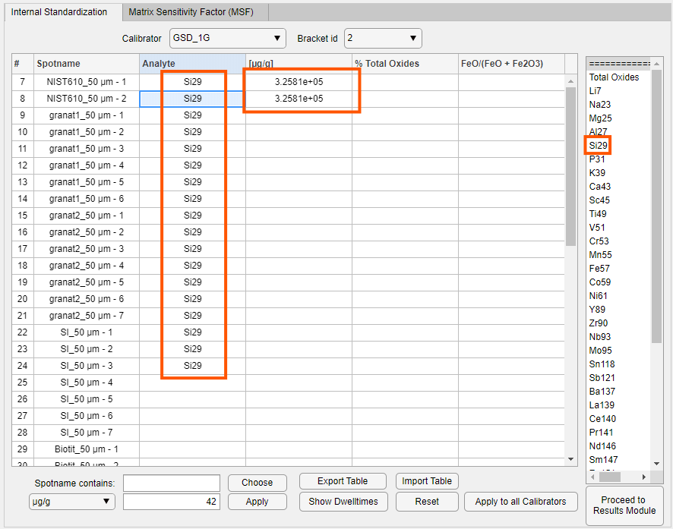
For the other spots, simply mark the cells of µg/g and type in the number and press “Enter” on your keyboard.
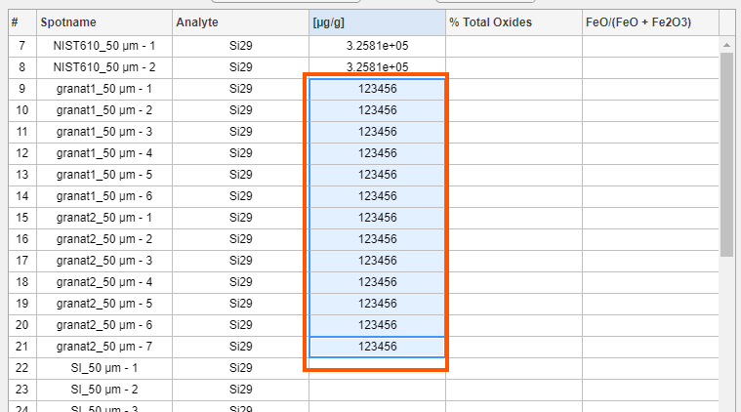
You can also use a string search similar to the one in the Classification Module.
First, click in the “Analyte” column to make the list box holding the analytes pop up. Next, type in the string and press the “Choose” button. Now all spots containing that string are chosen. Then click on an analyte in the list box to select the internal standard element. It is also possible to use && (and) and || (or) for the string search. For example you could type “amp && micas” (which would select all spots containing “amp” and “micas”. Similarly it would work with “amp || micas” which selects all spots containing “amp” or “micas”. This is it though, no parentheses or other fancy stuff. Just two strings with either a && or a || in between them.
Next, select the µg/g option in the drop-down menu, type in the number and press the “Apply” button.
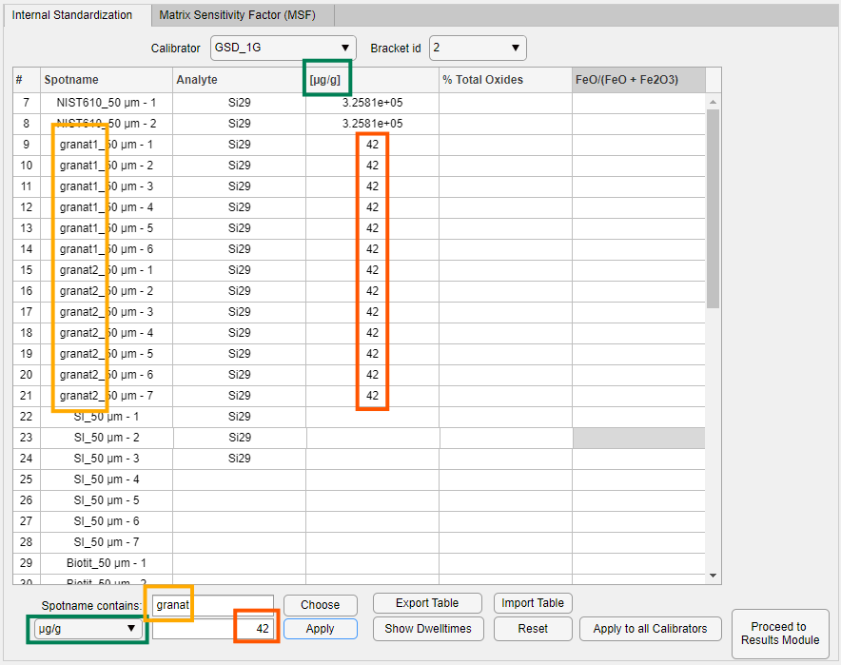
Once you filled in the internal standards, you can press the “Apply to all CAL” button to make the other CALs have the same internal standards. This only works CAL-wise and not bracket-id wise.
Make sure to fill in the internal standards for all CAL – bracket id pairs! You can change them using the drop down menus above the table, similar to the Drift Module.
You can also export a .xlsx file of the active table (that is the table that you are looking at when you press the button). Before you export the table, make sure to already fill in the correct analytes that should be used.
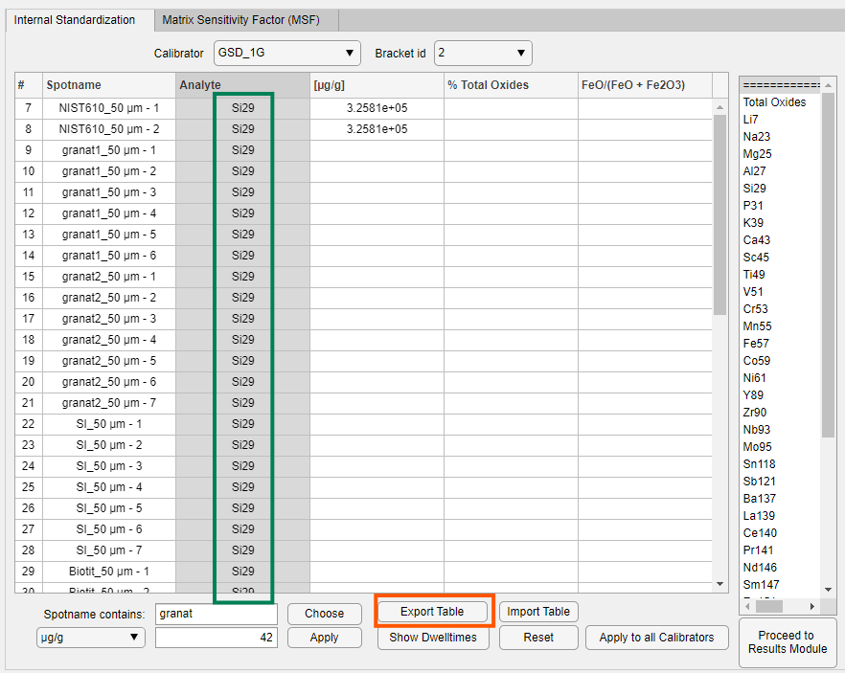
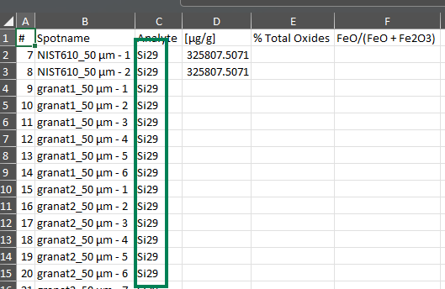
No fill in your internal standard values. Don’t touch the first three columns, the general layout, the column headers or stuff will break!
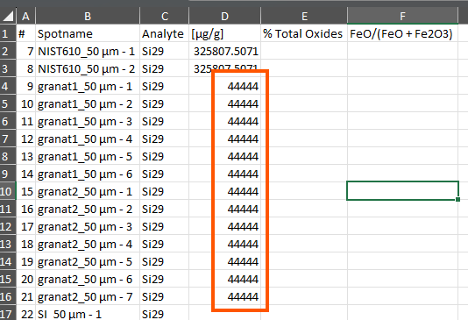
Save the table and import it back into the software using the “Import Table” button
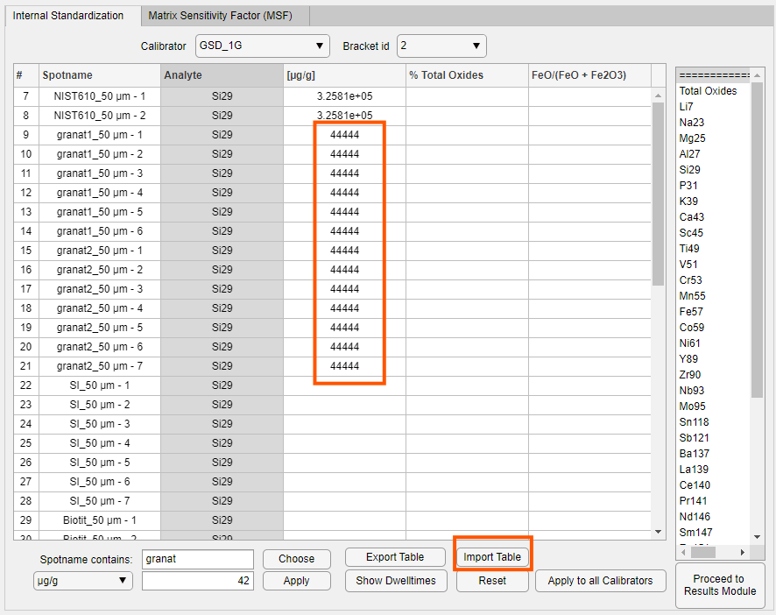

Total Oxides
If you do not know an internal standard analyte mass fraction for your spot to be used for internal standardization, you can also choose to quantify the measurement using a normalization to a given amount of total element oxides. In order to choose "Total Oxides for internal standardization, highlight the cells you wish in the Analyte column and then select "Total Oxides" at the top of the list to the right. If Total Oxides is used, the “µg/g” column is emptied. To fill in the values in the total oxides column to be used for internal standardization, you can use the same tools as explained above in section 7.2.1. You can also use the string search and fill in the values by changing the dropdown menu (bottom left) to % Total Oxides.
Note that the sum of total oxides must correspond to the sum of total oxides you actually recorded during measurement! A typical case is that you measured water-bearing minerals, for example amphibole. For this example, search the stoichiometric H₂O wt% mass fraction online (2.2 wt% for a typical amphibole) and use 100 wt% - 2.2 wt% = 97.8 wt% as the value for Total Oxides.
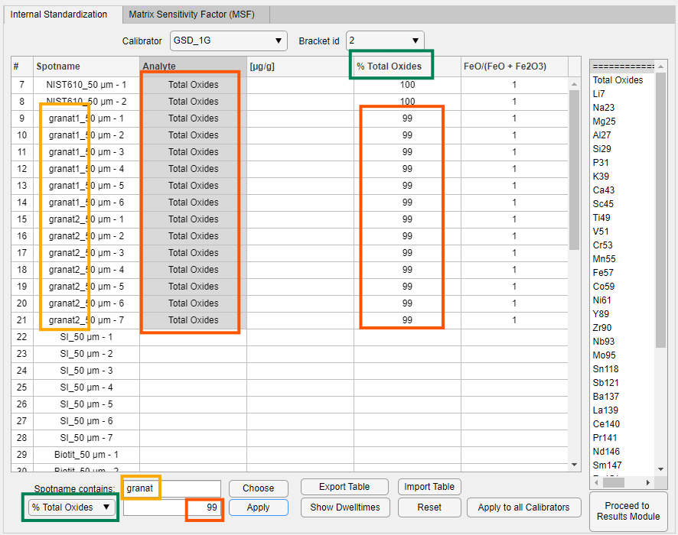
In the “% Total Oxides” column you can enter a value between 0 and 100, in the “FeO/(FeO + Fe2O3)” column you can enter values between 0 and 1. If you put 1 for the iron ratio, all Fe is considered to be ferrous (i.e., Fe²⁺). Note that when choosing Total Oxides, an entry in the “FeO/(FeO + Fe2O3)” column is needed, otherwise no quantification will be executed.

How it works
ICP-Base calculates apparent mass fractions (µg/g) of all analytes for a spot. No internal standard was yet applied. Next, ICP-Base converts those apparent mass fractions to wt % oxides (based on an oxide list that can be customized, see next chapter) and normalizes them to the wt % Total Oxides value input by you (e.g. 97.8 wt % for an amphibole). After the normalization, it converts them back to element µg/g, which is the output you get.
Attention: If you use "Total Oxides" for internal standardization, the CAL you want to use must have all the element mass fractions known that you wish to quantify this way. For example for the reference material Sca-17, which only contains 9 elements of known mass fraction, only those 9 can be used for the normalization. The result will therefore not properly reflect the "true" composition (since so many elements are missing). For example, if Sca-17 does not have Mg but you want to use the feature on an olivine, Mg is not considered in the normalization which will give you no result for Mg. The safest approach therefore is: If you use the % total oxides feature, make sure to do it with a CAL that contains all the major and most of the minor and trace elements of your sample! Alternatively, you can delete e.g. Mg out of the Oxides.csv and then total to the total oxide value of 100 % minus the volatiles (as normal) and then also minus the amount of MgO but this is only recommended if you have no other choice.

Customizing the oxide list
Similar to the RM_Files and the Plot_Styles, in the ICP-Base folder you find a subfolder called “Total_Oxide_Calculations”, which contains the Oxides.csv file.
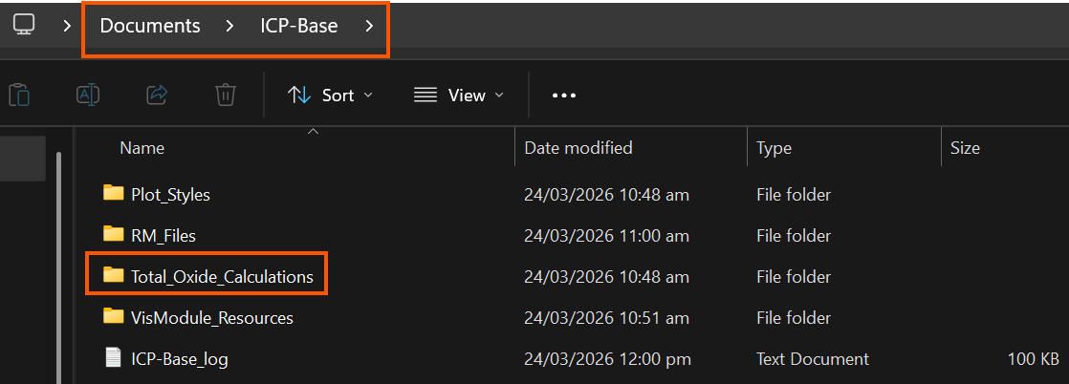
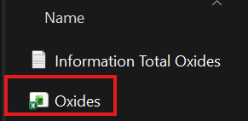
ICP-Base will read in this Oxides.csv file every time the spots are quantified (if it is named differently it is ignored!). This means that if you change the Oxides.csv and forget to change it back, you will keep going with the altered list, possibly rendering the subsequent quantifications errorneous! ICP-Base cannot magically know which oxides you really wanted to use! You are responsible for what you input!
Alternatively, If you don’t have administrator rights to your computer, you can select the “Settings” menu and then “Change Total Oxides folder” and select a folder of your choice.
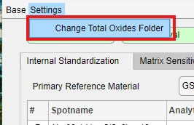
This will then always load in the Oxides.csv from this folder – be careful if you change the path or rename the folder. By default, it will always use the folder that was installed. You have to change this for every session individually.
This file holds a list of elements, their oxide names, and the conversion factors between wt% element oxide and element µg/g. These can be changed as needed (added/deleted/different speciation). There are more elements listed in this file than there may be measured in a given session. This is fine, ICP-Base ignores all the elements that were not analyzed. If you want to disregard an element for the total oxide calculations, simply delete it out of the list.
The column Preferred_Isotope becomes important if you analyzed multiple isotopes of an element e.g. Ni61 and Ni62. If we would consider both for normalization, it would be wrong since the element is considered twice. Therefore, you can choose a preferred isotope which is then used for the total oxide calculation. If you don’t specify that, ICP-Base will take the first isotope it comes across e.g. Ni61 in this case.
The isotope that is not the preferred one will not be considered in the normalization but it will still be quantified.
In the last column, you can specify if an element should be considered as a “Major” or not. This has nothing to do with the quantification calculation, this is just for the Results Module where the majors can be displayed as oxides. In other words, this is just for cosmetics.
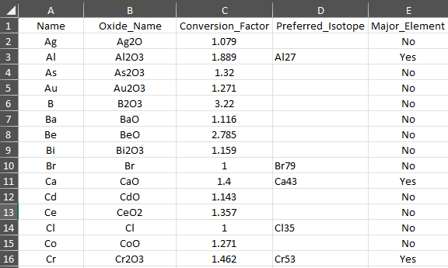

Sequential quantification
Up to this point, I only explained the case where all your CAL – bracket id pairs are quantified in parallel but as teased above, they can also be quantified in sequence. This is only possible for spots that are bracketed by at least two different CALs.
This sequential quantification approach is needed for the case where the analyte that you want to use for internal standardization is only present in one of the CALs.
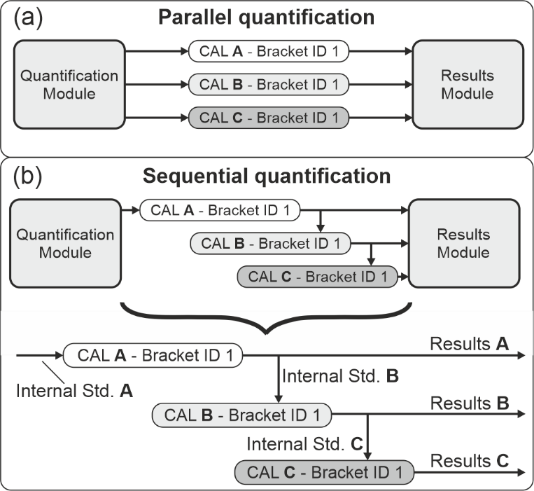
Example: The internal standard element that should be used (for some reason) is Ti49. This element is known in the GSD-1G reference material but does not exist in the Sca-17 CAL! Here, the sequential quantification comes in. First set Ti49 for the GSD-1G as the internal standard.
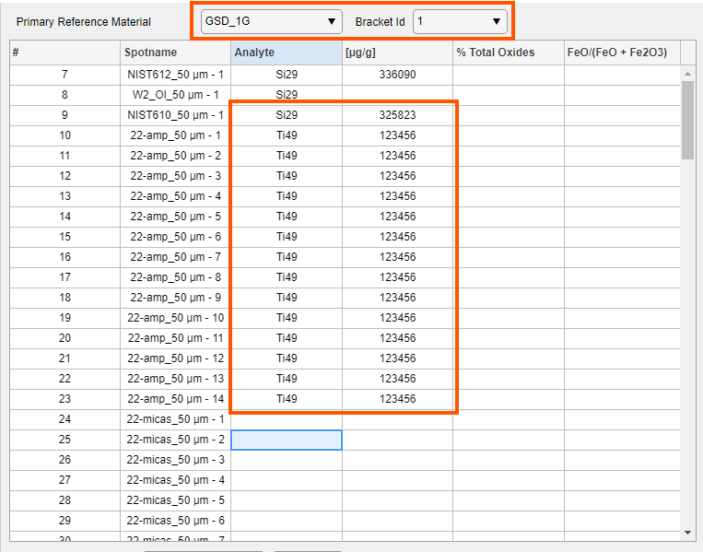
Next, switch to the Sca_17 CAL with the dropdown menu above the table. For this CAL, choose one of the possible analytes as the internal standard. Then click in the “µg/g” column. On the right side of the table, a new list box will pop up. Since the selected spots are bracketed by both the GSD-1G and the Sca-17 CAL, you have the option to choose “from GSD_1G”.
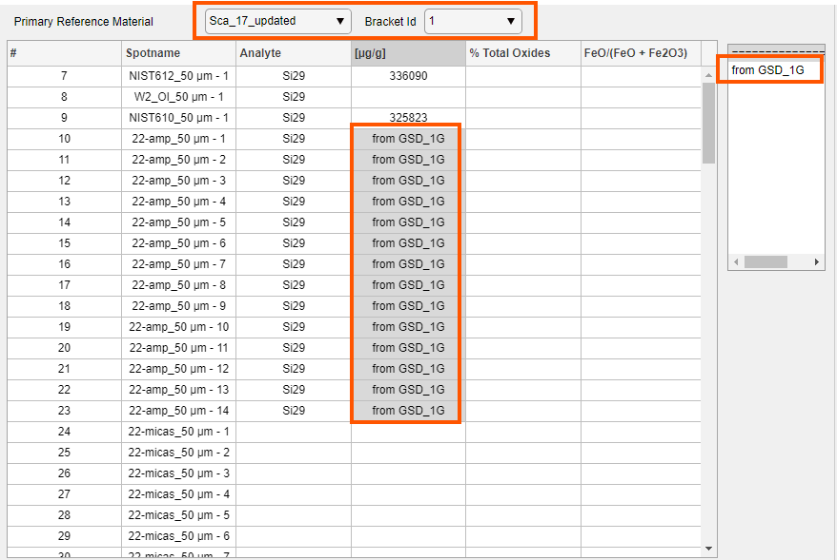
ICP-Base will first quantify the spots using the GSD-1G reference material and Ti49 as the internal standard. Once this is done, it will quantify the same spot using the Sca-17 reference material with Si29 as the internal standard, as quantified before via the use of GSD-1G and Ti as the internal standard element.
So we do the quantification for one chosen reference material first and then use one of the analytes quantified as the internal standard element for the use of another reference material. This can be done with as many CALs as desired and in any order. There has to be a start somewhere for this step-by-step procedure, of course. Obviously, if your first CAL does not quantify the analyte that the other CAL should use, it will not work.
If you have simply no clue about any internal standard element for a given spot, you can start this sequential quantification by using % Total Oxides. And then getting e.g. Si29 form that quantification for all other CALs.
This feature also works CAL-wise and not bracket id-wise. You can do it separately for all bracket ids though.
Be aware that not all CALs contain all analytes! If you choose e.g. Co59 “from Sca17” but CAL Sca17 does not quantify Co59, this will not work (obviously).

Inclusion quantification
When it comes to the quantification of inclusion, everything works pretty much the same way as described above. To set the internal standard for the inclusions, use the dropdown menu and go to “Inclusion” (only visible in Inclusion Mode, that’s why it is not there in the above explanations).
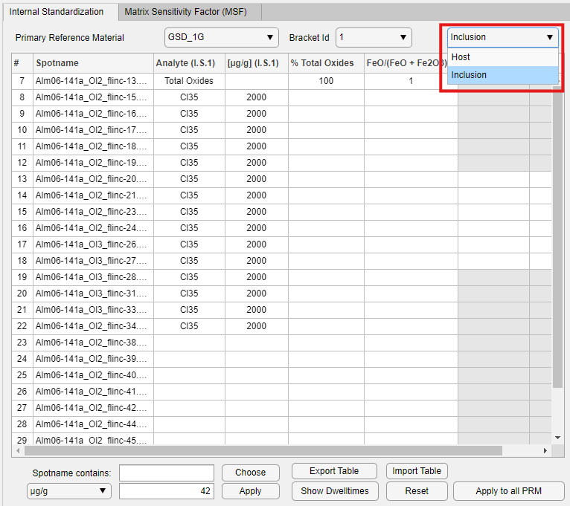
If you leave the dropdown menu on “Host” you will quantify the host, and not the inclusion.
You can also use the sequential quantification feature. This feature works within the “Host” and “Inclusion” – so it is not possible to use the host somehow to quantify the inclusion, they are separate.
In order to calculate the limits of detection for the inclusion, the host needs to be quantified, so don’t forget doing that.
If the inclusion results are Inf or NaN if the internal standard has 0 cps in the inclusion after host-inclusion unmixing. Therefore, nothing can be quantified.

NaCl salinity equivalent (wt%)
If you have fluid inclusion, you might only know the NaCl salinity equivalent. In SILLS, it was possible to input this directly but we decided against that since the conversion of NaCl eq. (wt%) to Na (µg/g) or Cl (µg/g) is pretty straightforward.
To convert sodium chloride (NaCl) weight percent (wt%) to sodium (Na) concentration in micrograms per gram (µg/g), we have to understand that 1 wt% means 1 gram of NaCl is present in 100 grams of the total sample. Since Na makes up only part of the NaCl molecule, we can use the ratio of the molar mass of sodium (22.99 g/mol) to that of NaCl (58.44 g/mol), which is approximately 0.3934. This means that for every gram of NaCl, there are about 0.3934 grams of Na. To find the Na content per gram of sample, divide the 0.3934 grams of Na by 100 grams of sample, giving 0.003934 grams of Na per gram of sample. Finally, convert grams to micrograms by multiplying by 10⁶ resulting in 3934 µg of Na per gram of sample.
Therefore, 1 wt% NaCl is equivalent to 3934 µg/g Na. Equally, 2 wt% NaCl is equivalent to 2 x 3934 µg/g = 7868 µg/g Na and so on. Just take whatever wt% NaCl eq. you have and multiply it by 3934 to get the Na mass fraction in µg/g. You can use this value and Na as your internal standard.
To get the Cl mass fraction, simply subtract 3934 µg/g Na from 10000 µg/g NaCl which gives 6066 µg/g of Cl (or follow the same molar mass ratio procedure as above for Na but for Cl). So 1 wt% NaCl is equivalent to 6066 µg/g Cl. Equally 2 wt% NaCl is equivalent to 2x 6066 µg/g = 12132 µg/g Cl and so on.

Salt correction
ICP-Base is made for LA-ICP-MS data processing, not salt correction calculations, therefore it is not implemented directly. However, in the Example Data folder in the install folder, you can find “Salt_Correction_Example.xlsx”. This sheet shows how a salt correction for K and Ca is done and can be used to do your own correction with some minor adjustments. It is based on Heinrich et al. (2003) Geochim. Cosmochim. Acta, 67(18) 3473-3496 and Allan et al. (2005) Amer. Min. 1767-1775 and the same as SILLS did it.
There are two steps you have to do in ICP-Base before you can use the excel sheet: (i) In the quantification module, set Na as the internal standard for the inclusions and input any number (or 0) as the internal standard (it does not matter right now, you just need to get to the Results Module by any means). (ii) In the Results Module, export the background-corrected CPS data for the inclusion and the sensitivities of the inclusion spots for the CAL of your choice (not “CAL sensitivities”!). The sensitivities of the unknowns are different for each CAL but are the same for the host and the inclusion. These two datasets, the CPS and the sensitivities, are crucial input for the excel sheet. The sheet itself is quite simple and straightforward to navigate and I will leave it to the avid user to figure it out.
After you have done the correction in the excel sheet, you will get a Na µg/g value for each spot. These values should then be used as the internal standard values for Na in the Quantification Module in order to do the quantification properly.

Ignoring and disregarding spots
If you leave a CAL – bracket id pair empty or just do not input any internal standard for the host, ICP-Base will simply ignore it so it is no problem. Generally, cells that are left empty or do not have all the information (e.g. Si in the “Analyte” column but no value in the “µg/g” column) are ignored.
A quick way of deleting multiple entries of the “µg/g” column is to simply type few letters and press “Enter” on your keyboard. ICP-Base will recognize the letters as wrong input and make the cell empty.
Once an analyte was chosen in the “Analyte” column you cannot get rid of it, just let the “µg/g” column empty and ignore it.

Exporting and importing tables
This feature exports the current active table (that is the table you are looking at when clicking the “Export Table” button). Before exporting the table, set the internal standard analytes (so that the analyte names are also exported). Once the table is exported, fill in your internal standard values in the excel sheet (don’t change anything else in the table). At last, import the table back into ICP-Base to set the internal standard values.

Matrix Sensitivity Factor (MSF)
To assess which analytes may suffer from matrix-related element fractionation issues, and to which extent, the matrix sensitivity factor (MSF) can be used. The MSF is unique for each pair of distinct matrices and relates their analyte sensitivities (S) (intensity expressed as counts-per-second divided by the mass fraction expressed in µg/g).
By calculating the ratio of the relative sensitivity as determined on a given QCRM (e.g. NIST610) and normalizing to the relative sensitivity obtained on the CAL (e.g. GSD-1G; (^{NIST610}Sensitivity_{Al27}/ ^{NIST610}Sensitivity_{Si29}) / (^{GSD_1G}Sensitivity_{Al27}/ ^{GSD_1G}Sensitivity_{Si29})) we can evaluate the assumption inherent in LA-ICP-MS quantification, namely that one analyte used for internal standardization is sufficient for accurate quantification of all analytes measured in this given QCRM.
For this feature to be useful, it is important to use a QCRM that is matrix-matching (or at least as has a similar matrix) as the unknowns that should be quantified. For this visualization, it does not matter if the reference materials are CAL or QCRM, you can compare all of them to each other.
If the MSFs for all analytes are close to 1.0 (i.e., deviating by a few % maximum), the assumption of a constant relative sensitivity is confirmed. In this case, internal standardization using a single analyte will accurately account for matrix-dependent differences between those analytes. However, the MSF of an analyte can deviate more strongly from 1.0 if the mass fractions of the QCRM or CAL are poorly constrained or the analyte used for internal standardization does not adequately correct for matrix-dependent differences. For well-characterized QCRM and CAL, the MSF thus represents a measure of the extent of inter-analyte fractionation issues that grossly relate to different matrices, i.e., collectively called matrix effects.

How it works
In the upper list box on the right hand side, you can choose elements that you are interested in using as internal standards. In my example, I am want to use Si as the internal standard for quantification of my unknowns. I select those two analytes by holding “ctrl” on the keyboard and clicking on them. This will fill the lower list box with all the possible ratios. Now it is possible to select those ratios and they will be plotted. By changing the “Compare to” dropdown menu, you can adjust the vertical axis of the plot. It will always plot all possible reference materials. You can also export a table with the values by clicking on the “Export Table” button above the plot.
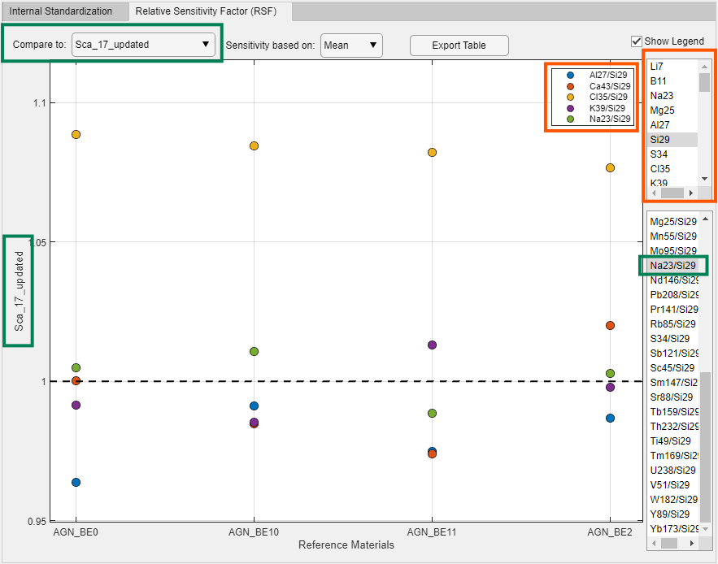

What it means
Let’s look at an example. First, the relative sensitivities (e.g. Sensitivity_{Cl35}/Sensitivity_{Si29}) are calculated for the selected analytes for each reference material pair. Next, the sensitivity ratio of the reference materials on the horizontal axis are ratioed by the sensitivity ratio of the reference material on the vertical axis. So we get e.g. (^{AGN-BE11}S_{Cl35}/^{AGN-BE11}S_{Si29})/(^{Sca-17}S_{Cl35}/^{Sca-17}S_{Si29}).
The closer this ratio is to 1.0 the better, this means that the internal standard analyte (Si in this case) does correctly account for matrix-dependent differences between the reference materials.

How we can use it
In this example, I used scapolite Sca-17 as the CAL and I want to check whether I can correctly quantify Cl in my sodalite crystals (AGN-BEXX) (QCRM). The analytes feasible as being used for internal standardization (Na, K, Ca, Al, Si) for the sodalite crystals display MSFs close to 1.0. This implies, that Si used for internal standardization does accurately correct for matrix-dependent differences between sodalite and scapolite matrices for Na, K, Ca and Al. On the other hand, Cl shows MSFs consistently higher (1.077 to 1.098) for all sodalite-scapolite pairs. Since Si and the other analytes feasible as internal standard show consistent MSFs close to 1.0, none of these analytes can accurately correct for the matrix effect influencing Cl.
In simpler words, whichever analyte you use as the internal standard, Cl will always be way higher than it should be, it suffers from a matrix effect.
For some reference material pairs you will see systematic discrepancies and for some perfect matches. This is just a visualization so don’t be scared to play around with it, it will not affect the calculations previously made.

Adjusting the dwell times
The dwell times are important for the calculation of the LODs. If you did not import ICP-MS metadata containing the dwell times, press the “Show Dwelltimes” button and change them accordingly. Now change the value (in seconds) to whatever you want and press “Enter” on your keyboard. Then close the Dwell Times table using the x and done.
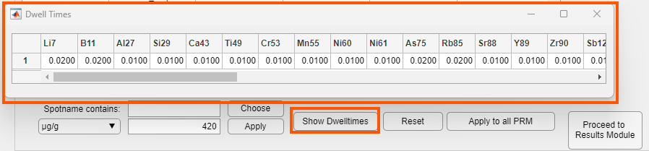

Proceeding to next module
Once you set all your internal standards, you are ready to proceed. The quantification will trigger once you press the “Proceed to Results Module” button. Depending on how much spots you want to quantify, this can take a few seconds.

Results Module
This module shows your results in µg/g element mass fraction by default. It shows the results of a given CAL – bracket id pair as selected in the dropdown menu at the top of the table. At the bottom left near "Show", a series of other options can be chosen.

Results
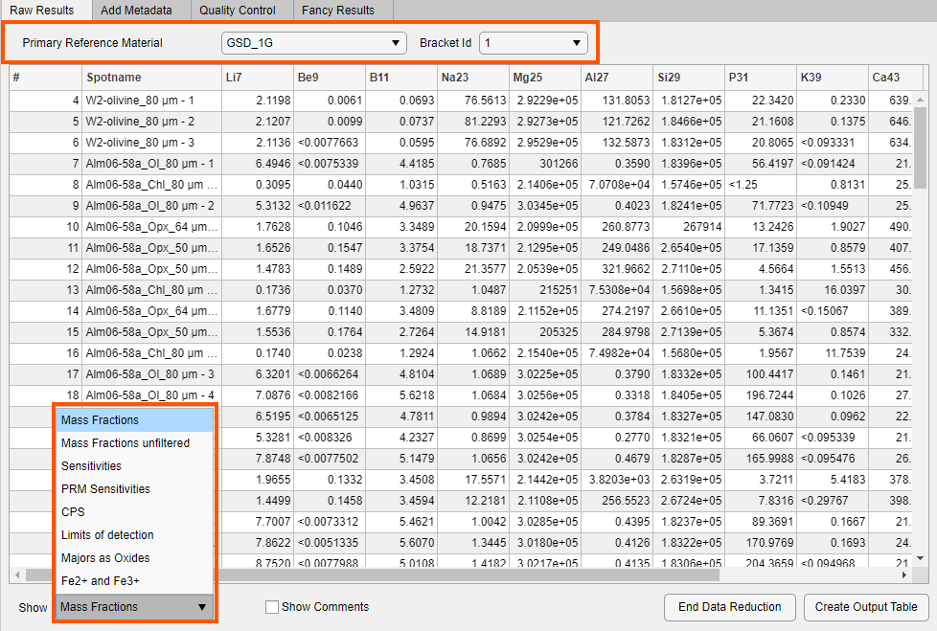
It is also possible to show "Mass Fractions unfiltered", i.e., where all the calculated element fractions are shown WITHOUT LOD filtering. If you choose “Majors as Oxides” the majors, as defined in the Oxides.csv file (see chapter 7.2.2.2), will be converted to wt% oxides. If you defined the FeO/(FeO+Fe2O3) ratio for a given measurement spot, you can also visualize the Fe²⁺ and Fe³⁺ contributions (µg/g) to the total Fe57, popping up in a separate table when you show it.
Whenever you press the “Create Output Table” button, it will save the table that is currently displayed. Be aware that if you have an already existing excel file and you want to replace it, for some reason it does not actually replace it but it adds the new data in sheets to the existing file.
By right clicking the “Create Output Table" button you can output all mass fractions and limits of detections for all CALs and bracket ids into one excel sheet.
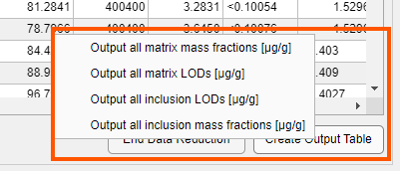

Inclusion data
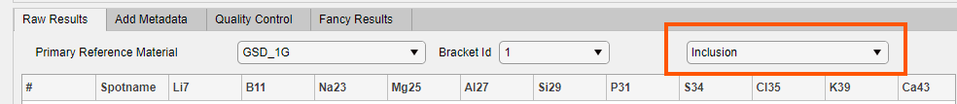
To visualize your quantified inclusion data, make sure to switch to “Inclusion” in the dropdown menu. This dropdown menu is hidden in “Matrix Mode” hence it is not visible in the example above.

Add Metadata
You can just type in your metadata in the table or use the “Spotname contains” string compare. This works the same way as the string compare in the Classification Module.
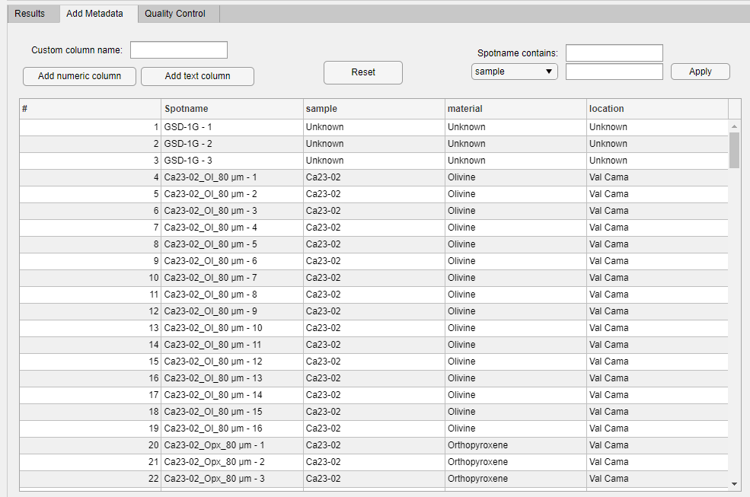
You can also add custom metadata columns. Simply type the name of the column in the field and choose text or numeric.
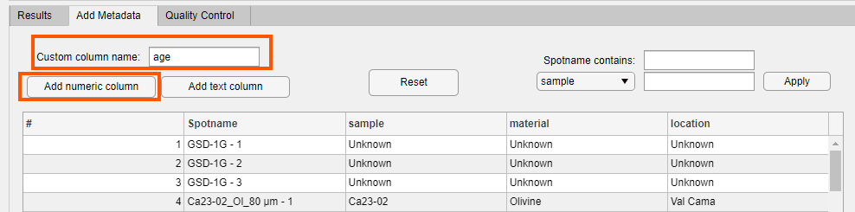
This will add an empty numeric column.
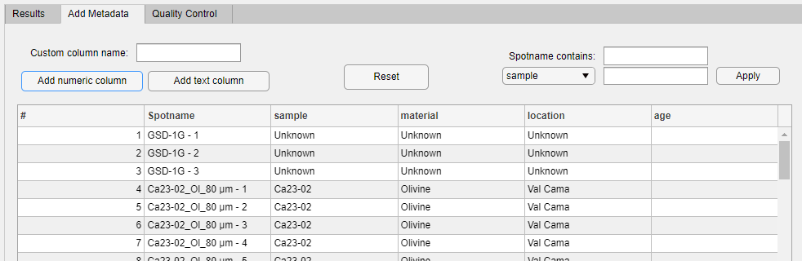

Quality Control

Quality Control Reference Material
In this Tab, you can compare how well the quality control standards were reproduced. The plot ratios the measured value with the “Preferred Value” which is the value from the reference material file. If the ratio is 1, it is perfectly reproduced. The green area is from 0.9 to 1.1 (so ± 10 %), the yellow area is from ± 10 to ± 20 %, the orange area is from ± 20 to ± 30 % and everything red is more than ± 30 % deviation from the perfectly reproduced value.
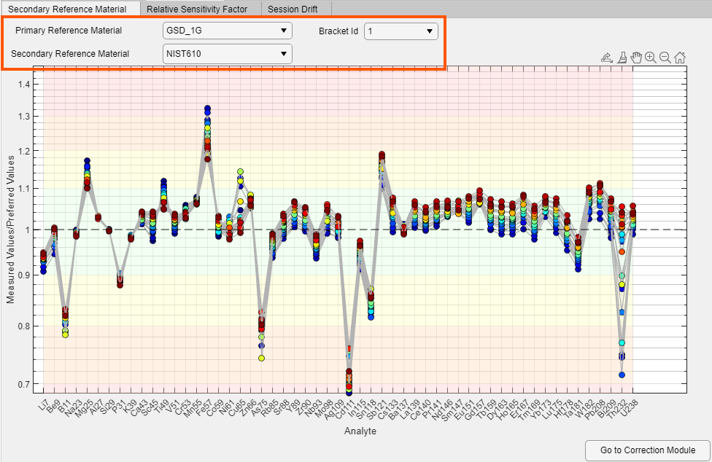
This example shows the NIST610 QCRM (without uncertainties in the RM file) that was quantified using the GSD-1G as CAL with bracket id 1. Most analytes were reproduced within 10 % (which is mostly good enough for LA-ICP-MS).
The colors of the points represent the time of the analysis (acquisition time; integer time points). If the spot was measured at the start of the session it will be dark blue and the spots measured at the end of the session are red (colormap “Jet”, google it). In the example we can see that e.g. the REEs were reproduced better at the start of the session vs the end of the session. Fe57 is way off but behaves opposite.
If the reference material file contains the uncertainties of the elements in µg/g, ICP-Base shows this range as the green area in this plot. In the plot below, we measured too high on purpose in order to make the green area over the REE range nicely visible ;)
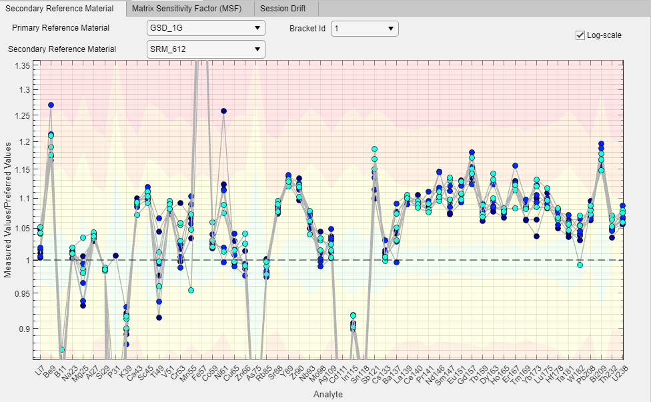

Matrix sensitivity factor
Same as in the Quantification Module (see chapter 7.3).

Configure Output Table
Use the tree to select which analyte should be taken from which CAL.
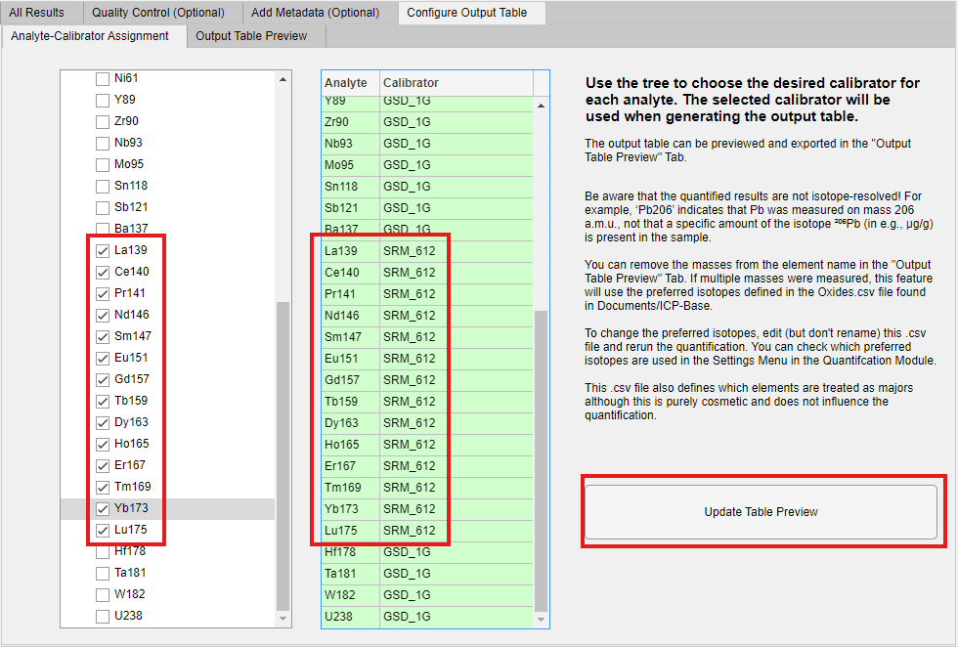
In this example, Most element data is taken from the quantification using the GSD-1G CAL except the REEs which are from SRM_612. The output table can be previewed after pressing the “Update Table Preview” Button in the “Output Table Preview” Tab.
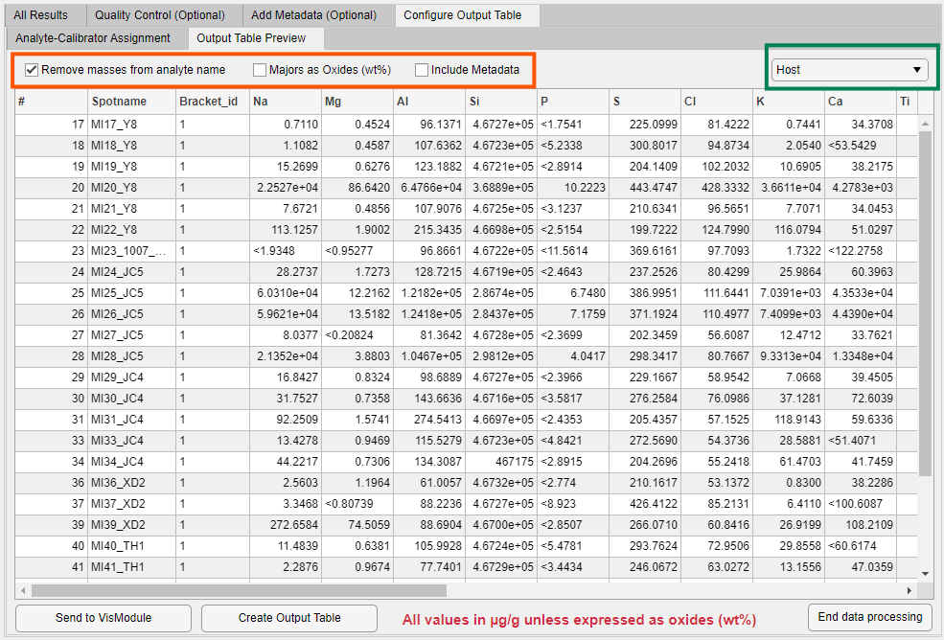
In this example the masses were removed from the element name. The elements from the selected calibrators are taken for host and inclusions. The table lists all possible bracket ids.

End Data Reduction – Saving the Base
This button will end the data reduction. Congrats you did it!
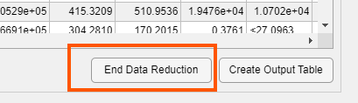
The Results Module will be closed and all modules will be shown in green in the Base.
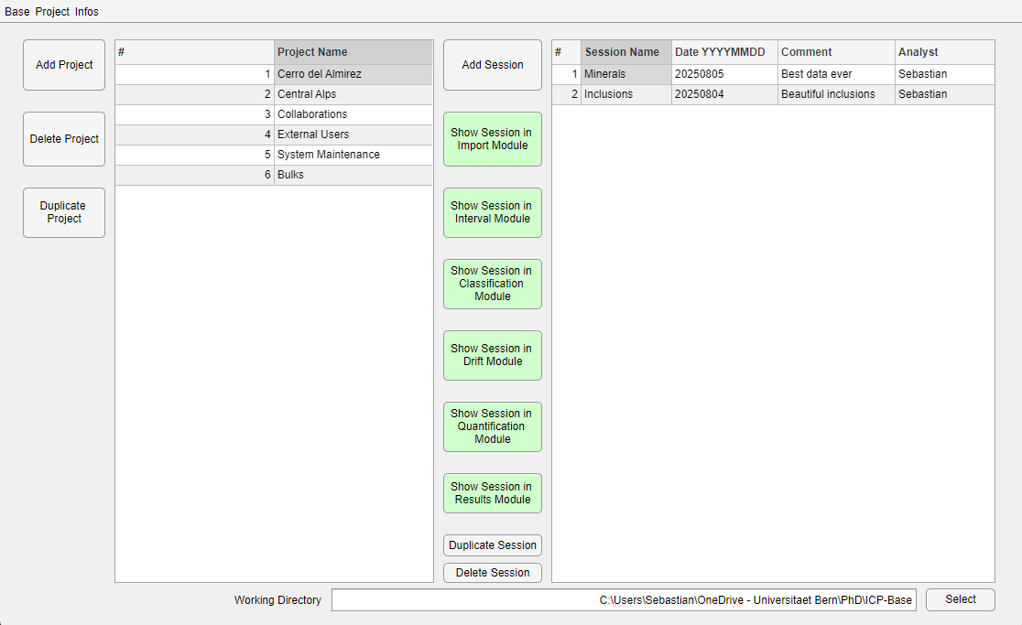
You can now select a session and jump to any module. You can also duplicate or delete the session. If you want to test a few things or do method development, I recommend duplicating the session and then playing around with it.
Now make sure to actually also save the Base itself to your computer!
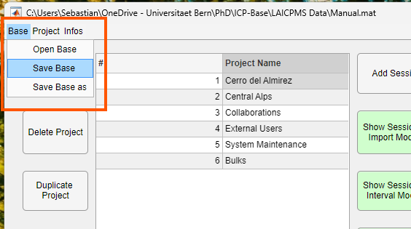
I recommend to not store the Base in the ICP-Base folder but somewhere else.
Next time you want to do something, open ICP-Base and click “Open Base” and load it back in (see Chapter 2.2). Then you can proceed with your new measurement sessions and everything will be stored at the same place.

