BoK Annotation Tool (BAT)

UCGIS Tools User guides

**Table of Content**

About 2

Tools Login & Registration 3

forgot your password 3

create a new account 4

User details and organizations 4

join an organization 5

leave organization 5

create an organization 5

delete your organization 5

create or delete divisions 6

remove users 6

add users 6

Annotating view 6

upload a PDF 7

add annotations to a PDF 7

save or download the PDF 8

My annotated PDFs view 8

edit an annotated PDF 9

download an annotated PDF 9

remove an annotated PDF 9

filter annotated PDFs 9

start a new annotation 9

Detail view 9

Glossary of terms 10

## 

## About

The [BoK Annotation Tool (BAT)](http://ucgis-tools-bat.web.app/) allows to easily annotate (associate) any PDF document with EO4GEO Body of Knowledge (BoK) concepts, to be used later in the [BoK Matching Tool (BMT)](http://ucgis-tools-bmt.web.app/) to discover best matches.

BAT automatically edits the pdf file’s metadata, adding the requested annotations using the Resource Description Framework (RDF).

The BoK Annotation Tool (BAT) is part of the EO4GEO tool suite, and was developed by the [Geospatial Technologies Research Group](http://geotec.uji.es/) (GEOTEC) from the Universitat Jaume I, Castelló de la Plana, Spain.

## Tools Login & Registration

The BAT has two types of users: anonymous and registered users. An anonymous user can directly annotate a PDF, without being logged in (See Home page section). A registered user needs to log in and hereby gains access to additional functionalities.

Figure 1 shows the login page from all UCGIS Bok-related tools, including BAT. If you have an account, type in your email (1), your password (2) and click button ‘Login’ (3).

If you

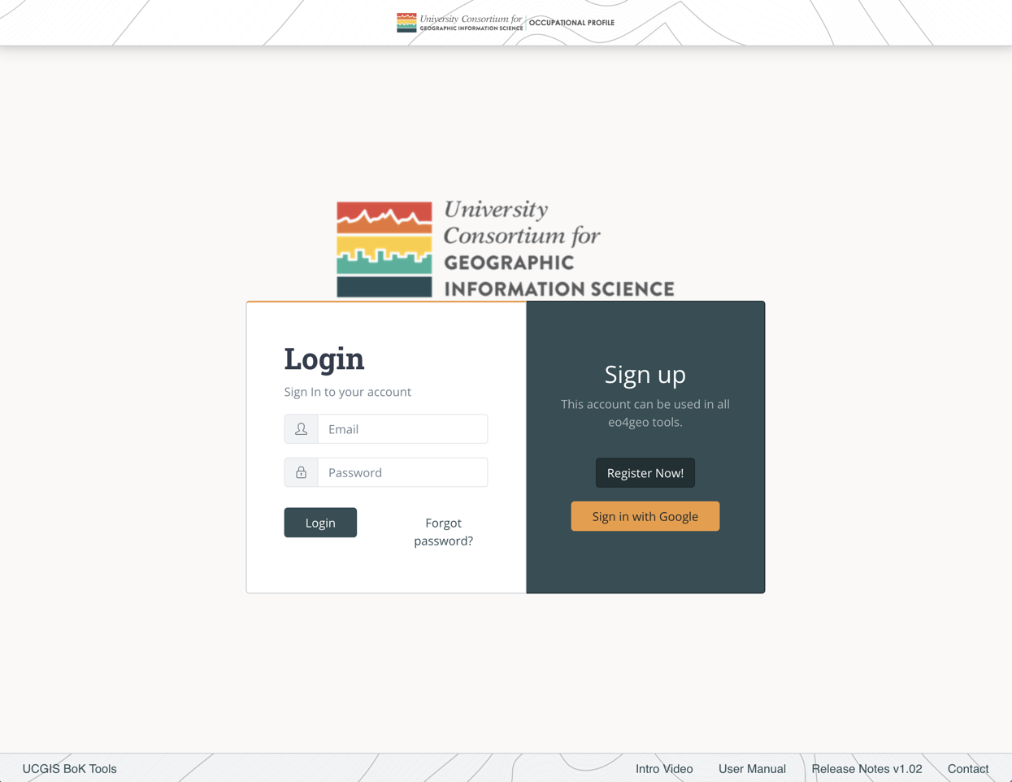

1

2

3

4

5

6

Figure 1. UCGIS Tools login page

#### 

forgot your password

, type in your email (1) and click ‘Forgot password?’ (4). You will receive an email to recover your password. If you don’t have an account, click Register Now! (5) and proceed to Figure 2 Registration form. You can also sign in with your Google account (6).

To

#### 

create a new account

, fill in your email (1), your password (2) and repeat your password (3). The password you chose should contain at least 6 characters.

Then click the ‘Register’ button (4) and you will be immediately redirected to the Home page (Figure 2).

Figure . Registration form

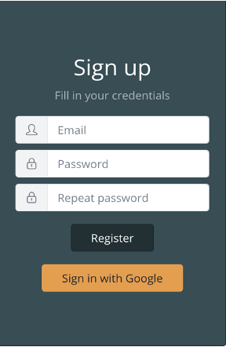

1

2

3

4

When registering, if you see the error ‘The email address is already in use by another account’, it means your email is already registered. Write your email in the login part of the form and click ‘Forgot password?’ to receive a link with instructions to recover it.

## 

## User details and organizations

After logging in, the user will be able to see his/her email address in the top navigation bar (Figure 3).



1

2

3

4

Figure 3. Navigation bar

Clicking in the email address (1) the user will be able to save his / her name and recover the password.

Clicking on the ‘Your organization’ (2) link displays every organization the user belongs to. These organizations are important in order to make collaborative edits of the content created in the tool, as users belonging to the same organizations are able to edit content from within these organizations. Also, private content within an organization is not shown to anonymous or external users, but users belonging to the same organization can see it.

To create new content the user needs to belong to at least one organization.

The ‘Home’ button (3) goes to the list page.

The ‘Log Out’ button (4) logs out the user and brings them to the login page.

To

join an organization

, click on the ‘Your organization’ button (2). In the organizations page (Figure 4) click on the dropdown to search for the desired organization. You can type to filter by text. Once you find the desired organization, select it and click Join button (2).

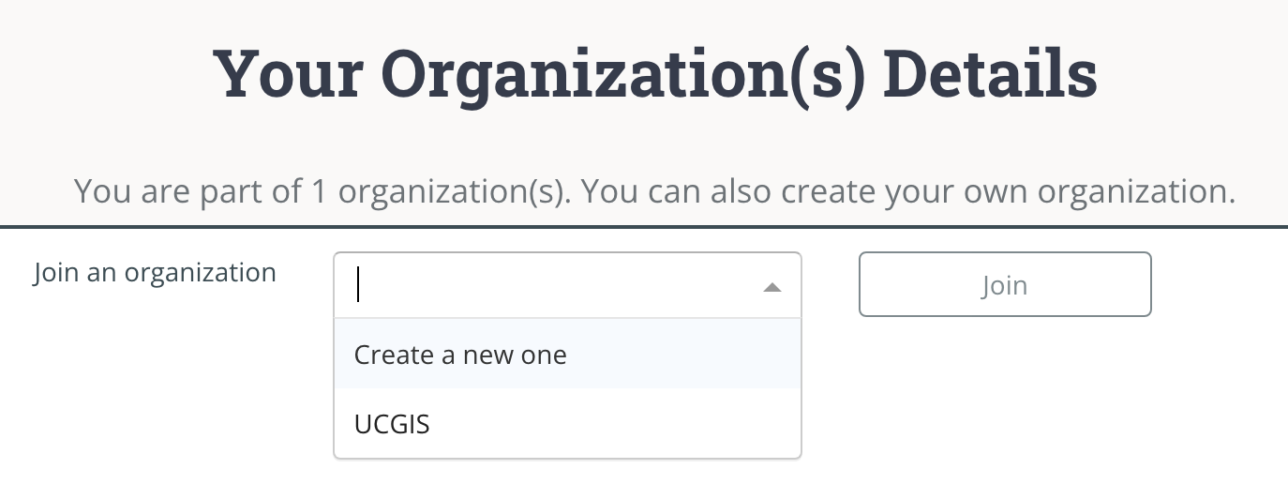

2

1

Figure 4. Dropdown in organizations page

You will be automatically added to that organization as a regular user. You can click on the

leave organization

button to be removed from it (1) (Figure 5).

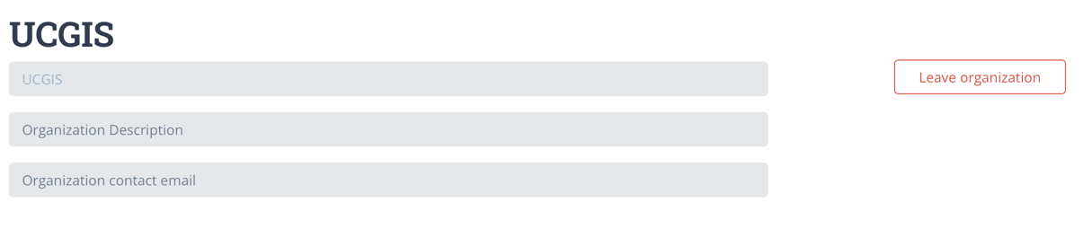

1

Figure 5. A regular user being member of an organization

If you want to

create an organization

select the ‘Create a new one’ option and click on the ‘Join’ button (1) (Figure 6). After that, you can fill in your organization name and description (2) and save changes (3) or you can

delete your organization

(4).

To help in organizing the content inside your organization you can create ‘Divisions’ under an organization. As you are the creator of the organization, that makes you ‘Admin’. As an Admin, you can

create or delete divisions

, by typing the name and ‘Add division’ button (5). They are not compulsory to be able to create content but divisions will help in organizing the content inside your organization.

You can change a user role (Admin / Regular) inside your organization by clicking the button group (6). An admin can also

remove users

(7) of an organization.

Finally, you can

add users

to your organization by typing the email address they used to log in. After your organization is created, new users can also join themselves.

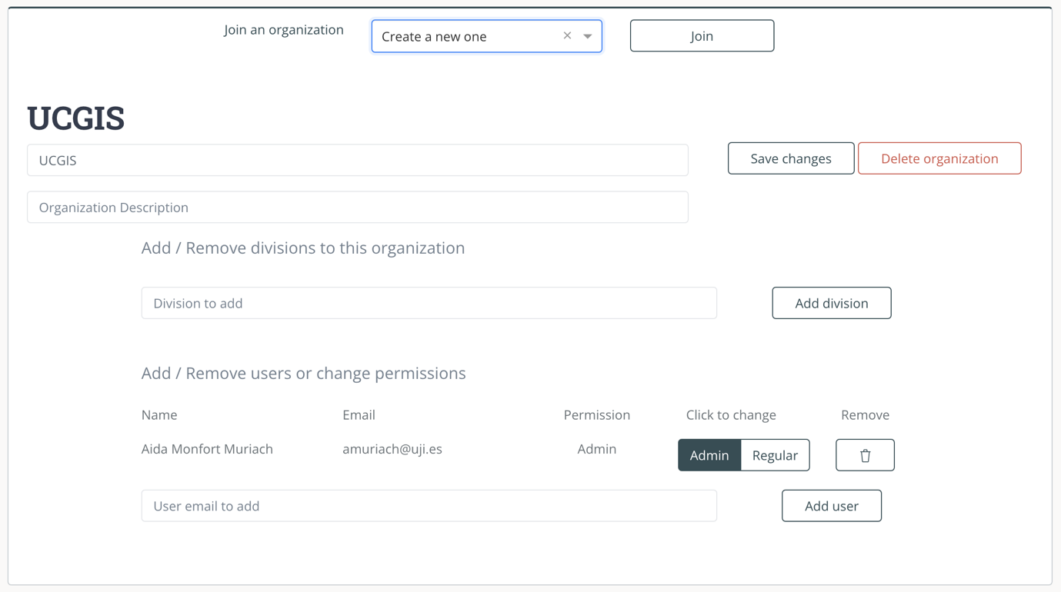

1

2

3

4

5

6

7

8

Figure 6. Organization administration

## Annotating view

Figure 7 shows BAT’s annotating view for a logged in user. If user is anonymous, BAT allows to annotate a PDF and download it, but not to save it for later use.

Annotated PDFs can be saved to be used in BoK Matching Tool (BMT) by other members of your organization, you can select it from the dropdown (1) when saving the Annotated PDF. Division is not mandatory but can help organizing your content.

The visibility swich (2) determines if everybody can see the annotation from BMT or only people inside your organization.

The ‘Save’ button (3) makes the PDF available in the BMT and in ‘My annotated PDFs’, see section My annotated PDFs view.

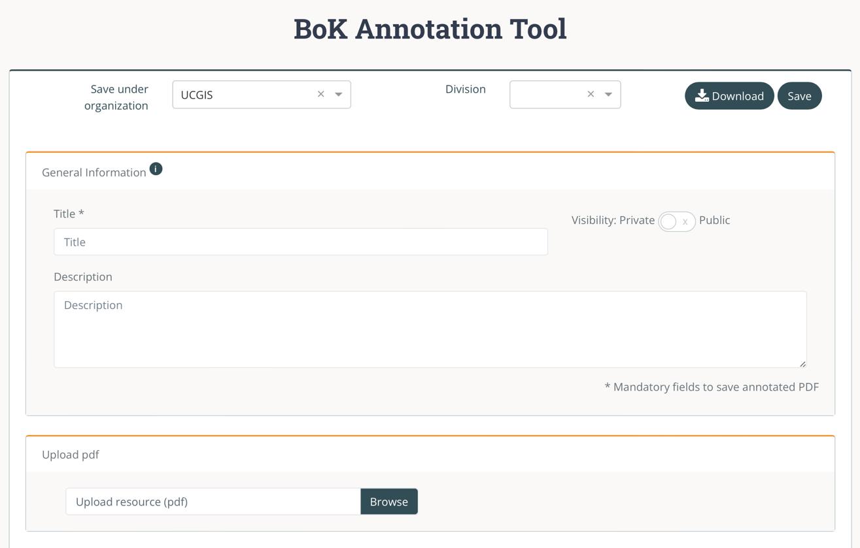

3

2

4

1

Figure . General information to annotate a PDF

To

#### 

upload a PDF

, click ‘Browse’ button (4) and select a PDF file from the computer. Then you can add annotations to it.

To

#### 

add annotations to a PDF

, (Figure 8) browse the Body of Knowledge either graphically, clicking on the concepts, or textually, clicking on the links to sub/superconcepts.

You can also search for any concept in the search bar (3), results appear in the text and selected in the graph.

Once you find a concept you want to annotate with, click the ‘Add’ button (4) and the concept will appear in the ‘Knowledge annotated’ list. You can remove a concept from the list by clicking the ‘x’ (5).

Once all concepts desired are selected,

save or download the PDF

to save it to your computer. The annotations are stored in the metadata, and BMT can afterwards interpret them.

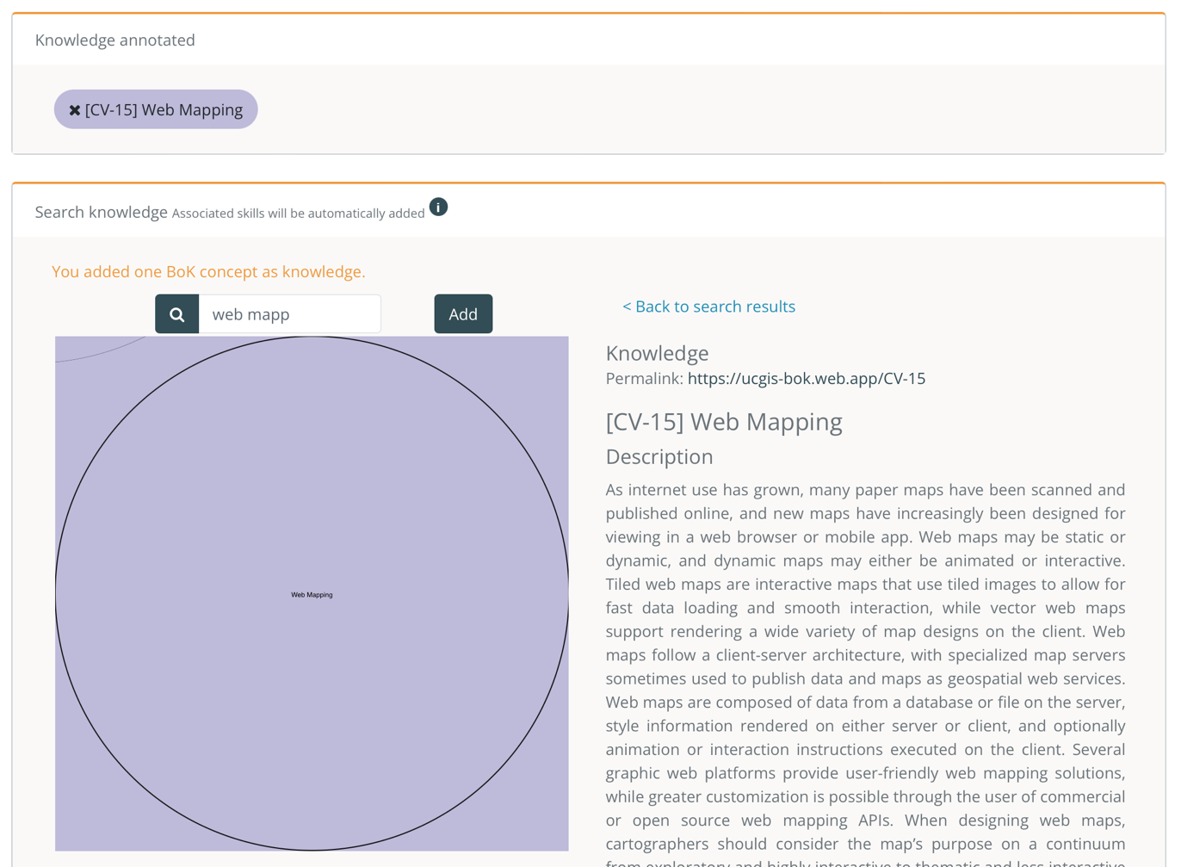

5

4

3

2

1

Figure . Browsing the BoK to add annotations

## My annotated PDFs view

A user can check her/his previously annotated PDFs saved in ‘My annotated PDFs’ accessible by the top menu (Figure 9).



Figure . Top menu

This view (Figure 10) allows users to check a previously annotated PDFs clicking on its title (1).

To

edit an annotated PDF

, click the ‘Edit’ button (2) to add or remove annotations as explained in Annotating view section.

To

#### 

download an annotated PDF

, click the ‘Download’ button (3) to save the file in your computer.

To

#### 

remove an annotated PDF

, click the ‘Remove’ button (4) to remove it from your list and from BMT.

You can also

filter annotated PDFs

by searching in the text field (4) or

start a new annotation

with the ‘Annotate new PDF’(5).

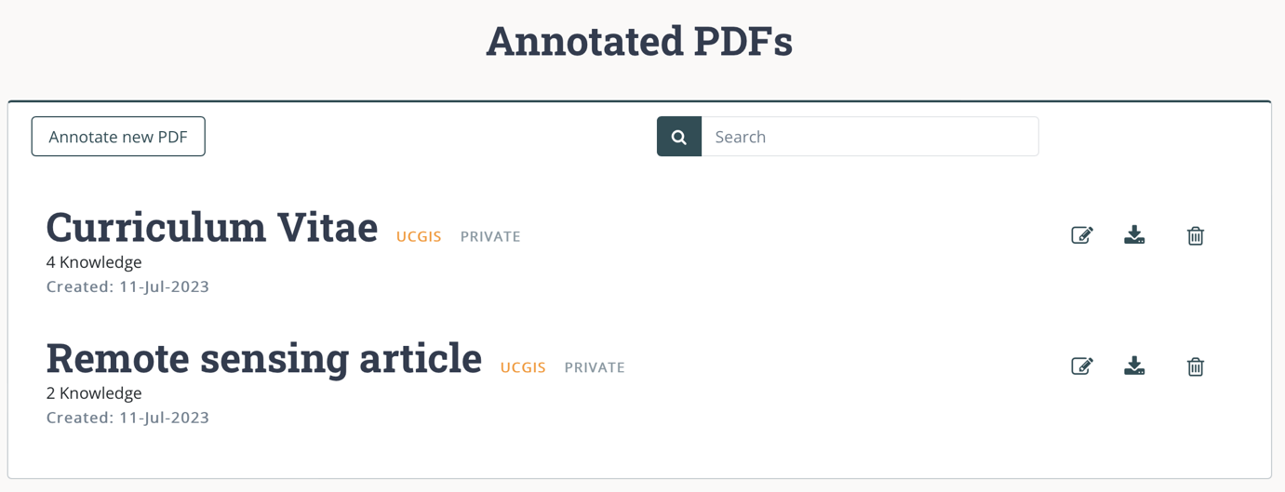

5

4

4

3

2

1

Figure . Annotated PDFs list

## Detail view

Figure 11 shows details of a previously saved annotated PDF, title and description and knowledge annotated (1).

You can also download the annotated PDF (2) and remove it (3) from the list and the BMT.

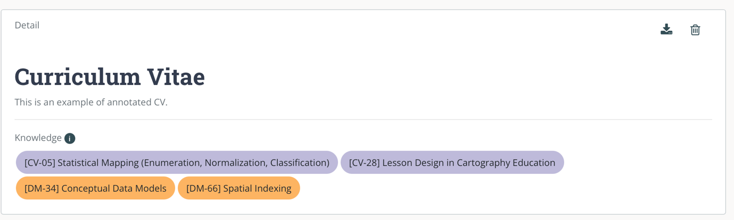

3

2

1

Figure . Detail view of an annotated PDF

# Glossary of terms

**ESCO.** Classification of European Skills, Competences, Qualifications and Occupations

**EQF.** The European Qualifications Framework for Lifelong Learning. The core of the EQF concerns eight reference levels describing what a learner knows, understands and is able to do, ranging from basic (Level 1) to advanced (Level 8)

<https://ec.europa.eu/ploteus/sites/eac-eqf/files/broch_en.pdf>

**Field**. Term related to a specific area of study, following the ISCED-F classification

**ISCED-F**. International Standard Classification of Education: Fields of Education and Training 2013, maintained by UNESCO.

<https://ec.europa.eu/esco/portal/escopedia/International_Standard_Classification_of_Education_58__Fields_of_Education_and_Training_2013__40_ISCED-F_41_>

**Knowledge.** The body of facts, principles and theories and practices that is related to a field of work or study

**Skills** means the ability to apply knowledge and use know-how to complete tasks and solve problems.

**Transversal Skills** are those typically considered as not specifically related to a particular job, task, academic discipline or area of knowledge but as skills that can be used in a wide variety of situations and work settings, since they are a combination of people skills, social skills, communication skills, character or personality traits, attitudes, career attributes, social intelligence and emotional intelligence quotients, among others, that enable people to navigate their environment, work well with others, perform well, and achieve their goals with complementing hard skills.