BoK Matching Tool (BMT)

UCGIS Tools User guides

**Table of Content**

About 2

Anonymous users, login & registration 3

forgot your password 3

create a new account 4

User details and organizations 4

join an organization 5

leave organization 5

create an organization 5

delete your organization 5

create or delete divisions 6

remove users 6

add users 6

Matching view 6

save a match 6

select an UCGIS resource 8

choose a custom BoK selection 8

upload an annotated PDF file 9

My matches view 11

share a match 12

remove a match 12

search matches 12

Detail view 12

Glossary of terms 14

## 

## About

The [BoK Matching Tool (BMT)](http://ucgis-tools-bmt.web.app/) allows to compare UCGIS BoK-annotated resources with respect to knowledge and skills and visually discover (dis)similarities.

Resources can be ranked according to best/worst match and detailed statistics can be seen for every individual match.

BoK-annotated resources understood by BMT are any content created by any of the other tools in the UCGIS tools ecosystem: an educational offer (CDT), a job offer (JOT), an occupational profile (OPT) or an annotated PDF file (BAT).

The BoK Matching Tool (BMT) is part of the UCGIS tool suite, and was developed by the [Geospatial Technologies Research Group](http://geotec.uji.es/) (GEOTEC) from the Universitat Jaume I, Castelló de la Plana, Spain.

## Anonymous users, login & registration

The BMT has two types of users: anonymous and registered users. An anonymous user can directly annotate a PDF, without being logged in (See Home page section). To save a document to be able to download it later, the user needs to be registered.

Figure 1 shows the login page from all EO4GEO Bok-related tools, including BMT. If you have an account, type in your email (1), your password (2) and click button ‘Login’ (3).

If you

#### 

forgot your password

, type in your email (1) and click ‘Forgot password?’ (4). You will receive an email to recover your password. If you don’t have an account, click Register Now! (5) and proceed to Figure 2 Registration form. You can also sign in with your Google account (6).

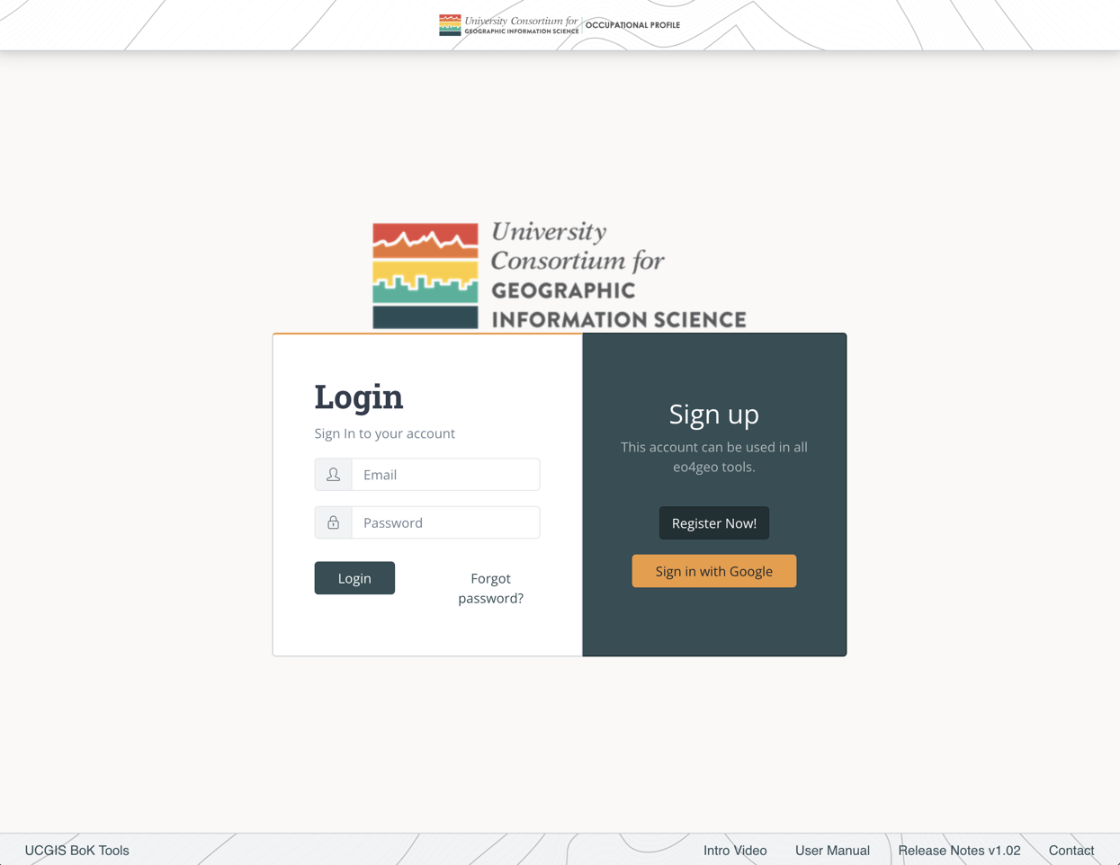

1

2

3

4

5

6

Figure 1. UCGIS Tools login page

To

#### 

create a new account

, fill in your email (1), your password (2) and repeat your password (3). The password you chose should contain at least 6 characters.

Then click the ‘Register’ button (4) and you will be immediately redirected to the Home page (Figure 2).

1

2

3

4

Figure . Register form

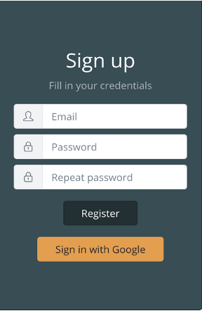

1

2

3

4

When registering, if you see the error ‘The email address is already in use by another account’, it means your email is already registered. Write your email in the login part of the form and click ‘Forgot password?’ to receive a link with instructions to recover it.

## 

## User details and organizations

After logging in, the user will be able to see his/her email address in the top navigation bar (Figure 3).



1

2

3

4

Figure 3. Navigation bar

Clicking in the email address (1) the user will be able to save his / her name and recover the password.

Clicking on the ‘Your organization’ (2) link displays every organization the user belongs to. These organizations are important in order to make collaborative edits of the content created in the tool, as users belonging to the same organizations are able to edit content from within these organizations. Also, private content within an organization is not shown to anonymous or external users, but users belonging to the same organization can see it.

To create new content the user needs to belong to at least one organization.

The ‘Home’ button (3) goes to the list page.

The ‘Log Out’ button (4) logs out the user and brings them to the login page.

To

join an organization

, click on the ‘Your organization’ button (2). In the organizations page (Figure 4) click on the dropdown to search for the desired organization. You can type to filter by text. Once you find the desired organization, select it and click Join button (2).

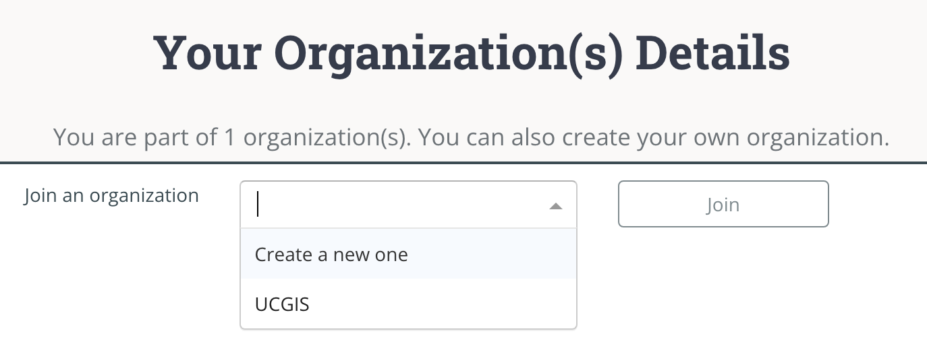

2

1

Figure 4. Dropdown in organizations page

You will be automatically added to that organization as a regular user. You can click on the

leave organization

button to be removed from it (1) (Figure 5).

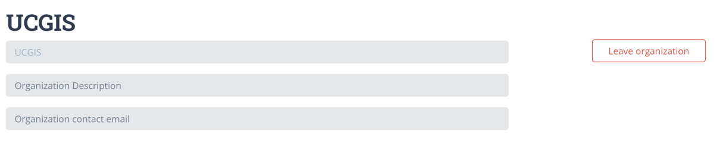

1

Figure 5. A regular user being member of an organization

If you want to

create an organization

select the ‘Create a new one’ option and click on the ‘Join’ button (1) (Figure 6). After that, you can fill in your organization name and description (2) and save changes (3) or you can

delete your organization

(4).

To help in organizing the content inside your organization you can create ‘Divisions’ under an organization. As you are the creator of the organization, that makes you ‘Admin’. As an Admin, you can

create or delete divisions

, by typing the name and ‘Add division’ button (5). They are not compulsory to be able to create content but divisions will help in organizing the content inside your organization.

You can change a user role (Admin / Regular) inside your organization by clicking the button group (6). An admin can also

remove users

(7) of an organization.

Finally, you can

add users

to your organization by typing the email address they used to log in. After your organization is created, new users can also join themselves.

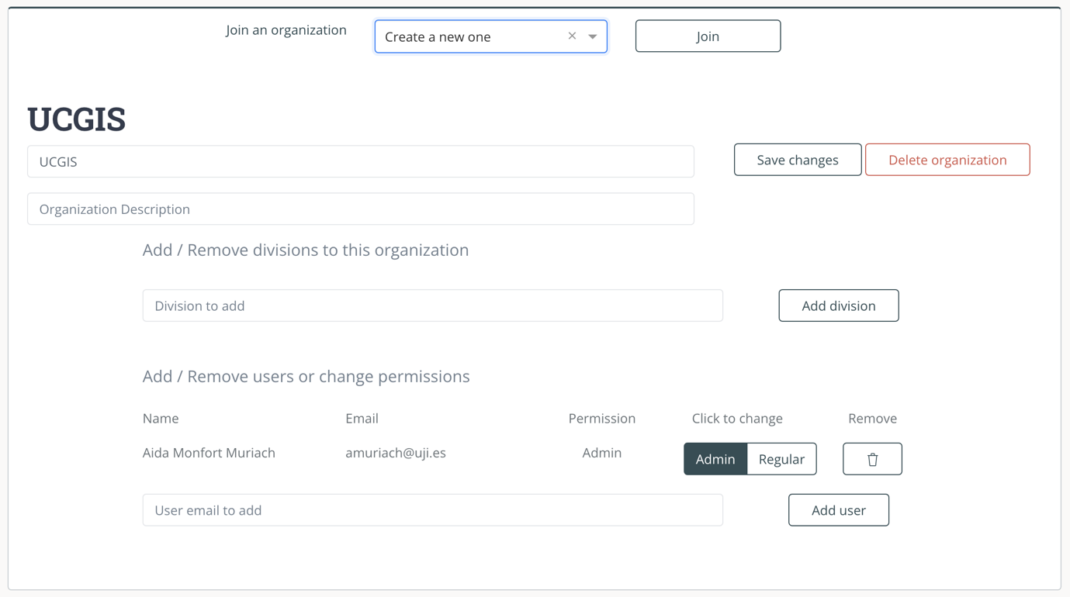

1

2

3

4

5

6

7

8

Figure 6. Organization administration

## Matching view

**Error! Reference source not found.** shows BMT’s matching view for a logged in user. If user is anonymous, BMT allows to match two BoK resources, but not to save it for later use.

To

save a match

is mandatory to save it under an organization, you can select it from the dropdown (1). To assign a Division to a match is not mandatory but can help organizing your content.

Title and description fields (2) are mandatory to save the match.

The ‘Save’ button (3) makes the match available in ‘My matches’, see section

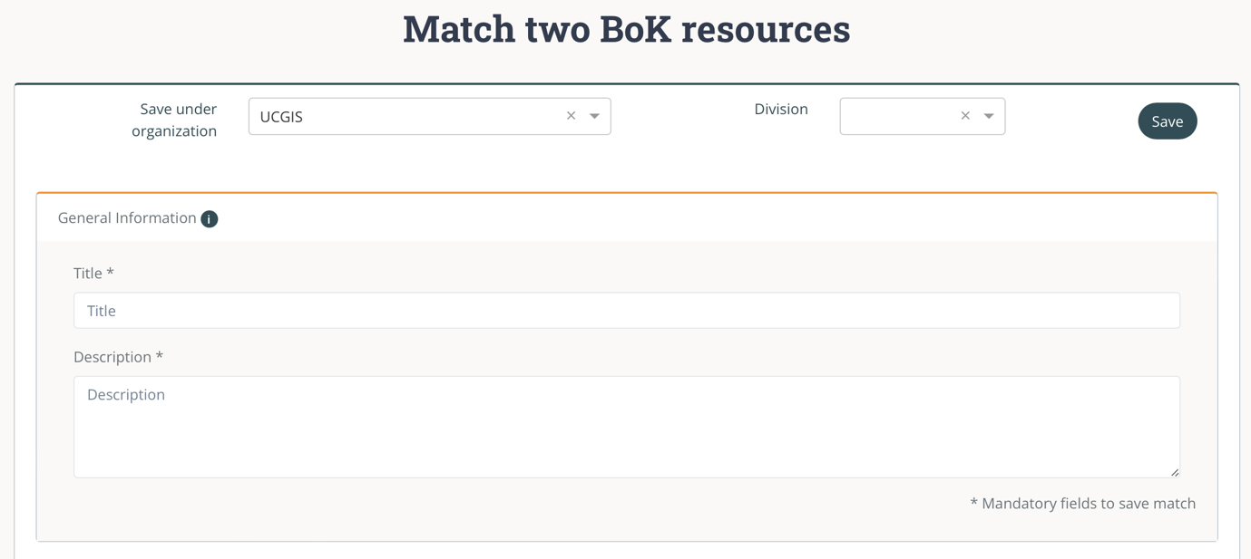

3

2

1

Figure . General information of a match

After the general information two columns of BoK annotated resources are presented (Figure 8). When a resource is selected in one column, the best matching score resource is automatically displayed in the other column.

Each column consists of three tabs: Search EO4GEO Resource (1), Custom BoK selection (2) and Upload (3). A matching could be started by choosing one of the three possibilities.

First tab (1) allows to

select from one of the EO4GEO BoK resources previosuly saved in one of the EO4GEO BoK end-user tools (CDT, JOT, OPT, BAT). The search bar (4) allows to filter the content by text. The buttons (5) allow to filter the resources depending on the type, select Educational Offers to show only content created in the Curriculum Design Tool (CDT), select Occupational Profiles to show only content from the Occupational Profile Tool (OPT), Job Offers for the Job Offer Tool (JOT), Training Material to show only the training material developed within the project, and finally, select Others to see external PDFs annotated and saved in the BoK Annotation Tool (BAT).

Results can also be sorted by the criteria using the buttons (6). Right column works the same as left column except that it has an extra sorting criterion, by matching score (7) that works only one a resource is selected on left column.

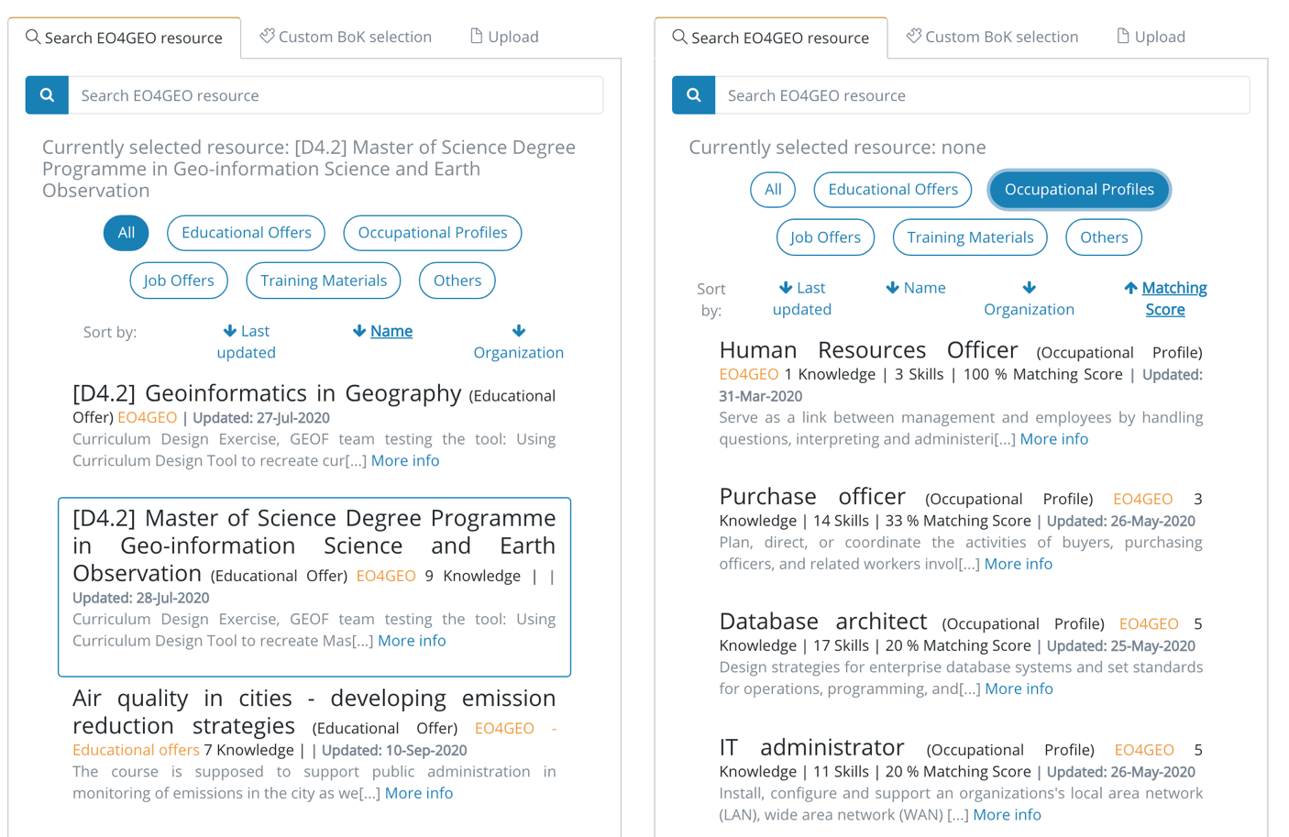

2

3

4

1

7

6

5

8

Figure 8. Resources available to match

To

select an UCGIS resource

, click on its information (8) and a blue border appears to indicate which resource is selected. Then click on another resource on right column to see the matching.

Second tab of BoK resource is to

choose a custom BoK selection

, (Figure 9), click on the ‘Select concepts from Body of Knowledge’ button (1) to open the BoK Visualizer and Search to browse the BoK either graphically, clicking on the concepts, or textually, clicking on the links to sub/superconcepts. When the desired concept is found, click on the ‘Select’ button to add it to the custom selection list and click ‘Finish’ when all desired concepts are in the list. This list can be later edited by removing the concepts clicking the ‘x’ (2).

You can clear the list of concepts by clicking the ‘Clear custom selection’ button (3).

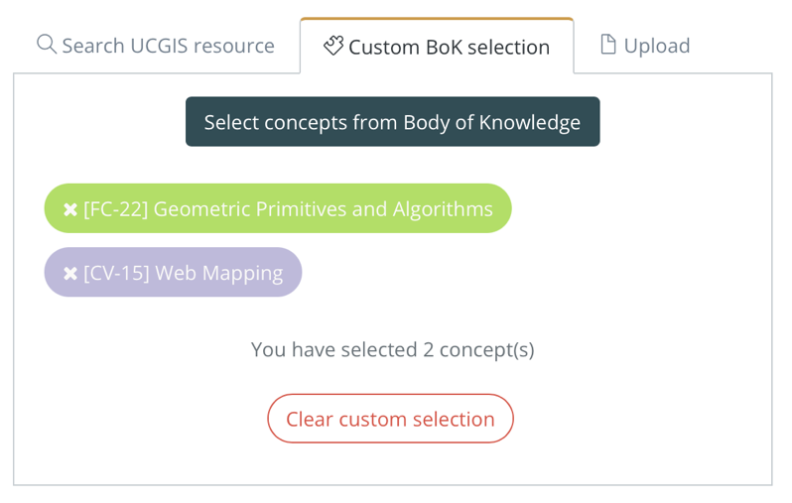

3

2

1

Figure 9. Custom BoK selection

The match is then based on the concepts selected from the BoK.

Last tab of BoK resources is to

upload an annotated PDF file

(Figure 10), click on the ‘Browse’ button (1) and choose a BoK annotated PDF file (previously annotated with BAT) to match its annotated knowledge against the other selected resource.

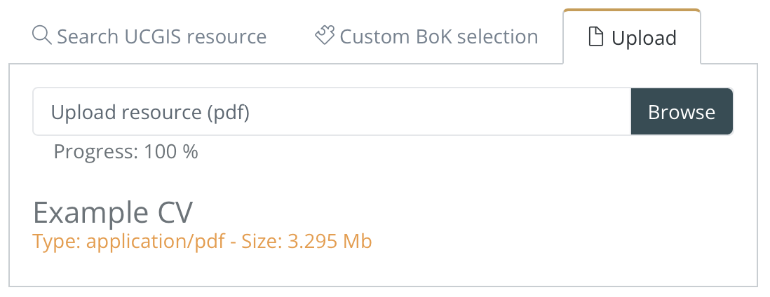

1

Figure 10. Uploading an annotated PDF file

If the PDF does not have knowledge annotated a warning is displayed.

When each column has one resource selected, the BMT shows the matching between the currently selected resources. BMT compares EQF level (Figure 11), BoK Knowledge (Figure 12) and Skills, Field of study and transversal skills (Figure 13) when available.

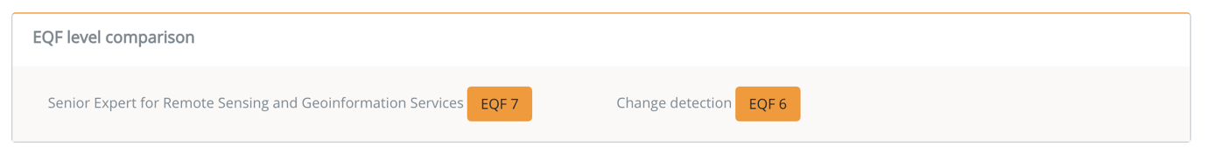

Figure 11 EQF level comparison

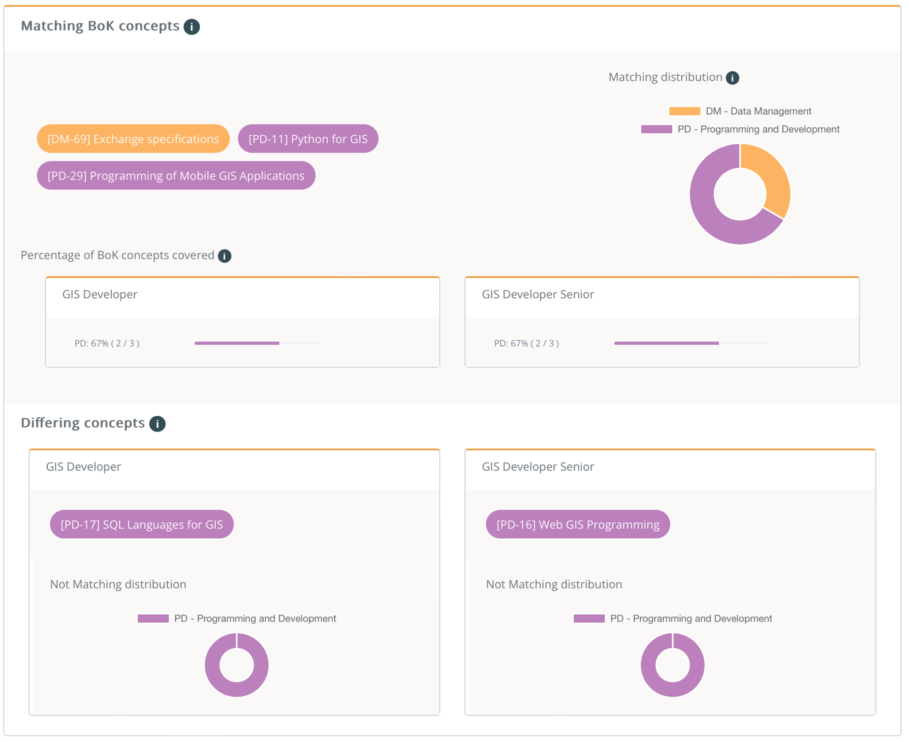

4

3

2

1

Figure 12. BoK concepts comparison

BMT shows matching and differing concepts from two resources based on the UCGIS BoK. When available, BMT shows knowledge (BoK concepts) both resources have in common (Figure 12), so the matching, (1) statistics about how many concepts in that knowledge area are covered by these common concepts are shown (2). The respective differing knowledge is also shown, therefore concepts just annotated for one of the resources (left or right) are shown (3) (4).

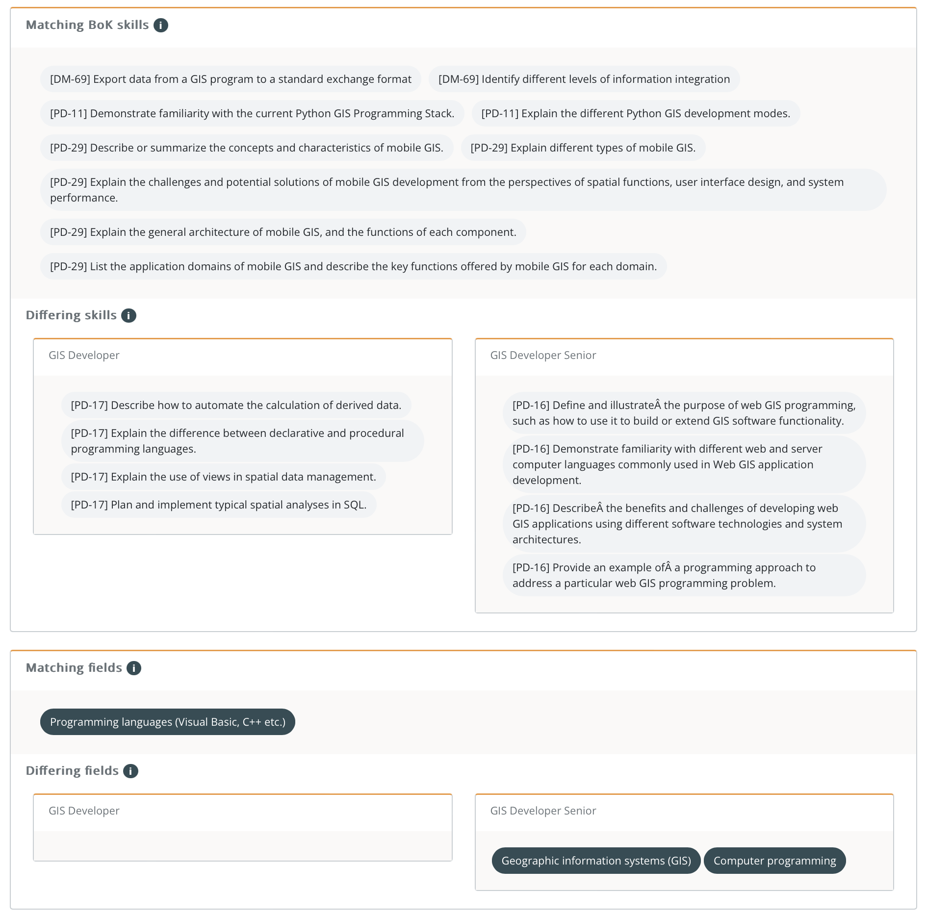

Figure 13. Skills, fields and skills compared

For BoK skills, fields and transversal skills (Figure 13) the same structure applies, common ones appear at the top of each section, and the differing ones of each of the resources compared appear in the respective column.

## My matches view

The user can check previously saved matches with ‘My matches’ button in the top menu (Figure 14).



Figure 14. Top menu

This view (Figure 15) allows users to check previously saved matches clicking on the title (1) see Detail view section for more information. These matches are only visible to the user who saved them.

To

share a match

, click the ‘Share’ button (2) and copy the link from the pop-up. Other users can view the match with the link.

To

remove a match

, click the ‘Remove’ button (3).

To

search matches

, type in the search box (4) or click on the ‘Advanced Search’ to be able to search concepts present in the match.

You can also start a new match with the ‘New match’ button (6).

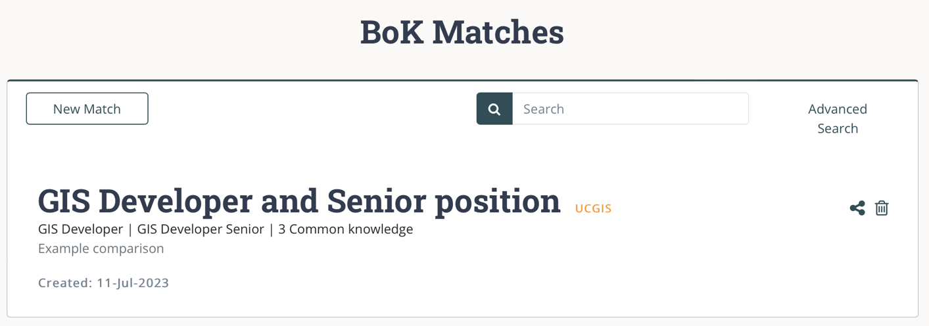

1

6

5

3

2

4

Figure 15 Annotated PDFs list

## Detail view

This view (Figure 16) shows details of a previously saved match, title and description and the matching itself. Users can share (1) and remove (2) the match from this view.

The matching refers to each of the resources compared (3) and (4) and provides links to open them to further check its details. Thus, the matching view is displayed.

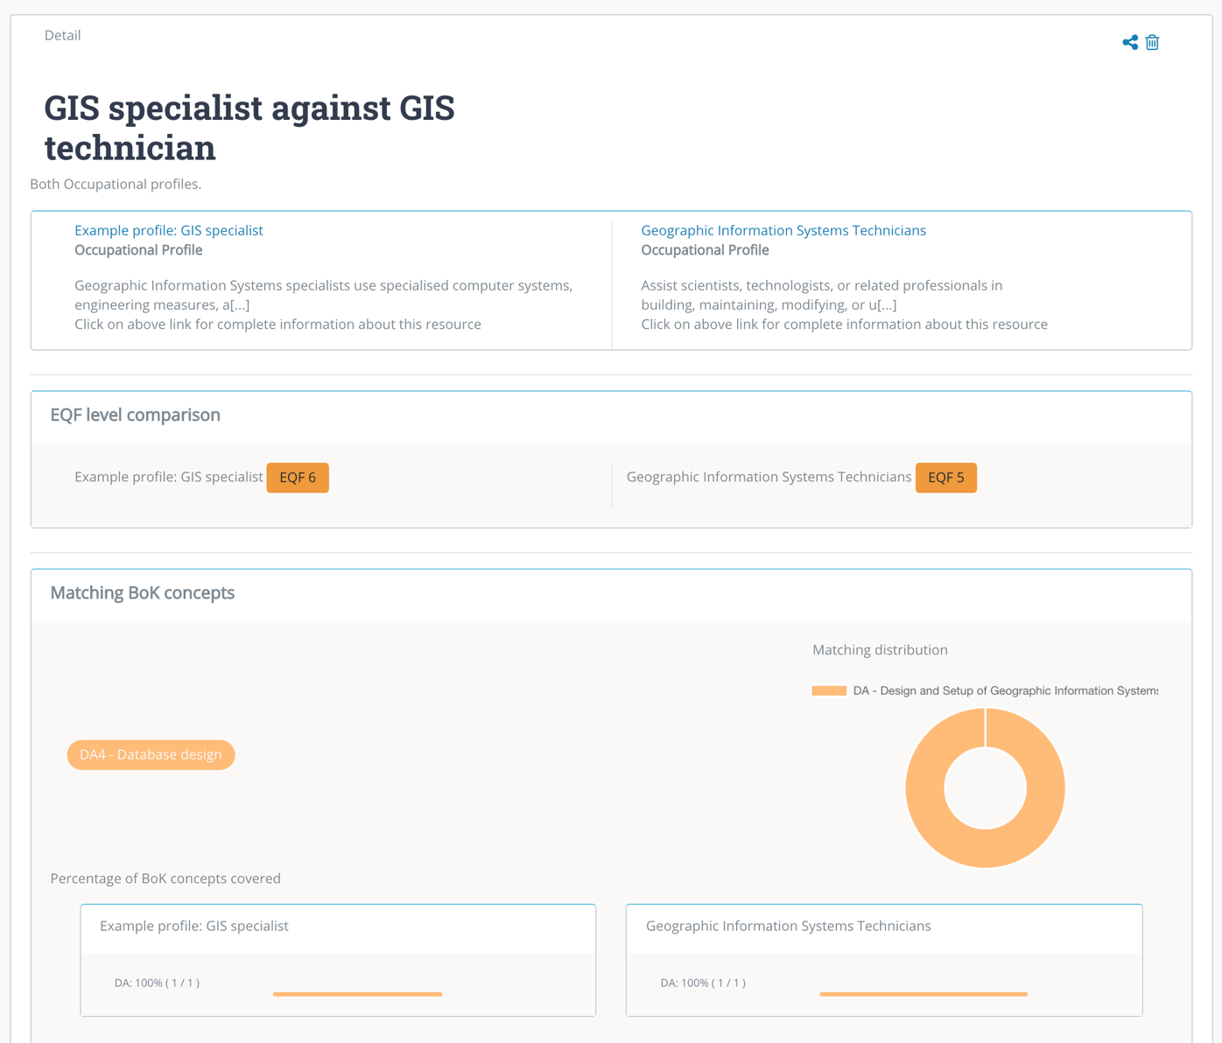

5

4

2

1

3

Figure 16 Detail view of saved match

# Glossary of terms

**BAT** BoK Annotation Tool

**CDT** Curriculum Design Tool

**ESCO.** Classification of European Skills, Competences, Qualifications and Occupations

**EQF.** The European Qualifications Framework for Lifelong Learning. The core of the EQF concerns eight reference levels describing what a learner knows, understands and is able to do, ranging from basic (Level 1) to advanced (Level 8)

<https://ec.europa.eu/ploteus/sites/eac-eqf/files/broch_en.pdf>

**Field**. Term related to a specific area of study, following the ISCED-F classification

**ISCED-F**. International Standard Classification of Education: Fields of Education and Training 2013, maintained by UNESCO.

<https://ec.europa.eu/esco/portal/escopedia/International_Standard_Classification_of_Education_58__Fields_of_Education_and_Training_2013__40_ISCED-F_41_>

**JOT** Job Offer Tool

**Knowledge.** The body of facts, principles and theories and practices that is related to a field of work or study

**OPT** Occupational Profile Tool

**Skills** means the ability to apply knowledge and use know-how to complete tasks and solve problems.

**Transversal Skills** are those typically considered as not specifically related to a particular job, task, academic discipline or area of knowledge but as skills that can be used in a wide variety of situations and work settings, since they are a combination of people skills, social skills, communication skills, character or personality traits, attitudes, career attributes, social intelligence and emotional intelligence quotients, among others, that enable people to navigate their environment, work well with others, perform well, and achieve their goals with complementing hard skills.