BoK Version management Tool (BVMT)

UCGIS Tools User guides

**Table of Content**

About 2

Tool Login 3

Comparing BoK versions 4

Publishing BoK versions 6

Manage current version(s) 6

## About

The development of BoK content is done by regularly releasing new versions. A new version is created in the Living Textbook (LTB) and exported to the URL endpoint of the BoK platform, so that the BoK content can be made available to all UCGIS BoK tools.

The [BoK Version management Tool (BVMT)](https://ucgis-tools-bvmt.web.app/#/managenew) assists in the transition from one BoK version to another by easily identifying the differences between two BoK versions, before it is published and installed as new BoK version. In this way, basic checks can be performed on entries in the new BoK, related to the use of concept codes, relationships, etc. Finally, the new BoK version can be published, which automatically makes it available in all tools. The versioning procedure (including LTB functions) to which the BVMT provides support, is described in a separate document.

The BoK Version management Tool (BVMT) is part of the UCGIS BoK tool suite, and was developed by the [Geospatial Technologies Research Group](http://geotec.uji.es/) (GEOTEC) from the Universitat Jaume I, Castelló de la Plana, Spain, with support by [University of Twente, Faculty of Geo-Information Science and Earth Observation (ITC)](http://www.itc.nl/), The Netherlands

## Tool Login

The BVMT has only registered users. A registered user with privileges needs to log in and hereby gains access to additional functionalities.

Figure 1 shows the login page from all UCGIS Bok-related tools, including BVMT. If you have an account, type in your email (1), your password (2) and click button ‘Login’ (3).

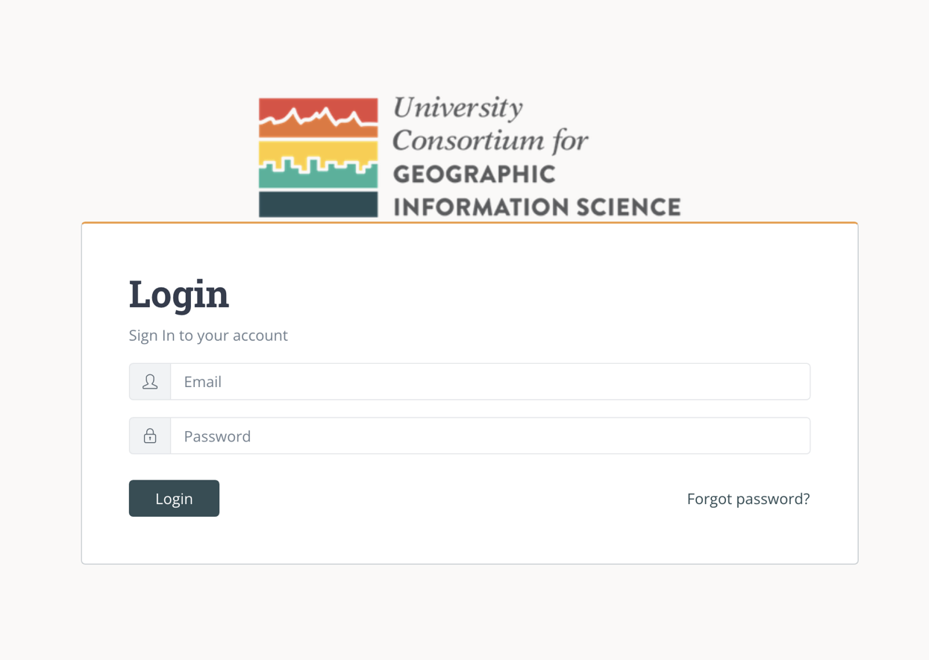

Figure UCGIS Tools login page

1

3

2

## Comparing BoK versions

Figure 2 shows BVMT’s BoK comparison view for a logged in user. It lists the totals of items in the current BoK at the left and those in the newly created BoK (“draft BoK version”) on the right. The differences are shown in brackets.

By comparing the two BoK versions, checks can be performed on whether the adding and deleting of topics in the new BoK were performed correctly. This assists in cleaning the Master BoK version in LTB.

If the LTB BoK Master needs more cleaning, select ‘Discard’ and perform the necessary edits to the BoK in LTB. If no cleaning is needed, select ‘Publish’. This will publish and install the draft BoK version as new version of the BoK, available via the BoK Visualization and Search tool and in all the BoK tools. The checks are assisted by the further information provided by the BVMT (see Figure 3-Figure 5).

Figure BVMT overview of comparison

Figure 3 shows an example of which topics in the current BoK do not appear anymore in the new BoK.

Figure BVMT Topic title and code list: Deleted topics

Figure 4 shows an example in which new topics have been added in the new BoK, but without codes.



Figure BVMT Topic title and code list: New topics

Figure 5 shows the occurrence of:

(1) A self-referencing relation (a relation that has the same source and target)

(2) Orphan topics (topics that are not connected to any other topic)

(3) Topics with duplicated codes in the draft version.

2

3

1

Figure Other BVMT check information

## Publishing BoK versions

Once the comparison has been made and the content is ready to be published, click the ‘Publish’ button (1 in Figure 6). This installs the new version of the BoK in the BoK platform, from where it is online available. Once installed, the ‘Manage current version’ view will load and show the new published version. See section Manage current version(s).

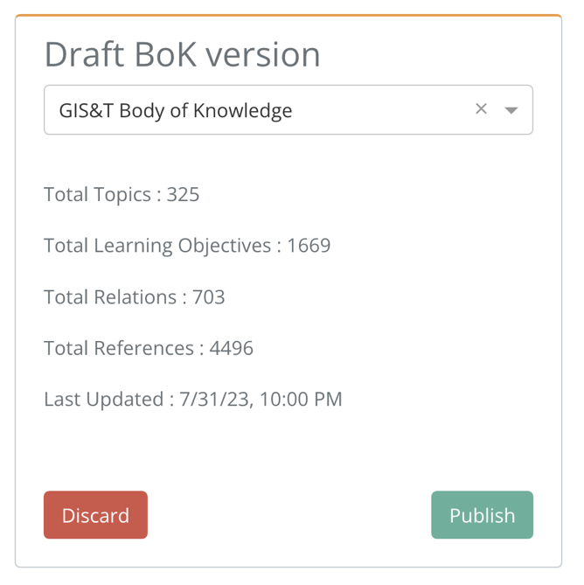

1

Figure Draft version ready to be published

## Manage current version(s)

In this view, all BoK versions currently present in the BoK platform will be listed as shown in Figure 7.

Versions are in descending date order, meaning that the first version appearing (current) is the last one published and the one which will be visualized in the [BoK Visualizer and Search](https://gistbok-bok.ucgis.org/) tool.

To delete a version, click the ‘Delete’ button (1) Figure 7. After confirming in the warning message, the current version will be deleted and the previous version will be converted to the current version. In Figure 7, version v1 would become the new current version, after the current version is deleted.

Only the current version can be deleted. If the current is the only version, it is not possible to delete it.

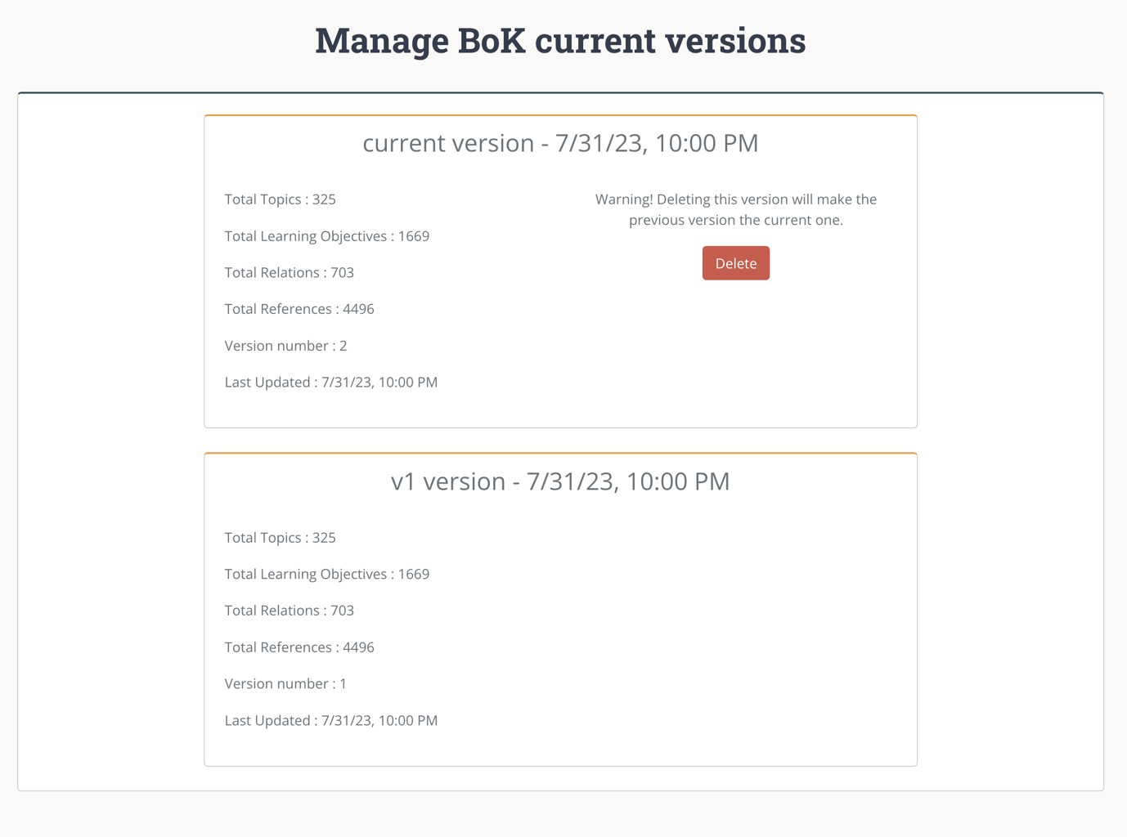

1

Figure Manage current versions view