**BoK Annotation Guidelines**

UCGIS Tools User guides

Table of Contents

1. Annotating a resource with BoK knowledge 2

2. Supported file types 3

2.1. PDF files 4

2.1.1. Programmatically generated PDF’s 4

2.1.2. Manually generated PDF’s 4

2.2. HTML 5

1. Annotating a resource with BoK knowledge

To describe properties about resources (= annotating them with BoK concepts), we use the commonly accepted and widely used W3C recommendation “Resource Description Framework” (RDF), as a data model and representation language. These RDF descriptions will annotate the entire resource, or parts of it, with BoK concepts. RDF concepts are identified using URIs (usually, a url). BoK concept can thus been seen as RDF concepts, identified using a URI (a url), which resolves to an online page containing further details on the BoK concept.

Usually, one relies on existing vocabularies – or extensions from them – to describe properties of concepts in RDF. We use the widely used Dublin Core Metadata Initiative (DCMI) Metadata Terms vocabulary[1], which is typically used to describe general properties of digital or physical resources.

These RDF descriptions will be embedded in the resource, so a resource is completely self-describing. The guidelines below describe this situation. Evidently, in line with the RDF recommendation[2], external annotations are always possible, but they are not described in this document. In this document, we use the turtle notation[3] for RDF.

We distinguish two cases, namely annotating a complete resource (for example, a job offer), or annotating a part of a resource (for example, a module of a study program).

**Annotating a complete resource**

General form (example):   
@prefix dc: <http://purl.org/dc/terms/> .  
@prefix ucgis: < https://ucgis-bok.web.app/> .  
<> dc:relation ucgis:AM .  
<> dc:relation ucgis:CP .

Whereby:

* Line 1: defines the Dublin Core metadata terms vocabulary namespace
* Line 2: defines the UCGIS vocabulary namespace
* Line 3: <> denotes the current resource
* Line 3: dc:relation , a Dublin Core relation which denotes a relationship between the current resource (<>) and an UCGIS concept (ucgis:AM, see next)
* Line 3: ucgis:AM denotes the BoK concept annotating the current resource, using the ucgis namespace. As such, ucgis:AM resolves to the URI <https://ucgis-bok.web.app/AM>.
* Line 4: similar as line 3, denotes a relationship between the current resource and ucgis:GC concept, i.e., the current resource is annotated with ucgis:CP.
* Note: in a similar way as line 3 and 4, as many annotations as desired can be added.

In other words, the above RDF statements describe that the current resource (e.g., a specific job offer) is annotated with the BoK concept name “Analytical Methods” with URI <https://ucgis-bok.web.app/AM> and “Computing Platforms” with URI <https://ucgis-bok.web.app/CP>.

**Annotating part of a resource**

General form:   
@prefix dc: <http://purl.org/dc/terms/> .  
@prefix ucgis: < https://ucgis-bok.web.app/> .  
<> dc:hasPart [ dc:type "Module";   
 dc:title "Mathematics";  
 dc:relation ucgis:AM;  
 dc:relation ucgis:GC ] .

Whereby:

* Line 1: defines the Dublin Core metadata terms vocabulary namespace
* Line 2: defines the UCGIS vocabulary namespace
* Line 3: <> denotes the current resource
* Line 3: dc:hasPart denotes the current resource has a certain part ([ … ] – see next)
* Line 3: […] denotes an blank node, about which we can make statements ( … - see next)
* Line 3: dc:type "Module" denotes that the blank node (i.e., the part of the current resource we are describing) has a type, which is “Module”.
* Line 4: dc:title "Mathematics" denotes that the blank node (i.e., the part of the current resource we are describing) has a title, which is “Mathematics”.
* Line 5: dc:relation ucgis:AM denotes that the blank node (i.e., the part of the current resource we are describing) is annotated with the BoK concept ucgis:AM, which resolves to the URI <https://ucgis-bok.web.app/AM>.[4]
* Line 6: dc:relation ucgis:CP denotes that the blank node (i.e., the part of the current resource we are describing) is annotated with the BoK concept ucgis:GC, which resolves to the URI <https://ucgis-bok.web.app/CP>.
* Note: in a similar way, as many annotations as desired can be added.

In other words, the above RDF statements describe that the current resource (e.g., a specific study program) has a certain part. This part is a “Module” with title “Mathematics”, and is annotated with the BoK concept with name “Analytical Methods” and URI <https://ucgis-bok.web.app/AM>, and BoK concept with name “Computing Platforms” and URI <https://ucgis-bok.web.app/CP>.

1. Supported file types

PDF files

In UCGIS, we will use PDF files as universal format for any resource, which can be annotated with BoK knowledge (= BoK concept). In particular, in UCGIS we will use the ‘Subject’ metadata field of the PDF file to store the RDF descriptions, as this is the field which allows the longest description.

### Programmatically generated PDF’s

When programmatically generating a PDF, BoK annotations can be added with the jsPDF[5] library as seen in the example below, in the subject field.

const doc = new jsPDF();

doc.page = 1;

doc.setProperties({

title: 'Mathematics',

subject: '@prefix dc: <http://purl.org/dc/terms/> .' +

'@prefix ucgis: <https://ucgis-bok.web.app/> .' +

'<>dc: hasPart[dc: type "Module";' +

'dc: title "Mathematics";' +

'dc: relation ucgis: AM;' +

'dc: relation ucgis: CP ] .',

author: 'UCGIS Tools',

keywords: 'ucgis, curriculum design tool',

creator: 'Curriculum Design Tool'

});

### Manually generated PDF’s

If there is no possibility to add the metadata programmatically to the PDF, it is possible to add it manually with [Adobe Acrobat Pro](https://get.adobe.com/es/reader/) under the menu File > Properties.

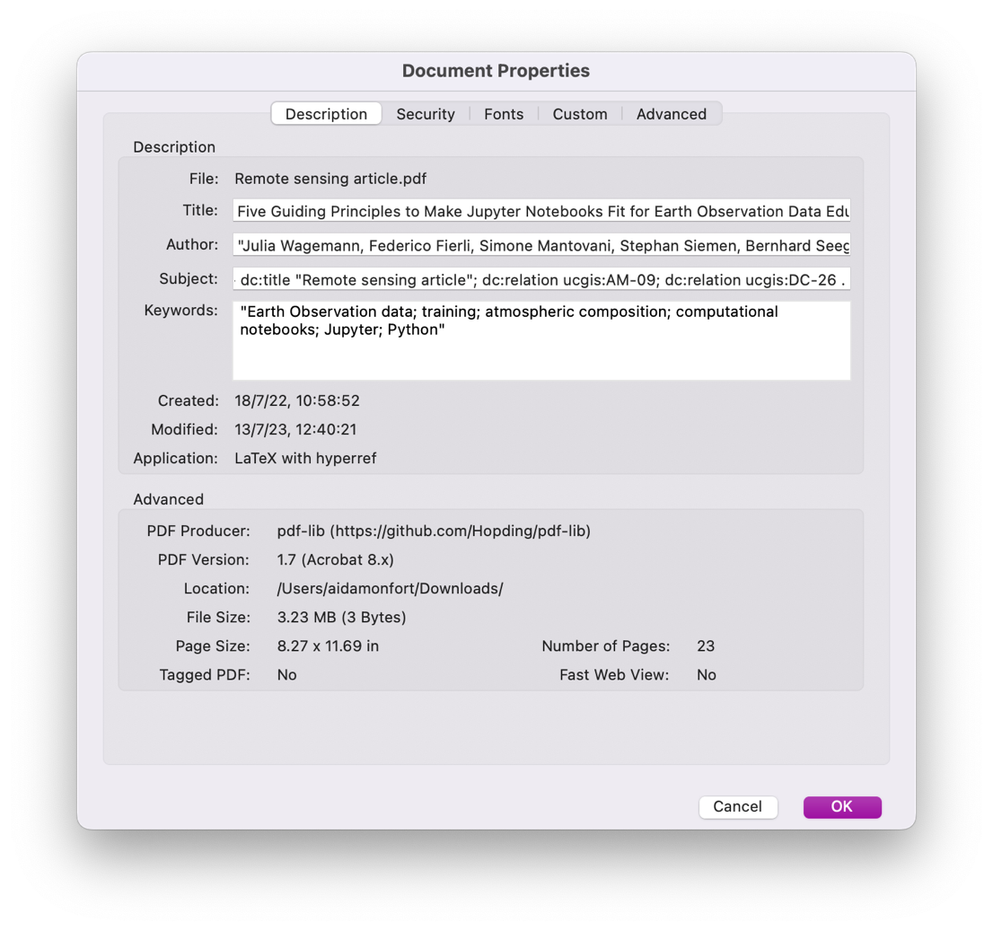

The input fields are editable, type in subject the annotated BoK knowledge and save the file.

If the Pro version of Adobe is not available, you can use alternative free web tools as PDFCandy[6] which allows you to upload a PDF, change the metadata and save it again.

HTML

RDFa[7] is a W3C recommendation which can be used to embed RDF statements in an HTML document. This allows the descriptions as described in Section 1 to be embedded as attributes in HTML files.

1. https://www.dublincore.org/specifications/dublin-core/dcmi-terms/
2. https://www.w3.org/RDF/
3. https://www.w3.org/TR/turtle/
4. See previous, “Annotating a complete resource”, for a more detailed description.
5. https://parall.ax/products/jspdf
6. <https://pdfcandy.com/edit-pdf-meta.html>
7. https://www.w3.org/TR/html-rdfa/