# Curriculum Design Tool (CDT)

UCGIS Tools User guides

Table of Content

How to start working with CDT 3

Tools Login & Registration 4

forgot your password 4

create a new account 5

User details and organizations 5

join an organization 6

leave organization 6

create an organization 6

delete your organization 6

create or delete divisions 7

remove users 7

add users 7

Home page 8

share an educational offer 8

duplicate an educational offer 9

edit an existing educational offer 9

remove an educational offer 9

create a new (blank) educational offer 9

default search 9

filter contents 9

advanced search 9

search by BoK concepts 9

Educational offer detail view 10

graphical view 10

textual view 11

Create or Edit a Curriculum 11

create child offer 11

explore existing educational offers 11

reuse existing educational offers 12

add content to your offer 13

explore the BoK 13

re-use content from the BoK 14

annotated concepts 15

select the study area(s) 15

add custom learning outcomes 16

add transversal skills 16

promote a unit 17

Glossary of terms 18

**About**

The [Curriculum Design Tool (CDT)](https://ucgis-tools-cdt.web.app/) allows users to create, edit and find educational offers (also known as curricula) in the field of Earth Observation and Geographic Information. Therefore, is mainly addressed to Academia and training providers. Educational offers are linked to the UCGIS Body of Knowledge (BoK) for EO/GI-specific concepts, since CDT allows the reuse of concepts and learning outcomes contained in the UCGIS BoK.

The Curriculum Design Tool is part of the UCGIS tool suite, and was developed by the [Geospatial Technologies Research Group](http://geotec.uji.es/) (GEOTEC) from the Universitat Jaume I, Castelló de la Plana, Spain.

## How to start working with CDT

CDT allows user to create any curriculum item: study program, module, course or lecture.

The hierarchy of the items is as follows:

Study program, *composed of*

Module (s)*, composed of*

Course (s), *composed of*

Lecture (s)

Where:

* A Study program is a curriculum of two or more courses (grouped or not in Modules) that is intended to lead to a degree, diploma, or certificate.
* A Module is a collection of courses grouped because courses are run over the same year or semester or tackle the same topic.
* A Course is a unit of teaching, a set of lectures or a plan of study on a particular subject, usually leading to an exam or qualification.
* A Lecture is a formal talk on a serious subject intended to display information or teach people about a particular subject (also known as lessons or classes)

CDT is versatile and provides full modularity. Therefore, - and because of different educational systems in different European countries - a user can start creating content from every level of the hierarchy and can skip any level. Thus, an educational offer can be started from a study programme or a complete academic degree, which will be composed by modules, courses and lectures, or from simply a single lecture.

## Tools Login & Registration

The CDT works in a view mode for anonymous users, and extended functionality is added for logged in users. An anonymous user directly sees public Educational Offers, without being logged in (See Home page section).

Figure 1 shows the login page from all UCGIS BoK-related tools, including CDT. If you have an account, type in your email (1), your password (2) and click button ‘Login’ (3).

If you

forgot your password

, type in your email (1) and click ‘Forgot password?’ (4). You will receive an email to recover your password. If you don’t have an account click Register Now! (5) and proceed to Figure 2 Registration form. You can also sign in with your Google account (6).

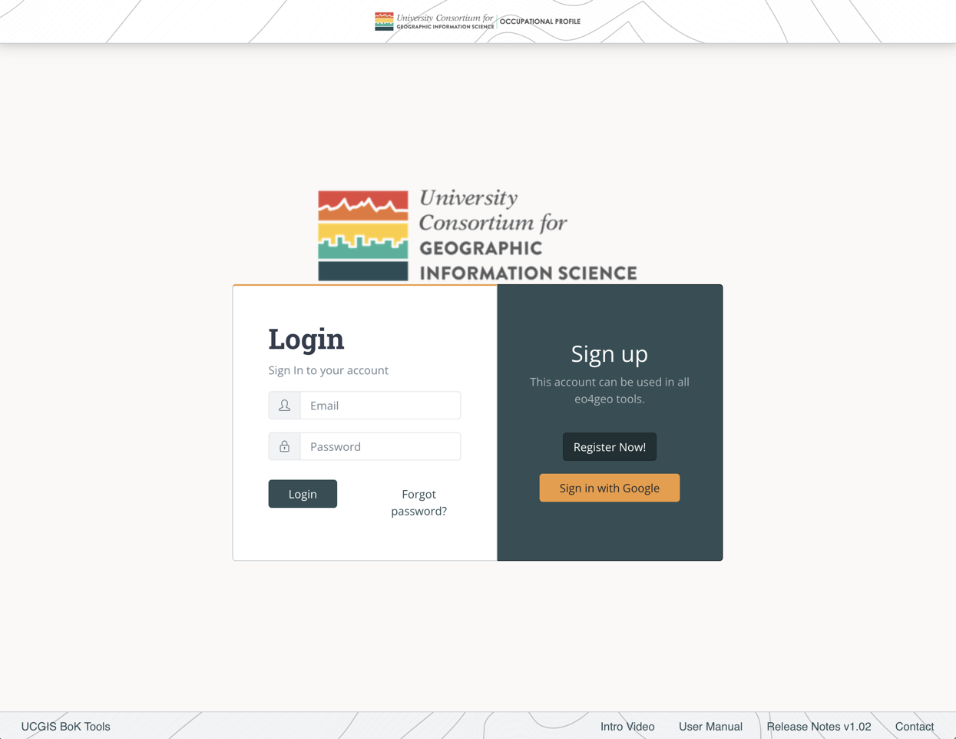

1

2

3

4

5

6

Figure . UCGIS Tools login page

To

create a new account

, fill in your email (1), your password (2) and repeat your password (3). The password you chose should contain at least 6 characters.

Then click the ‘Register’ button (4) and you will be immediately redirected to the Home page (Figure 2).

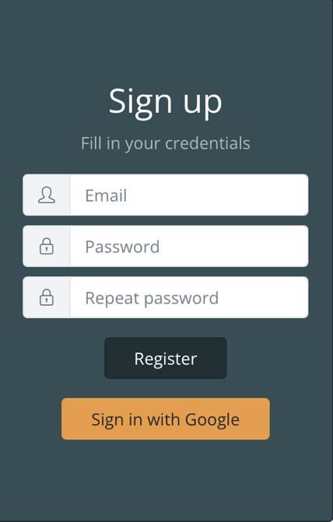

1

2

3

4

Figure . Register form

When registering, if you see the error ‘The email address is already in use by another account’, it means your email is already registered. Write your email in the login part of the form and click ‘Forgot password?’ to receive a link with instructions to recover it.

## User details and organizations

After logging in, the user will be able to see his/her email address in the top navigation bar (Figure 3).



4

3

2

1

Figure 3. Navigation bar

Clicking in the email address (1) the user will be able to save his / her name and recover the password.

Clicking on ‘Your organization’ (2) the list of organizations a user belongs to is displayed. These organizations are important in order to make collaborative edits of the content created in the tool, as users belonging to same organizations are able to edit content from within this organizations. Also private content within an organization is not shown to anonymous or external users, but users belonging to the same organization can see it.

To create new content the user needs to belong to at least one organization.

The ‘Home’ button (3) goes to the list page.

The ‘Log Out’ button (4) logs out the user and brings them to the login page.

To

join an organization

, click on the ‘Your organization’ button (2). In the organizations page (Figure 4) click on the dropdown to search for the desired organization. You can type to filter by text. Once you find the desired organization, select it and click Join button (2).

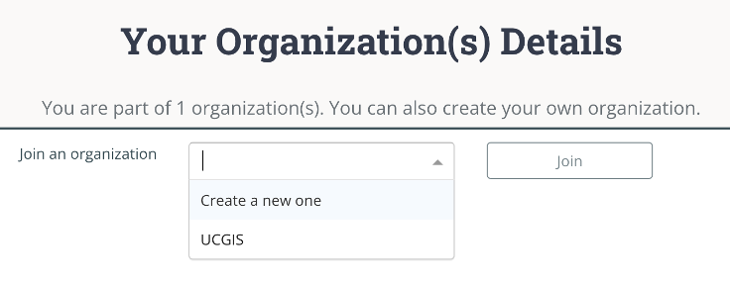

2

1

Figure 4. Dropdown in organizations page

You will be automatically added to that organization as a regular user. You can click on the

leave organization

button to be removed from it (1) (Figure 5).

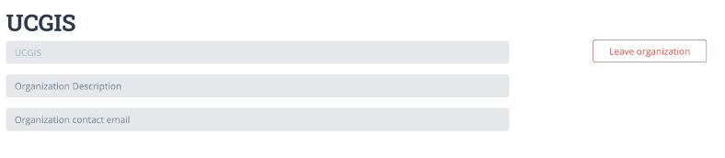

1

Figure 5. A regular user being member of an organization

If you want to

create an organization

select the ‘Create a new one’ option and click on the ‘Join’ button (1) (Figure 6). After that, you can fill in your organization name and description (2) and save changes (3) or you can

delete your organization

(4).

To help in organizing the content inside your organization you can create ‘Divisions’ under an organization. As you are the creator of the organization, that makes you ‘Admin’. As an Admin, you can

create or delete divisions

, by typing the name and ‘Add division’ button (5).

You can change a user role (Admin / Regular) inside your organization by clicking the button group (6). An Admin can also

remove users

(7) of an organization.

Finally, you can

add users

to your organization by typing the email address they used to log in. After an organization is created, new users can also join themselves.

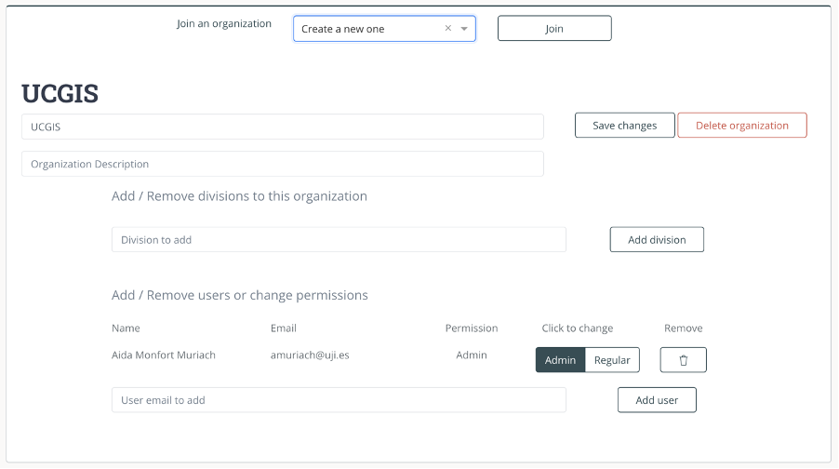

7

6

8

5

4

3

2

1

Figure . Creating a new organization

## Home page

Figure 7 shows CDT’s home page with the list of Educational Offers available in the tool (1). Name, hierarchy of the offer, organisation under which the offer was created, affiliation, its description, EQF level and last updated date is shown per each offer listed. An educational offer can be public or private.

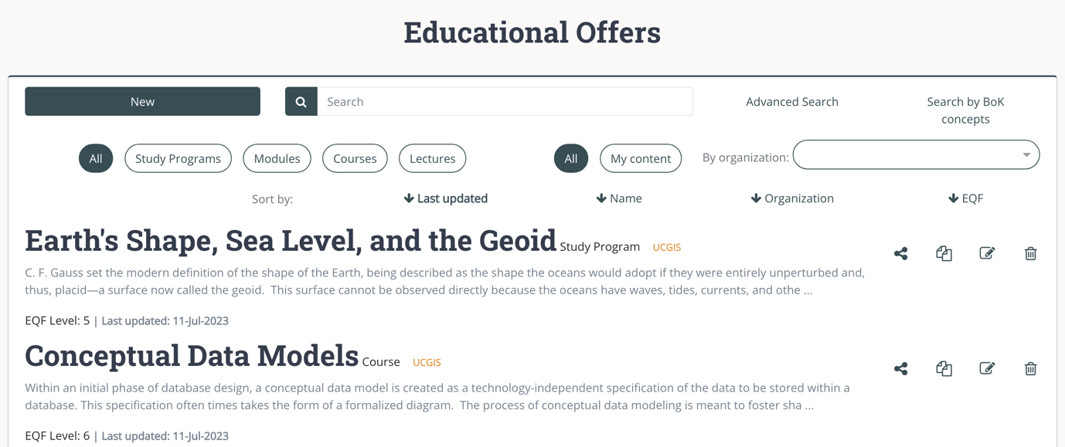

8

7

6

5

4

2

3

1

Figure . Home or list view of the CDT

Each educational offer has a toolbox menu (2), in which the user can find the following options from left to right: share, duplicate, edit and delete. Some actions may be disabled depending on the type of user (anonymous or logged in), see Figure 8.

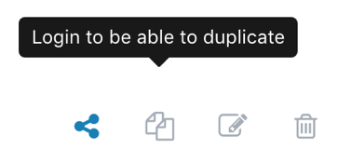

Figure . Toolbox with some actions disabled as in the anonymous view

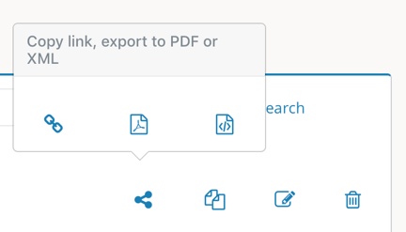

Figure . Options to share an curricula

To

share an educational offer

, click the ‘Share’ option and select one of the alternatives (from left to right) ‘copy link’, ‘export to pdf’ or ‘export to xml’ format (Figure 9).

To

duplicate an educational offer

, the ‘Duplicate’ option creates a new offer which is prefilled with all information from the original offer. You can then edit this information, rename the educational offer and save it. This new offer is owned by you, so you can later modify it.

To

edit an existing educational offer

, the ‘Edit’ option allows the user to modify those offers he/she previously created. Finally, the ‘Delete’ option allows to

remove an educational offer

. Educational offers created by other users out of your own user organizations cannot be edited nor deleted.

To

create a new (blank) educational offer , click the ‘New’ button (3), this button is only active when the user is logged in.

Educational offers can be filtered by text typing in the search box (4). The

default search

looks for the text typed in title and description of the educational offers and filters according to it.

To

filter contents

by its level in the hierarchy

(study programme, module, course or lecture) please select the desired level in the buttons group (5), the list will show then only the items created under the selected level.

To

filter contents by who created them (all, your content or an specific organization) please select the desired option in the buttons group (6) or in the organizations dropdown, the list will show then only the items created under the selected organization.

If you also need to search by ‘Affiliation’, ‘Knowledge annotated’, ‘Learning outcomes’ or ‘Field of study’ use the ‘

advanced search

’ button (7). Then, enable the options you want to search in by clicking on each slider and type in your search. Educational offers will be filtered according to your defined search criteria.

The CDT last search criteria is ‘

search by BoK concepts

’ (8) , if you want to explore the BoK and select one or more concepts to filter the educational offers, with search by concept you can do so. Click the link ‘Search by BoK concepts’ and the BoK Visualiser and Search component will be open to explore and search. When you find the required concept, select it and click on ‘Finish’ to show the filtered results or continue searching to refine the results.

## Educational offer detail view

The user can see an educational offer by clicking its title (Figure 10). In the detailed view, the screen is divided in two parts: graphical view (1) and textual view (2).

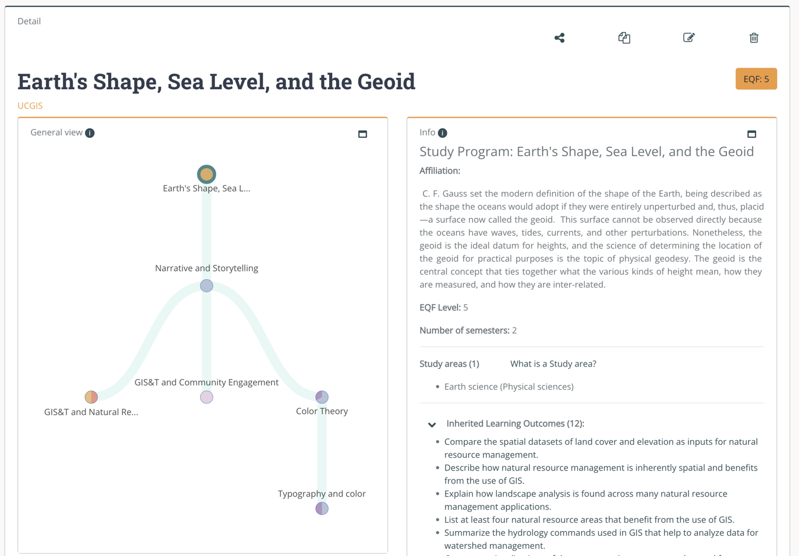

3

2

1

Figure 10. Detail view of an educational offer

The

graphical view

(1) is a visual representation of an educational offer created. It was designed to help the user during the description of an offer and to navigate through the content using an interactive graphic, where each node can be clicked to see its associated information on the textual view (2).

The graphic view is composed by nodes and links. A node can be a Study programme, Module, Course or Lecture, depending on from which level of the hierarchy a user started an educational offer (see ‘How to start working with CDT’ section as reference). The upper node represents the starting point of an educational offer, and all other nodes are its children. Links represent the relation between nodes, meaning parent/children relation. For instance, if a user creates a Module, the Module will be in the upper level, Courses at the middle level and Lectures at the lowest level.

You can hide or show a node’s links and associated nodes by clicking on it twice.

Colours in the nodes give an indication of the composition, in terms of UCGIS BoK working groups.

The right side of the screen (2) contains the

textual view

of an educational offer.

Whereas the graphical view provides an overview of the whole educational offer, the information shown in textual view refers to only one node. Clicking the different nodes in the graphical view will update the information in the textual view. Different fields describing the node are shown depending on its level on the hierarchy. Some of these fields can be expanded or contracted with the arrows present at the left of the field’s name (3).

## Create or Edit a Curriculum

When clicking the ‘New’ button an information page is displayed before starting the edits. (see section How to start working with CDT)

In this page the starting point of the educational offer should be selected using the dropdown (Figure 11).

If the logged in user does not belong to any organization, it will need to create or join one as explained in the User details and organizations section.

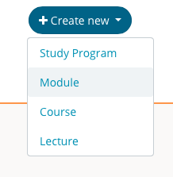

Figure 11. Dropdown to select starting point of educational offer

Once the starting level is selected, the edit view is shown. In this view the user is able to fill in all details corresponding to the educational offer and save them under an organization / division.

The top menu (Figure 12) allows to

create child offer

nodes of the current selected node, by clicking the ‘Create new’ button (1) and selecting the desired level. Only lower levels will be active, as only lower levels can be children of your selected node.

Apart from creating new nodes, you can

explore existing educational offers

to reuse and customise them. By clicking the ‘Explore existing educational offers’ button (2), the user can add them as children of the current node. (See section about how to reuse existing educational offers)

You can save at any point of your edits with the ‘Save’ button or when you finish editing you can click the ‘Save and Exit’ button (3) to go directly to the List view.

By default, a job offer is saved as ‘Public’. If you want to keep your content ‘Private’, you can turn off the visibility switch (4) before saving. Remember that other members of your organization will be able to see it even if it’s private.

In order to be able to save, an organization must be selected (5), by default the first one is selected but it can be changed. Optionally a division can also be selected (6) to keep your content better organized. Division is not mandatory.

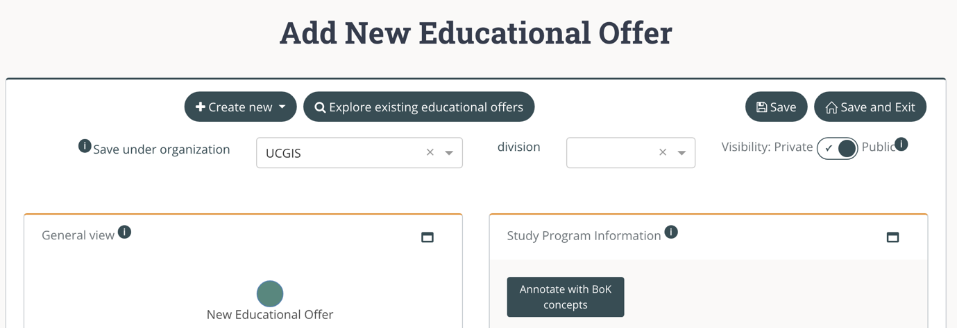

6

5

4

3

2

1

Figure 12. Edit view of CDT

To

reuse existing educational offers

a side view with content appears (Figure 13). This is the content that can be added to your offer as a child of the current selected node. You can filter by type of content clicking on the desired type (1) and you can search typing in the search box (2).

You can close this view with the ‘Close’ button (3).

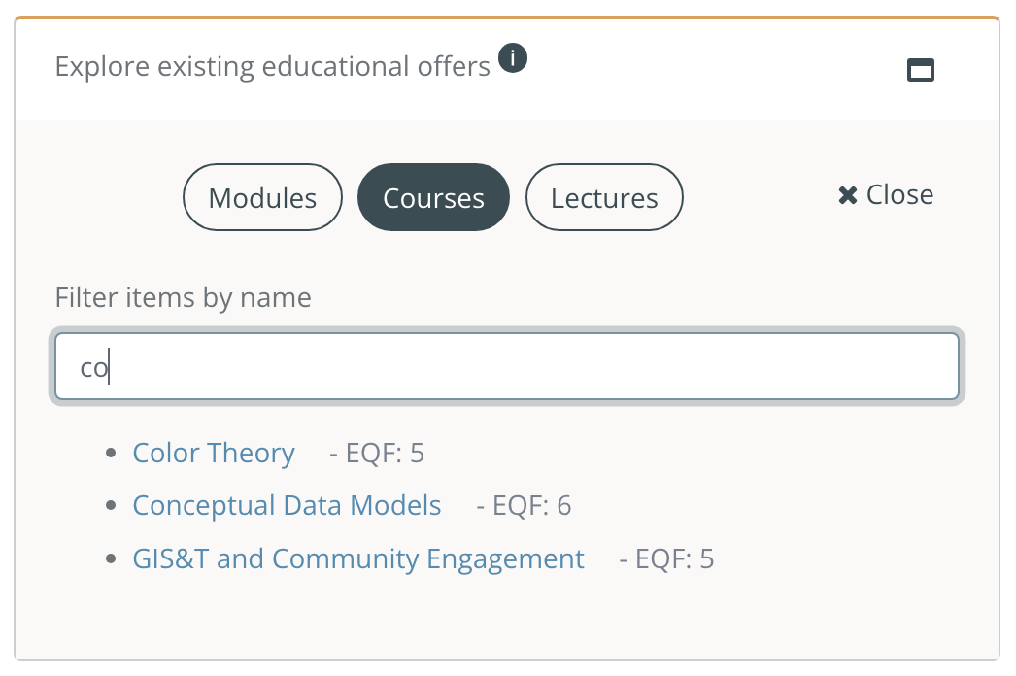

2

3

1

Figure 13. Reusing educational offers

Once the desired content is found click on the name to see full details (Figure 14), if you want to add it to your educational offer click on the ‘Add to my educational offer’ button (1), it will be automatically added to your current selected node including all information it contains. Then you can go back (2) to close this view.

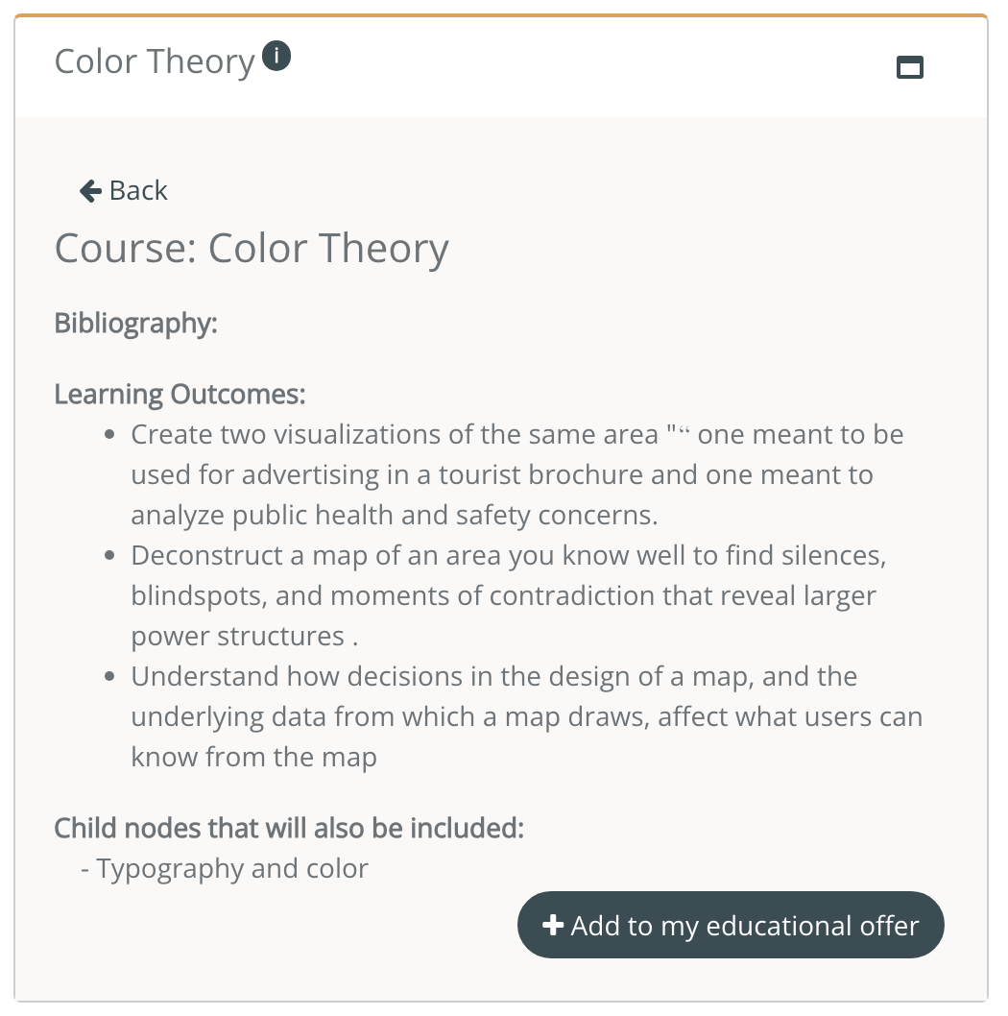

2

1

Figure 14. Detail of a course when exploring existing content

To

add content to your offer

you can directly type your own information in the fields or you can reuse content from the BoK, simply clicking on the buttons that allow to do so. For example to reuse BoK content in the title of your educational offer, you can click on the ‘Re-use BoK title’ button (1) to open the BoK Visualizer and Search (Figure 15) and select a title of a concept that matches your offer. Each field contains a tooltip that helps you understand the information to be filled in in each of the fields.

BoK Visualizer and Search component (Figure 15) allows to navigate graphically and textually to

explore the BoK

and to search by typing in the search field (1) for concepts matching your search. Once you find a suitable concept, click on ‘Details’ (2) to see full concept details and click the ‘Re-use’ button at the bottom to select the concept information.

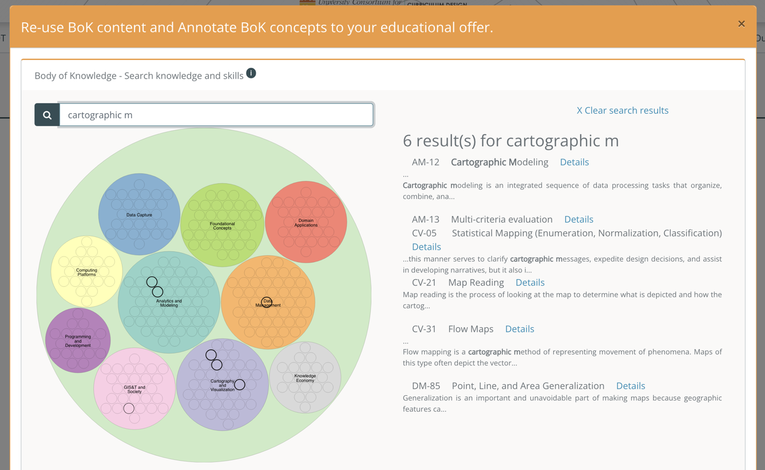

2

1

Figure 15. BoK Visualizer and Search

After re-using a concept, the BoK visualizer closes and the text is placed into the field, this text can be edited afterwards.

You can

re-use content from the BoK

(Figure 16) for the title (the BoK concept title), the description (the BoK concept description) (2), the learning outcomes (the BoK concept demonstrable skills), the bibliography (the BoK concept source documents) or you can set a concept to be a prerequisite for your current selected node.

Re-using content from the BoK creates a link between your offer and the BoK concept you selected, which allows comparison of information contained in the [UCGIS tools](https://ucgis-tools.web.app/). These links are known as annotations.

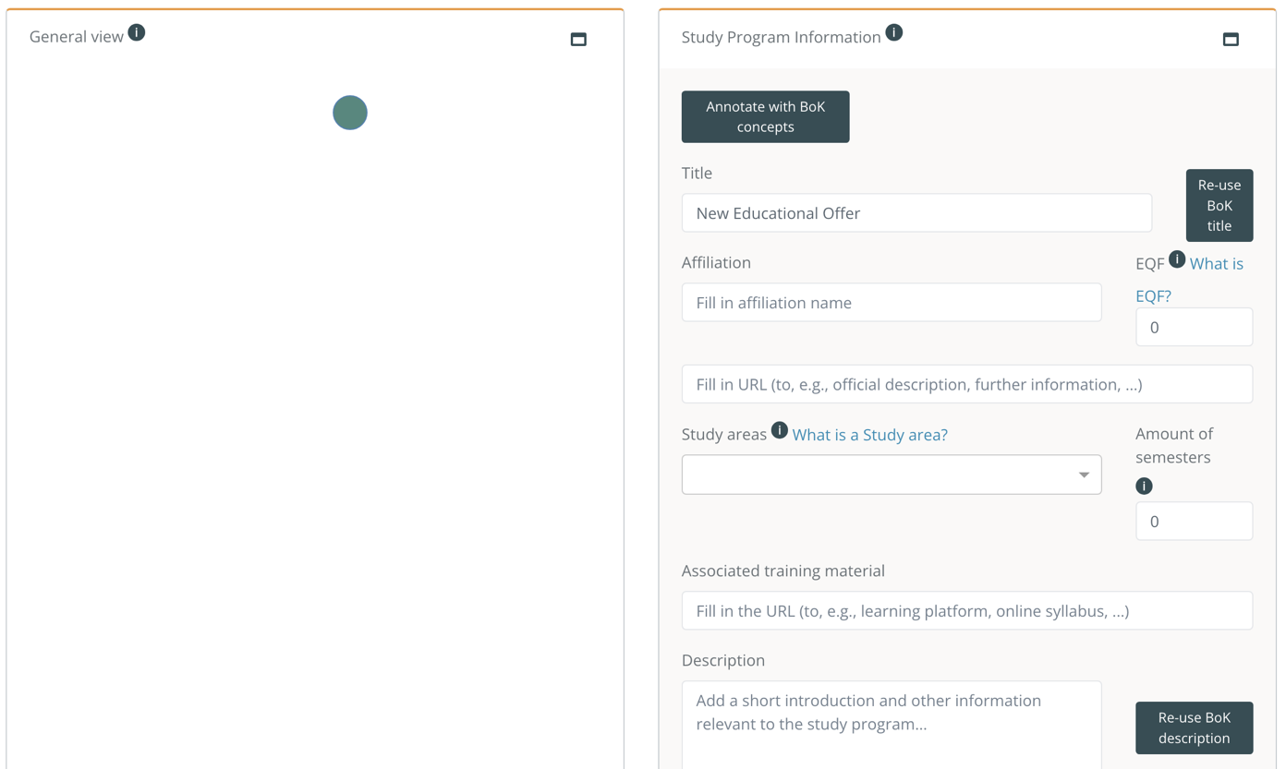

2

1

Figure 16. Editing an educational offer

Every time content from the BoK is re-used the concept gets annotated to the educational offer (Figure 17), you can see a list of

annotated concepts

next to the ‘Annotate with BoK concepts’ (1). This list can be edited, you can remove an annotation by clicking on the ‘x’ button next to it (2), and you can add more annotations if needed, even if no content is re-used with the ‘Annotate with BoK concepts’ button (3), which open the BoK Visualizer and Search and allows you to select more concepts to annotate.

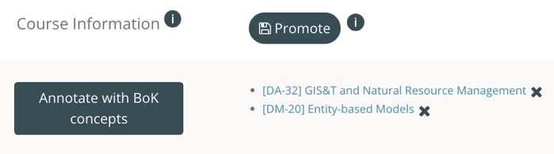

3

2

1

Figure 17. Annotated concepts in the educational offer

Click in the dropdown to

select the study area(s)

related to the educational offer. These are the ‘list of the Fields of Education and Training by [UNESCO’s ISCED-F](https://ec.europa.eu/esco/portal/escopedia/International_Standard_Classification_of_Education_58__Fields_of_Education_and_Training_2013__40_ISCED-F_41_). Type to search by name of the Field and select the most suitable one(s).

After one are is added, it can be removed with the ‘x’ button (Figure 18).

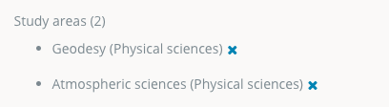

Figure 18. List of study areas

As mentioned before, learning outcomes can also be reused from associated learning outcomes/skills present in BoK concepts. Once you select a BoK concept all its learning outcomes/skills are added (Figure 19). However, this list of learning outcomes can be customized by removing them with the ‘x’ button (1). Learning outcomes can also be custom if they are not found in the BoK. To

add custom learning outcomes

type it in the text field (2) according to the guidelines (3) and click ‘Add custom LO’ button. Clicking in a linked BoK-learning outcome opens the BoK concept it belongs to. Custom learning outcomes are not linked.

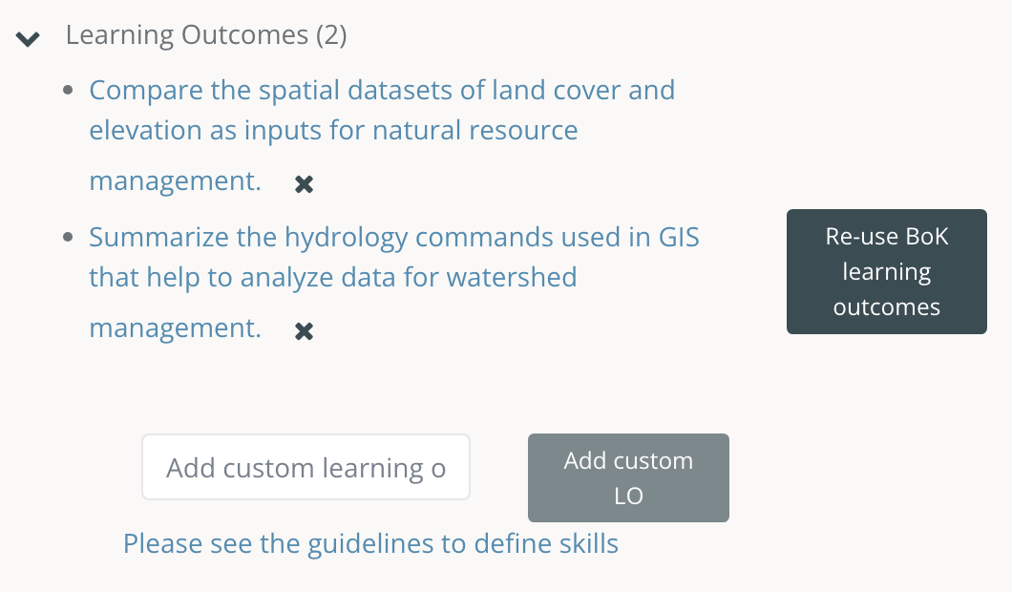

3

2

1

Figure 19. Learning outcomes

To

add transversal skills

(Figure 20) they should be selected from a closed list that contains a selection of skills from the ESCO classification (1). Typing in the text box filters in the list. Clicking on the switch (2) allows a full search on all ESCO skills. If a specific transversal skill is not found, this can be added as a custom skill, by typing it in custom skill text box (3) and then clicking the ‘Add custom transversal skill’ button. To remove a transversal skill, click the ‘x’ symbol and the list will be updated (4). Linked (in blue) transversal skills are the ones coming from the ESCO list, whose links open the related ESCO skill page, whereas those in grey are custom transversal skills.

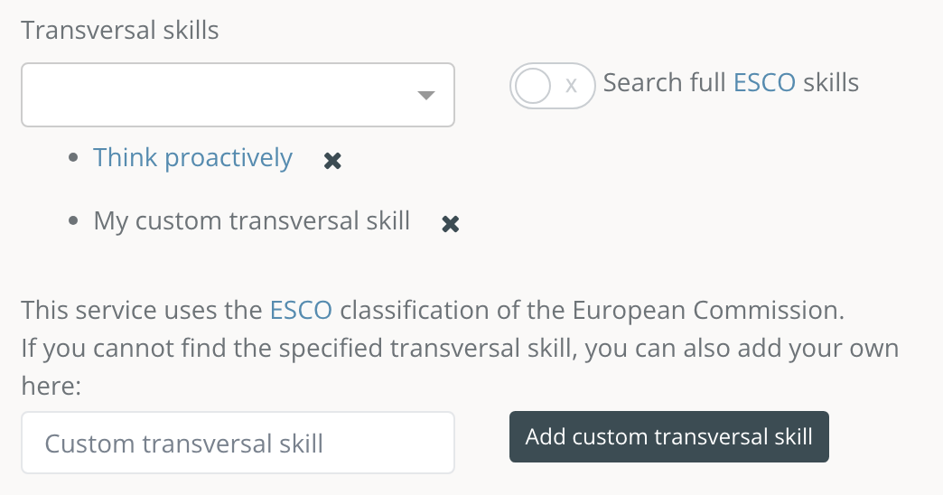

3

4

2

1

Figure 20. Transversal skills

CDT allows to

promote a unit

(Figure 21) by pressing the ‘Promote’ button (1). A unit promoted is saved as an independent educational offer, which allows an easy way to reuse/adapt existing nodes.

This new educational offer can be accessed from the link ‘edit it here’ (2), and both edits are reflected separately from the moment it is promoted.

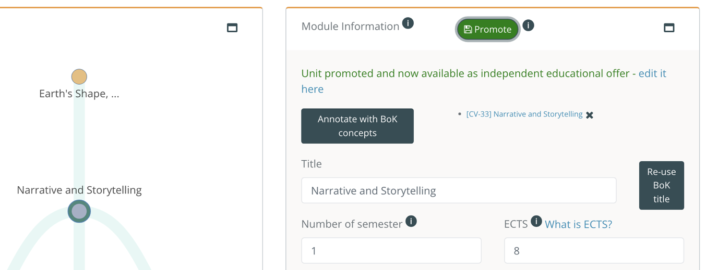

2

1

Figure 21. Promoting a child node

# Glossary of terms

**ESCO.** Classification of European Skills, Competences, Qualifications and Occupations

**EQF.** The European Qualifications Framework for Lifelong Learning. The core of the EQF concerns eight reference levels describing what a learner knows, understands and is able to do, ranging from basic (Level 1) to advanced (Level 8)

<https://ec.europa.eu/ploteus/sites/eac-eqf/files/broch_en.pdf>

**Field**. Term related to a specific area of study, following the ISCED-F classification

**ISCED-F**. International Standard Classification of Education: Fields of Education and Training 2013, maintained by UNESCO.

<https://ec.europa.eu/esco/portal/escopedia/International_Standard_Classification_of_Education_58__Fields_of_Education_and_Training_2013__40_ISCED-F_41_>

**Knowledge.** The body of facts, principles and theories and practices that is related to a field of work or study

**Learning outcomes** are statements of what a learner knows, understands and is able to do on completion of a learning process. In UCGIS they are described in terms of Knowledge and Skills. They should be characterized by: A time frame, a performer and an action verb (observable and measurable)

**Skills** means the ability to apply knowledge and use know-how to complete tasks and solve problems.

**Transversal Skills** are those typically considered as not specifically related to a particular job, task, academic discipline or area of knowledge but as skills that can be used in a wide variety of situations and work settings since they are a combination of people skills, social skills, communication skills, character or personality traits, attitudes, career attributes, social intelligence and emotional intelligence quotients, among others, that enable people to navigate their environment, work well with others, perform well, and achieve their goals with complementing hard skills.