
SPACE & INTELLIGENCE

DESIGNER, INTEGRATOR & OPERATOR OF MISSION CRITICAL SYSTEMS

Station Keeping Analysis Tool

Software Design Document

Approval table:
 | Name | Date | Signature
Prepared by | L. Maisonobe, CS  M. Renard, DEIMOS | 19/12/2013
Validated by | P. Parraud, CS  J.L. Cano, DEIMOS | 19/12/2013
Approved by

Document Change Table:
Version number | Date | Motive
1.0 | 09/12/2011 | Creation
2.0 | 27/01/2012 | SKAT version 2.0
3.0 | 02/03/2012 | SKAT version 3.0
3.3 | 19/12/2013 | SKAT version 3.3  Released by DEIMOS-Space S.L.U.

1. Introduction 3
2. Applicable and Reference documents 4
3. Terms, definitions and abbreviated terms 5
4. Software Design Overview 6
4.1 Design standards, conventions and procedures 6
4.2 Software static architecture 6
4.2.1 Packages organisation 6
4.2.1.1 Scenario package 7
4.2.1.2 Control package 9
4.2.1.3 Strategies package 10
4.2.1.4 Realization package 12
4.2.1.5 Utils package 13
4.3 Software dynamic architecture 15
4.3.1 Scenario handling 15
4.3.2 Control loop engine 16
5. Software Design Details 17
5.1 SKAT algorithms 17
5.1.1 The main loop 17
5.1.2 The control laws 19
5.1.2.1 GEO 19
5.1.2.1.1 Longitude 19
5.1.2.1.2 Eccentricity 20
5.1.2.1.3 Inclination 21
5.1.2.2 LEO 22
5.1.2.2.1 Mean Local Solar Time 22
5.1.2.2.2 Grid-based algorithms 23
5.1.2.2.2.1 Common features 23
5.1.2.2.2.2 In-Plane corrections 25
5.1.2.2.2.3 Out-Of-Plane corrections 25
5.1.3 The analytical modeling of the maneuvers 25
5.2 External algorithms 27
5.2.1 Random generator 27
5.2.2 Curve fitting 27
5.2.3 Orbit propagation 27
5.2.3.1 Numerical propagator 27
5.2.3.2 Semi-analytical propagator 28
5.2.3.3 ODE integrator 28
5.2.4 Force models 29
5.2.4.1 Gravity field 29
5.2.4.2 Third body 29
5.2.4.3 Atmospheric drag 30
5.2.4.3.1 Atmosphere and solar activity 30
5.2.4.4 Solar radiation pressure 30
5.2.4.5 Maneuvers 31

Introduction
This software design document provides description of the software architectural design and the software detailed design for the SKAT prototype. SKAT stands for Station-Keeping Analysis Tool. It is a prototype simulator for station-keeping of both Low Earth Orbit (LEO) and Geostationary Earth Orbit (GEO) spacecrafts. SKAT aims at long-term simulation, up to the full lifetime of a spacecraft, which can exceed 20 years.
SKAT is an analysis prototype. It must be flexible enough to allow simulation of different types of station keeping control strategies and to take various mission profiles or constraints. As such, the following design is highly modular and some parts could be later extended by adding new types of controls or constraints for example.
The design presented here is split in two parts. The first part is an overview based on Unified Modeling Language (UML) methodology, it covers static and dynamic aspects. The second part corresponds to the implementation details and mainly describes the algorithms.

Applicable and Reference documents
 | Title | Reference | Issue & Date
SoW | A Study for LEO & GEO Orbit Maintenance Concepts Evaluation | EUM/SES/SOW/11/0170 | 1.0  31 March 2011
AD1 | A Study for LEO & GEO Orbit Maintenance Concepts Evaluation :  Technical Proposal | CSSI/111/1/FXL/LR/11.428 | 1.0  17 June 2011
AD2 | CS clarifications and amendment | CSSI/111/1/FXL/CR/11.556 | 27 July 2011
AD3 | Enhanced LEO & GEO Station Keeping options | EUM/SES/DOC/11/0533 | V1Draft  7 September 2011
Table 1 : Applicable Documents

 | Title | Reference | Issue & Date
RD1 | UML Specification | http://www.omg.org/spec/UML/2.3/ | V2.3  May 2010
RD2 | SKAT Software User Manual | CS/ESPACE/SKAT/SUM/11.002 | V3.0  02/03/2012
RD3 | Semi-analytical approach  to MLST variation | EUMETSAT communication  (informal) | Draft  21 February 2012
Table 2 : Reference Documents

Terms, definitions and abbreviated terms
Term | Explanation
AD | Applicable Document
CSV | Comma Separated Value
DSST | Draper Semianalytical Satellite Theory
GEO | Geostationary Earth Orbit
GT | Ground Track
LEO | Low Earth Orbit
MLST | Mean Local Solar Time
RD | Reference Document
SDD | Software Design Document
SK | Station Keeping
SKAT | Station Keeping Analysis Tool
SoW | Statement of Work
TBC | To Be Confirmed
TBD | To Be Defined
TSV | Tabulation Separated Values
UML | Unified Modeling Language

Software Design Overview

Design standards, conventions and procedures
The software methods used in the design are object-oriented design using the UML language [RD1]. The implementation is done using the Java language, version 6.

Software static architecture
SKAT is a prototype station-keeping simulator. It is a standalone application developed in the Java language. The prototype is a command-line program that reads its configuration from a semi-structured key-value text file and produces Comma Separated Values (CSV) or Tabulation Separated Values (TSV) output files.
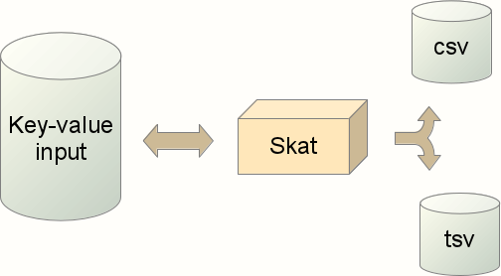
The SKAT program relies on the Orekit library which itself depends on the Apache Commons Math library. SKAT also uses some classes from Apache Commons Math directly.

Packages organisation
As a java program, SKAT is built from class components that are organized in a few packages. The selected organization is based on the main focus of each package and not on implementation details. This means that for example some interface definition and its implementing classes can be in the same package, there are no dedicated packages for implementations.
The top level package is named eu.eumetsat.skat. It follows the general Java guidelines for naming by using the reversed internet domain name as a way to ensure unicity. There is one little adaptation here because the official eumetsat domain name is eumetsat.int so the main package should rather be int.eumetsat.skat. However, int is a reserved keyword and forbidden for java package names. As it appears that eumetsat also owns the eumetsat.eu domain name that points back to its main domain name, we decided to replace the forbidden int identifier with the allowed eu identifier.
The top level package contains directly only one class, the Skat class which acts as the main class and the entry point of the program.
This top level package contains several sub-packages: scenario, control, strategies, realization and utils. All processing is done in the classes of these sub-packages, which are described in the following sections.
The SKAT application depends on two external components:
- the Orekit space flight dynamics library,
- and the Apache Commons Math mathematical library.
Orekit provides all flight dynamics features, like orbit propagation using various models, time, frames as well as useful mechanisms like event detections and step handlers that can be used to monitor propagation.
Apache Commons Math provides all mathematical algorithms, like random generator and curve fitter.
The following figure depicts all the packages and the two external dependencies:

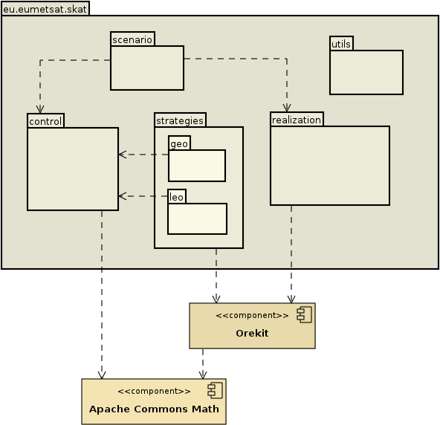

Scenario package
The scenario package contains all the elements related to the building of simulation scenarios like orbit determination being performed before maneuvers adjustement or cycles being repeated in loops.
The central design idea for this package is to mimic the classical station-keeping process in operational systems, which is data-driven. At the beginning of the cycle, the spacecraft is in a yet unknown orbit that may escape the window. The first step performed by flight dynamics team is to determine precisely this orbit. Once they know this initial state, they can propagate it, check it against the station-keeping window boundary and adjust a maneuver to ensure the spacecraft stays within these boundaries for all cycle duration. Then they perform the maneuver and the spacecraft real orbit is updated.
There are in fact two orbital states involved in this process. The first one is the real orbit that evolves due to the laws of mechanics, and the second one is the estimated orbit that is used on ground and is an approximation of the real orbit, which remains unknown. In a simulation tool like SKAT, the real orbit is known and propagated by the system. For the sake of a realistic simulation, it should however not be confused with the estimated orbit. This is implemented in SKAT using the ScenarioState class, which is a container holding both the real orbit (in an Orekit SpacecraftState instance) and an estimated orbit. In addition to the orbit, the maneuvers list is also stored both as theoretical maneuvers as computed by the ground system and as the real maneuvers performed by the spacecraft, including any realization errors or delays. All instances or orbit and maneuvers list are always available and will be used appropriately throughout the simulation of the station-keeping process.

State data | producer | consumer
Real orbit | Propagator | Orbit determination  Maneuver realization
Estimated orbit | Orbit determination | Control Loop
Theoretical maneuvers | Control Loop | Maneuver error simulation
Performed maneuvers | Maneuver error simulation | Maneuver realization  Propagator
The table above shows that all components of the scenario consume some data form the scenario state and produce other data in the scenario state. This is the rationale behind the following class diagram. The ScenarioState is a container class that is updated by several elements (ControlLoop, OrbitDetermination …), all of them implementing the same interface: ScenarioComponent. This interface declares a single function updateState that uses a ScenarioState as its input, and produces an updated ScenarioState as its output.

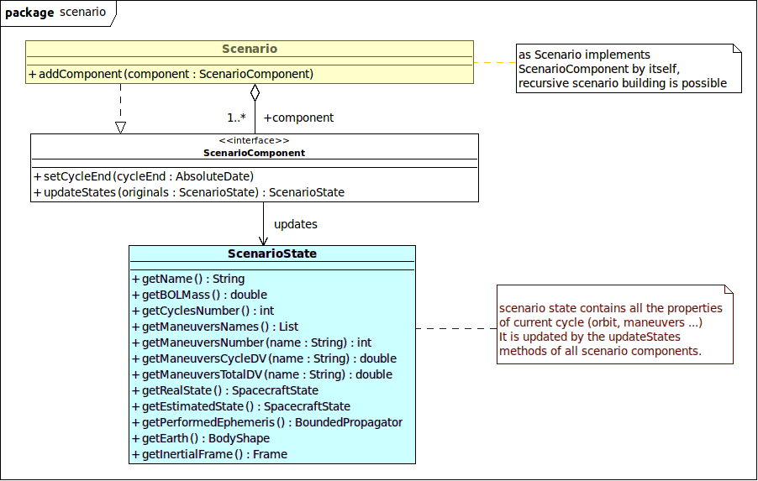
The Scenario class will run all the components that have been registered to it in a loop. The Scenario class doesn't know anything about what each component is. It simply performs the loop and uses the updateState method.
This design is very flexible for users. They can set up both very simple strategies (registering and OrbitDetermination component, followed by a ControlLoop implementing its maneuver profile, followed by some ManeuvreRealizationError, followed by Propagation). They can also set up more complex scenarios, like for example splitting in-plane and out-of-plane maneuvers with a quick orbit determination in between to check maneuvers coupling for example. They can also set up their control loop as only one component computing all maneuvers simultaneously and therefore all maneuvers taking into account the other maneuvers, or as separate components with several loops computing a subset of the maneuvers without any feedback between these loops as they would be run sequentially.
The Scenario class by itself also implements the ScenarioComponent interface. This allows tree-like constructs, which is useful for example to have one type of scenario at the beginning of the spacecraft life, and another scenario for the end of life. Most station-keeping simulation would in fact only use one level and only a few cases would need two levels. There is however no depth limit and no performance issue if a highly convoluted scenario were set up, as the computation cost is only driven by the simulation duration.
The implementations of the ScenarioComponent class are not defined in the scenario package, which simply defines the framework. They are defined in the other packages.

Control package
The control package provides another core framework for SKAT: the maneuvers computation engine. Its entry point is the ControlLoop class, an implementation of the ScenarioComponent interface and as such can be inserted inside a scenario. The purpose of this class is to organize the computation of theoretical maneuvers (which are part of the scenario state) from the estimated orbit (which is also part of the scenario state). So the main method of this class is the updateState method declared by the SenarioComponent interface.
The ControlLoop class does not change the other state elements. So once it will simply update the maneuvers and will not touch the real orbit, estimated orbit or already computed maneuvers that may be present in the state. It can therefore be chained with the other scenario components easily.
It is configured to manage a set of SKControl laws and ensure, through an iterative process, they satisfy their constraints (like longitude window or eccentricity circle) when tuning SK parameters (i.e. maneuvers ΔV and dates). The ControlLoop class can handle any number of control laws added at configuration time by calling the addControl method.
In the class diagram below, the control laws are represented as implementations of the SKControl interface, which declares mainly an initializeRun method and a tuneManeuvers method.
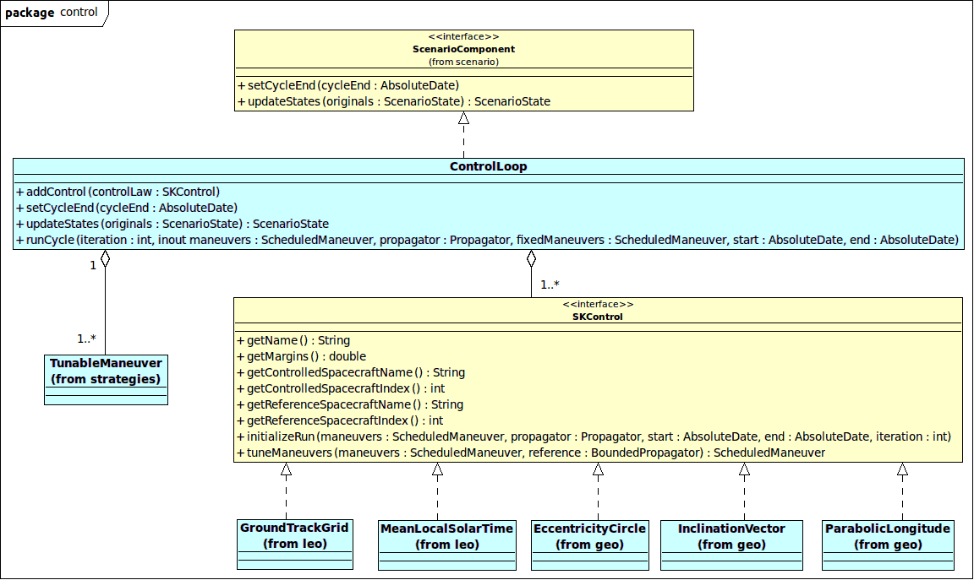

Strategies package
The strategies package holds 2 classes dealing with maneuvers.
The TunableManeuver class is a simple container for available maneuvers features, while the ScheduledManeuver class represents the discrete nature of planned maneuvers with respect to propagation. It allows it to be added to a propagator that will trigger it automatically when its occurring date is reached during propagation. The following figure shows the class diagram.
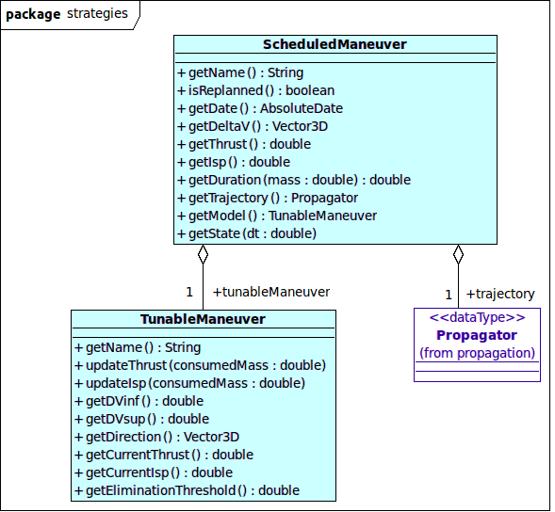
The sub-packages leo and geo gather all implementations of the SKControl interface and provide station-keeping control laws dedicated to their orbit types.
In the prototype application, several control laws are available. The class diagram below shows all of them, however the number and nature of these control laws is extensible so these available classes should not be considered as the only possible one. All control laws implement the SKControl interface, which allow them to be handled by the control loop engine.
They incorporate a step handler, thanks to the Orekit OrekitStepHandler interface, which represents the continuous nature of these control laws with respect to propagation. It allows them to be added to a propagator that will monitor their value throughout propagation.
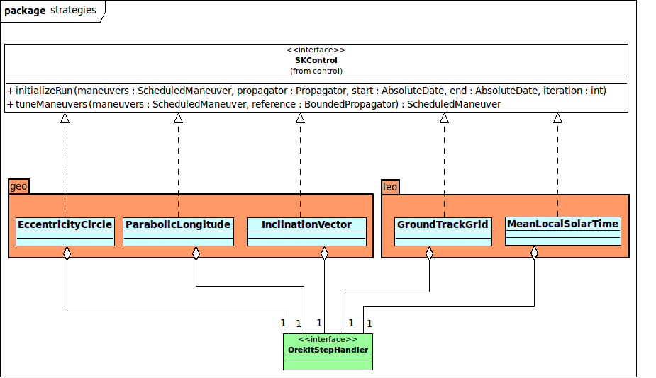

Realization package
The realization package implements the physical parts of the simulation strategy.
The first part is mainly represented by the OrbitDetermination class, which simulates orbit determination by using a CorrelatedRandomVectorGenerator from the Apache Commons Math library. This class generates randomly orbit determination errors to be applied to the orbit, using a correlation matrix and a standard deviation vector set up by the user at configuration time. This matrix and this vector can be expressed with respect to any orbit types, regardless of the orbit type used by propagation. As an example, an orbit can be propagated using the DSST model as an equinoctial orbit (this is mandatory for this model), and the correlation matrix and the standard deviation vector can be expressed with respect to the Keplerian parameters if this is what the existing real orbit determination system used in operation uses and so if this is how the correlation matrix and the standard deviation vector data are available. The generator used can handle under-determined systems, i.e. it knows how to cope with degenerated cases where there is a high correlation between some parameters, for example for almost circular orbits. This class implements the ScenarioComponent interface and its updateState method does reset the estimated orbit part of the state.
The second part is represented by the various maneuver realization error and Propagation classes, which correspond to processing steps that occur after station-keeping maneuvers have been adjusted by the control loop engine, and that realize the maneuver on the real state.
The maneuver realization error classes are similar in spirit to the OrbitDetermination class. They add random errors to the maneuvers, which can change dates, amplitude or direction. These classes consume theoretical maneuvers and produce performed maneuvers, which will be performed by the propagation. These classes may also implement deterministic coupling effects.
Propagation is a simple propagator, which consumes previous real state and performed maneuvers to produce an updated real state at station-keeping cycle end which will be used to start next cycle.
Just as the classes presented in the strategies package are not all the classes that may be present in the prototype application, several other realization components can be added if needed.

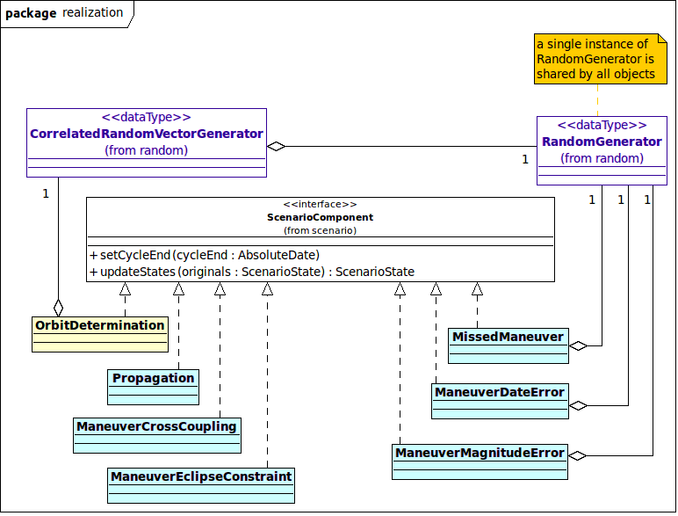

Utils package
The utils package holds the low level logistic like input-output features. Input is based on key-value files parsing. This is implemented using the parameterized class SkatFileParser that is in fact a copy of a similar class from Orekit tutorials. Copying this class instead of simply using it cannot be avoided because the class is not included in the compiled library, it is only a standalone feature used in some example tutorials. This class is parameterized using a ParameterKey enumerate which simply lists all configurable parameters that should be in the input file. This enumerate will be completed during development, as configuration parameters are added.
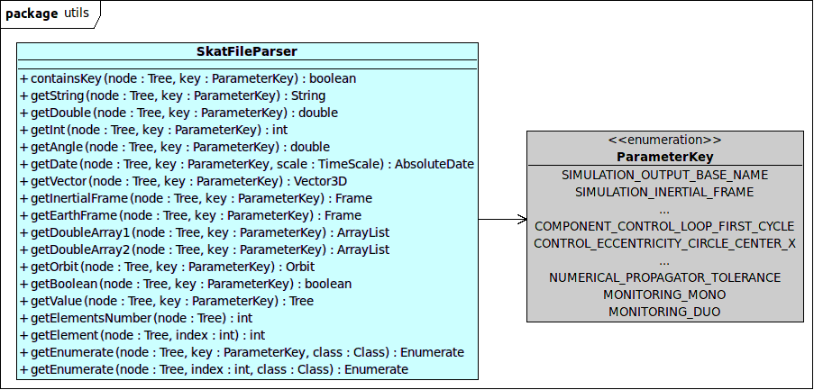

The MonitorableMono, MontorableDuo, MonitorMono and MonitorDuo interfaces are used to gather all the results to be displayed as curves and tables in the output files. They correspond to an implementation of the Observable and Observer design pattern. The names have been changed to avoid clash with standard Java classes.
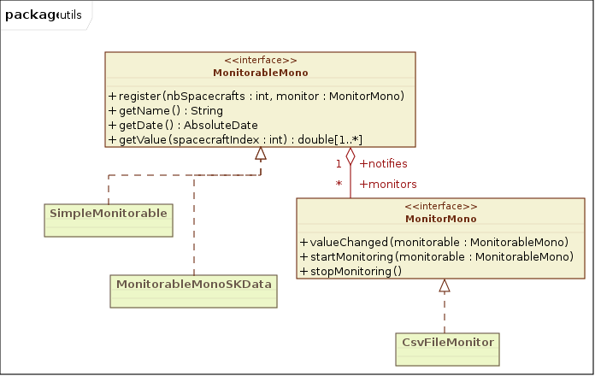
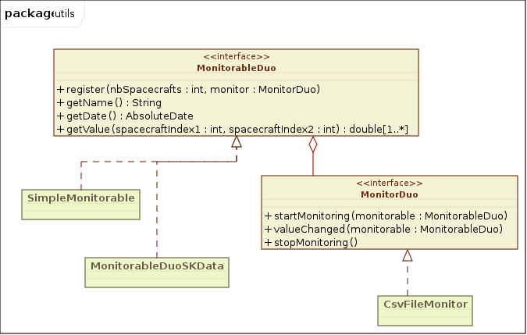

Software dynamic architecture
The dynamic behavior of SKAT consist in two different sets:
- scenario handling
- control loop engine

Scenario handling
Scenario handling is basically a simple iteration loop over all scenario components. At each station-keeping cycle, the scenario will call each component updateState method, providing the previous scenario state and retrieving an updated state. Then it will provide this updated state to the next component and ask it to update this state.
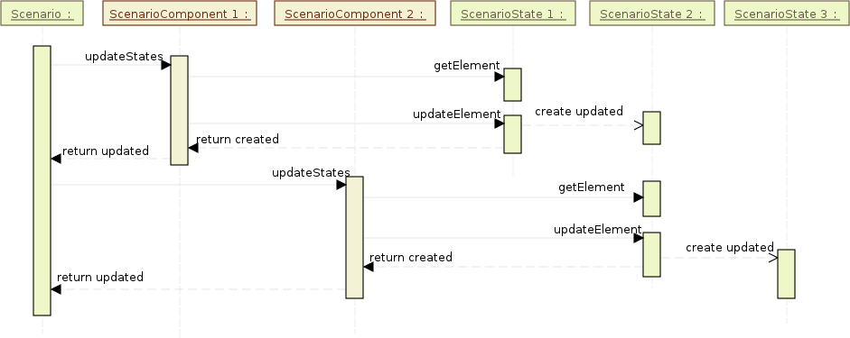
Each component will use the state provided as a parameter to get some data from it (for example the real orbit), and will create a new state with updated data (for example the estimated orbit). Following a common guideline for the Java language, the ScenarioState class which is mainly a small structure containing a few pointers to other objects (orbit, list of maneuvers …) is an immutable object. This is the reason why the components create a new instance each time. These small objects are throwaway instances and the virtual machine is particularly well optimized to handle this kind of data.

Control loop engine
The control loop deals with two main elements that are important for the user: the maneuvers to set up and the control laws to fulfill. The control laws are in charge of tuning the user chosen maneuvers in order to respect the constraints, while the control loop manages the various control laws through an iterative process until convergence is reached on maneuvers date and ΔV, with respect to the given thresholds.
Each control law implements a specific motion model of the controlled parameter (longitude, eccentricity, inclination, MLST, GT grid) and tunes the given maneuvers to correct this motion, mainly the mean motion, in order to fulfill their own constraints.
The following sequence diagram shows a simplified call sequence of the process, implemented in the updateState method of the ControlLoop class, as a scenario component. The sequence starts by the ControlLoop asking the ReferencePropagator, the one set by the user, to generate an ephemeris taking into account the already schedules maneuvers for the cycle. The iterative process starts with the ControlLoop asking every control law to initializeRun and to add their StepHandler, if any, to the ephemeris. Then the ControlLoop performs a propagation in order to gather data for the control laws and asks every control law to tuneManeuvers. The sequence: initializeRun, propagate, tuneManeuvers is repeated till convergence. Finally, the ControlLoop updates the ScenarioState with the adjusted maneuvers.
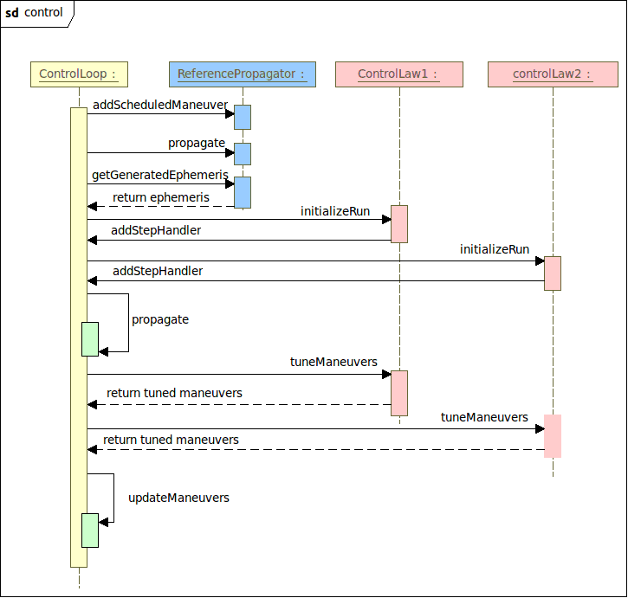

Software Design Details
This chapter is devoted to describe the details of the algorithms used within SKAT. It is split in two parts:
- the 1st part describes the algorithms designed specifically for SKAT,
- the 2nd part describes the algorithms provided by the external libraries: commons-math, mainly about mathematics, and Orekit, mainly about spaceflight dynamics.

SKAT algorithms

The main loop
The main loop used by the simulator is depicted in the figure below. One iteration on this loop corresponds to one station-keeping cycle, it is named scenario in SKAT. The components used as the iteration is performed correspond to the various procedures of a ground segment flight dynamics system, they are collectively called scenario components. All these components consume some data set and produce data sets which are gathered in one large data structure: the scenario state.
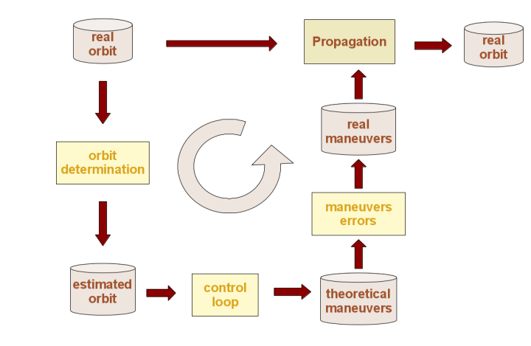
The entry of the loop is at the top left. The initial scenario state contains only the real state of the spacecraft: an idealized absolute corresponding to the real physics as it is simulated by SKAT. This real state is unknown in real operations, as the orbit is only estimated using orbit determination. So the first component in any realistic scenario is likely to be an orbit determination component, which adds a random error vector to the real state to produce an estimated state. The error vector is drawn according to a user specified correlation matrix and standard error. If the correlation matrix is set to identity and the standard error vector is set to the zero, the orbit determination will be a perfect determination, i.e. the estimated orbit will be the real orbit. The correlation matrix and standard deviation can be specified according to any orbit type supported by Orekit. The random drawings are realized by using Apache Commons Math standard algorithms, which are based on Cholesky decomposition of the correlation matrix. The implementation does support semi-definite correlation matrices, i.e. matrices with very high correlation factors resulting in a rank-deficient matrix. The random vector generated with the specified orbit type is converted if needed into the orbit type used for the simulation using analytical Jacobian matrices with respect to a pivot representation which is Cartesian position and velocity.
Once the orbit determination component has been run, the scenario state contains an estimated orbit, representing what the ground system knows about the spacecraft, but also contains the real orbit, which will be reused later on.
After orbit determination, several instances of the control loop component can be run to compute theoretical maneuvers. Each instance of this component uses the current estimated orbit, the set of theoretical maneuvers that may have been already computed by earlier instances of the component, and it computes, thanks to the control laws selected by the user, a set of theoretical maneuvers, which is added to the existing set. Users can decided to run only one control loop component that will compute all the maneuvers of the station-keeping cycle, or they can decided to split the maneuvers computation into several control loop, for example one control loop for out-of-plane corrections and another control loop for in-lane corrections.
Once the control loop instances have been run, the scenario state contains a set of theoretical maneuvers to be performed.
After theoretical maneuvers computation, several components can be run to model the physical errors and operational limits of the station keeping, like maneuvers magnitude errors, eclipse constraints, maneuvers misses ... All these components are very small one-purpose components that take the set of maneuvers and change some of them (change their values, change their dates...).
Once the operational errors components have been run, the scenario state contains a set of real maneuvers to be performed.
After real maneuvers have been set up, the propagation component can be used to simulate the real physics of the station keeping. This component is the only one that will reused the real state from the beginning, apply the real maneuvers, and will compute a real state taking the maneuvers into account, as well as a complete ephemeris covering the cycle. This ephemeris is used for monitoring the station keeping parameters (orbital state, control laws violations, control laws residuals ...).
Once the propagation component has been run, the scenario state contains an updated real state.
After the propagation component has been run, most of the time the iteration cycle will be finished, and the real state will be used as the initial state for the next iteration of the main loop, i.e. for the next station keeping cycle.
As all component consumes and produces a similar data structure using incremental updates, they can in fact be organized almost at will. It is possible to perform several orbit determinations and propagation between control loops for example, but monitoring will be limited to the last propagation (because it will override the ephemeris produces by previous ones). It is also possible to embed one scenario as a component inside the loop of another scenario, but this is more tricky and should be done with care.
The components choice, their organization and configuration are the responsibility of the user. This is a feature aimed at allowing the simulation framework to be as flexible as possible and to let user test new station-keeping strategies and procedures without being limited by a predefined architecture.

The control laws
As explained in the preceding section, station-keeping maneuvers are computed within the control loop component thanks to the control laws, which are responsible for adjusting the maneuver parameters, amplitude and date, in order to fulfill their specific constraints.

GEO

Longitude
The ParabolicLongitude control law attempts to center a parabolic longitude excursion around a specified center target throughout a cycle.
The longitude drift ζ (i.e. time derivative of the mean longitude) depends linearly on semi major axis, and is null at geosynchronous semi major axis:
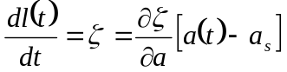
where a_{s} is the synchronous semi major axis and ∂ζ/∂a is a negative coefficient depending only on the gravity field with a theoretical value for Keplerian motion: 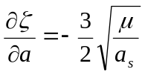.
The model for semi major axis drift is limited to secular terms only here:
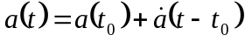
where is the secular time derivative of the semi major axis.
This implies the model for mean longitude is quadratic:
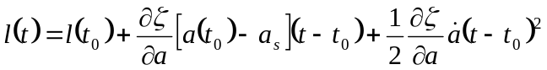
The initial longitude l(t₀) is inherited from the previous cycle motion. The curvature comes from which depends on the station-keeping longitude slot. So the only control parameter left is the initial drift, which is adjusted by changing the offset [a(t₀) - a_{s}] at initial time t₀ thanks to in-plane maneuvers. The aim of the control law is to achieve a parabolic motion that is centered in the station-keeping window during one cycle duration, i.e. with a peak (depending on acceleration direction, of course) longitude at cycle middle time.
The model parameters ∂ζ/∂a, a_{s} and are not computed from Keplerian motion, but rather fitted to the real evolution of the parameters against the polynomial models above. The fitting is performed on the longest maneuver-free interval of the cycle after the last in-plane maneuver.
The maneuvers aim at putting the end of cycle longitude at a longitude which will start a perfectly centered parabola for next cycle first maneuver. This works regardless of the initial point, which may be either already in the longitude slot, westward to the slot or eastward to the slot. This implies it does work also for longitude changes.
If we are too far from the station keeping longitude slot, we set up several maneuvers to reach the slot faster, up to the maximal number of allowed maneuvers par cycle and fulfilling the constraints on velocity increment sizes.

Eccentricity
The EccentricityCircle control law attempts to follow perigee solar pointing with respect to a specified eccentricity circle.
The mean eccentricity vector moves along a circle mainly due to radiation pressure. In addition to this mean motion, third body attraction adds a lot of short period variations.
This control law attempts to control only the mean motion along a user prescribed circle with center (c_{x}, c_{y}) and radius r. If the radius is different from the natural radius induced by radiation pressure, the control should split the natural motion in different pieces and spread these pieces on the prescribed circle. However, due to short periods, this piecewise reconstruction is not very clear and appears as a circular points clouds with many overlapping parts. This is normal behavior.
The control law simply computes for each observed point the theoretical circle center by subtracting the natural offset (r.cos(α_{s}), r.sin(α_{s})) where α_{s} is the Sun right ascension and r is the prescribed radius. This has the effect of computing a reference point which is independent of the date. Maneuvers are then computed so this reconstructed center is put at the user specified location.
This control law tunes maneuvers by selecting the last pair of in-plane maneuvers from the current maneuver set, and changing their relative size and date to change eccentricity, but without changing the overall ΔV (i.e. the algebraic sum of the existing maneuvers). The rationale is the overall ΔV should be tuned by the longitude control law (cf. § 5.1.2.1.1), and only changes that do not change drastically the longitude are allowed. If there is only one maneuver available (which is the case for example on the first iteration, since longitude control often generates only one maneuver), then the maneuver is split in two. If there are no maneuvers at all, a pair of maneuvers with a zero algebraic sum is created.
When the eccentricity control is not authorized to split longitude control maneuvers into pairs, the only optimization done by the algorithm is to change the time at which the single longitude burn is applied in order to try to stick to the ideal circle. The delta-eccentricity vector resulting from such maneuvers does not have the best magnitude but at least it goes in the correct direction. This is especially useful when OOP control interferes with IP control by forcing it to delay its maneuvers, thus losing the optimal longitude of application.
In cases of high OOP-to-IP cross coupling, it is possible to ask the eccentricity control algorithm to anticipate the effects of IP delta-V leakages when inclination maneuvers are performed. To do so, just add the name of the maneuver that will be used by the inclination control. The algorithm will use the classical average delta-V necessary to compensate for inclination drift (about 41 m/s per year) and the in-plane components of the OOP thruster to approximate how much delta-V will leak into the plane per time and its impact on the eccentricity vector. This delta-eccentricity will be compensated for, even before it happens, by artificially pushing the eccentricity vector to the opposite direction of the OOP-to-IP cross-coupling. The figure presented here below shows the different behaviors. On the left, the control does not know about the next-to-come OOP disturbances (black lines), it needs to compensate for them once they drove the eccentricity off-circle. On the right, it does and pre-compensates for them.

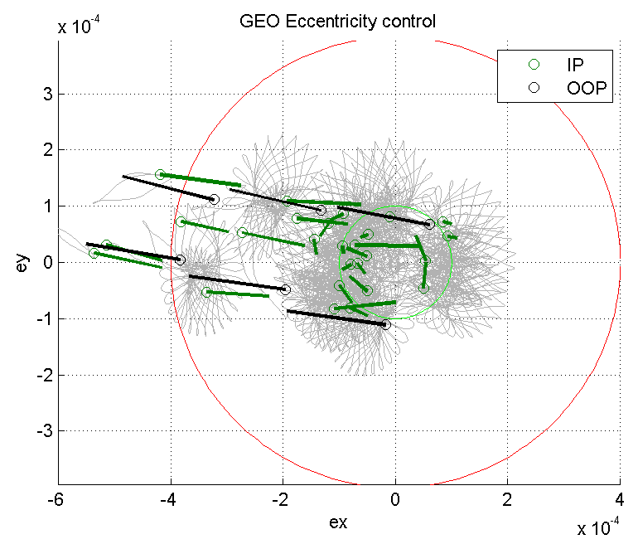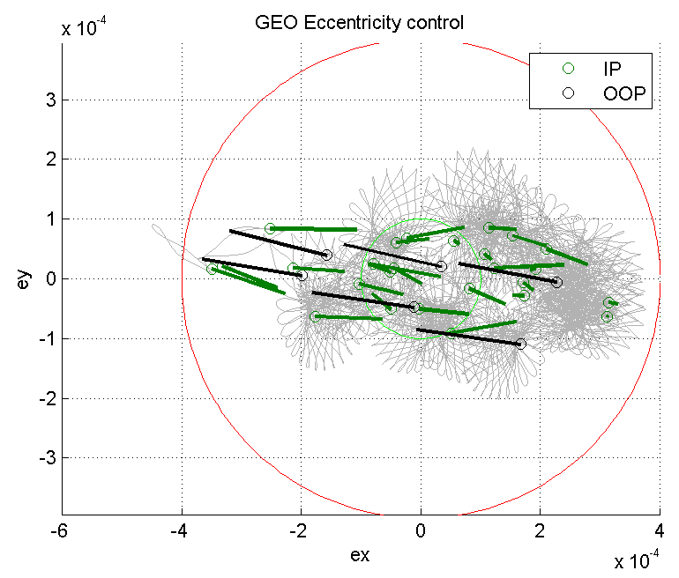
This mitigation of the OOP cross-coupling works only for OOP controls applying single-burn maneuvers (paired_maneuvers flag set to false in the inclination vector control law definition). The OOP paired maneuver strategy is another cross-coupling mitigation strategy which would make useless the eccentricity pre-compensation described here.

Inclination
The InclinationVector control law attempts to keep a nominal inclination vector.
The mean inclination vector moves along a line mainly due to third body attraction with 13 days and 6 months long period variations (half Moon period and half Sun period), and also some short period terms.
This control law attempts to control only the secular motion and bring it back to a reference point only when it escapes an allowed circle.
The control law simply fits the actual motion with a simplified model with secular and long period terms and when this motion escapes the allowed region, it tries to bring the secular part back to the prescribed point.
The prescribed point is on the lower edge of the control circle. It is computed so that when starting from it, the linear part of the fitted inclination drift will intercept the circle center. When at end of life, the last maneuver does not need to place the inclination vector back on the lower edge of the circle: this is too much delta-V effort for a last drift period that might not need all that free drift space. Instead, the target point is still placed on the line intersecting the circle center, and oriented as the secular part of the fitted motion, but at a distance proportional to the remaining mission time.
This control law tunes maneuvers by using an out-of-plane maneuver, which may be split if it exceeds maximal ΔV.
GEO inclination vector control can also take into account yaw-flipped platforms. Two “maneuvers”, i.e. thrusters, can be defined for the same control (e.g. north and south for OOP), as well as a sequence of dates, so as to rotate the platform by 180° at these dates and continue controlling the inclination correctly. This is useful to take into account the different values of cross coupling of each set of thrusters. Internally, the yaw flip is performed within the algorithm tuning the maneuvers, not at realization level.
When opposite thrusters are defined as different maneuvers, it is also possible to ask the algorithm to systematically use both thrusters to accelerate the maneuvers. The control law will perform “pairs” of maneuvers: one North burn followed, 12 hours later, by one South burn. The maximum delta-V capacity of both thrusters will be used each time in order to reach as fast as possible the required maneuver delta-V.

LEO

Mean Local Solar Time
Instead of using an Earth reference for out-of-plane station-keeping in LEO orbits, one can use a celestial reference when orbit is also Sun Synchronous, which is the case for most optical remote sensing missions.
Sun Synchronous Orbits (SSO) use the Earth oblateness (J2) effect for inducing a slow plane rotation rate equal to one complete rotation per tropical year. This is paramount to reduce lightning conditions changes on observed ground throughout year. SSO conditions for one remote sensing mission are defined by constraining Mean Local Solar Time (MLST) at some orbit reference point such as descending node. SKAT allows setting MLST at any hour from 0 to 24 for one latitude and one crossing direction.
For the sake of station-keeping, MLST is computed by using a mean sun right ascension from mean sidereal time (i.e. using IAU-1982 GMST-UT1 model and without equation of equinoxes correction) and adding the angular offset corresponding to UTC time. This mean Sun is at Greenwich meridian at noon.
Mean Local Solar Time evolves quadratically with time with an additional long period yearly modulation and several short period terms (mainly 12h and 24h). As fitting directly MLST requires very long fitting period in order to have accuracy, this would impair performances and is not done for all terms. MLST evolution is a consequence of inclination evolution (hence it is controlled by controlling inclination). The relationship is as follows:
MLST is an offset from orbit node. Orbit node drifts linearly with respect to offset from SSO inclination at first order, and neglecting semi-major axis effects (if we consider semi-major axis is itself maintained by in-plane strategy). Offset from SSO inclination is related to inclination which itself evolves drifts. Inclination drift is a constant plus additional long and short periodic terms. So basically, MLST results from one integration from inclination drift to inclination, one shift to get offset with respect to SSO, one multiplication factor to get node drift, another integration to get node motion, and a final shift to get solar time.
The initial inclination drift should be provided by users as a simple analytical model, where doy is Day Of Year, with 3 user-provided constants {i₀, i_{cos}, doy₀} (cf. RD3):
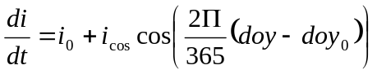
The offsets and integration steps are performed automatically by SKAT, which involves finding two integration constants, one corresponding to initial MLST and the second one corresponding to initial slope. The user-provided constants end up defining the curvature (i₀ integrated twice) and long period terms (i_{cos}). The constants are computed by SKAT using short term curve fitting, which can be done with limited time horizons. An order of magnitude of 30 days for this short term fitting is good. The fitting is performed on a long maneuver free interval, and based on observed MLST at the specified latitude/crossing direction for all crossings occurring during the fitting interval.
Once the constants have been determined at the beginning of each cycle, the analytical model can be used to estimate MLST evolution on a very long interval which exceeds time horizon and may be larger than one year, without any orbit propagation. this estimation is therefore highly dependent on the quality of the user provided constants for the model, mainly curvature.
If the MLST evolution is outside of allowed station-keeping window at cycle start, and emergency window reentry is scheduled with a maneuver set up as early as possible in the cycle. The target of this emergency maneuver is to put MLST at the center of the window at the end of the cycle time horizon. This should not happen in nominal situations.
If the MLST starts from within the windows (which is nominal situation), the window exit conditions are estimated. As the MLST evolution is roughly parabolic, the curve peak is expected to stay within the window and maneuvers should happen near curve tail. If the estimated peak exits window, an early maneuver is scheduled. If the estimated peak is within the window, the exit time of the tail part of the MLST curve is checked and a maneuver is scheduled. For operational considerations and to keep MLST evolution small, user must provide rough desired dates for these maneuvers as Day Of Year (for example one maneuver each year near mid-October). If the desired date is consistent with exit time near curve tail, then this date will be used. If the tail curve exits the window earlier, then the maneuver will be scheduled just before exit, with a 1.5-orbit margin (in order not to interfere with the eclipse constraint algorithm that searches for eclipses around the maneuver). So the desired dates provided by user are hints only. they will be obeyed if there is some margin in the station-keeping, but may be overruled if station-keeping threshold are too tight.
The target for maneuvers in nominal situations is to have the final part of the MLST curve (from peak to tail) balanced with respect to window MLST center, i.e. station-keeping tries to have the same margins on both sides of the window. Note that this has an unexpected side effect: if the inclination drift is large with respect to the desired maneuvers schedule, the station-keeping strategy may select first a large maneuver that put both a window violation at curve peak and a symmetric window violation at curve tail, and then it will try to fix this curve a few cycles later by adding a reversed maneuver.
This should be improved and a protection should be added to avoid this. This protection is not implemented yet.
The correction maneuver is computed by changing the slope constant in the MLST curve and checking peak and tail. This slope is linked to inclination using a scaling factor. Once inclination change is known, the out-of-plane maneuver is computed.

Grid-based algorithms

Common features
There are two grid-based algorithms for LEO orbits, one is dedicated to in-plane corrections and the other one is dedicated to out-of-plane corrections.
Both algorithms need a set of Earth reference points representing a grid over which the nominal orbit should pass. The grid is used as the way to define the Earth phasing properties of the orbit. The grid is provided as a text file containing one line per point and for fields per line.
- the first field is the offset in seconds of the point with respect to some arbitrary reference date in the phasing cycle (such as the first ascending node for example),
- the second field is the point geodetic latitude in degrees,
- the third field is point geodetic longitude in degrees,
- the fourth field is an ascending indicator showing if the satellite pass over this point for South to North (if keyword is set to true) or from North to South (if keyword is set to false).
The order of the points in the file is irrelevant. When a point corresponding to a latitude and a crossing direction (ascending or descending) is present in the file, all points corresponding to the same latitude and the same crossing direction must also be in the file. Often, only a few latitude will be set up (such as 0/ascending, 30/ascending, 30/descending). The number of lines in the file is therefore a multiple of the number of orbits in the phasing cycle. As an example, for a Metop case with a phased orbit of 412 orbits for 29 days, the file will contain 412*n lines where n is the number of latitude/crossing directions included in the file.
During the simulation, the spacecraft position is compared to the grid points as follows:
- if a grid point is at an intermediate latitude (i.e. between -76.3 and +76.3), the time at which the spacecraft crosses exactly the reference point latitude is selected, so the spacecraft sub-point and the reference grid point are separated exactly along the East-West direction,
- if a grid point is at an extreme latitude (i.e. below -76.3 or above +76.3), the time at which the spacecraft crosses exactly the reference point longitude is selected, so the spacecraft sub-point and the reference grid point are separated exactly along the North-South direction.
In both cases, once a spacecraft position has been selected, the offset from the grid point is computed as the horizontal Cartesian distance on ground between the reference grid point and the spacecraft sub-point. This distance is checked against the station-keeping thresholds (typically 5000 m for classical station-keeping, or 1000 m for fine station-keeping).
For both in-plane and out-of-plane strategies, at each station-keeping cycle the spacecraft trajectory is synchronized with the reference grid, using the closest approach to one grid point on the first orbit for reference. Once the first appropriate grid point has been selected, the remaining ones are forced according to their relative time offset to the first one, as deduced from the file first column. This prevents the grid from jumping from one ground track to the next one when the semi-major axis is wrong and the current trajectory slowly drift between two ground tracks. It also allows the station-keeping time horizon to be different from the phasing cycle.
The horizontal distances (East-West or North-South depending on the latitude) between the spacecraft sub-points and the reference grid points are then computed on the longest maneuver-free interval occurring during the station-keeping cycle. These distances are then used to fit evolution models for ascending node and inclination. The model take into account quadratic behavior as well as mean and long-period terms (12 hours, 24 hours, 6 months and 12 months). Fitting cannot be done directly though, because fitting ascending node for reference points at non-null latitude requires knowing the inclination and fitting inclination requires knowing the ascending node. So fitting is performed in two passes:
- first pass first fits node assuming constant inclination and then fits inclination using the first node model just fitted,
- second pass first fits node using the inclination model fitted in first pass and then fits again inclination using the first node model just fitted.

In-Plane corrections
The in-plane corrections strategy is based on semi-major axis control. This control is used to change the orbit period and hence adapt the time at which the spacecraft will cross the reference latitudes. This shifts the spacecraft all spacecraft positions in the East-West direction relative to the grid which moves with Earth rotation irrespective to their latitude (but of course shift depends on long term time, i.e. shift will be small for points just after maneuver and larger for points near cycle time horizon). This implies that the in-plane correction can use only intermediate latitude reference points. It cannot use extreme latitude points because by construction the selected spacecraft points are exactly at the right latitude which would artificially put perfect points in the observed sample (latitude crossing cannot be used at extreme latitudes). The reference grid points provided to in-plane strategy can contain extreme latitude points, they will be silently ignored by the strategy (this allows using the same grid file for bot in-plane and out-of-plane strategies).
The semi-major axis correction uses the ascending node evolution mean model obtained by removing the periodic terms and looking only at the quadratic evolution of the node. The constant term of the parabola depends on initial state and cannot be changed. The curvature term of the parabola depends on the underlying physics and natural evolution and cannot be changed. The slope term of the parabola is related to semi-major axis and can be changed by tangential maneuvers.
If the parabola for the node is already outside of the tolerance window at start time (i.e. if spacecraft crosses reference latitude too Eastwards or too Westwards), then a semi-major axis change is scheduled that will change the initial slope of the parabola such that the parabola ends up at a good position at time horizon so the next station-keeping cycle will be fine.
If the parabola for the node is inside the tolerance window at start time, then the exit conditions of the window are checked. A maneuver is triggered only if the parabola exits the window before time horizon. It is set up such that the parabola peak will be tangent to window boundary, i.e. the strategy tries to keep the satellite inside the window for the longest possible duration.

Out-Of-Plane corrections
The out-plane corrections strategy is based on inclination control. This control is used to change the orbit plane. This shifts the spacecraft position in the East-West direction depending on latitude (i.e. if at time t a point at +30 degrees latitude is shifted Eastwards, then at the same time a point at latitude -30 degrees will be shifted Westwards). This implies that the out-of-plane correction can use only non-null latitude reference points. It cannot use null latitude points because they are insensitive to inclination changes. The reference grid points provided to out-of-plane strategy can contain null latitude points, they will be silently ignored by the strategy (this allows using the same grid file for bot in-plane and out-of-plane strategies).
The inclination correction uses the inclination node evolution mean model obtained by removing the periodic terms and looking only at the linear evolution of the inclination. The slope term of the line depends on initial state and cannot be changed. The constant term of the line is related to inclination and can be changed by normal maneuvers.
If the inclination motion exceeds the window, it will be simply offset on the boundary so it travels throughout the window up to next maneuver. As the inclination motion is slow, few maneuvers are needed.

The analytical modeling of the maneuvers
In order to speed up trajectory computation, a two level propagation is used.
The first propagation level is computed only once, at the beginning of each cycle. It is a classical orbit propagation using the propagator configured by user for the control loop. This propagation takes into account all the effects that are not related to the tuned maneuver parameters (gravity, drag, third bodies, radiation pressure, as configured by user). It also takes into account the maneuvers that have already been scheduled by former control loop and which parameters have been fixed. A typical example would be maneuvers for the out-of-plane control of geostationary spacecrafts that are finalized before the control loop for in-plane correction is started. The maneuvers that have not been scheduled yet and that will be adjusted during this iterative process are not considered in this first propagation level. In fact, everything is computed as if these maneuvers were null maneuvers. The first propagation level produces a reference ephemeris of the spacecraft trajectory valid throughout the current station keeping cycle.
The second propagation level is computed for each set of maneuvers parameters generated by the iterative process. This propagation takes into account the maneuvers with their current trial parameters. It is this one that must be really fast because it will be called a much larger number of time than the first one. Speed is achieved by using an analytical differential model for this propagation, which is provided by Orekit. Given a small maneuver with its date (t₀, dV₀), it computes analytically at any time t₁ > t₀ the differential effect of the maneuver on the orbit:
O(t1) = O_{ref} (t₁) + f(t, t₀, dV₀)
where O(t₁) is the orbital state at date t₁ with the maneuver, O_{ref} (t₁) is the orbital state at date t₁ from the reference ephemeris, and f is the differential model for one maneuver which is computed for date t₁ using the maneuver date t₀ and velocity increment dV₀.
The differential model f is computed using combination of orbital states Jacobians as follows:
Let J₀ be the Jacobian of keplerian or equinoctial elements with respect to cartesian elements at date t₀. Multiplying this Jacobian matrix by the 6 elements column vector (0, 0, 0, dVx₀, dVy₀, dVz₀) produces a column vector representing the keplerian or equinoctial orbital elements change due to the maneuver (da₀, de₀, di₀, dpa₀, draan₀, dM₀) or (da₀, dex₀, dey₀, dhx₀, dhy₀, dλ_{M0}) at maneuver date t₀.
Let J_{1/0} be the Jacobian of Keplerian or equinoctial elements at date t₁ with respect to Keplerian or equinoctial elements at date t₀. This second Jacobian, J_{1/0}, is trivially computed using a simple Keplerian. It is the identity matrix except for the mean motion row which also includes a single off-diagonal element due to semi-major axis change. Multiplying this Jacobian matrix by the column vector obtained before produces a column vector representing the Keplerian or equinoctial orbital elements change due to the maneuver (da₁, de₁, di₁, dpa₁, draan₁, dM₁) or (da₁, dex₁, dey₁, dhxv, dhy₁, dλ_{M1}) at date t₁ > t₀.
Let J₁ be the Jacobian of desired orbital elements with respect to Keplerian or equinoctial elements at date t₁. Multiplying this Jacobian matrix by the column vector obtained before produces a column vector representing the orbital elements change in the type desired by user, which may be any type supported by Orekit (keplerian, circular, equinoctial or Cartesian).
The choice between keplerian or equinoctial elements is done automatically by the Orekit model based on eccentricity (thus allowing the model to be used including hyperbolic orbits).
The model being an additive one, it can in fact take any number of maneuvers into account by simply adding several evaluations of f, one for each maneuver considering their respective t₀, dV₀. Of course each maneuver has different times and care is taken to apply only the appropriate maneuver when asking for the changed orbital state between two maneuvers.
This model is very effective and quite accurate as long as the maneuvers are small, which is the case for station-keeping.

External algorithms
The external libraries used by SKAT provide specialized algorithms for mathematics, through commons-math, and flight dynamics, through Orekit. These algorithms implement the state of the art in the covered fields and have been chosen with confidence because of their recognized quality.

Random generator
A random generator is widely used throughout SKAT when generating random errors, for missing maneuvers for example, or applying uncertainties, for orbit determination for example.
Commons-math provides to SKAT the WELL19937a pseudo-random generator with better properties than the JDK-supplied java.util.Random. This pseudo-random generator is used to generate sequences of pseudo-random double values according to a Gaussian ("normally") distribution with mean 0.0 and standard deviation 1.0, this sequence being initialized thanks to the seed chosen by the user for one SKAT simulation [RD2].
This generator is described in a paper by François Panneton, Pierre L'Ecuyer and Makoto Matsumoto Improved Long-Period Generators Based on Linear Recurrences Modulo 2 ACM Transactions on Mathematical Software, 32, 1 (2006).
More information about the pseudo-random generators provided by commons-math can be found at: http://commons.apache.org/math/userguide/random.html

Curve fitting
Curve fitting is widely used by control laws to construct a motion model for the controlled parameter.
Commons-math provides to SKAT a curve fitter for parametric univariate real functions y = f(x). When a univariate real function y = f(x) does depend on some unknown parameters p0, p1 ... pn-1, this class can be used to find these parameters. It does this by fitting the curve so it remains very close to a set of observed points (x₀, y₀), (x₁, y₁) ... (x_{k-1}, y_{k-1}). This fitting is done by finding the parameters values that minimizes the objective function ∑(y_{i}-f(x_{i}))². This is really a least squares problem.
More information about the curve fitter provided by commons-math can be found at:
http://commons.apache.org/math/userguide/optimization.html - Curve Fitting

Orbit propagation
The two available orbit propagators are provided by Orekit.
They both rely on a first order integrator provided by commons-math to integrate the differential equation of motion of the spacecraft.
More information about orbit propagation with Orekit can be found at:
https://www.orekit.org/static/architecture/propagation.html

Numerical propagator
The numerical propagator is a major part of the Orekit project. Based on commons-math integrators, it realizes the interface between spacecraft dynamics and mathematical resolutions.
The mathematical problem to integrate is a dimension 7 time derivative equations system.
The state seen by the integrator is a simple 7 elements double array. The 6 first elements are either:
- the equinoctial orbit parameters (a, e_{x}, e_{y}, h_{x}, h_{y}, λ_{M} or λ_{E} or λ_{v}),
- the Keplerian orbit parameters (a, e, i, ω, Ω, M or E or v),
- the circular orbit parameters (a, e_{x}, e_{y}, i, Ω, α_{M} or α_{E} or α_{v}),
- the Cartesian orbit parameters (x, y, z, v_{x}, v_{y}, v_{z}).
The last element is the mass in kilograms.
The users only needs to register the various force models required for the simulation. Various force models are already available in the library, specialized ones can be added by users easily for specific needs.
The time derivatives are computed automatically by Orekit according to the force models and the orbit representation for the 6 first parameters and the flow rate for mass evolution during maneuvers.
It must be noted that without force model added, the numerical propagator in SKAT will simply perform a keplerian propagation by taking into account the central attraction coefficient μ.
The integrator (cf. § 5.2.3.3) provided by commons-math need the state vector at t0, the state vector first time derivative at t0, and then calculates the next step state vector, and ask for the next first time derivative, etc until it reaches the final asked date.

Semi-analytical propagator
The semi-analytical propagator provided by Orekit implements the Draper Semianalytical Satellite Theory according to the very detailed technical report by Danielson & al. Semianalytic Satellite Theory published in 1995, which can be found at http://www.math.nps.navy.mil/~bneta/th0-5.pdf. The DSST was developed by Paul Cefola and his colleagues in the mid-1970s, it is recognized to be complete in term of perturbing forces models, applicable to all orbits classes, very flexible (cf. Vallado Fundamentals of Astrodynamics and Applications, 3rd edition, Springer-Verlag NY inc.) and has been widely used for 30 years with noteworthy results
The main principle of all semianalytical theories for orbit propagation is to separate the short periodic contributions from the long-periodic and secular effects, so we can numerically propagate the mean element rates. As the short periodic variations constrain the integration step size, dealing only with long-term and secular effects allows to integrate the equation of motion with very large step sizes, typically on the order of one day. The short periodic variations being 2Π periodic in the fast variable, they are modeled analytically using Fourier series and they are simply added to the long-term and secular contributions at the integrator’s step-size time. Thus, the semianalytical theories combine the speed of the analytical approach with the accuracy of the numerical one.
At the moment, the implementation in Orekit is partial, it only deals with mean elements propagation, carried out by one ODE integrator provided by commons-math and chosen by the user as for the numerical propagator, but takes into account all the main perturbations: central body with zonal and tesseral harmonics, third body, atmospheric drag and solar radiation pressure. An automatic procedure has been set up in order to convert a given osculationg orbit into a mean orbit according to DSST sense. The DSST propagator has been validated with respect to the Orekit numerical propagator and the results are quite good in term of precision, the speed is also improved up to a ratio between 3 and 10, according to the orbit, GEO or LEO, and to the considered forces.
The implementation of the DSST in Orekit, which has been undertaken in parallel and for the need of SKAT development, is still a work in progress. So the DSST propagator is only available in the specific Orekit library provided for SKAT and won’t appear in the public version till completion.

ODE integrator
Both propagators use the 8(5,3) Dormand-Prince integrator for Ordinary Differential Equations.
This integrator is an embedded Runge-Kutta integrator of order 8(5,3) used in local extrapolation mode (i.e. the solution is computed using the high order formula) with step size control (and automatic step initialization) and continuous output. This method is based on an 8(6) method by Dormand and Prince (i.e. order 8 for the integration and order 6 for error estimation) modified by Hairer and Wanner to use a 5th order error estimator with 3rd order correction.
More information about ODE integration with commons-math can be found at:
http://commons.apache.org/math/userguide/ode.html.

Force models
The force models available in order to take into account realistic physical perturbations when propagating the orbit are provided by Orekit. They are handled differently by the numerical and by the semi-analytical propagator, but they share some common characteristics.

Gravity field
For the numerical propagator, the gravity field acceleration is computed through an algorithm designed by Leland E. Cunningham (Lockheed Missiles and Space Company, Sunnyvale and Astronomy Department University of California, Berkeley) in his 1969 paper: On the computation of the spherical harmonic terms needed during the numerical integration of the orbital motion of an artificial satellite (Celestial Mechanics 2, 1970).
For the DSST propagator, the gravity field contribution is seen as a conservative perturbing force and we can derive the acceleration from specific potential functions when splitting the zonal and the tesserals harmonics contributions.
In both cases, the required gravity field coefficients C and S are read within files. Orekit can automatically managed the reading of different public available formats: EGM, GRGS, SHM, ICGEM (see https://www.orekit.org/static/configuration.html). SKAT has been delivered with the eigen-5c.gfc file, the eigen-5c model in ICGEM format, but it can be replaced by any convenient file more suitable for the user.

Third body
For both propagators, the third body gravitational contribution can be set up for the Moon and the Sun.
For the numerical propagator, the third body gravitational acceleration is traditionally expressed in the inertial frame as:
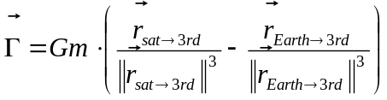
For the DSST propagator, the third body contribution is seen as a conservative perturbing force and the acceleration is derived from a specific potential function.
Data for the Moon and the Sun is available, based on JPL DE406 ephemeris provided to SKAT within orekit-data [RD2].

Atmospheric drag
For both propagators, the atmospheric drag acceleration is traditionally expressed in the inertial frame as:
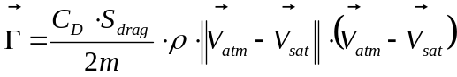
This formula assumes a spherical spacecraft. ρ is the atmosphere density at spacecraft location and 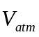 is the inertial velocity of atmosphere, which is supposed to be null in Earth frame for the all available atmospheric models in Orekit.

Atmosphere and solar activity
The model used to compute the atmosphere density for the drag is the DTM-2000 model described in the paper by S. Bruinsma, G. Thuillier and F. Barlier The DTM-2000 empirical thermosphere model with new data assimilation and constraints at lower boundary: accuracy and properties Journal of Atmospheric and Solar-Terrestrial Physics 65 (2003) 1053–1070.
The model needs geographical and time information to compute general values, which are available through propagation, but also needs space weather data : mean and instantaneous solar flux and geomagnetic indices, mean solar flux being represented by the F10.7 indices and geomagnetic activity by the Kp indices.
These solar activity data are provided thanks to the NASA Marshall Solar Activity Future Estimation (MSAFE) as estimates of monthly F10.7 Mean solar flux and Ap geomagnetic parameter.
The data can be retrieved at the NASA Marshall Solar Activity website. If several MSAFE files are available, some dates may appear in several files (for example August 2007 is in all files from the first one published in March 1999 to the February 2008 file). In this case, the data from the most recent file is used and the older ones are discarded. The date of the file is assumed to be 6 months after its first entry (which explains why the file having August 2007 as its first entry is the February 2008 file). This implies that MSAFE files must not be edited to change their time span, otherwise this would break the old entries overriding mechanism.

Solar radiation pressure
For both propagators, the solar radiation pressure acceleration is traditionally expressed in the inertial frame, assuming a spherical spacecraft, as:
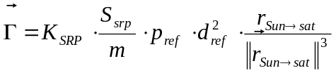
For SKAT, the reference solar radiation pressure p_{ref} and the reference distance for the solar radiation pressure d_{ref} are set to classical default values:
p_{ref} = 4.56 N/m² d_{ref} = 149597870000 m
One subtle difference in the definition of the coefficient K_{srp} has to be noted in order to compare the 2 propagators:
- for the numerical propagator, K_{srp} is build upon the user defined absorption coefficient C_{A} and reflection coefficient C_{R} as : K_{srp} = 1 + 4(1-C_{A})(1-C_{R})/9
- for the DSST, K_{srp} is build upon the user defined reflection coefficient C_{R} as : K_{srp} = C_{R}
Both propagators take eclipse into account in order to cancel the force during eclipse. In Orekit, the penumbra is also taken into account through a lightning ratio.
Here again, data for the Sun is available, based on JPL DE406 ephemeris provided to SKAT within orekit-data [RD2].

Maneuvers
The numerical propagator handles maneuvers as constant thrust maneuvers, so the thrust acceleration is directly integrated and the flow rate is used in order to compute the mass consumption.
For the DSST propagator, given the specific underlying averaging model, this can’t be done. Maneuvers are considered as impulsive and handled as events which change instantaneously the state within the integration process.

