GitHub Open-Source Pulse: End-to-End Data Pipeline
ITC6050 Data Engineering
Final Team Project: Group 5
George Antonakis, Orestis Pappas, Aaron Thomas Duesing
Instructor: Dr. Maira Kotsovoulou
21 July 2026
Repository: https://github.com/Geoanto8043/itc6050-project-group5/tree/main

Introduction

Many companies use open-source software, with GitHub being at the forefront, especially for modern data infrastructure and data engineering. Unfortunately, the health of the communities that maintain this infrastructure can be hard to see.

GitHub, like most online communities, allows users to "star" repositories as a way to bookmark projects, show interest, and signal appreciation. Although stars do not directly improve a repository, they can increase visibility by helping projects gain recognition and attracting contributors. However, star counts alone do not reveal whether a project is actively maintained, responsive to issues, or supported by a healthy contributor community. What matters to users, contributors, and especially organizations is whether issues are resolved, how quickly they are resolved, and whether the maintenance workload is distributed across a broad contributor base or concentrated among a small number of individuals.

GitHub records these interactions through its API, but the data is spread across multiple endpoints and requires processing before meaningful analysis can be performed. This project develops an end-to-end data pipeline that transforms raw GitHub activity into comparable community health metrics. The pipeline collects repository statistics and issue activity from a configurable set of projects, stores raw data snapshots in PostgreSQL, transforms the data into validated analytical models using dbt, and presents the results through an interactive Streamlit dashboard.

The default configuration is deliberately self-referential: it tracks the open-source tools used to build the pipeline itself: dlt, dbt-core, Streamlit, Airflow, pandas, and DuckDB, so that the system monitors the health of its own supply chain.

The intended users are those responsible for evaluating and selecting software dependencies. An engineering team comparing two libraries can assess metrics such as median issue resolution time rather than relying solely on popularity indicators like star counts. Open-source maintainers can use these insights to understand their backlog, responsiveness, and performance relative to similar projects. Platform and developer-relations teams can monitor whether community engagement and responsiveness are improving over time.

In each case, the pipeline replaces subjective impressions with measurable, reproducible evidence. Because each pipeline run creates a complete data snapshot, results can be regenerated and verified on demand rather than relying on static screenshots.

Data Source and API

All data is collected from the GitHub REST API. The API version is specified to ensure consistent responses and prevent future changes from affecting pipeline results. For each tracked repository, the pipeline retrieves data from two API endpoints: one containing repository-level statistics and another containing issue activity data.

The repository endpoint retrieves basic repository metadata, including popularity metrics, programming language, and issue counts. The issues endpoint retrieves both open and closed issues, including creation and closure dates, labels, authors, and comment counts. This data is used to calculate community health metrics such as issue resolution time and contributor activity.

A GitHub personal access token with the "public_repo" scope is used as for authentication. The token is then loaded into a git-ignored .env file, while the repository includes a .env.example template for configuration.

Using a personal access token increases the GitHub API rate limit from 60 to 5,000 requests per hour. A complete pipeline run makes approximately 18 API requests (for this specific project, six repository requests with up to three pages). To keep execution predictable and efficient, ingestion is intentionally limited to the 300 most recent issues from each repository. These limitations were generated to keep the pipeline fast, easy to demonstrate, and within GitHub's rate limits.

By contrast, retrieving the complete issue history of a large repository, such as pandas, would require thousands of additional API requests. Restricting ingestion to recent issues therefore provides predictable execution times while ensuring the data communicate the intended purpose.

Two characteristics of the GitHub API influenced the design of the ingestion process. First, the Issues endpoint returns both issues and pull requests, as GitHub represents pull requests as a subtype of issues. Records containing a "pull_request" field are therefore excluded during extraction to ensure that issue-based metrics are calculated solely from issues. Without this filtering step, pull requests would be included in all issue-related analyses.

Second, the repository "open_issues_count" field includes both open issues and open pull requests. Consequently, the value reported in the repository snapshot may differ from the number of open issues derived from the filtered issues dataset. This difference is expected, as the two values are based on different definitions rather than representing inconsistent data. Section 6 describes the validation procedures implemented to ensure the correctness of the ingested data.

Pipeline Architecture

GitHub REST API (/repos, /issues)
│
pipeline.py (dlt)
│
PostgreSQL (raw schema)
│
dbt
├─ stg_issues (view)
├─ repo_issue_summary (table)
└─ 8 data quality tests
│
dashboard.py (Streamlit)
(Figure 1: Architecture diagram)

The pipeline follows ELT (extract, load, transform) architecture rather than ETL. In this approach, API responses are loaded into the raw schema with minimal modification. Aside from flattening nested data structures and filtering out pull requests, no other manipulation is applied during extraction. All transformations are performed afterwards within the data warehouse.

This design provides three practical benefits. First, the raw data is preserved, allowing transformations to be modified and re-executed without making additional API requests. Second, implementing transformations using version-controlled SQL makes them easier to review and maintain than if they were embedded it into the ingestion code. Third, debugging is simplified because the raw tables provide an unmodified record of the data returned by the GitHub API, making it easier to determine whether discrepancies originate from the source data or from downstream transformations.

Each layer's tool was selected for a specific purpose. dlt was used for ingestion because it automates several aspects of the loading process and reduces the potential for manual errors. It infers and creates table schemas and automatically normalizes nested structures. It also does not duplicate data if the pipeline is rerun multiple times. This approach is appropriate because repository data is constantly updated, where records may be updated over time.

PostgreSQL is used to manage the database, with separate schemas for raw data and analytical outputs. dbt is responsible for data transformation, including the creation of a staging view that cleans and derives issue-level fields, a mart table that aggregates data at the repository level, source definitions, column documentation, and eight data quality tests that are executed during each build.

Streamlit generates a user-facing dashboard by querying the analytical mart rather than the raw tables. Project dependencies are managed through a local virtual environment with versions specified in requirements.txt, while the repository history reflects the development sequence: project setup, ingestion, transformation models and tests, and dashboard implementation.

When this pipeline was run for the intentions of this project, the verified data contained rows in "raw.repos", 418 issues in "raw.issues" after applying the pull-request filter, and 931 rows in the dlt-generated "raw.issues__labels" child table. The pull-request filter is necessary because active repositories often contain a high proportion of pull requests among their most recent items, which would otherwise affect issue-based analysis. The staging layer retains all 418 filtered issue records, while the analytical mart aggregates the data into six repository-level records.

Data Modeling

The warehouse follows a three-layer architecture, with each layer serving a distinct purpose and level of granularity.

The raw layer stores the data as it is received from the GitHub API. The "raw.repos" table contains one snapshot record for each tracked repository, while "raw.issues" contains one record for each issue together with its associated repository. A third table, "raw.issues__labels", is generated automatically by dlt during the normalization process. Because each issue can have multiple labels, dlt stores these in a separate child table linked to the parent issue using the generated "_dlt_parent_id" key, rather than embedding the labels within a single column. This design satisfies first normal form (1NF), making labels easy to query and analyze, for example when counting issues is assigned a label such as bug.

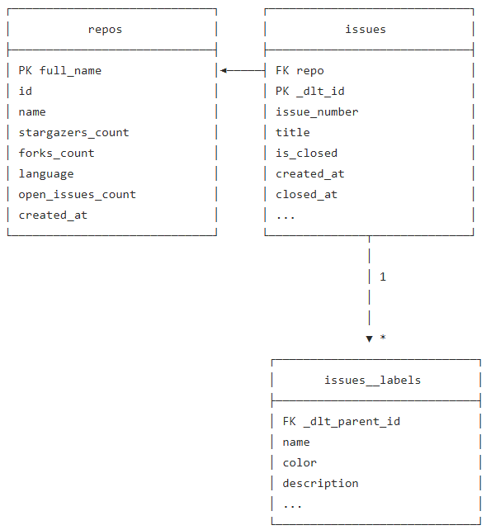
(Figure 2: Entity–Relationship Diagram (ERD) illustrating the relational schema used for the GitHub dataset.)

The staging layer ("stg_issues" table) retains the same level of granularity as "raw.issues", with one row per issue, while preparing the data for analysis. Date fields are converted from strings to timestamp values, an "is_closed" Boolean column is derived from the issue status, and a "days_open" column is calculated to measure the length of time an issue remains unresolved. Records with null values in the "id", "repo", or "state" fields are excluded. Although these fields are expected to be populated in the GitHub API response, enforcing this constraint ensures that the downstream analytical models are built only from complete and valid records.

The mart layer ("repo_issue_summary" table) changes the level of granularity from one row per issue to one row per repository. It contains aggregated metrics, including the total number of issues, counts of open versus closed issues, the average time taken to close an issue, and a ranked list of the most active authors. This mart table is generated because it performs computationally expensive aggregations that are reused by the dashboard, improving query performance.

Transformation

Two derived fields provide the primary analytical metrics, each based on a defined rule.

The "days_open" field measures the duration of an issue by calculating the difference between "created_at" and either "closed_at" (for closed issues) or the current timestamp (for open issues). As a result, the value for closed issues remains fixed after closure, while the value for open issues continues to increase over time. This enables the same field to measure both issue resolution time and the age of unresolved issues.

The "avg_days_to_close" metric in the analytical table is calculated using only closed issues. Excluding open issues ensures that the average represents completed resolution times, as the eventual resolution time for an open issue is not yet known and could distort the result.

The "top_authors" column demonstrates the use of SQL window functions. Within each repository, authors are ranked by the number of issues they have created using ROW_NUMBER(). If results are equal between different authors, it is then alphabetically sorted. The five highest-ranked authors are then combined into a single value using STRING_AGG. Records with null author names, which potentially represent deleted GitHub accounts, are excluded before ranking is performed.

Data Quality

Eight dbt tests are executed during each build to validate the integrity of the transformed data. Seven are generic tests defined in schema.yml, while one is a custom singular test. All eight tests were valid on the current dataset.

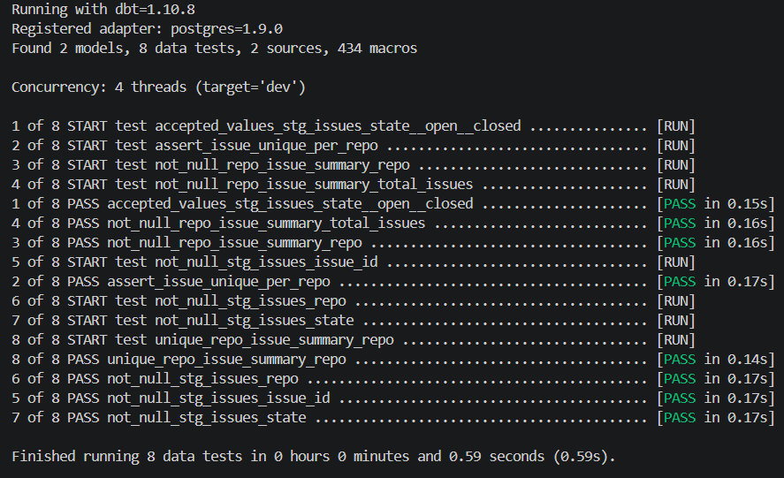
Figure 3: Output from dbt test.

- not_null tests are applied to "stg_issues: issue_id, repo, and state", and to "repo_issue_summary: repo and total_issues". These fields define the level of granularity of each model, so null values would indicate incomplete or invalid records.
- accepted_values is applied to the "state" column, ensuring that it contains only the values "open" or "closed", which is predefined by GitHub API. Any other value would indicate an unexpected API change or an error during data ingestion.
- unique is applied to the "repo" column in "repo_issue_summary" to verify that the model contains exactly one row per repository, as intended.
- assert_issue_unique_per_repo checks for duplicate ("issue_id", "repo") pairs in the staging model. Because GitHub issue IDs are globally unique, duplicate pairs indicate an error during ingestion, such as the same page of API results being processed more than once. This test validates the correctness of the pipeline's pagination logic rather than the source data itself.

Together, these tests verify both the assumptions made about the source data and the correctness of the pipeline implementation.

Dashboard and Visualization

The Streamlit dashboard queries only the transformed dbt models: "stg_issues" for issue-level analysis and "repo_issue_summary" for repository-level summaries. It does not access the raw schema directly. This ensures that all visualizations are built from validated data. Database queries are cached for ten minutes using @st.cache_data(ttl=600), reducing unnecessary requests to PostgreSQL during user interaction.

The dashboard provides three filters: repository, issue state, and issue creation date. These filters are applied consistently across all visualizations and summary metrics. Three KPI cards display the number of repositories, the total number of issues, and the average time taken to close issues.

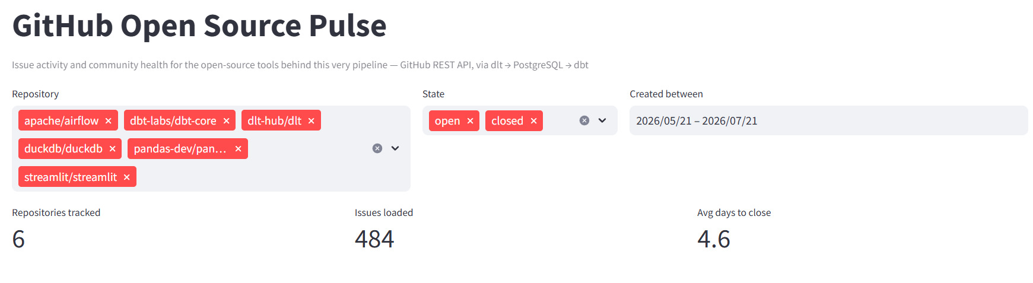

The dashboard includes two charts: a grouped horizontal bar chart compares the number of open and closed issues for each repository; and a time series graph showing number of issues created over time.

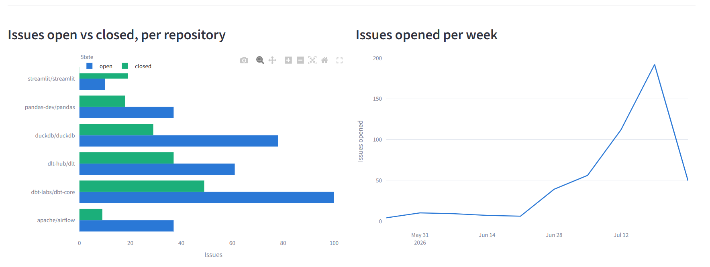

Two tables provide additional detail: one ranks contributors by the number of open issues, and the other displays the "repo_issue_summary table", allowing the reported metrics to be traced directly to the validated analytical model.

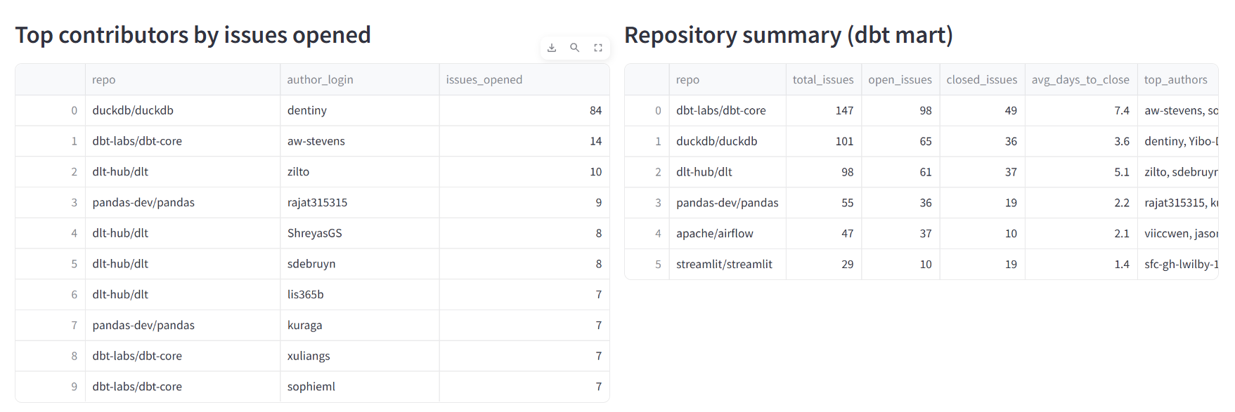
Figures 4–6: Dashboard views showing the overview, filtered results, and analytical tables.

The dashboard is intended to support engineering leads when evaluating software dependencies. By comparing repositories using metrics such as issue status, average resolution time, and recent development activity, users can make more informed decisions about the health and maintenance of candidate libraries.

Challenges and Lessons Learned

Ensuring a consistent development environment. Team members developed the project on different operating systems and with different Python versions, leading to inconsistencies and environment-specific errors. Specifically, setuptools<81 was required to avoid a deprecated pkg_resources import issue in dlt 1.6, while pyarrow<20 was required to prevent macOS segmentation faults during Streamlit reruns.

To ensure reproducibility, the project uses a dedicated Python virtual environment together with a Docker image that provides a consistent runtime environment across all platforms. The project documentation was also updated to include separate setup instructions for Bash and PowerShell.

Pull requests returned by the Issues API. Initial ingestion produced issue counts that were substantially higher than those displayed in the GitHub web interface. Our investigation revealed that the GitHub REST Issues endpoint returns both issues and pull requests, as pull requests are considered an issue. To ensure accurate issue-based analysis, records containing a "pull_request" field are excluded during extraction.

We also identified a second challenge: the "open_issues_count" field also includes open pull requests, which differs from the number of open issues calculated from the filtered dataset. Although this difference is expected because the two values are based on different contexts, this observation highlights the importance of understanding the underlying data model.

Limiting the ingestion scope. Retrieving the complete issue history of large repositories, such as pandas, would require thousands of API requests. Ingestion was therefore limited to the 300 most recent issues per repository. This recency window keeps a complete pipeline run to approximately 18 API requests, well within GitHub's limit of 5,000 requests per hour, while ensuring that enough data is collected for a proper analysis. Defining the scope of data collection proved to be important in architectural decision, as monetary cost and time are factors to consider in data engineering.

A mid-project pivot. The project was initially developed using a different data source that provided university ranking data (user error). Although the data source changed, the underlying pipeline architecture required relatively few modifications. The dlt ingestion pattern, the separation between staging and analytical models, the testing framework, and the dashboard structure were all reusable across domains. This demonstrated that a layered data pipeline can be adapted to different data sources with minimal architectural changes.

Conclusion

This pipeline fulfils the project requirements end to end by providing authenticated data ingestion into a raw PostgreSQL schema using dlt, tested staging and analytical models in dbt, and a dashboard that queries only the transformed data. Each pipeline execution produces a reproducible snapshot, while all transformations are maintained as version-controlled SQL models. Eight automated tests validate both assumptions about the source data and the correctness of the pipeline implementation.

Three enhancements would further improve the pipeline's production readiness. First, automated scheduling through cron or an orchestration tool such as Airflow would replace manual execution of pipeline runs. Second, implementing incremental loading with merge operations based on issue IDs would preserve historical records rather than replacing snapshots. Third, extending ingestion to include comments and reviews would provide a more complete view of community responsiveness and repository health.

These improvements can be integrated into the existing architecture because they extend the current pipeline components rather than requiring a fundamental redesign.

Word count: 2,663 (excluding code).

