A Numerical Comparison of Explicit Euler, a Velocity-Verlet-type Scheme, and Classical RK4 for the Damped Harmonic Oscillator
Yi Zhou
Draft v0.1 — 2026-09-29

Abstract
We compare three time-integration schemes—explicit Euler, a velocity-Verlet-type scheme adapted for velocity-dependent damping, and classical fourth-order Runge–Kutta (RK4)—on the dimensionless damped harmonic oscillator x″ + 2ζ x′ + x = 0 with x(0) = 1, x′(0) = 0, for damping ratios ζ∈{0.1,1,2}. Using closed-form analytic solutions as reference, we measure the maximum displacement error E∞ over step sizes h∈{0.2,0.1,0.05,0.025,0.0125} on t∈[0,20]. The observed convergence orders are 1.27/1.03/1.11 (Euler), 2.02/2.10/2.20 (Verlet-type), and 4.00/4.07/4.19 (RK4), matching the theoretical orders 1, 2, and 4. A fine scan around the Euler linear-stability boundary at ζ = 0.1 shows the measured envelope-decay error crossing 100% exactly at the predicted boundary h = 2ζ = 0.2, agreeing with the amplification-factor theory to within 3.1×10⁻⁵. In a long undamped (ζ = 0) run to t = 100, Euler exhibits secular energy growth (1 + h²)ⁿ (reaching 3.3×10⁸ at h = 0.2), the Verlet-type scheme keeps energy bounded within ∼ h²/4, and RK4 shows the smallest drift (4.4×10⁻⁴). We document honestly that the Verlet-type scheme used here is not the standard symplectic velocity Verlet, and we report all anomalies and limitations of the measurements.

Introduction
The damped harmonic oscillator is one of the simplest differential equations with a non-trivial interplay between oscillation and decay, and it admits closed-form solutions in every damping regime. It is therefore an ideal benchmark for time-integration schemes: accuracy, convergence order, linear stability, and long-time energy behaviour can all be checked against exact answers.
This study compares three explicit schemes:
- the explicit (forward) Euler method (first order),
- a velocity-Verlet-type scheme modified for velocity-dependent damping (second order),
- the classical fourth-order Runge–Kutta method RK4.
We evaluate them on accuracy versus step size, cost versus accuracy, behaviour at and beyond the linear stability boundary, and energy drift over long integrations. All experiments are scripted, all data are saved as CSV files, and every figure in this paper is regenerated from the saved data alone, so the results are byte-for-byte reproducible from the repository.

Model

Dimensionless equation
The dimensional damped oscillator mẍ + cẋ + kx = 0 is nondimensionalised with the natural frequency ω₀ = √(k/m) and the damping ratio ζ = c/(2√(mk)), giving
x″ + 2ζ x′ + x = 0, x(0) = 1, x′(0) = 0, (1)
where primes denote derivatives with respect to dimensionless time t. We study ζ = 0.1 (underdamped), ζ = 1 (critically damped), ζ = 2 (overdamped), and additionally ζ = 0 (undamped) for the energy-drift experiment.

Analytic reference solutions
Equation (1) has closed-form solutions used as the exact reference throughout:
ζ = 0.1: x(t) = exp(-ζ t)[cos(ω₍d₎ t) + (ζ)/(ω₍d₎)sin(ω₍d₎ t)], ω₍d₎ = √(1-ζ²),
ζ = 1: x(t) = (1 + t)exp(-t),
ζ = 2: x(t) = ((ζ + s)exp(r₁ t)-(ζ-s)exp(r₂ t))/(2s), s = √(ζ²-1), r₍1,2₎ = -ζ± s,
ζ = 0: x(t) = cos t,
all satisfying x(0) = 1, x′(0) = 0. The implementation (model.py) includes self-tests: the ζ→0 limit recovers cos t, the initial conditions hold, velocity is the analytic derivative of displacement, and the overdamped tail follows the slow root r₁.

Energy
For ζ = 0, the exact energy E = (x² + v²)/2 is conserved at E₀ = 1/2. This makes the undamped case a clean probe of each scheme's long-time energy behaviour.

Numerical methods
Write the acceleration as a(x,v) = -x-2ζ v. All solvers share the interface solve(zeta, h, t_end) returning the time grid and the (x,v) trajectory (solvers.py).

Explicit Euler
xₙ₊₁ = xₙ + h vₙ, vₙ₊₁ = vₙ + h a(xₙ,vₙ).
First-order accurate; the cheapest per step.

Velocity-Verlet-type scheme
aₙ = a(xₙ, vₙ),
xₙ₊₁ = xₙ + h vₙ + (1/2) h² aₙ,
v₍pred₎ = vₙ + h aₙ,
aₙ₊₁ = a(xₙ₊₁, v₍pred₎),
vₙ₊₁ = vₙ + (1/2) h (aₙ + aₙ₊₁).
Second-order accurate. Important caveat: the standard velocity Verlet algorithm is derived for accelerations that depend only on position, a = a(x), i.e. conservative systems, where it enjoys symplecticity and excellent long-time energy behaviour. Our problem has velocity-dependent damping, a = a(x,v), so standard Verlet does not apply directly. The variant above evaluates the damping term at an explicitly predicted velocity v₍pred₎. Consequently it is not a symplectic integrator and does not inherit the long-time energy conservation properties of textbook Verlet; the predictor step is only first-order in v (the overall scheme remains second order, but with a larger error constant than true Verlet on a conservative problem). Throughout this paper we call it the “velocity-Verlet-type scheme for velocity-dependent damping” and never abbreviate it to plain “Verlet”.

Classical RK4
The standard fourth-order Runge–Kutta method applied to the state vector y = (x,v). Fourth-order accurate; roughly four times the cost per step of Euler.

Error metrics and experiment design
The primary metric is the maximum displacement error against the analytic solution on the solver grid,
E∞ = maxₙ |xₙ - x(tₙ)|,
together with the RMS error E₍RMS₎. For the underdamped case we additionally fit the numerical peak envelope ln Aₖ = ln A₀ - ζ₍fit₎ tₖ and report the relative decay-rate error |ζ₍fit₎-ζ|/ζ. Convergence orders are least-squares slopes of log E∞ versus log h.
The main matrix covers 3 methods × 3 damping ratios × 5 step sizes (h = 0.2 down to 0.0125), 45 runs on t∈[0,20], each timed with the minimum of three time.perf_counter repeats. Two focused experiments extend it: a stability scan at ζ = 0.1 with h∈{0.16,0.18,0.19,0.20,0.21,0.22,0.25} on t∈[0,40] (experiments/stability_scan.py), and an energy-drift experiment at ζ = 0 with h∈{0.2,0.1,0.05} on t∈[0,100] (experiments/energy_drift.py). Environment: Python 3.12.3, NumPy 1.26.4, Matplotlib 3.6.3.

Results

Convergence
Figure 1 shows E∞ versus h on log–log axes for all three damping regimes, with reference lines of slope 1, 2, and 4. The fitted orders are:
Method | ζ = 0.1 | ζ = 1 | ζ = 2
Explicit Euler | 1.27 | 1.03 | 1.11
Velocity-Verlet-type | 2.02 | 2.10 | 2.20
RK4 | 4.00 | 4.07 | 4.19
All three schemes attain their theoretical orders. The Euler order of 1.27 at ζ = 0.1 is above 1 because the coarsest step h = 0.2 is not yet in the asymptotic regime there—it sits exactly on the linear stability boundary (Section 4.2)—so the fit is steepened by the pre-asymptotic point. At ζ = 1 and ζ = 2 the behaviour is cleanly first order. RK4 reaches E∞∼10⁻⁹–10⁻¹⁰ at h = 0.0125, well above double-precision machine epsilon. The fitted slope of 4.19 at ζ = 2 reflects the finite step-size range; no round-off plateau is demonstrated by these runs.
Figure 2 compares trajectories at ζ = 0.1, h = 0.2: Euler's amplitude visibly fails to decay (the marginal-stability symptom quantified below), while the Verlet-type and RK4 curves are indistinguishable from the exact solution at this scale. The critically damped and overdamped trajectories (not shown) are monotone and clean for all three methods.
On cost versus accuracy (Fig. 3), RK4 dominates: at equal wall-clock cost it is 3–6 orders of magnitude more accurate than Euler (e.g. at ζ = 0.1, for ∼1.7 ms of compute, RK4 at h = 0.05 gives E∞ = 1.9×10⁻⁷ while Euler at h = 0.0125 gives 2.4×10⁻²). The Verlet-type scheme is the economical middle ground; Euler is defensible only when very coarse accuracy suffices. Timing is machine-dependent, so the exact positions in Fig. 3 vary between runs.
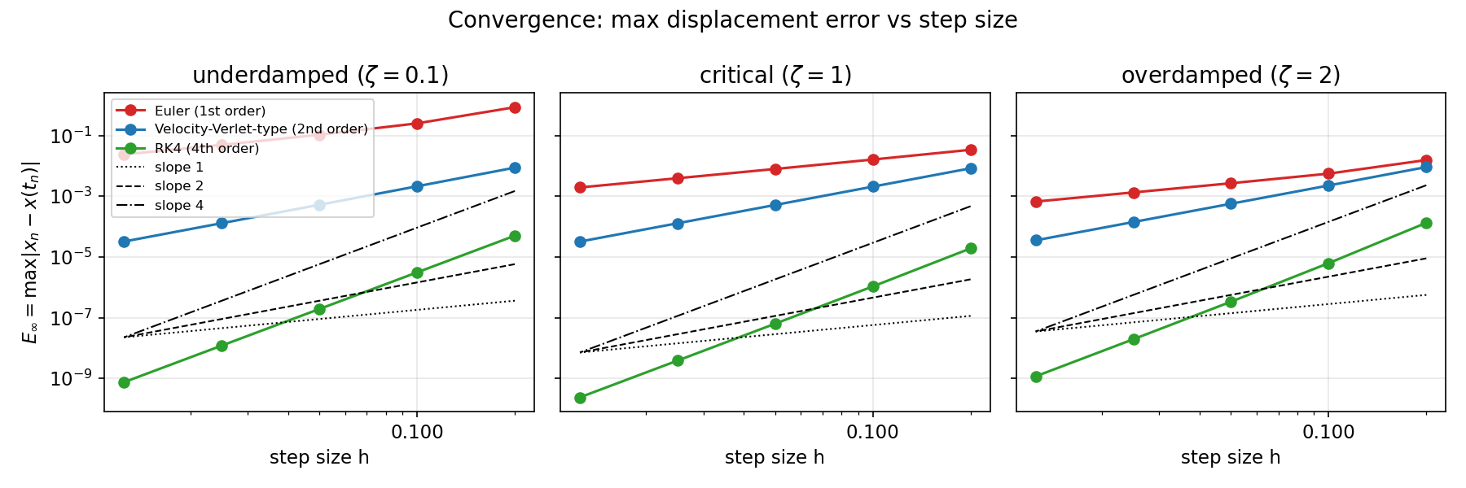
Figure 1. Maximum displacement error E∞ versus step size h (log–log) for the three damping regimes, with reference slopes 1, 2, and 4.
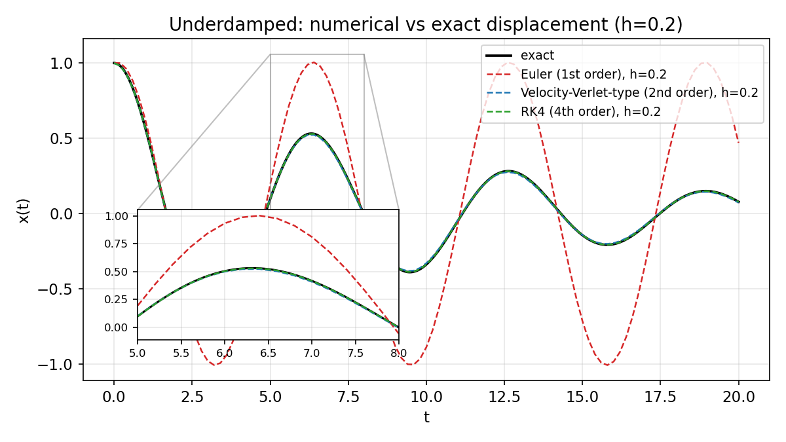
Figure 2. Underdamped (ζ = 0.1) displacement at h = 0.2 with a zoomed inset on the first peak. Euler does not decay; the Verlet-type and RK4 solutions overlay the exact curve.
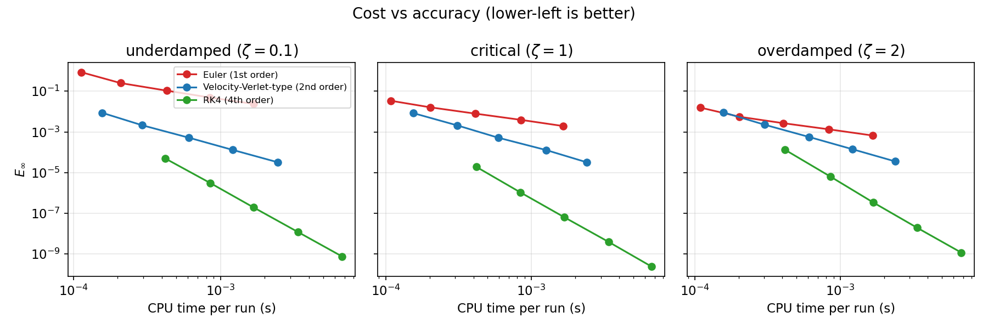
Figure 3. Wall-clock cost versus E∞ at ζ = 0.1. RK4 gives 3–6 orders of magnitude better accuracy at equal cost.

Linear stability boundary
For explicit Euler applied to the underdamped system, the eigenvalues are λ = -ζ± iω₍d₎ and one step multiplies each eigenmode by 1 + hλ, with squared modulus
|1 + hλ|² = (1-hζ)² + h²ω₍d₎² = 1 - 2ζ h + h².
Stability (|1 + hλ| < 1) therefore requires h < 2ζ; at h = 2ζ the amplification factor is exactly 1 and the numerical envelope neither grows nor decays. The discrete decay rate is ζ₍disc₎ = -ln(1-2ζ h + h²)/(2h), so the predicted relative envelope-decay error is |ζ₍disc₎-ζ|/ζ, which passes continuously through 1 (100%) at h = 2ζ.
Figure 4 compares this prediction against the independent fine scan at ζ = 0.1. The measured Euler errors run from 0.799 (h = 0.16) through 1.000 (h = 0.20) to 1.248 (h = 0.25), crossing 100% exactly at the theoretical boundary; the largest absolute deviation from the amplification-factor prediction over the seven step sizes is 3.1×10⁻⁵ (at h = 0.2 the agreement is 3.2×10⁻⁶). The Verlet-type errors grow smoothly from 0.0065 to 0.0160 and RK4 stays below 8×10⁻⁵ (its small nonmonotonic wiggles come from peak-fit noise, not from the integrator).
Well beyond the boundary, at h = 0.5, Euler blows up exponentially (max|x| = 15 on t∈[0,20]) while the other two schemes stay bounded but visibly distorted (Fig. 5).
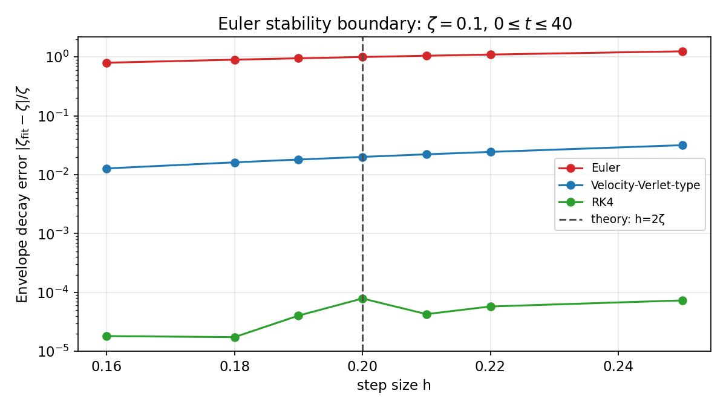
Figure 4. Fine scan of the Euler stability boundary at ζ = 0.1: relative envelope-decay error versus h. The dashed line marks the theoretical boundary h = 2ζ = 0.2, where Euler's error passes through 100% (neutral numerical envelope).
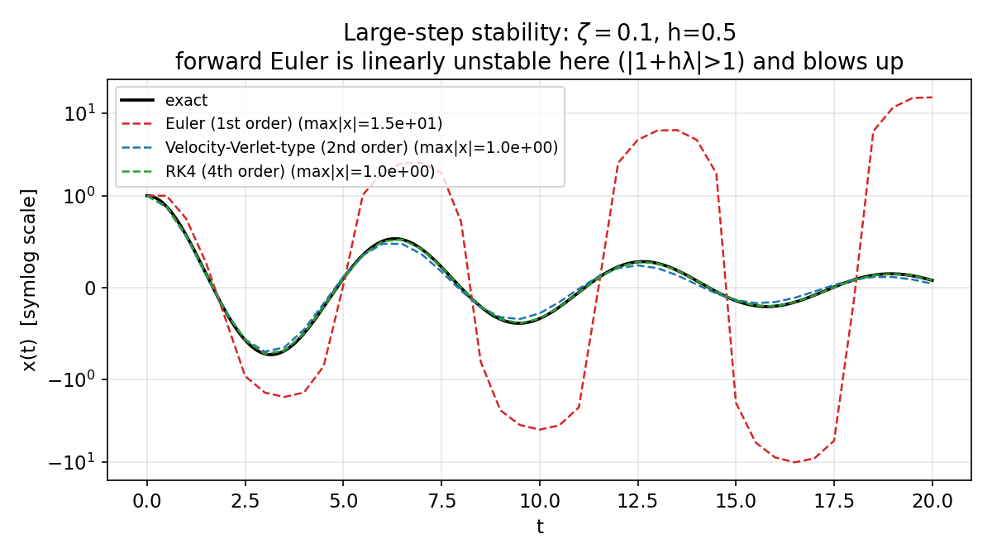
Figure 5. Large-step behaviour at ζ = 0.1, h = 0.5 (symlog scale): Euler is linearly unstable and diverges; the Verlet-type and RK4 solutions stay bounded but are distorted.

Long-time energy behaviour
At ζ = 0 the exact energy E₀ = 1/2 is conserved, exposing each scheme's secular behaviour over t∈[0,100] (Fig. 6). Euler multiplies the energy by exactly (1 + h²) per step:
(Eₙ)/(E₀) = (1 + h²)ⁿ,
so at h = 0.2 (n = 500 steps) the energy grows to (1.04)⁵⁰⁰ = 3.286×10⁸, matching the measured 3.2860158×10⁸ to all printed digits. Even at h = 0.1 the growth reaches 2.1×10⁴.
At ζ = 0 the Verlet-type scheme reduces to standard velocity Verlet (the acceleration no longer depends on v), and its relative energy error is bounded and oscillatory with maximum h²/4 (measured 0.0099998 at h = 0.2, i.e. ∼1%; 0.0025 at h = 0.1). RK4 has the smallest drift: its per-step energy multiplier is 1-h⁶/72 + h⁸/576, giving a slow secular loss of only 4.4×10⁻⁴ at h = 0.2 (1.4×10⁻⁵ at h = 0.1).
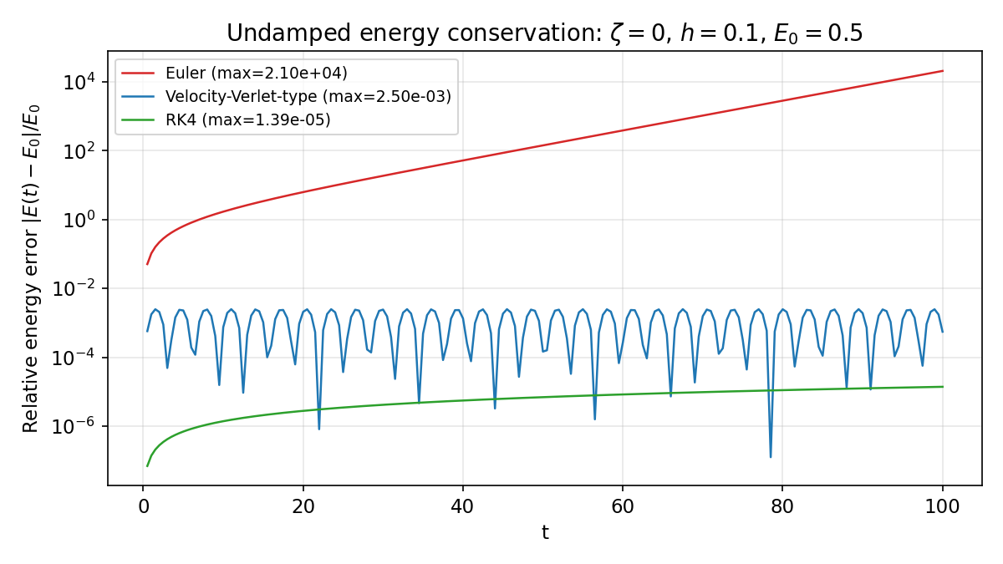
Figure 6. Relative energy error |E(t)-E₀|/E₀ at ζ = 0, h = 0.1, t∈[0,100] (log scale). Euler grows secularly; the Verlet-type error is bounded and oscillatory; RK4 drifts the least. Legend maxima are taken over the full integration grids.

Discussion
The Verlet-type scheme is not symplectic.
We stress again (Section 3.2) that the scheme used here is a pragmatic adaptation of velocity Verlet to velocity-dependent damping, not the textbook symplectic algorithm. Its bounded energy error in Fig. 6 comes from the fact that at ζ = 0 it coincides with standard velocity Verlet—not from any symplectic property of the damped variant. For ζ > 0 no energy conservation should be expected, and the second-order convergence in Section 4.1 is the property that actually transfers.
Phase (dispersion) measurement limitation.
The saved metrics.csv column phase_slope holds per-period peak-time drift. The implementation (analysis.phase_error) returns the least-squares slope; the CSV values have been refreshed to match the corrected implementation. A direct recomputation from the saved trajectories at ζ = 0.1, h = 0.2 with parabolically refined peaks gives approximate drifts of -0.042 s/period (Euler), -0.0097 s/period (Verlet-type), and + 0.0003 s/period (RK4) against the exact period T = 6.315 s—but with only three peaks in t∈[0,20] these are coarse estimates, and we present them as such.
Other limitations.
The Euler convergence order at ζ = 0.1 (1.27) is steepened by the pre-asymptotic h = 0.2 point sitting on the stability boundary; it is not evidence of superlinear convergence. RK4 at the finest step remains above machine epsilon; these runs do not establish a round-off floor. CPU timings are machine-dependent. All figures are regenerated from saved CSVs without re-running the solvers, so the images are exactly reproducible from the repository data.

Conclusion
On the damped harmonic oscillator, textbook expectations are confirmed quantitatively: explicit Euler is first-order, cheap per step, but linearly unstable for h > 2ζ and energetically disastrous over long runs; the velocity-Verlet-type adaptation is robustly second-order and an economical middle ground, though it must not be confused with symplectic Verlet; classical RK4 is fourth-order and dominates on accuracy per unit cost, with the smallest long-time energy drift. The stability-boundary scan validates the linear theory |1 + hλ|² = 1-2ζ h + h² to 3.1×10⁻⁵, and the energy-growth law Eₙ/E₀ = (1 + h²)ⁿ for Euler is confirmed to machine precision.
Data and reproducibility.
All solvers (solvers.py), the analytic model (model.py), the analysis (analysis.py), the experiment runners (experiments/), the saved data (data/*.csv), and the figure script (figures/make_figures.py) are in the local repository damped-oscillator. Figures were built from the CSVs only; re-running the experiments reproduces the data (modulo machine-dependent timings).

Supplementary images supplied with the draft
Conversion note: The following two images are present in paper_figures but are not cited in main.tex. The source provides no captions for them; the manuscript text has been preserved.
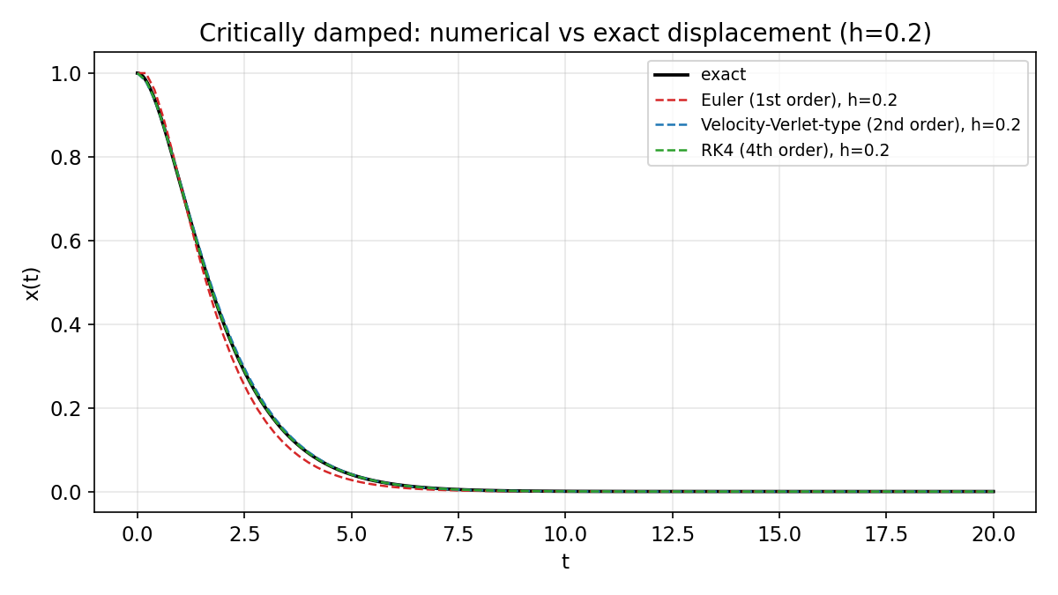
fig2_critical_trajectory.png — No caption provided in the source manuscript.
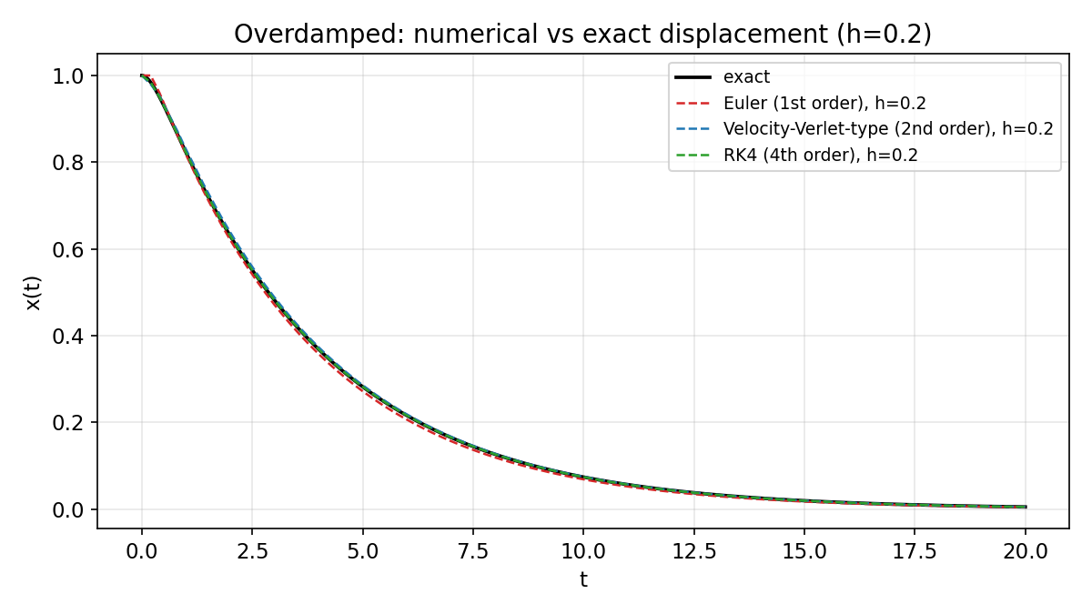
fig3_overdamped_trajectory.png — No caption provided in the source manuscript.

