Installation Cow Server

For Windows 2012 Server

Input: File cowserver_0.1.zip

Prerequisites:

. IIS 8.0 is installed

. Web Deploy is installed (<http://www.iis.net/downloads/microsoft/web-deploy>)

. Optional: Web sockets role is enabled (<http://www.iis.net/learn/get-started/whats-new-in-iis-8/iis-80-websocket-protocol-support>)

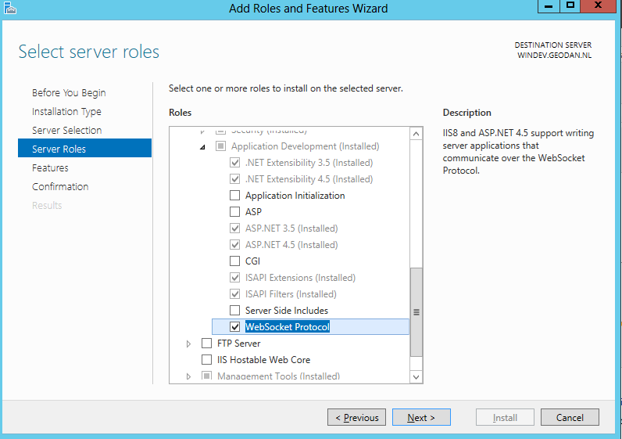

1] Installatie

Open IIS Manager

Go to ‘default web site’ -> right click -> Deploy -> Import Application

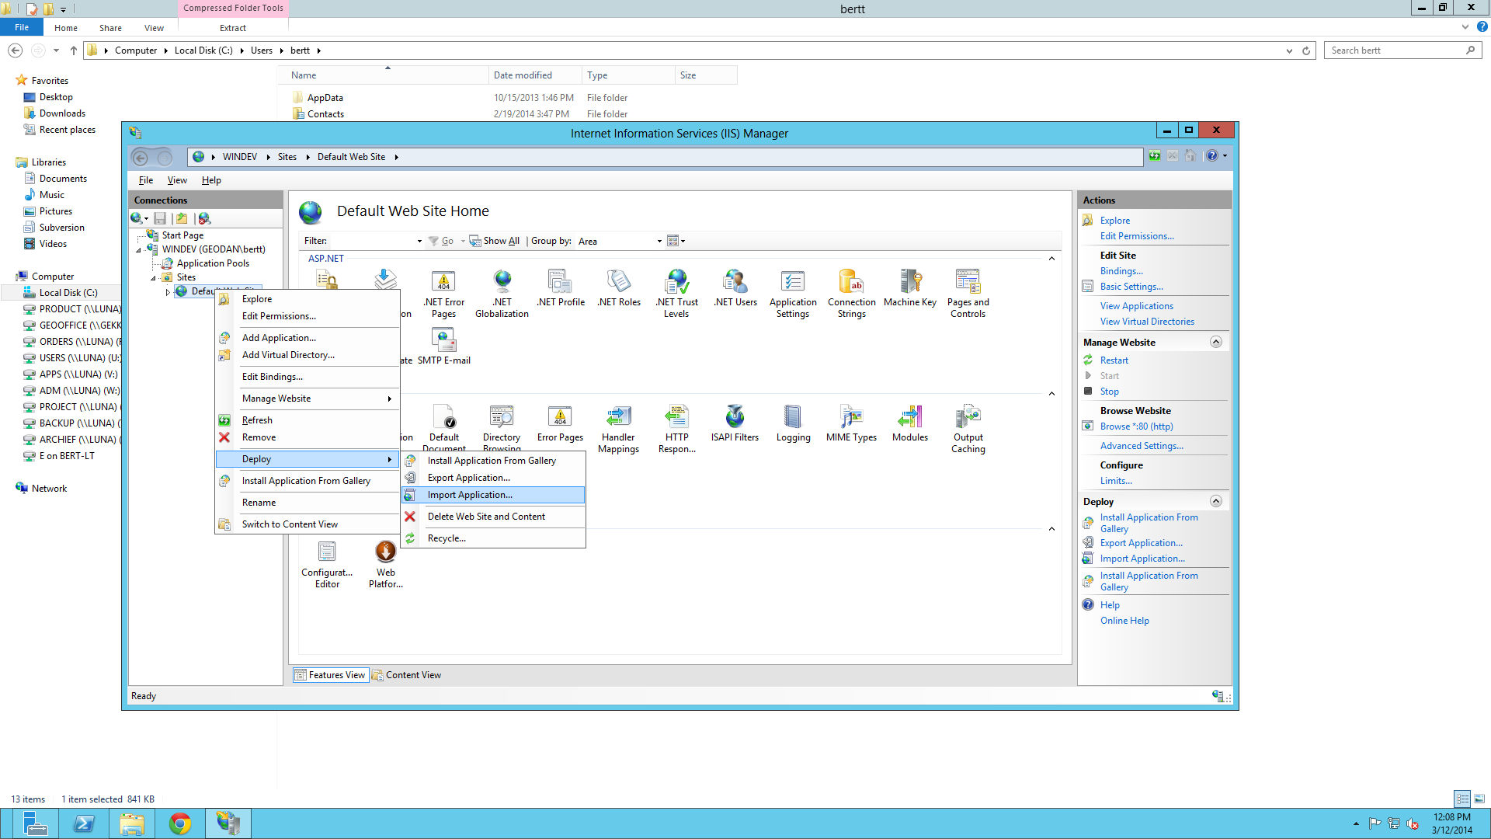

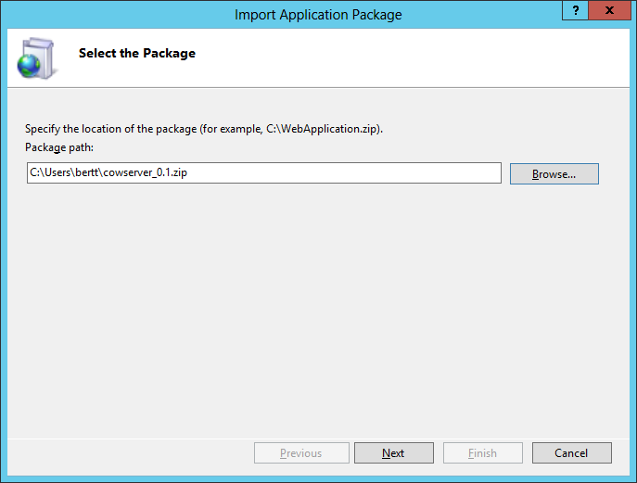

Next

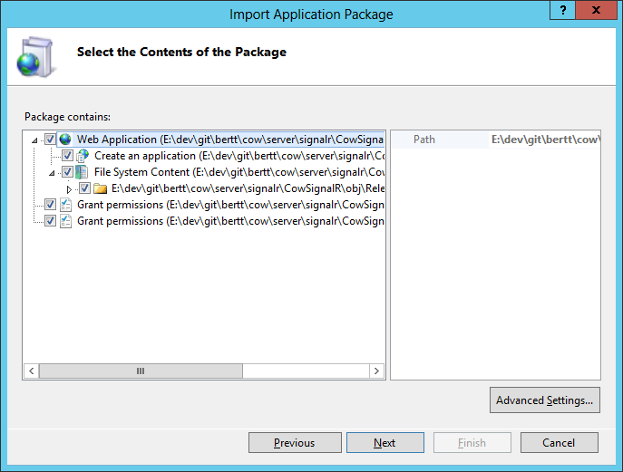

Next

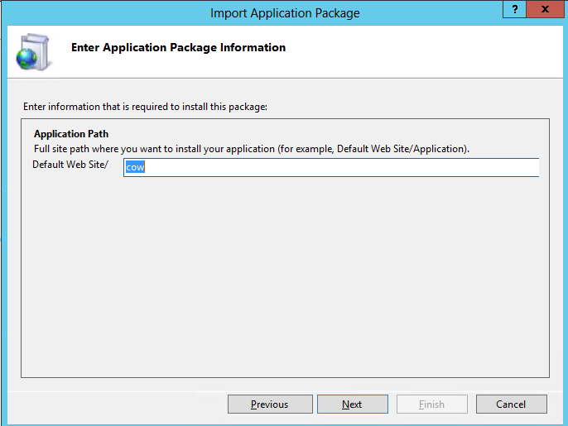

Next

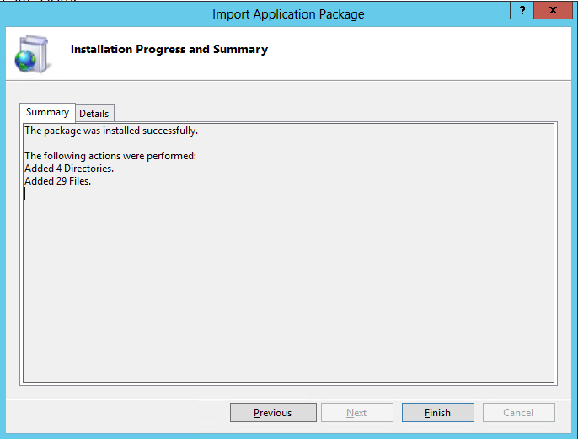

Finish

Bestanden zijn geinstalleerd onder:

C:\inetpub\wwwroot\cow

2] Test

Open browser <http://localhost/cow/cowhub.html>

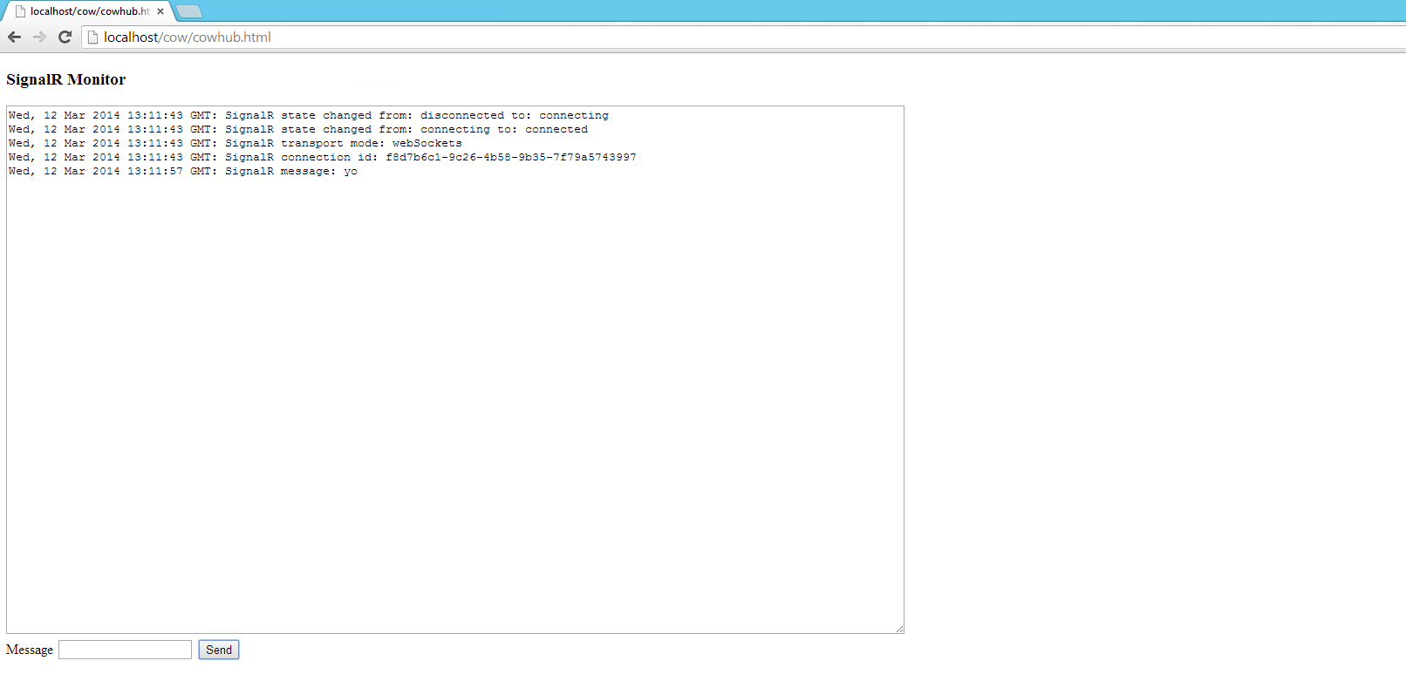Klaar