1. Which company has launched the most rockets?

SELECT company, COUNT(*) AS num_rockets_launched

FROM space_missions

GROUP BY company

ORDER BY num_rockets_launched DESC

Limit 5;

"company" "num_rockets_launched"

"RVSN USSR" 1723

"CASC" 1050

"SpaceX" 710

"Arianespace" 680

"NASA" 650

2. What is the most common location for space missions?

SELECT location, COUNT(*) AS num_missions

FROM space_missions

GROUP BY Location

ORDER BY num_missions DESC

Limit 5;

"country" "num_missions"

" USA" 3214

" Russia" 1618

" China" 1120

" Kazakhstan" 886

" France" 702

3 Cost by the top 5 countries

SELECT country, COUNT(*) AS num_missions, SUM(price) AS total_cost, ROUND(AVG(price), 2) AS avg_cost

FROM space_missions

GROUP BY country

ORDER BY num_missions DESC

LIMIT 5;

"country" "num_missions" "total_cost" "avg_cost"

" USA" 3214 226219.64 111.22

" Russia" 1618 5603.12 3.85

" China" 1120 18912.26 30.80

" Kazakhstan" 886 24259.48 31.92

" France" 702 36320 81.43

4 What is the most common street for space missions?

SELECT street, COUNT(*) AS num_missions

FROM space_missions

GROUP BY street

ORDER BY num_missions DESC

LIMIT 5;

"street" "num_missions"

"LC-39A, Kennedy Space Center, Florida" 596

"ELA-3, Guiana Space Centre, French Guiana" 363

"Site 31/6, Baikonur Cosmodrome" 339

"SLC-41, Cape Canaveral AFS, Florida" 304

"SLC-40, Cape Canaveral AFS, Florida" 290

5. Has the number of space missions increased or decreased over time ( in decades)?

SELECT year, COUNT(*) AS num_missions

FROM space_missions

WHERE year IS NOT NULL

GROUP BY year

ORDER BY year DESC;

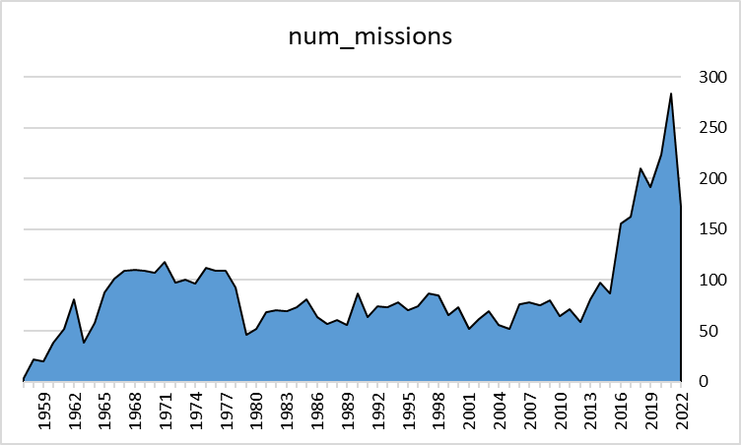

6 SELECT FLOOR(year/10)*10 AS decade_start, COUNT(*) AS num_missions

FROM space_missions

WHERE year IS NOT NULL

GROUP BY FLOOR(year/10)*10

ORDER BY decade_start DESC;

"decade_start" "num_missions"

2020 680

2010 1182

2000 673

1990 758

1980 651

1970 989

1960 784

1950 45

7. What is the success rate of space missions?

SELECT (round(COUNT(*) FILTER (WHERE missionstatus = 'Success') * 100.0 / COUNT(*)),2) AS Success_percentage,

(round(COUNT(*) FILTER (WHERE missionstatus = 'Failure') * 100.0 / COUNT(*)),2) AS Failure_percentage,

(round(COUNT(*) FILTER (WHERE missionstatus = 'Partial Failure') * 100.0 / COUNT(*)),2) AS Partial_Failure_percentage,

(round(COUNT(*) FILTER (WHERE missionstatus = 'Prelaunch Failure') * 100.0 / COUNT(*)),2) AS Prelaunch_Failure_percentage

FROM space_missions;

"success_percentage" "failure_percentage" "partial_failure_percentage" prelaunch_failure_percentage"

"(64,2)" "(4,2)" "(2,2)" "(0,2)"

8. Are there any correlations between rocket status and mission success?

SELECT rocketstatus, missionstatus, COUNT(*) AS num_missions, SUM(CASE WHEN missionstatus = 'Success' THEN 1 ELSE 0 END) AS num_successes, AVG(CASE WHEN missionstatus = 'Success' THEN 1 ELSE 0 END) AS success_rate

FROM space_missions

WHERE rocketstatus IS NOT NULL

GROUP BY rocketstatus, missionstatus

"rocketstatus" "missionstatus" "num_missions" "num_successes" "success_rate"

"Active" "Failure" 75 0 0.00000000000000000000

"Active" "Partial Failure" 26 0 0.00000000000000000000

"Retired" "Prelaunch Failure" 3 0 0.00000000000000000000

"Retired" "Success" 3515 3515 1.00000000000000000000

"Active" "Success" 1754 1754 1.00000000000000000000

"Retired" "Failure" 289 0 0.00000000000000000000

"Retired" "Partial Failure" 100 0 0.00000000000000000000

9. What is the total number of space mission completed till date?

SELECT COUNT(*) AS num_missions

FROM space_missions

"num_missions" 2518

10. What is the average price of a space mission?

SELECT AVG(Price) AS avg_price

FROM space_missions

"avg_price" 56.2777334258937869

11. What are the most expensive space missions?

SELECT price, country, COUNT(*) AS num_missions

FROM space_missions

WHERE price IS NOT NULL

GROUP BY price, country

ORDER BY price DESC

Limit 5;

"price" "country" "num_missions"

5000 " Kazakhstan" 4

1160 " USA" 26

450 " USA" 272

350 " USA" 26

200 " France" 160

10. What are the cheapest space missions?

"price" "country" "num_missions"

0 " New Zealand" 3

0 " Pacific Ocean" 32

0 " Barents Sea" 3

0 " Japan" 83

0 " South Korea" 5