HI BELLE I CANT BELIEVE YOURE 18 NOW!!!! I HOPE YOU HAVE THE MOST WONDERFUL DAY AND LIVE IT UP BECAUSE 18 IS A BIG DAY :,) I hope you get lots of Steven universe, undertale, scooby doo, and cute aesthetic stuff!! I love you so much and miss you bunches and I cant wait until season 6 comes back so we can gush about lapidot together ♡ Happy 18th and many more birthdays to come! Love, Coral
-@coralcatbear
howdy bang 😎 (I finally understand that cjsjcjsn),
I still remember the first time we talked, I was at the airport waiting to board a flight. Imma be honest, I usually text new ppl when i’m in a situation so I have an excuse to leave if I wanna but with you I didn’t want the convo to end, but sadly my flight had other plans. You showed me your wall with the SU characters and I showed you my pins (this may have been later I have a horrible sense of time so bare with me). I’m so glad I got to talk to you that day bc you became one of my closest friends 💕. Idk how long it’s been since our first convo but it feels like i’ve known you forever. I really hope I get the chance to meet you irl sometime (*cough* adopt me I hate america and the fucking cheeto we have as president). I also hope you have an amazing birthday bc you deserve it. You are someone that i can always rely on and trust. You are so sweet and have a great sense of humor. And you deserve all the happiness in the world and i’m so glad I met you. Happy birthday ❤
-Ash/Em/whatever name I pick lmao
Happy birthday, dear ❤❤💕 you're an amazing being that deserves only the best!! my wish for you this birthday is that in this year you get to conquer all your dreams and expectations, only happiness and good things 💕❤❤ lovee you ❤❤💕
@iamrosequartz
Happy Birthday Blue!
- Fred
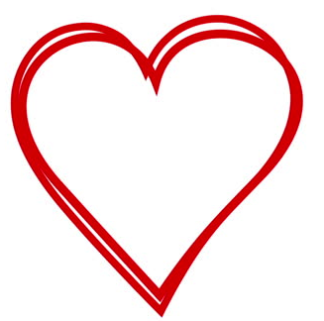
Happy birthday!
I realized that none of your twitter friends would be able to get anything, so I asked around and compiled all of their birthday wishes for ya. As well as mine. So here goes.
I love you. More than words can describe. I’m so super duper sorry you don’t have all your presents on your birthday, especially your big one but its taking way longer then I was hoping it would.
You’re the most perfect girl in the world. I love every minute I spend with you, talking about undertale which I now cannot wait to play!, SU which I cannot wait to watch the move with you! Then star soon then possibly some of my shows!
Through this past month you’ve been the one who’s kept me sane I’ve been so stressed but coming to see you is just the best escape I love you so much.

