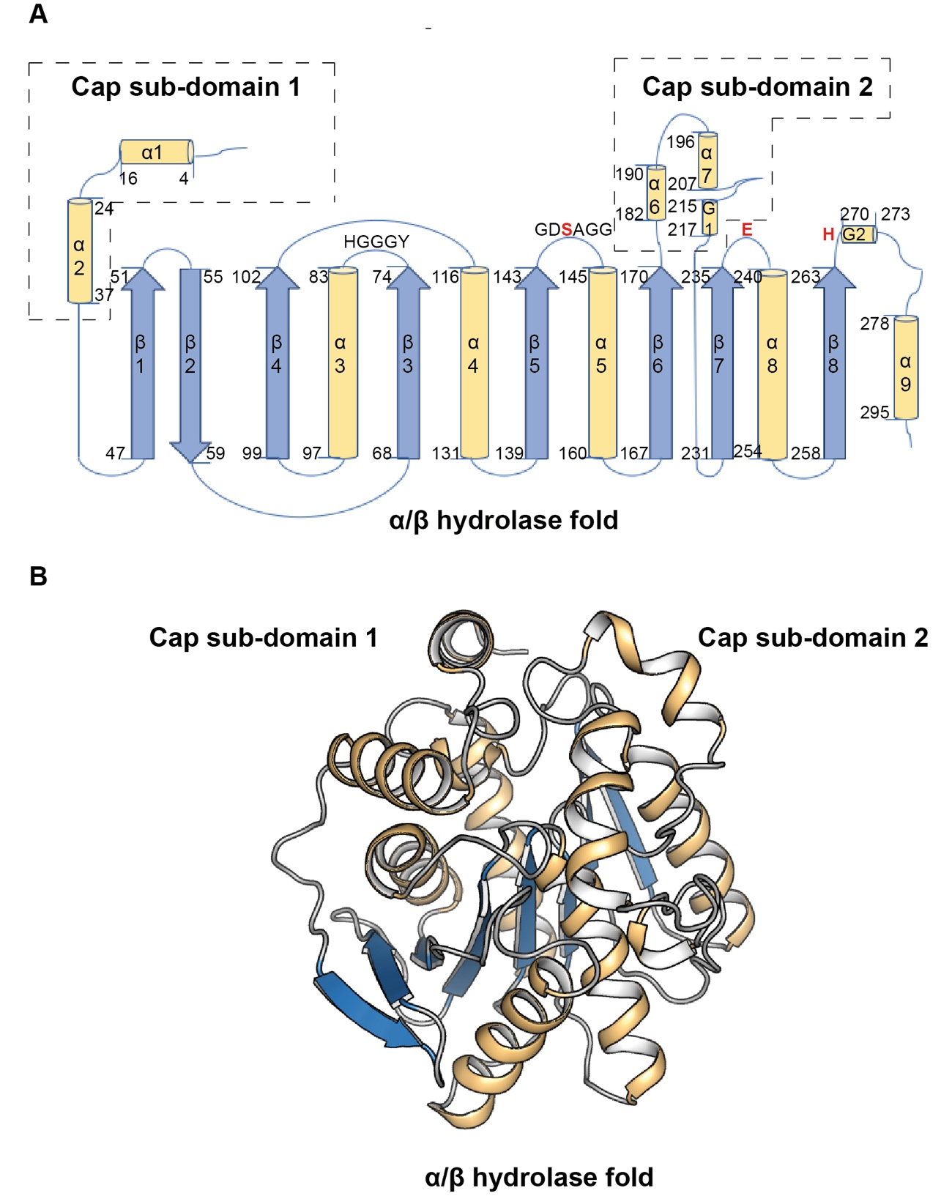

***Figure S6.* Secondary structure in EstD11. (A)** Topology diagram of EstD11. a-helices are represented as yellow cylinders (labeled a1-a9), and b-sheets as blue arrows (labeled b1- b8).Relevant residues labeled and catalytic **(**Ser144, Glu238 and His268) highlighted in red. **(B)** Three-dimensional structure of EstD11 with secondary structure elements colored as in panel A.

The catalytic cavity is covered by a cap domain (Fig. 6B) composed by two subdomains coming from different parts of the sequence. Cap subdomain 1 is located at the N-terminal region (residues 2–43) and cap subdomain 2 is inserted between beta strands β6 and β7 of the α/β hydrolase core (residues 172–225) (Fig. S6).

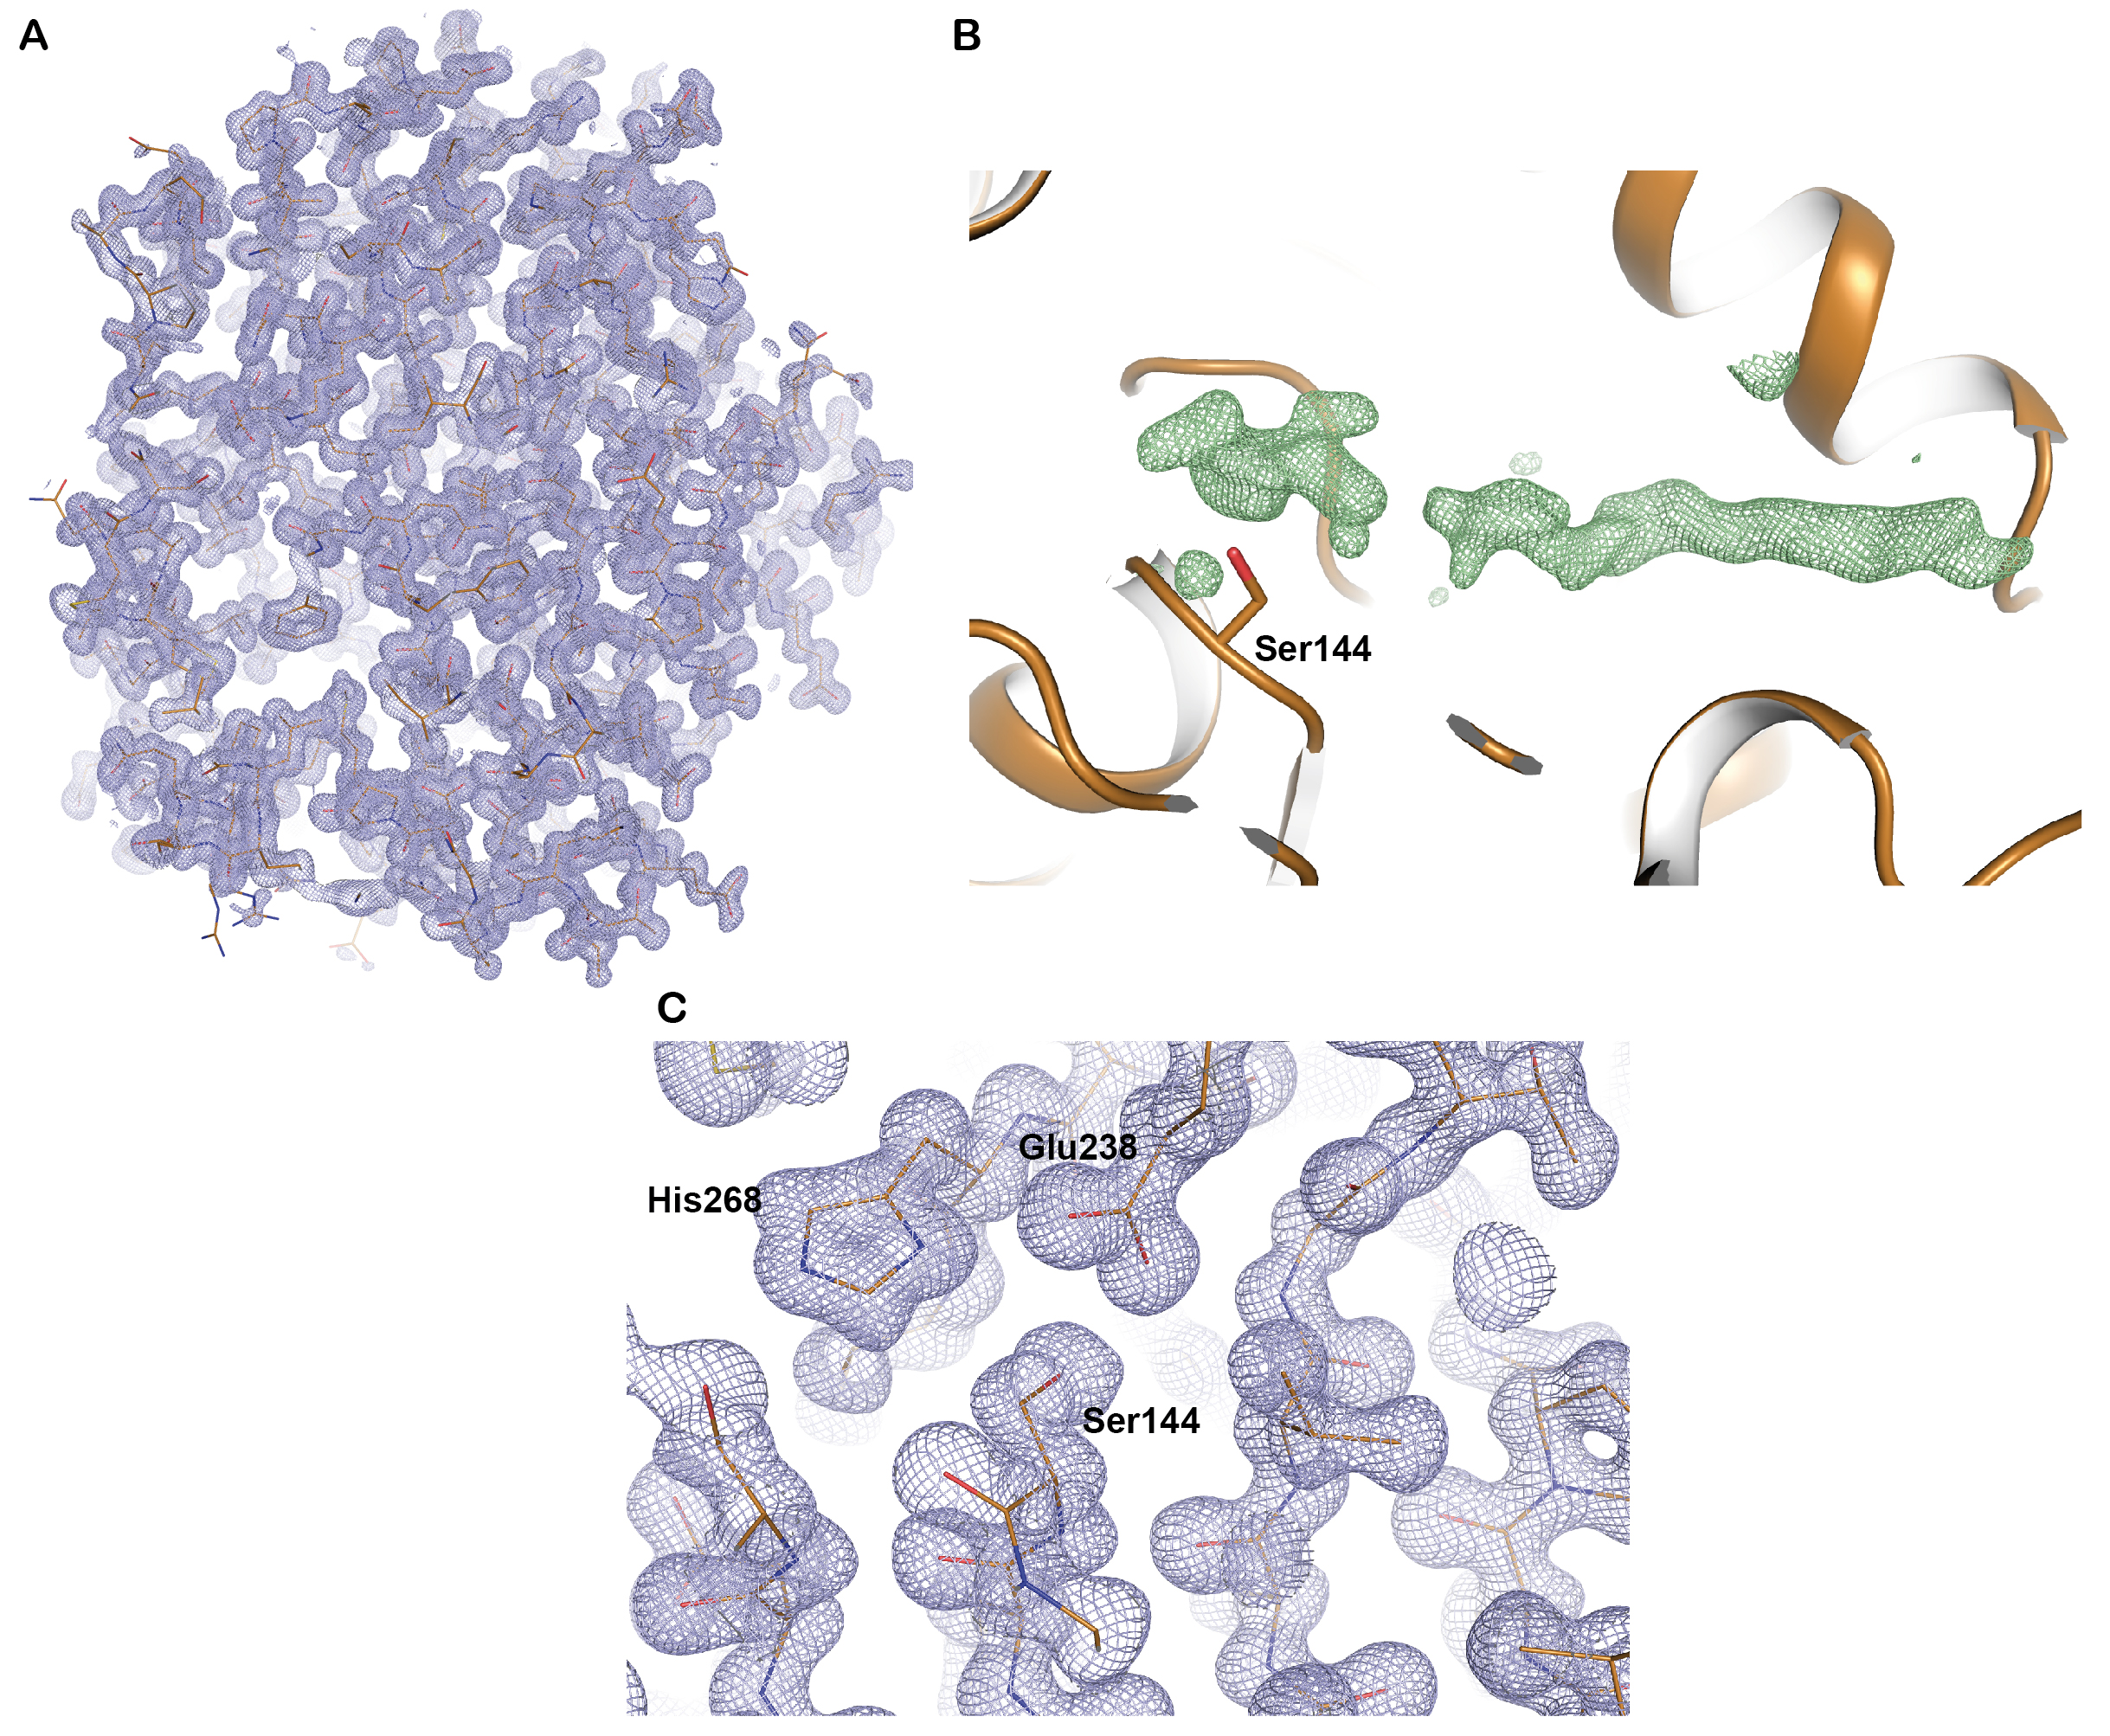

***Figure S5.* Final refined electron density map of EstD11 at 1.2Å resolution.** The protein is shown as orange lines. **(A)** Overall representation of EstD11 (chain A) 2*F*o –*F*celectron density map in blue contoured at 1σ. **(B)** Difference map (*F*o –*F*c)for an unmodeleled density inside the substrate pocket, colored in green and contoured at 2.5 σ. (**C**) A close up on the catalytic triad residues (Ser144, His268 and Glu238). 2*F*o –*F*c electron density map in blue, contoured at 1σ.

Based on structural superimposition with other HSL family members (see below) the catalytic machinery of EstD11 is carried out by a catalytic triad (Ser144, Glu238, His268) and an oxyanion hole delimited by residues Gly76, Gly77 and Ala145. The oxyanion sequence His-Gly-Gly-Gly (74–77), upstream of the active site, is conserved in the HSL family and it agrees with the classification criteria established in the α/β-hydrolase fold 3DM database [2]. Furthermore, the N-terminal neighbor of the Nucleophile serine is an Aspartic (Asp143), a feature conserved in members of IV subfamily.

Structural analysis reveals that, while keeping conserved polar interactions connecting α2 with the αβ hydrolase core (involving Arg28, Glu111, Ala109 and Val79), EstD11 lacks bulky hydrophobic residues at the L1 /α 7 interface (Fig. 11C). Instead Arg201 in α 7 stablishes H-bond interactions with main-chain atoms of L1 (Fig. 11C). Interestingly, a Met zipper is observed linking cap subdomain 1 (Met27, Met34, Leu19, Leu13) with α 7 (Met193, Met202, Met205) that results in a similar conformation for L1 loop to that observed in other thermophilic esterases (Fig. 11D).

python run_inference.py inference.deterministic=False diffuser.T=200 inference.output_prefix=output/ligand_protein_motif/mes_entire_ inference.input_pdb=input/design_1.pdb contigmap.contigs=[\'10-150,A86-86,A268-268,10-150\'] contigmap.length="150-300" inference.ligand=MES inference.num_designs=5 inference.design_startnum=0

**Design 1**

**2 residues only**

**His86 - > Met**

**His268 -> Glu**

python run_inference.py inference.deterministic=False diffuser.T=200 inference.output_prefix=output/ligand_protein_motif/mes_entire_ inference.input_pdb=input/design_1.pdb contigmap.contigs=[\'10-100,A86-86,50-200,A268-268,10-100\'] contigmap.length="150-300" inference.ligand=MES inference.num_designs=5 inference.design_startnum=0

**Design 1a**

ligand mpnn entire enzyme to bind mes

**Design 1b**

Diffuse entire enzyme to bind mes then ligand mpnn

**Design 2**

**2 residues + fix cap proteins**

**His86 - > Met**

**His268 -> Glu**

**Fix -> 2–43, 172–225**

python run_inference.py inference.deterministic=False diffuser.T=200 inference.output_prefix=output/ligand_protein_motif/mes_fixcap- inference.input_pdb=input/design_1.pdb contigmap.contigs=[\'A2-43, 5-50, A86-86, 50-200, A172-225, 5-50, A268-268, 5-50\'] contigmap.length="150-350" inference.ligand=MES inference.num_designs=5 inference.design_startnum=0

note: need to fix the residues in protein MPNN or the structures are bad – 16/5/24

**Design 3**

**Redesign binding pocket, fix the rest <- try just Ligand mpnn and see if its good enough for a redesign of the pocket**

Change -> ['13', '27', '31', '75', '76', '77', '80', '81', '86', '143', '144', '202', '267', '268', '269', '270', '272', '273']

Fix -> A2-12, A14-26, A28-30, A32-45, A48-58, A60-67, A69-73, A82-85, A87-108, A120-142, A146-179, A198-201, A205-216, A218-265

python run_inference.py inference.deterministic=False diffuser.T=200 inference.output_prefix=output/ligand_protein_motif/mes_activesite_ inference.input_pdb=input/design_1.pdb contigmap.contigs=[\'A2-12, 2-5, A14-26,2-5, A28-30, A32-74, 2-5, A78-79, 2-5, A82-85, 2-5, A87-142, 2-5, A145-201, 2-5, A203-266\'] contigmap.length="150-350" inference.ligand=MES inference.num_designs=5 inference.design_startnum=0

1a – fix most of enzyme, use ligand mpnn to redesign active site residues only.