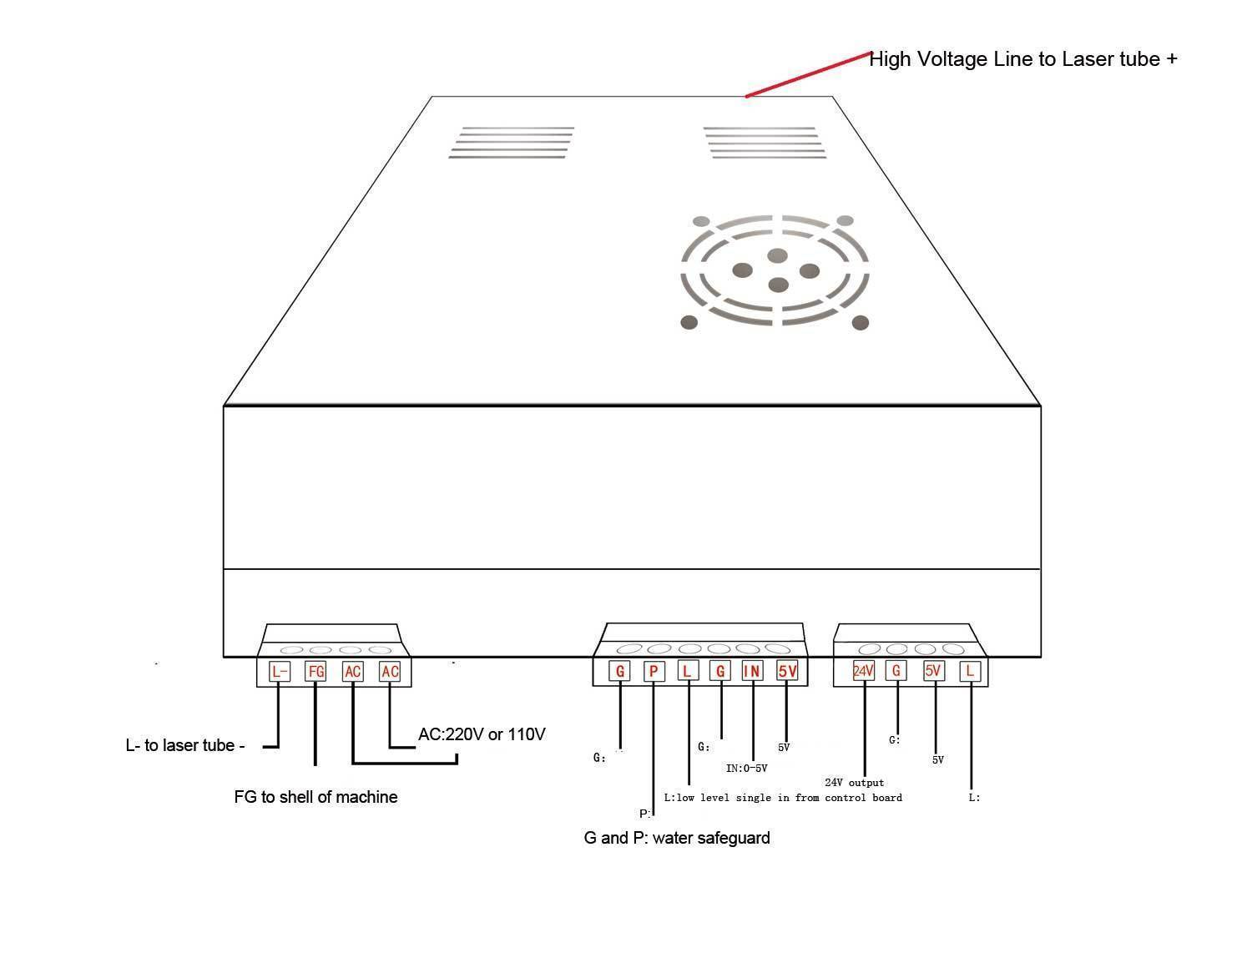
4 Pin Connector to Powet
L | Earth fro laser tube cathode
FG | Chassis ground
AC | active
AC | neutral

6 Pin Connector To Control Panel
G1 | 0
P1 | 0 | G1 and P1 may be swapped, check!
L1 | 0 | Connected to L1 on 4 pin connector,Low to enable
G1 | 0 | To potentiometer
IN | Centre pin | To potentiometer
5V | 0 | Supply to potentiometer only

4 Pin Connector to Controller
24V | 0 | 0
G1 | 0
5V | 0 | 0
L1 | 0 | Connected to L1 on 6 pin connector, low to enable

