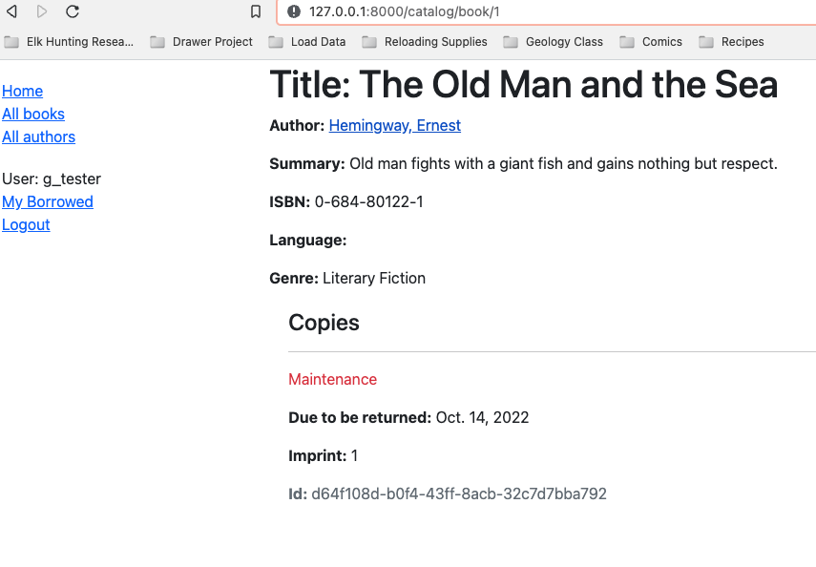

The book detail page outlines all copies of the books and their status.

The Author List page lists all authors of books in the library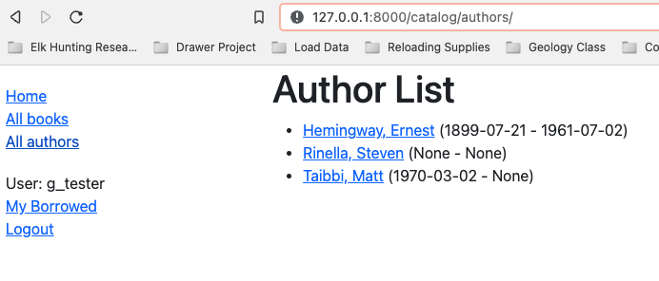

The Author Detail page list the authors name and all the books he/she has written which are in the library.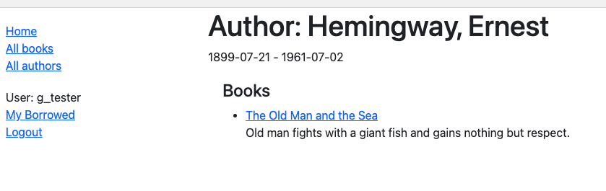

The Book list shows a list of all books in the library and their authors.