**Walks and open spaces by Croham Valley Road** (written for nr.97)

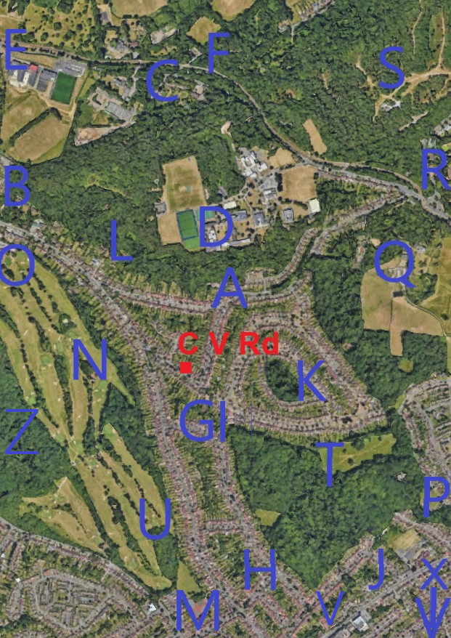

There’s a bridle path at end's of Crest Road **(A)** that takes you to Whitgift Sports Club playing fields, at end of Croham Valley Rd. It runs along the edge of Ballards Woods**(L)**, owned by Royal Russell School (that’s the wooded hillside seen from 97’s back bedrooms, with the school's spire on top**(D)**; (it’s pleasant to just pick up its bells playing the quarter-hours in the garden; & wind from the spires huge golden wind-vane). This bridle path takes you onto a 2nd bridle path**(B)** through woodland to delightful Coombe Woods Gardens**(C)** with its courtyard cafe, ponds and well maintained walks. Next to that is a Beefeater which makes a nice woodland walk for an evening meal in the summer. From there, cross the road onto open woodlands**(F)** leading onto Lloyds Park**(E)**  with its tram,tennis,childrens’play area & cafe

Alternatively, when you reach the end of Ballards Farm bridleway; Cross Croham Valley Rd to entrance of Croham Hurst woods**(Z)**. We enjoyed this wood a lot, has great views on-top of its high ridges. Its holds more birds than Selsdon’s Bird Sanctuary, perhaps because its ancient woodland. (Stone-age settlement found here & has a Bronze-age barrow on summit) ; (It’s where some of the bright green parakeets spend the day. They visit 97’s garden just before sunset,on the way uphill roost). (on nice days, we used to walk home from St Peter primary school through these woods via bridalway & Crest Rd. A footpath tracks the edge of the golf course towards Selsdon allowing a circular walk back through Littleheath Woods**(T)**.

Four buildings up from the house there's a footpath to Littleheath Road**(G)** so you can walk to Selsdon on quiet side streets. Half way up the hill**(H)** we always turn round for great views over Croydon's 'Little Manhattan', across London to the Chilton Hills on the other side.

Two more buildings up CV Rd, there's a little green park**(I)** that leads onto Littleheath Woods with many footpaths. It has ponds and 2 quite large parks (one perfect for tobogganing)**(T)**. It's a great walk through the woods to Selsdon, and takes about 18 minutes, with the footpath emerging opposite Iceland shop**(J)** next to Selsdon’s community club. For meeting-up with locals & exercise, the friendly local community group meet each Tuesday to maintain Littleheath Woods.

The walk to the local shops at Chapel View**(K)** is much closer than Selsdon. It’s next to the small little ancient woodland hill of ‘The Ruffets’. The convenience shop delivered newspapers to nr.97 (nice that he’ll deliver just a Sunday paper to some; They also came to collect 97’s dry cleaning & shirts to launder)

A side exit out of Littleheath Woods takes you near Queenshill Rd & its community tennis clubhouse, with 5 courts.**(H)** Behind that is Queenshill playspace park. A path through woods**(U)** from there takes you onto Croham Hurst Golf Course**(N)** . It's a nice walk round the golf course boundary to the clubhouse and its restaurant**(O)** (a good walk for a booked tea, or Sunday lunches). Cross Croham Valley Rd from there for the option to walk home on the bridle-way to Ballads Farm mentioned above.

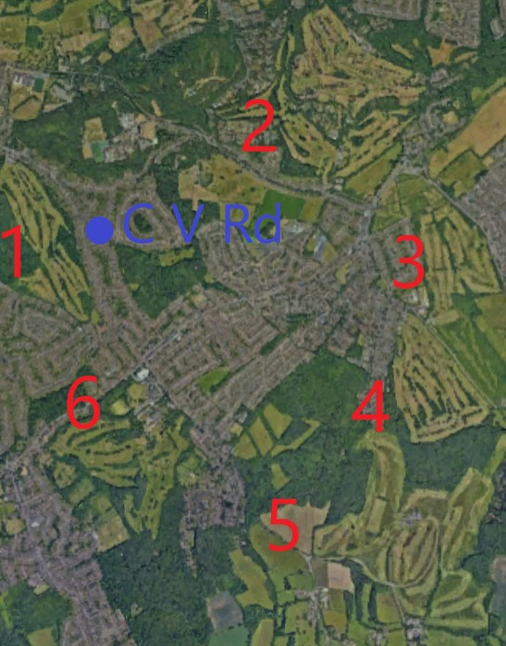

Between Heathfields & Littleheath is Bramley Bank Nature Reserve**(Y)**, 28acres; withs easy paths, ponds & widlife; upkeep by local volunteers, good for bluebells in spring; access from Littleheath or Ballards Way

Croham Valley Road is part of Costain’s development called “Selsdon Garden Village” when it started 1926, and then “Croham Heights” when it expanded in early 1930s. Court Wood, with Selsdon Wood**(X)** & bird sanctuary, 200acres were bought & protected around this estate; The 433 bus from Croham Valley Rd runs to the bird sanctuary.

If shopping at Selsdon’s Sainsburys, a nice local walk, 50mtrs from the car park, is to walk through woods between Selsdon Park’s entrance lodges**(V)**, then cross the road to Sanderstead Plantation woodland, Croydon highest point 575ft

Another favorite area. At the top of Ballards Way is Heathfields**(Q)** estate with rhododendron walks

ornamental gardens & ponds. Has walled gardens run by volunteers to visit. It has a car park, but can be reached by footpaths from CV Rd via Littleheath Woods. Across the road from that is Addington Hills**(R)**, big woods with hill-top walks, (A Chinese Restaurant**(S)** is within the woods & worth visiting on a walk). A stone viewing platform**(S)** looking over London and used to be a day trip destination for Londoners.

**Further Afield**

For more enthusiastic walking; The 66 mile long Vanguard Way, is one of Britain's 17 long distance footpaths, crosses Croham Valley Rd, 6 buildings up from 97 & goes through Littleheath Woods**(P)** to Newhaven on The Channel Coast. (Nearly finished doing it in 7 afternoon strolls)

If you catch the 64 bus\* to Addington's quaint ancient village (or take a long trek from Littleheath), You can walk through Addington Park(Q**)** (park of Addington Palace, once home of Archbishops of Canterbury). From there is a good track South, following a straight Roman road around the edge of New Addington (to the North, the Roman road is mostly built-over, but remains of a villa can be seen is not far away and further north is Orpington Villa’s museum) but the southern walk is on footpaths heading towards White Bear Pub in the countryside, with footpaths all round (warning from last experience at end of a long walk, it now shuts on many days) (\*64 bus is 3 minutes away from the house & in other direction goes to South, East & West Croydon stations, 6 per hour, (& 2ph all night); also from same bus stop nr.433 from Addington & Selsdon to Fairfield Halls, Croydon at 5 per hour, so average wait less than 3 minutes)

Our parents lived at 97 CV Rd for 68 years, they didn't golf too much, but it became a bit of a hobby to visit the 6 hill-top golf courses that surround them for coffee and cake in the pleasant club-house cafes, for the views and walks. [nr.6 ex.Selsdon Park Hotel’s course got converted to wildlife reserve & is on the market]

A good trip was the 17 minute drive to Godstone Vineyard, & its restaurant. It’s by the junction onto the M25. After lunch, footpaths are there, and The North Downs Way (another of UK's 17 long distant paths run along ridgetop from Winchester to Canterbury).

Hope that's helpful, Geoff, March 2025

**Openspaces listed above;**

**S; Addington Hills,** 130acre

**Y; Bramble Bank Nature Reserve,** 10acres [https://www.wildlondon.org.uk/nature-reserves/bramley-bank](https://www.wildlondon.org.uk/nature-reserves/bramley-bank" \t "https://mail.google.com/mail/u/0/" \l "inbox/_blank)

**E; Coombe Gardens & Woods,** 14acres <https://www.croydon.gov.uk/sites/default/files/2021-02/Coombe_Wood_Leaflet.pdf>

**N; Croham Hurst Golf Club** <https://www.chgc.co.uk/>; attached to;

**Z; Croham Hurst Woods, 85acres** <https://friendsofcrohamhurstwoods.com/map/> <https://www.croydonist.co.uk/croham-hurst/>

**Q; Heathfield woods & gardens**,18acres <https://www.croydon.gov.uk/libraries-leisure-and-culture/parks-and-open-spaces/parks-and-playgrounds/parks-and-playgrounds-directory/heathfield> es <https://www.croydon.gov.uk/libraries-leisure-and-culture/parks-and-open-spaces/parks-and-playgrounds/parks-and-playgrounds-directory/addington-hills>

**T; Littleheath Woods**; 61acres <https://www.folw.co.uk/the-woods.php>

**L; Loyds Park,** 114acres <https://en.wikipedia.org/wiki/Lloyd_Park_(Croydon)>

**K; Ruffet Wood**, Chapel View, 2½acres, <https://cnhss.co.uk/green-place/the-ruffet/>

**V; Sanderstead Plantation; 22acres** <https://www.woodlandtrust.org.uk/visiting-woods/woods/sanderstead-plantation/>

**M; Selsdon Tennis Club;** <https://www.selsdon-tennis-club-ltd.co.uk/>

**X; Selsdon Wood**, 200acre; ‘Bird Sanctuary’; Friends of Selsdon Woods; <https://www.friendsofselsdonwood.co.uk/>

**H; Queenshill Playspace** park, 2acres <https://www.croydon.gov.uk/libraries-leisure-and-culture/parks-and-open-spaces/parks-and-playgrounds/parks-and-playgrounds-directory/queenhill-road-playspace>

**G to P; Vanquard Long Distance Path**; 66 miles;<https://ldwa.org.uk/ldp/members/show_path.php?path_name=Vanguard+Way>

**Videos**

Walk around **Selsdon**, giving some history <https://www.youtube.com/watch?v=rsMhsN_CbFY>

- and on **Littleheath Woods** <https://www.youtube.com/watch?v=xqLSZLR652M>

- and on the rewilding of **Selsdon Park** Hotel’s golf course <https://www.youtube.com/watch?v=AGU6Ure94aE>