BECE351E

Internet Of Things

*SOIL MOITURE AND*

*GAS SENSOR*

Prepared By:

Name: Geoffrey Anto

Register Number: 21BPS1388

BECE351E- Internet of Things Lab

Page 1

**List Of Tasks**

**S.No**

**Date**

**Task**

**Page.No.**

Soil Moisture Level Sensor

1

04/07

3

2

04/07

5

Gas/Air Monitor

3

4

5

6

7

8

9

BECE351E- Internet of Things Lab

Page 2

Task 1

Soil Moisture Level Monitor

**Arduino Code**

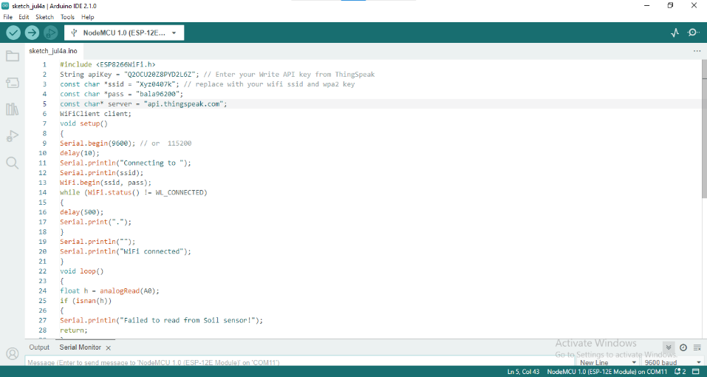

**Arduino Output**

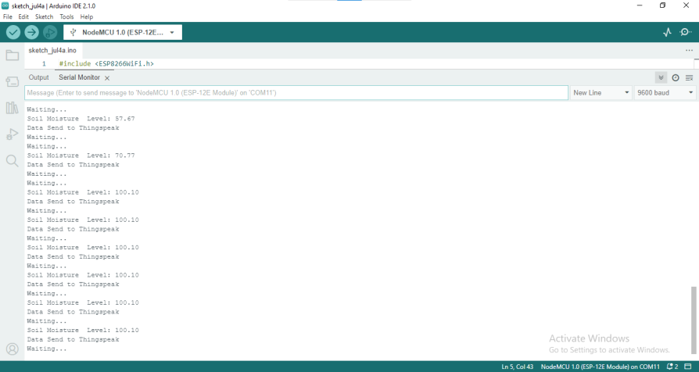

BECE351E- Internet of Things Lab

Page 3

**Thingspeak Configuration:**

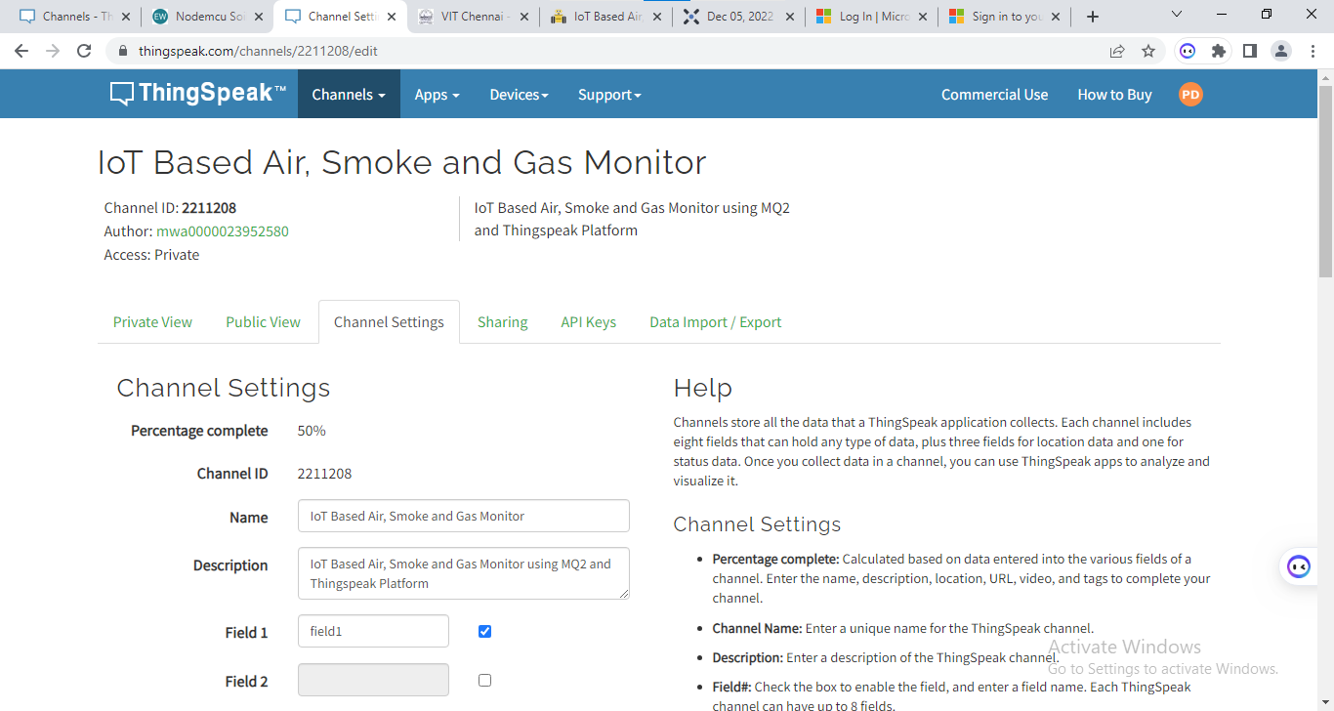

**Thingspeak Output:**

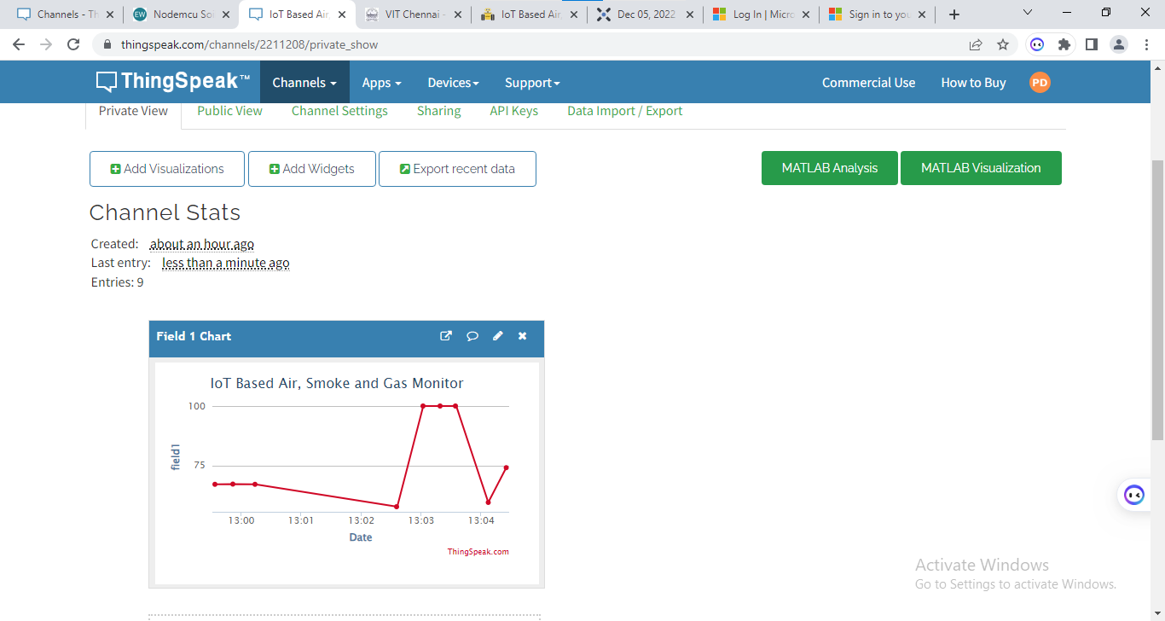

BECE351E- Internet of Things Lab

Page 4

Task 2

Gas/Air Monitor

**Arduino Code**

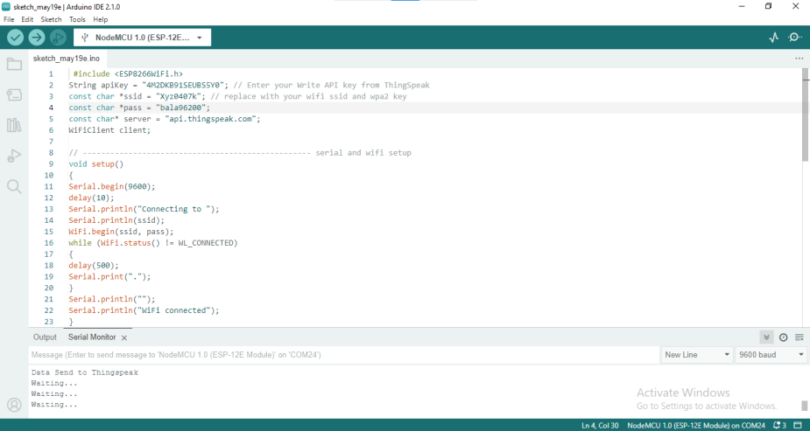

**Thingspeak Output:**

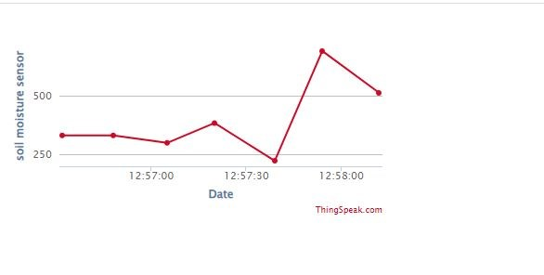

BECE351E- Internet of Things Lab

Page 5