**CSE361 Software Design Use Cases**

Team Maverick Applications Corporation:

Ryan Carlson, Stephen Pandorf, Jeremy Wagner, Kevin Rock

November 5, 2013

**4.1 Use Cases**

**4.1.1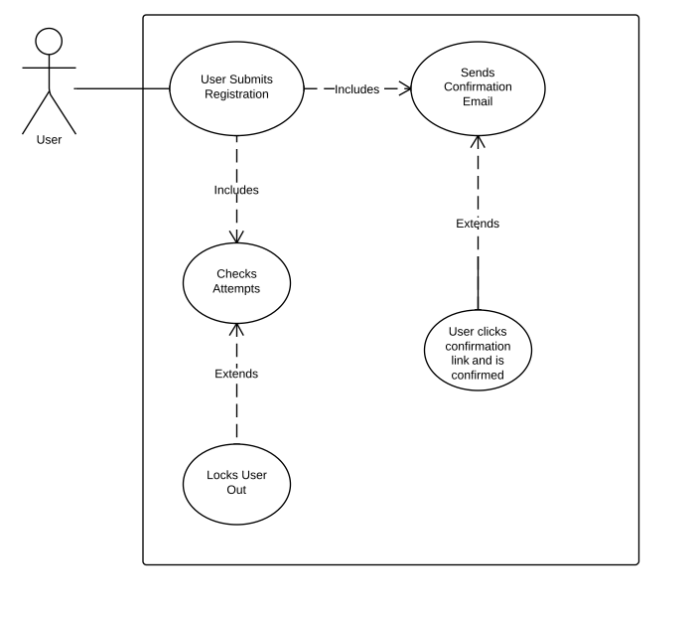 R2,R4.4**

This use case shows how the user can register and receive an email, and also shows how they will be locked out after attempting to log in after n attempts.

**4.1.2 R3,R4.1-4.3**

This use case shows how the user can register on the website. It offers alternate usernames if the one entered is already taken, and displays p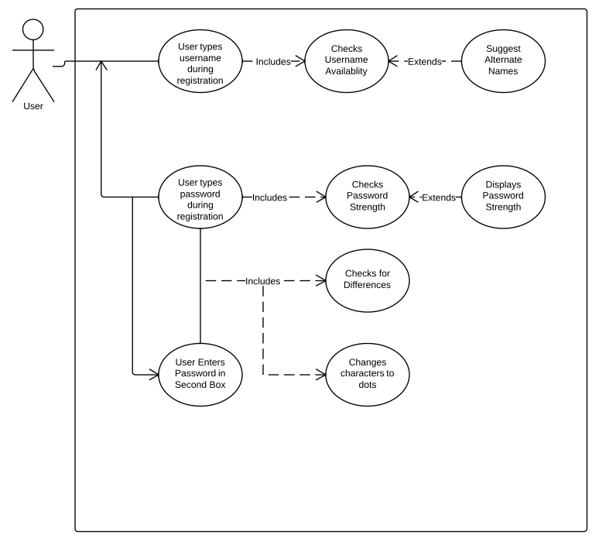assword strength. It outlines how the password will be checked for consistency after entered. Finally it shows how the password will be entered discreetly.

**4.1.3 R10**

This use case handles R10; it illustrates how the system will check if the 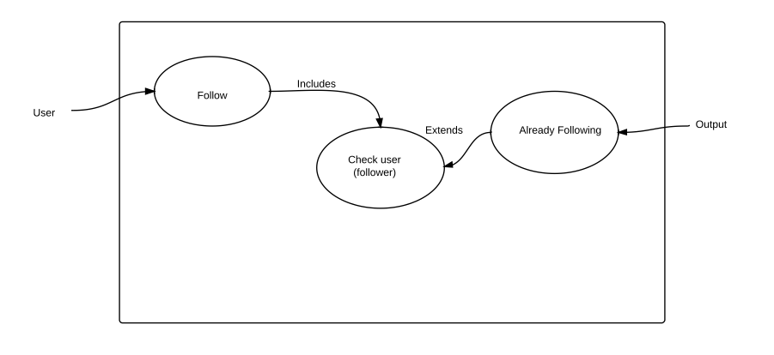user is already following another user when trying to follow them.

**4.1.4 R11**

This use case shows how the system will check if the user that i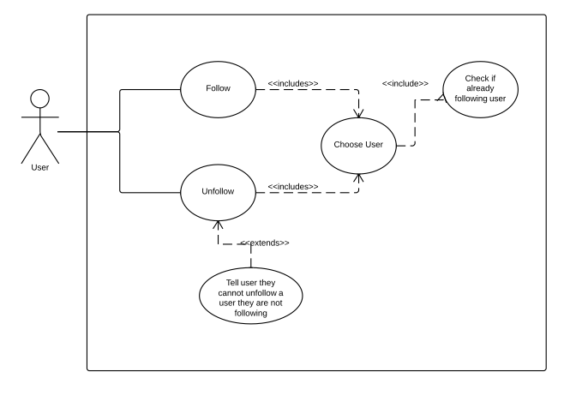s trying to be unfollowed is being followed in the first place.

**4.1.5 R12**

This use case shows how the user can type a post and have the character count updated as the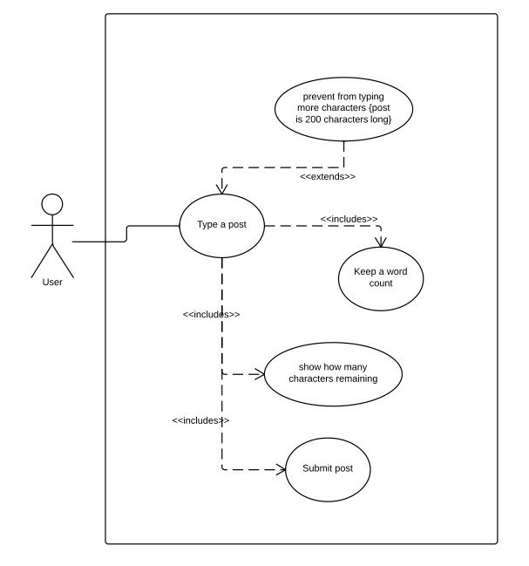y type. It prevents the user from typing if they already have 200 characters in the post text box.

**4.1.6 R13**

This use case handles R13, and more specifically R13.2. It illustrates how the contents of the main page can b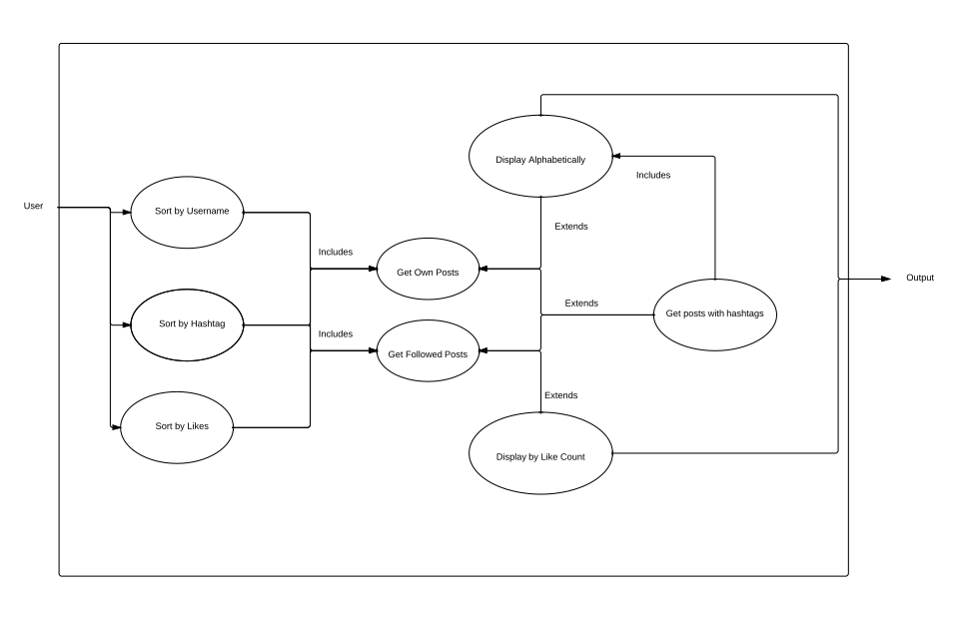e sorted by username, hashtag, or by likes. It considers the situation where a post may not have a hashtag as well.

**4.1.7 R14**

This use case shows how the user can comment on a post. It shows how the system checks if the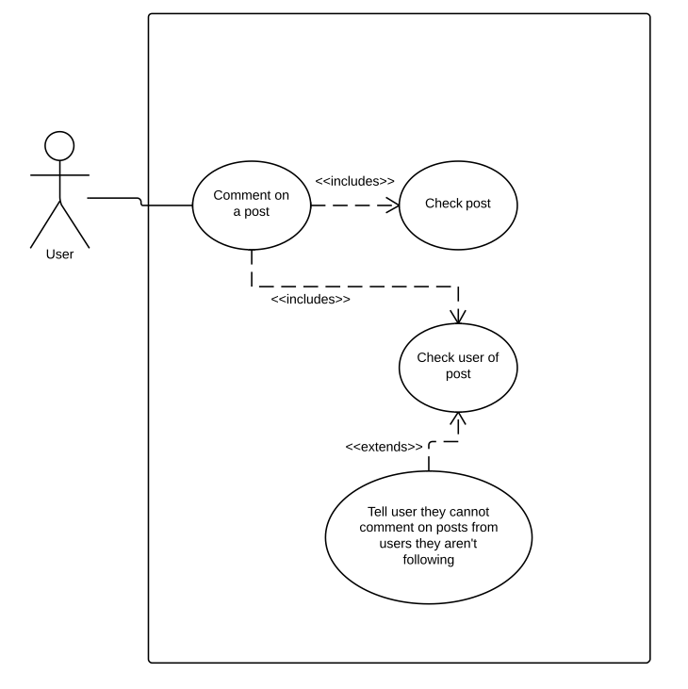 user is following the user the post is by, which they would not be allowed to comment in that case.

**4.1.8 R15,R16,R18**

This use case shows how the user can create and watch a hashtag. It shows how they can like a post and how it updates the like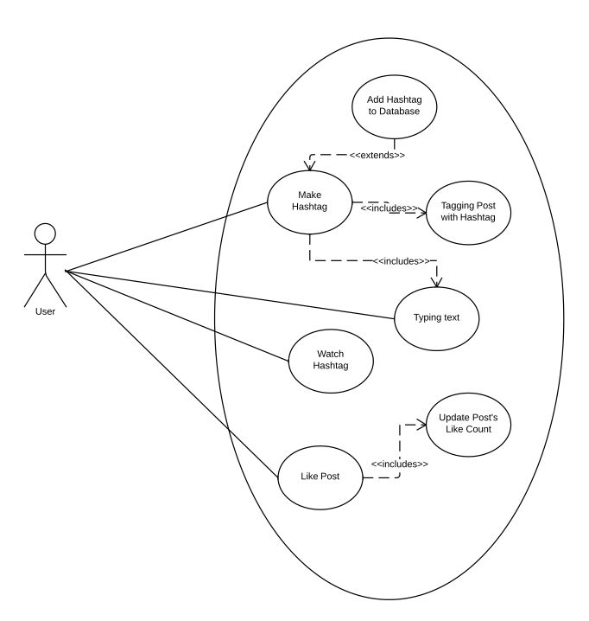 count on the post. It shows how in the case of a new hashtag, the hashtag is added to the database, and how the hashtag is related to the post.

**4.1.9 R17**

This use case handles R17. It illustrates how searching is accomplished by getting the posts, then ones matching the field, then displaying the relevant inf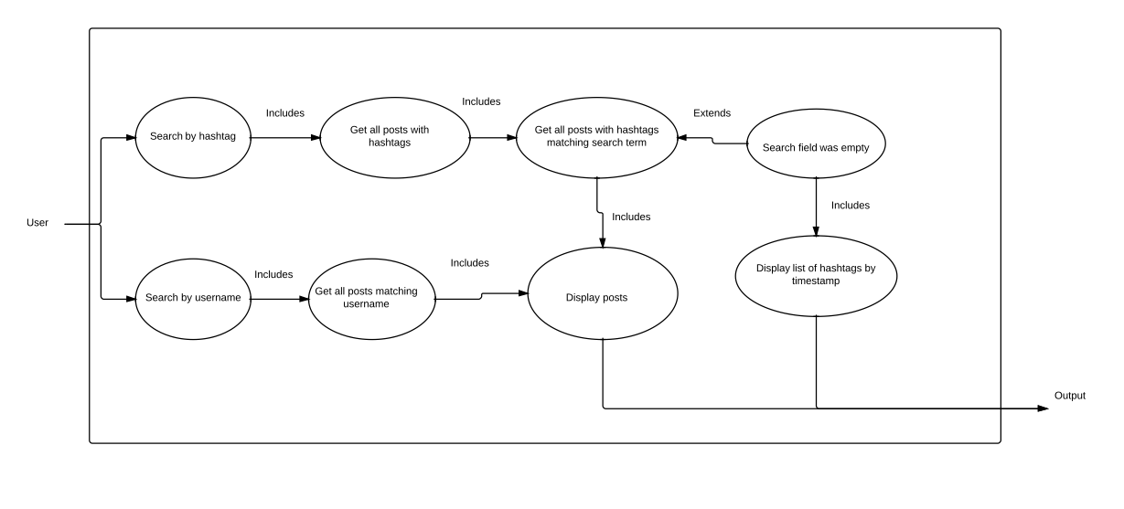ormation. It considers the case where the search field is empty, where the system will display a list of all hashtags ordered by their time of creation.

**4.1.10 User Management**

This use case shows how the user can login, and how the system checks their credentials, in the special case where the user d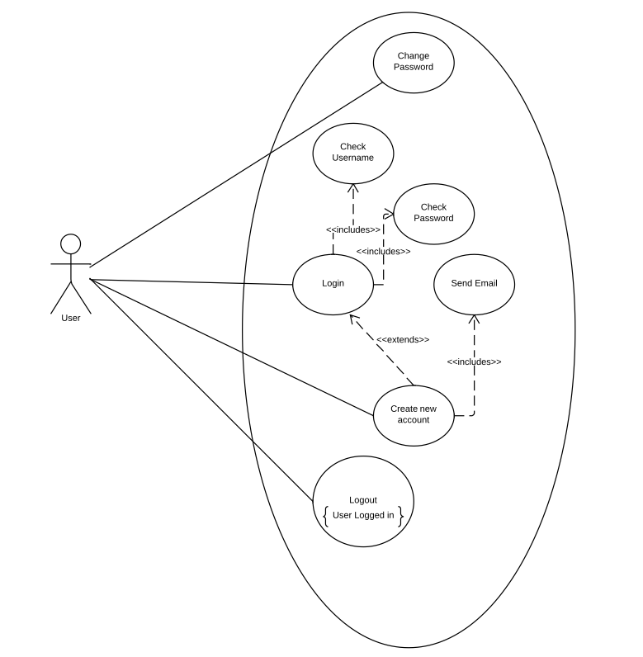oesn’t have an account, the system will create a new account. It shows how the user can change their password, and how they can logout of the system.