Requirements Specification

For

Carpool Application

Prepared By: Eric Borisow, Ty Huynh, Geoff Scholl
SWENG 500 – Software Studio
May 10, 2009

Table of Contents
1. Introduction 3
1.1 Purpose 3
1.2 Project Mission Statement 3
1.3 Scope 3
1.4 Definitions, acronyms, and abbreviations 3
1.5 References 4
2. Overall Description 5
2.1 Product Perspective 5
2.1.1 System Interfaces 5
2.1.2 User Interfaces 5
2.1.3 Hardware Interfaces 5
2.2 Product Functions 5
2.3 User Characteristics (Stakeholders) 6
2.4 Constraints 6
2.5 Assumptions and dependencies 6
3. Specifications 7
3.1 Overview 7
3.2 Blackberry Device Requirements 7
3.2.1 Description 7
3.2.2 Functional Requirements 7
3.3 Create Trip - Blackberry 13
3.3.1 Description 13
3.3.2 Functional Requirements 13
4. Non-Functional Requirements 16
4.1 Standards 16
4.2 Reliability (Backup) 16
4.2.1 Description 16
4.2.2 Requirements 16
Appendix A – References 18

Introduction

Purpose
This document is a Requirements Specification providing the details for the Carpool website. The document will be used to elaborate the functionality of the Carpool website. The document addresses the concerns of two domains within the system. One domain that is intended is a web-based application that is accessible from an Internet browser. The other domain is via a Blackberry device and is intended to be used by a user utilizing the device with mobile communications.
The intended audience is the employees whom intend to carpool within the company, developers who create the website, testers who perform rigorous testing on the website, and maintenance developers who will maintain the system once the website is up and running.

Project Mission Statement
The primary objective of the project is to provide a tool where a group within an organization can establish carpool arrangements. The carpools may be established to various pre-determined locations. The specific locations are determined by the organization. Each user of the system can also establish a single start point and end point location that is the user’s home location. Each of these points becomes part of the system’s list of locations that are available. Allowing this type of use will permit users to create personalized carpool trips or simply utilize the pre-determined locations. As an example, Mary may establish a starting location as her home address. Mary’s home address then becomes a location point that is available in the system as a meeting place for a carpool. Other users may find Mary’s location convenient and simply wish to use her start point as a meeting place. On the other hand, the all of the people in the car pool may want to establish an end point as the work office location since they will all need to go to that destination. The work location would be an example of a pre-determined meeting place that would be available to the car pools.

Scope
The scope of the carpool website will allow the users to register and edit the profile. Users will be able to search for other carpools near his or her area and form groups to car pool to pre-determined locations or locations of special events. The carpool website will be accessible through the internet and will also support the Blackberry phone.

Definitions, acronyms, and abbreviations
C
Carpool - an arrangement among a group of automobile owners by which each owner in turn drives the others to and from a designated place.

References
See Appendix A for a list of references

Overall Description

Product Perspective
The carpool website will allow the users to register and update their profile. Once registered, users will be able to see locations of other users near his or her area. Users can then select groups to carpool to a pre-determined location or a location for special events. The carpool website will be internet driven and will also support the Blackberry phone.

System Interfaces
The application has several components that are required to make the system work. The server-side application will execute on an Apache Tomcat 5.5 application server. That server must use a database to store data. We will be using MySQL 5.0.67 to persist application data. Most of the services that the Tomcat server will provide will be via web service interfaces to the Blackberry application.
In addition, the Blackberry component requires a Blackberry Enterprise Server (BES) and Mobile Data System (MDS). BES is required to provide basic wireless connectivity. The MDS module is required to provide an interface for web services to communicate with the application servers. MDS also provides the connectivity to display maps within the Blackberry application.

User Interfaces
On the main page, the user will be given an option to login or register as a new user. Once logged in, the user will be a given the option to edit their profile, perform a carpool search, create a one-time event, create a recursive carpool, view one-time events and recursive carpools, and delete carpool.
When creating carpools, users will have the ability to establish their own preferred start and end points. Then, when establishing carpools, they will be able to select from others’ start and end locations or use on of the pre-defined locations.

Hardware Interfaces
The hardware interfaces (such as network connectivity) will be managed by a third-party Internet Service Provider.

Product Functions
The carpool website and Blackberry will support the following functionality:
- Self-registration – first time registration to subscribe for carpooling.
- Login – logging onto the website
- Carpool search – search other members participating in the carpool
- Create one-time event – create carpooling for special events
- Create recurring carpool – create recurring carpool event.
- View schedules – view detail of the one-time event and recurring event schedules.
- Edit schedules – Edit the schedules.
- Delete Schedules – Delete the schedule.

User Characteristics (Stakeholders)
The primary users of the carpool website are as follows:

Stakeholder Name | Priority
Full-time Employee | High
Software developer | Medium
Software tester | Medium
Administrator maintaining the website | High

Constraints
Stakeholder must have internet access and the latest web browser (Firefox, Internet Explorer, or Chrome) to access the carpool website. Although the application should theoretically run on most modern Blackberry devices, the application is being developed using the Blackberry Java Development Environment (JDE 1.4.5) and was tested on a Blackberry Curve 8320 and Blackberry Curve 8330. Blackberry users also require an internet service to access the website.

Assumptions and dependencies
Stakeholder should be proficient enough to browse the World Wide Web. Each stakeholder has appropriate information to register for carpool.
Administrator will have the web server running at all times to avoid downtime of the website.

Specifications

Overview
This section contains the explicit requirements that we compiled for the carpool website and Blackberry access. Each requirement will include a ranking of 1 to 10, 1 being the lowest priority while 10 considers the highest priority.

Blackberry Device Requirements

Description
With the growing popularity of mobile devices, we decided that our application would target the segment of the population that would be able to take advantage of their wireless device. In order to do that, we established a set of requirements that would address the specific needs for a mobile application. Some of the supporting services and functionality are found as part of the main application because those areas could be shared by the Blackberry application as well as a web application.

Functional Requirements

ID | Title | Priority
 | Application Login | 10
In order to provide the same level of security as a web application, the system shall provide a login screen on the user’s mobile device. The login entered by the user shall be user name and password. The values shall be verified by the system prior the user having access to the system.
Sample Screen:
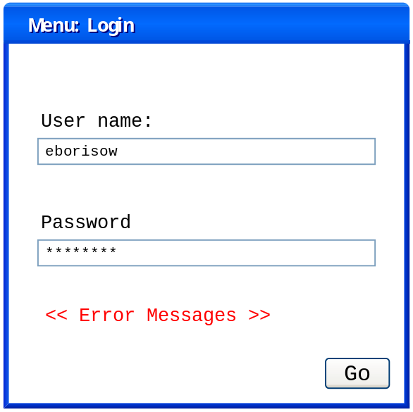

ID | Title | Priority
 | Main Screen | 10
Once the user has successfully logged in, the system shall display the primary menu for the system. The main menu shall contain a list consisting of the areas of the system that the user has access. The main screen shall also provide any additional capabilities for the user to personalize their experience. At this point, the menu items are:
- Search
- Create Car Pool Trip
Options:
- User options

Sample Screen:
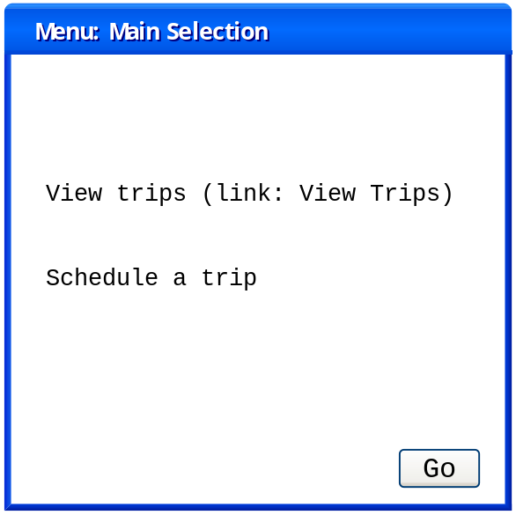

ID | Title | Priority
 | Search – Menu | 10
The system shall provide a menu screen for the user to select a search for a existing trips.
Sample Screen:
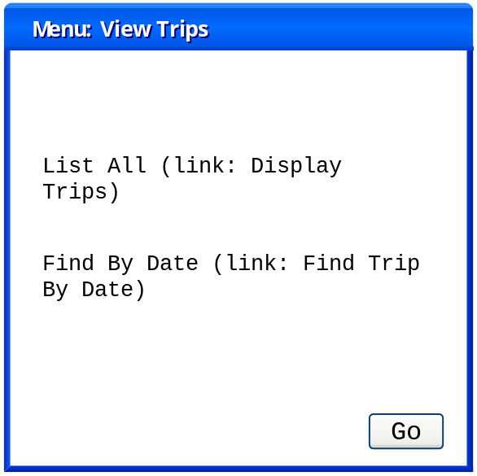

ID | Title | Priority
 | Search – My Trips | 8
The system shall provide a feature to permit the user to search for carpool trips that the user is a participant (driver or passenger).

ID | Title | Priority
 | Search – My Trips By Date | 8
The system shall provide a screen for the user to select a date to display trips. The trips shall be filtered for the current user.
Sample Screen:
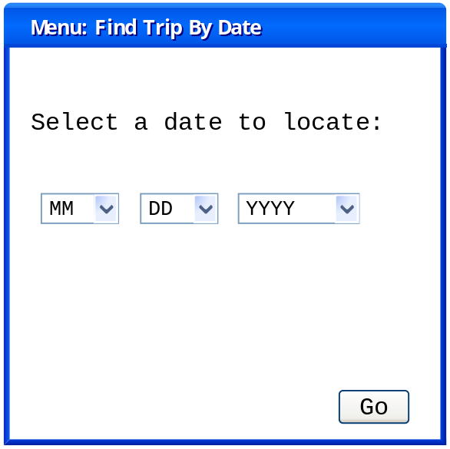

ID | Title | Priority
 | Results screen | 10
The system shall provide a common screen that displays the results of any type of search query. Each result is a unique carpool trip. If the user clicks on the trackball, the details of the trip shall be displayed. The elements of the car pool trip to be displayed are:
Trip Id, Date of trip, Trip Title
Sample Screen:
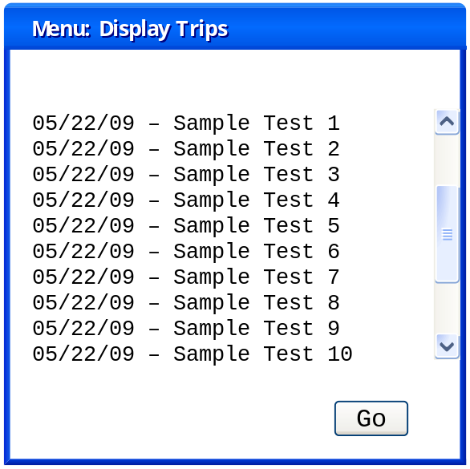

ID | Title | Priority
 | Display trip detail | 10
The system shall provide a common screen that displays trip details. When the user specifies a certain trip, a screen is displayed on the device that displays the following:
Trip Id, Date of trip, start time, end time, start location, end location, members of the trip
The display trip detail screen shall also provide a menu item to display the driving directions for the car pool trip.
Sample Screens:
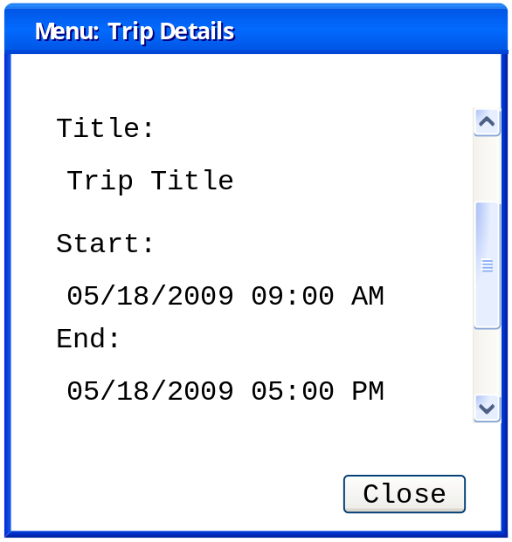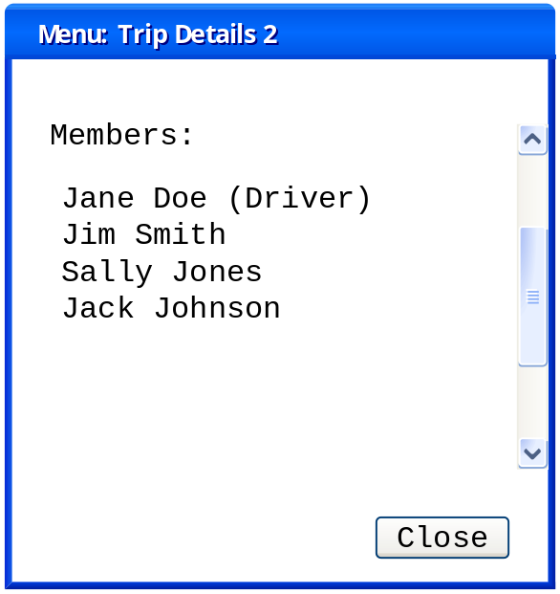

ID | Title | Priority
 | Display turn-by-turn directions for Carpool | 5
The system shall contain a screen to display turn-by-turn car travelling directions between two points. The two points will be specified by the calling screen. Typically, the start and end point for the directions will be from the start location and proceeding to the end location.

ID | Title | Priority
 | Search – All Trips | 8
The system shall contain a list item to display all of the carpool trips in the system. This list in unfiltered so the user is able to browse all car pool trips.

ID | Title | Priority
 | Search – All Trips By Date | 8
The system shall provide a function similar to Search – All Trips. The difference is that this version will also display a date control to prompt the user to select the date to perform the search.

ID | Title | Priority
 | View User Options | 7
The main screen of the application shall have a menu item that displays the options that are available to customize the user’s experience.

ID | Title | Priority
 | Specify a default start point for a user | 6
The user shall have the ability to select a start point that is used as the start point for all map screens. The start point itself becomes a location that is available to the application. The application shall display a map. The user will then use the map navigation to select a point on the map. Once clicked, the user shall confirm that the point selected is used as the start point.

ID | Title | Priority
 | Specify a default end point for a user | 6
The user shall have the ability to select a end point that is used as the end point for all map screens. The end point itself becomes a location that is available to the application. The application shall display a map. The user will then use the map navigation to select a point on the map. Once clicked, the user shall confirm that the point selected is used as the end point.

ID | Title | Priority
 | Go to point using address | 4
The user shall have the ability to jump to a point on any map by selecting a menu item on any map. The system shall display a pop-up box containing a text field where the user inputs a street address. The system shall use a third-party API to locate the coordinates of the location and returns it to the program. Once complete, the system shall re-display the map using the coordinates as the new center-point.

Create Trip - Blackberry

Description
One major piece of functionality for the Carpool application is for the user to create or update an existing trip. This process allows the user to select the start and end points of the carpool along with the date/times of the trip. As each user selects the same points and dates/times, each user is added to the carpool as a participant. This section contains the requirements that pertain directly to this functionality.

Functional Requirements

ID | Title | Priority
 | Create basic trip | 10
The system shall permit the user to create a trip using the following data: start latitude/longitude, end latitude/longitude, trip date, start/end time, the title of the trip and the type of member that the user would like to be (passenger or driver).

ID | Title | Priority
 | Select start point from pre-determined places on map | 10
The system shall permit the user to select the start point for a trip. The points that are available to select are all of the valid places that have been selected by users as start points and from the list of pre-determined locations that have been configured by the administrator.
Sample Screen:
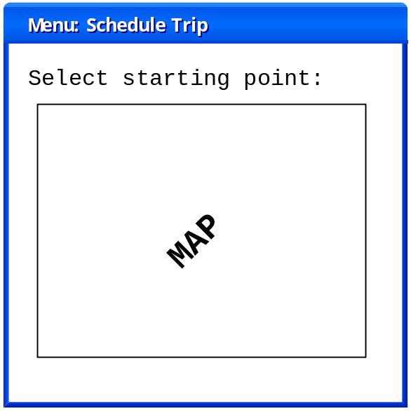

ID | Title | Priority
 | Find by address function | 10
The system shall contain a menu item that the user may select while selecting a start or end point. The menu item shall produce a pop-up screen that permits the user to enter an address. Once the user presses ok, the system shall perform a search using a Geocoding service. The service shall return the latitude and longitude of address entered. The map shall be adjusted to center the map on the address entered.

ID | Title | Priority
 | Select end point from pre-determined places on map | 10
The system shall permit the user to select an end point for a trip. This functionality is similar to selecting the start point on the map. The difference is that the point selected shall be stored as the end point of the car pool trip.
Sample Screen:
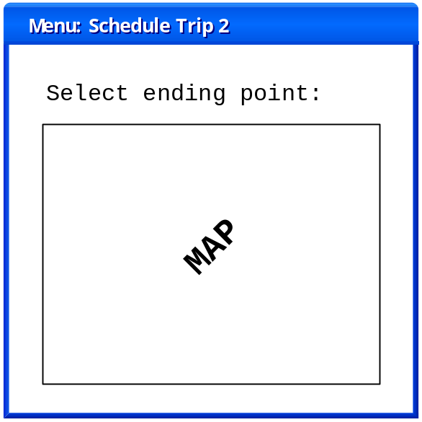

ID | Title | Priority
 | Input screen for carpool trip date, start and end time | 10
The system shall contain a screen to input the carpool trip date using a Blackberry calendar control. The screen will also contain time controls to enter the start and end time of the car pool trip. When the user clicks on Next, the system shall temporarily store the date, start and end time in order to create a carpool trip.
Sample Screen:
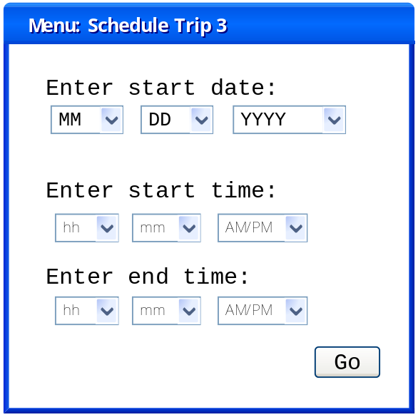

ID | Title | Priority
 | Input screen for entering carpool trip data | 10
The system shall contain a screen that permits the user to enter the title of the carpool and whether the user would like to be a driver or passenger in the carpool.

ID | Title | Priority
 | Search for matching carpool trips | 7
The system shall have a point after the carpool trip date, start and end times are selected where the system shall perform a search for any trips that match the specifications of the carpool trip exactly. The system shall attempt to compare the start point, end point, trip date, start time and end time. If such a condition occurs, the system shall display the results that match the search.
The list of results that match shall also contain an option to continue to create the new carpool. If the user selects ok, the carpool trip is updated by adding the current user to the trip as a participant.
If the user is already a member of the trip, the system shall prompt the user to ask whether or not the user would like to update their membership in the trip.

ID | Title | Priority
 | Search for similar carpool trips | 8
The system shall prompt the user to search for similar carpool trips that have similar criteria to the trip that the user is attempting to create. This search shall be performed as follows:
Trip start location – the system shall attempt to find a location that is near the starting point that the user has selected.
Trip end location – the system shall attempt to find a location that is near the end point that the user has selected.
Trip date – The system shall attempt to find a matching trip that has the exact same trip date as the date selected.
Trip start/end time – The system shall attempt to find a matching trip that has a start/end time that is similar to the new trip.
If a trip is found that matches the criteria, the system shall display the list of matching carpool trips. The system shall also add an additional entry to the list that permits the user to continue creating the trip without selecting an existing trip. If the user selects an existing trip, the trip is updated with the current user. If the user is already a participant in the carpool, the system shall prompt the user to find out if the user would like to update their existing participant data.
Sample Screen:
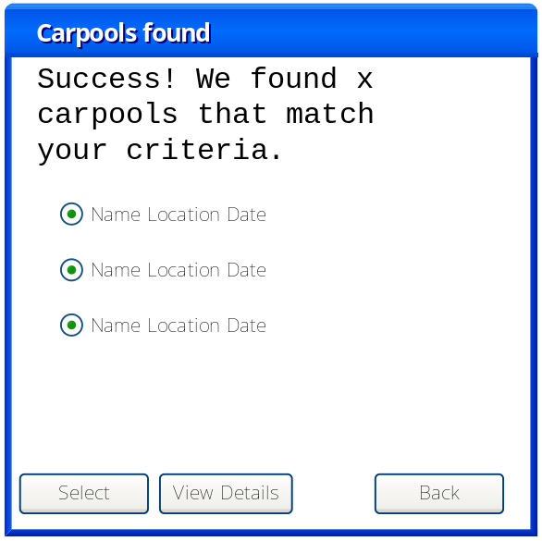

Non-Functional Requirements

Standards
The following standards shall be adhered to by carpool software.
- Apache Tomcat 5.5 – http://tomcat.apache.org/tomcat-5.5-doc/index.html
- BlackBerry JDE 4.5.0 - http://na.blackberry.com/eng/developers/javaappdev/overview.jsp
- Java 2 Standard Environment 1.4.2 – http://java.sun.com/j2se/1.4.2/
- BlackBerry Simulators 8320 4.5.0.81 - http://na.blackberry.com/eng/developers/resources/simulators.jsp
- MySQL - http://mysql.com/

Reliability (Backup)

Description
As carpooling becomes more and more pervasive to organize carpool schedules, it will come to a point where the stakeholders start to depend on the system. This section provides the details of the system reliability.

Requirements

ID | Title | Priority
 | System uptime requirement | 10
The system shall be available with an uptime of 180 days. That is, the system shall be tested two times per year by an authorized specialist. During those two days, the system shall be taken offline for testing and maintenance.

ID | Title | Priority
 | System MTBF requirement | 9
MTBF (Mean Time Before Failure) for the system outside of scheduled down time is 10 (ten) months of continuous operation. Anything less than this number is determined to be unreliable.

ID | Title | Priority
 | System MDT requirement | 9
MDT (Mean Down Time) for the system is 10 hours. If the system should fail, the authorized specialist of the system shall replace the device (while retaining the database) within 10 hours from the failure.

ID | Title | Priority
 | Power backup service to system | 8
A power backup service shall provide the system with 12 hours of battery power in the case of a power failure.

ID | Title | Priority
 | Persistent storage of device settings | 9
During failure, all registered stakeholder information will be stored in the database in order to provide service when the system is restored.

ID | Title | Priority
 | Failover to manual operation when system is down | 10
In the event of system failure, all devices shall return to a manual operation state.

Verifiability

Description

This section identifies the approach to verifying the requirements. In verifying these requirements the approach is to execute and verify multiple requirements with multiple test scenarios; this is the premise for scenario base test. Each scenario will cover multiple requirements on each test case.

Verification matrix

Features | Verification method | Requirements
Logon | TC-01) Verify the success and fail cases for logging onto the Carpool system. | 3.2.2.1 and 3.2.2.2
Search & Detail | TC-02) Verify of search technique for all trips, trips by user, trip by date, and trip by user and date. In addition it will also verify the detail of the trip. | 3.2.2.2 to 3.2.2.10
Set default start and end location | TC-03) Verify that the user’s default and end location is saved. | 3.2.2.11 to 3.2.2.14
Create trip | TC-04) Verify the creation of new and existing trips for the user. | 3.3.2.1 to 3.3.2.8

Appendix A – References
[1] Taylor, Alex S. and Swan, Laurel, Artful Systems in the Home, CHI '05: Proceedings of the SIGCHI conference on Human factors in computing systems, April 2005, Portland, Oregon, USA
[2] Menga, David; Durand, David; Marhic, Bruno; Delahoche, Laurent; Loge, Christophe, The smart home concept: Our immediate future, 2006 1st IEEE International Conference on E-Learning in Industrial Electronics, Dec 18-20 2006, Hammamet, Tunisia
[3] Jiang, Li; Liu, Da-You; Yang, Bo, Smart home research, Machine Learning and Cybernetics, 2004. Proceedings of 2004 International Conference, 26-29 Aug. 2004, Changchun, China
[4] Roy, A.; Das, S.K.; Basu, K., A Predictive Framework for Location-Aware Resource Management in Smart Homes, Mobile Computing, IEEE Transactions, Nov. 2007, Geyonggi-do, Korea
[5] Yamazaki, T., Beyond the Smart Home, Hybrid Information Technology, 2006. ICHIT '06. International Conference, 9-11 Nov. 2006, Cheju Island, South Korea
[6] Baeg, Seung-Ho; Park, Jae-Han; Koh, Jaehan; Park, Kyung-Wook; Baeg, Moon-Hong, Building a smart home environment for service robots based on RFID and sensor networks, Control, Automation and Systems, 2007. ICCAS '07. International Conference, 17-20 Oct. 2007, Seoul, South Korea
[7] Elliot, Kathryn, Watson, Mark, Neustaedter, Carman, Greenberg, Saul, Location-dependent information appliances for the home, ACM International Conference Proceeding Series; Vol. 234 archive, 2007, Montreal, Canada
[8] Green, William; Gyi, Diane; Kalawsky, Roy; Atkins, David, Capturing user requirements for an integrated home environment, ACM International Conference Proceeding Series; Vol. 82 archive, October 2004, Tampere, Finland
[9] Merabti, Madjid, Networked appliances in home entertainment, CyberGames '06: Proceedings of the 2006 international conference on Game research and development, December 2006, Perth, Australia
[10] Elsenpeter, Robert C.; Velte, Toby J., Build Your Own Smart Home, New York : McGraw-Hill Professional, 2003.
[11] Baeg, Seung-Ho; Park, Jae-Han; Koh, Jaehan; Park, Kyung-Wook; Baeg, Moon-Hong, RoboMaidHome: A Sensor Network-based Smart Home Environment for Service Robots, Robot and Human interactive Communication, 2007. RO-MAN 2007. The 16th IEEE International Symposium, 26-29 Aug. 2007, South Korea
[12] Lutolf, R., Smart Home concept and the integration of energy meters into a home based system, Metering Apparatus and Tariffs for Electricity Supply, 1992., Seventh International Conference, 17-19 Nov 1992, Glasgow, United Kingdom
[13] LaPlante, Philip; Neil, Colin., Requirements Engineering, 2009 est.

