Team #2

Group Report

Prepared By:
Eric Borisow, Geoff Scholl, Ty Hyunh

Project Assessment
Working with the Carpool application was a fun project. Nobody in the group had ever written code for a mobile device before so getting started was a learning experience and took quite a bit of time. In addition, there were quite a few APIs that we were able to use that are truly used for enterprise-level applications. Here is a listing of all of the tools and APIs that we had to work with and/or learn while working with this project:

- Blackberry API  - Blackberry Java Development Environment (JDE)  - Hibernate Persistence  - Apache Tomcat  - Subversion (SVN)  - Another Neat Tool (ANT) – Build script tool | - Eclipse  - Blackberry Plugin for Eclipse  - Structure 101  - Spring Framework  - Apache Axis 2  - MySQL  - MGMaps map API  - Apache HTTP

Thankfully, Geoff already pays for a provider for the Tomcat, MySQL and Apache HTTP server that we could share. However, we still needed to setup our own environments to build the project locally on our own desktops.
Getting Started
When we first started the project, Ty came up with the idea for the project and Eric suggested using the Blackberry since he had one that we could use for actual testing. So, we started by putting together a project plan and just laying out the basic plan for our development effort. Since we were using a completely fixed deadline, it was easy to map out a rough estimate. We decided that we would break up the effort into initial discovery for the project, then three iterations when we would development the major components of the application. Anything that we were planning to do had to be placed into one of the three iterations.
We knew that one of the biggest tasks for the project was going to be finding and learning a mapping API that would satisfy our requirements. Our main task going into the first week then was to try to figure out which mapping API we could use. We first checked into one of the most popular mapping APIs available which most people would say is Google Maps. Although Google Maps is a great API and is highly customizable, there was one problem. It didn’t translate well to a mobile application. There is, of course, the Google Maps application that is available software for the Blackberry device, but unfortunately that API is closed and not available for public use for mobile devices. The only other option is to produce a static map on a web server and point the mobile device to the map, but that simply produces an image that is available to the user. No interactivity is possible with this setup.
Deciding on the Map API
Our next step was to rely on finding an API by searching on the Google Search Engine. The first API we found was called J2MEMap. The name is taken from the Java standard J2ME that is the Java environment that is standard on Java-enabled mobile phones. The Blackberry is a J2ME-compliant device so using J2MEMap was a possibility. So, the first week was spent setting up a project and trying to learn the API to see what it could do. It was rough getting started with the API and we found that we couldn’t get it up and running as quickly as we hoped. So, at the same time, we started looking for any other alternatives. We found others but the most likely choice was a product called MGMaps. Then, for the next two weeks, we continued to vacillate between J2MEMap and MGMaps. MGMaps gave us a compelling choice because they also had a second version available that was written to work specifically with the Blackberry API. So, the choice was actually between three different possibilities. We could use J2ME with the J2MEMap API. We could use J2ME with the MGMaps API. Or, we could use the Blackberry API with the MGMaps API. If we chose one of the J2ME versions, we felt that it was more of a conservative choice because then we could simply swap out the map API if we ran into some issues with any particular API. Alternatively, with the Blackberry API, we knew we would get better support on the Blackberry device since the API was written specifically for the device.
Both APIs were open-source and basically maintained by volunteers, so it was quite difficult to get any level of support with the application. After a few weeks though, we decided that we wanted to go ahead with the MGMaps version running on the Blackberry API. The reason was that we were able to put together some prototypes using the MGMaps API that did most of the things that we were trying to accomplish with our project.
Setting up the Environment
At the same time that we were trying to decide on which map API we should use, we were also working to build our development environment. This was happening simultaneously with our map API prototypes since we needed to use a proper IDE to develop for the device. Even here we had a few decisions to make and it would take some time to pick the right choice. We started out thinking that there were two primary IDEs available. One IDE from Sun is called Netbeans and is a comprehensive IDE not unlike Eclipse, for several different Java-based technologies. However, Netbeans only has a plugin for creating J2ME applications and is not designed for the Blackberry IDE. For the Blackberry API, we found that Research In Motion (RIM), the maker of Blackberry, created an IDE called the Blackberry Java Development Environment (JDE). So, we installed both to start building our prototypes. While our tight timeline wasn’t terribly conducive to learning a new IDE, we felt that it would be important to use an IDE that was designed for the type of development that we would be doing. As it turned out, the Blackberry JDE was pretty clunky and, while functional, had the misfortune of being written as a Java Swing application which is not really streamlined like a typical Windows application. Luckily, we found that Blackberry had recently released a 1.0 version of a plugin for Eclipse. So, we decided to switch over to the Eclipse plugin since the team had more experience with that particular IDE.
Our problems with Blackberry plugin for Eclipse started pretty much from day one. After installing the plugin, the first thing we ran into was that the plugin needed to work using a Blackberry workspace. We spent a few nights simply just trying to figure out how to create a workspace for the plugin. In fact, we would be hard-pressed to be able to provide any instruction on how to actually configure the workspace to work with the Blackberry plugin. Once we were able to get the plugin working, the next thing we needed to figure out was how to build the Blackberry application using the Eclipse program. We can spare all of the details, but the Blackberry forums are a godsend. However, as we went on through the project, we were constantly having to deal with disappearing projects, missing links to the MGMaps libraries and also not having code compile. It was frustrating to say the least.
So, finally, we settled on the least common denominator which is ANT. ANT is a build tool that is used regularly in Java development. It is a scripting language that allows you to automate various tasks from copy files, to compiling code, to creating application packaging and performing code signing. Thankfully, someone created a tool for ANT that allows a developer to compile and build an application in the format required for the Blackberry. Since this utility ran from the command line, we knew that our code was getting compiled and deployed properly. So, in the end, we settled for using Eclipse as a really nice and fancy text editor and ANT to do our compiling and building to create files for the Blackberry.
Model (Database) Code
In the meantime, while we were overcoming the challenges with the development environment and the learning the map API, we were simultaneously building out our backend code. We knew that we would need the ability to store our data, so we built our data model and created our database scripts. We decided to use Hibernate to perform Object-to-Relational Mapping (ORM) between the database and the objects in our application. At the same time, a nice complement to Hibernate is the Spring Framework which manages the creation and lifecycle of the components in the application. We figured that in either case, we would need the database services in some form regardless of whether we had a web-based application or a Blackberry application.
We turned back to the Blackberry device to understand how the Blackberry accesses data. At first, we thought that there would be a simple JDBC driver available that would simply be able to send messages over the air. We found one API that claimed that it perform a database operation, but the API was written over four years ago and so we weren’t really that confident in being able to use that. Surprisingly, there was not an alternative from Blackberry. The only method for accessing any data from the Blackberry was to use web services. We found a popular API called ksoap2 that seemed pretty popular but then we discovered that there was actually a standard available called JSR-172 – J2ME Web Services Specification. So, we began implementing all of our data access points as web services. To do that, we used the Axis2 web services API on the server side to publish our web services. On the Blackberry (client) side, we found that we could generate the client web service code using the Netbeans IDE.
Web Services Issues
The creation of the web services seemed to be pretty straight-forward. We didn’t really have to deal with multiple types of clients accessing our services, so that wasn’t really a concern. The Blackberry though, seemed to have a few issues that we needed to overcome to have our services work correctly.
The first issue that was puzzling was the inability to use a nested element to hold a list of elements. To illustrate, Figure ??? shows a definition for a complex type named Trip and then we defined a WebService_Response element for our web service that contains an element named trips which contains a list of trips.
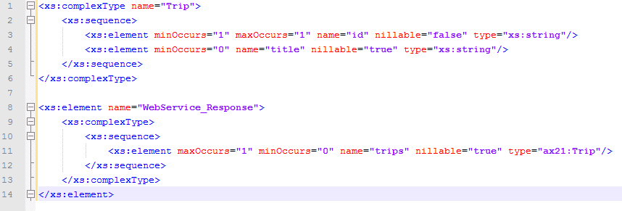
Figure 1 - Complex Type example
So, an example of the XML that gets passed would look like Figure ???. There is a single <trips> element that can contain multiple <trip> elements.
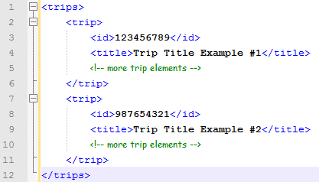
Figure 2 - XML example
Unfortunately, this doesn’t work with the Web Services that the Blackberry is expecting. The Blackberry code is expecting a flattened structure so that there is no arbitrary nesting. Basically, we needed to remove the trips element and simply output a series of <trip> elements from the service.
Our other web service issue had to do with nillable elements. Typically, if you have an element that is defined as nillable, you don’t need to pass any element at all. We found that the Blackberry API has a bug where you must output an element regardless of whether or not nillable is allowed. So, instead of passing nothing, you have to pass an empty element. Figure ??? illustrates the bug we found.
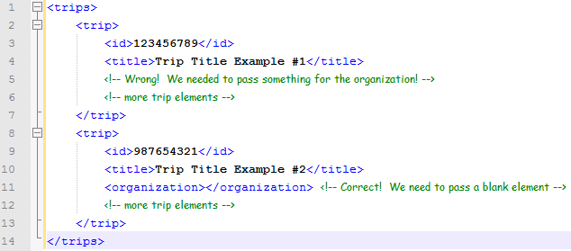
Figure 3 - Empty element example
The Development Process
Early in the project, we realized that we would need to be able to share source code, documentation, etc. between the team. So, one of the tasks that we handled early in the project was to establish an SVN repository. We found a free service that was available on the Internet where we could create our repository for our project. It is currently available at: http://code.assembla.com/psu-edu-sweng500/subversion/nodes
Having our project in SVN made it easy for the team to work in a distributed manner. Source code changes were made on the local machine and then checked in when they were ready to be shared with the team.
Another tool that proved helpful while working on the project was Microsoft Livemeeting which is software that allows you to share your computer desktop with other people that are invited. That combined with a conference phone line allowed us to take a look at what others on the team were doing and also work through troubleshooting any problems over the phone.
To develop the actual software, we used an iterative method where features were decided and built individually rather than a comprehensive approach. This allowed us to remain open to new functionality and also abandon a particular feature if we felt that we wouldn’t have enough time. The typical pattern that we followed was to first start by updating the database model to contain the data that we would need. To access the data, we would update one of the class interfaces and write the code to access the data using Hibernate. Next, we would create at least one test method that would perform the function (such as retrieving or saving the data) that we wanted to achieve. With our data-access code in place, we would then update the WSDL for our web service and re-generate the classes using Axis2. Next, we would implement the interface for the web service by invoking our data-access code. Once we had the web service created, it was a matter of updating the client web service code for the Blackberry and then building the interface to invoke the web service from the Blackberry User Interface (UI). We would continue to make iterations until the functionality was complete.

Lessons Learned

Initial Project Selection

Challenges with APIs

Challenges with Project Setup (IDE)

ISP Issue

Best Practices

