Carpool Application

Analysis & Design

Final Documentation

Prepared By: Eric Borisow, Geoff Scholl, Ty Hyunh
SWENG-500
July 27, 2009
Table of Contents
1. Executive Summary 4
2. Introduction 5
3. Analysis 6
3.1 Actors 6
3.2 System Use Case 6
3.3 Use Cases 8
3.3.1 Use Case: Login 8
3.3.2 Use Case: Find Trips (All or By User) 9
3.3.3 Use Case: Find Trips By Date (All or By User) 9
3.3.4 Use Case: View Details 10
3.3.5 Use Case: Show Route Directions 10
3.3.6 Use Case: View User Options 11
3.3.7 Use Case: Set Default Start (or End) Location 11
3.3.8 Use Case: Find point by Address 12
3.3.9 Use Case: Create Trip 13
4. Design 16
5. Create Trip Design 17
5.1 Description 17
5.2 Sequence Diagrams 19
6. Geocoding Design 22
6.1 Description 22
7. Map Function Design 23
7.1 Description 23
8. Carpool Security Design 24
8.1 Description 24
8.2 WSDL Input/Output 25
9. Carpool Web Service Design 27
9.1 Description 27
9.2 Web Service Definition Language (WSDL) 27
9.2.1 Common Types 28
9.2.2 Binding: findPlaces 32
9.2.3 Operation: findPlacesNearLocation 33
9.2.4 Operation: findSimilarTrips 34
9.2.5 Operation: findTrips 34
9.2.6 Operation: getTrip 35
9.2.7 Operation: getTripsByUser 36
9.2.8 Operation: getUser 36
9.2.9 Operation: updateSavedAddresses 37
9.2.10 Operation: updateTrip 38
9.2.11 Operation: updateTripUser 38
9.3 WSDL Update Process 39
10. Object to Relation Mappings 40
10.1 Description 40
10.1.1 User 40
10.1.2 Organization 43
10.1.3 Address 43
10.1.4 Trips 44
10.1.5 TripUser 47
11. Class Diagrams 49
12. Component Diagram 50
13. Data Classes 51
13.1 Deployment Diagram 53
14. Metrics 55
15. Project Plan 58

Executive Summary
The Car Pool Application is designed to provide an organization with a way to manage the car pool activities within their group. It provides a place for people to organize car pools in order to save on the costs of traveling to pre-defined locations. The locations are common areas that are accessible to the public and are generally regarded as a good common meeting point for participants. The management system that we are designing is based on this concept.
The application is broken down into two major components: a web-based application and an application for a mobile device (in particular, the Blackberry mobile device). The web application will be used primarily receiving the web services. The web application will be written so that a future version could potentially contain a typical HTML-based interface. The Blackberry application will contain a subset of the same functionality and will provide a mobile method for performing similar tasks.
The application will contain two components that are a particular challenge. The first is the use of live data within the mobile device. To overcome this challenge, the team is planning to utilize web services in order to communicate with a central database. The other component is the use of real-time mapping software. This functionality will incorporate maps in a Google mashup style.

Introduction
This document details the analysis that was performed for the Car Pool Application. The requirements document provides a comprehensive analysis of the proposed system. Although there are many aspects to the system, we are focusing only on the user’s experience using the Blackberry application and the services that are available via web services to the Blackberry application. Web services were proposed for the solution not only to illustrate the complexity of adding web services into the mix of components, but because the Blackberry does not provide any built-in ability to communicate directly with a data source via a standard interface such as JDBC.

Analysis

Actors
Actor Name | Description
User | A user of the car pool application.
Participant | A participant is a special type of user that is participating in a car pool trip instance.
Driver | This is a specific type of participant that is responsible for providing the vehicle to perform the commute.
Application Administrator | The person that is responsible for setup and maintenance of the system.

System Use Case
The diagram provided here is a high-level overview of the functionality required for the Blackberry mobile application. In the diagram, just about all of the use cases are dependent on our Carpool web application. The reason for that is because the Blackberry API does not natively connect to a database resource. We decided that the primary method of obtaining the data for our application would be via web services. JSR-172 is the standard that covers web services on J2ME devices. The final release of the standard was published in March of 2004 (ref???).
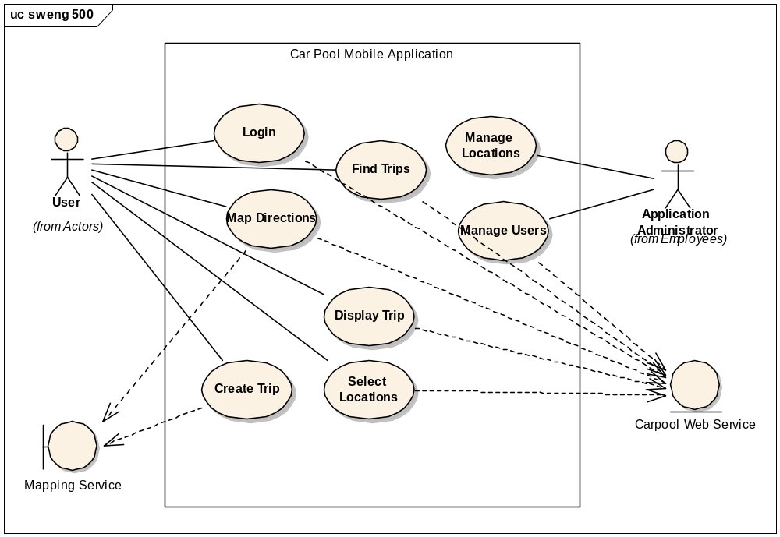
Figure 1 - Blackberry System Use Case
We also provide another use case diagram to display the use cases of our web application. This diagram assumes that the User actor is basically any user of our web services. For this project, we know that the user represents the calling methods from the Blackberry Application but the application could be extended to allow access from any web service client. Our second use case includes the actor application administrator that represents the super user who would typically help manage the data of the application.

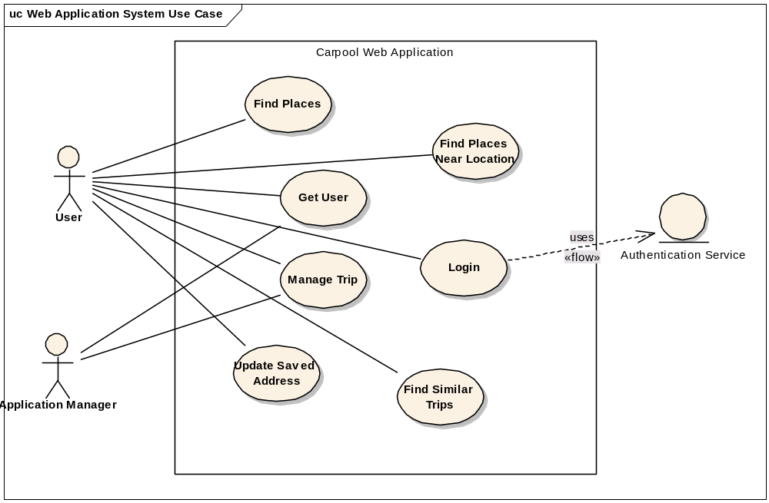
Figure 2 - Web Service System Use Cases

Use Cases

Use Case: Login
Primary Actor | Carpool Participant
Preconditions | None
Postconditions | The user’s account data (id and username) is stored temporarily in the flash memory of the Blackberry device.
Main Success Scenario | - The user clicks on the Carpool Application icon using the trackball in the Blackberry main screen.  - A splash screen is displayed for 2 seconds.  - An input screen is displayed to the user containing two fields: user name and password.  - The user clicks the ok button.  - The system sends a message to the Carpool web services to verify the user account.  - The user is verified and permitted to access the Carpool Application.  - The main screen of the application is displayed.
Extensions | 4a. If the user account is not valid, the system presents a Login Failed message.  5a. If the web service is not available or MDS is not available, the system displays a Login Failed message along with a message to notify the user that the web services are unavailable.

Use Case: Find Trips (All or By User)
Primary Actor | Carpool Participant
Preconditions | The user’s account data is stored in the Blackberry flash memory.
Postconditions
Main Success Scenario | - The user selects the option to search for trips.  - The system performs a remote call to obtain the trips.  - The list of trips is displayed to the user.  - Each trip may be selected for the purpose of performing an additional operation.
Extensions | 2a. If the user has selected the option to search for trip only for the current user, the remote search is performed passing the current user id as an additional parameter.

Use Case: Find Trips By Date (All or By User)
Primary Actor | Carpool Participant
Preconditions | The user’s account data is stored in the Blackberry flash memory.
Postconditions
Main Success Scenario | - The user selects the option to search for trips by date.  - The user is presented with a screen to enter the date on which to perform the search.  - The system performs a remote call to obtain the trips that match for the selected date.  - The list of trips is displayed to the user.  - Each trip may be selected for the purpose of performing an additional operation.
Extensions | 3a. If the user has selected the option to search for trip only for the current user, the remote search is performed passing the current user id as an additional parameter.

Use Case: View Details
Primary Actor | Carpool Participant
Preconditions | The id of the trip to display is set for the details screen.
Postconditions
Main Success Scenario | - For any trip that can contain details, the user clicks on the Blackberry key to retrieve the details of the trip.  - The system performs a remote call to retrieve the data regarding the trip specified.  - The data of the trip is displayed to the user.
Extensions

Use Case: Show Route Directions
Primary Actor | Carpool Participant
Preconditions | The user is already on a Trip Details screen.
Postconditions
Main Success Scenario | - The user presses the Blackberry key to pull up the list to Map the directions for the Trip.  - The system performs a remote call to the backend to retrieve the data for the coordinates for the trip.  - The coordinates are updated on the MapComponent.  - The map is centered on the start place of the Trip.  - The map is displayed for the user to interact with.
Extensions

Use Case: View User Options
Primary Actor | Carpool Participant
Preconditions | The user’s account data is stored in the Blackberry flash memory.
Postconditions
Main Success Scenario | - The user presses the Blackberry key on the main menu.  - The user selects User Options from the Blackberry menu.  - The User Options screen is displayed.
Extensions

Use Case: Set Default Start (or End) Location
Primary Actor | Carpool Participant
Preconditions | The user’s account data is stored in the Blackberry flash memory.
Postconditions
Main Success Scenario | - From the User Options menu, the user selects Set Default Start Location.  - A map is displayed for the user to set the default location for their start location.  - The user uses the map controls to select a start location.  - The system stores the latitude and longitude of the point selected as the default start location.  - The system prompts the user for a name of the location.  - The system performs a remote call to store the data for the start location.
Extensions | 1a. For endpoint locations, the user is selecting the end point location.

Use Case: Find point by Address
Primary Actor | Carpool Participant
Preconditions
Postconditions | The selected latitude and longitude points are available to the calling program.
Main Success Scenario | - The user presses the Blackberry key while on a map. The user selects the option to Find an Address.  - The system displays a screen that contains an input field and the ok button.  - The user enters the address to locate and presses the ok button.  - The system performs a remote call to locate the address entered by the user.  - The latitude and longitude of the entered address are returned to the calling screen.
Extensions | 3a. The user clicks on the Cancel button.  3b. The address popup screen is popped and the user is returned to the previous screen.  5a. The address entered could not be located.  5b. An error message is displayed telling the user that the address could not be found.

Use Case: Create Trip
Primary Actor | Carpool Participant
Preconditions | The user’s account data is stored in the Blackberry flash memory.  The user may or may not have entered a default start and end address.
Postconditions
Main Success Scenario | - The user selects the option to create a new trip.  - The system performs a remote call to do a search for the user’s starting point.  - The system performs a remote call to do a search for the places that must be displayed on the map.  - The system displays a screen containing the map.  - The user selects a place from the places that are displayed on the map.  - The system stores the place selected in the Blackberry flash memory.  - The system performs a remote call to do a search for the user’s ending point.  - The system performs a remote call to do a search for the places that must be displayed on the map.  - The system displays a screen containing the map.  - The user selects a place from the places that are displayed on the map.  - The system stores the place selected in the Blackberry flash memory.  - The system displays a screen for the user to enter: trip date, start time and end time.  - The user clicks ok to submit the data.  - The system stores the data entered in the Blackberry flash memory.  - The system performs a remote call to do a search for trips that match the new trip data.  - The system prompts the user to search for trips that are similar to the new trip data.  - The system displays a screen that contains the fields: trip title and passenger type.  - The user enters the trip title and passenger type and clicks ok.  - The system prompts the user with a dialog asking the user if they want to create the trip.  - The system performs a remote call to save the data and create the trip.
Extensions | 2a. If the user does not have a default starting point specified, the system uses the default starting point.  3a. If the system does not have any places specified, the system displays a message and exits the Create Trip process.  5a. If the user selects to Close the screen, the user is asked if they are sure.  5b. If the user selects Yes, the system exits the Create Trip process.  5b1. If the user selects No, the system closes the dialog box and remains on the map.  7a. If the user does not have a default ending point specified, the system uses the system default ending point.  8a. If the system does not have any places specified, the systems displays a message and exists the Create Trip process.  12a. If the user enters a trip date, start time or end time that causes the trip to be earlier than the current date/time, an error message is displayed since a trip cannot occur in the past.  15a. If a trip is found that matches the current new trip, a screen is displayed to the user that lists the trips that match and an option to create a new trip.  15b. If the user selects an existing trip, the system performs a remote call to update the trip.  15c. The system forces the user to exit the Create Trip process.  15b1. If the user selects to create a new trip, the system directs the user to continue with the normal process.  16a. The user selects yes to perform a similar search. The system performs a remote call to search for any similar trips.  16b. If a trip is found, the system displays a screen that contains the list of matching trips as well as the option to create a new trip.  16c. If the user selects an existing trip, the system performs a remote call to update the trip.  16d. The system forces the user to exit the Create Trip process.  19a. If the user selects to not create the project, the system pushes the user back to the previous screen.

Design

This application is designed to be deployed as two main components. One component provides the services that are typically found in the controller and model layers of an application. That application is written as a JEE (Java Enterprise Edition)-based web application. The second component is a Java-based application that is designed to be deployed onto a Blackberry Curve 8320. The design uses a number of common design patterns.

Singleton – Pattern used for creating objects that are shared in the domain and require the same object instance.
Façade – A single controller provided by the Spring Framework provides the start point for the system.
Controller (Command Pattern) – Business Logic is implemented in controllers that are responsible for gather data from the model.
Factory Pattern (Creator) – The Hibernate persistence layer creates a representation of database functionality that is dependent on the underlying configured database.
Decorator – This project will utilize a paging mechanism that takes a generic list and allows you to create decorators to modify a column type and display it according to its type. (e.g. Currency fields are displayed with the monetary symbols)
Iterator – The iterator concept is used in several areas of the application to utilize the small footprint of the Blackberry.
Pure Fabrication – Some classes in the domain such as DAOs and various Decorators have no relation to the domain.
Expert – In the system, the Car Pool Trip represents an example of the Expert pattern since it must contain data about actual Trip as well as the Participant and the properties of the underlying user objects.
Low Coupling/High Cohesion – As an example of this pattern in the system, all of the controllers contain a reference to the appropriate DAO or interface. In addition, the Spring framework provides an additional layer of abstractness by inserting the appropriate DAO via configuration rather than instantiation in code.

Create Trip Design

Description
This section describes the work that was performed to design the components for the Create Trip process. The Create Trip process is one of the core pieces of functionality for the Blackberry Application. To begin, we put together an activity diagram that provides an overview of the entire create trip process. The diagram is shown in Figure 3.
The process is a simple workflow process. It begins by allowing the user to select the start and end point locations for the trip. It then prompts the user for the date of the trip as well as the start/end time. With that information, the system then performs a search to locate a trip that matches the same criteria. If a matching trip exists, the system displays the list of matching trips. The user has the opportunity to select from the list of matching trips or continue creating a new trip. If an existing trip is selected, the trip is updated with the current user’s information. At this point, the creation of the trip is executed if the user simply selects the option to update the trip.
If the user continues with creating a new trip, the user is next prompted to search for similar trips that are in the same area. Once the user opts to perform this search, the system will attempt to locate nearby carpool trips that are near the start and end points along with a similar start date. If there are any trips that match, a screen is displayed similarly to the matching trips search.
Once the user continues with creating a new trip, the system prompts the user for the trip name and the type of participant (driver or passenger) that the user would like to be. One final prompt to confirm and the trip is created. The system completes the process by displaying a map of the driving directions between the start and end point.

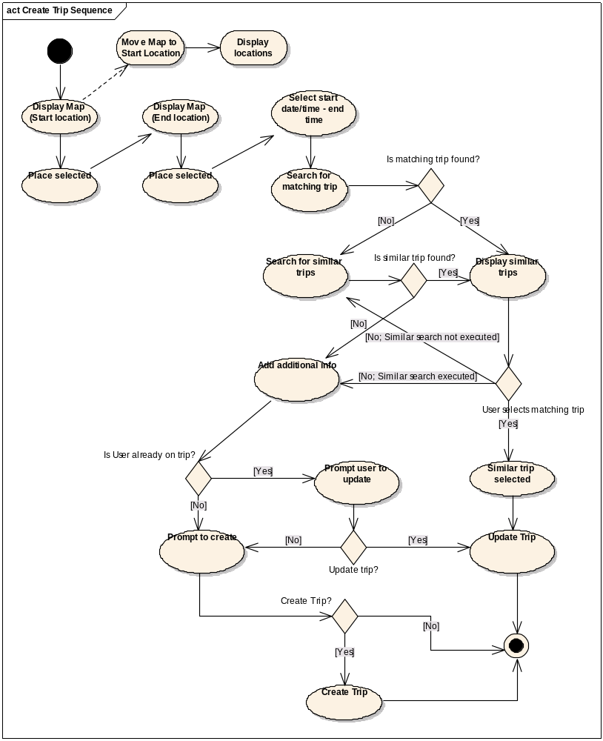
Figure 3 - Create Trip Activity

Sequence Diagrams
The following diagrams illustrate the class-level interactions for processing the create trip functionality. The first diagram shows the process of the user selecting a location on the map. Most of the calls here are straight-forward. The user selects the option to create a trip. The controller class initializes the Create Trip screen and subsequently the MapComponent API. There are several areas for initialization for the MapComponent, but of note is re-centering the map on the user’s stored start location. The other major functionality where the controller must interact with the web service is to locate the places that are available to the map. Once these places are located on the map, they are displayed on the map for the user. Upon selecting a place, the user’s selection is stored using the Blackberry’s memory card.
The next step which is virtually identical is to allow the user to select the end place on the map. The only change to the design is that we are now locating the preferred end location for the user. That end location is used for centering of the map.

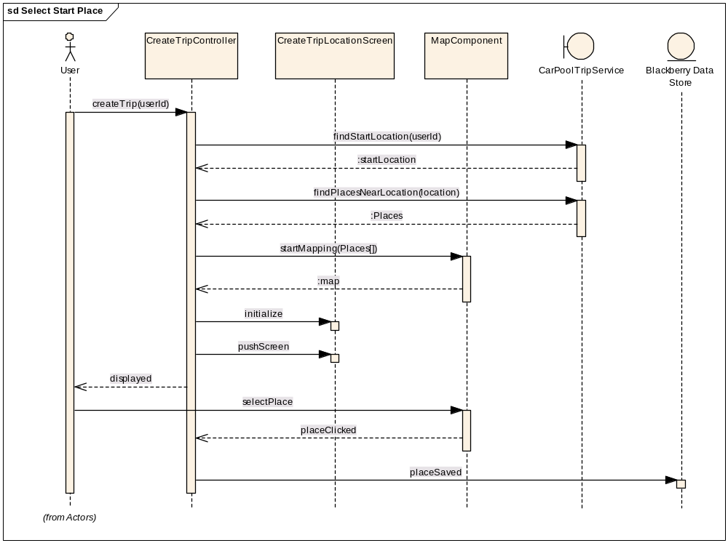
Figure 4 - Select Start Place
The next few screens of the Create Trip function are displayed in the following sequence diagram. In these steps, the user completes the steps that we outlined in the activity diagram in Figure 5. The sequence diagram provides the details for the class interactions of the components.
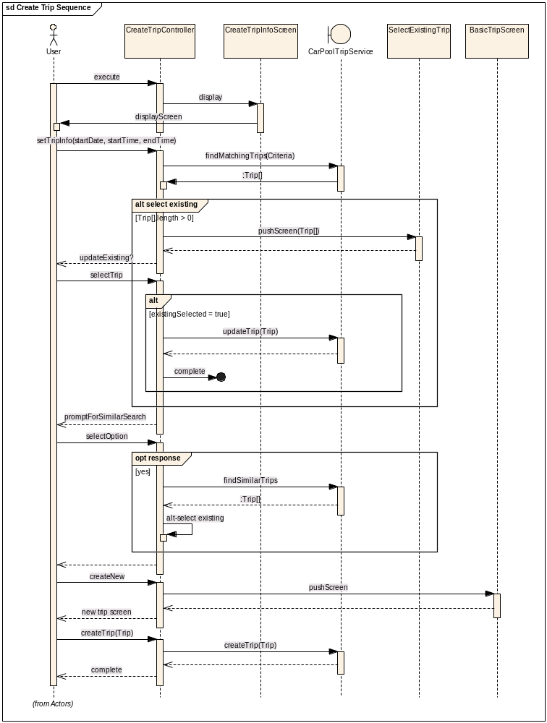
Figure 5 - Create Trip Process (Part 2)

Geocoding Design

Description
The basic Map API from MGMaps provides some very good controls that are intuitive comparative to other mapping technologies that are currently in use today. The one piece of functionality that we found would be good for working with the maps was to provide a method for the user to jump directly to an address. When entered, the map that was currently on display would re-center on the coordinates of the entered address.
In order to provide this functionality, we needed to use an existing Geocoding API. We decided to use the Google Maps Geocoding API. The Sequence Diagram in Figure 6 illustrates the interaction with the Google Maps API. First, the user enters a free-form address in the dialog box on their Blackberry. The system encodes the address string so that it can be sent to Google via a HTTP request. Next, the URL for the Google Geocoding API is invoked via HTTP request. The Google Maps API returns the latitude and longitude of the address entered. Since the result is passed back as a string, we must convert the result into a string array so that we can retrieve the specific values. These values are extracted and passed back to the calling MapScreen and the screen is re-centered on the entered address.

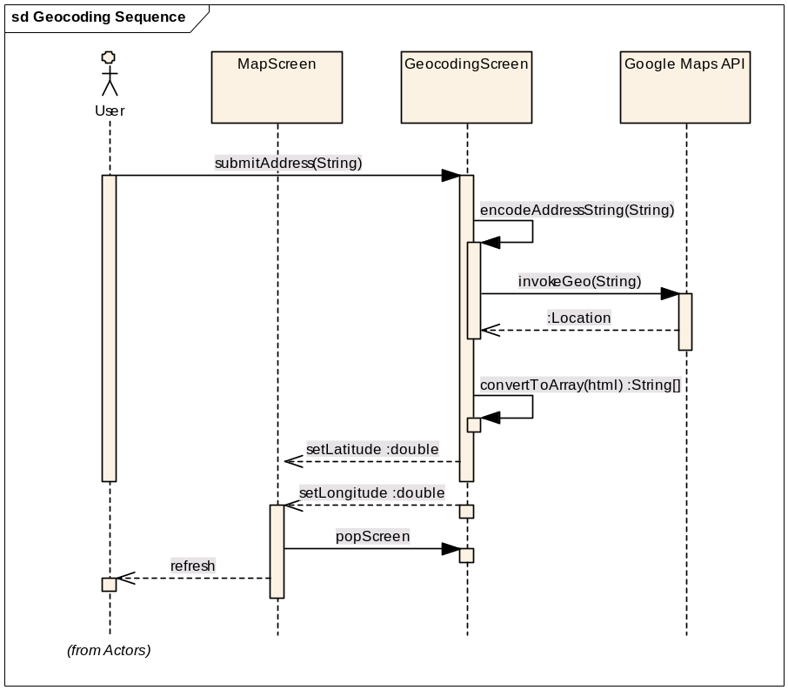
Figure 6 - Geocoding Sequence

Map Function Design

Description
Early in our design process, we determined that we want to display a map that the user could use to select various points for the carpool trip. It took some time, but we finally decided to use the MGMaps API (ref???). The basic requirements that we had for an API were basic. We need something was free. And, we needed something that worked on the Blackberry. MGMaps fulfilled both of these requirements.
The next step was determining what the MGMaps could do for our project. The functionality that we found that we could use in our application was a) select a point on the map, b) select a predefined place on the map and typical map controls such as zoom and scrolling. Two nice additional nice features were the ability to use Cloudscape to perform point to point directions and also integration with Panoramio that displays user-submitted images on the map.
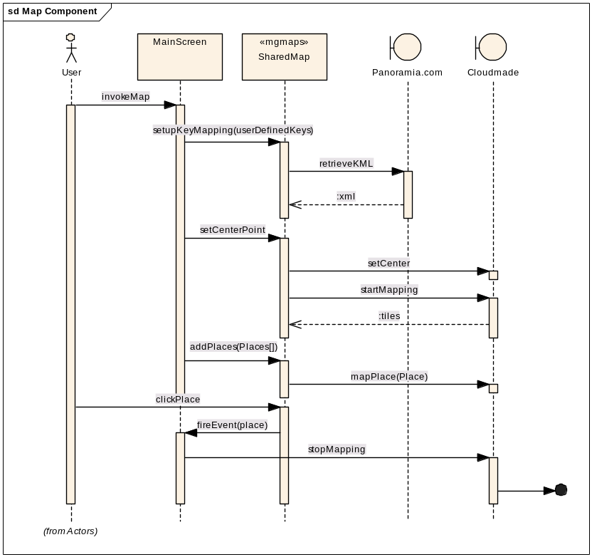
Figure 7 - Map Component Sequence
The sequence diagram in Figure 7 shows the interaction of the classes with the Mapping API. For the screens that use the maps, we must setup the keys that map to the Blackberry device. Then, we must retrieve the KML for the points of interest. For each map that is displayed, we need to center the map for the specific user. Finally, we can make the request to start mapping that triggers the API to start downloading the tiles to display.

Carpool Security Design

Description
The Carpool application is based primarily on a single user setting up carpools for themselves. In order to ensure that the user is who they claim, we are implementing a login process for the users to complete when the first open the application. The login screen is displayed before any other screens are displayed on the Blackberry application. The login process consists of the user entering a user name and password. The password field is masked while the user is entering it by replacing it with * characters. Currently, our login implementation is relatively simplistic. We are storing the user name and password in the database. When the user attempts to login, we are passing the user name and password to the web service and the web service simply confirms that the user name and password match. In the future, we could implement a standard authentication mechanism such as Lightweight Directory Access Protocol (LDAP) authentication without changing the web service implementation.
The sequence diagram for the Login process is relatively simple. If it fails, an error is displayed to the user that prevents access to the application.

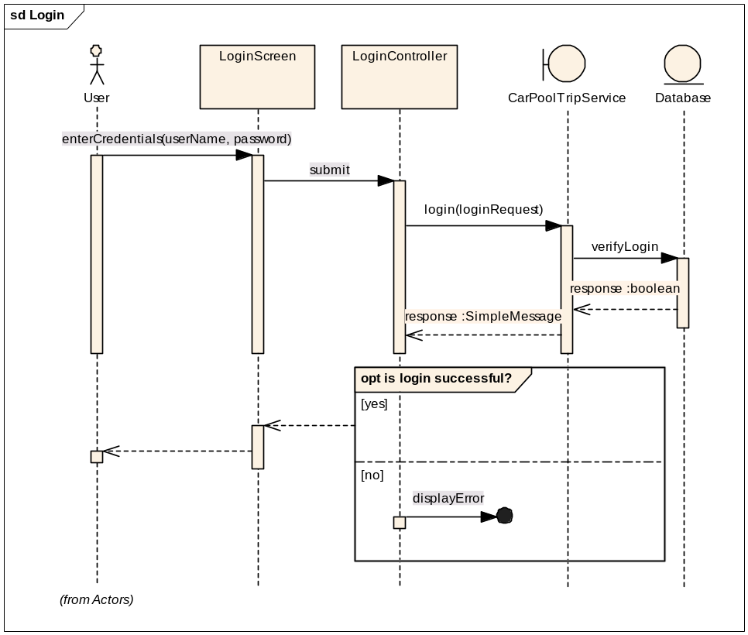
Figure 8 - Login Sequence

WSDL Input/Output
The diagram below shows the input request and output response that are required for the login service.

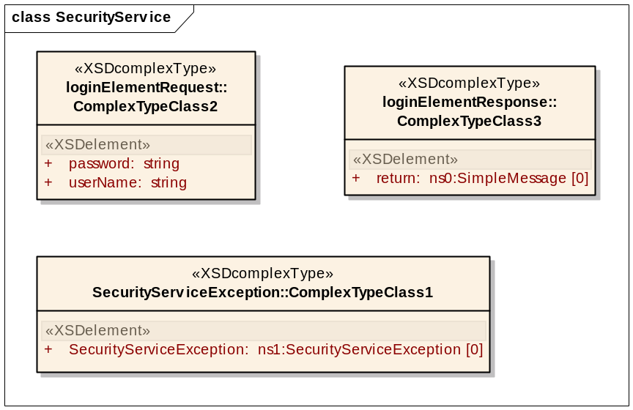
Figure 9 - Login WSDL complex types

In the diagram, you can see that our loginElementRequest complex type contains two parameters: the username and password that are the input to the service. The response that we receive back is a complex type that is shared by various other services. It is a complex type named SimpleMessage. The attributes of SimpleMessage can be seen in Figure 10.

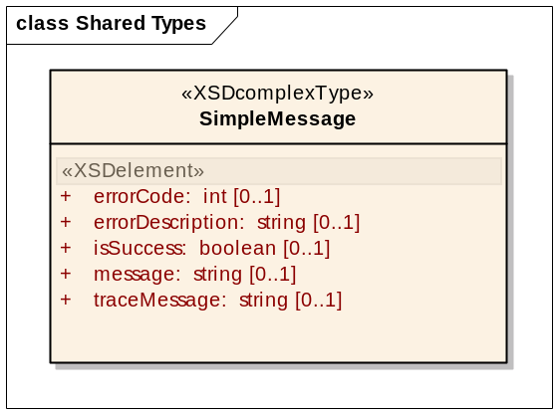
Figure 10 - SimpleMessage Complex Type
The primary attribute that we’re concerned with is the isSuccess attribute that contains the boolean value that notifies us if login was successful or not.

Carpool Web Service Design

Description
The web services developed for our application provide the model of our application. The web services are required for our Blackberry application and will also be shared by any potential web application. This will allow us to abstract the model code from the rest of the application and allow the model focus only on the activities that are required to interact with the database. This design gives us the ability to change the model implementation to another technology such as Enterprise Java Beans (EJB), Microsoft .NET implementation or any other technology that can service web services. In our application, they are implemented using the Spring Framework for consuming the messages and directing them to our implementation classes. The Apache Axis 2 framework is used to provide marshalling functionality from XML to objects and vice-versa.
This section contains the design of the web services that are implemented in our application project.

Web Service Definition Language (WSDL)
For the Carpool services, we defined one service that will be used as the endpoint. The diagram below shows our service along with the bindings that we are implementing for the service.
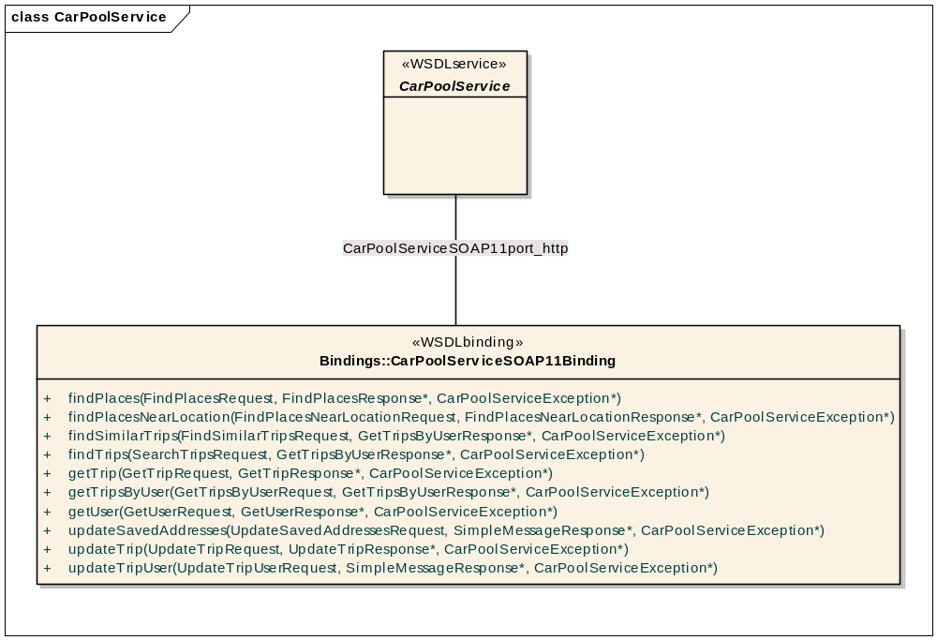
Figure 11 - Car Pool Services Bindings

From the diagram, there are ten bindings that our service will respond. Each is detailed in the next few sections.

Common Types
This section contains the complex types that are shared by our web services. They are provided here as reference for each of the bindings that we have detailed. This is so we don’t have to explicitly review the complex type in each binding description. Each complex type is essentially composed of various simple types.

Parameter
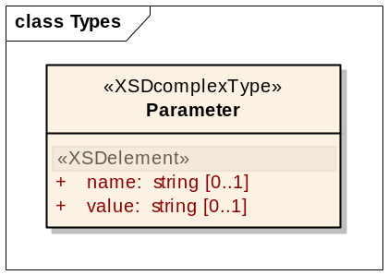
Figure 12 - Parameter complex type

Place
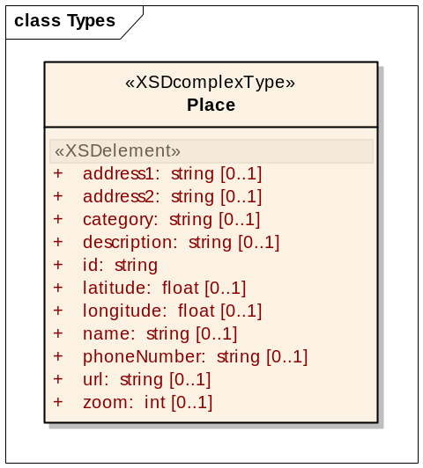
Figure 13 - Place complex type

Place List
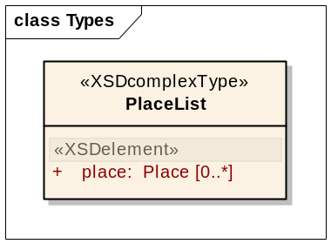
Figure 14 - PlaceList complex type

Organization
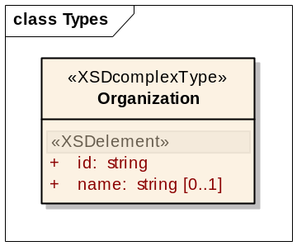
Figure 15 - Organization complex type

User
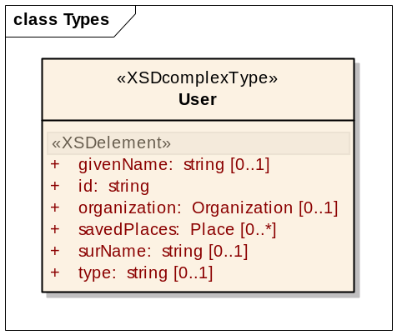
Figure 16 - User complex type

Trip
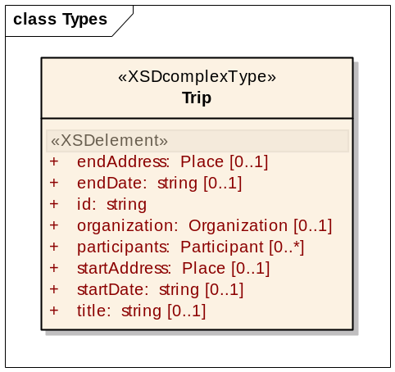
Figure 17 - Trip complex type

TripUser
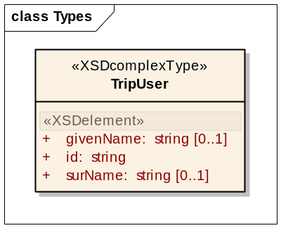
Figure 18 - TripUser complex type

Participant
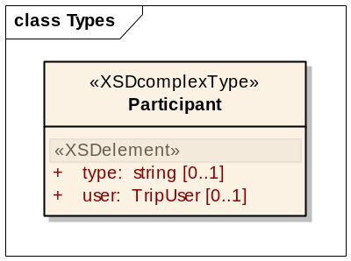
Figure 19 - Participant complex type

TripList
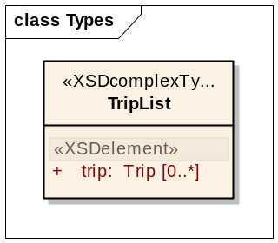
Figure 20 - TripList complex type

SimpleMessage
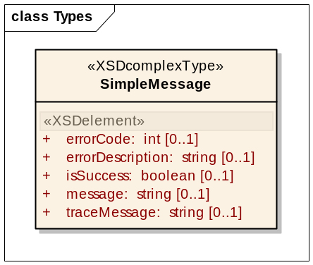
Figure 21 - SimpleMessage complex type

SearchCriteria
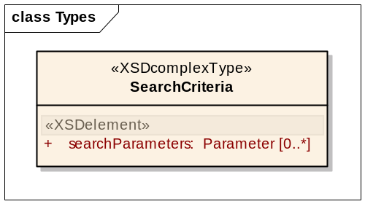
Figure 22 - SearchCriteria complex type

Binding: findPlaces
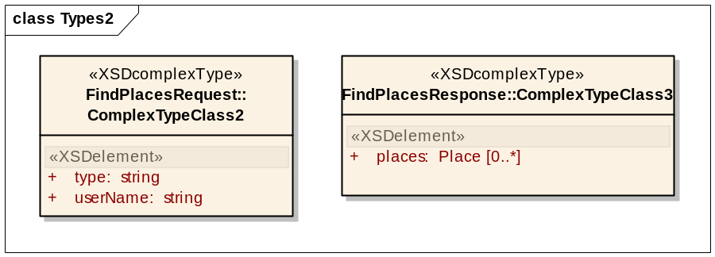
Figure 23 - findPlaces Operation

Description | This binding will locate “places” which are basically addresses that we have stored in the database.
Input | FindPlacesRequest  username – The user id to locate places.  type – The type of places to locate (start or end)
Output | FindPlacesResponse  places – An array on places that were found
Exceptions | CarPoolServiceException

Operation: findPlacesNearLocation
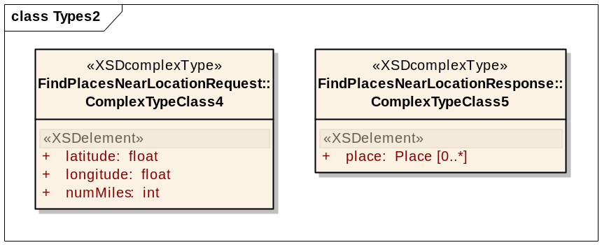
Figure 24 - findPlacesNearLocation Operation

Description | Locates other places near an existing location.
Input | FindPlacesNearLocationRequest  latitude –The latitude of the point to search near.  longitude – The longitude of the point to search near.  numMiles – The number of miles to search near the specified point
Output | FindPlacesNearLocationResponse  places – An array on places that were found
Exceptions | CarPoolServiceException

Operation: findSimilarTrips
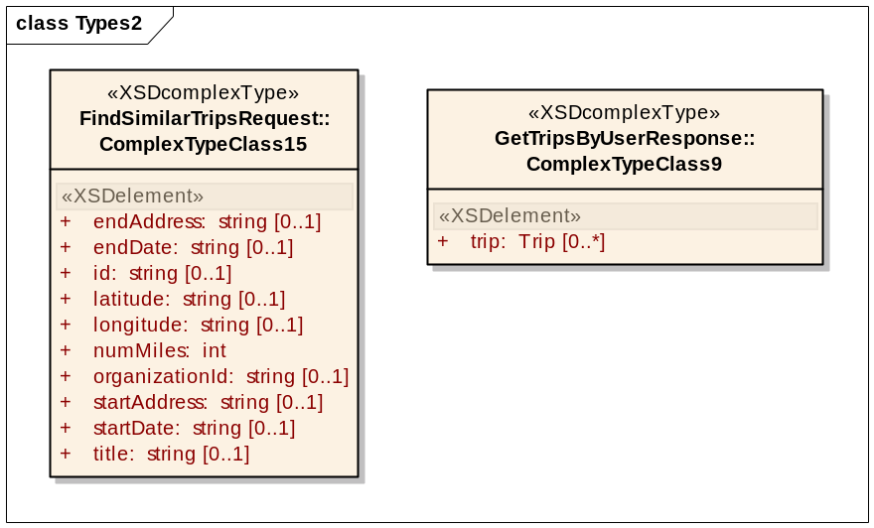
Figure 25 - findSimilarTrips Operation
Description | Locates trips that are similar to the trip that was specified.
Input | FindSimilarTripsRequest  Each of the parameters is pretty self-explanatory and is an attribute of a trip.
Output | GetTripsByUserResponse  trip – An array of trips that were found
Exceptions | CarPoolServiceException

Operation: findTrips
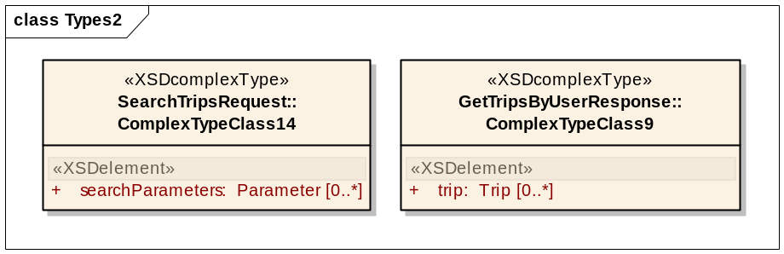
Figure 26 - findTrips Operation
Description | Locates trips using the specified criteria. The parameters that may be specified here are open-ended and not explicit. Each parameter must match an attribute that the web service is expecting.
Input | SearchTripsRequest  searchParameters – Basically, a name and value pair. The name of the parameter that the user would like to search and the value is the value to search.
Output | GetTripsByUserResponse  trip – An array of trips that were found
Exceptions | CarPoolServiceException

Operation: getTrip
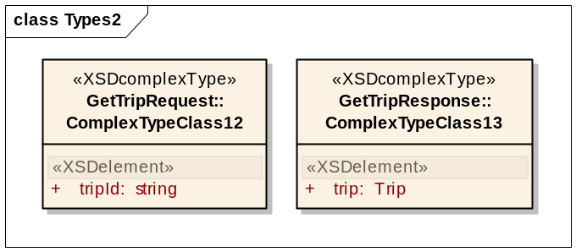
Figure 27 - getTrip Operation
Description | Locate a trip using the specified id.
Input | GetTripRequest  tripId –The id of the trip to retrieve.
Output | GetTripResponse  trip – An array on places that were found
Exceptions | CarPoolServiceException

Operation: getTripsByUser
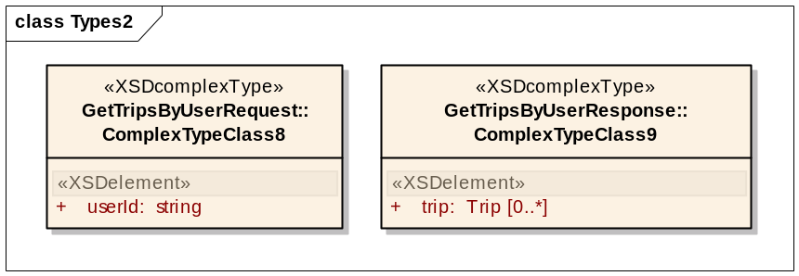
Figure 28 - getTripsByUser Operation
Description | Locates the trips that exist for a specified user.
Input | GetTripsByUserRequest  userId –The user id of the user to search. The user id specified must be the user’s unique identifier (not login name).
Output | GetTripsByUserResponse  trip – An array on trips that were found
Exceptions | CarPoolServiceException

Operation: getUser
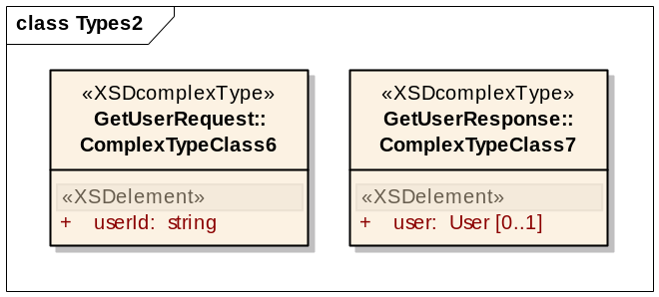
Figure 29 - getUser Operation
Description | Retrieve a user using the specified user id.
Input | GetUserRequest  userId – The user id of the user to search. The user id specified must be the user’s unique identifier (not login name).
Output | GetUserResponse  user – The user found using the specified id.
Exceptions | CarPoolServiceException

Operation: updateSavedAddresses
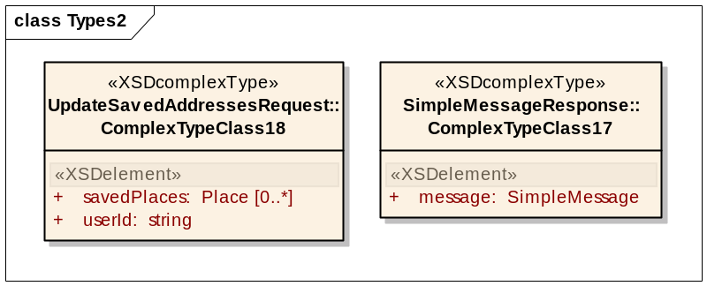
Figure 30 - updateSavedAddress Operation
Description | Perform update of saved places for the specified user id.
Input | UpdateSavedAddressesRequest  savedPlaces –An array of places to update for the user specified.  userId – The user id of the user to search. The user id specified must be the user’s unique identifier (not login name).
Output | SimpleMessageResponse  message – A basic message response that simply tells us whether the operation was successful.
Exceptions | CarPoolServiceException

Operation: updateTrip
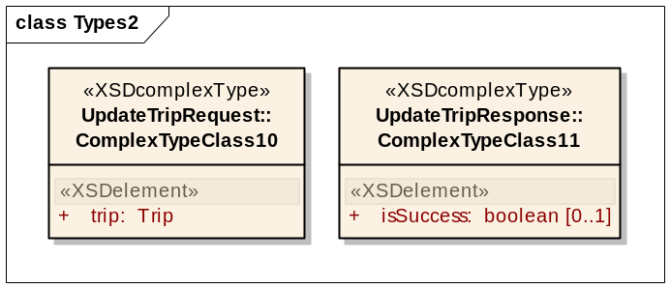
Figure 31 - updateTrip Operation
Description | Update the attributes of the specified trip.
Input | UpdateTripRequest  trip – The trip to update.
Output | UpdateTripResponse  isSuccess – true – the update was successful. false – the update was not successful.
Exceptions | CarPoolServiceException

Operation: updateTripUser
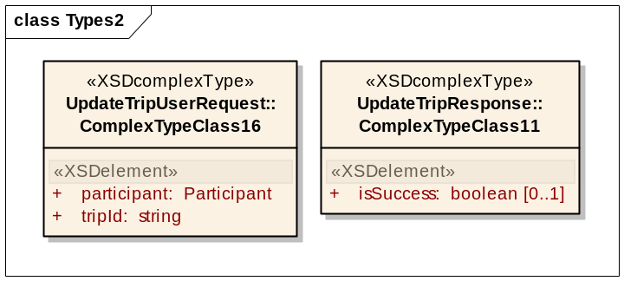
Figure 32 - updateTripUser Operation
Description | Create or update a participant for a specified trip.
Input | UpdateTripUserRequest  participant –The participant to update for the trip.  tripId – The id of the trip to update.
Output | UpdateTripResponse  isSuccess – true – the update was successful. false – the update was not successful.
Exceptions | CarPoolServiceException

WSDL Update Process
For the project, we are using Axis2 to create the interfaces and web service code for the application. The tool is able to generate the classes necessary for the services, but there are quite a few manual steps that must be followed in order to perform an update to any of the Web Services. The diagram in Figure 33 illustrates the process for updating the WSDL.
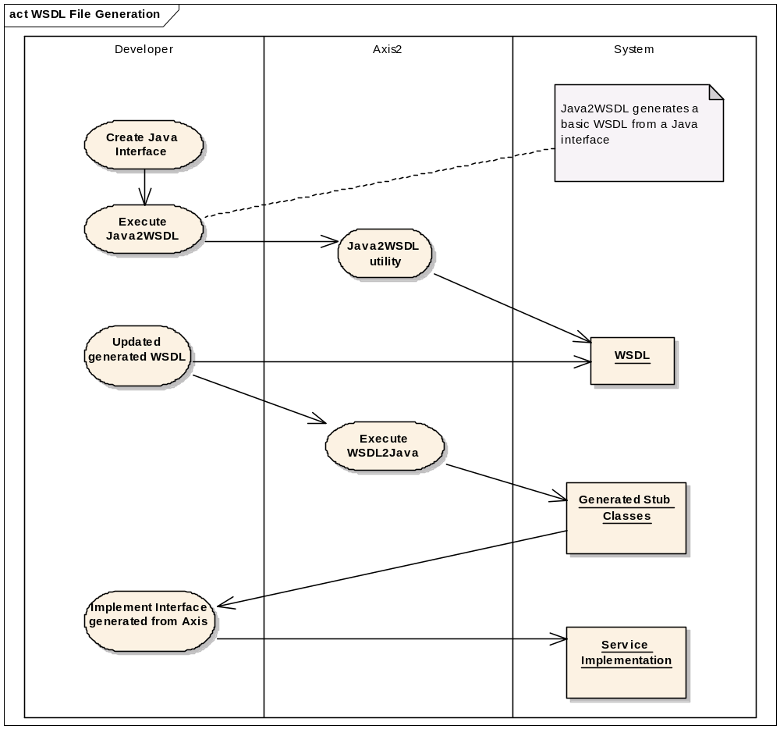
Figure 33 - WSDL update operation

Object to Relation Mappings

Description
Like most applications, our project requires the use of a database for persistent storage of data for the Carpool application. Writing database code (particularly SQL code) is typically regarded as problematic for two main reasons. One reason is because you must construct the SQL query by appending string text to formulate the complete query. The other reason is due to accidentally leaving database connections open after the database operations are complete. To avoid this scenario and to avoid having to write additional code to map our database schema to Java objects, we are using the open-source Hibernate API to perform our database operations. In this section, we will detail the design of our Hibernate configuration.
Our application has five objects that need to be stored in the database. These objects are:
- Address
- Organization
- Trip
- TripUser
- User
We will walk through the User object in detail and provide design data for the other objects.

User
The User object represents a user of the system. It has some basic properties. Figure 34 illustrates the data model.
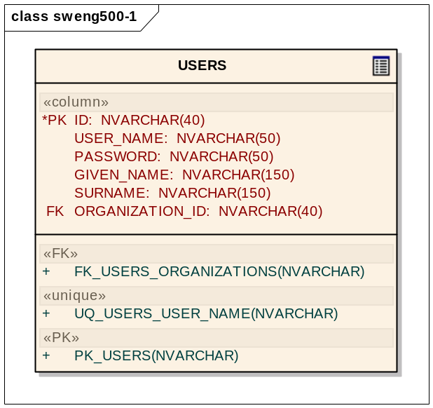
Figure 34 - USERS table
For Hibernate, we create a configuration file and create our mapping to the database. The Users table is mapped using the following XML:

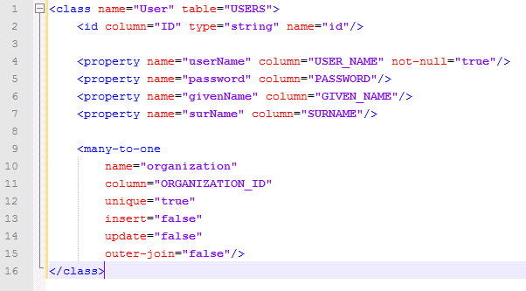
Figure 35 - USERS-to-User mapping

From the snippet of the configuration file, we can see:

Line 1: The User class object will be mapped to the USERS table.
Line 2: There is a primary key named ID in the table that will be mapped to the id property.
Line 4: The username property will be mapped to the USER_NAME column. We have a unique constraint on the table, so not-null is set to true.
Line 9: There is a many-to-one relationship to the organization object. The USERS table contains a column named ORGANIZATION_ID that will be used to retrieve an object from the ORGANIZATIONS table. This is essentially a foreign key to the ORGANIZATIONS table.

Then, here is the actual code that retrieves a user object from the database:
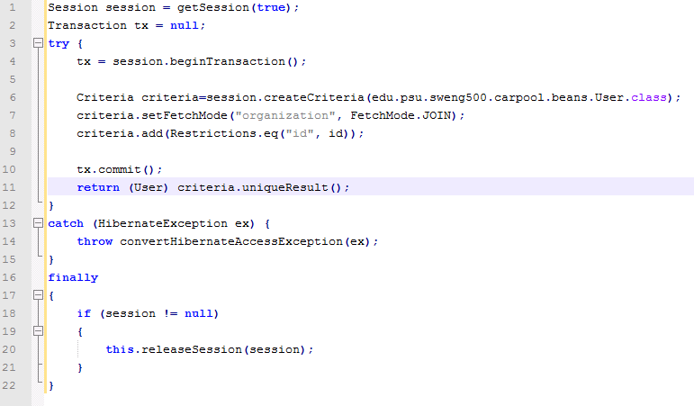
Figure 36 - User Sample Code

Line 1: Retrieve a session from Hibernate. The parameters such as database host, user name, and password are defined in a configuration file so that all of the Hibernate objects can share the same connection information.
Line 4: Start a new transaction.
Line 6: Create a new Criteria object that is used to provide parameters to Hibernate. Here, you can see that we want to use the User object that we specified in the configuration.
Line 7: Tell Hibernate that we want to do a join to get the organization.
Line 8: Add a restriction on the id. We want to retrieve the user based on the specified id.
Line 9-10: Commit the transaction and return the result.

Organization
Here are the details for the organization mapping.
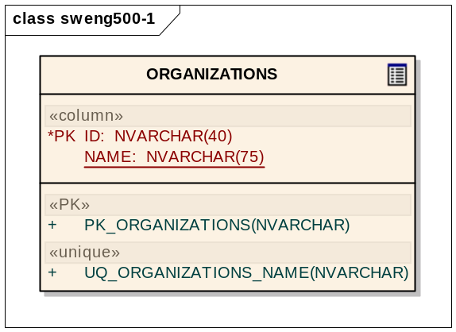
Figure 37 - ORGANIZATIONS Table
The organizations object mapping is relatively straight-forward. We only have an id and a name property.
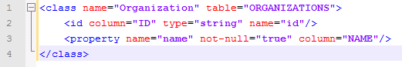
Figure 38 - ORGANIZATIONS to Organization mapping

Address
This section contains the details for the Address mapping. The Address is also relatively simple.
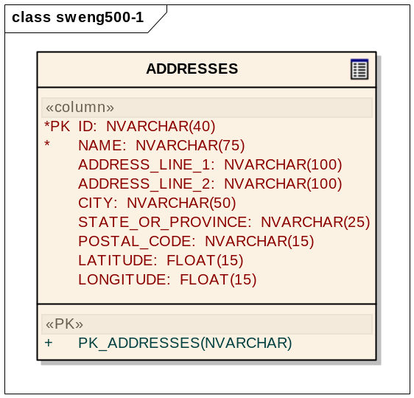
Figure 39 - ADDRESSES table

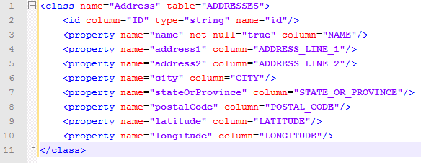
Figure 40 - ADDRESSES to Address mapping

Trips
This section contains the details for the Trips table and mapping. This mapping is more complex because of the relationships between tables.
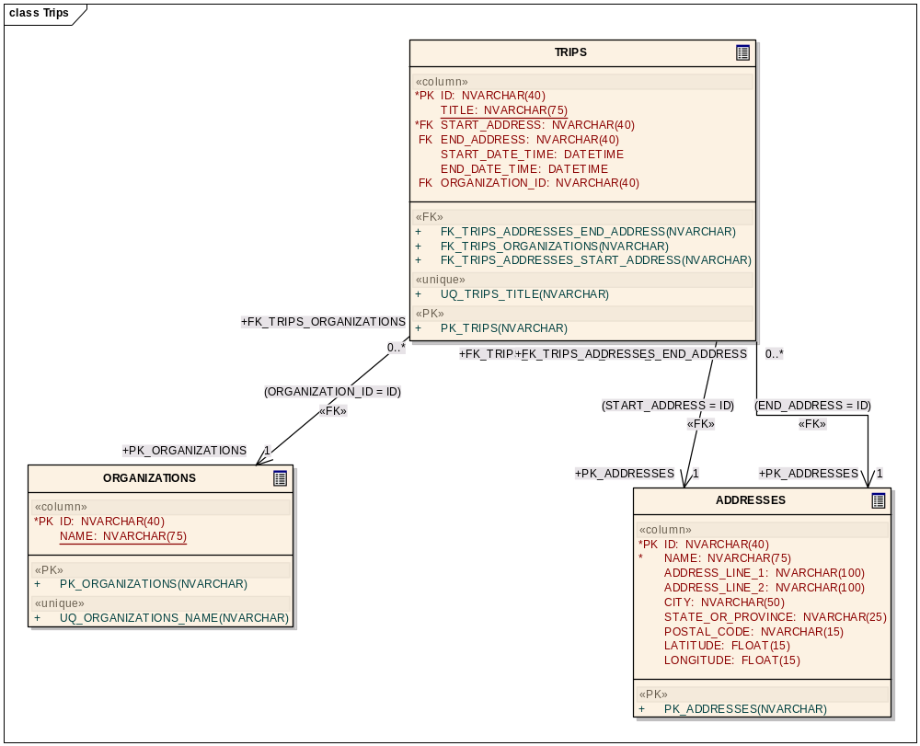
Figure 41 - TRIPS table
In this mapping, we have 3 columns that are foreign keys to another table: organization, start address and end address. In addition, in our application, we need access to the participants of the trip, so our mapping contains another element which is a set called members. This new element allows us to add a Set object to our Trip that will contain the TripUsers who are participating in the car pool.
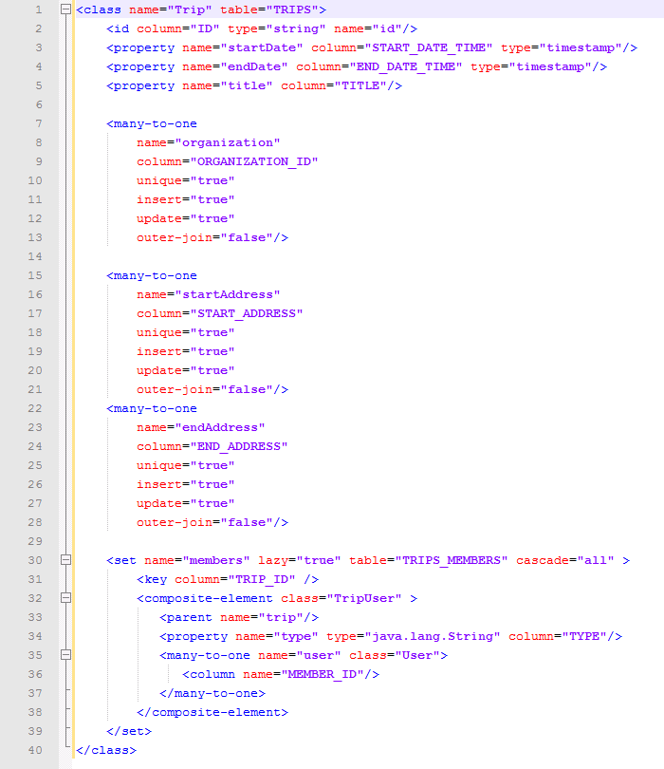
Figure 42 - TRIPS to Trip mapping
Having the members mapping allows Hibernate to use the Trip’s ID as a key to perform a query on the TripUser table. That query will return the TripUser objects that contain the type which is just a string designating the person as a Driver or Passenger and the actual User object that is associated from the Users table.

TripUser
The TripUser mapping is an explicit mapping of the Trips and the Users that they are associated. This mapping allows our application to perform operations only on the Trips_Members table. For example, we need this functionality to simply perform an update to an existing Trip by adding a new user to the trip or removing a user from the trip.
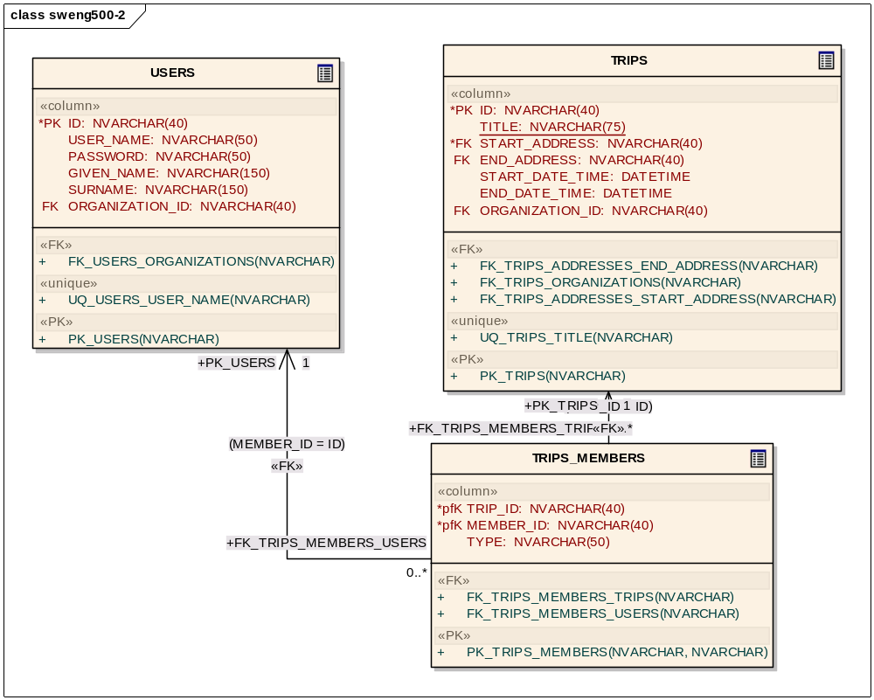
Figure 43 - TRIPUSER table
In the mapping, there are essentially two areas of concern. The first is the composite ID that is composed of the Trip ID and the User ID. So, to retrieve a specific TripUser from the database, we will need to pass in these two IDs. The other area is the many to one mappings that will give us the Trip and User objects that are associated to the TripUser that we are interested.
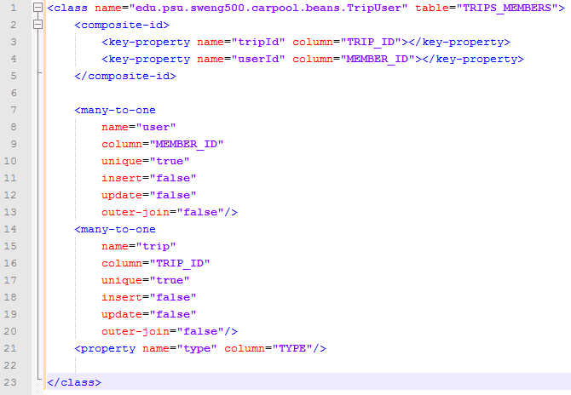
Figure 44 - TRIPUSER to TripUser mapping

Class Diagrams

Carpool Blackberry Project:
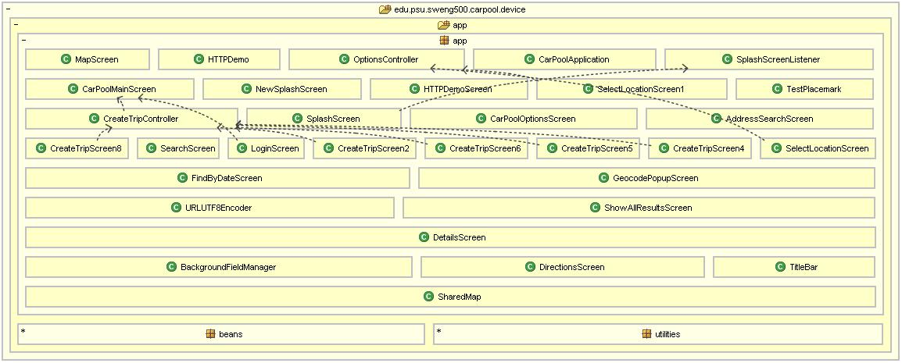

Carpool Web Project:
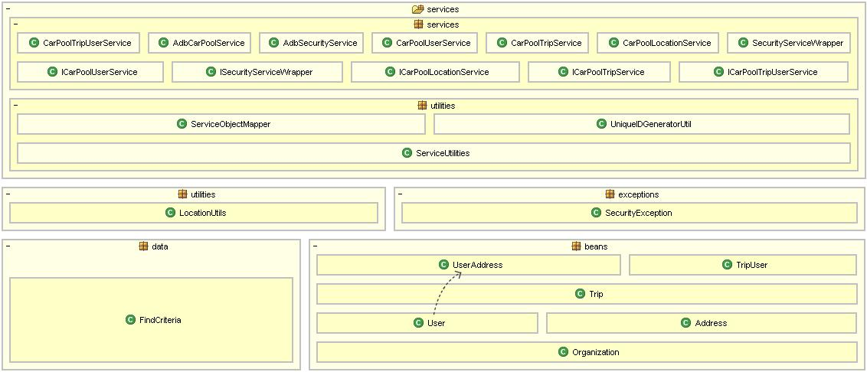

Component Diagram
Here are the details of the components that are required for our system. The User Interface components are to the left side of the diagram. Those components require the services in the next layer. Of note is the ServiceObjectMapper that creates a mapping from the Web Service version of an object to the database version and vice versa. Next, we have the objects in the data layer that have a mapping to the persistence layer.

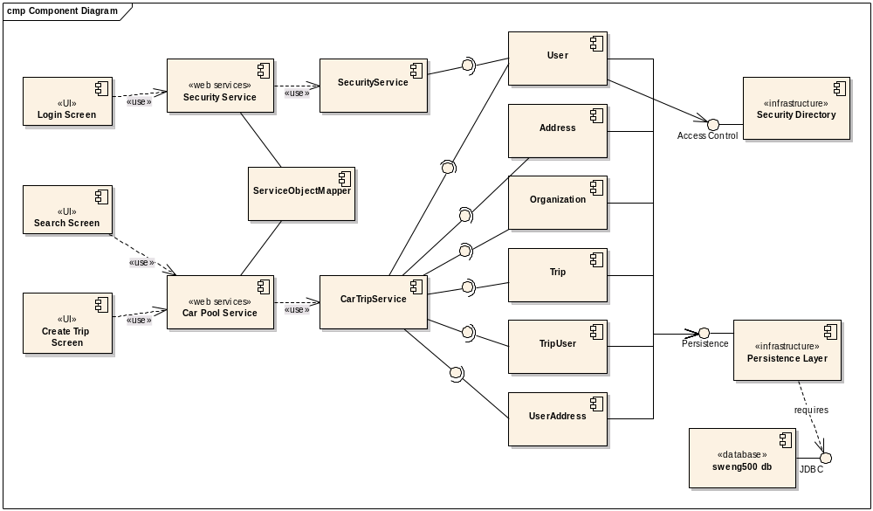
Figure 45 - Component Diagram

Data Classes
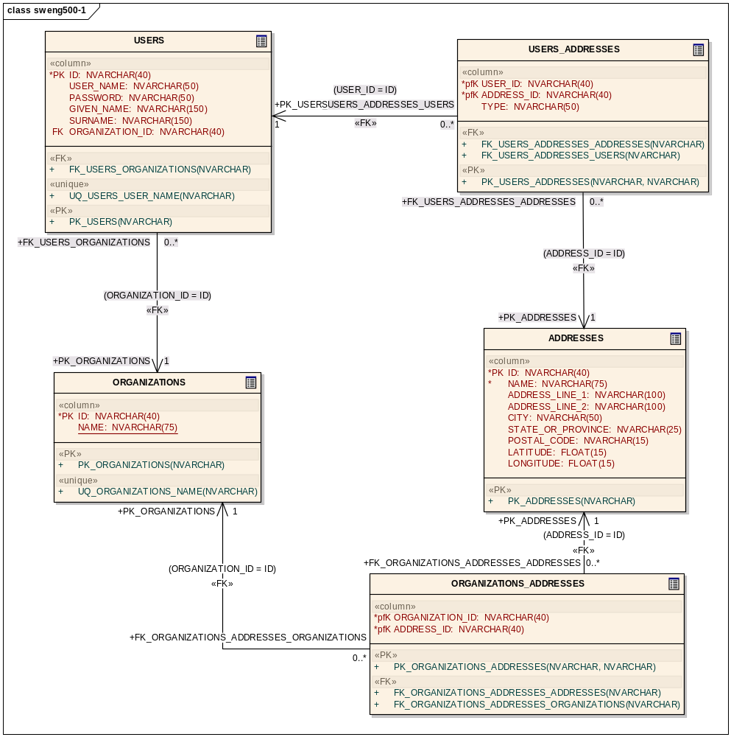
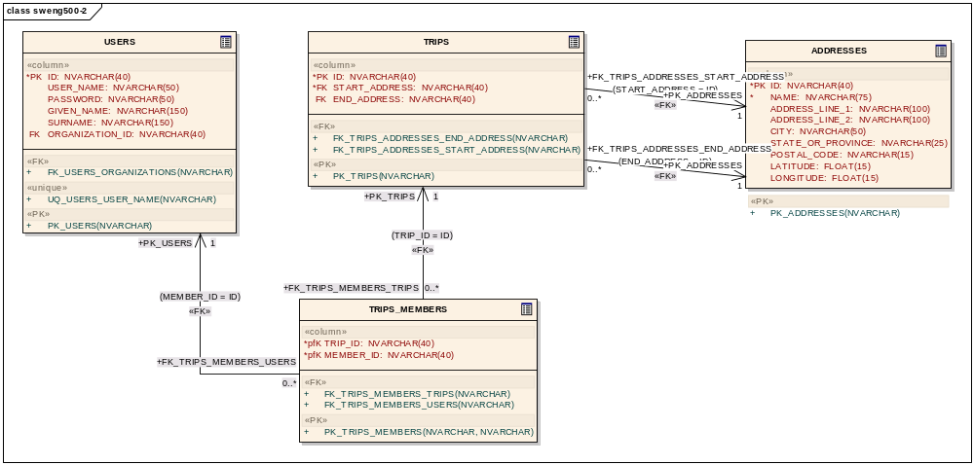

Deployment Diagram
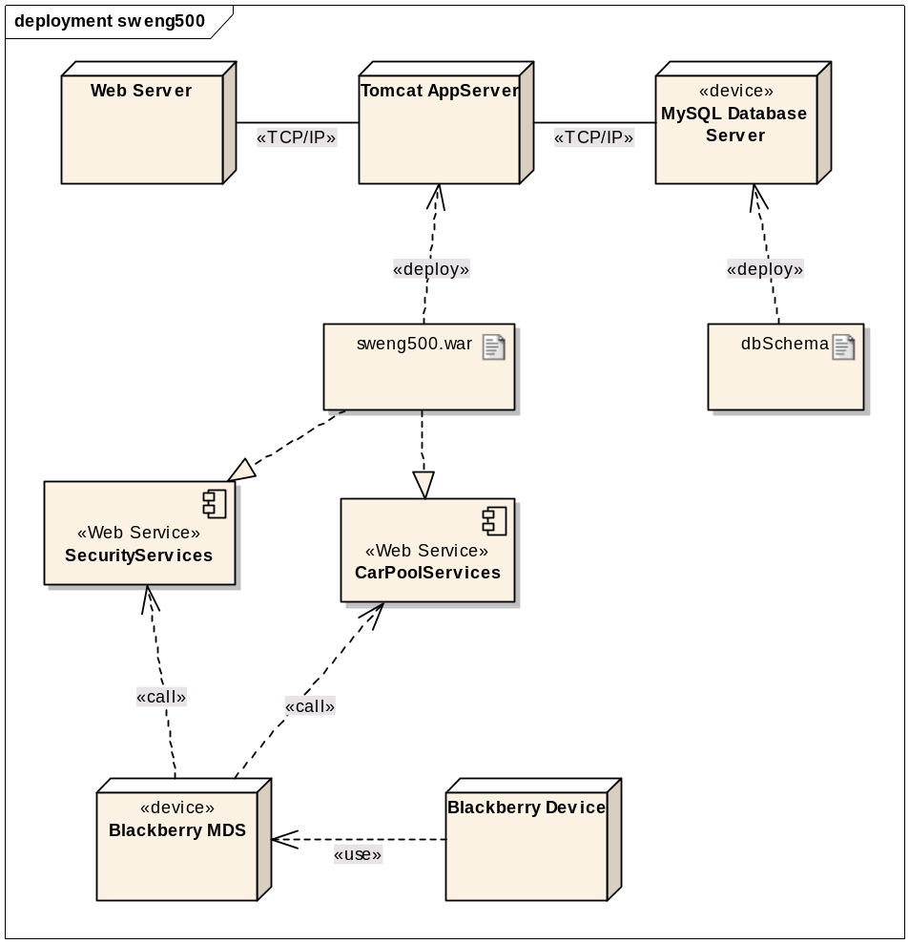
Figure 46 - Deployment Diagram
The Deployment Diagram depicts the physical objects in the system where our application operates. In this section, we will explain the role of the various components.

Component | Description
Web Server | A basic web server (Apache HTTP) that provides HTTP access to our application.  No code needed to be deployed to this component.
Tomcat Application Server | The Apache Tomcat server is a reference server that implements some of the components of the JEE standard.  Our web services code was deployed to this server.
MySQL Database Server | The MySQL Database server was used to store persistent data for the application.  The database schema was deployed to the database server to support our application.
sweng500.war | The Web Application Archive (WAR) is the packaging for our web services portion of our application.
Web Services | The web services in our application are deployed as part of our WAR file.
Blackberry MDS | The Blackberry Mobile Data Services (MDS) provide internet access to Blackberry devices. This service is required for both the simulator and the device.
Blackberry Device | This is the actual Blackberry device that a user would use to access the system. We tested on a Blackberry Curve 8320 and a Curve 8330.

Metrics
Carpool Web Project:
As can be derived from the metrics below, the design of the web project is highly cohesive and loosely coupled. Only one class is tangled (has tight coupling) and only one method within that class has excessive structural complexity (is not cohesive). We would expect this for the findSimilarTripsClass because it contains a fairly complex algorithm which finds trips similar to the data the user has entered by date proximity.
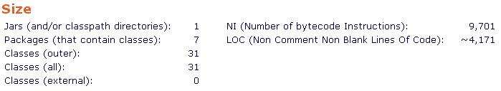
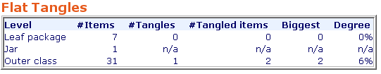

Carpool Blackberry Project:
As can be derived from the metrics below, the design of the blackberry project is also highly cohesive and loosely coupled. Only one class is tangled (has tight coupling) and only two methods have excessive structural complexity (are not cohesive). We would expect this for the CreateTripController class because it is the controller in our Model-View-Controller design, i.e., it responds to user input by choosing the correct screen to display.
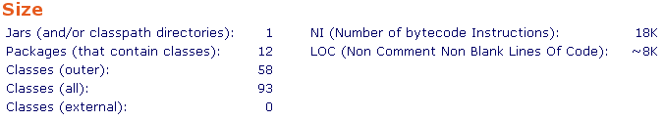
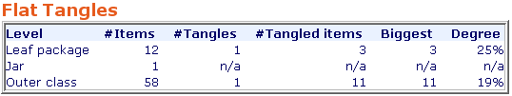
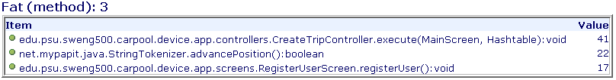
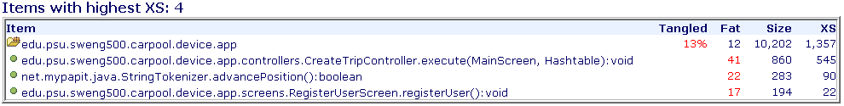

Project Plan
This section contains the project plan that we used for building the application. We tried to stick to an iterative model although our schedules made it somewhat difficult. The early work was primarily to do discovery for the project such as prototyping and estimating the schedule to determine if the project was feasible. As we became more comfortable with the capabilities and the API, we were able to refine the schedule based on the features that we were planning. By the third iteration, we were only adding 2-3 new features and the rest of the work was primarily bug fixes.
During an iteration, the basic progression was to first determine what we want to do in the application, then create the underlying support (model) code and create one or more tests. Once the code was tested, then we would attempt the operation using the web services and the Blackberry device.
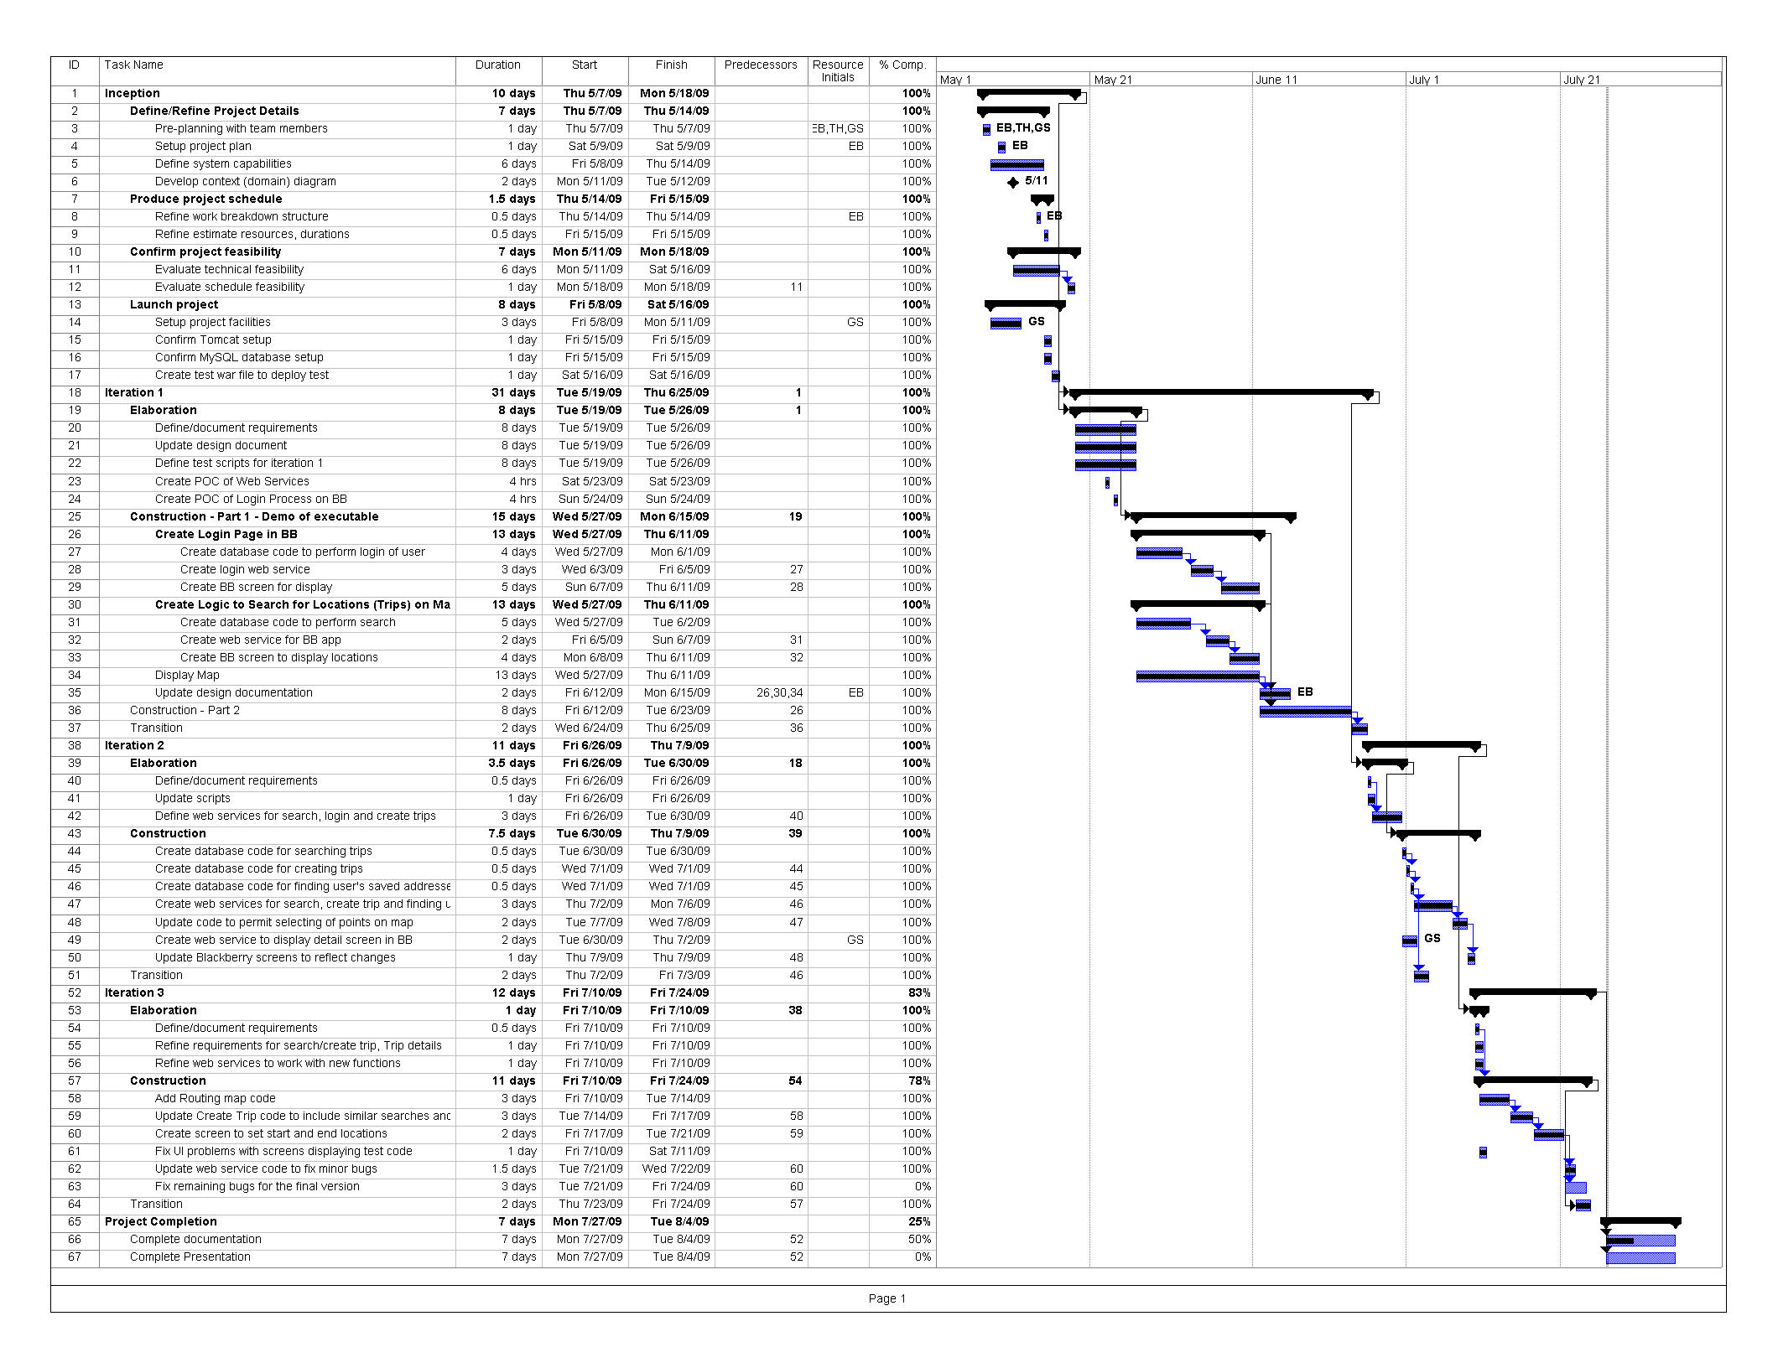
Table of Figures
Figure 1 - Blackberry System Use Case 7
Figure 2 - Web Service System Use Cases 8
Figure 3 - Create Trip Activity 18
Figure 4 - Select Start Place 19
Figure 5 - Create Trip Process (Part 2) 21
Figure 6 - Geocoding Sequence 22
Figure 7 - Map Component Sequence 23
Figure 8 - Login Sequence 24
Figure 9 - Login WSDL complex types 25
Figure 10 - SimpleMessage Complex Type 25
Figure 11 - Car Pool Services Bindings 28
Figure 12 - Parameter complex type 28
Figure 13 - Place complex type 29
Figure 14 - PlaceList complex type 29
Figure 15 - Organization complex type 29
Figure 16 - User complex type 30
Figure 17 - Trip complex type 30
Figure 18 - TripUser complex type 30
Figure 19 - Participant complex type 31
Figure 20 - TripList complex type 31
Figure 21 - SimpleMessage complex type 31
Figure 22 - SearchCriteria complex type 32
Figure 23 - findPlaces Operation 32
Figure 24 - findPlacesNearLocation Operation 33
Figure 25 - findSimilarTrips Operation 34
Figure 26 - findTrips Operation 34
Figure 27 - getTrip Operation 35
Figure 28 - getTripsByUser Operation 36
Figure 29 - getUser Operation 36
Figure 30 - updateSavedAddress Operation 37
Figure 31 - updateTrip Operation 38
Figure 32 - updateTripUser Operation 38
Figure 33 - WSDL update operation 39
Figure 34 - USERS table 41
Figure 35 - USERS-to-User mapping 41
Figure 36 - User Sample Code 42
Figure 37 - ORGANIZATIONS Table 43
Figure 38 - ORGANIZATIONS to Organization mapping 43
Figure 39 - ADDRESSES table 43
Figure 40 - ADDRESSES to Address mapping 44
Figure 41 - TRIPS table 45
Figure 42 - TRIPS to Trip mapping 46
Figure 43 - TRIPUSER table 47
Figure 44 - TRIPUSER to TripUser mapping 48
Figure 45 - Component Diagram 50
Figure 46 - Deployment Diagram 53

