Compilation of GDAL C++-based Boltzmann Entropy Computation Package in Ubuntu 18.04

The guide is designed to help users use the C++-based package that calculates Boltzmann entropy of numerical raster data.

Before installing GDAL for Linux, please open the terminal and then run the following commands.

sudo add-apt-repository -y ppa:ubuntugis/ppa
sudo apt update
sudo apt upgrade

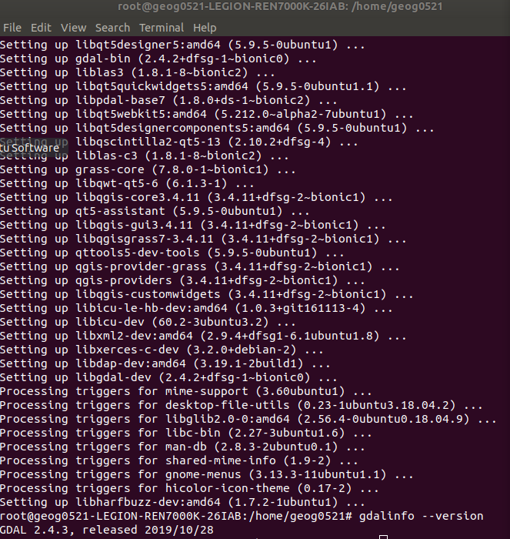

Thereafter, you should input the command as follows:

sudo apt install gdal-bin python-gdal python3-gdal libgdal-dev
[Warming tips: you can run “sudo su” to change to the root. In this case, all gdal libraries will be automatically installed in the directory of “usr/local”, indicating that you do not need to set up the environmental variable.]

When the installation is completed, you can run “gdalinfo --version” to check out the version of gdal installed in your system.

Click “other locations” and then click “Computer” on the right side to see the director of “usr” and go to the folder “local/include”.

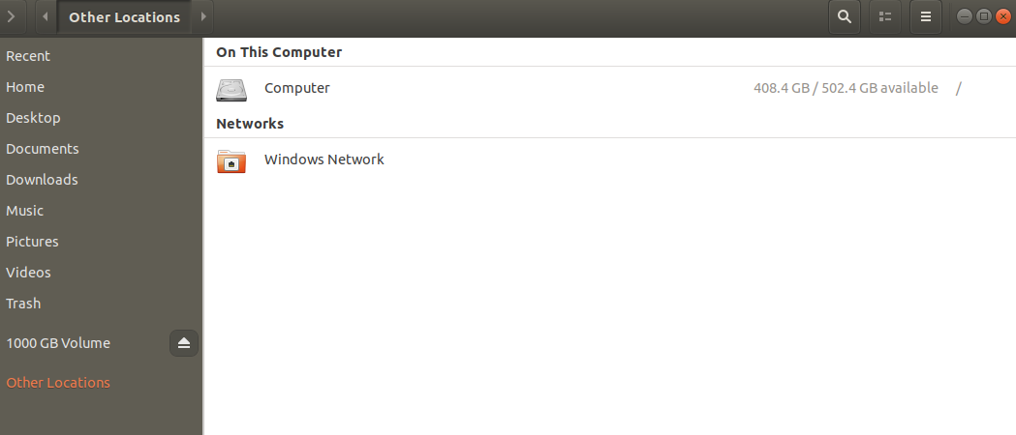

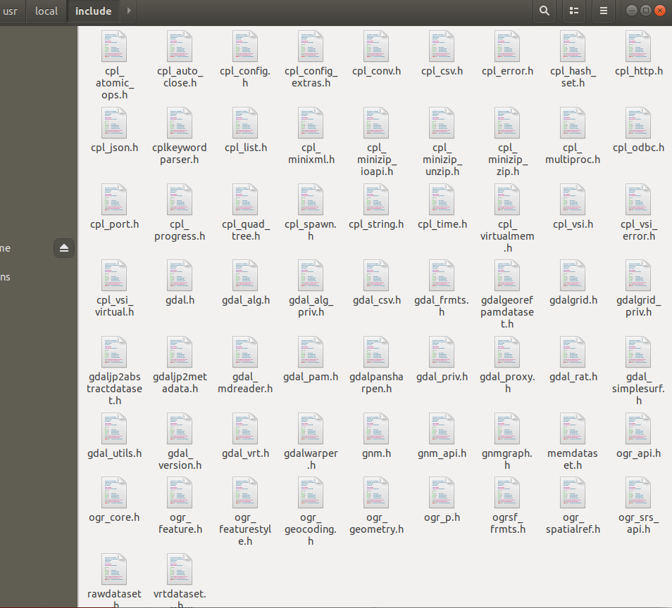

To test the GDAL, you should install G++ by the command of “sudo apt-get install g++”. Then, you can input the command of “g++ path/tetstGDAL.app -lgdal -o hellofunction” to get the compiled function called “hello”. Afterwards, you can input “./hello” to get the output: ”hello world!” (see Fig 2).

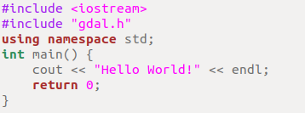
Fig 1. The codes in the “testGDAL.app”.

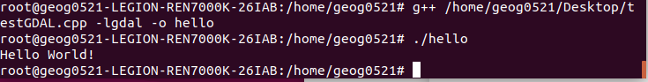
Fig 2. Results of running the compiled function of “hello”.
Next, you should compile the c++ file (i.e., cppBE_0414_test.cpp) of calculating Boltzmann entropy with the following command:

g++ /home/geog0521/Desktop/BECplusplus/cppBE_0414_test.cpp -lgdal -o /home/geog0521/Desktop/BECplusplus/BECplusplus_0414_test -lgomp

The compiled file is “BECplusplus_0414_test”.

Then, you can use “BECplusplus_0414_test”. to calculate the Boltzmann entropy of an image (e.g., a tif file in Fig 3) with the command as follows:

./BECplusplus_0414_test /home/geog0521/Desktop/BECplusplus/test_integer.tif 2 1 1

(“2” represents the logarithmic base for S=klogW. The first “1” means normalization with image size (e.g., 500×500). The second “1” means that the output Boltzmann entropy value will be the sum of Boltzmann entropy of each band.)

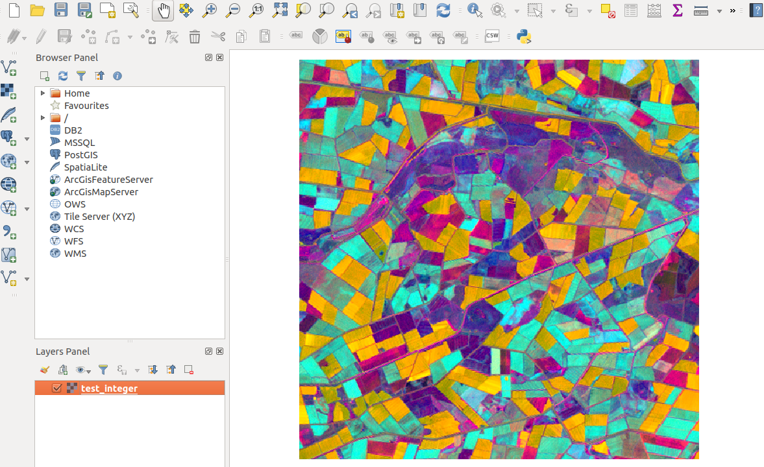Fig 3. Test_integer.tif visualized with three bands.

The results are seen in Fig 4.

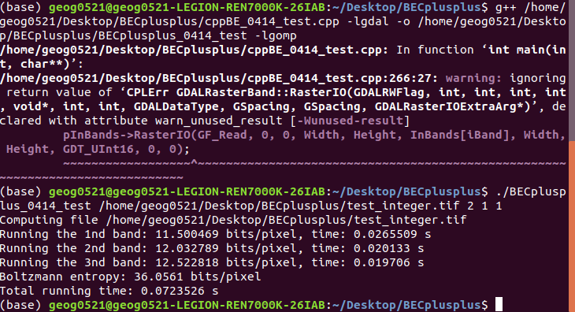
Fig 4. The computation results of “test_integer.tif” (size:500×500). [Note: the total running time is varied among different operating environment].

In the python environment, you can use the following codes to calculate the relative Boltzmann entropy of “test_integer.tif”

import subprocess

if __name__ == '__main__':
BEcomputa_results = subprocess.run(['/home/geog0521/Desktop/BECplusplus/BECplusplus_0414_test','/home/geog0521/Desktop/BECplusplus/test_integer.tif','2','1','1'],universal_newlines=True,stdout=subprocess.PIPE)
nmap_lines = BEcomputa_results.stdout.splitlines()
# print(nmap_lines)
BE_str = nmap_lines[len(nmap_lines)-2]
print(BE_str)
splited_str = BE_str.split(" ")
print(splited_str[len(splited_str)-2])

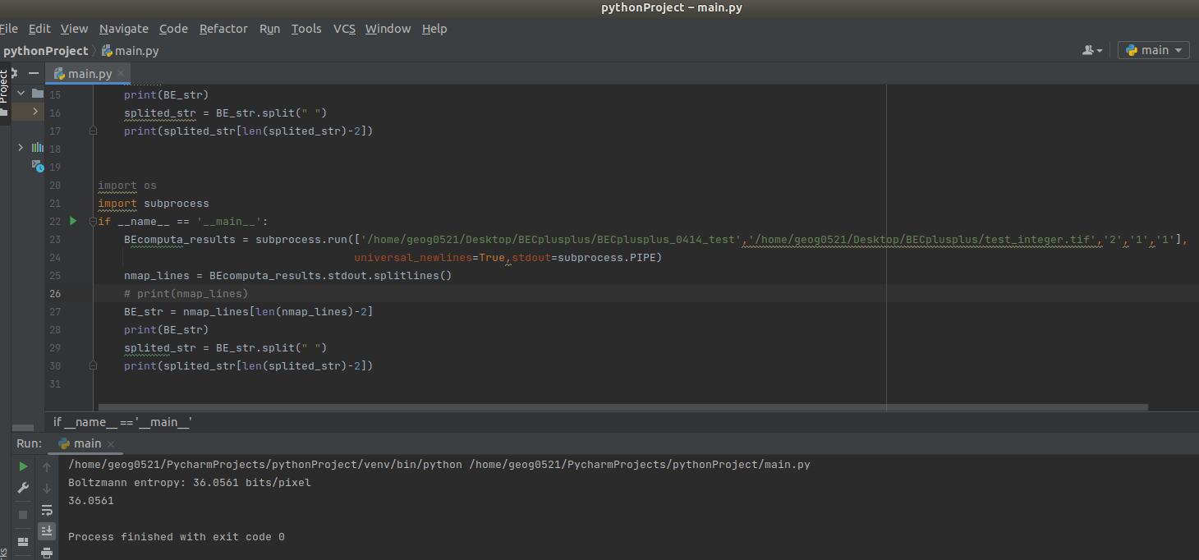
Fig 5. The computation results of “test_integer.tif” by using python and the .exe file.

