Retail leaders help to refine geographic data service retail centres data product.
This week, the Geographic Data Service has been running a series of stakeholder workshops with retail leaders to refine and improve one of their most popular open data products.
Background: GeoDS retail centres
GeoDS retail centre boundaries (& indicators) have historically been a popular data product, used by researchers and practitioners to better understand how the geography and characteristics of high streets and retail centres across the UK are changing over time. Emerging from early efforts by the Centre for Advanced Spatial Analysis (CASA) in 2004, the GeoDS (formerly CDRC) have produced multiple iterations of this popular data product, which consists of polygon extents (i.e. boundaries) for retail centres. In 2016, data from the Local Data Company was integrated within a bespoke spatial clustering algorithm (Pavlis et al., 2018), and then in 2021, open data from the Valuation Office Agency (VOA) and OpenStreetMap was fed into a H3-based algorithm to generate ~ 6,500 retail centres across the UK (Macdonald et al., 2022).
Given well-known licencing and geocoding challenges with VOA data, there was a need to identify a new source of retail location data for the latest iteration of the data product. Recently, new open POI data from Foursquare Places, comprising over 100,000,000 POIs in 200+ countries, offered great potential to this problem. Given the accuracy of the boundaries produced using the algorithm seen in Macdonald et al. (2022), the GeoDS opted to evaluate whether Foursquare POIs could be used in tandem with this algorithm to produce a new set of retail centre boundaries for 2025. Furthermore, the GeoDS also made some enhancements to the existing methodology, notably the use of localised measures of retail density in a graph network structure to delineate sub-centres (i.e. districts) within larger retail centres and agglomerations.
Translating data into reality: incorporating knowledge of retail leaders
To establish whether this newest iteration of the GeoDS retail centre boundaries data product was a marked improvement on previous iterations, a diverse group of retail leaders were invited to participate in a series of stakeholder workshops. These leaders represented experts from the public, private and academic sectors, each of whom was deemed to have domain knowledge of high streets/retail centres, and local knowledge of different geographic areas of the UK. The group consisted of representation from: University of Liverpool, Cardiff University, Stirling University, University of Oxford, Centre for Cities, Greater London Authority, Liverpool City Region Combined Authority, West Midlands Combined Authority, Pets at Home and Boots.
In advance of the workshops, retail leaders were provided with a simple dashboard (see below), which enabled them to explore various layers. They were encouraged to think about whether the 2025 boundaries were an improvement on the 2021 boundaries, whether there were any missing/incorrectly identified boundaries in 2025, whether any boundaries were drawn incorrectly, and whether the new sub-centre methodological augmentation is useful in large city centres. Finally, they were also encouraged to think about how the 2025 boundaries could be useful for their organisations, and the types of supplementary indicators (e.g., vacancy rates) that could be developed for different use cases.
Workshop findings
In general, the consensus from the retail leaders was that the 2025 boundaries represent an improvement on the previous version (2021), in terms of better coverage and more accurate delineation of boundaries (in most locations). The augmented methodology which enables division of large city centres into sub-centres also appeared to be well-received, with stakeholders finding that the algorithm worked well here too, drawing on examples from Liverpool, Birmingham and London. One stakeholder was also able to illustrate cartographically that the 2025 boundaries represent an improvement on other available high street datasets, notably those used in London, through improved capturing of smaller, less-obvious locations (e.g. mixed-purpose, gentrifying locations). Interestingly also, a couple of our stakeholders offered unique insights into the effectiveness of the algorithm in remote locations, which appears to be working well in Anglesey and the Outer Hebrides.
Furthermore, there was great interest from the retail leaders in different use cases for this data product. Many leaders presented interesting ideas for potential indicators, including measures of category occupation, category churn, overall spend and patterns of human mobility, with nearly all documenting a clear evidence gap for indicators that focus on temporal patterns. One stakeholder also discussed the need for this (and other) GeoDS data products to be better connected with proprietary GIS platforms (e.g., ESRI), enabling a wider pool of practitioners to overlay these data products in typical day-to-day GIS workflows. In response, the Geographic Data Service plans to host a follow-up workshop in early 2026 to delve deeper into some of these ideas, using the insights to shape the future development and enrichment of the GeoDS retail centre boundaries data product over the next 3-4 years.

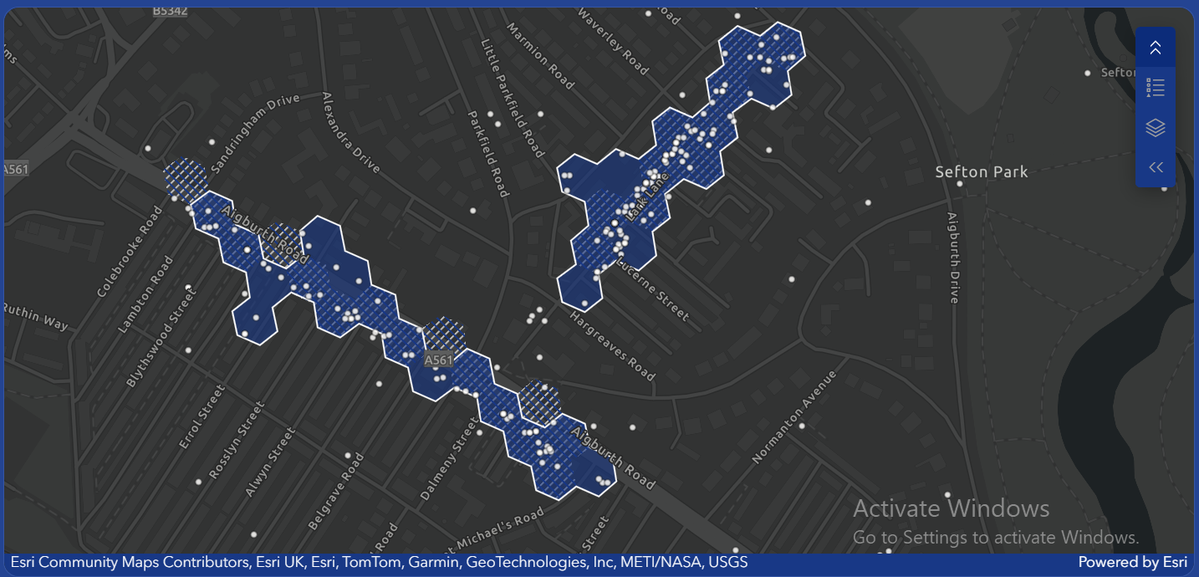
Figure. Dashboard used by retail leaders to evaluate the 2025 GeoDS retail centre boundaries data product.
In addition to lots of positive feedback and ideas for future development, the stakeholder workshops also uncovered specific problems with the latest iteration of the GeoDS retail centres data product. A key limitation is the accuracy and reliability of the Foursquare POI data, which according to various retail leaders is misleading in that it often ‘over-counts’ specific places, and often contains data for places which have been closed for a long time. Another issue flagged was the use of thresholds to remove retail centres below a certain size; at present this is set to 10 retail POIs minimum. Some stakeholders in London argued that this threshold produces a good result, whereas other stakeholders in other parts of the UK demonstrated that lowering of this threshold could generate better results in their local areas. Another issue identified by stakeholders was the apparent merging of traditional ‘high streets’ with peripheral retail parks and shopping centres, and the exclusion of large supermarkets which occupy a key role in many retail centres. Finally, and in response to discussions about merging of traditional versus purpose-built centres, as well as ways to improve/refine the sub-centre augmentation, stakeholders recommended exploring the use of natural delimiters (e.g., major roads, rivers) to improve the results.
Taking stock: refining our data products to reflect lived experiences
Following the workshops, data scientists at the Geographic Data Service have begun working to integrate some of the solutions and recommendations proposed by stakeholders. The aim here is to refine the boundaries once more so that the underlying algorithm and data is not modified extensively, but still incorporates some of the suggested modifications and tweaks to ensure the boundaries reflect the lived experiences and expertise of retail leaders. For example, the data scientists are testing whether the newest version of Foursquare POIs is better than the version used to build the boundaries, as Foursquare have since developed an algorithm to better detect long-standing vacancies. Furthermore, we are also conducting tests on the impacts of different thresholds, use of natural delimiters and ways to better detect retail parks/shopping centres as being separate from nearby ‘traditional’ retail centres. We are planning to finalise the 2025 boundaries before Christmas, so keep an eye out for updates about the newest release of this popular data product.

