Dangers & Dwellers
  - Extended rulebook
4–8 Stakeholders · 6 years · One shared treasury

Welcome to Geolie
An enchanting island, a crystal-clear sea... and a few problems with landslides, floods and earthquakes. Work together to protect Geolie while pursuing your Stakeholder’s own goals. If any health statistic reaches 0, everybody loses. Survive six years, then compare medals: Gold beats Silver; Silver beats Bronze. Players tied for the highest medal win together.

What you need
1 Island Board, 3 hazard boards, 1 Timeline; 32 Stakeholder cards (8 roles, 4 portraits each), 94 Action cards and 22 Event cards. Provide 12 statistic markers, a turn marker, one vote token per Stakeholder and Geuros or a treasury record.

Set up the game
1. Choose roles. Each player or team takes a different Stakeholder and its Action deck. A team of 2–4 people shares one hand, one ability and one vote. Choose a Master to manage the Event deck.
2. Deal cards. Shuffle each Stakeholder’s Action deck separately. Draw 3 cards; place the rest face down. Keep at most 3 cards in hand.
3. Set the boards. Start Happiness, Wealth and Population at 50; all nine defence statistics at 0. Put 200 Geuros in the common treasury. Place the turn marker on year 1.
4. Prepare Events. Randomly select 3 Level I, 2 Level II and 1 Level III cards. Stack them face down to be drawn in this order:
Year | 1 | 2 | 3 | 4 | 5 | 6
Level | I | I | I | II | II | III

5. Choose who starts. Proceed clockwise. At the end of each year, the next Stakeholder clockwise becomes the starting player.
If nobody agrees who should begin, use the first participating role in this order: Citizenship, Scientists, Local Government, Mass Media, Ministry of Finance, Ministry of Infrastructure, Civil Protection, Firefighters.
For a harder game, start all three health statistics at 45 or 40; for an easier game, use 55 or 60. The initial treasury remains 200 Geuros.

The island and its defences

Island health
 All three health statistics start at 50 and stay between 0 and 100. Reaching 0 in any one means immediate defeat after resolving any applicable protection or rescue.
 | Statistic | What it measures
 | Happiness | People’s well-being and satisfaction.
 | Wealth | Infrastructure, services and economic development.
 | Population | The island’s ability to sustain and attract inhabitants.

 Wealth is not cash. Spending Geuros does not reduce Wealth. Wealth determines the income collected at the end of the year; keep the treasury separately.

Three hazards
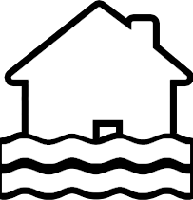 Floods 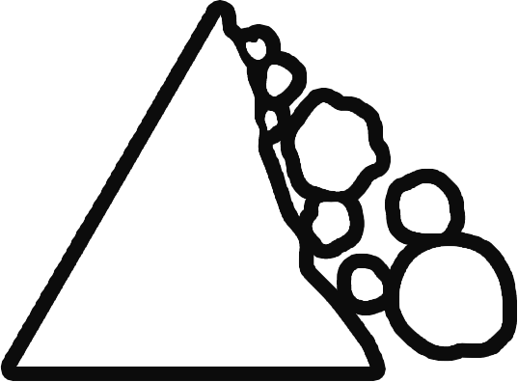 Landslides 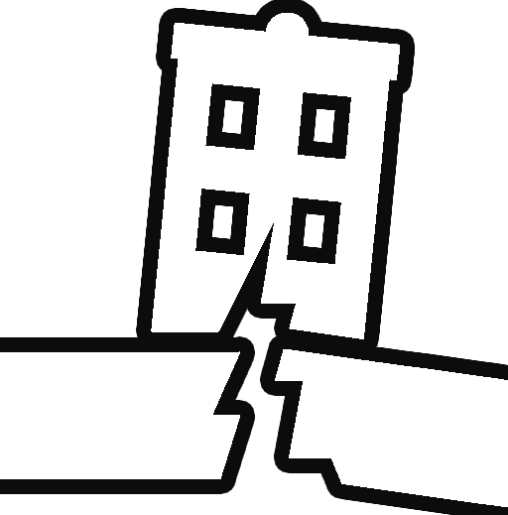 Earthquakes
Each hazard has its own three defence values, all starting at 0, with a maximum of 10. A card changes only the hazard columns and statistics that contain a value.
 | Defence | Role during an Event
 | Forecast | Meet the threshold in Phase I to gain protection.
 | Mitigation | Subtract from Magnitude in Phase II.
 | Response | Subtract from Damage in Phase III.

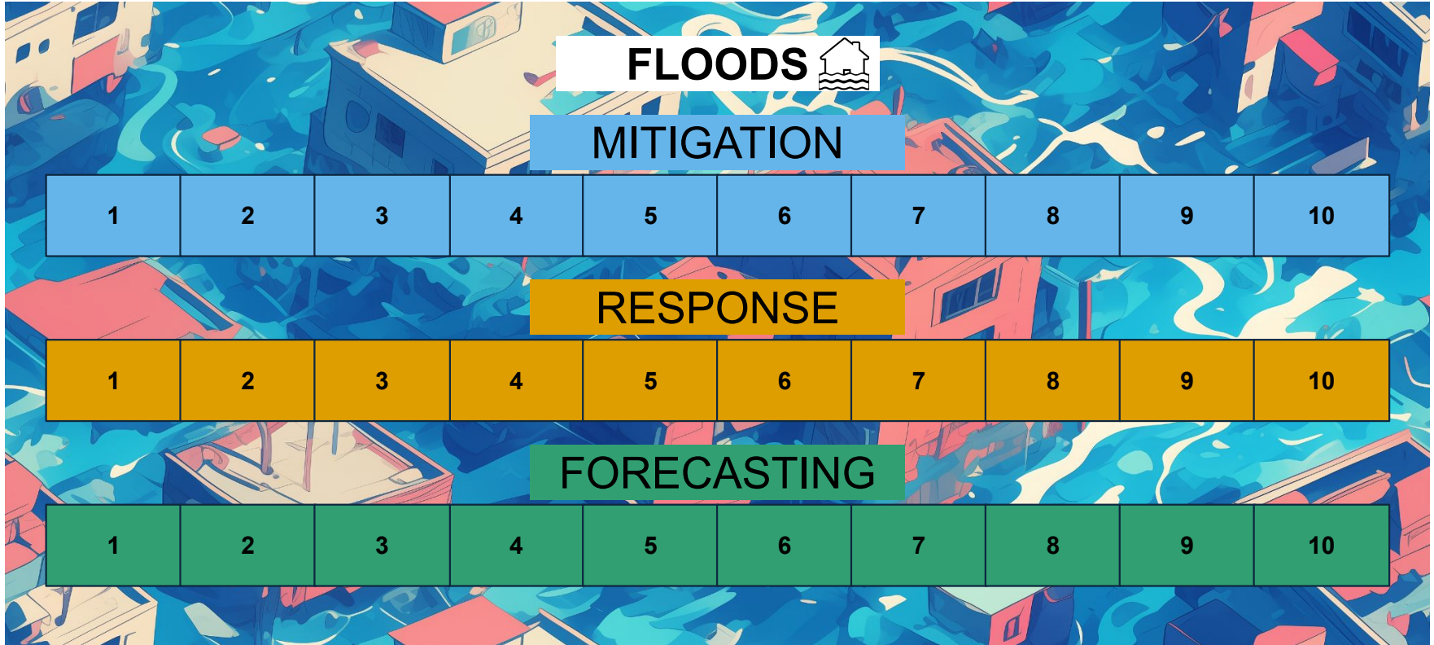
The flood board tracks its own Mitigation, Response and Forecast.
Record temporary modifiers and their expiry separately. Add them to the permanent value, then limit the effective defence to 0–10. When a modifier expires, remove that modifier; preserve the underlying permanent value.

Stakeholders and winning
Choose 4–8 different roles, controlled by individual players or teams. Each role has its own Action deck, ability and medal conditions. Portrait variants have identical rules; use them to form teams if you wish.
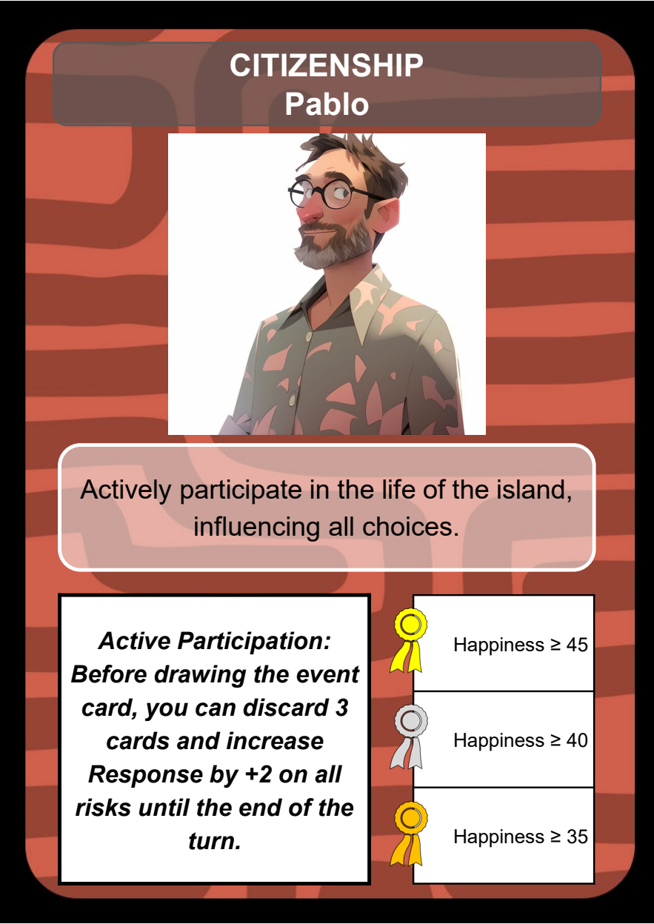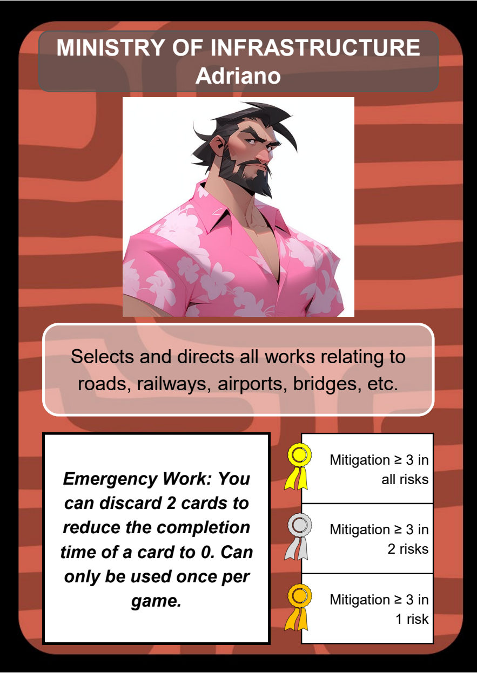
The Stakeholder card shows the role, its ability and three medal conditions.

Keep the island alive
If Happiness, Wealth or Population reaches 0, everyone loses, including in year 6. Apply protection or a timely rescue before moving the affected marker; later effects cannot reverse a resolved defeat.
After collecting turn 6 income, check medals with that turn’s temporary bonuses still active. Each Stakeholder earns the highest medal whose conditions they meet. All holders of the highest earned medal win together. If nobody earns a medal, the island survives but there is no individual winner.
Stakeholder | Bronze | Silver | Gold
Citizenship | Happiness ≥ 35 | Happiness ≥ 40 | Happiness ≥ 45
Scientists | Forecast ≥ 4  in 1 hazard | Forecast ≥ 4  in 2 hazards | Forecast ≥ 4  in all 3
Local Government | Wealth ≥ 10 | Wealth ≥ 15 | Wealth ≥ 25
Mass Media | Population ≥ 40 | Population ≥ 50 | Population ≥ 60
Ministry of Finance | Treasury ≥ 250 | Treasury ≥ 300 | Treasury ≥ 350
Ministry of Infrastructure | Mitigation ≥ 3  in 1 hazard | Mitigation ≥ 3  in 2 hazards | Mitigation ≥ 3  in all 3
Civil Protection | Population ≥ 40  and Wealth ≥ 5 | Population ≥ 45  and Wealth ≥ 10 | Population ≥ 50  and Wealth ≥ 15
Firefighters | Response ≥ 5  in 1 hazard | Response ≥ 5  in 2 hazards | Response ≥ 5  in all 3

Treasury values are in Geuros. Meet both conditions where two are listed. Count each hazard board separately for Forecast, Mitigation and Response.

The Action phase
Each year begins with decisions and investments. Normally, the island can fund up to two Action cards. A special ability may change this limit.

Begin the year
Activate cards scheduled for this year. In years 2–6, each Stakeholder draws 1 Action card. Do not draw in year 1: use the three setup cards. Put excess cards of your choice on the bottom of your deck until you have at most three.

Propose
Clockwise from the starting Stakeholder, each proposes one card face up or passes. Discuss cost, effects and implementation time. Hands and abilities may be shared openly. Money belongs to the island, not to individual players.

Vote
Each Stakeholder casts one vote for another Stakeholder’s proposal. You cannot vote for your own. The two highest-voted cards are selected. With unanimous agreement, select the cards directly instead of placing vote tokens.
If a tie affects a funding slot, vote again among the tied cards. If they are still tied, choose the cheapest, then draw lots if costs also match. Two cards tied for first can both be selected without a runoff.

Fund
Apply cost-changing effects, then pay from the common treasury. If funds cannot cover the selected cards, give priority to the higher-voted proposal and replace an unaffordable card with the next affordable proposal in vote order. Fund fewer cards when necessary.
The group chooses the order of affordable actions. Money explicitly gained immediately is available in this phase and may make another selected card affordable. It does not add a funding slot. Unfunded proposals return to their owners’ hands.

Hands and discarded cards
All discarded cards go on the bottom of their owner’s Action deck, including cards discarded to pay for abilities. They are not shuffled. Keep funded cards and cards awaiting implementation out of the draw deck. If your deck is empty, you draw nothing.
A proposed card is no longer in your hand. Before voting starts, you may withdraw your proposal to pay an ability cost; you then make no proposal that year. After funding, returned proposals may pay for abilities due later in the turn.

Action cards and the Timeline
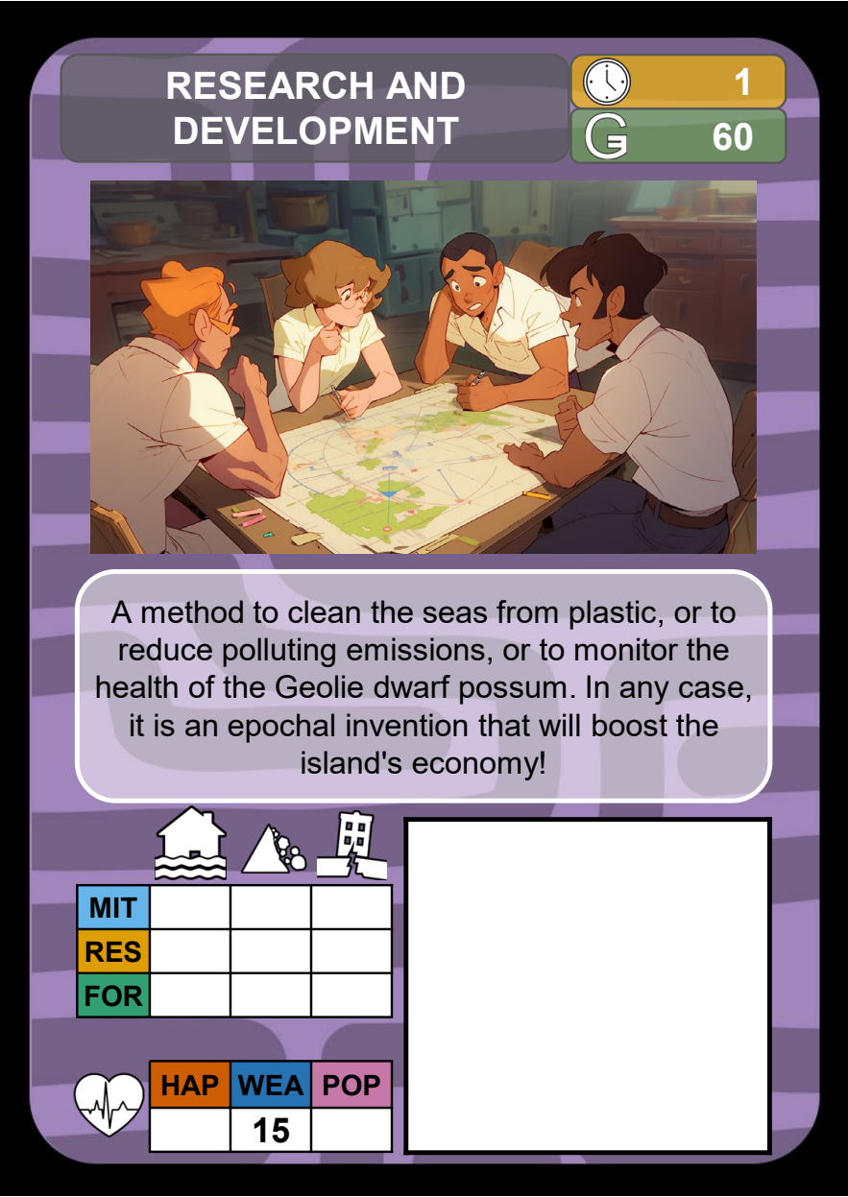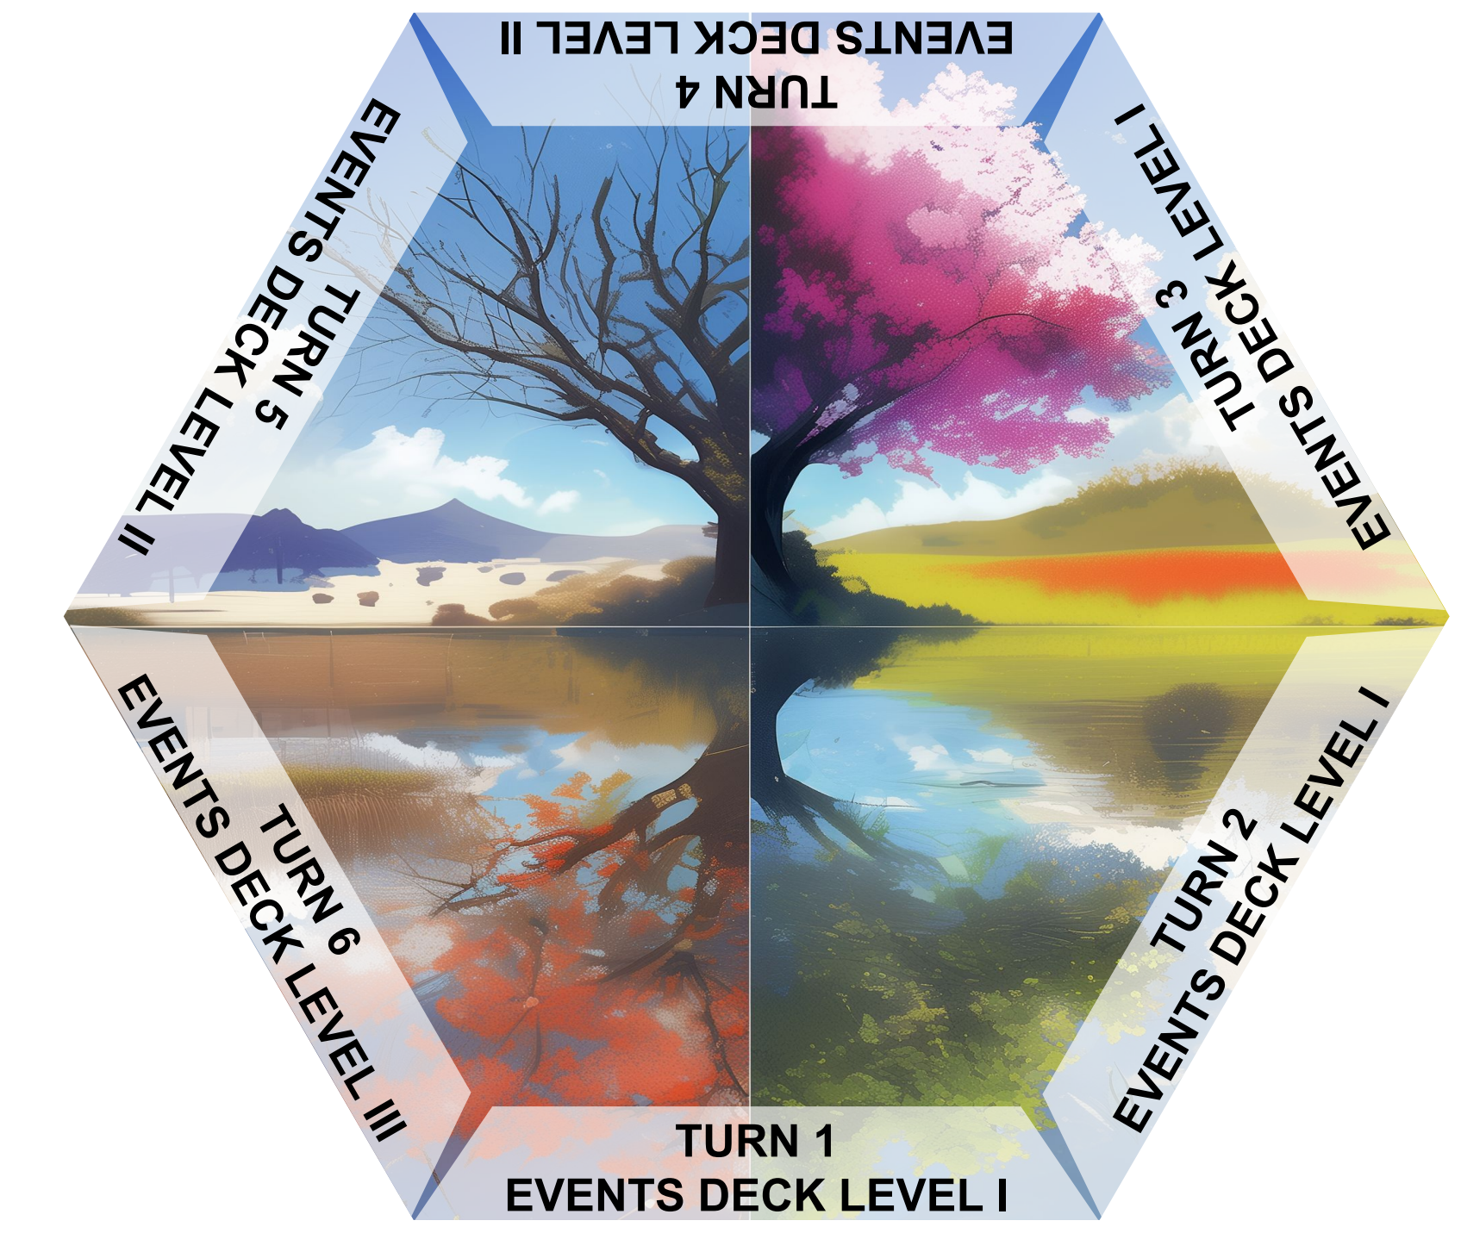
An Action card and the six-year Timeline.

Read the card
The clock gives implementation time; the Geuros symbol gives the cost. Use the printed hazard columns and statistic labels to apply each change. Blank cells make no change. Read any instructions on the card when playing it.
Floods Landslides Earthquakes
Island health groups Happiness, Wealth and Population.
 | Island changes |  | Defence changes
 | Happiness |  | Forecast
 | Wealth |  | Mitigation
 | Population |  | Response

Pay now and activate when ready
Pay the full cost when a card is funded. Time 0 activates now; time 1 activates at the beginning of next year; time 2 at the beginning of the year after that. Put delayed cards at the correct year on the Timeline.
When a card activates, apply its effects once. It uses no new funding slot and costs nothing more. Keep permanent cards visible beside the boards; keep track of temporary effects and follow their printed expiry.
An action scheduled after year 6 will not activate during the game. Implementation time cannot fall below 0. Specific card instructions take precedence over the general procedure.

Stakeholder abilities
Use your own ability at its stated moment by discarding the required cards from your hand to the bottom of your deck. No vote, payment in Geuros or funded-action slot is required. Abilities are limited to once per turn, except those marked once per game.
Stakeholder | Discard | Ability
Citizenship | 3 cards | Before drawing the Event: +2 Response to all hazards until the end of this turn.
Scientists | 3 cards | Before voting: inspect the next 3 Events for 10 seconds with the Master. Once per game; procedure below.
Local Government | 1 card | Draw a replacement, before your proposal or after unfunded proposals return. Once per turn.
Mass Media | 2 cards | After votes: transfer all votes from one proposal to another, including your own. Recount before funding.
Ministry of Finance | 3 cards | When a card wins the vote: reduce its cost to 0 before checking funds. Once per game.
Ministry of Infrastructure | 2 cards | Before the Event: make one funded card active immediately, including a card awaiting implementation. Once per game.
Civil Protection | 2 cards | During voting: this year, fund up to 3 cards instead of 2, if the treasury can pay.
Firefighters | 3 cards | After calculating an Event’s effects, before Population loss: reduce that loss to 0. Other losses remain.

Cassandra and the Master
Before voting, discard 3 cards. The Master shows you the next 3 Event cards in random order for 10 seconds, covering their Level labels. If fewer remain, use those. The Master then shuffles them and returns them to the top, keeping the levels in their required order. Once per game.
Shuffle only the viewed cards of the same level with each other. Keep unrevealed cards hidden from the other Stakeholders.

Remember the timing
A card on the table cannot pay an ability cost unless its proposal is withdrawn before voting. You must be able to discard the full number of cards. Using an ability does not grant an extra draw unless the ability says so.

The Event phase
Before revealing the Event, resolve any abilities due before the draw. Use the level scheduled for this year. Read the card and use the matching hazard board.

I Forecast
Compare Forecast with the FOR threshold. If it meets or exceeds the threshold, apply Yes; otherwise apply No. Resolve immediate effects and keep any protection to apply to the relevant loss.

II Mitigation
Calculate Magnitude − Mitigation. Find that column in Phase II: apply its Wealth change, after any protection, and carry the printed Damage value into Phase III.

III Response
Calculate Damage − Response. Find that column in Phase III: apply its Population and Happiness changes after protection and any timely rescue ability.
Use column 0 for a negative result and 10 for a result above 10. Apply Damage modifiers before subtracting Response. Read the result from the table even in column 0.
A reduction cannot turn a loss into a gain. When halving a loss, round down to a multiple of 5: 15 becomes 5; 25 becomes 10. If both a fixed reduction and halving apply, subtract the fixed reduction first. An effect reducing a loss to 0 takes precedence.

Read a result from the table
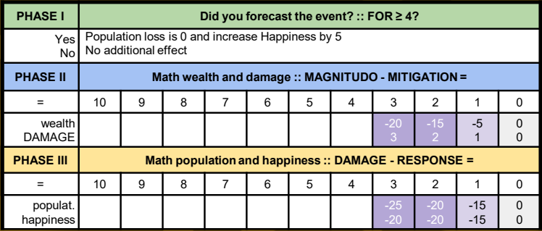
The three resolution tables on Flash Flood.
Example. Geolie has 50 in each health statistic. Its flood defences are Forecast 4, Mitigation 1, Response 1. For this card:
I. Forecast 4 meets the threshold: Population loss is 0 and Happiness rises to 55.
II. 3 − 1 = 2: lose 15 Wealth and take Damage 2. Wealth becomes 35.
III. 2 − 1 = 1: the table gives −15 Population and −15 Happiness. Protection cancels the Population loss, so the final values are Happiness 40, Wealth 35, Population 50.

End the year
After resolving the Event, check survival. If Geolie survives, collect income for its current Wealth, once per year, including year 6. Add it to the shared treasury.
Wealth | Income | Wealth | Income
5 | 30 | 55 | 200
10 | 40 | 60 | 220
15 | 60 | 65 | 240
20 | 80 | 70 | 260
25 | 100 | 75 | 280
30 | 110 | 80 | 300
35 | 120 | 85 | 320
40 | 140 | 90 | 340
45 | 160 | 95 | 360
50 | 180 | 100 | 380

Income is in Geuros. There is no extra income before year 1: start with the 200 Geuros provided during setup.
In years 1–5, remove effects whose duration has ended, move the turn marker forward and pass the starting-player marker clockwise. Return or discard cards as instructed; all discards go to the bottom of the owner’s Action deck. Keep resolved Events visible and delayed actions on the Timeline.
After collecting turn 6 income, check medals with that turn’s temporary bonuses still active.

Every year at a glance
ACTION Activate scheduled cards → draw one card (years 2–6) → propose → vote → pay and implement.
EVENT Reveal the correct level → Forecast → Magnitude − Mitigation → Damage − Response.
YEARS 1–5 Check survival → collect income → remove expired effects → pass the starting-player marker.
YEAR 6 Check survival → collect income → check medals with temporary bonuses still active.
Shared survival first. Personal medals second.

